NucE 530 Kamalesh Bhambare
Spring 2008 Final Exam- Report

3. Parallel Point Jacobi Iterations:
Verification for I = 4 with TH = 1, 2 and 3. The result is independent of number of threads used.

Threads | T(0.25,0.25,0.25) | T(0.5,0.5,0.5) | T(0.75,0.75,0.75) | Iterations
1 | 0.0269607420937688 | 0.0514704690260046 | 0.0269607420937688 | 38
2 | 0.0269607420937688 | 0.0514704690260046 | 0.0269607420937688 | 38
3 | 0.0269607420937688 | 0.0514704690260046 | 0.0269607420937688 | 38

For I = 32
Threads | T(0.25,0.25,0.25) | T(0.5,0.5,0.5) | T(0.75,0.75,0.75) | Iterations
1 | 0.0299596039279548 | 0.0561177853013142 | 0.0299596039279548 | 1803
2 | 0.0299596039279548 | 0.0561177853013142 | 0.0299596039279548 | 1803
3 | 0.0299596039279548 | 0.0561177853013142 | 0.0299596039279548 | 1803
4 | 0.0299596039279548 | 0.0561177853013142 | 0.0299596039279548 | 1803
5 | 0.0299596039279548 | 0.0561177853013142 | 0.0299596039279548 | 1803
6 | 0.0299596039279548 | 0.0561177853013142 | 0.0299596039279548 | 1803
7 | 0.0299596039279548 | 0.0561177853013142 | 0.0299596039279548 | 1803
8 | 0.0299596039279548 | 0.0561177853013142 | 0.0299596039279548 | 1803

I = 64
Threads | T(0.25,0.25,0.25) | T(0.5,0.5,0.5) | T(0.75,0.75,0.75) | Iterations
1 | 0.0299896979129977 | 0.0561453739235151 | 0.0299896979129977 | 6066
2 | 0.0299896979129977 | 0.0561453739235151 | 0.0299896979129977 | 6066
3 | 0.0299896979129977 | 0.0561453739235151 | 0.0299896979129977 | 6066
4 | 0.0299896979129977 | 0.0561453739235151 | 0.0299896979129977 | 6066
5 | 0.0299896979129977 | 0.0561453739235151 | 0.0299896979129977 | 6066
6 | 0.0299896979129977 | 0.0561453739235151 | 0.0299896979129977 | 6066
7 | 0.0299896979129977 | 0.0561453739235151 | 0.0299896979129977 | 6066
8 | 0.0299896979129977 | 0.0561453739235151 | 0.0299896979129977 | 6066

I = 128
Threads | T(0.25,0.25,0.25) | T(0.5,0.5,0.5) | T(0.75,0.75,0.75) | Iterations
1 | 0.0299510704470613 | 0.0560216667579809 | 0.0299510704470613 | 19675
2 | 0.0299510704470613 | 0.0560216667579809 | 0.0299510704470613 | 19675
3 | 0.0299510704470613 | 0.0560216667579809 | 0.0299510704470613 | 19675
4 | 0.0299510704470613 | 0.0560216667579809 | 0.0299510704470613 | 19675
5 | 0.0299510704470613 | 0.0560216667579809 | 0.0299510704470613 | 19675
6 | 0.0299510704470613 | 0.0560216667579809 | 0.0299510704470613 | 19675
7 | 0.0299510704470613 | 0.0560216667579809 | 0.0299510704470613 | 19675
8 | 0.0299510704470613 | 0.0560216667579809 | 0.0299510704470613 | 19675

I = 256
Threads | T(0.25,0.25,0.25) | T(0.5,0.5,0.5) | T(0.75,0.75,0.75) | Iterations
1 | 0.0297590264198006 | 0.0554748689077155 | 0.0297590264198006 | 60424
2 | 0.0297590264198006 | 0.0554748689077155 | 0.0297590264198006 | 60424
3 | 0.0297590264198006 | 0.0554748689077155 | 0.0297590264198006 | 60424
4 | 0.0297590264198006 | 0.0554748689077155 | 0.0297590264198006 | 60424
5 | 0.0297590264198006 | 0.0554748689077155 | 0.0297590264198006 | 60424
6 | 0.0297590264198006 | 0.0554748689077155 | 0.0297590264198006 | 60424
7 | 0.0297590264198006 | 0.0554748689077155 | 0.0297590264198006 | 60424
8 | 0.0297590264198006 | 0.0554748689077155 | 0.0297590264198006 | 60424

d) Parallel Speedup Plots

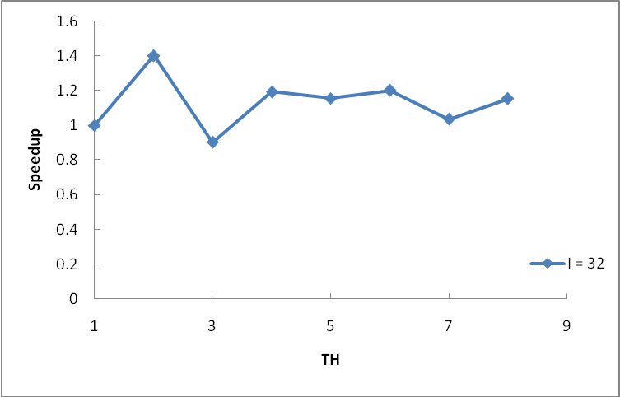

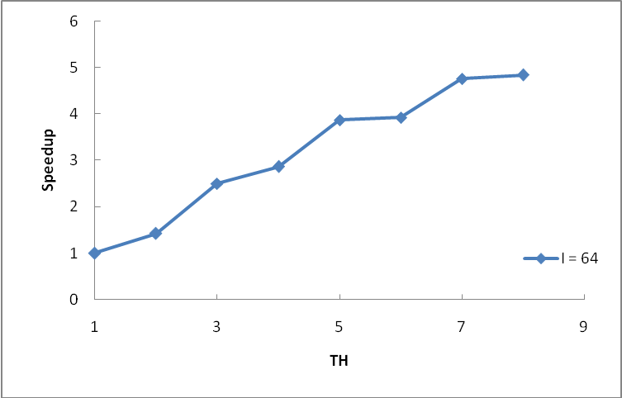

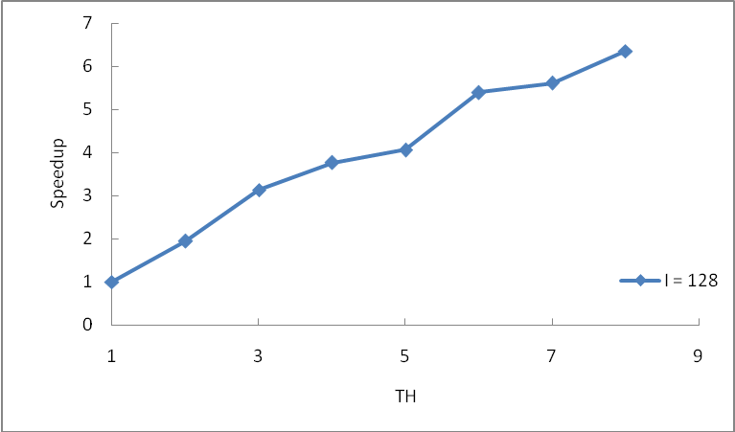

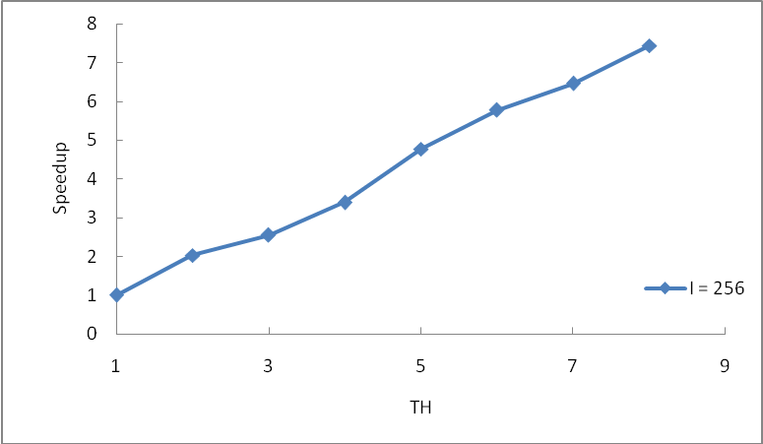

e) Parallel Efficiency Plots
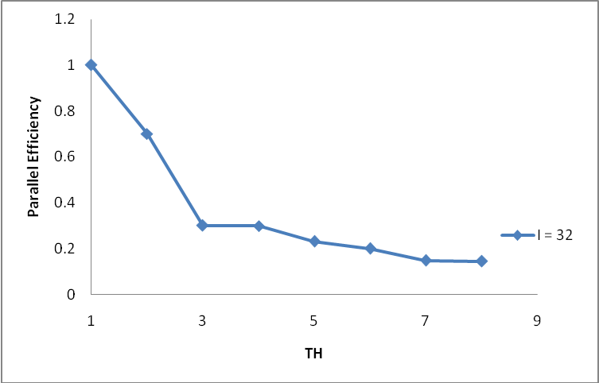

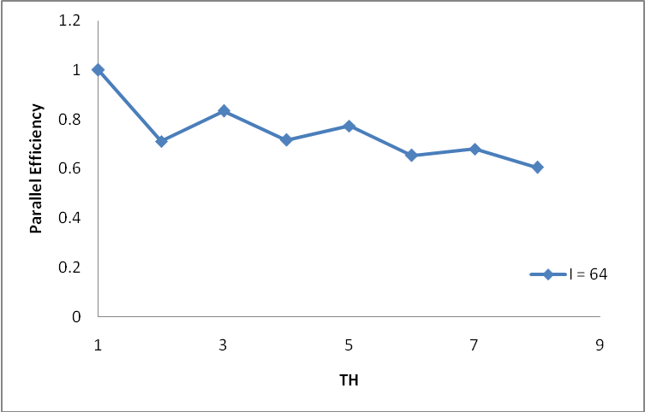

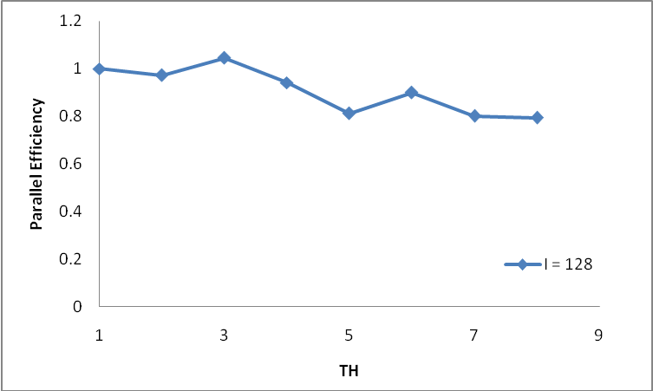
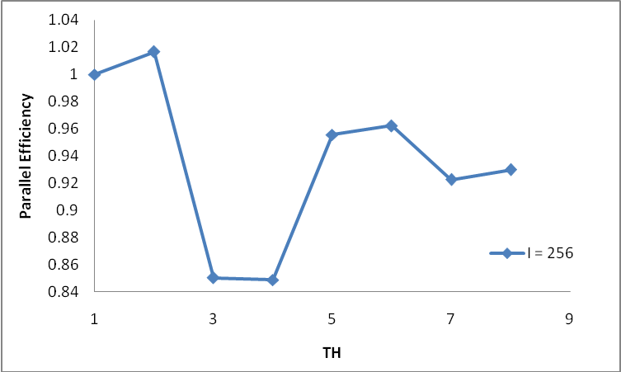

4). Verification of code at I = 4 for SOR. It was verified that number of iterations and solution is independent of number of threads.

Threads | T(0.25,0.25,0.25) | T(0.5,0.5,0.5) | T(0.75,0.75,0.75) | Iterations
1 | 0.0269607832248164 | 0.0514705811215527 | 0.0269607832248164 | 11
2 | 0.0269607832248164 | 0.0514705811215527 | 0.0269607832248164 | 11
3 | 0.0269607832248164 | 0.0514705811215527 | 0.0269607832248164 | 11
For I = 32
Threads | T(0.25,0.25,0.25) | T(0.5,0.5,0.5) | T(0.75,0.75,0.75) | Iterations
1 | 0.0299636019381092 | 0.0561291010256719 | 0.0299636019381092 | 78
2 | 0.0299636019381092 | 0.0561291010256719 | 0.0299636019381092 | 78
3 | 0.0299636019381092 | 0.0561291010256719 | 0.0299636019381092 | 78
4 | 0.0299636019381092 | 0.0561291010256719 | 0.0299636019381092 | 78
5 | 0.0299636019381092 | 0.0561291010256719 | 0.0299636019381092 | 78
6 | 0.0299636019381092 | 0.0561291010256719 | 0.0299636019381092 | 78
7 | 0.0299636019381092 | 0.0561291010256719 | 0.0299636019381092 | 78
8 | 0.0299636019381092 | 0.0561291010256719 | 0.0299636019381092 | 78
I = 64
Threads | T(0.25,0.25,0.25) | T(0.5,0.5,0.5) | T(0.75,0.75,0.75) | Iterations
1 | 0.0300059727671677 | 0.0561913996340284 | 0.0300059727671676 | 148
2 | 0.0300059727671677 | 0.0561913996340284 | 0.0300059727671676 | 148
3 | 0.0300059727671677 | 0.0561913996340284 | 0.0300059727671676 | 148
4 | 0.0300059727671677 | 0.0561913996340284 | 0.0300059727671676 | 148
5 | 0.0300059727671677 | 0.0561913996340284 | 0.0300059727671676 | 148
6 | 0.0300059727671677 | 0.0561913996340284 | 0.0300059727671676 | 148
7 | 0.0300059727671677 | 0.0561913996340284 | 0.0300059727671676 | 148
8 | 0.0300059727671677 | 0.0561913996340284 | 0.0300059727671676 | 148

I = 128
Threads | T(0.25,0.25,0.25) | T(0.5,0.5,0.5) | T(0.75,0.75,0.75) | Iterations
1 | 0.0300164173729534 | 0.0562064359647195 | 0.0300164173729534 | 279
2 | 0.0300164173729534 | 0.0562064359647195 | 0.0300164173729534 | 279
3 | 0.0300164173729534 | 0.0562064359647195 | 0.0300164173729534 | 279
4 | 0.0300164173729534 | 0.0562064359647195 | 0.0300164173729534 | 279
5 | 0.0300164173729534 | 0.0562064359647195 | 0.0300164173729534 | 279
6 | 0.0300164173729534 | 0.0562064359647195 | 0.0300164173729534 | 279
7 | 0.0300164173729534 | 0.0562064359647195 | 0.0300164173729534 | 279
8 | 0.0300164173729534 | 0.0562064359647195 | 0.0300164173729534 | 279

I = 256
Threads | T(0.25,0.25,0.25) | T(0.5,0.5,0.5) | T(0.75,0.75,0.75) | Iterations
1 | 0.0300185629290271 | 0.0562089648228179 | 0.0300185629290271 | 522
2 | 0.0300185629290271 | 0.0562089648228179 | 0.0300185629290271 | 522
3 | 0.0300185629290271 | 0.0562089648228179 | 0.0300185629290271 | 522
4 | 0.0300185629290271 | 0.0562089648228179 | 0.0300185629290271 | 522
5 | 0.0300185629290271 | 0.0562089648228179 | 0.0300185629290271 | 522
6 | 0.0300185629290271 | 0.0562089648228179 | 0.0300185629290271 | 522
7 | 0.0300185629290271 | 0.0562089648228179 | 0.0300185629290271 | 522
8 | 0.0300185629290271 | 0.0562089648228179 | 0.0300185629290271 | 522

4d) Parallel Speedup and Efficiency –
