HW3 Kamalesh Bhambare
Solution of heat equation with source in a cube
Heat equation in Cartesian co-ordinates can be written as,
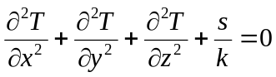
Where s is source per unit volume and k is conductivity.
Boundary Conditions- At the boundary, Dirichlet condition was used, with a temperature of T =0. Furthermore if the governing equation is normalized using θ= (T-Tb) then, boundary condition becomes θ =0, at all of six faces of the boundary. After solving for using F.D., T= Tb + .
Finite Difference Approximation- Using finite difference discretization for each of the term and simplifying we obtain an equation at the interior of the cell,
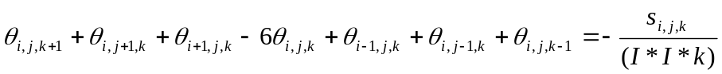

Depending on the location at the boundary (e.g. edge with two or one boundary cells, corner with three boundary cells) some of the neighboring cells will be absent in the equation of boundary. A structured grid, as shown in Fig. 1 is generated with a specified and equal grid size in x, y and z direction.
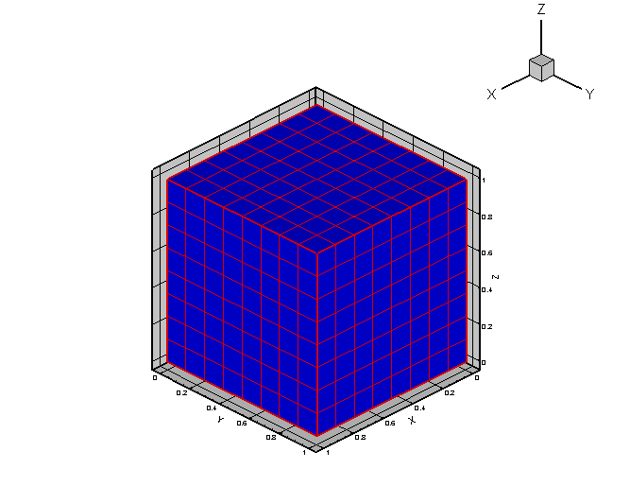
Fig. 1 Structured grid used in the problem
Results – Figure 2 shows the results contour plot at the x = 0.5, 0.25 and 0.75 location. Temperature is highest at the cube center and decreases gradually as moved towards surface. It is necessary to check the grid sensitivity for different number of cells. Figure 3 below shows the variation in the temperature at three different locations in the cube with increasing number of cells with I= 4, 8, 12, and 16.
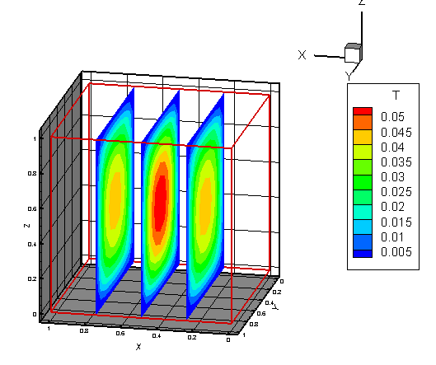
Fig. 2 Contour plot of temperature at x = 0.25, 0.5 and 0.75
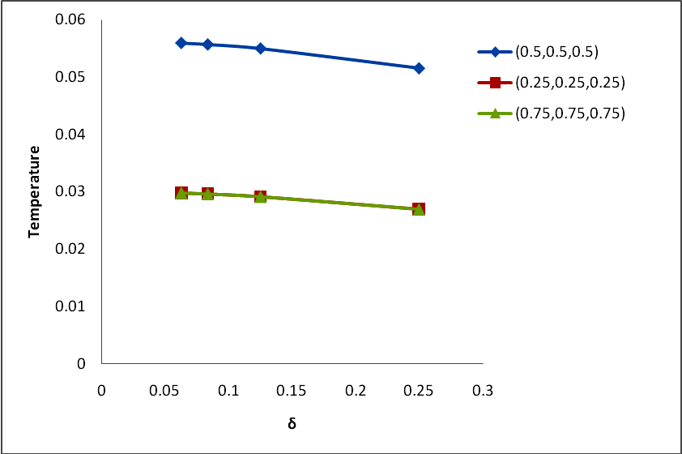
Fig. 1 – Plot of Temperature Vs Delta at locations (0.5,0.5,0.5), (0.25,0.25,0.25) and (0.75,0.75,0.75)
As expected solution shows symmetry in the solution and solution at (0.25,0.25,0.25) and (0.75,0.75,0.75) is same.
Higher accuracy is obtained with finer grid; however computation time increases exponentially with larger number of cells. This can be confirmed by the Fig. 2.
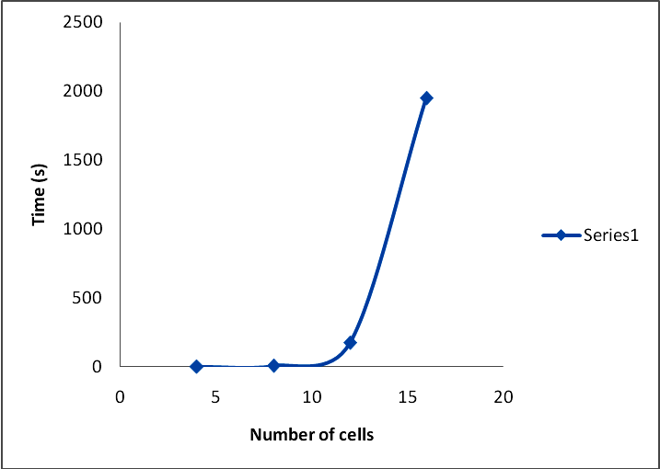
Fig. 2 – Number of cells Vs excution time
Sample input –
8
1
1

Output –
Code Name: main
Version Number: 1.0
Author Name: Kamalesh Bhambare
Date and time of execution: Sun Feb 10 16:23:54 2008

Input check...successful.

Number of cells per dimension = 8
Uniform distributed source strength = 1
Thermal conductivity = 1
Execution time = 4.87512 seconds

Results-
T(0.5,0.5,0.5) = 0.0549177
T(0.25,0.25,0.25) = 0.0291567
T(0.75,0.75,0.75) = 0.0291567

