HW3 Kamalesh Bhambare
Solution of heat equation with source in a cube
Heat equation in Cartesian co-ordinates can be written as,
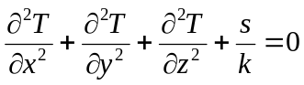
Where s is source per unit volume and k is conductivity.
Boundary Conditions- At the boundary, Dirichlet condition was used, with a temperature of T =0. Furthermore if the governing equation is normalized using θ= (T-Tb) then, boundary condition becomes θ =0, at all of six faces of the boundary. After solving for using F.D., T= Tb + .
Finite Difference Approximation- Using finite difference discretization for each of the term and simplifying we obtain an equation at the interior of the cell,
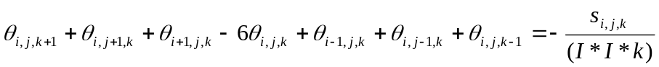

Depending on the location at the boundary (e.g. edge with two or one boundary cells, corner with three boundary cells) some of the neighboring cells will be absent in the equation of boundary. A structured grid, as shown in Fig. 1 is generated with a specified and equal grid size in x, y and z direction.
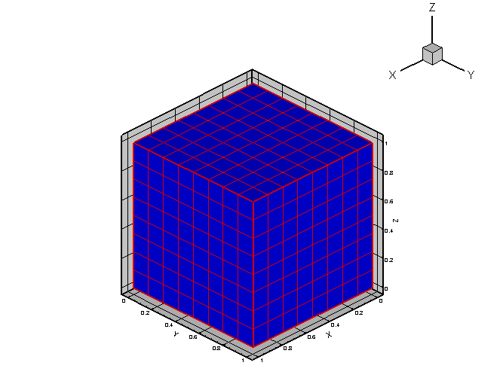
Fig. 1 Structured grid used in the problem
Results – Figure 2 shows the results contour plot at the x = 0.5, 0.25 and 0.75 location for point Jacobi method. Temperature is highest at the cube center and decreases gradually as moved towards surface. It is necessary to check the grid sensitivity for different number of cells. Figure 3 below shows the variation in the temperature at three different locations in the cube with increasing number of cells with I= 4, 8, 12, and 16.
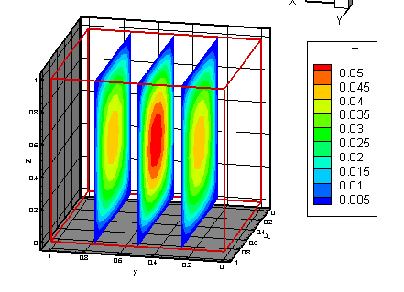
Fig. 2 Contour plot of temperature at x = 0.25, 0.5 and 0.75 for PJ method

Table 1 – Comparison of iterative schemes
 | Number of iterations | Execution time (s) | T(0.5,0.5,0.5) | T(0.25,0.25,0.25) | T(0.75,0.75,0.75)
Point Jacobi | 146 | 2.96509 | 0.054917 | 0.0291564 | 0.0291564
Gauss-Seidel | 79 | 1.53037 | 0.0549174 | 0.0291565 | 0.0291566
SOR | 26 | 0.533872 | 0.0549177 | 0.0291566 | 0.0291567

From the Table 1, which compares the performance of various schemes, it is clear that, SOR requires lowest number of iterations to converge and hence least execution time.

Rough estimate of number of iterations required for each scheme, which matches well with the above values in the Table 1.
PJ - 174
GS - 87
SOR - 17
Sample input –
8
1.0
1.0
1e-6
200
0

Output –
Code Name: main
Version Number: 1.0
Author Name: Kamalesh Bhambare
Date and time of execution: Wed Feb 20 21:12:45 2008

Input check...successful.

Number of cells per dimension = 8
Uniform distributed source strength = 1
Thermal conductivity = 1
Relative convergence criterion = 1e-06
Number of iterations used during solution = 200
Iterative method used = Point Jacobi
Number of iterations required for the Point Jacobi = 146
Execution time = 2.96509 seconds

Results-
T(0.5,0.5,0.5) = 0.054917
T(0.25,0.25,0.25) = 0.0291564
T(0.75,0.75,0.75) = 0.0291564

