NucE 530 Kamalesh Bhambare
Spring 2008 HW6- Report

1. Parallel Point Jacobi Iterations:
Verification for I = 4 with TH = 1, 2, 3 and 4. The result is independent of number of threads used.

Threads | T(0.25,0.25,0.25) | T(0.5,0.5,0.5) | T(0.75,0.75,0.75) | Iterations
1 | 0.0269607247090807 | 0.0514704193554673 | 0.0269607247090807 | 38
2 | 0.0269607247090807 | 0.0514704193554673 | 0.0269607247090807 | 38
3 | 0.0269607247090807 | 0.0514704193554673 | 0.0269607247090807 | 38
4 | 0.0269607247090807 | 0.0514704193554673 | 0.0269607247090807 | 38

2. b)
For I = 16
Threads | T(0.25,0.25,0.25) | T(0.5,0.5,0.5) | T(0.75,0.75,0.75) | Iterations
Serial | 0.0297950169506737 | 0.0558781216965981 | 0.0297950169506737 | 521
1 | 0.0297950169506737 | 0.0558781216965981 | 0.0297950169506737 | 521
2 | 0.0297950169506737 | 0.0558781216965981 | 0.0297950169506737 | 521
3 | 0.0297950169506737 | 0.0558781216965981 | 0.0297950169506737 | 521
4 | 0.0297950169506737 | 0.0558781216965981 | 0.0297950169506737 | 521
5 | 0.0297950169506737 | 0.0558781216965981 | 0.0297950169506737 | 521
6 | 0.0297950169506737 | 0.0558781216965981 | 0.0297950169506737 | 521
7 | 0.0297950169506737 | 0.0558781216965981 | 0.0297950169506737 | 521
8 | 0.0297950169506737 | 0.0558781216965981 | 0.0297950169506737 | 521

I = 32
Threads | T(0.25,0.25,0.25) | T(0.5,0.5,0.5) | T(0.75,0.75,0.75) | Iterations
Serial | 0.0299595841510452 | 0.0561177293637668 | 0.0299595841510452 | 1803
1 | 0.0299595841510452 | 0.0561177293637668 | 0.0299595841510452 | 1803
2 | 0.0299595841510452 | 0.0561177293637668 | 0.0299595841510452 | 1803
3 | 0.0299595841510452 | 0.0561177293637668 | 0.0299595841510452 | 1803
4 | 0.0299595841510452 | 0.0561177293637668 | 0.0299595841510452 | 1803
5 | 0.0299595841510452 | 0.0561177293637668 | 0.0299595841510452 | 1803
6 | 0.0299595841510452 | 0.0561177293637668 | 0.0299595841510452 | 1803
7 | 0.0299595841510452 | 0.0561177293637668 | 0.0299595841510452 | 1803
8 | 0.0299595841510452 | 0.0561177293637668 | 0.0299595841510452 | 1803

I = 64
Threads | T(0.25,0.25,0.25) | T(0.5,0.5,0.5) | T(0.75,0.75,0.75) | Iterations
Serial | 0.0299896780640936 | 0.0561453177823366 | 0.0299896780640936 | 6066
1 | 0.0299896780640936 | 0.0561453177823366 | 0.0299896780640936 | 6066
2 | 0.0299896780640936 | 0.0561453177823366 | 0.0299896780640936 | 6066
3 | 0.0299896780640936 | 0.0561453177823366 | 0.0299896780640936 | 6066
4 | 0.0299896780640936 | 0.0561453177823366 | 0.0299896780640936 | 6066
5 | 0.0299896780640936 | 0.0561453177823366 | 0.0299896780640936 | 6066
6 | 0.0299896780640936 | 0.0561453177823366 | 0.0299896780640936 | 6066
7 | 0.0299896780640936 | 0.0561453177823366 | 0.0299896780640936 | 6066
8 | 0.0299896780640936 | 0.0561453177823366 | 0.0299896780640936 | 6066

c) Wall Clock Time Plots

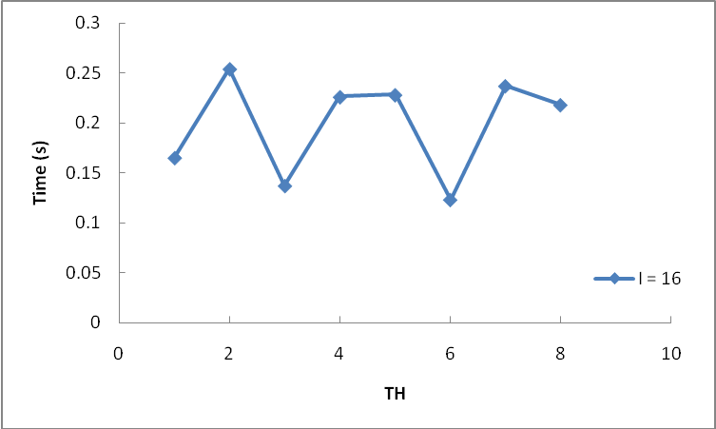

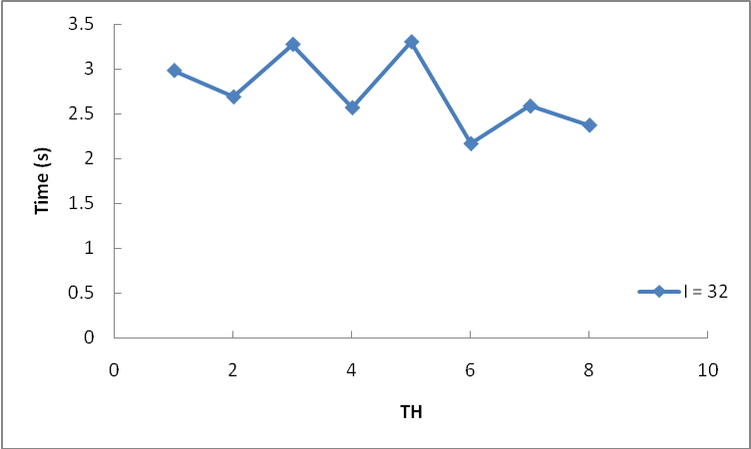

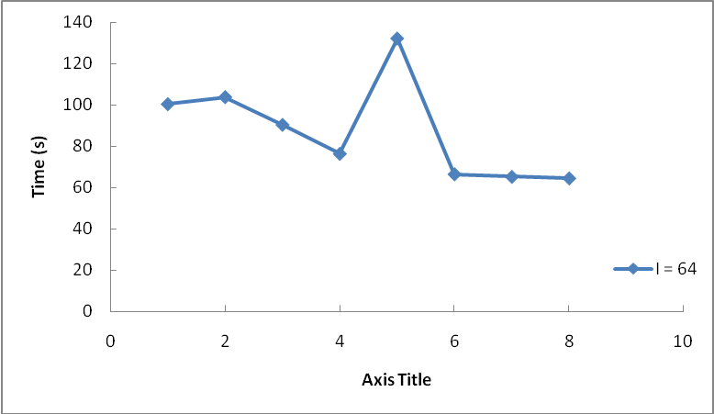

d) Parallel Speedup Plots

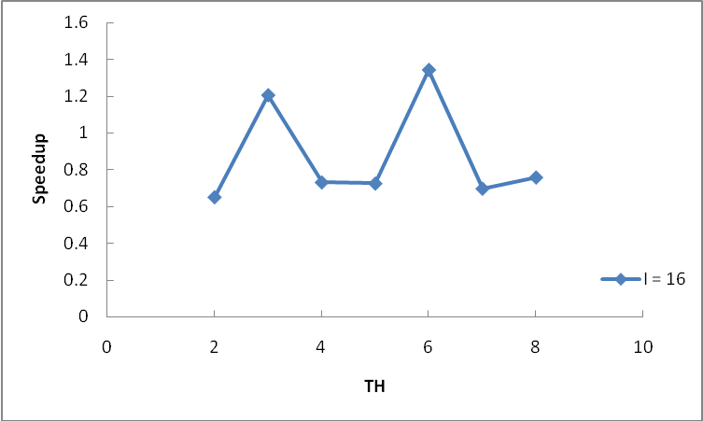

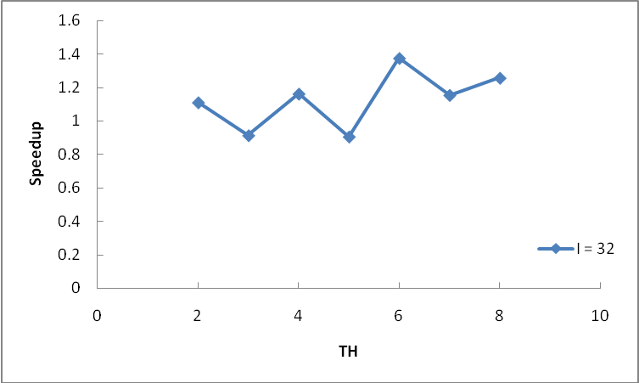

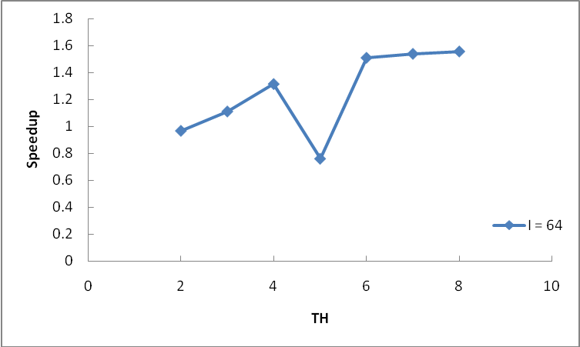

e) Parallel Efficiency Plots

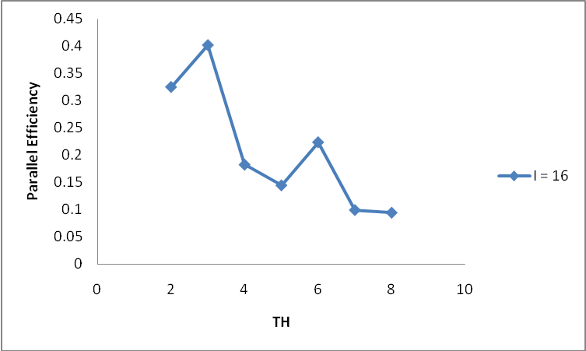

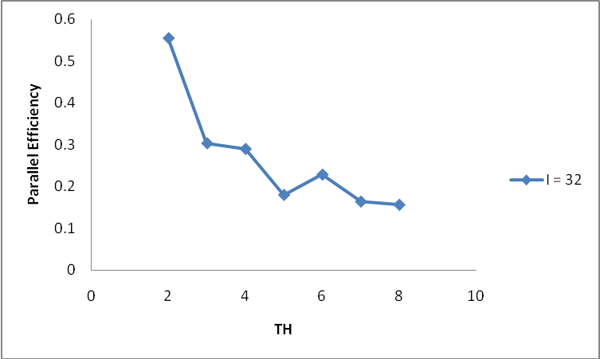

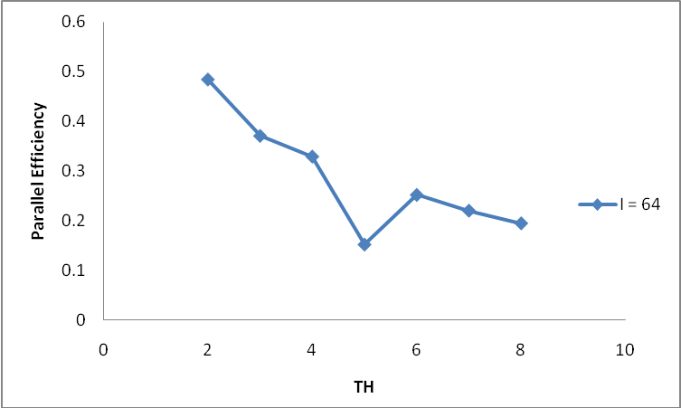

3a) Red/black method was implemented for SOR for solving heat equation. It was verified that for I = 4 serial code solution and parallel code solution matches till 7 digits. After 7 digits it differs.

3d) Verification of code at I = 4. It was verified that number of iterations and solution is independent of number of threads. But number of iterations are different from serial program.

Threads | T(0.25,0.25,0.25) | T(0.5,0.5,0.5) | T(0.75,0.75,0.75) | Iterations
serial | 0.0269607528250166 | 0.0514705803962452 | 0.0269607841004123 | 12
1 | 0.0269607783051981 | 0.0514705493854777 | 0.0269607783051981 | 11
2 | 0.0269607783051981 | 0.0514705493854777 | 0.0269607783051981 | 11
3 | 0.0269607783051981 | 0.0514705493854777 | 0.0269607783051981 | 11
4 | 0.0269607783051981 | 0.0514705493854777 | 0.0269607783051981 | 11

3e) Number of SOR iterations for red/black ordering is smaller than the number of iterations with natural ordering.

4b)
For I = 16
Threads | T(0.25,0.25,0.25) | T(0.5,0.5,0.5) | T(0.75,0.75,0.75) | Iterations
Serial | 0.0297960230750678 | 0.0558809957018724 | 0.0297960340597829 | 53
1 | 0.029795974073143 | 0.0558808344977713 | 0.029795974073143 | 41
2 | 0.029795974073143 | 0.0558808344977713 | 0.029795974073143 | 41
3 | 0.029795974073143 | 0.0558808344977713 | 0.029795974073143 | 41
4 | 0.029795974073143 | 0.0558808344977713 | 0.029795974073143 | 41
5 | 0.029795974073143 | 0.0558808344977713 | 0.029795974073143 | 41
6 | 0.029795974073143 | 0.0558808344977713 | 0.029795974073143 | 41
7 | 0.029795974073143 | 0.0558808344977713 | 0.029795974073143 | 41
8 | 0.029795974073143 | 0.0558808344977713 | 0.029795974073143 | 41

I = 32
Threads | T(0.25,0.25,0.25) | T(0.5,0.5,0.5) | T(0.75,0.75,0.75) | Iterations
Serial | 0.0299636790912345 | 0.0561293426122005 | 0.0299636911515066 | 105
1 | 0.0299635840367714 | 0.0561290489696626 | 0.0299635840367714 | 78
2 | 0.0299635840367714 | 0.0561290489696626 | 0.0299635840367714 | 78
3 | 0.0299635840367714 | 0.0561290489696626 | 0.0299635840367714 | 78
4 | 0.0299635840367714 | 0.0561290489696626 | 0.0299635840367714 | 78
5 | 0.0299635840367714 | 0.0561290489696626 | 0.0299635840367714 | 78
6 | 0.0299635840367714 | 0.0561290489696626 | 0.0299635840367714 | 78
7 | 0.0299635840367714 | 0.0561290489696626 | 0.0299635840367714 | 78
8 | 0.0299635840367714 | 0.0561290489696626 | 0.0299635840367714 | 78

I = 64
Threads | T(0.25,0.25,0.25) | T(0.5,0.5,0.5) | T(0.75,0.75,0.75) | Iterations
Serial | 0.0300061411856435 | 0.0561919213407831 | 0.0300061562617273 | 207
1 | 0.0300059556372673 | 0.0561913472432724 | 0.0300059556372673 | 148
2 | 0.0300059556372673 | 0.0561913472432724 | 0.0300059556372673 | 148
3 | 0.0300059556372673 | 0.0561913472432724 | 0.0300059556372673 | 148
4 | 0.0300059556372673 | 0.0561913472432724 | 0.0300059556372673 | 148
5 | 0.0300059556372673 | 0.0561913472432724 | 0.0300059556372673 | 148
6 | 0.0300059556372673 | 0.0561913472432724 | 0.0300059556372673 | 148
7 | 0.0300059556372673 | 0.0561913472432724 | 0.0300059556372673 | 148
8 | 0.0300059556372673 | 0.0561913472432724 | 0.0300059556372673 | 148

4c) Wall clock time for I = 16, 32, 64
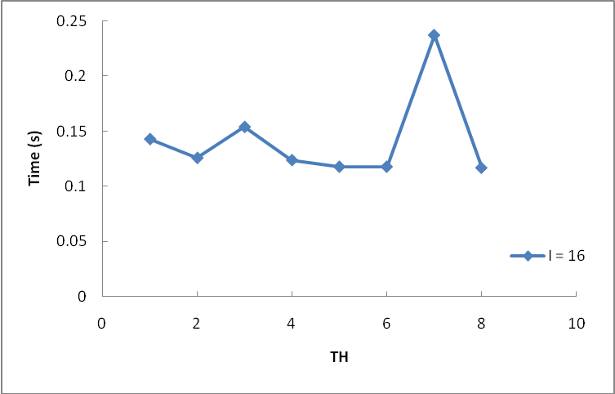

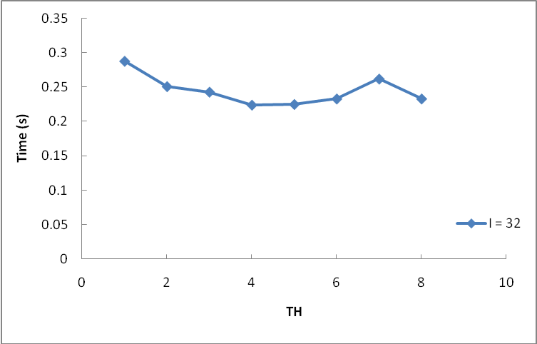
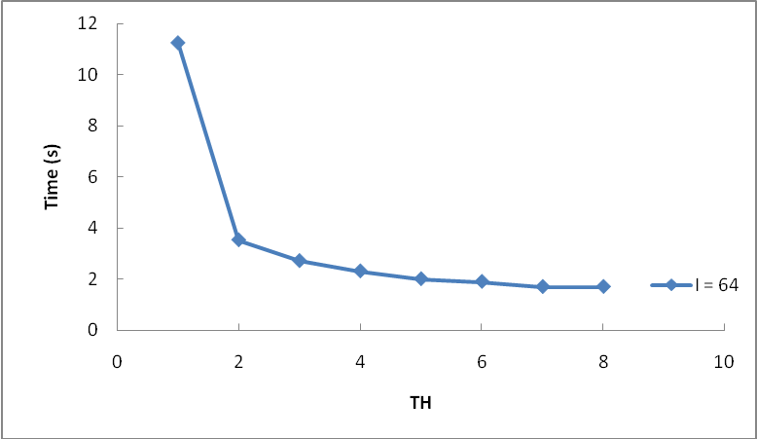

4d) Parallel Speedup and Efficiency –
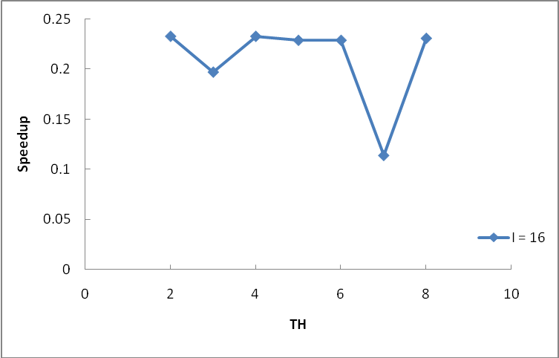

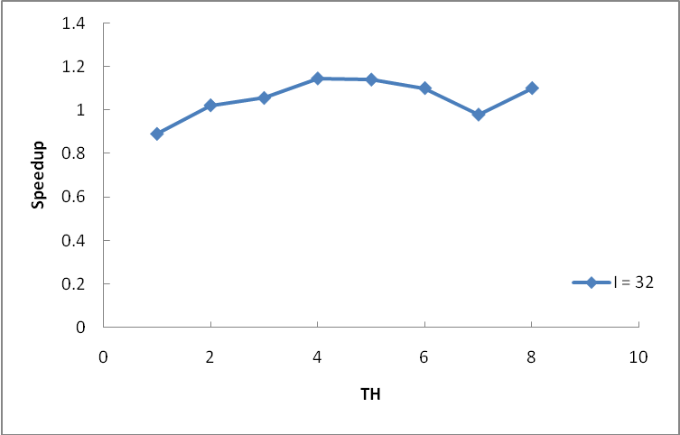

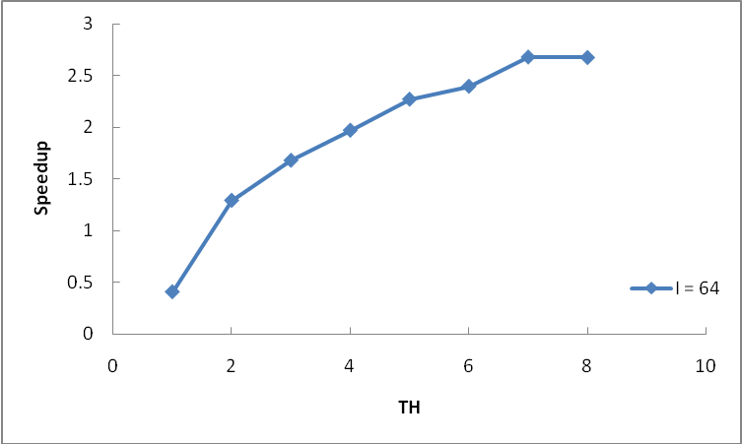

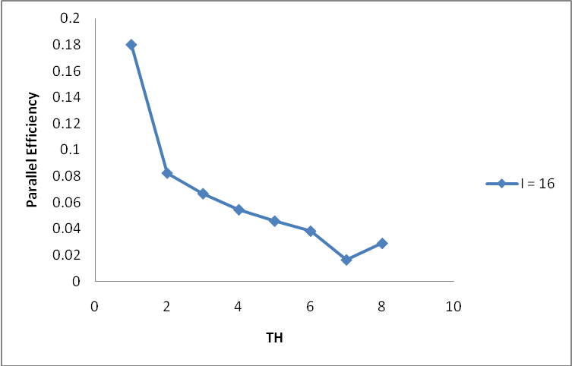

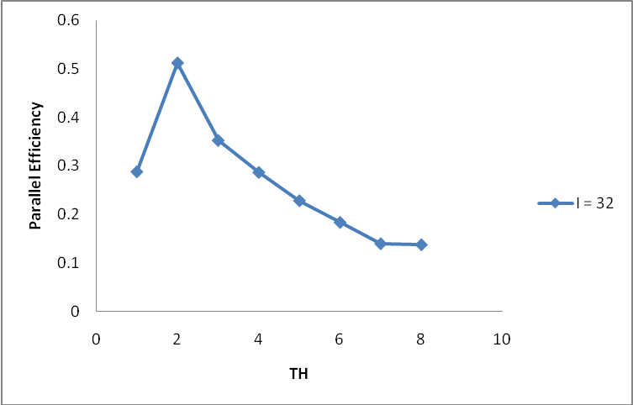
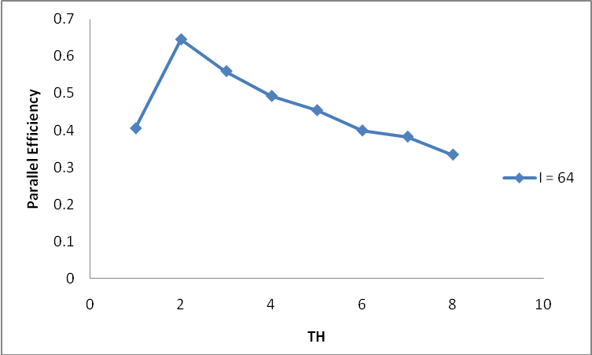

4e) To compute the speedup serial execution time was used in the above plots. Red/black algorithm uses two separate iterations (Red and Black) and a method slightly different from serial SOR. It is therefore necessary to compare the execution time of the Red/Black SOR with serial execution time.

