NucE 530 Kamalesh Bhambare
Spring 2008 Midterm - Report

For a given number of mesh I, number of grid points are n= (I+1)³. Small order scalar and vectors are neglected in the calculations here.

Smallest storage required for Point Jacobi, Gauss-Seidel and SOR:
[A] matrix: n x 7, (neighborhood nodes coefficient)
[B] matrix: n,
[T] matrix: n x 2 (previous and current iteration level),
Total: n x 10 = 10×(I+1)³ data points

Smallest storage required for direct solver:
[A] matrix: n x n,
[B] matrix: n,
[T] matrix: n,
Total: n x (n+2) ~ n² = (I+1)⁶ data points

Storage required = (number of data points)*8 / (1024*1024) MB

Figure 1 shows the variation of memory requirement on log scale with mesh size. Ratio of the number of iterations required for the direct solver and iterative solver increases exponentially, indicating high cost associated with direct solvers at fine mesh.
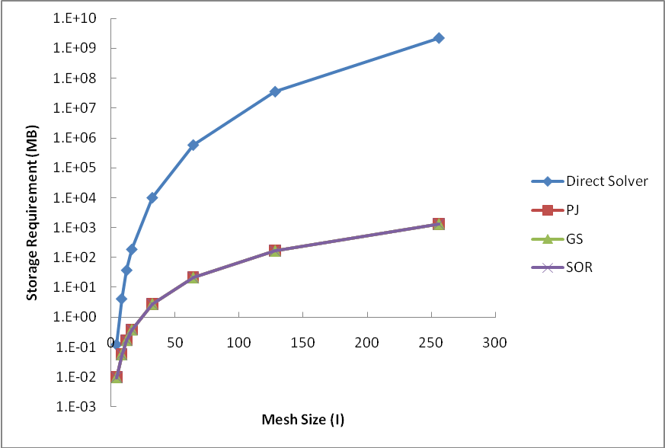
Fig. 1 – Storage requirement comparison of direct and iterative solvers for different mesh sizes
2. Figure 2 below shows the number of iterations Vs iterative scheme on a log-log scale. For both PJ and GS, number of iterations predicted by spectral analysis is greater than actually required. For SOR spectral method under predicts the number of iterations required.
Rate of rise of number of iterations required is higher in case of PJ and GS method. In case of SOR is less due to use of ω_{opt} .
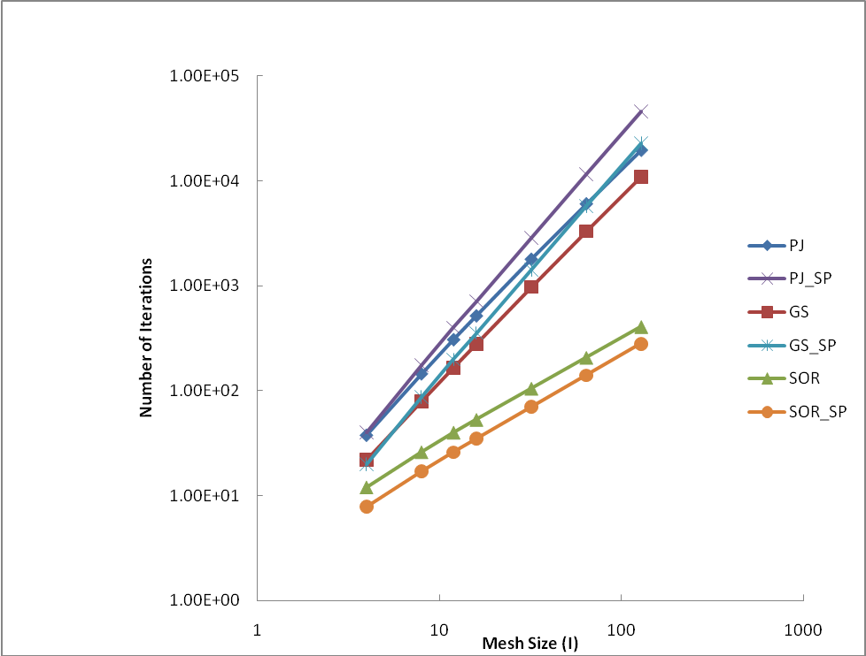
Fig 2 – Comparison of number of iteration required for a given mesh size on a log-log scale
3. Table 1, shows the comparison of agreement in number of digits of solution for the three iterative methods at different number of cells. For PJ method there is no difference between the number of digits of solution at two different locations (0.25, 0.25, 0.25) and (0.75, 0.75, 0.75). For GS and SOR there is difference after 6 and 7 digits of the solution.
In PJ, the solution at current iteration is updated from solution at earlier iteration. Effect in changes in the solution is felt within entire domain immediately. For GS, new solution only at west, bottom and south are used. So the changes are not updated immediately at all locations within the domain. This is also true in the case of SOR. This has implication on number of digits of agreement in GS and SOR scheme.
Table 1: Comparison of temperature at two different locations for different mesh sizes
I | Method | T(0.25,0.25,0.25) | T(0.75,0.75,0.75) | Agreement
4 | PJ | 0.026960724709081 | 0.026960724709081 | 15 (all )
 | GS | 0.026960745508630 | 0.026960779463087 | 7
 | SOR | 0.026960752825017 | 0.026960784100412 | 7
8 | PJ | 0.029156405768500 | 0.029156405768500 | 15 (all )
 | GS | 0.029156475546060 | 0.029156584929059 | 6
 | SOR | 0.029156638383261 | 0.029156653754520 | 7
12 | PJ | 0.029625121750097 | 0.029625121750097 | 15 (all )
 | GS | 0.029625314928171 | 0.029625485973402 | 6
 | SOR | 0.029625673542403 | 0.029625683296991 | 7
16 | PJ | 0.029795016950674 | 0.029795016950674 | 15 (all )
 | GS | 0.029795409776872 | 0.029795642211988 | 6
 | SOR | 0.029796023075068 | 0.029796034059783 | 7
32 | PJ | 0.029959584151045 | 0.029959584151045 | 15 (all )
 | GS | 0.029961402708508 | 0.029961875955352 | 6
 | SOR | 0.029963679091235 | 0.029963691151507 | 7
64 | PJ | 0.029989678064094 | 0.029989678064094 | 15 (all )
 | GS | 0.029997437845340 | 0.029998390037862 | 5
 | SOR | 0.030006141185644 | 0.030006156261727 | 7
128 | PJ | 0.029951050642059 | 0.029951050642059 | 15 (all )
 | GS | 0.029982926640420 | 0.029984827125409 | 5
 | SOR | 0.030016788900364 | 0.030016808177472 | 6
256 | SOR | 0.030019473555252 | 0.030019473616176 | 7

4. Absolute error variation (log scale) with mesh size at locations (0.25, 0.25, 0.25) and (0.75, 0.75, 0.75) is shown in Fig. 3 and Fig. 4. For all the three methods, absolute error decreases with mesh size increase. For PJ and GS absolute error increases beyond I= 64.
5. Theoretical error is given by δ²/96 (M_{x}⁴ + M_{y}⁴ ). Upper limit of theoretical error is δ². The absolute error follows theoretical error closely in all the iterative method follows. Deviation from this occurs after I = 64 for PJ and GS. This is due to increase in round of error and when mesh size is reduced, as GS and PJ undergo larger number of iterations than SOR, they have higher round off error.
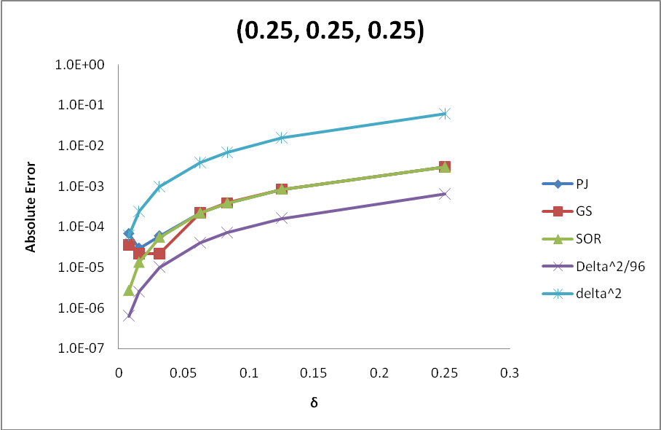
Fig. 3- Comparison of absolute errors for iterative errors at (0.25, 0.25, 0.25)
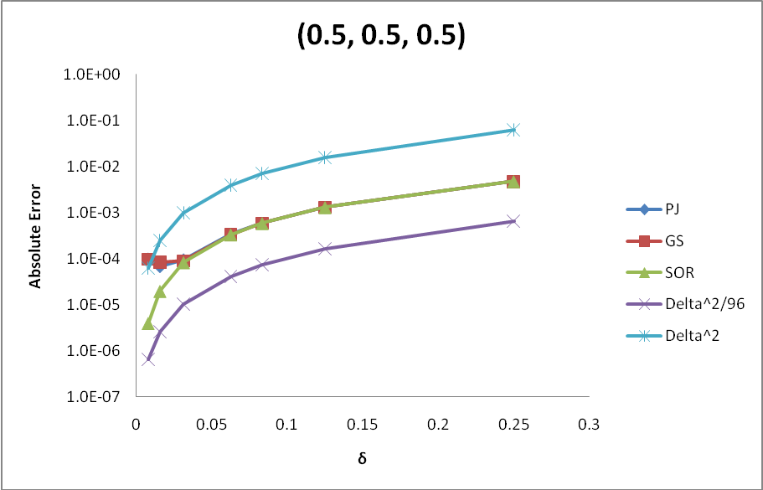
Fig. 4- Comparison of absolute errors for iterative errors at (0.5, 0.5, 0.5)

