**MINISTERUL EDUCAȚIEI ȘI CERCETĂRII AL REPUBLICII MOLDOVA**

**Universitatea Tehnică a Moldovei**

**Lucrarea individuală**

la cursul ***„Interfețe de comunicare”***

**A efectuat :**  **St. gr. CR-221FR Serba Cristina**

**A verificat:**  **Ababii Victor**

**Chișinău 2024**

**Tipologia retelei de calculatoare:**

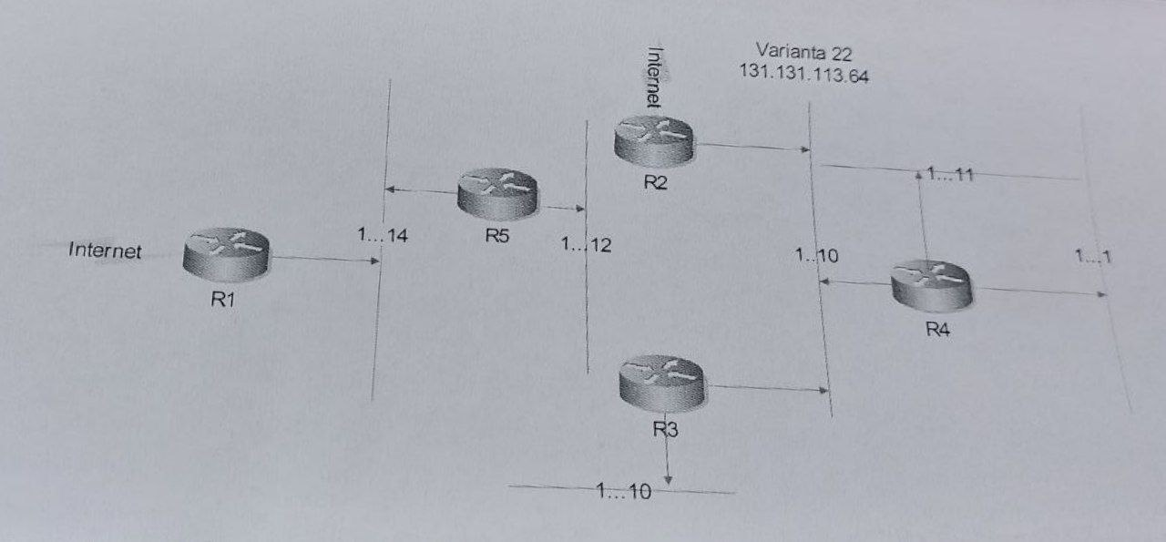

N = ]log2(max{14, 12, 10, 11, 1, 10} + 2)[ = ]log2(16)[ = 4

**Masca tuturor subretelelor:**

255.255.255.255-

000.000.000.015 =

255.255.255.240 sau 131.131.113.0/28 => 28 = 32 – 4

|  |  |  |  |
| --- | --- | --- | --- |
| SN | IP SN | SN Mask | Destinatie |
| LAN1 | 131.131.113.0  131.131.113.1  …  131.131.113.15 | 255.255.255.240 | SN IP address  Broadcast address |
| LAN2 | 131.131.113.16  131.131.113.17  …  131.131.113.31 | 255.255.255.240 | SN IP address  Broadcast address |
| LAN3 | 131.131.113.32  131.131.113.33  …  131.131.113.47 | 255.255.255.240 | SN IP address  Broadcast address |
| LAN4 | 131.131.113.48  131.131.113.49  …  131.131.113.63 | 255.255.255.240 | SN IP address  Broadcast address |
| LAN5 | 131.131.113.64  131.131.113.65  …  131.131.113.79 | 255.255.255.240 | SN IP address  Broadcast address |
| LAN6 | 131.131.113.80  131.131.113.81  …  131.131.113.95 | 255.255.255.240 | SN IP address  Broadcast address |

**Marcarea porturilor pentru Routere**

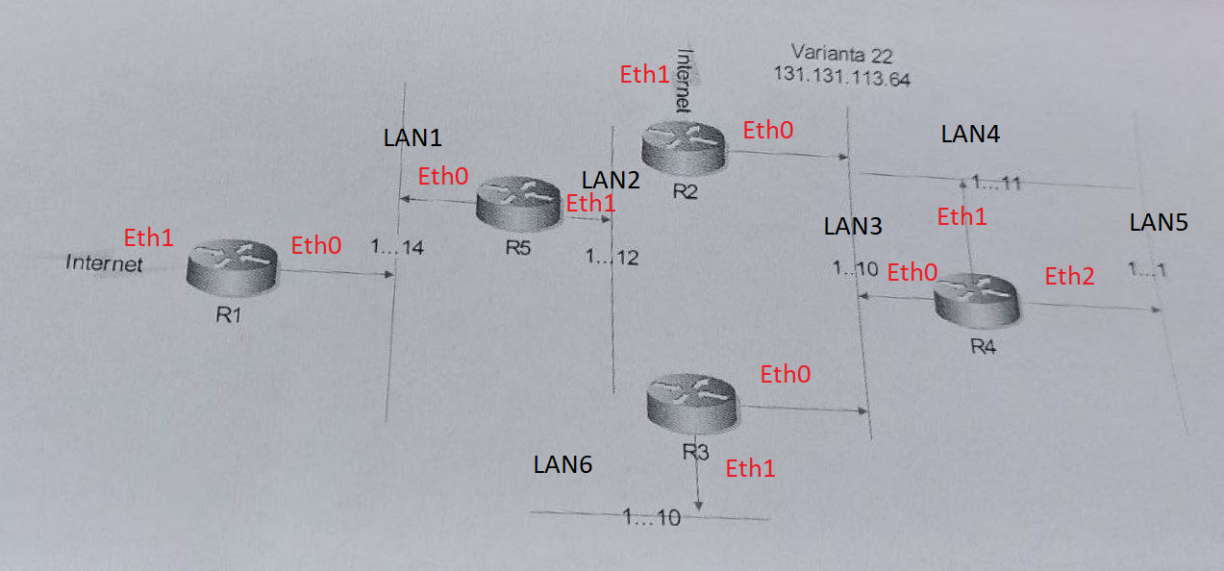

|  |  |  |  |
| --- | --- | --- | --- |
| Router | IP SN | SN Mask | Ethernet port |
| R1 | 131.131.113.0  131.131.113.16  *.*.*.* | 255.255.255.240  255.255.255.240  0.0.0.0 | Eth0  Eth0  Eth1 |
| R2 | 131.131.113.32  131.131.113.48  131.131.113.64  131.131.113.80  *.*.*.* | 255.255.255.240  255.255.255.240  255.255.255.240  255.255.255.240  0.0.0.0 | Eth0  Eth0  Eth0  Eth0  Eth1 |
| R3 | 131.131.113.32  131.131.113.48  131.131.113.64  131.131.113.80  *.*.*.* | 255.255.255.240  255.255.255.240  255.255.255.240  255.255.255.240  0.0.0.0 | Eth0  Eth0  Eth0  Eth1  Eth0 |
| R4 | 131.131.113.32  131.131.113.48  131.131.113.64  131.131.113.80  *.*.*.* | 255.255.255.240  255.255.255.240  255.255.255.240  255.255.255.240  0.0.0.0 | Eth0  Eth1  Eth2  Eth0  Eth0 |
| R5 | 131.131.113.0  131.131.113.16  *.*.*.* | 255.255.255.240  255.255.255.240  0.0.0.0 | Eth0  Eth1  Eth0 |

**Marcarea adreselor IP pentru fiecare port si SN**

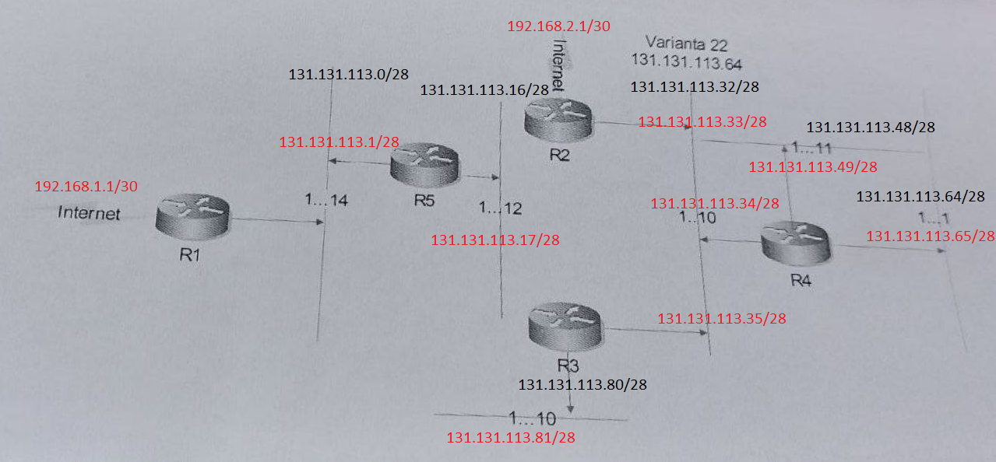

**Exemplu de parcugere a traseului din IP:** **131.131.113.33-> IP:** **131.131.113.89**

**Calculam adresa IP a SN pentru IP:** **131.131.113.33 si 131.131.113.89:**

131.131.113.33 AND 131.131.113.89 AND

255.255.255.240 255.255.255.240

131.131.113.32 131.131.113.80

**Traseul parcurs de pachete:**

131.131.113.33/28 -> 131.131.113.32/28 -> 131.131.113.35/28 -> 131.131.113.80/28 -> 131.131.113.89/28