RIVER VALLEY VIKINGS
DEFENSIVE PLAYBOOK

DIAGRAM EDITION — 2026 Season

CONFIDENTIAL — COACHING STAFF ONLY

4-DOWN FRONT CATALOG

SHADE (Base — Set Field)
A=5, T=3, N=2i, E=5. M=open A (field), W=open B (boundary). Edges contain.
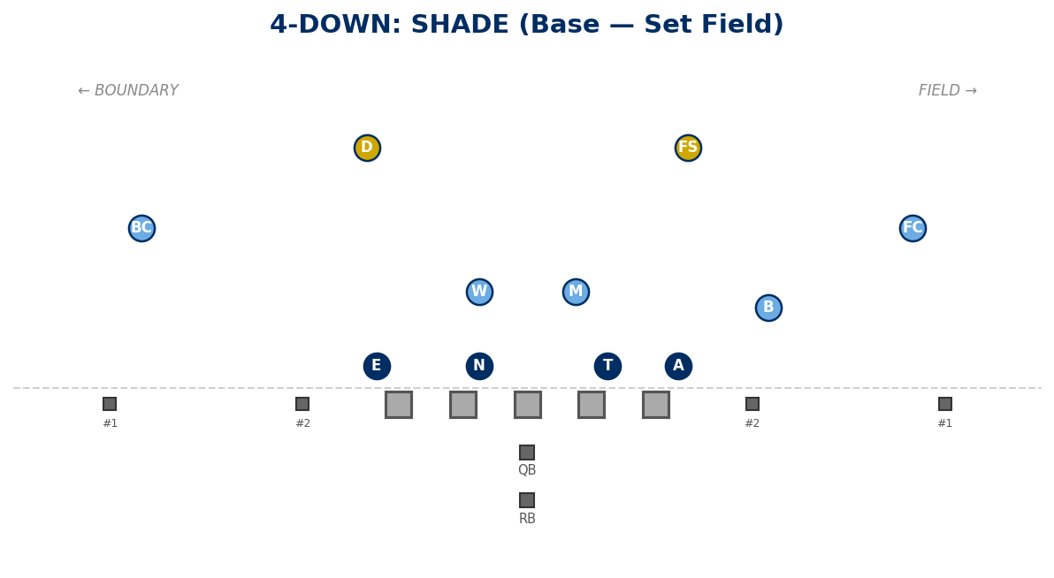

UNDER (Set Boundary)
A=5, T=2i, N=3, E=5. M=open B (field), W=open A (boundary). "Same as Shade just to the boundary."
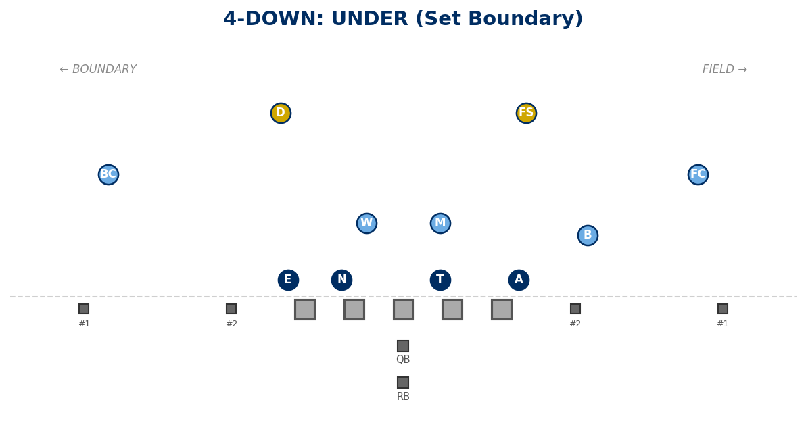

EYES (Balanced Interior)
A=5, T=2i, N=2i, E=5. M=open B, W=open B. Square interior vs zone/duo.
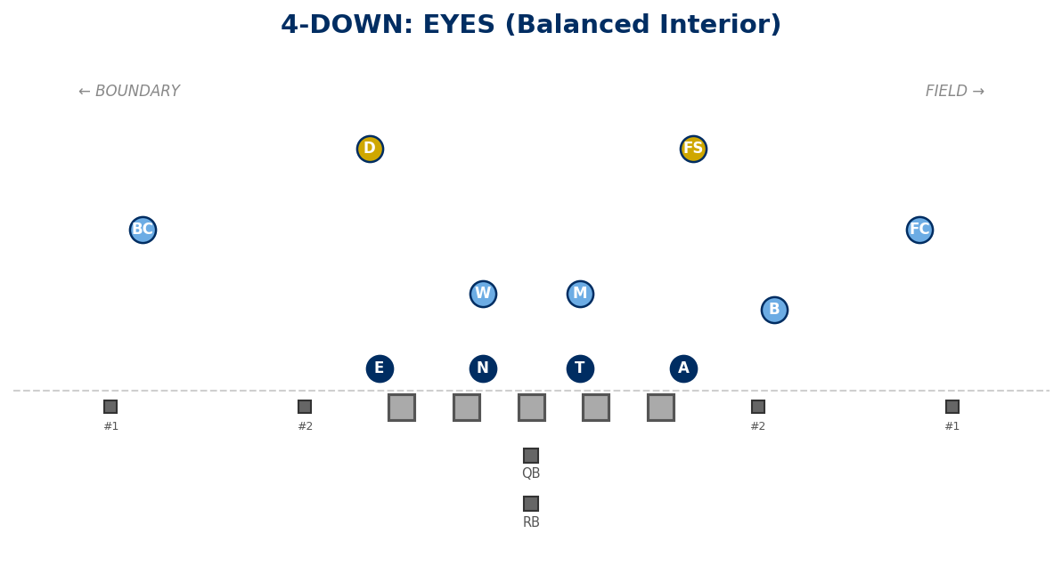

WIDE
A=5, T=3, N=3, E=5. M=open A, W=open A. Force bounce; vs B-gap heavy / gap schemes.
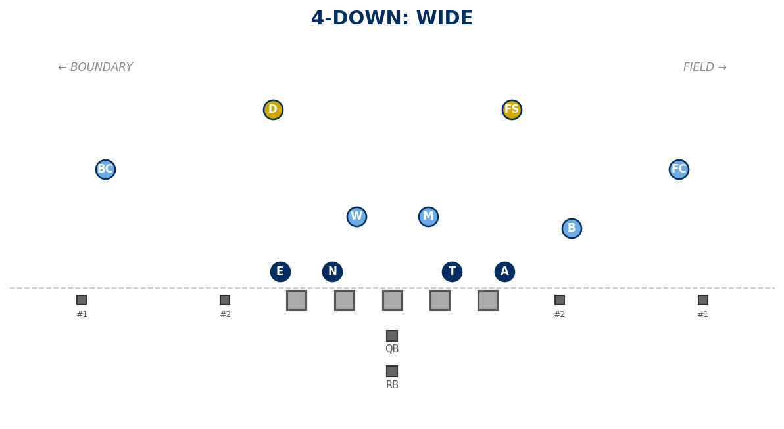

DEUCES
A=5, T=2, N=2, E=5. M/W make T and N right; gap only if stunt creates it. Vs Wing-T / pullers.
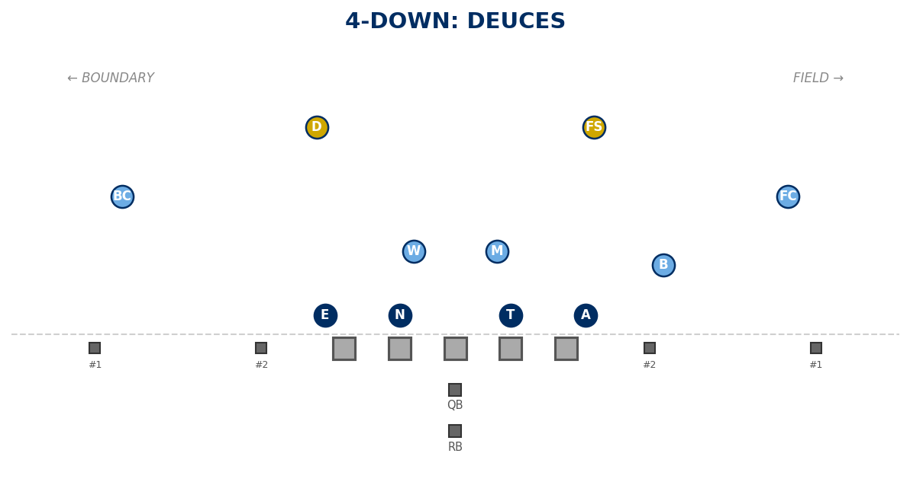

GRIZZLY
A=4i, T=2i, N=2i, E=4i. Special structure: B and W are OLBs. M in a 10-tech, no gap by default (C to TE if TE surface). TE SET does NOT override.
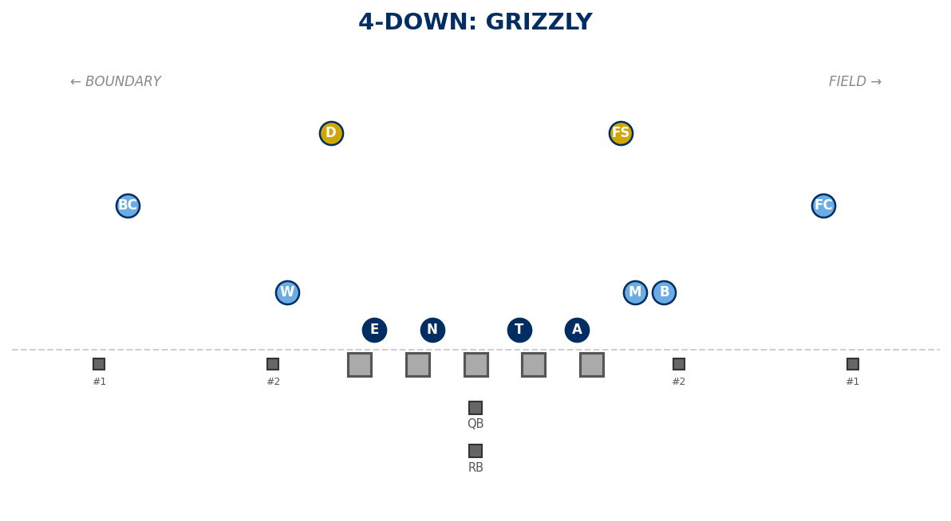

BOSS (Bigs to Field)
A=5, T=3 (field), N=1 (field), E=5. M=A gap boundary, W=B gap boundary. TE SET overrides if TE present.
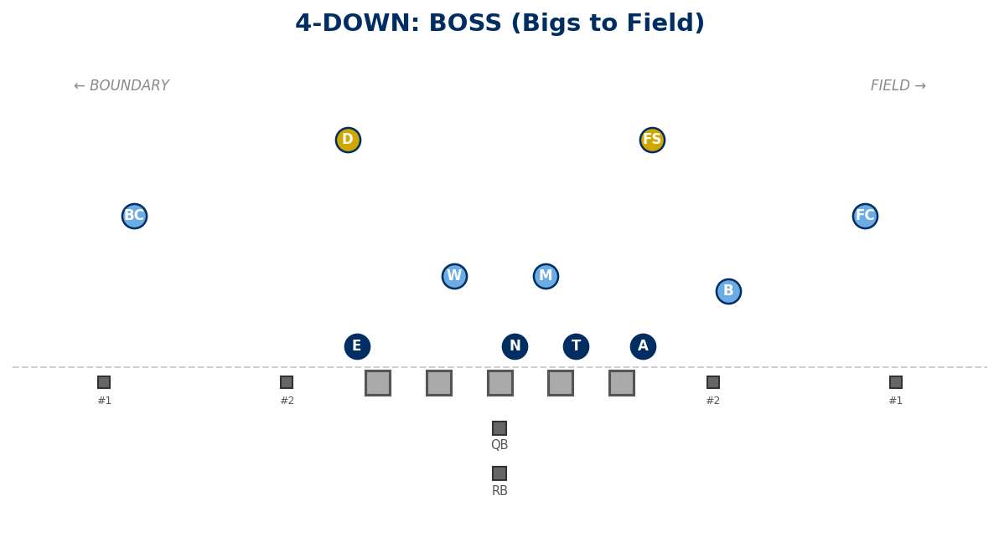

BOSS UNDER (Bigs to Boundary)
A=5, T=1 (boundary), N=3 (boundary), E=5. M=A gap field, W=B gap field. TE SET overrides if TE present.
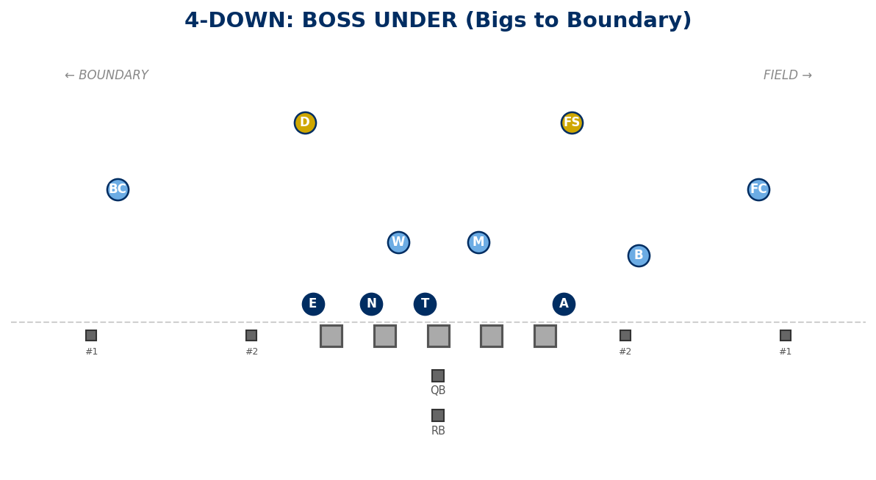

TE SET — Default 4-Down Adjustment
Overrides ALL fronts except Grizzly when TE/Y-off surface. Set front to TE: 3-tech to TE, 2i away. B inserts. End to TE aligns 7-tech and plays contain.
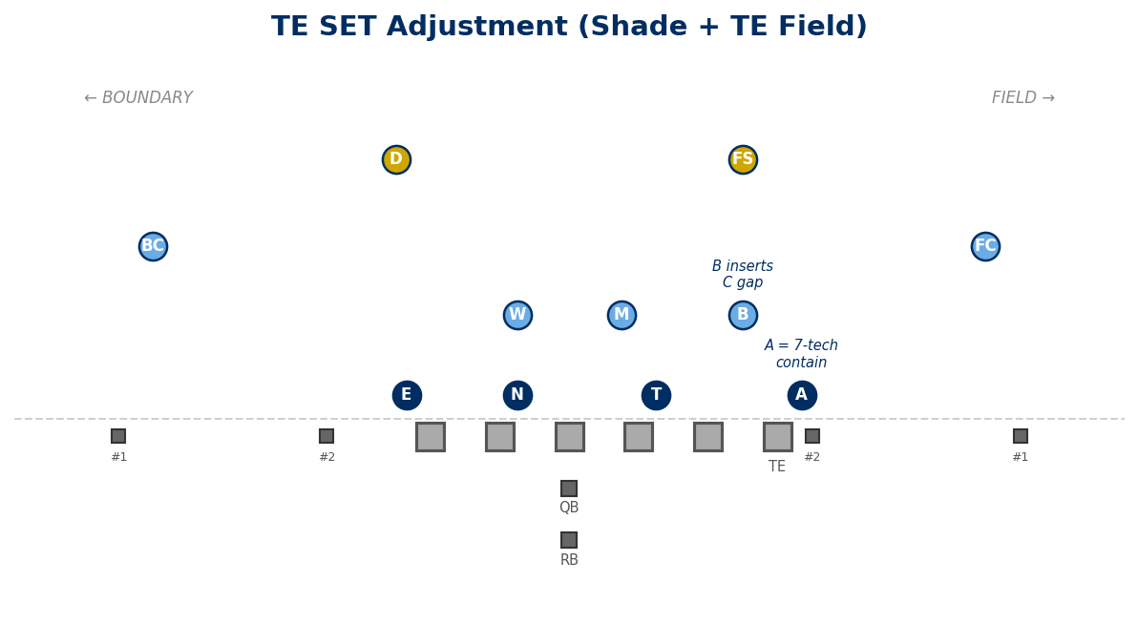

3-DOWN PACKAGES
Field OLB = B. Boundary OLB = E. Slice: backside OLB has slicer. ILB fits: play-to STACK B→D; play-away SLOW PLAY A.

MINT (4i / 0 / 4i)
A=4i, T=0, N=4i. Contain: man = B; NINJA/VIKING = M is QB contain.
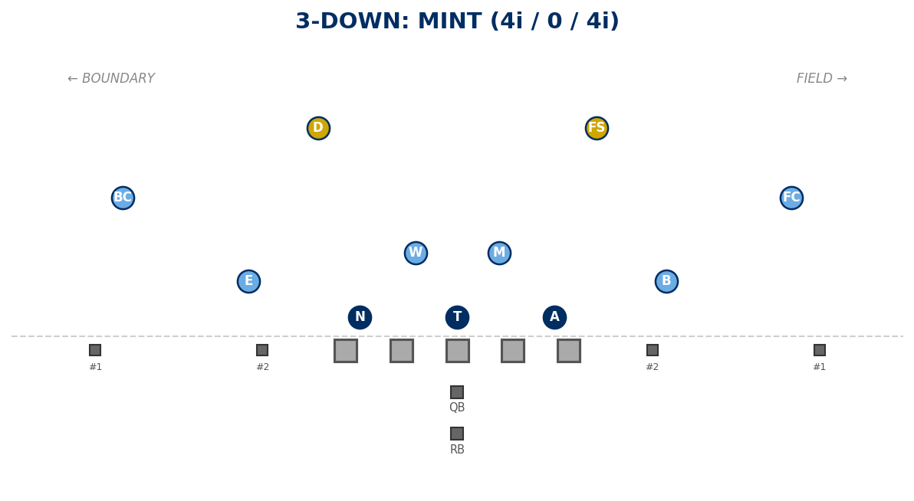

ACE (4 / 0 / 4)
A=4, T=0, N=4. A/T/N are ALL 2-gapping (no stunt). Contains = OLBs (B and E).
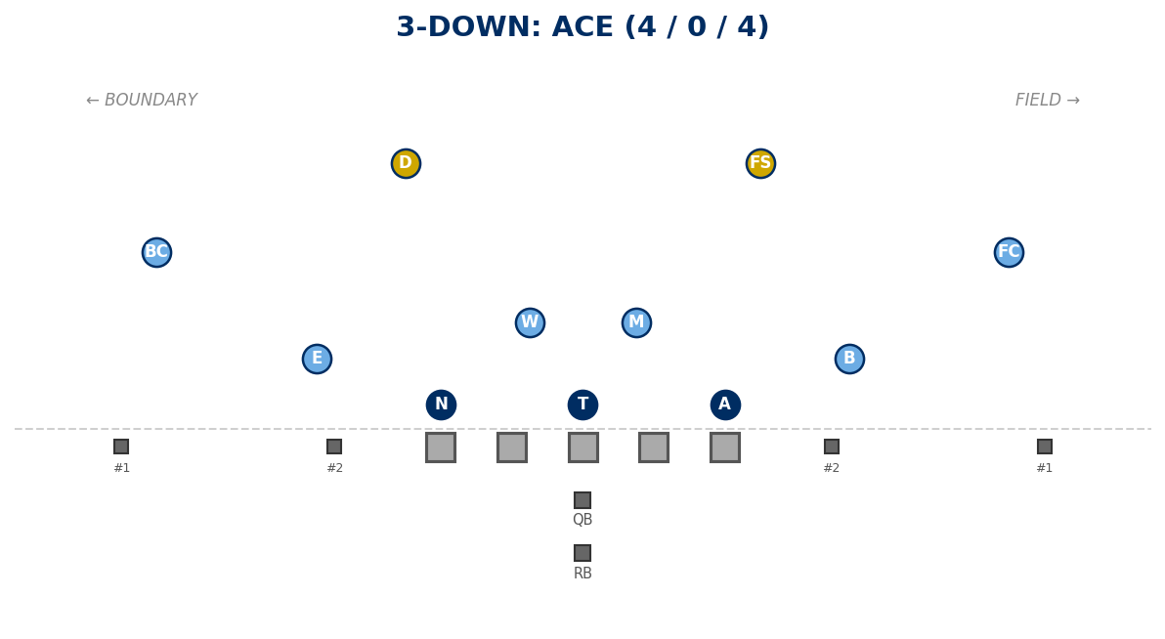

JET (5 / 0 / 5)
A=5, T=0, N=5. T is 2-gapping. A and N are contain (C-gap edges).
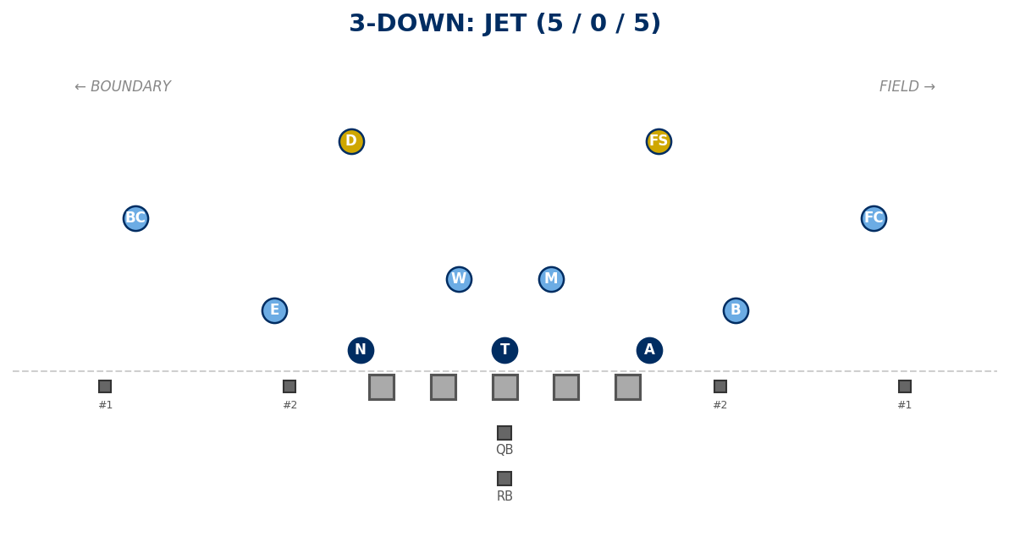

SLIP (5 / 0 / 4i)
A=5, T=0, N=4i. 1-gap penetrating. A and E are contain. Use: 3-down vs spread with NINJA or VIKING. Takes B out of conflict — B plays coverage clean.
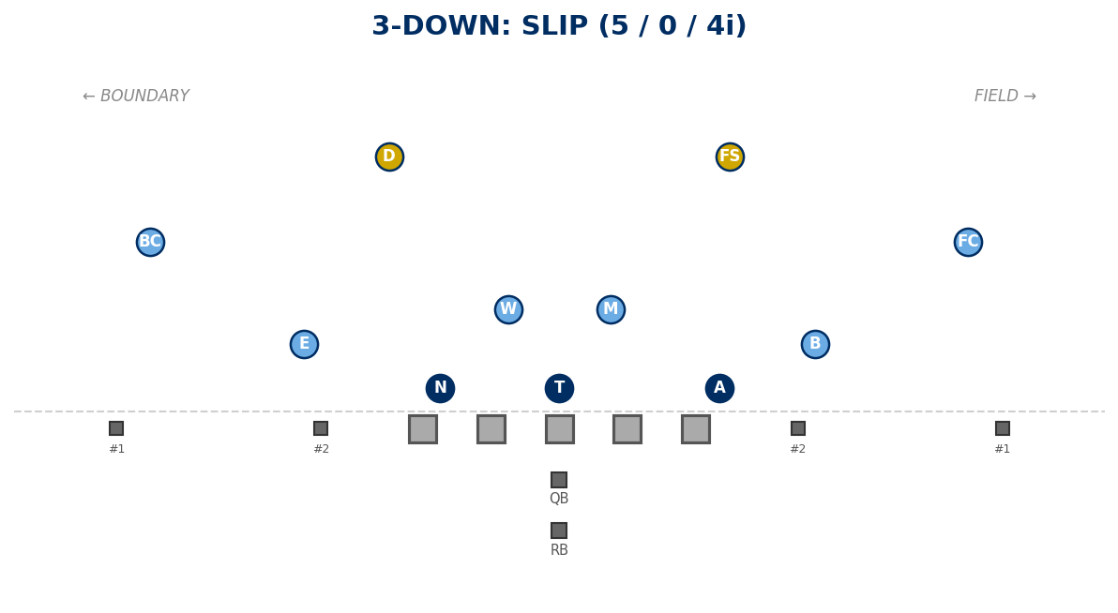

COVERAGE: NINJA (COVER 7 FAMILY)
Coach calls NINJA. DBs auto-check: 2x2 = MOD/CLAMP, 3x1 = POACH. Corners: inside leverage, 6 yards. Safeties: 10-12 deep, align off #2.

NINJA vs 2x2 — MOD / CLAMP
- Field: MOD (Field): FC man-match #1. FS top-down on #2. B apex to #2/#3.
- Boundary: CLAMP (Boundary): BC clamp technique on #1. D control #2 and help corner.
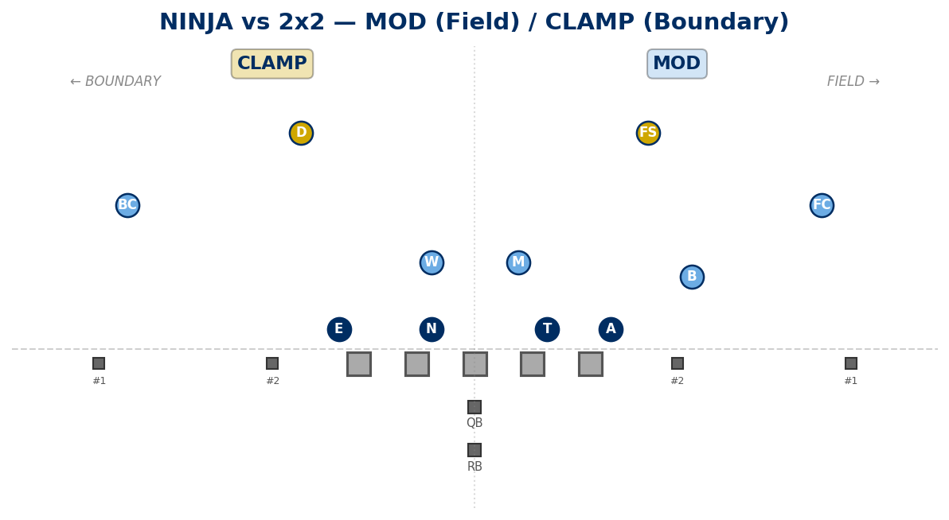

NINJA vs 3x1 — POACH
- Trips to field: D is poach safety. Trips to boundary: FS is poach safety.
- #3 vertical: poach player takes it. #3 shallow: overlap crossers. Backside stays sound.
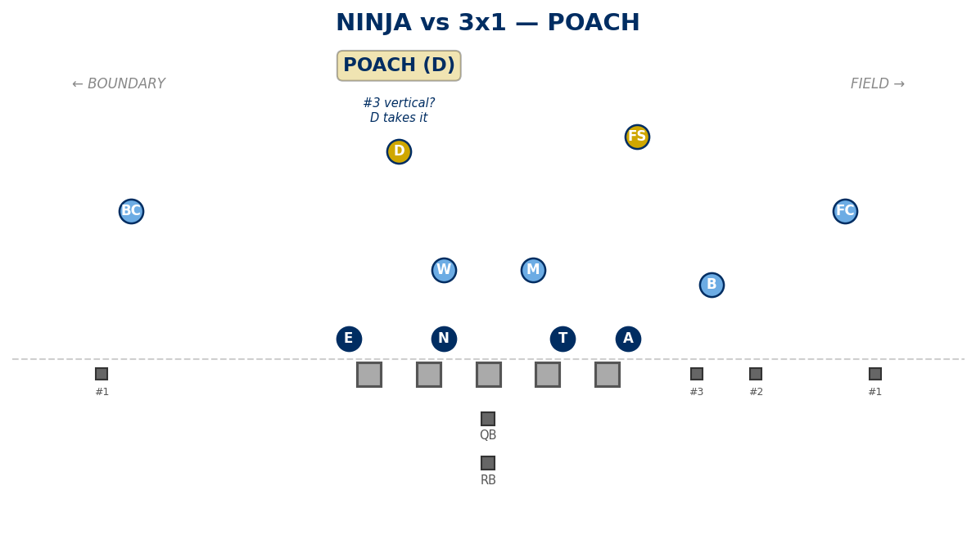

COVERAGE: COVER 1 FAMILY
CAMP: Corners = #1. Non-post safeties = #2 to their side or #3 away. M/W funnel RB.

OREGON (Post = FS)
- FS = Post (MOF). D = man #2 boundary. B = man #2 field. M/W = RB funnel.
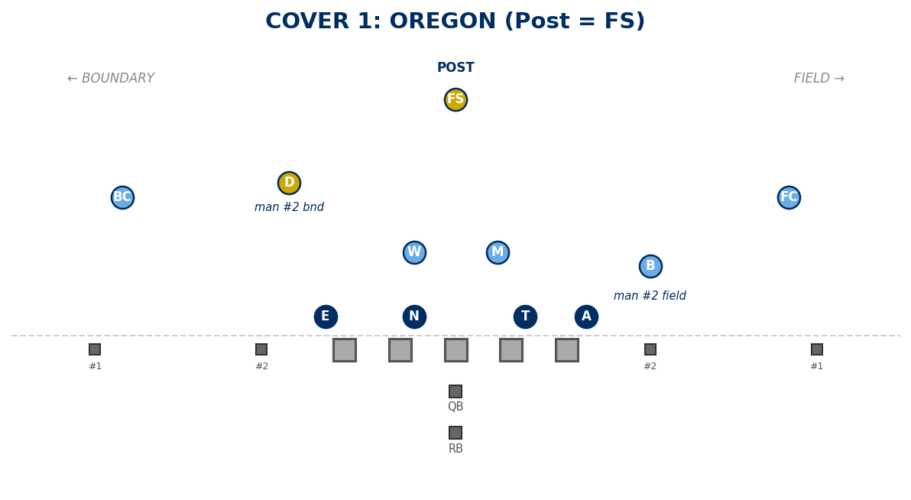

OKLAHOMA (Post = D)
- D = Post (MOF). FS = man #2 boundary. B = man #2 field. M/W = RB funnel.
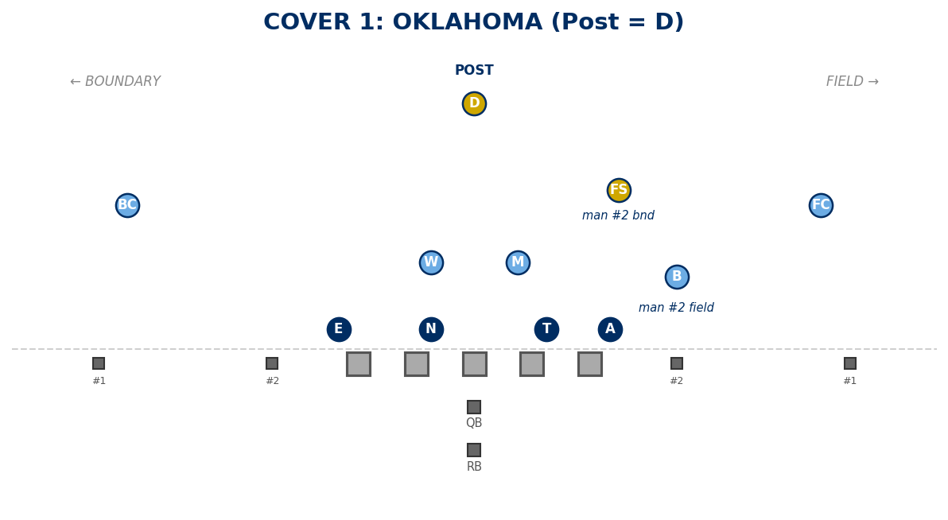

OHIO (Post = B)
- B = Post (MOF). FS = man #2 field. D = man #2 boundary. M/W = RB funnel.
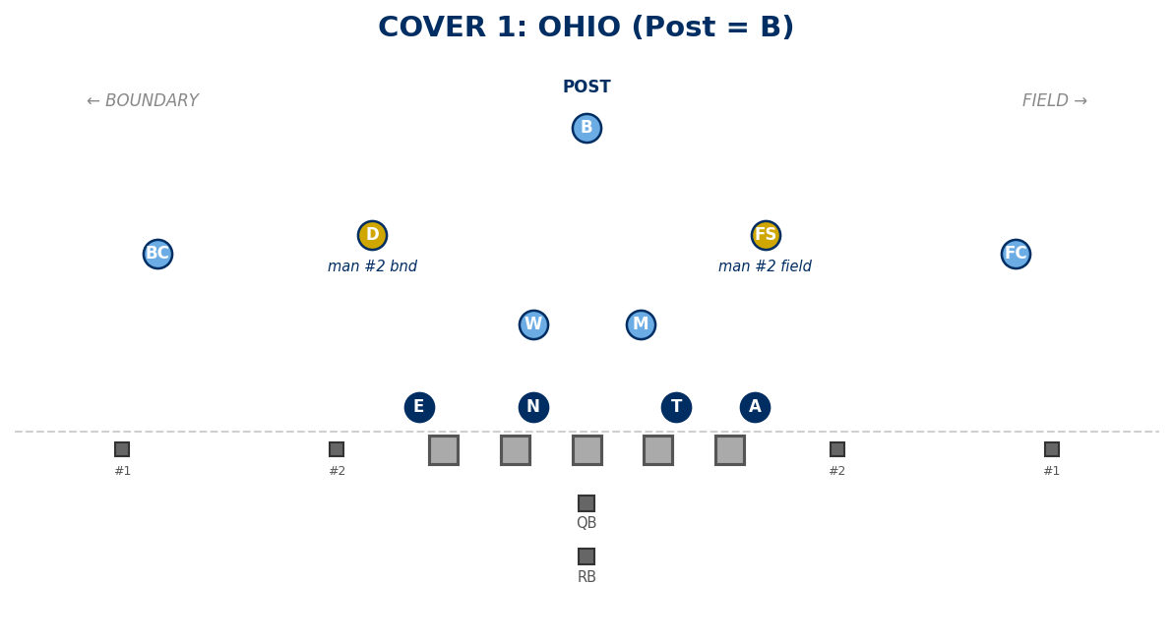

COVERAGE: COVER 0 / Z-FAMILY

ZEUS — Delayed Pressure
Run-first; on pass: A/T/N/E/M rush. A/E cage contain. B/W funnel RB (to your side = take; away = rush; middle = W). Call-off: bail to NINJA or VIKING.
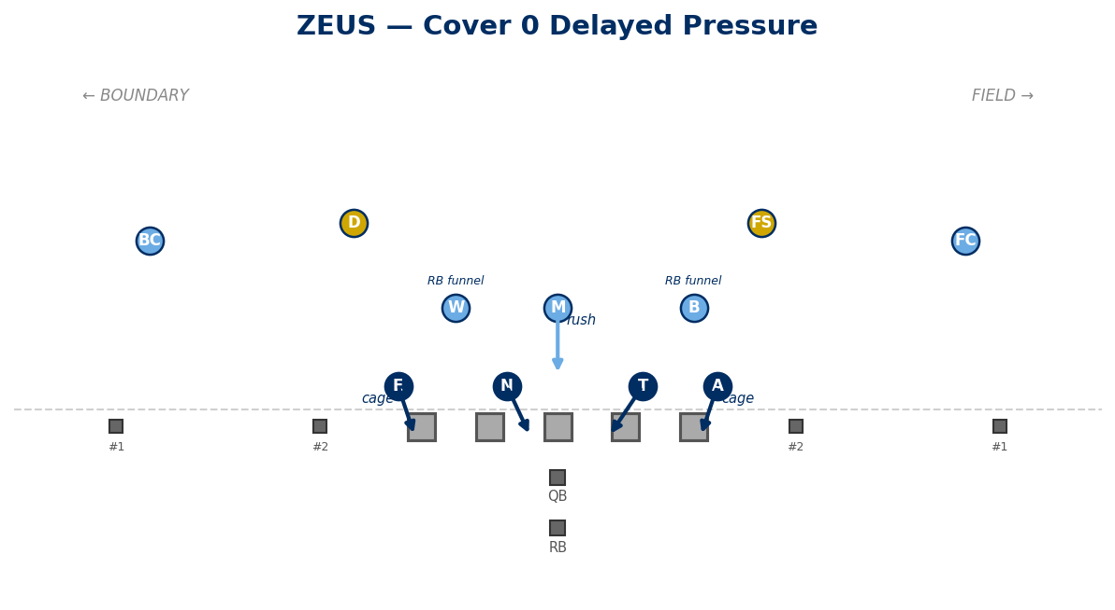

Z-Family RB Reference
Z-Call | RB Player
Zeus | B or W (funnel)
Zorro | B
Zunnel | M or W (funnel)
Zill | W
Zike | M

COVERAGE: VIKING (COVER 3)
Deep 3: FC=1/3 field, FS=1/3 middle, BC=1/3 boundary. Under: B=curl/flat, D=seam-curl-flat, M=hook, W=hook. Tags: SEAM, PUSH, CROSS, SCREEN. RIP/LIZ = true match 3.
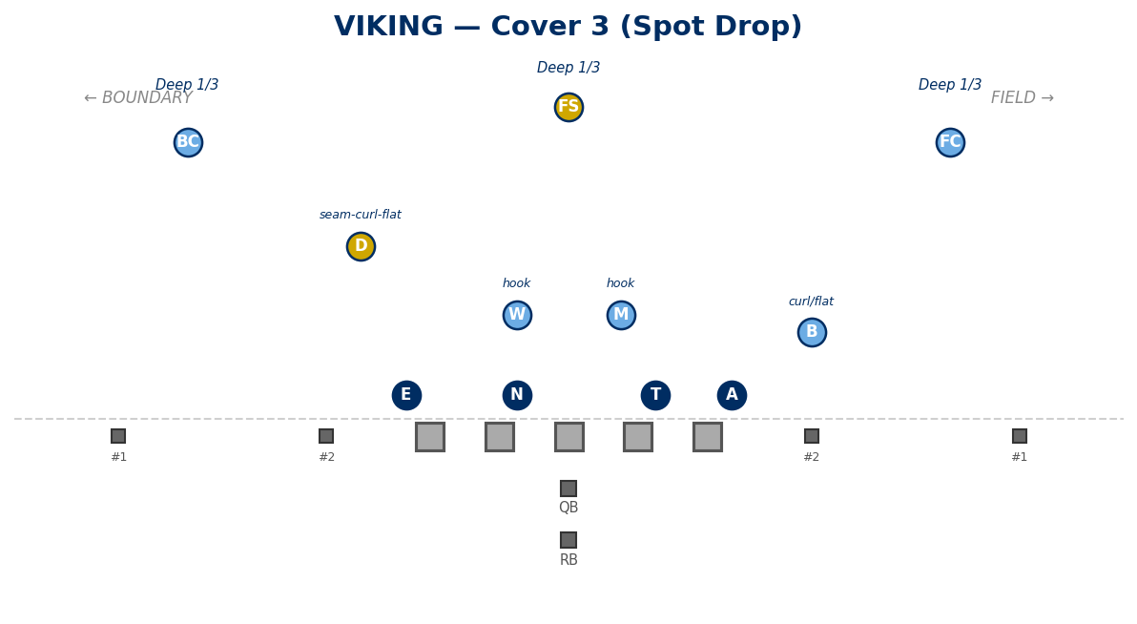

STUNT CATALOG

SLANT (to Field)
4-down: T+N slant to field. 3-down: A+T+N slant. Best fronts: Under, BOSS Under. Do NOT call with Shade.
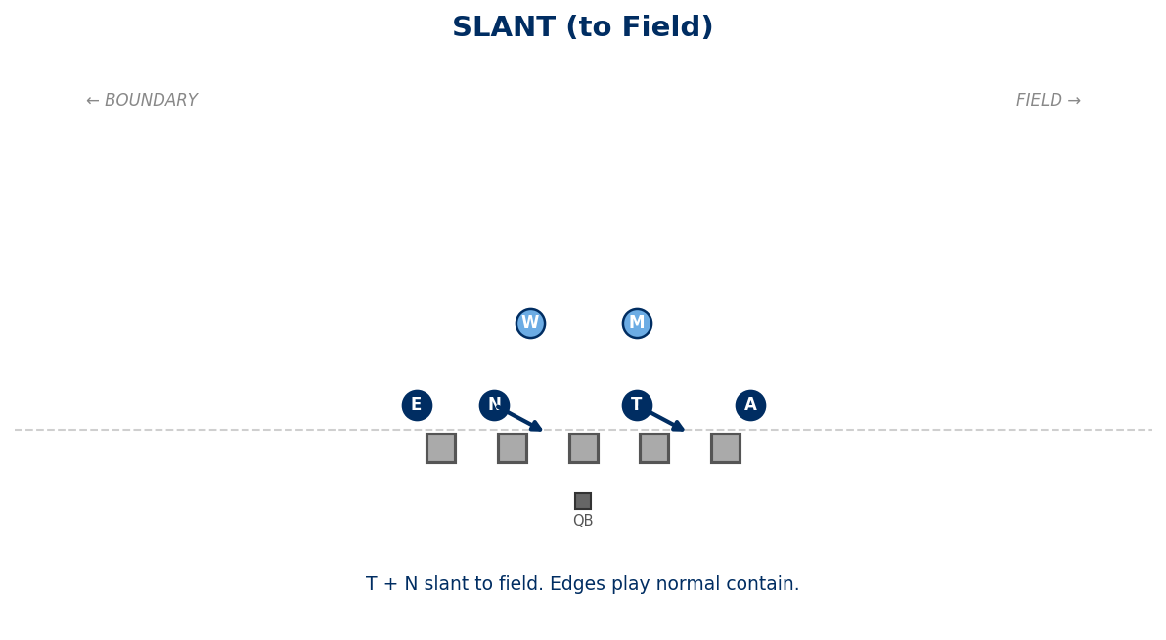

PINCH
4-down: T+N pinch A gaps. 3-down: A+N pinch B gaps. Best fronts: Shade, Under, Wide, Deuces.
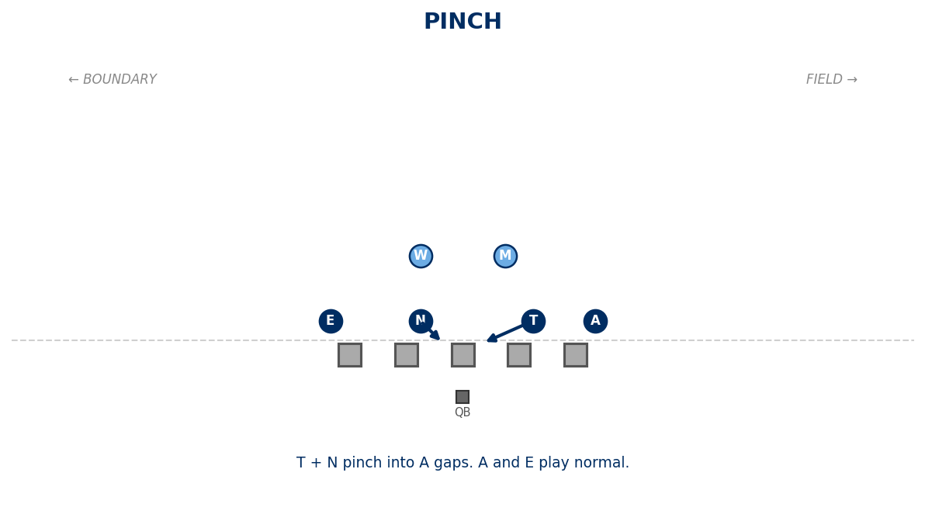

JACKS
4-down: T+N shoot B gaps. 3-down: A+N expand to C gaps (NOT pinch). Do NOT call with Wide. Best pressure: sWarM.
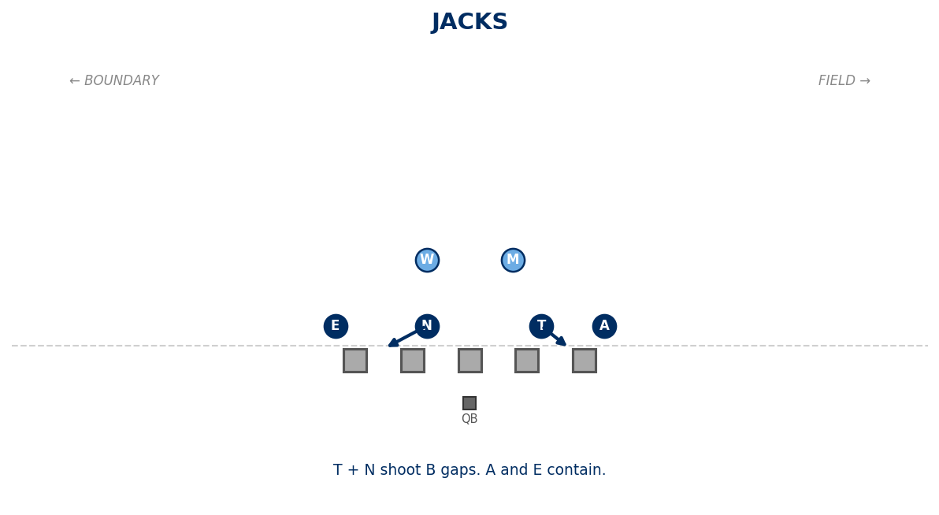

CRASH
A+E shoot B gaps. T+N shoot A gaps. B/M/W are contain. Do NOT call with Grizzly or Freebird. Best pressure: BoW.
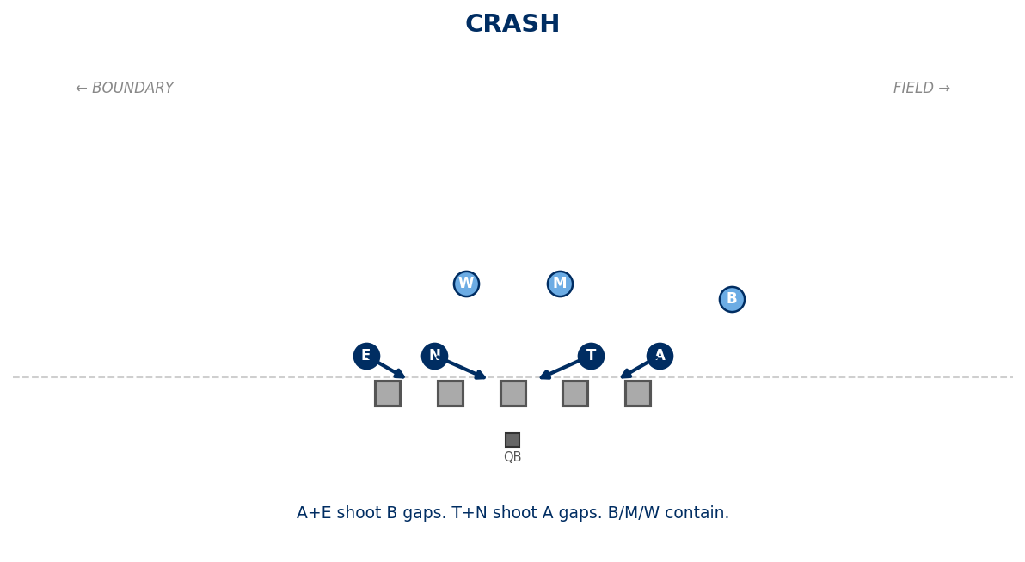

Other Stunts (Text Only)
- ANGLE: Same as Slant but to boundary. Do NOT call with Under/BOSS Under. Best fronts: Shade, BOSS.
- SPLIT: With BOSS: 1-tech crosses C face to opposite A. With GRIZZLY: field-side gap-out.
- ANCHOR ATTACK: A attacks OL closing one inside gap. NOT paired with Cobra.
- EDGE ATTACK: E attacks OL closing one inside gap. CAN pair with Cobra.
- ANCHOR RAVEN: A shoots B gap from 5. Signal: point field → flap flap. If + Bandit = BANDIT RAVEN.
- EDGE RAVEN: E shoots B gap from 5. Signal: point boundary → flap flap.

PRESSURE DIAGRAMS

sWarM (M + W)
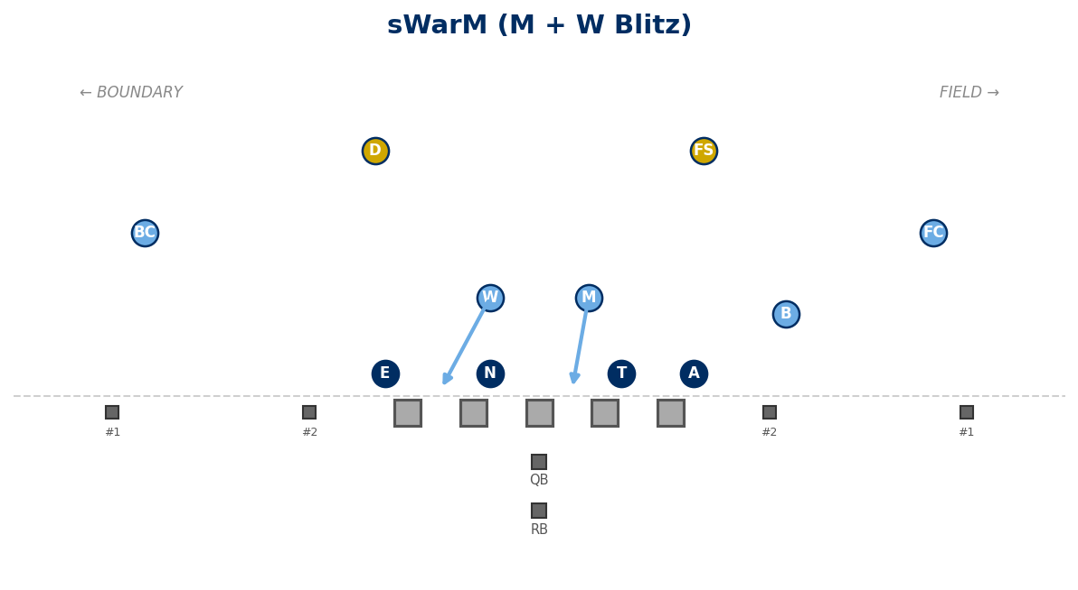

BooM (B + M)
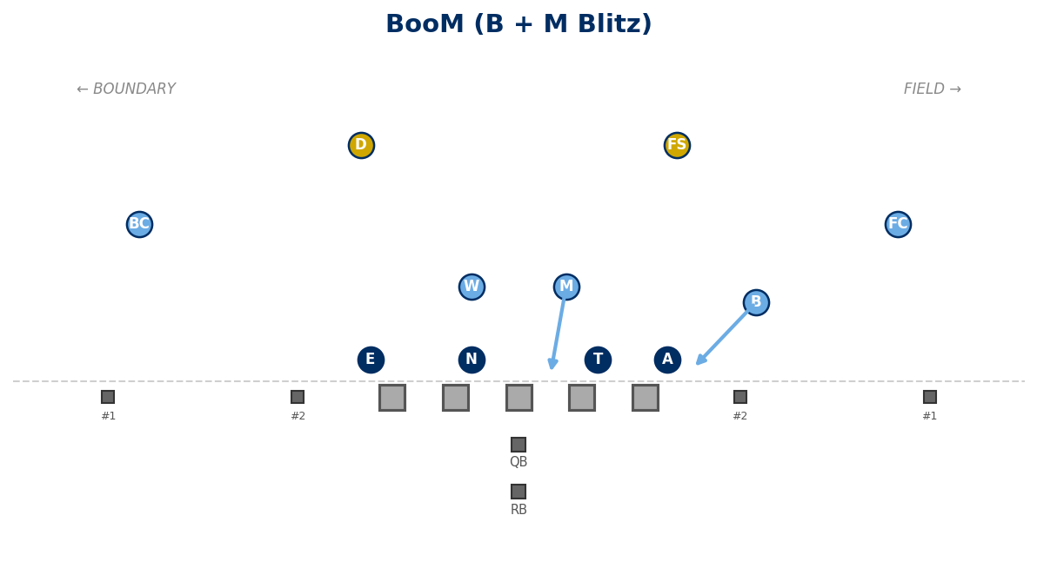

BoW (B + W)
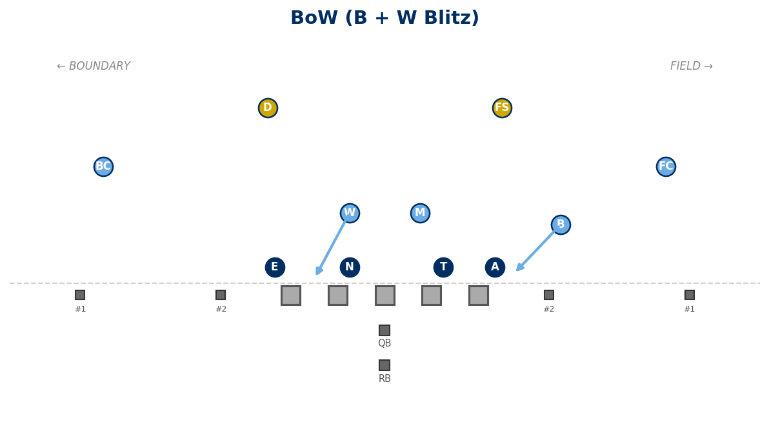

HAMMER (B Edge + Anchor Attack)
B blitzes off the edge. A attacks OL closing one inside gap.
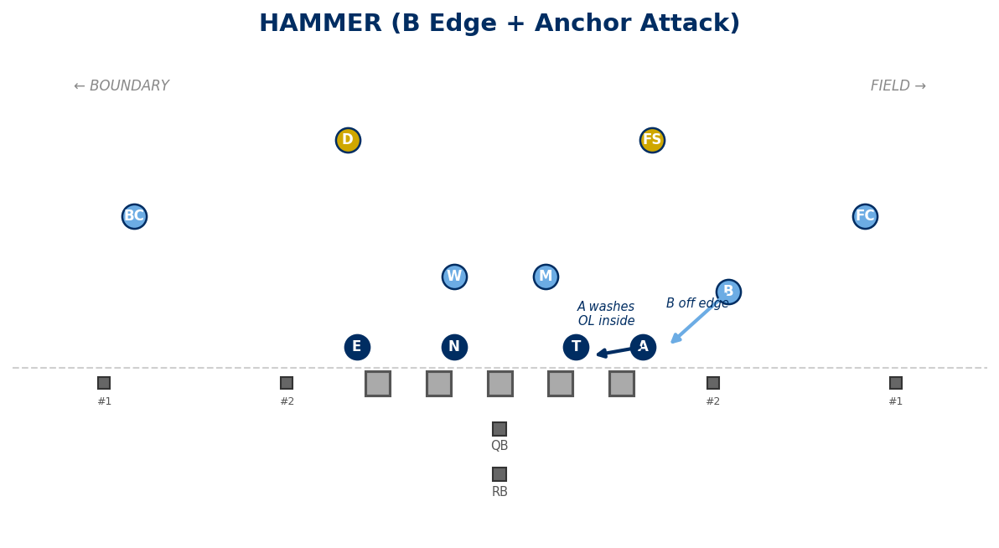

EAT (M + W + B)
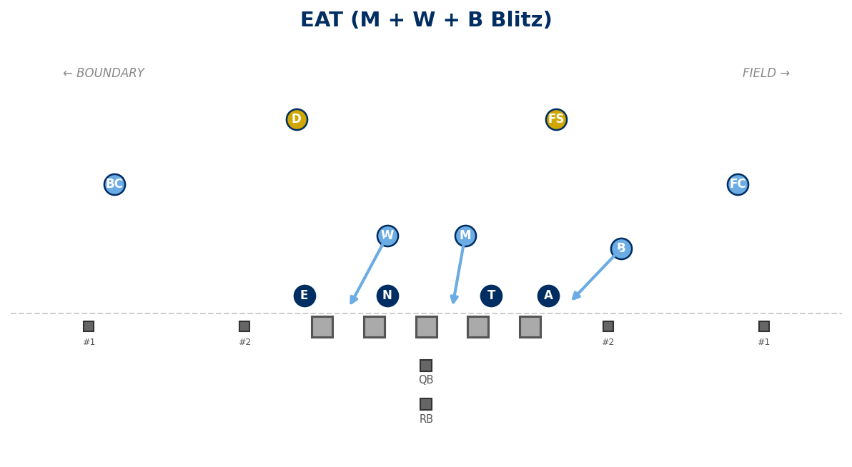

Other Pressures (Text Only)
- Mike: M blitzes to his gap.
- Will: W blitzes to his gap.
- Bandit: B blitzes to his gap.
- Dawg: D blitzes to his gap.
- staB: B one gap inside EOL.
- Freebird: MOF safety blitzes.
- Cobra: Boundary corner blitz. D takes #1 bnd, FS assumes D rules, B assumes FS rules.
- Shave: W edge + Edge Attack.
- MaD: M + D.

Weekly Pressure Menu (Locked)
Mike, Will, Bandit, sWarM, BooM, BoW, Hammer, Eat.

— END OF DIAGRAM EDITION —

Generated: February 19, 2026

