RIVER VALLEY VIKINGS
PRE-SNAP DISGUISE &
COVERAGE RULES

2026 Season

PRE-SNAP DISGUISE PRINCIPLE
Every coverage we run — NINJA, Oregon, Oklahoma, Zeus, Zunnel, Zill, Zike, Viking — looks the same before the snap. The offense sees the same two-high shell every time. DBs execute their coverage responsibilities post-snap.

The offense should never know what coverage we are in until after the ball is snapped.

Exceptions (2)
- OHIO: B moves from apex to ~8 yards deep in the middle of the formation to become the post/MOF safety. His movement tips the coverage.
- ZORRO: B moves from apex to ~8 yards deep in the middle of the formation to key the RB. His alignment change tips the coverage.

UNIVERSAL PRE-SNAP ALIGNMENT
This is the look the offense sees on every snap (except Ohio and Zorro).
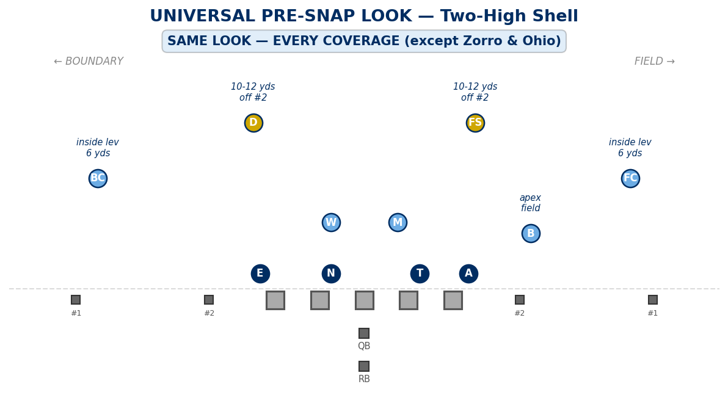

Alignment Rules
Position | Pre-Snap Alignment | Key
FC / BC | Inside leverage, 6 yards on #1 | Do not tip coverage with depth or leverage changes
FS | 10-12 yds deep, inside foot on #2 (~1 yd inside #2) | If no #2: hash-to-middle, eyes on #3/QB
D | 10-12 yds deep, inside foot on #2 (~1 yd inside #2) | If no #2: hash-to-middle, eyes on #3/QB
B | Apex to field, split between #2 and box | Same spot every coverage (except Ohio/Zorro)
M / W | Standard LB depth over assigned gap | Run-fit alignment does not change by coverage

- Compressed/stack splits: safeties tighten 1-2 steps, ready for BANJO. This is formation-driven, not coverage-driven — same adjustment in every coverage.
- Motion: NINJA re-checks (POACH/MOD/CLAMP). Man coverages use BUMP-BUMP. Either way, the pre-snap shell resets the same.

COVERAGE RULES — POST-SNAP DROPS
Below is every coverage with its post-snap responsibilities. Pre-snap alignment is identical for all (except Ohio and Zorro). Solid circles = pre-snap position. Dashed circles = post-snap drop.

NINJA vs 2x2 — MOD (Field) / CLAMP (Boundary)
No rotation needed. The pre-snap look IS the coverage alignment. DBs execute pattern-match rules at the snap.
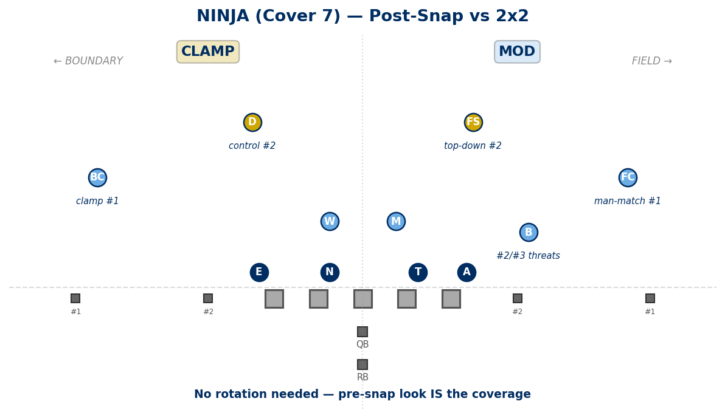

Coverage Rules
- FC: Man-match #1. Stay on top, deny explosives. #1 shallow = pass off if rules allow, look for next threat.
- BC: Clamp technique on #1. Physical, deny release. #1 vertical = stay on top.
- FS: MOD rules: top-down on #2. #2 vertical = match and stay on top. #2 out/flat = drive with control, don't open seams.
- D: CLAMP rules: control #2 and help corner. #2 vertical = match. #2 out fast = drive with leverage.
- B: Apex rules to #2/#3 threats. Eliminate quick RPO access. Carry seams long enough for safety help.
- M / W: Hook. Eyes to QB, relate to threats.

NINJA vs 3x1 — POACH
D is the poach safety when trips go to the field. FS is the poach safety when trips go to the boundary. Poach safety slides post-snap toward the trips side.
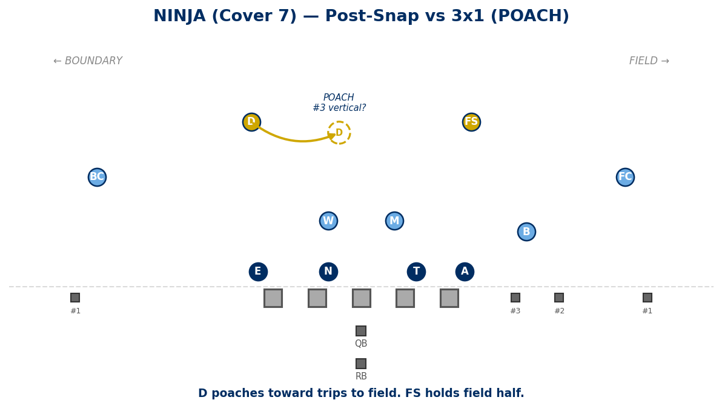

Coverage Rules
- #3 vertical: poach player takes it (no free seam).
- #3 shallow/under: poach player communicates and overlaps crossers.
- Backside stays sound — no free go balls or glance RPO.
- Key: Poach player (D in diagram) slides post-snap. Pre-snap he is still at 10-12 over #2 boundary.

OREGON (Cover 1 — Post = FS)
Pre-snap: same two-high. Post-snap: FS rotates to MOF as the post/fixer. D and B drop to man assignments.
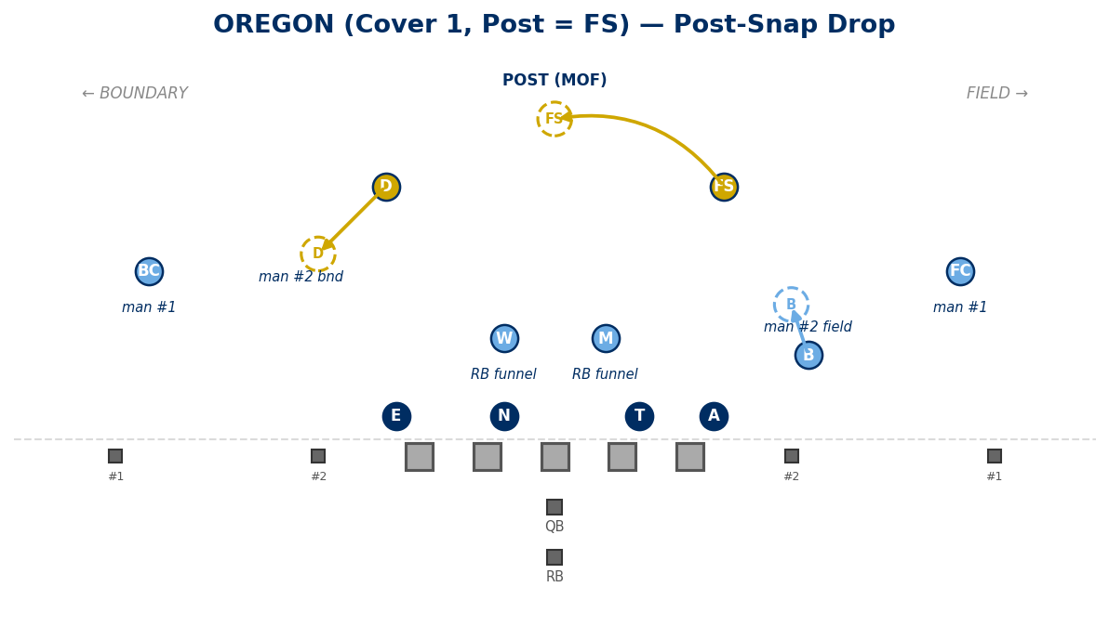

Coverage Rules
- FC / BC: Man on #1 to your side.
- FS: Post-snap: rotate to MOF. Fixer — make the corner right.
- D: Post-snap: drop to man on #2 boundary, or #3 away if no #2 boundary.
- B: Post-snap: drop to man on #2 field, or #3 away if no #2 field.
- M / W: RB funnel. RB to your side = take. RB away = rush. TAMPA: away LB = RAT.

OKLAHOMA (Cover 1 — Post = D)
Pre-snap: FS and D switch sides — D aligns to the field, FS aligns to the boundary. Post-snap: D rotates from field to MOF. FS drops from boundary to man #2 boundary.
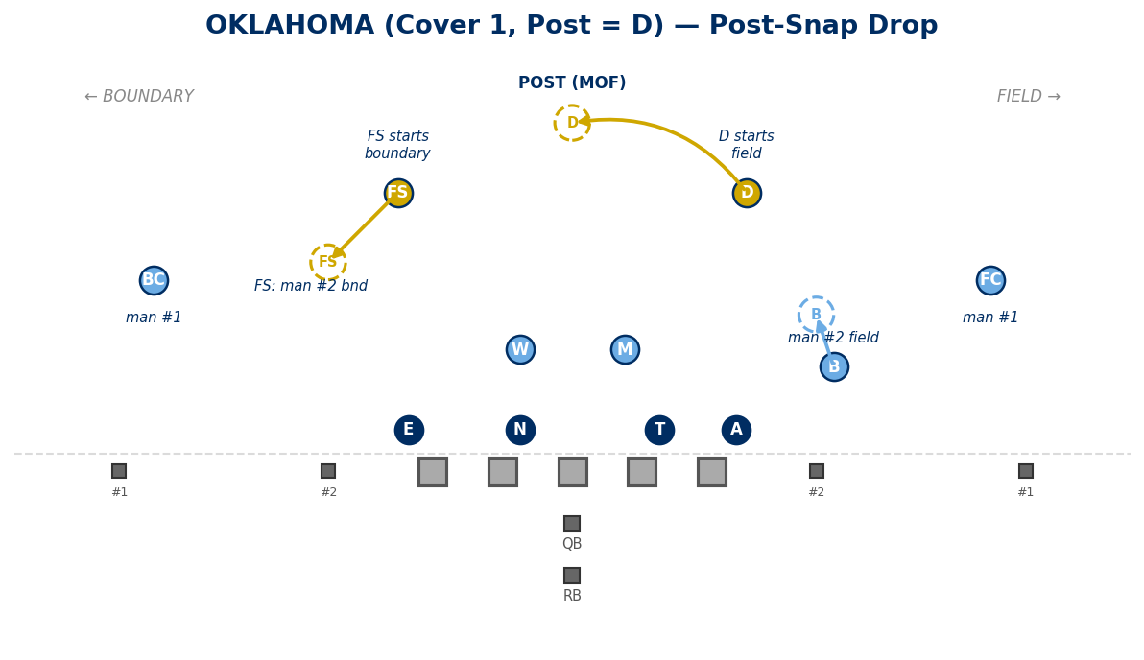

Coverage Rules
- FC / BC: Man on #1 to your side.
- D: Post-snap: rotate to MOF. Fixer.
- FS: Aligns to boundary pre-snap. Post-snap: man on #2 boundary, or #3 away.
- B: Post-snap: drop to man on #2 field, or #3 away if no #2 field.
- M / W: RB funnel.

OHIO (Cover 1 — Post = B) — EXCEPTION
B aligns at ~8 yards deep in the middle of the formation to become the MOF post/fixer. This changes the pre-snap picture — the offense may read B's alignment out of the apex. Both safeties drop to man on #2.
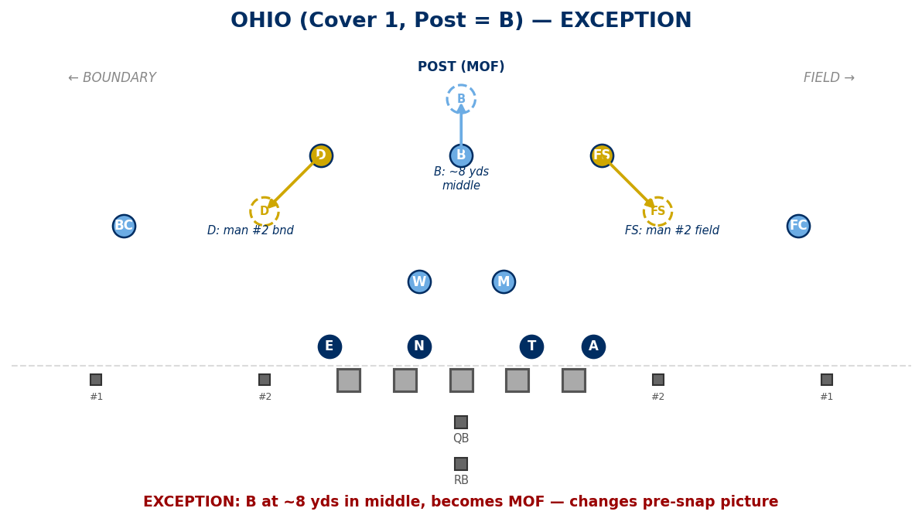

Coverage Rules
- FC / BC: Man on #1 to your side.
- B: Post-snap: rotate from apex to MOF. Fixer — make the corner right.
- FS: Post-snap: drop to man on #2 field, or #3 away if no #2 field.
- D: Post-snap: drop to man on #2 boundary, or #3 away if no #2 boundary.
- M / W: RB funnel.
Note: Because B vacates the apex, this is one of two coverages that changes the pre-snap look.

ZEUS (Cover 0 — Delayed Pressure)
Pre-snap: same two-high. Post-snap: both safeties drop to man. No deep help. Run-first read; on pass, DL and M rush, B/W funnel RB.
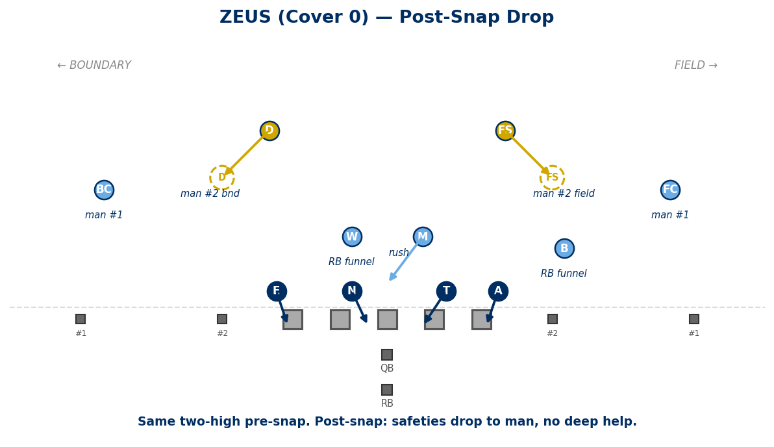

Coverage Rules
- FC / BC: Man on #1 to your side.
- FS: Post-snap: drop to man on #2 field; if no #2 field, #3 away.
- D: Post-snap: drop to man on #2 boundary; if no #2 boundary, #3 away.
- B / W: RB funnel. RB to your side = take (man). RB away = rush. RB middle = W takes.
- M: Primary add-on rusher on pass read.
- A / E: Cage/contain — do not run past QB depth. Force step-up.
- T / N: Vertical push / collapse pocket.

ZORRO (Cover 0) — EXCEPTION
B has the RB, so B aligns at ~8 yards deep in the middle of the formation instead of at his normal apex. This changes the pre-snap picture. M/W have no pass responsibility unless tagged.
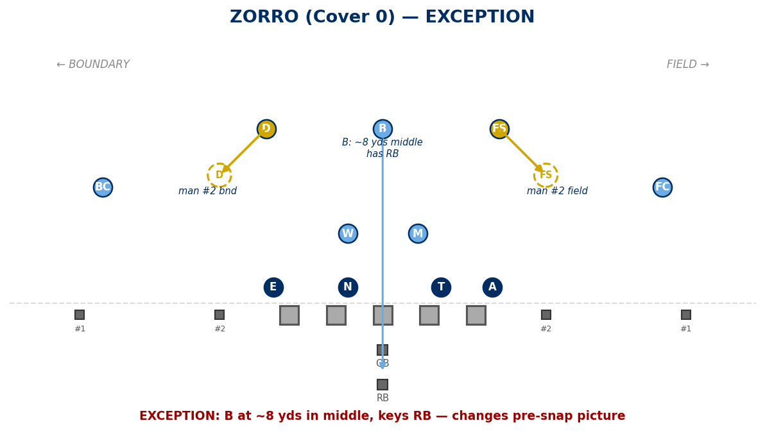

Coverage Rules
- FC / BC: Man on #1 to your side.
- FS: Post-snap: drop to man on #2 field; if no #2, #3 away.
- D: Post-snap: drop to man on #2 boundary; if no #2, #3 away.
- B: Has RB (man). Aligns at ~8 yds in the middle of the formation to key RB.
- M / W: No pass responsibility unless tagged. TAMPA = become droppers. SPY = spy QB.
Note: Because B aligns at ~8 yds in the middle instead of the apex, this is one of two coverages that changes the pre-snap look.

ZUNNEL / ZILL / ZIKE (Cover 0)
Pre-snap: same two-high. Post-snap: both safeties drop to man. RB handled per call.
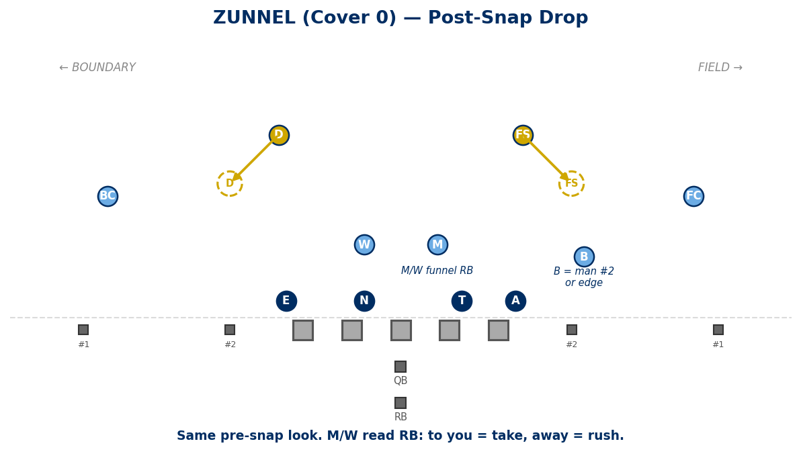

Coverage Rules (Shared)
- FC / BC: Man on #1.
- FS: Man on #2 field (or #3 away).
- D: Man on #2 boundary (or #3 away).
- B: Normal apex pre-snap. Post-snap: per call assignment.

RB Responsibility by Call
Call | RB Player
Zunnel | M/W funnel (to you = take, away = rush)
Zill | W has RB (man)
Zike | M has RB (man)

VIKING (Cover 3 — Spot Drop)
Pre-snap: same two-high. Post-snap: corners bail to deep thirds, FS rotates to deep middle third. D drops to seam-curl-flat. B plays curl/flat. M/W play hook.
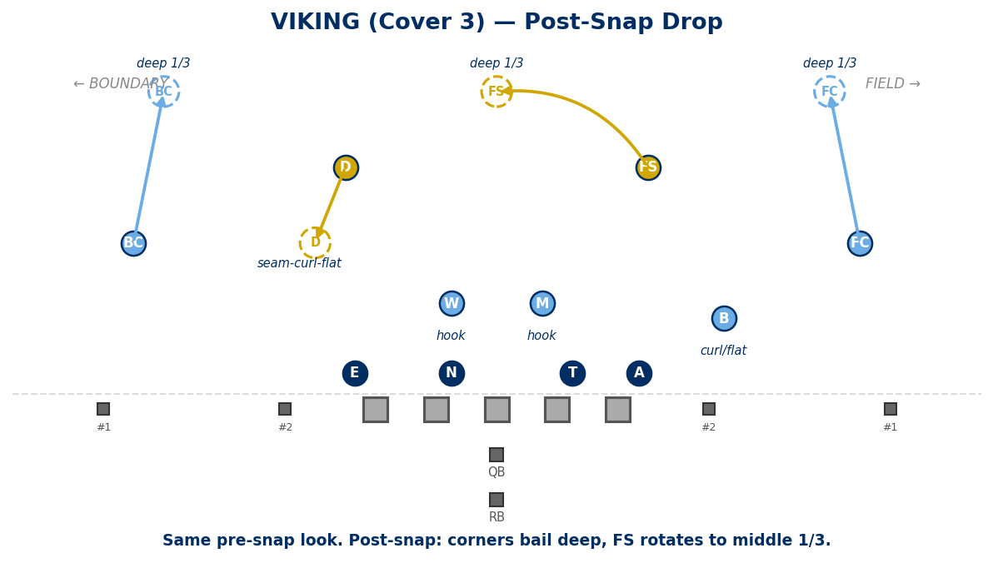

Coverage Rules
- FC: Post-snap: bail to deep 1/3 (field).
- BC: Post-snap: bail to deep 1/3 (boundary).
- FS: Post-snap: rotate to deep middle 1/3.
- D: Post-snap: drop to seam-curl-flat (boundary).
- B: Post-snap: curl/flat (field).
- M: Hook. Eyes to QB, relate to #3.
- W: Hook.

Tags
- VIKING SEAM: Match #2 vertical rules.
- VIKING PUSH: Distribution adjustment vs 3x1.
- VIKING CROSS: Carry crosser to depth before passing.
- VIKING SCREEN: Trigger/replace rules vs now/bubble.

COVERAGE SUMMARY — PRE-SNAP vs POST-SNAP
Coverage | Pre-Snap | FS Post-Snap | D Post-Snap | B Post-Snap
NINJA 2x2 | Two-high | MOD: top-down #2 | CLAMP: control #2 | Apex: #2/#3 threats
NINJA 3x1  (trips field) | Two-high | Hold field half | POACH toward trips | Apex: trips threats
NINJA 3x1  (trips bnd) | Two-high | POACH toward trips | Hold boundary half | Apex: trips threats
OREGON | Two-high | Rotate to MOF (post) | Man #2 bnd | Man #2 field
OKLAHOMA | Two-high | Man #2 bnd | Rotate to MOF (post) | Man #2 field
OHIO * | Changed | Man #2 field | Man #2 bnd | Rotate to MOF (post)
ZEUS | Two-high | Man #2 field | Man #2 bnd | RB funnel
ZORRO * | Changed | Man #2 field | Man #2 bnd | Has RB (~8 yds middle)
ZUNNEL | Two-high | Man #2 field | Man #2 bnd | Per call
VIKING | Two-high | Rotate to deep mid 1/3 | Seam-curl-flat | Curl/flat

* = Exception. Pre-snap look changes from the standard two-high shell.

PASS CONCEPT BREAKDOWN BY COVERAGE
How each coverage defends common pass concepts. Each concept is shown with a diagram for every coverage: NINJA, Oregon, Oklahoma, Zeus, and Viking. Red dashed lines = offensive routes. Navy circles = defensive players and drops.

1. FOUR VERTICALS (4 Verts)
All four eligible receivers push vertical. Stretches the defense deep.
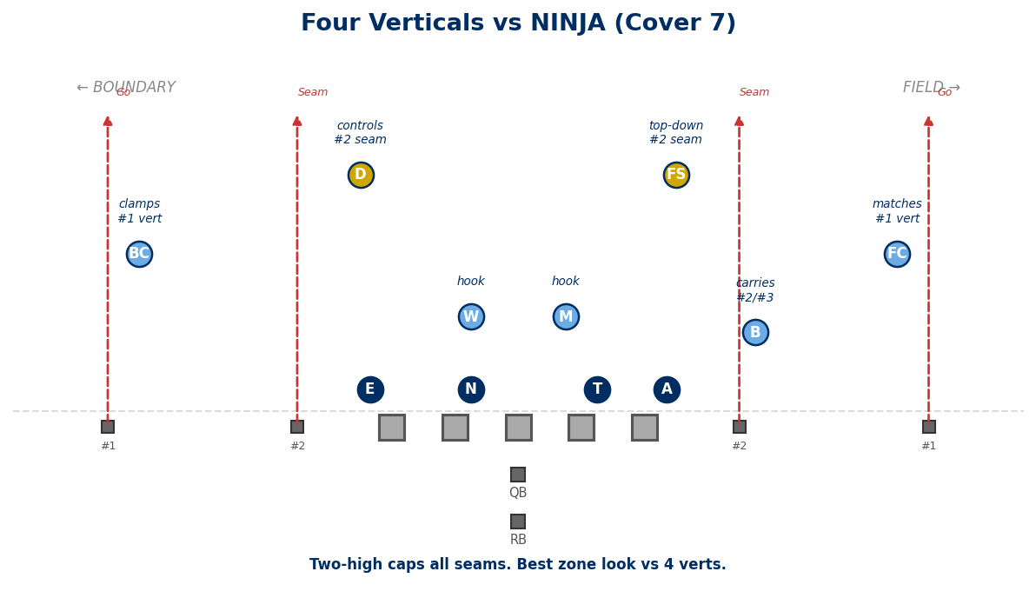
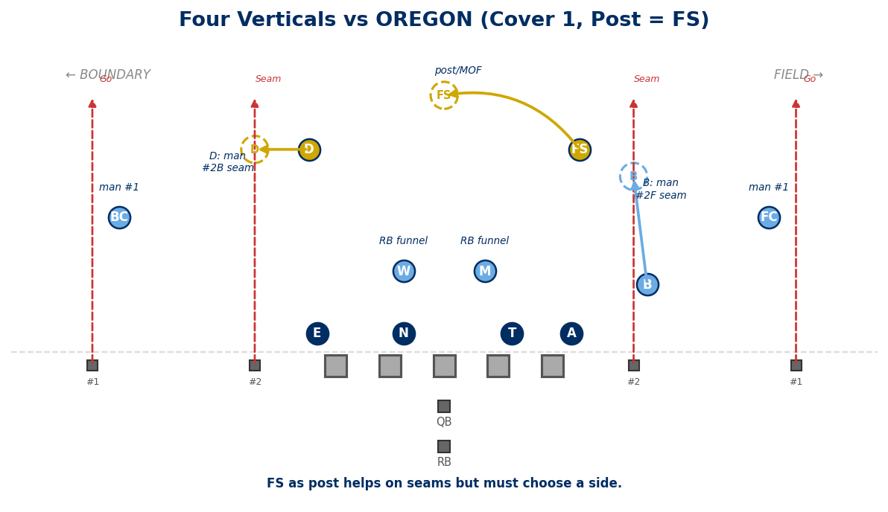

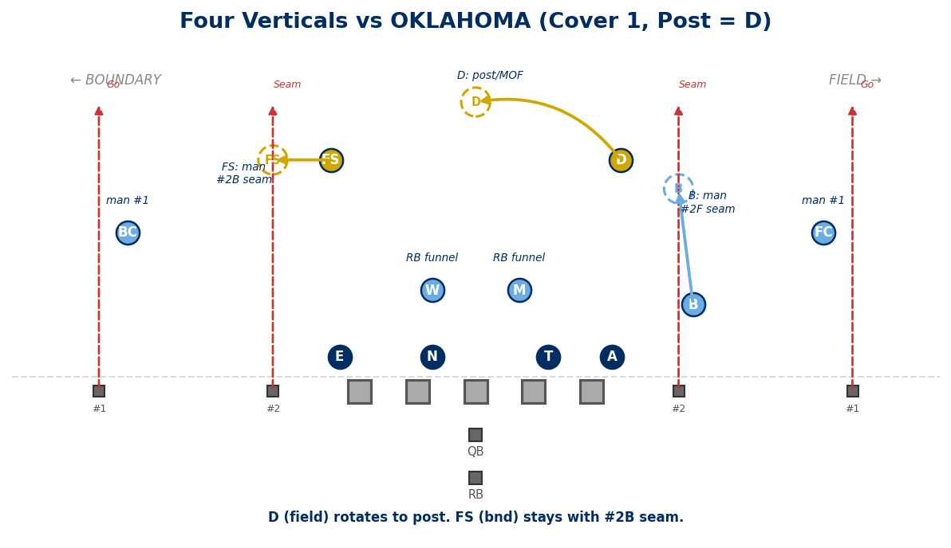
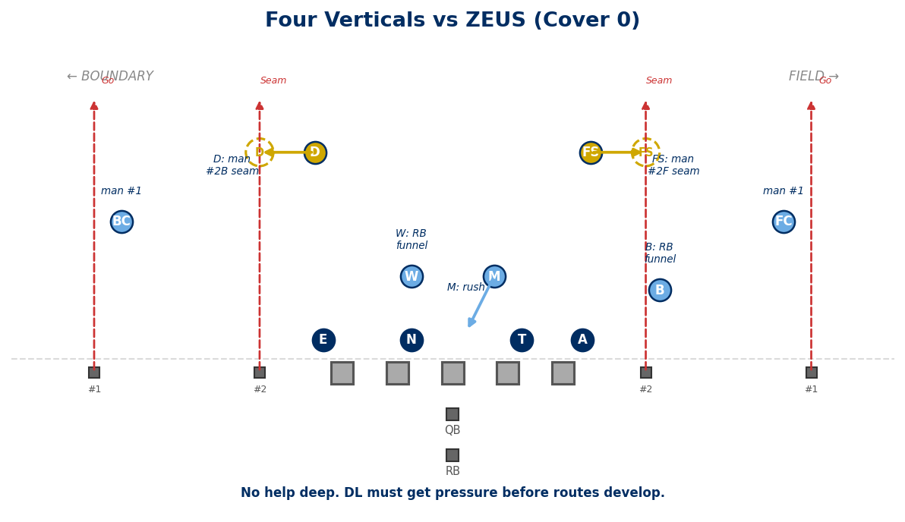

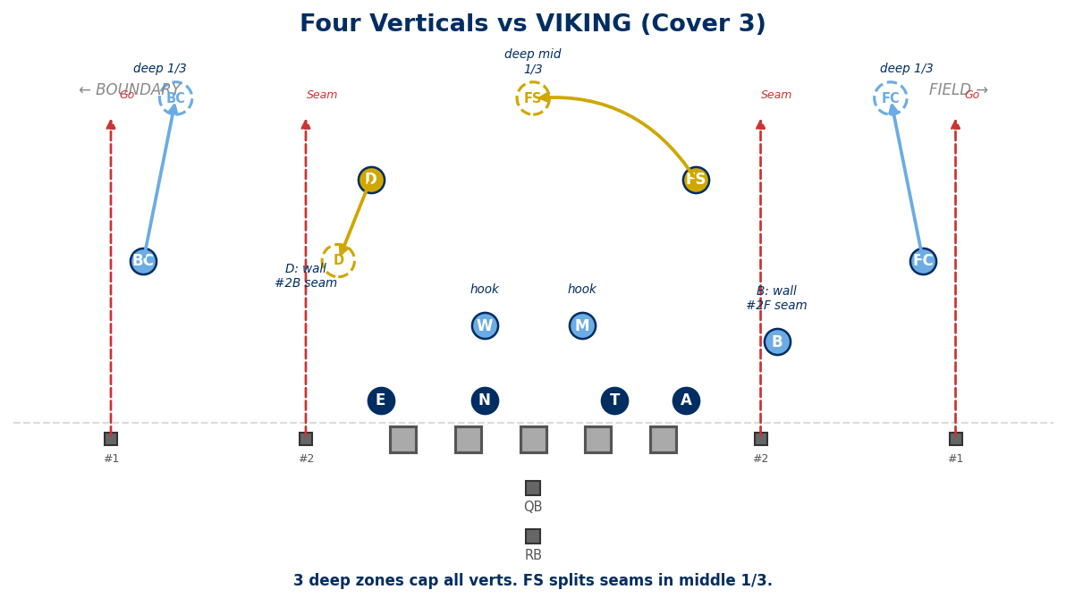

2. MESH / CROSSERS
Two receivers cross underneath. Creates pick/rub action.
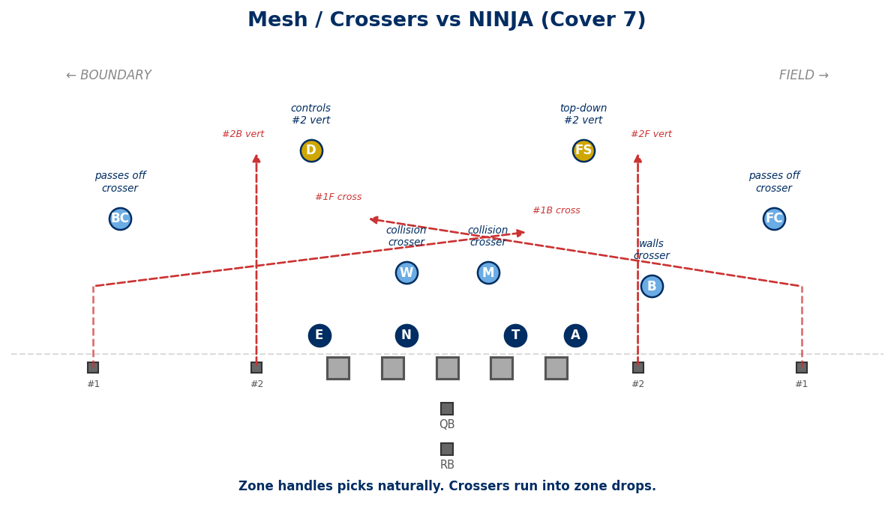
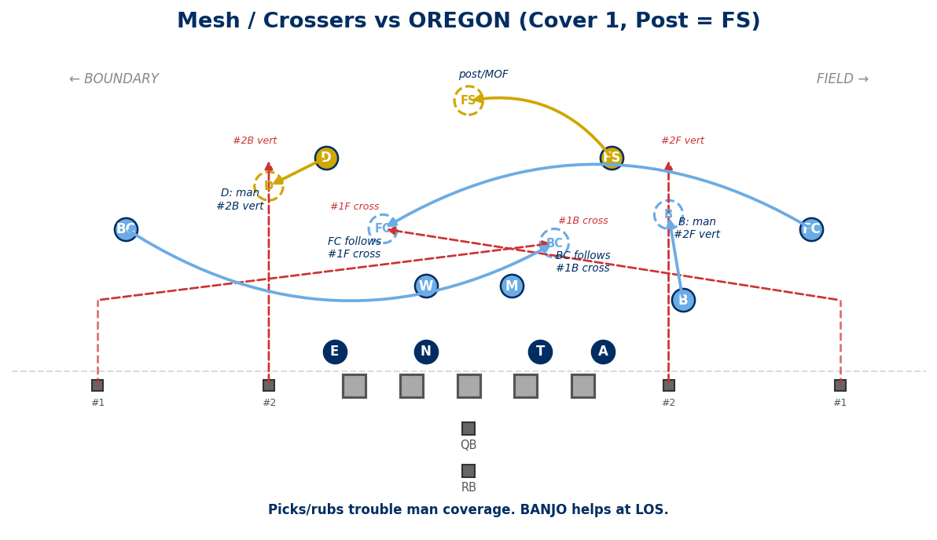

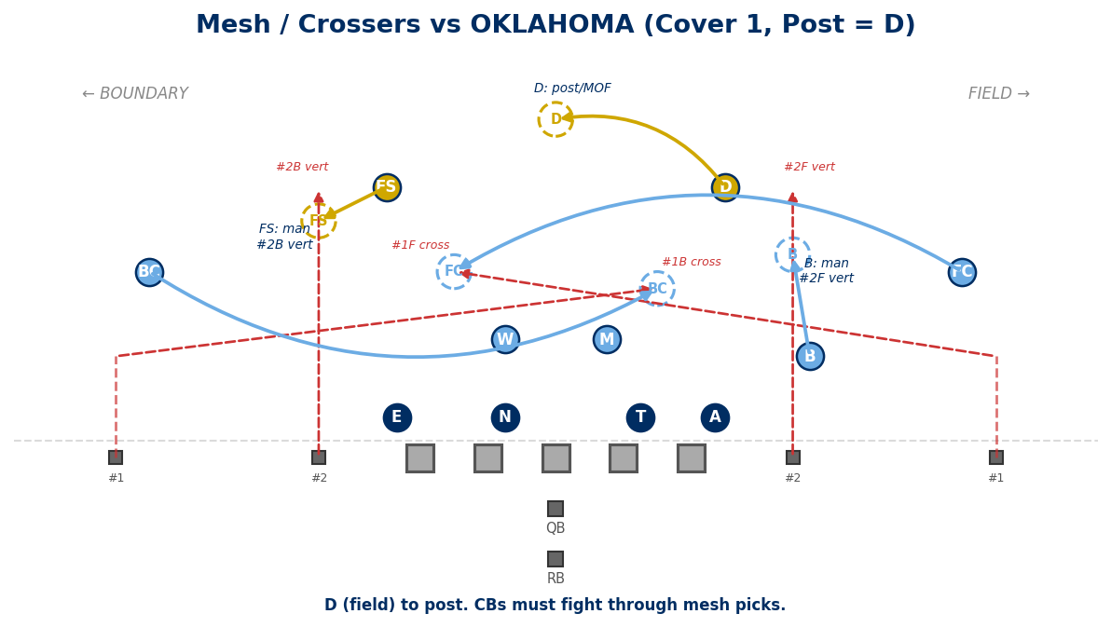
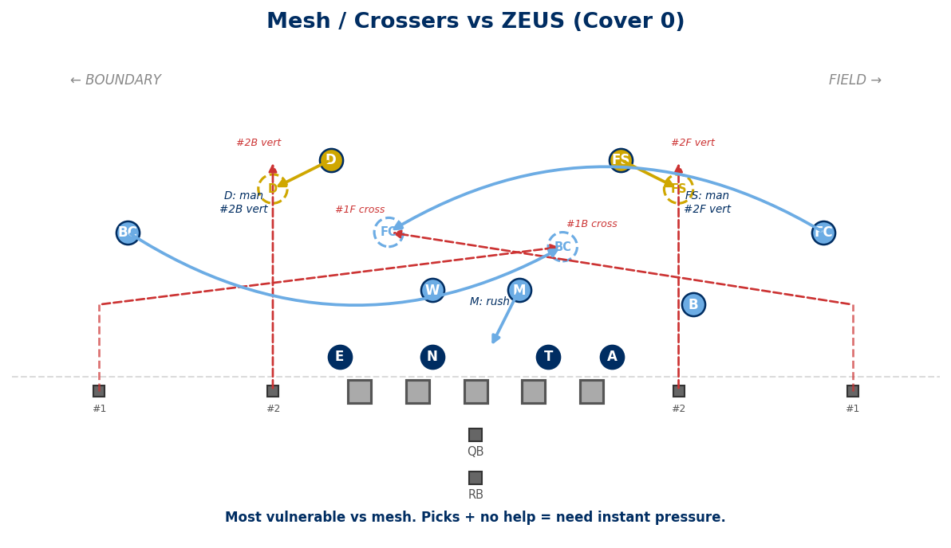

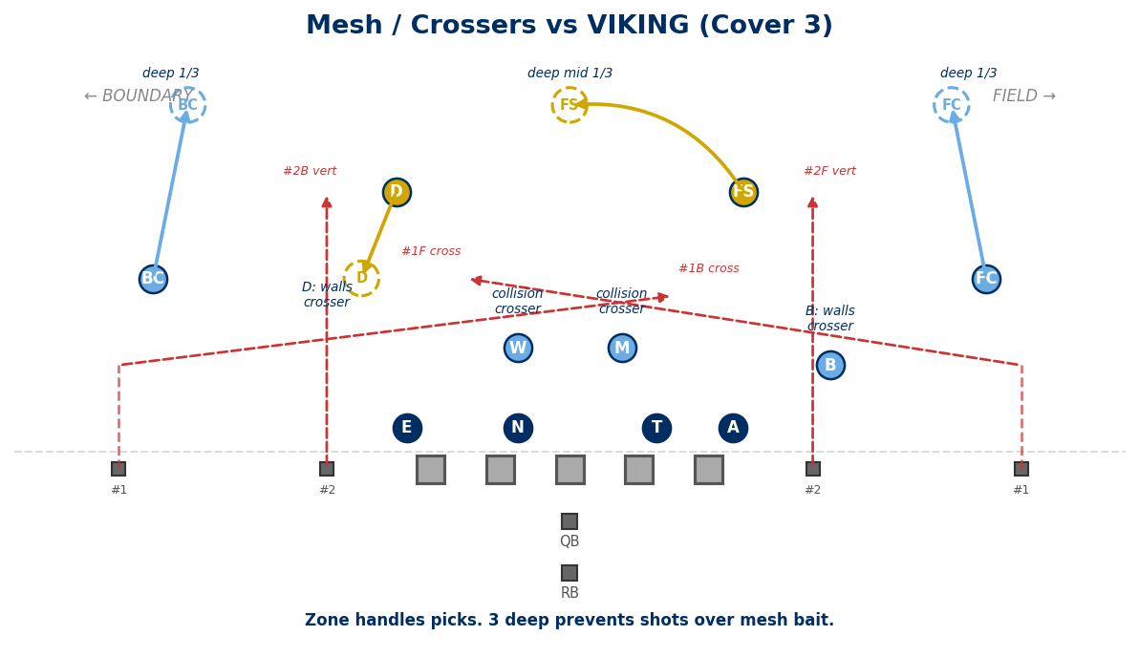

3. SMASH (Corner / Hitch)
#1 hitches at 5-6 yds. #2 runs corner behind it. Attacks the flat defender.
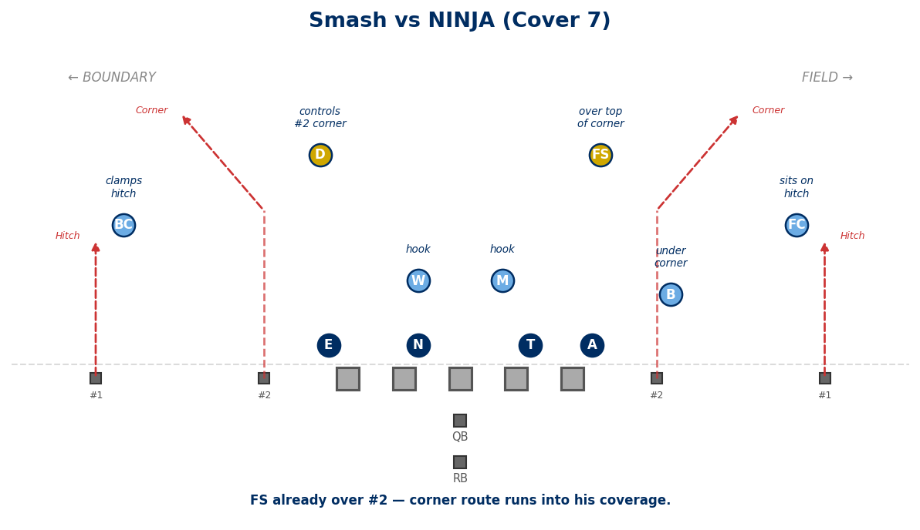
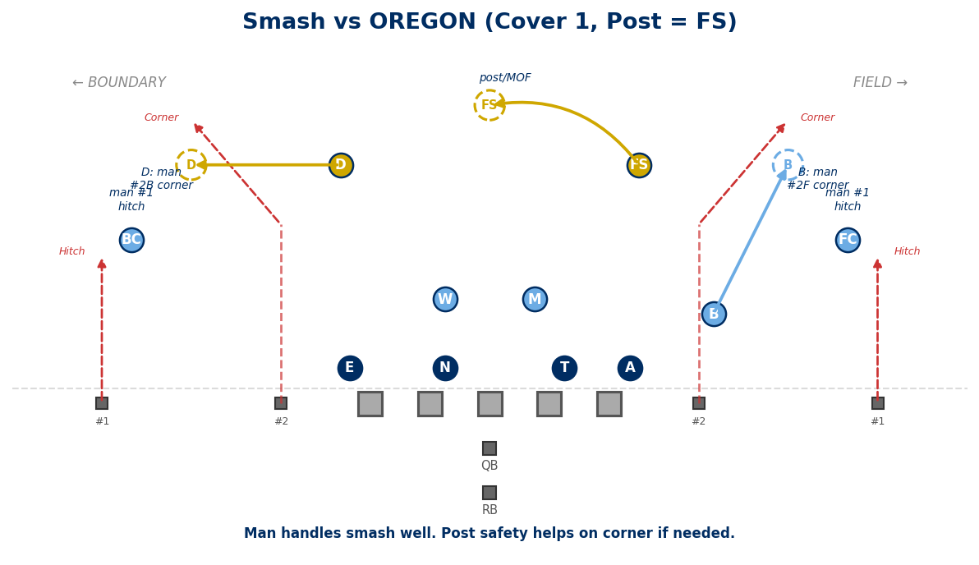

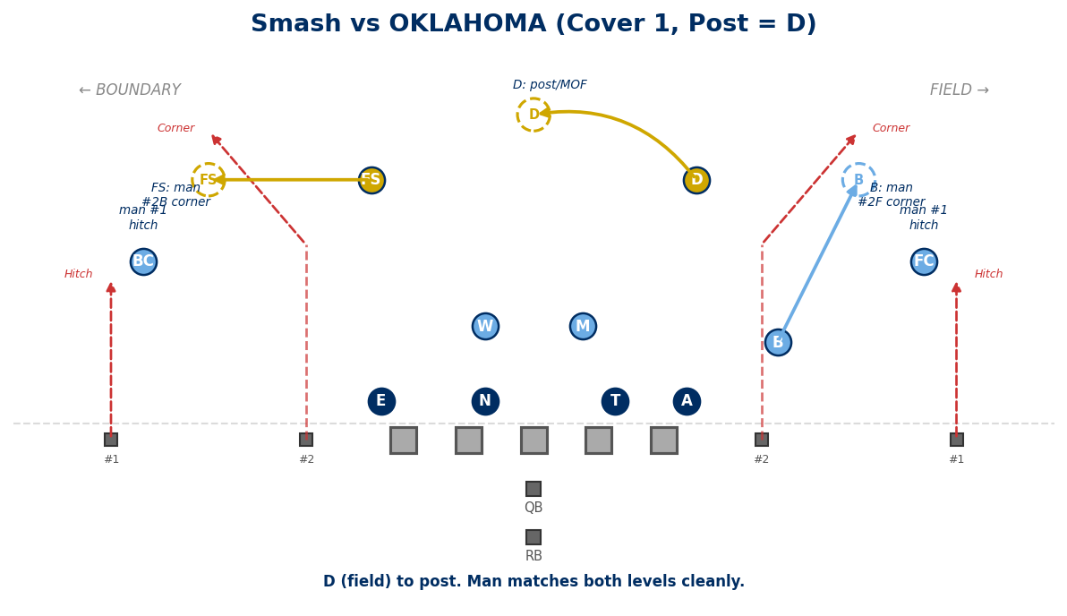
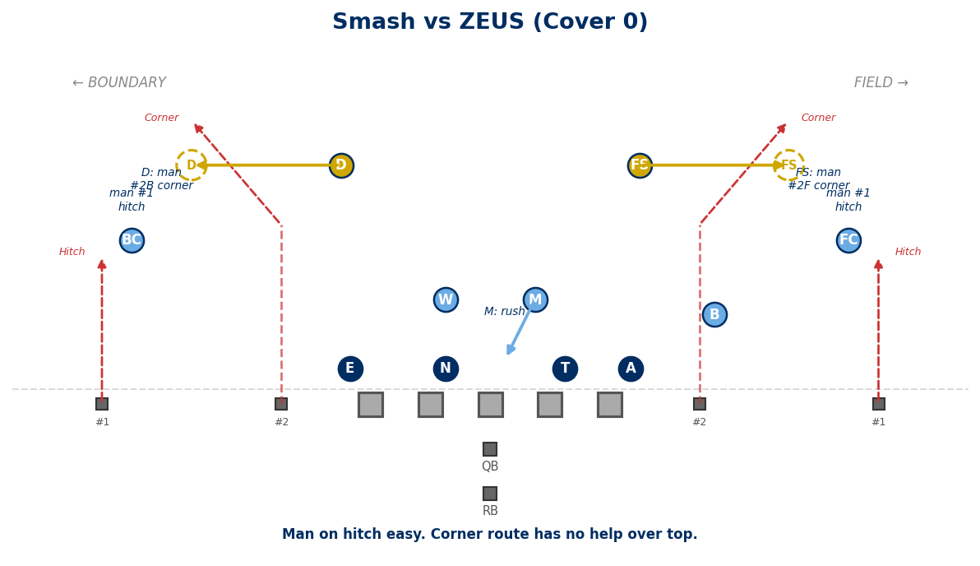

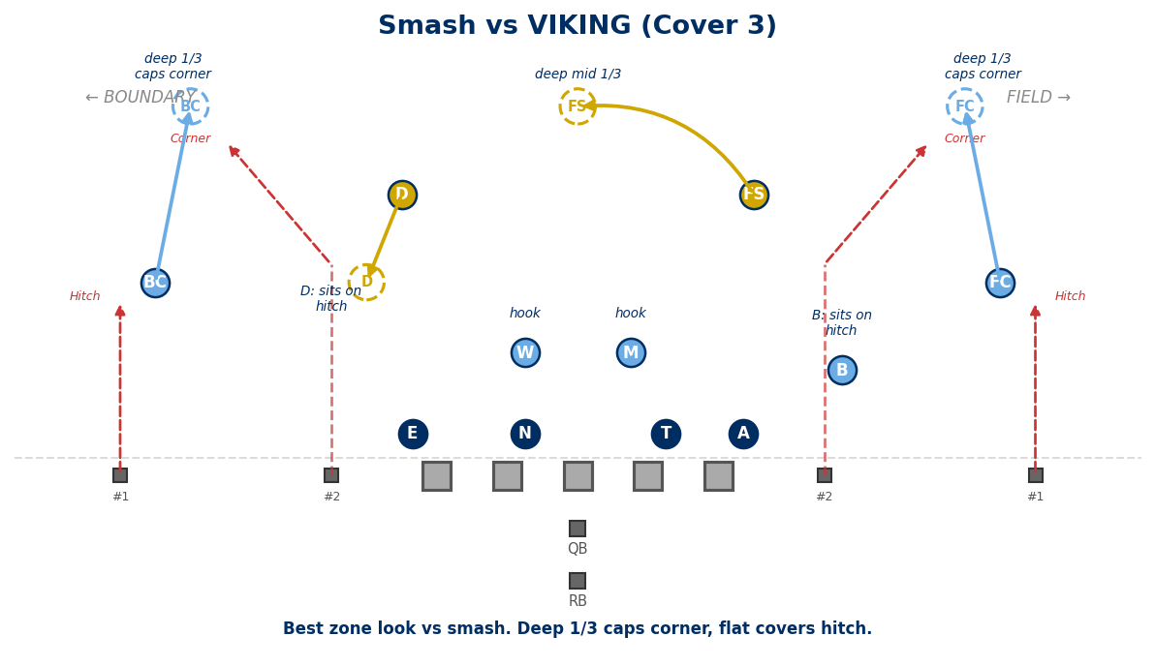

4. FLOOD / SAIL (3-Level Stretch)
Three receivers to one side at three levels: deep, intermediate, short.
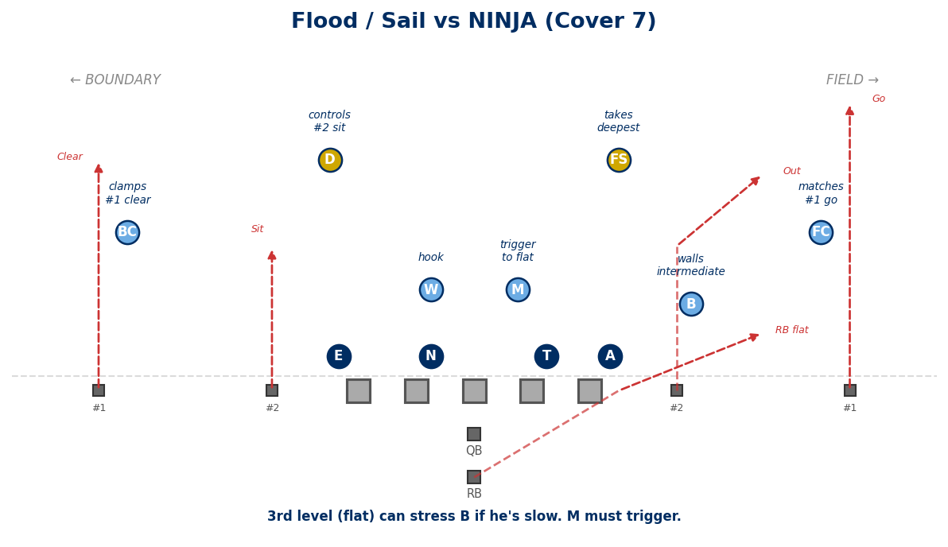
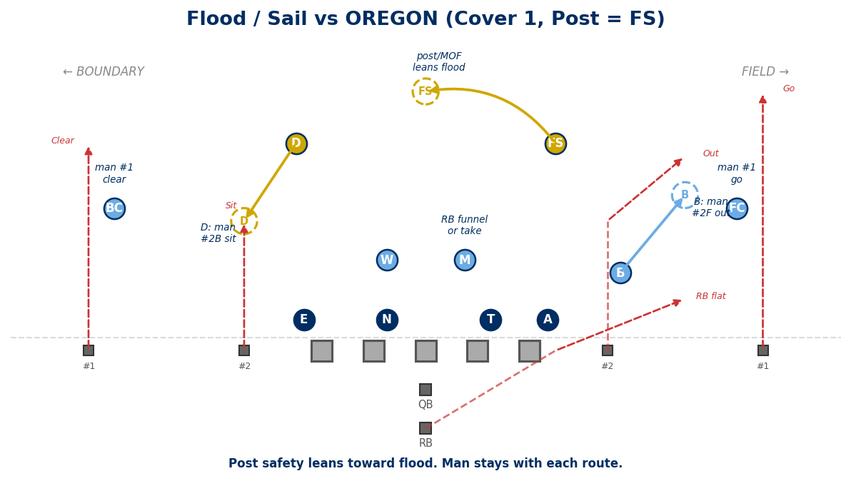

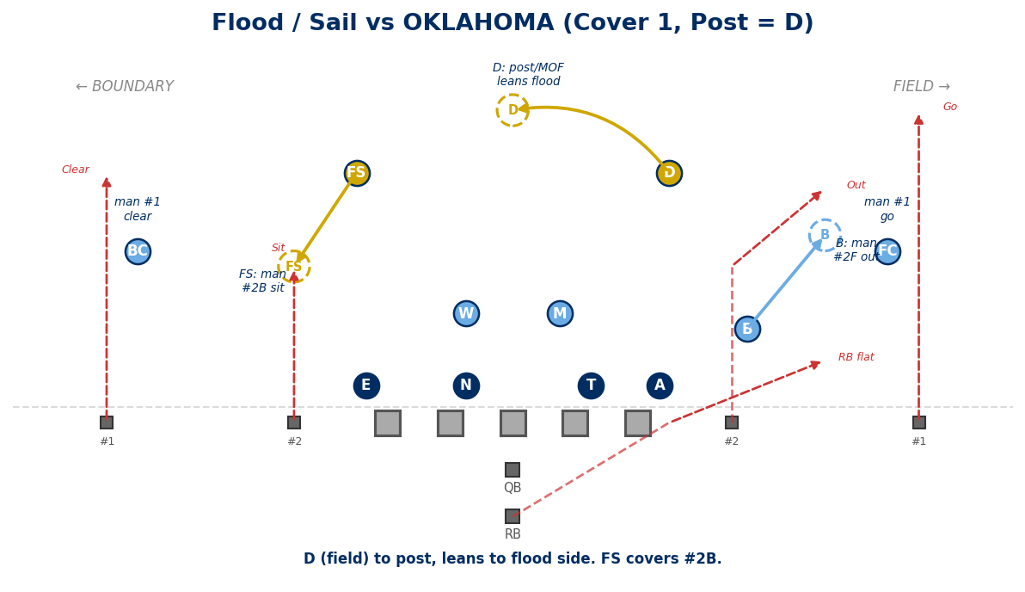
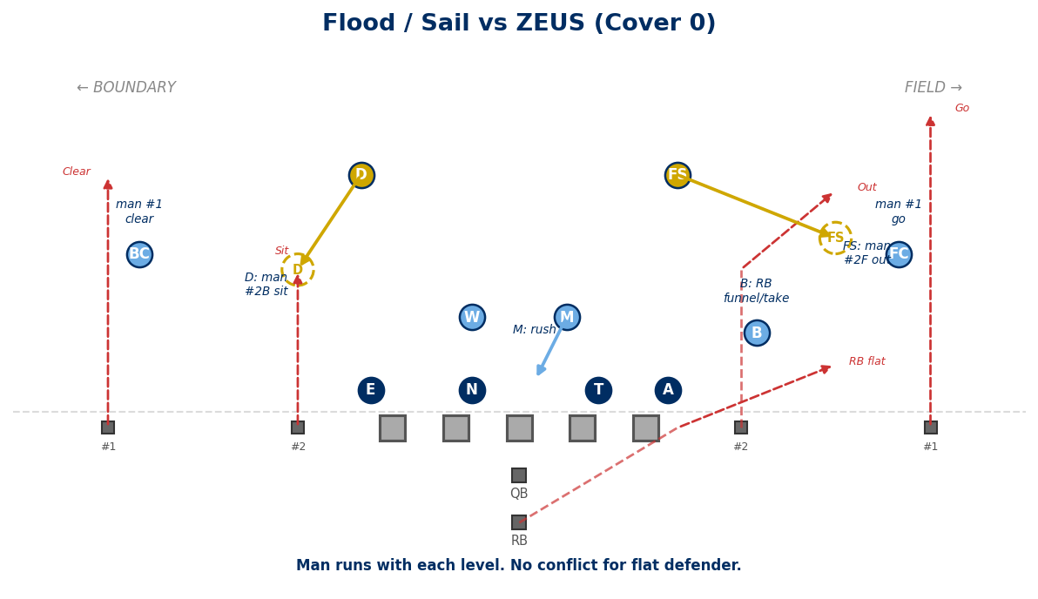

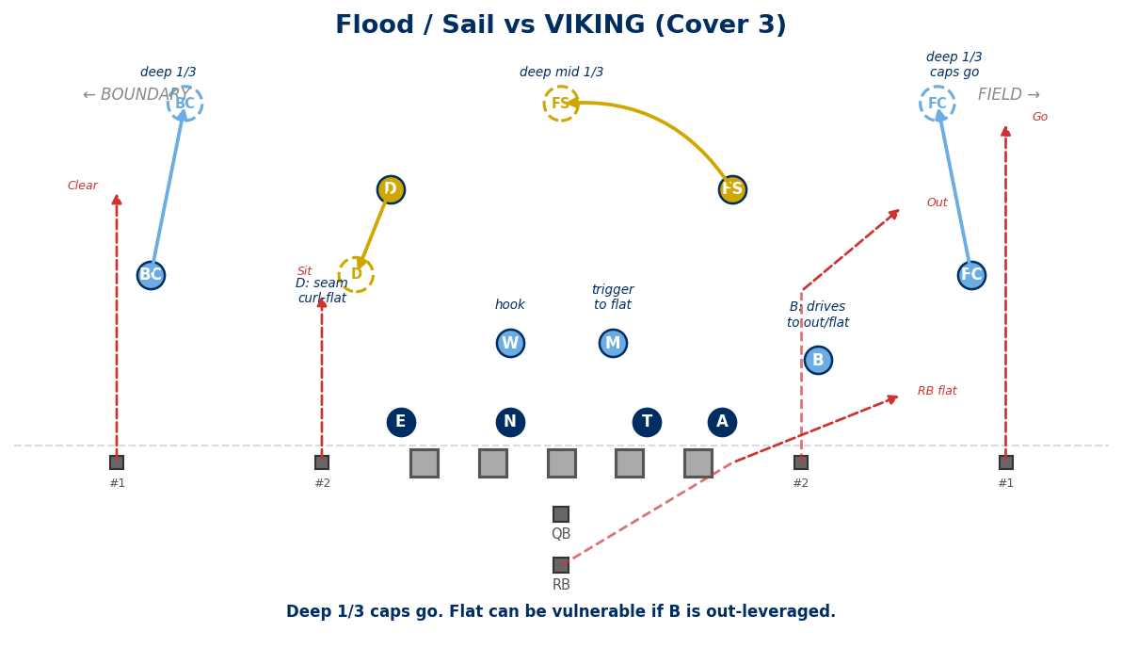

5. LEVELS (Hi-Lo Crossers)
Two crossers at different depths. Reads the hook/curl defender.
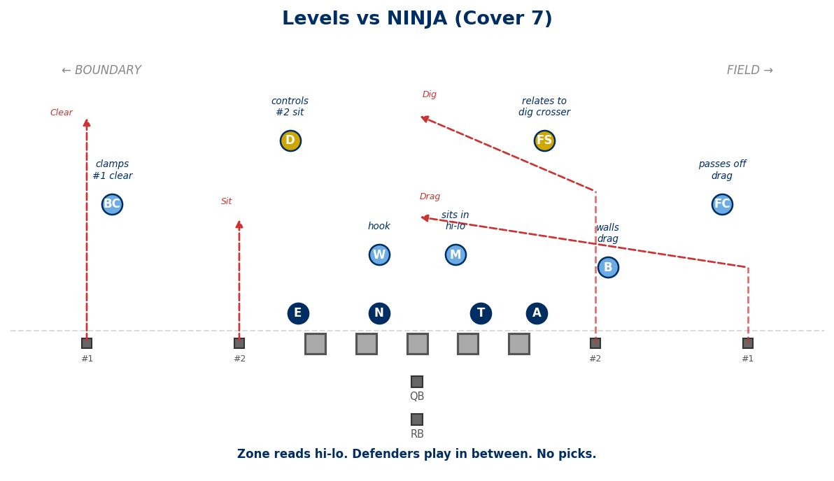
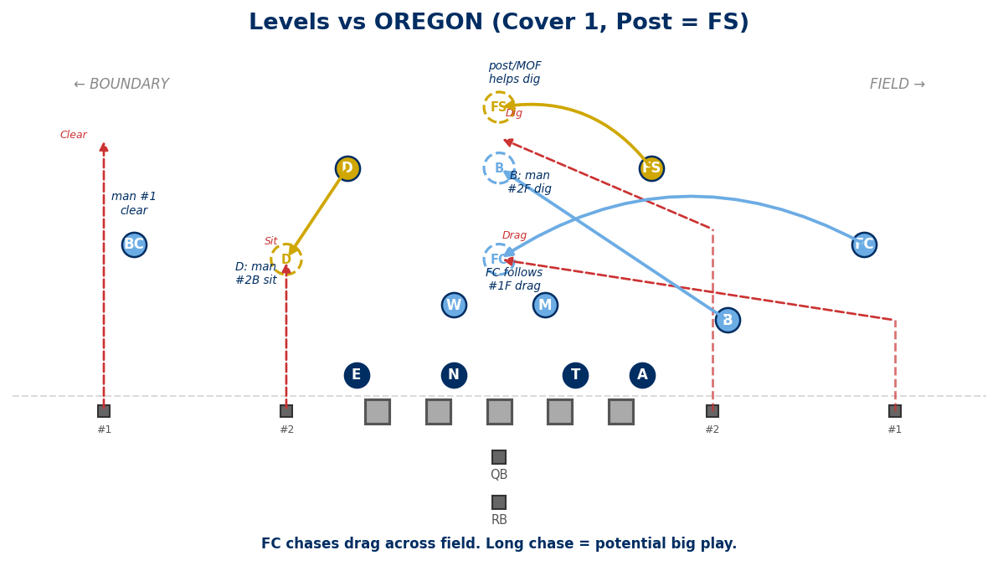

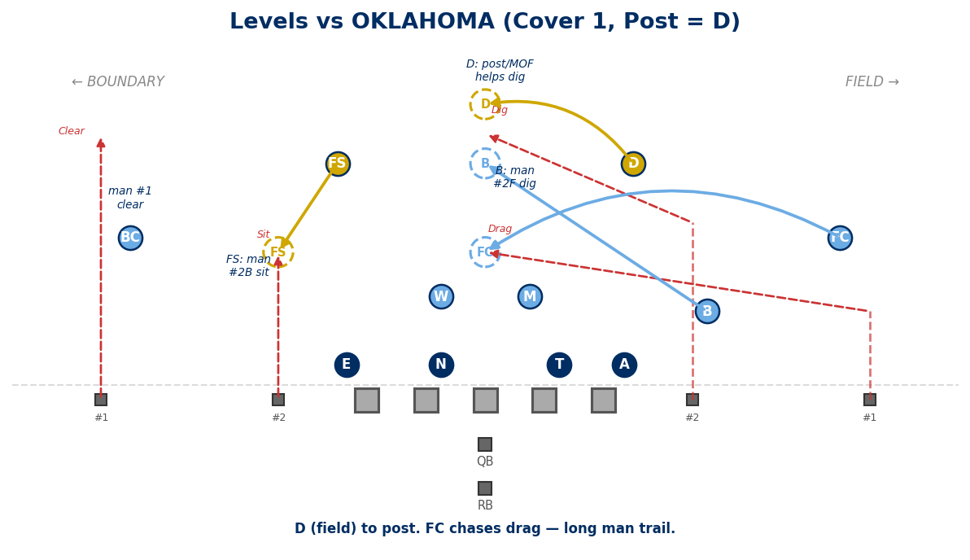
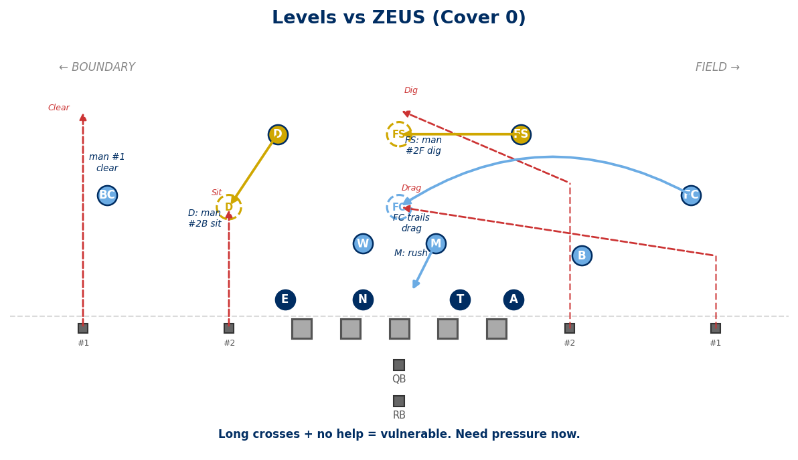

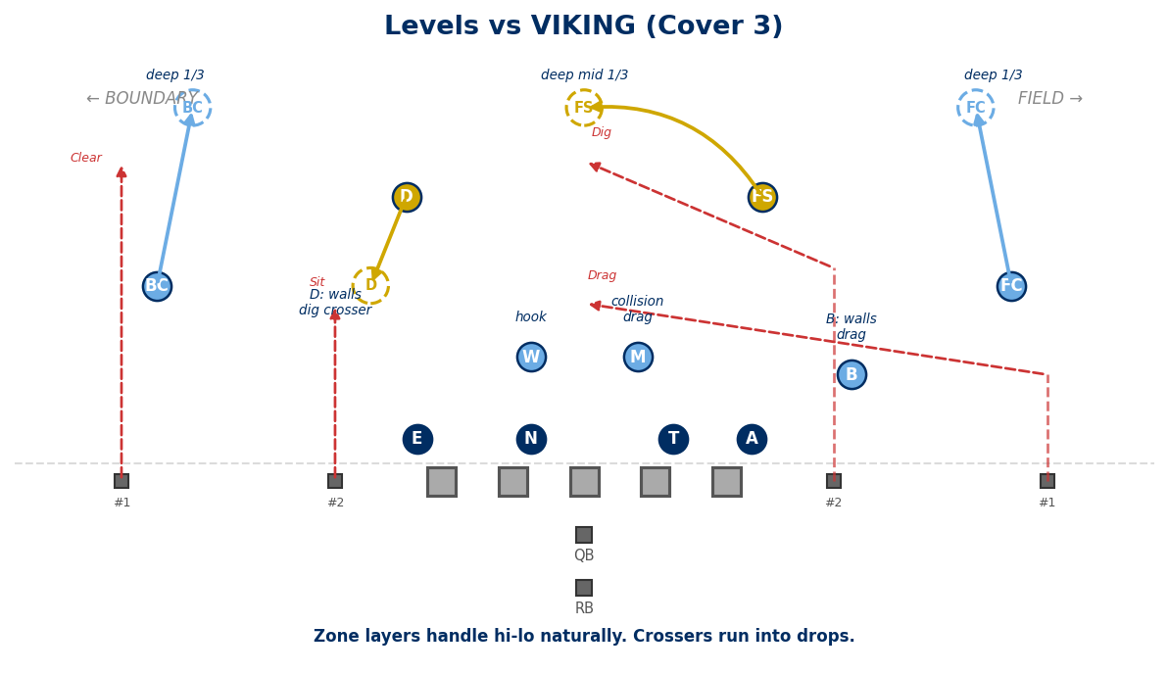

6. CURL / FLAT
#1 curls at 12 yds. #2 runs flat. Classic 2-man read of the flat defender.
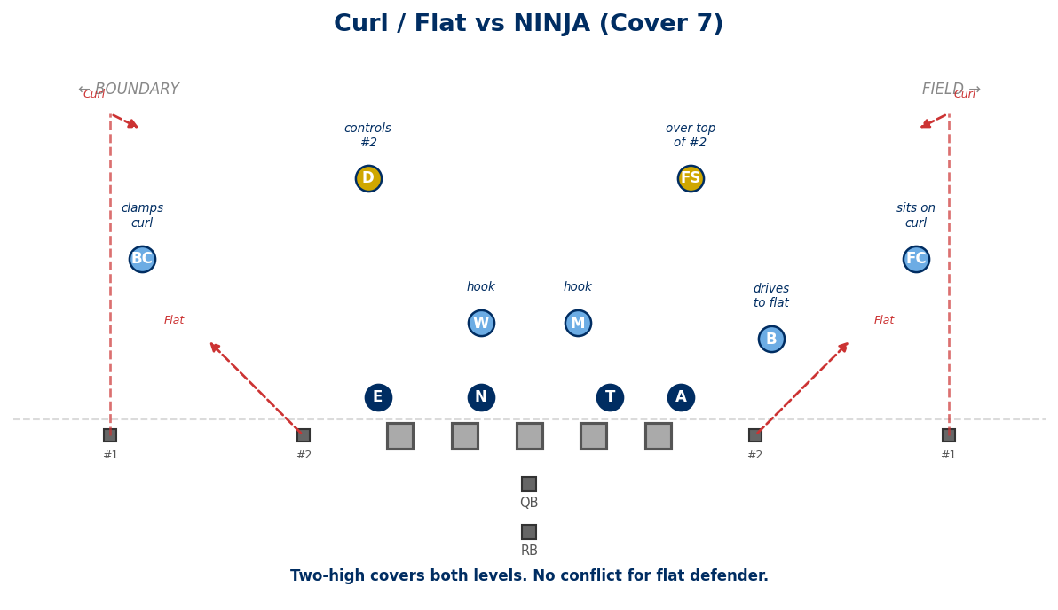
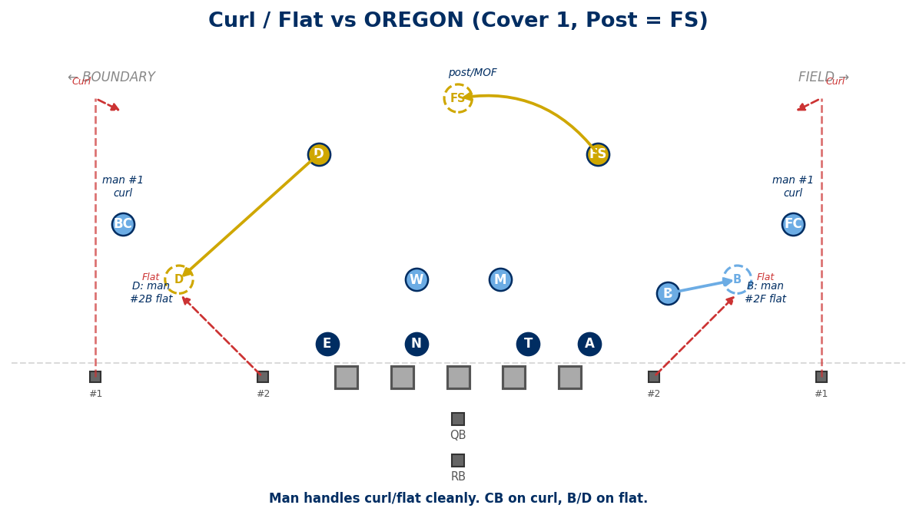

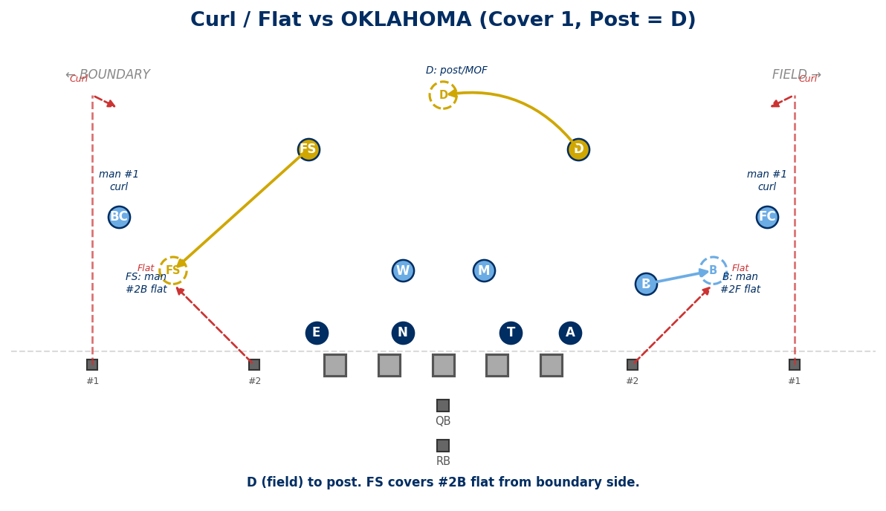
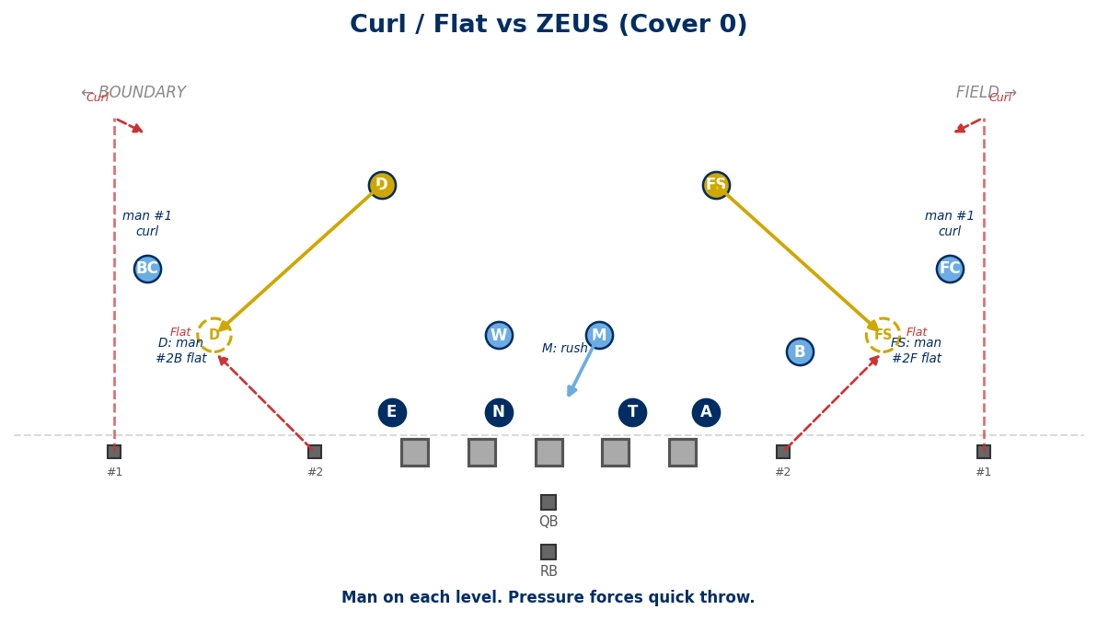

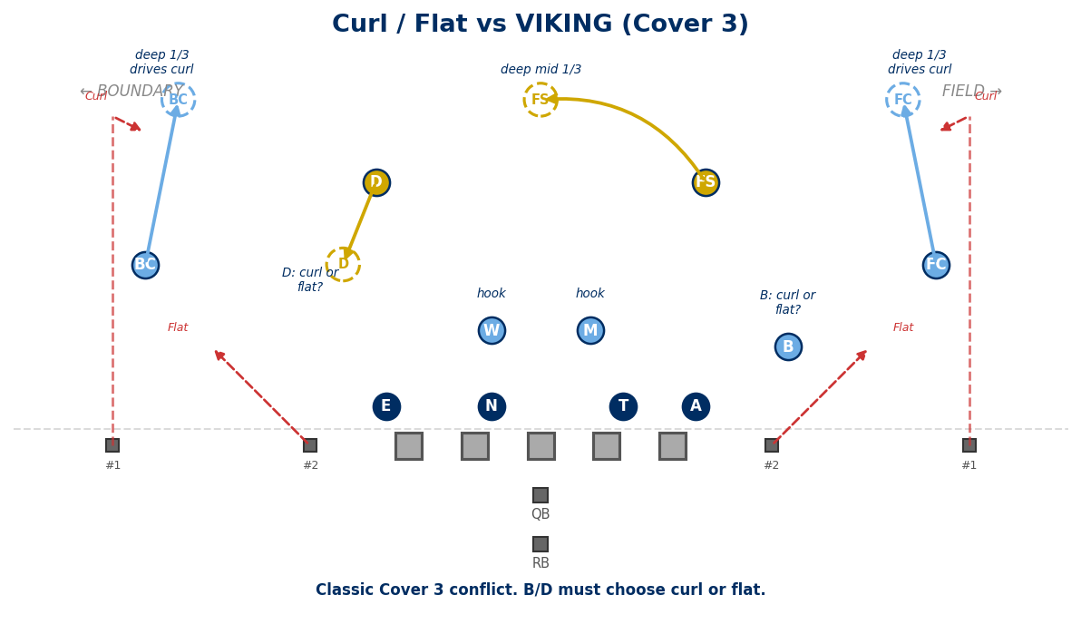

7. SLANT / FLAT (Quick Game)
#1 slants inside. #2 runs flat. Fast-developing quick game concept.
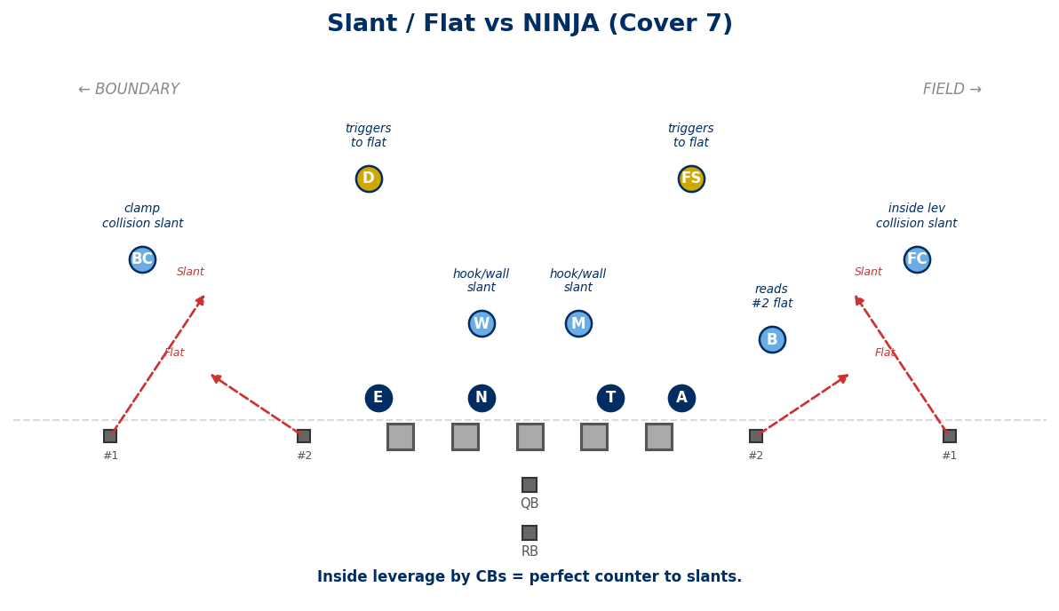
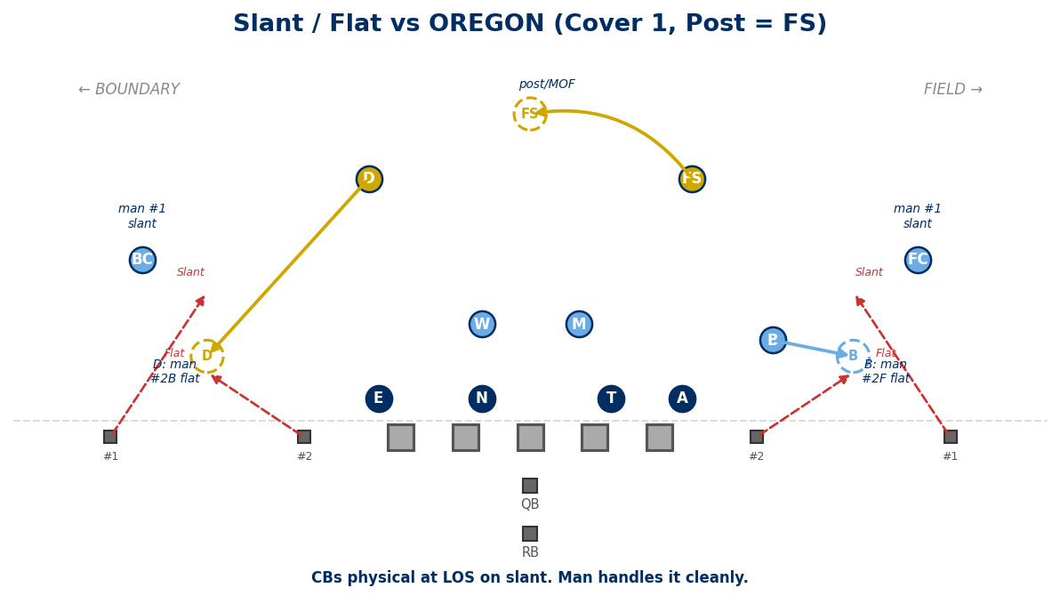

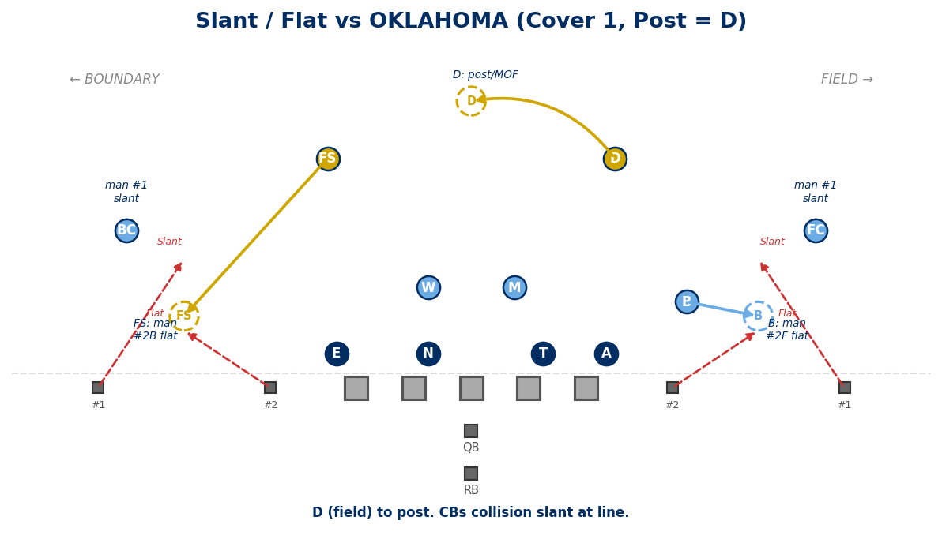
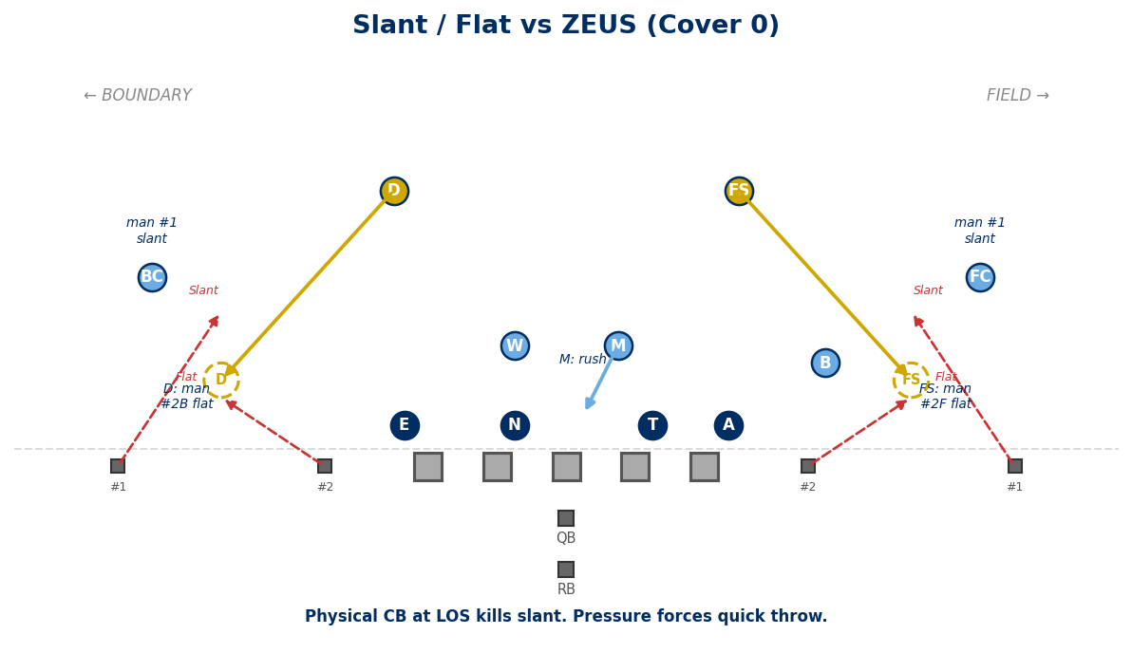

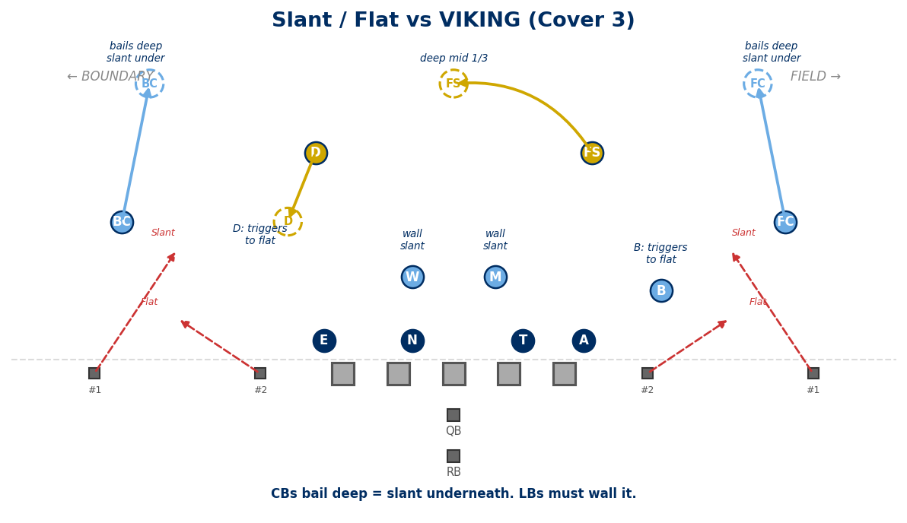

8. RPO CONCEPTS (Run-Pass Options)
QB reads a defender. If he bites on the run, QB throws the quick pass behind him.
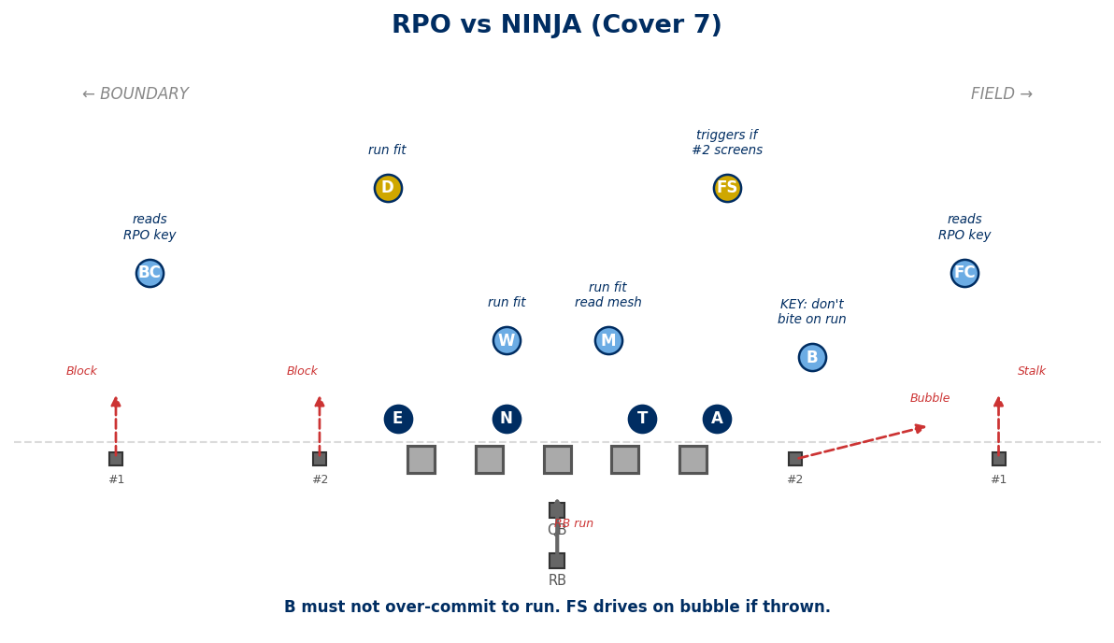
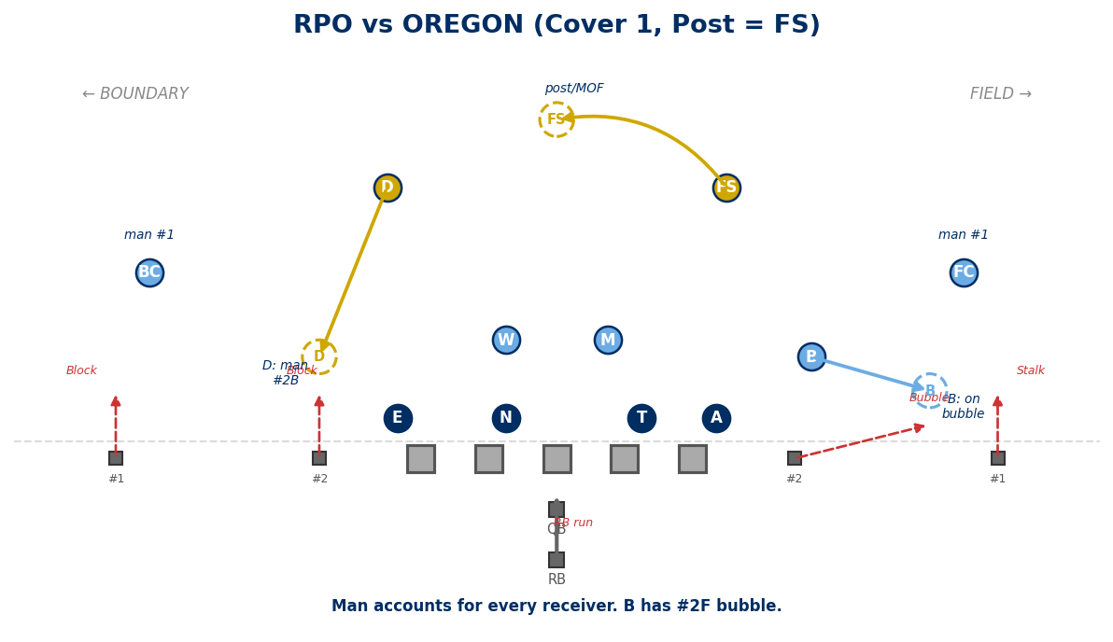

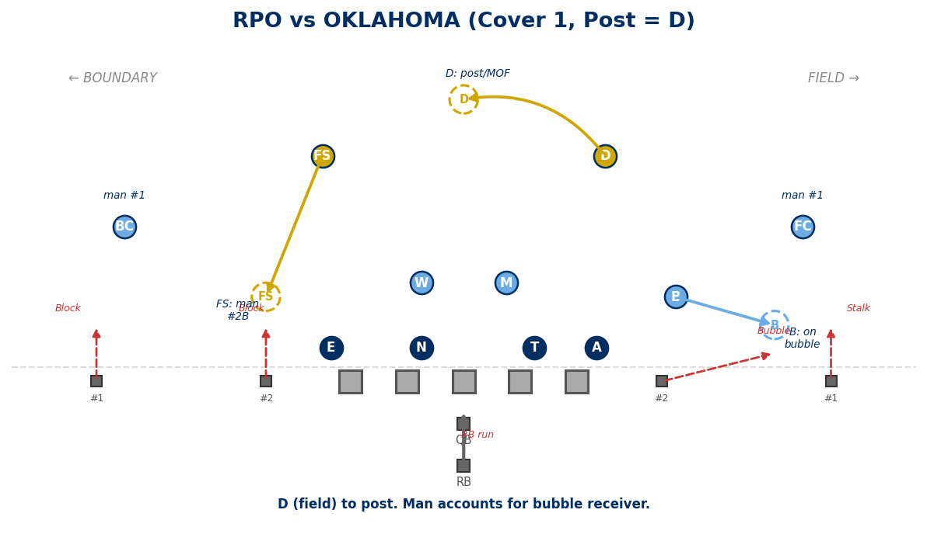
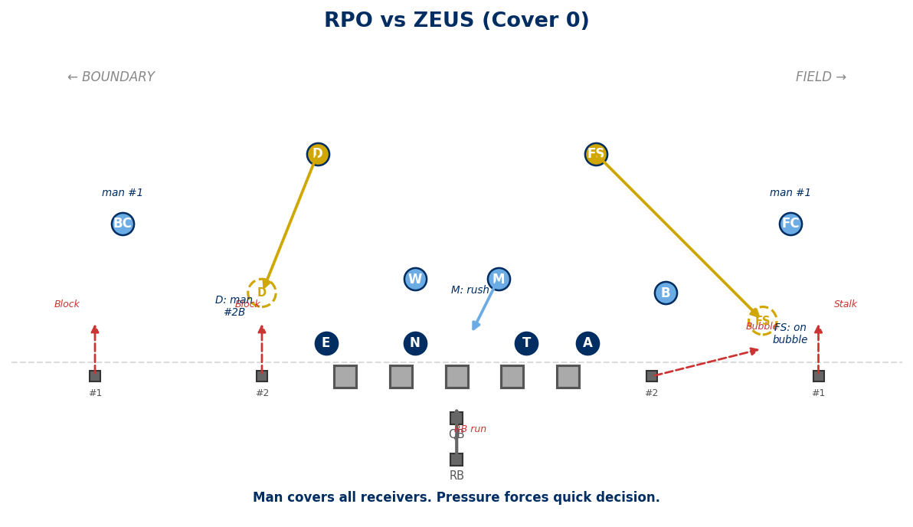

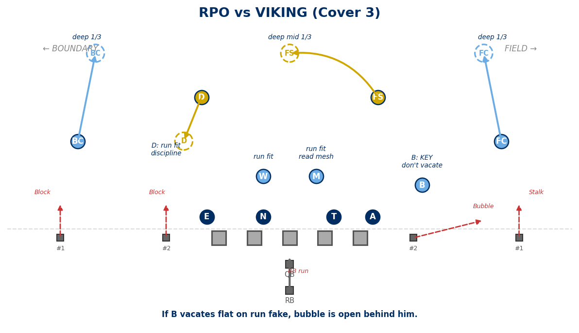

9. DOUBLE POST / POST-DIG
Two receivers run post routes. Attacks MOF, stresses single-high safeties.
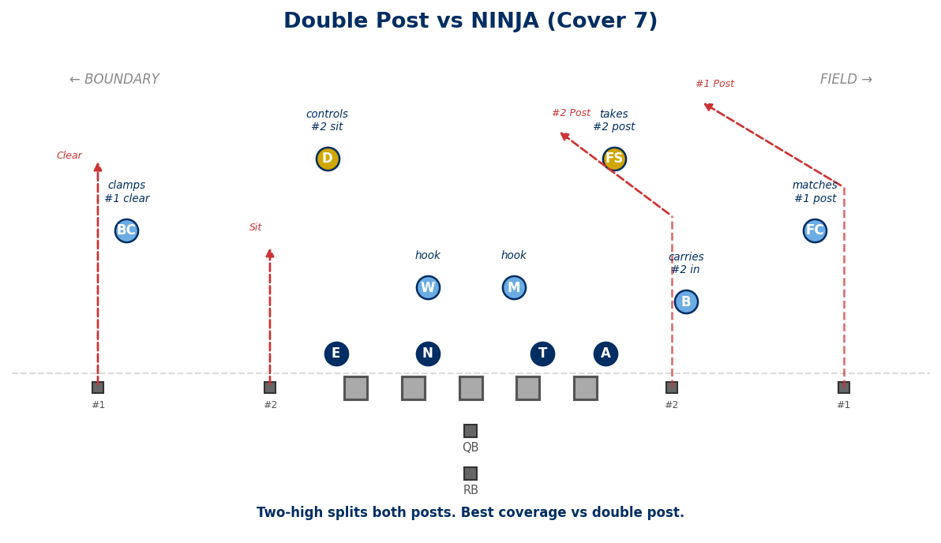
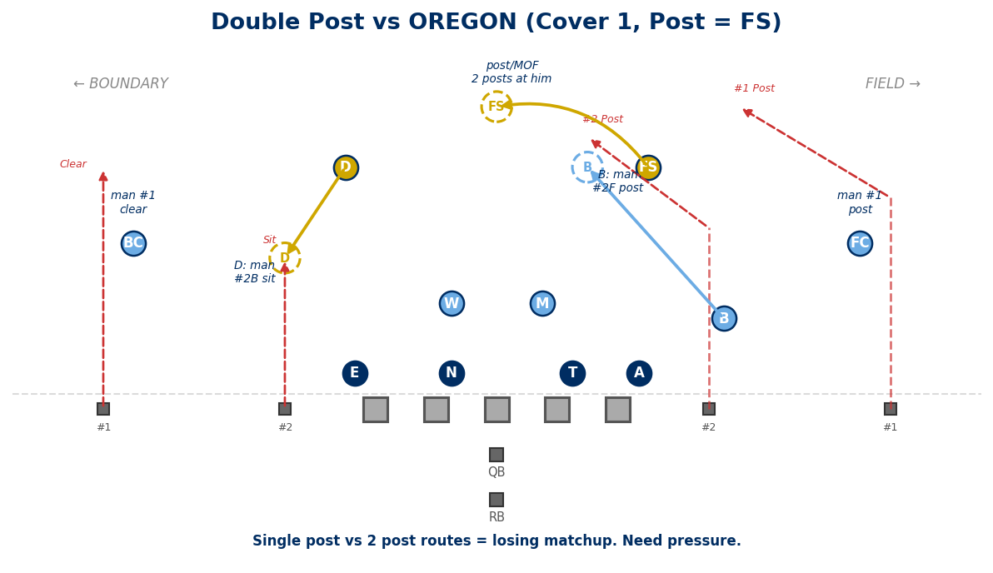

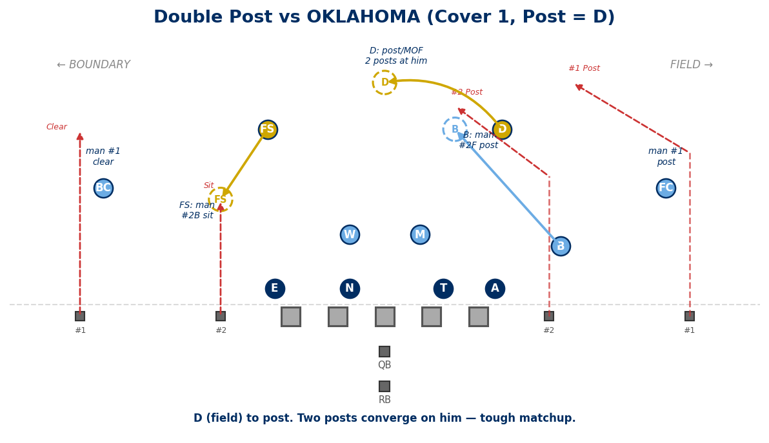
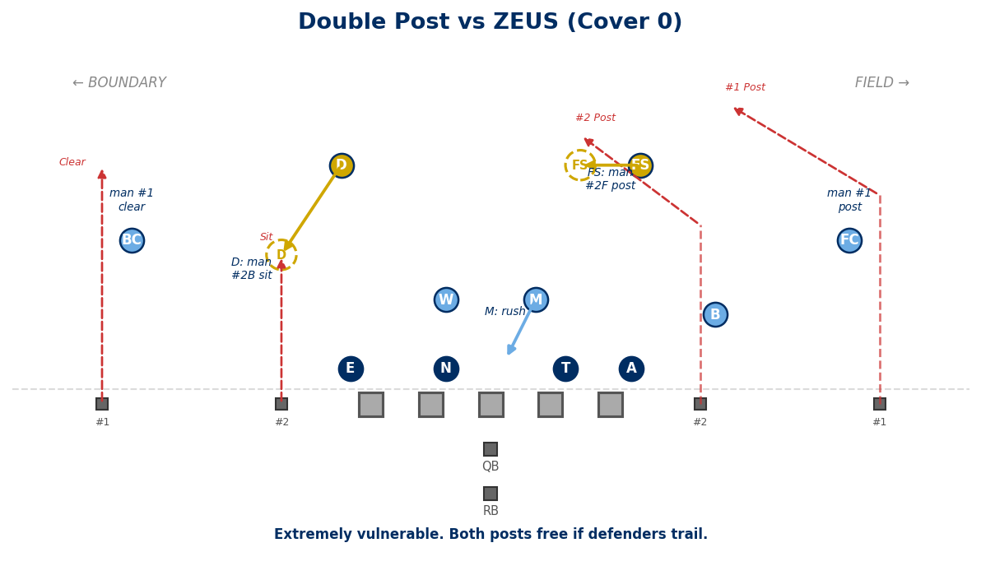

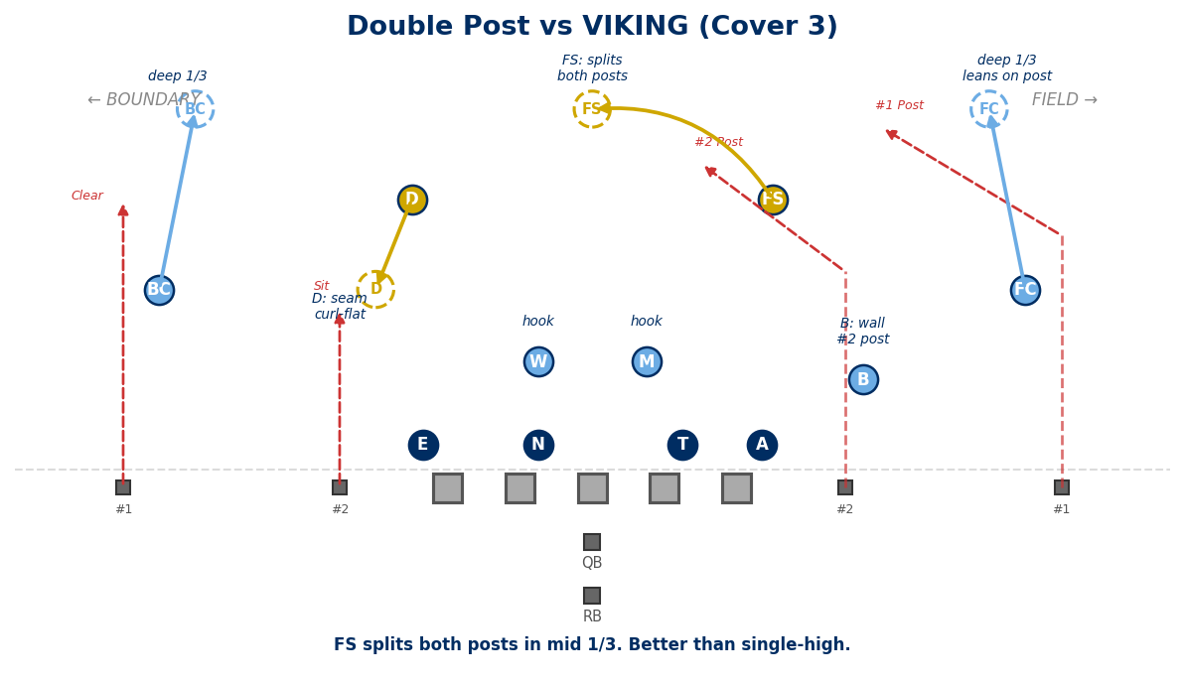

10. STICK (Quick Game)
#1 sticks at 6 yds. #2 flat. RB vertical push. A 3-level quick concept.
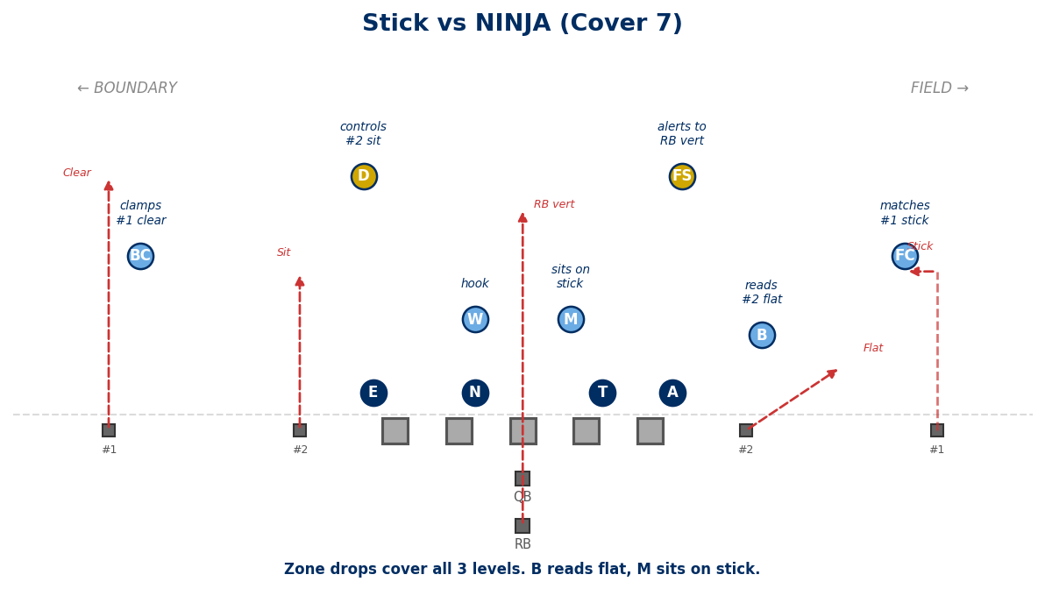
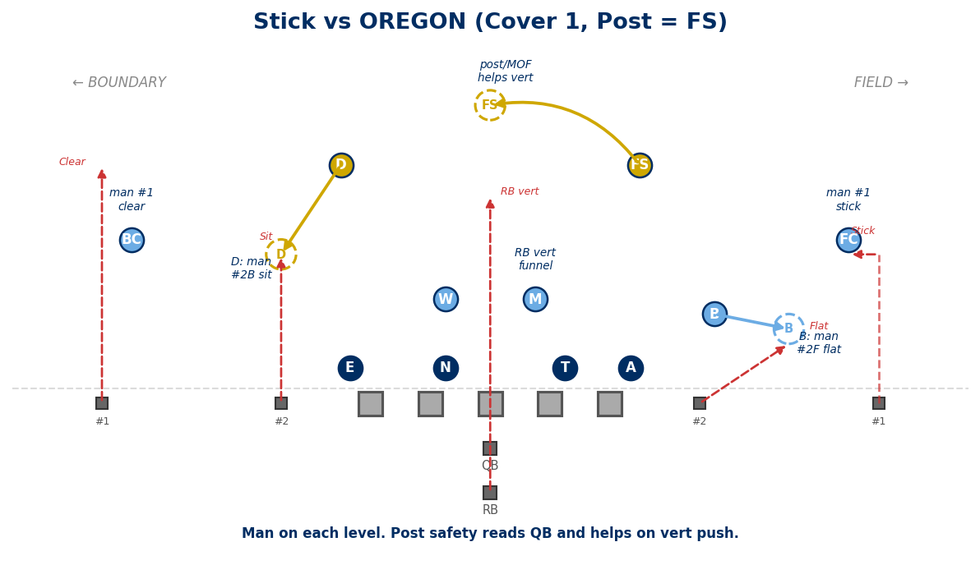

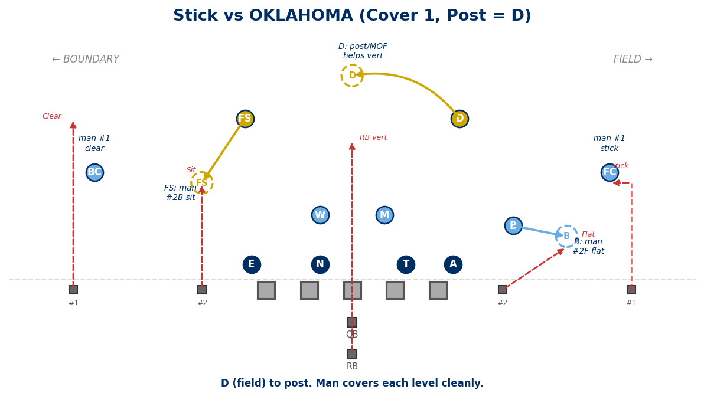
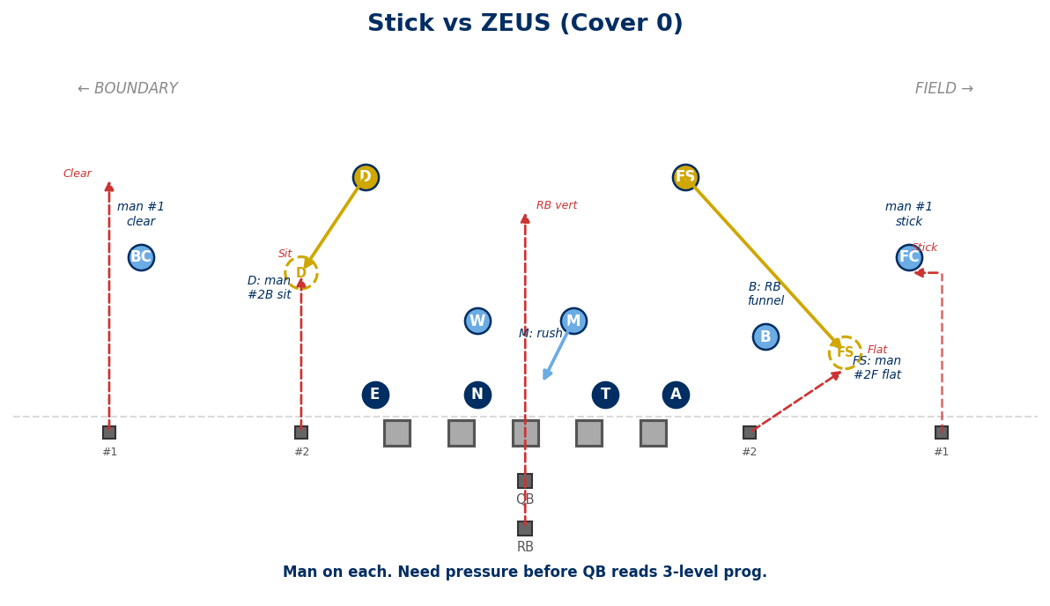

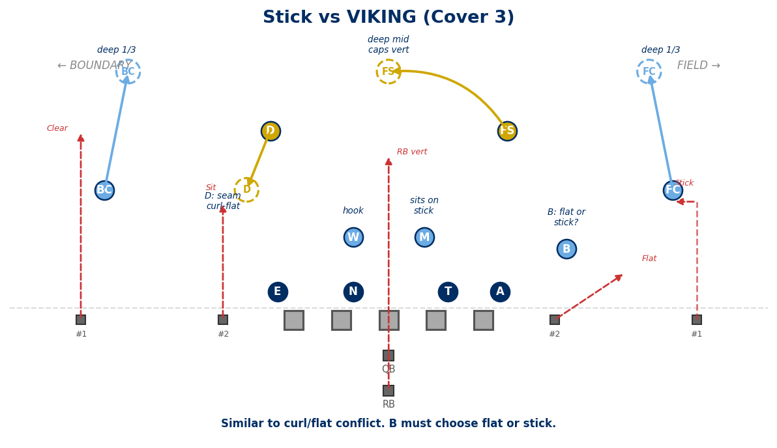

CONCEPT vs COVERAGE QUICK REFERENCE
Quick reference: which coverages are strongest and weakest against each common concept. ✅ = Strong matchup. ⚠️ = Caution/conflict. ❌ = Vulnerable.
Concept | NINJA (Cov 7) | Cover 1 (OR/OK) | Cover 0 (Zeus) | VIKING (Cov 3)
Four Verts | Strong — two-high caps seams | Caution — single post vs 4 seams | Vulnerable — no help deep | Strong — 3 deep zones cap it
Mesh / Crossers | Strong — zone handles picks | Caution — picks trouble man | Vulnerable — picks + no help | Strong — zone handles picks
Smash | Strong — FS on corner, CB on hitch | Strong — man matches both | Caution — no help on corner | Strong — deep 1/3 caps corner
Flood / Sail | Caution — 3rd level stress | Caution — post must commit | Strong — man runs with each | Caution — flat vulnerable
Levels | Strong — zone reads hi-lo | Caution — long chases across field | Vulnerable — trail + no help | Strong — zone layers
Curl / Flat | Strong — two-high covers both | Strong — man on each | Strong — man on each | Caution — flat conflict
Slant / Flat | Strong — inside leverage + FS | Strong — CB physical on slant | Strong — pressure + man | Caution — corners bail
RPO | Caution — B must read, not bite | Strong — man accounts all | Strong — man accounts all | Caution — flat discipline
Double Post | Strong — two-high splits posts | Vulnerable — single post vs two | Vulnerable — no help deep | Strong — FS splits posts
Stick | Strong — zone covers all levels | Strong — man on each level | Strong — man on each | Caution — flat conflict

Use this matrix to game-plan coverage calls based on opponent tendencies. If they love four verts and double posts, lean NINJA and VIKING. If they run heavy mesh/crossers, NINJA and VIKING handle picks best. If they live on quick game (slant/flat, curl/flat, stick), any coverage works but pressure helps most.

— END OF DOCUMENT —

Generated: February 16, 2026

