RIVER VALLEY VIKINGS
ACE FRONT

2026 Season

CONFIDENTIAL — COACHING STAFF ONLY

ACE
3-down: A=4, T=0, N=4. All DL 2-gapping (no stunt). Contains=B and E.

Alignments vs Offensive Formations
vs 2×2 Spread (10 pers.):
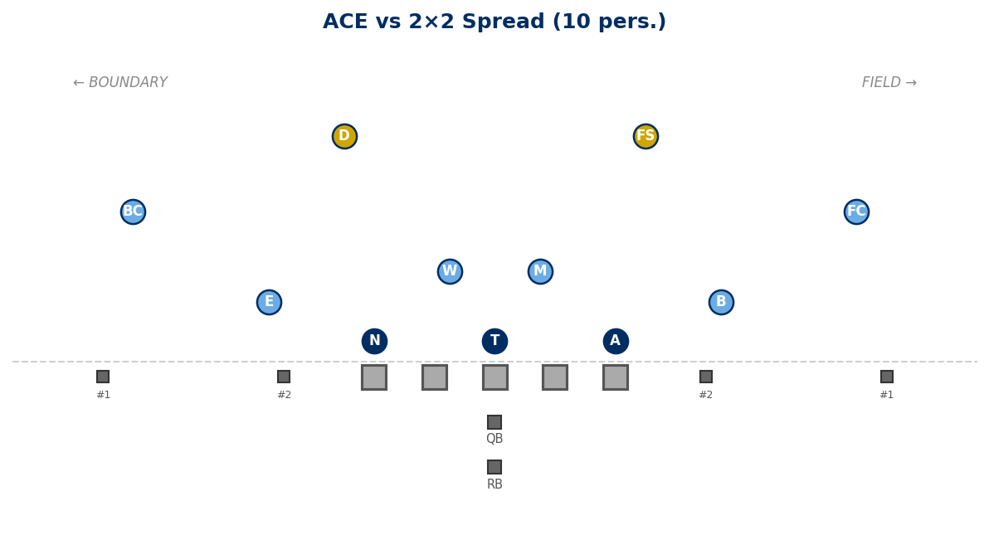

vs 3×1 Trips Field (10 pers.):
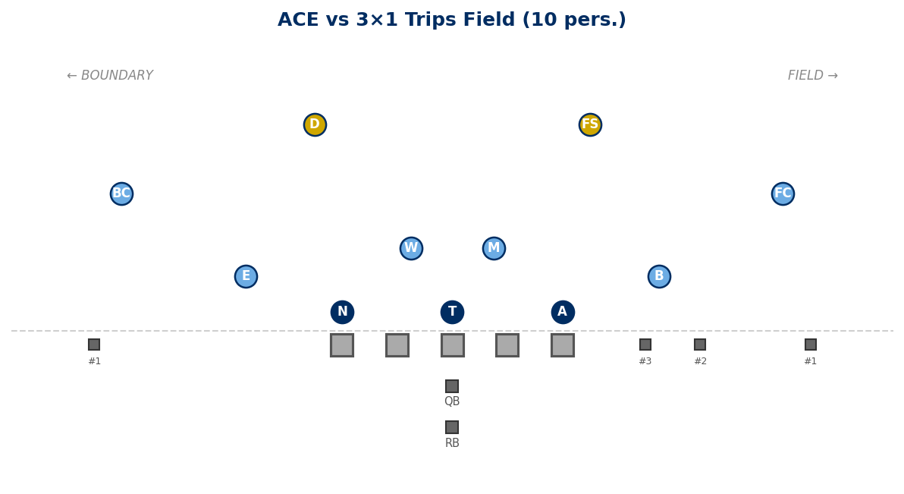

vs Empty 3×2 (10 pers.):
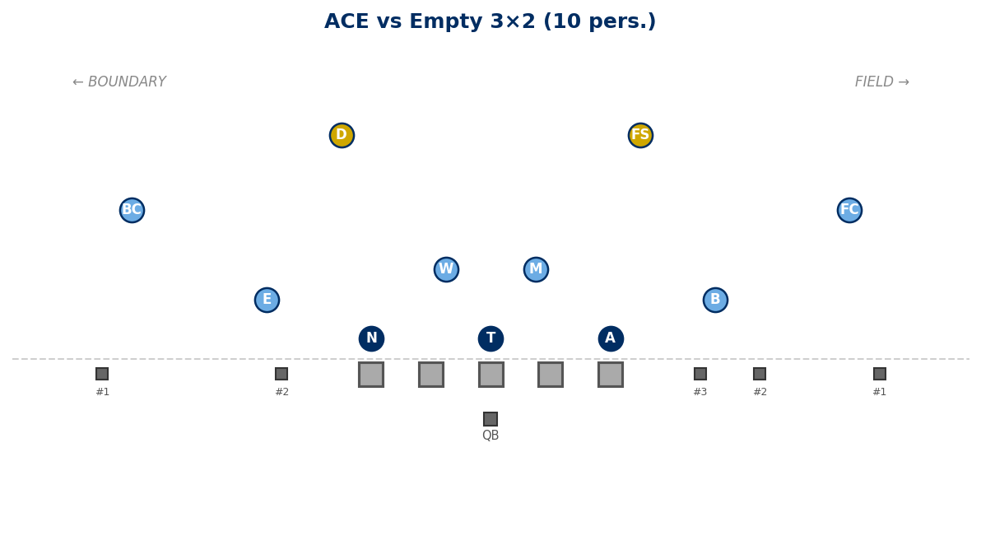

Generated: February 24, 2026 — 3 diagrams

