RIVER VALLEY VIKINGS
BOSS FRONT

2026 Season

CONFIDENTIAL — COACHING STAFF ONLY

BOSS
A=5, T=3(F), N=1(F), E=5. Bigs to field. M=A bnd, W=B bnd. Pressure setup.

Alignments vs Offensive Formations
vs 2×2 Spread (10 pers.):
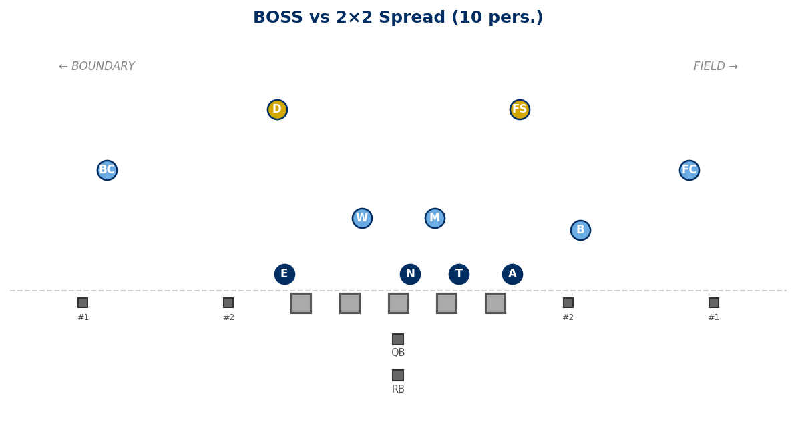

vs 3×1 Trips Field (10 pers.):
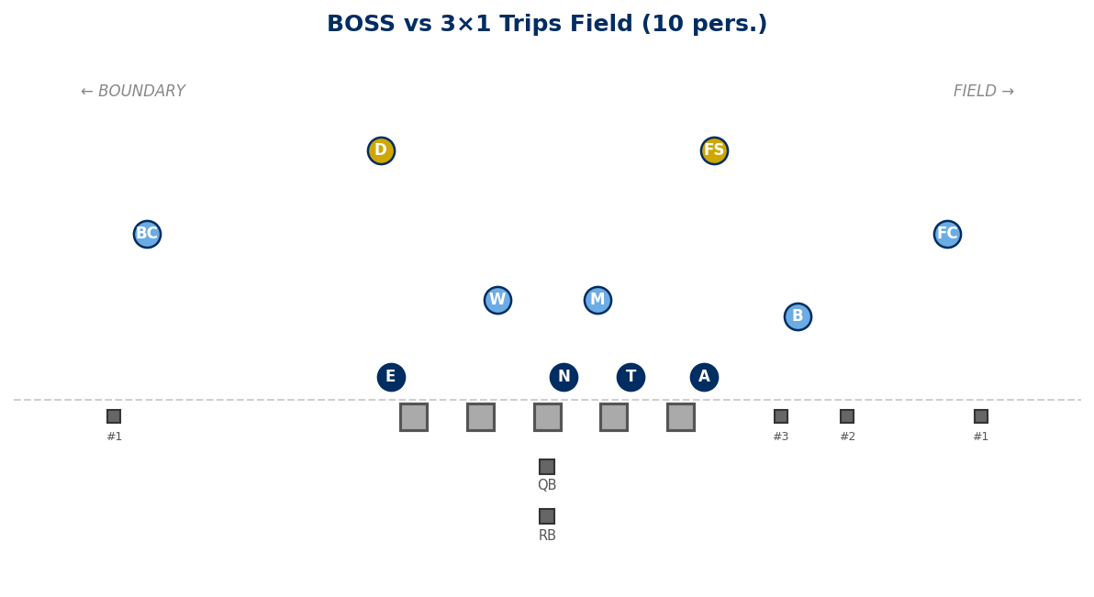

vs 2×2 + TE Field (11 pers.):
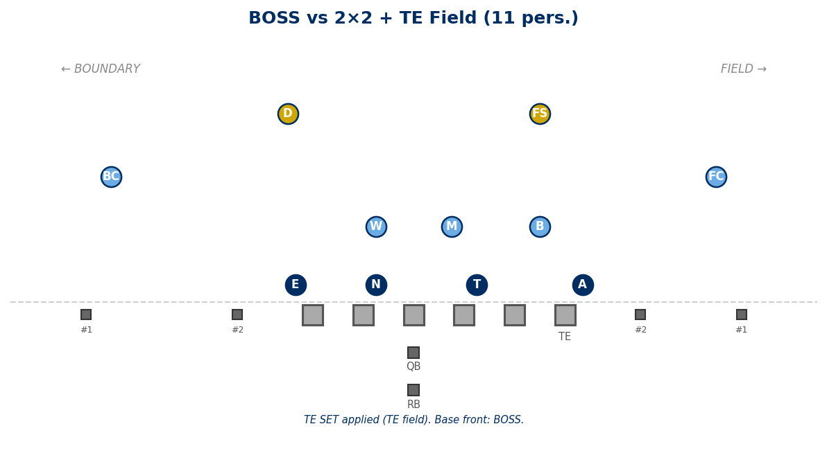

vs 2×2 + TE Boundary (11 pers.):
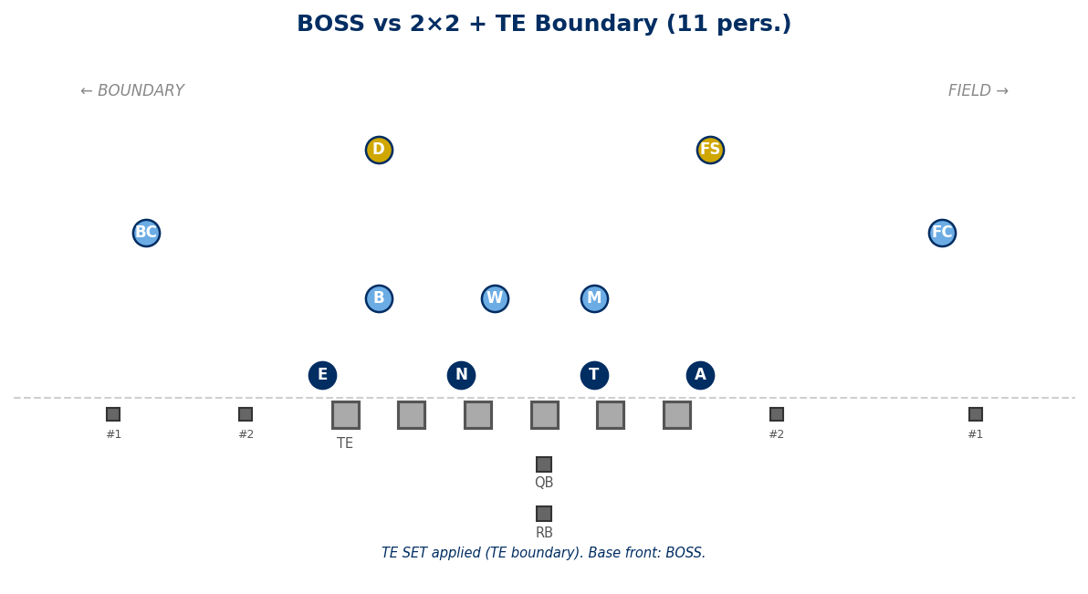

vs 21 Personnel (I-Form, TE Field):
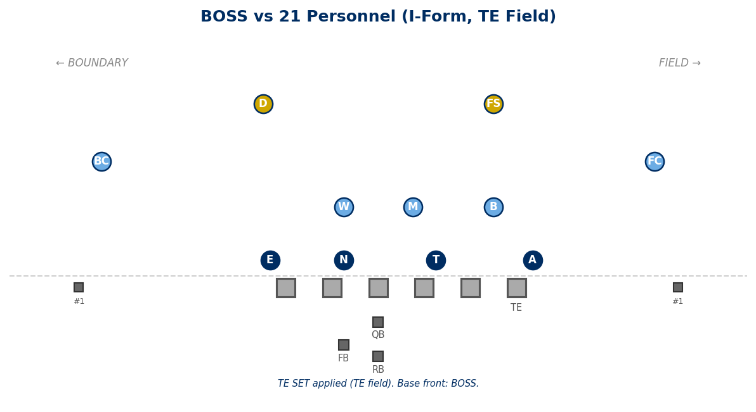

vs 22 Personnel (Heavy, 2 TE):
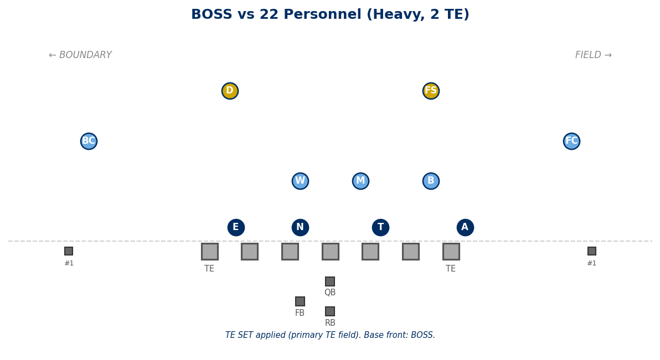

Legal Stunts on BOSS

Recommended Pairings
ANGLE:
T+N slant to boundary. Edges play normal.
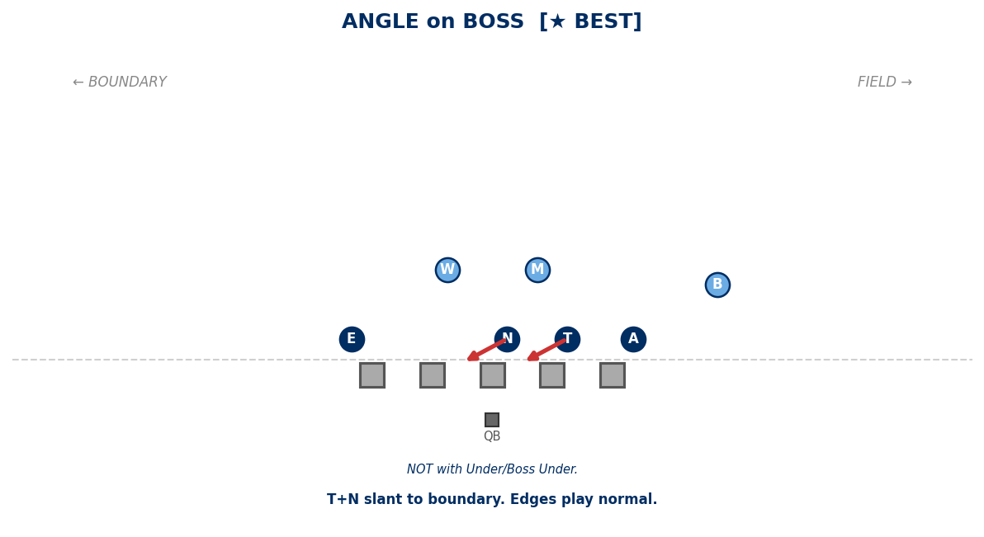

SPLIT (BOSS):
N (1-tech) crosses C face to opp A gap.
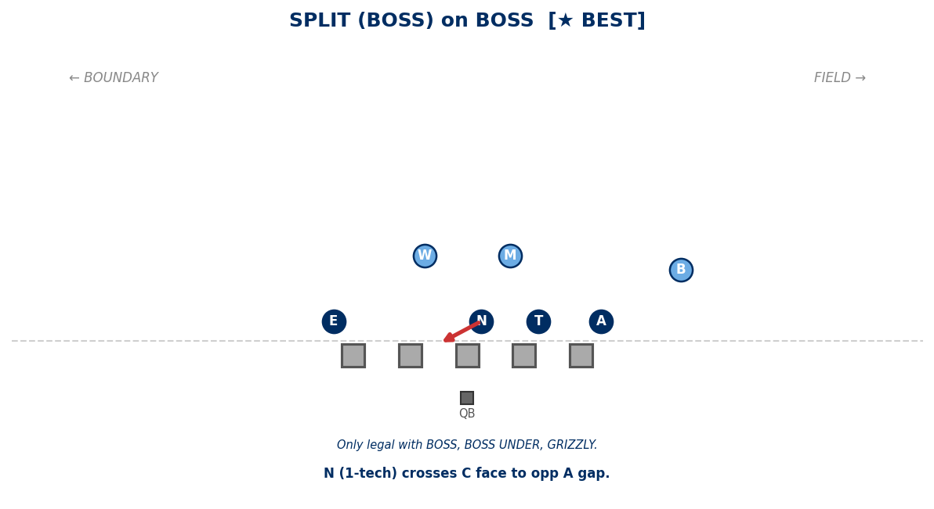

Legal Pairings
ANCHOR ATTACK:
A washes OL one gap inside.
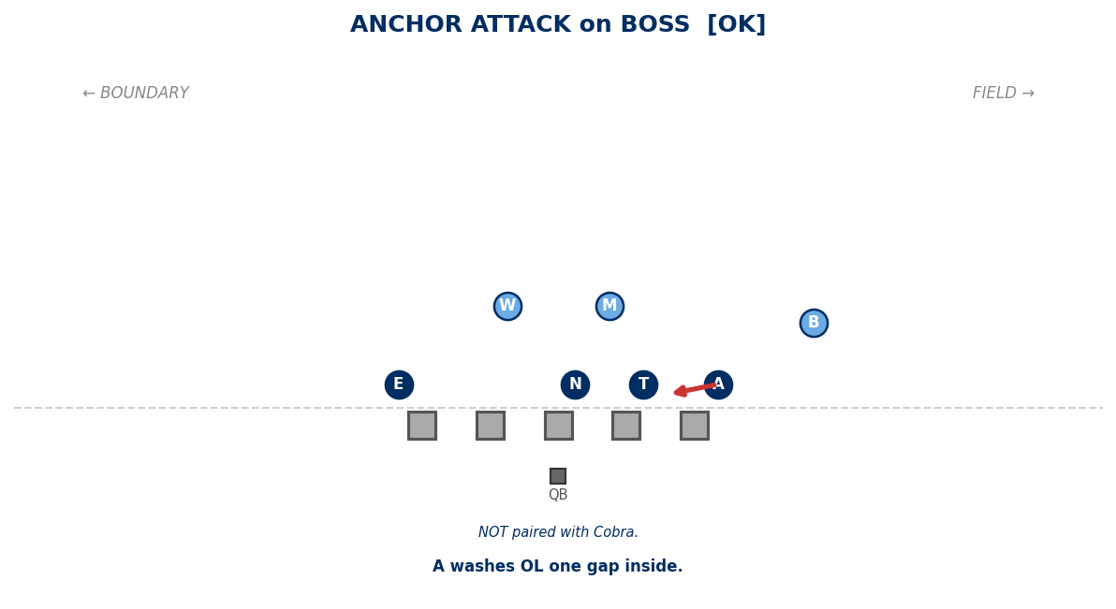

ANCHOR RAVEN:
A shoots B gap from 5-tech.
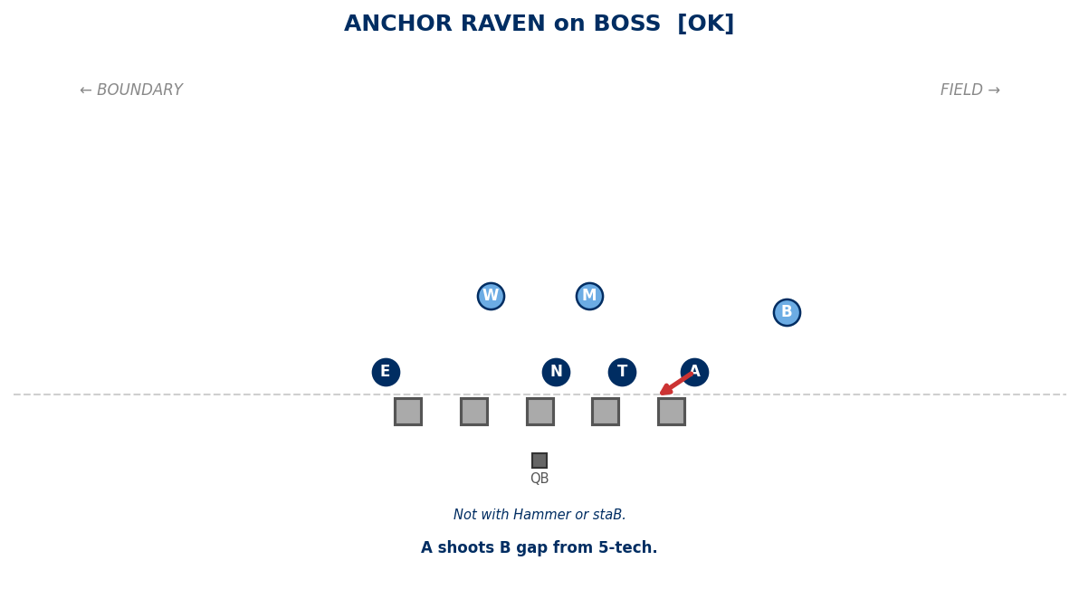

CRASH:
A+E shoot B gaps. T+N shoot A gaps.
B=field contain. W=bnd contain. M=free LB.
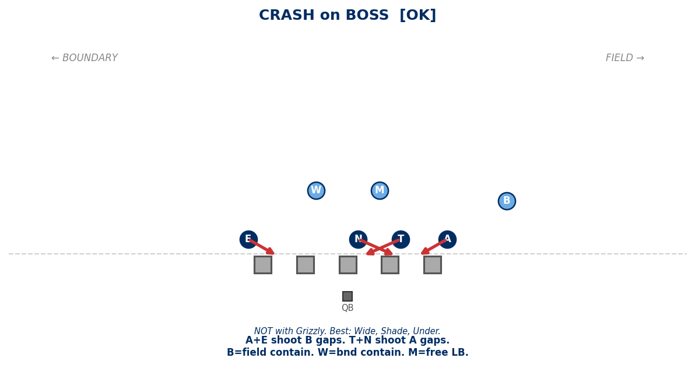

EDGE ATTACK:
E attacks OL one gap inside.
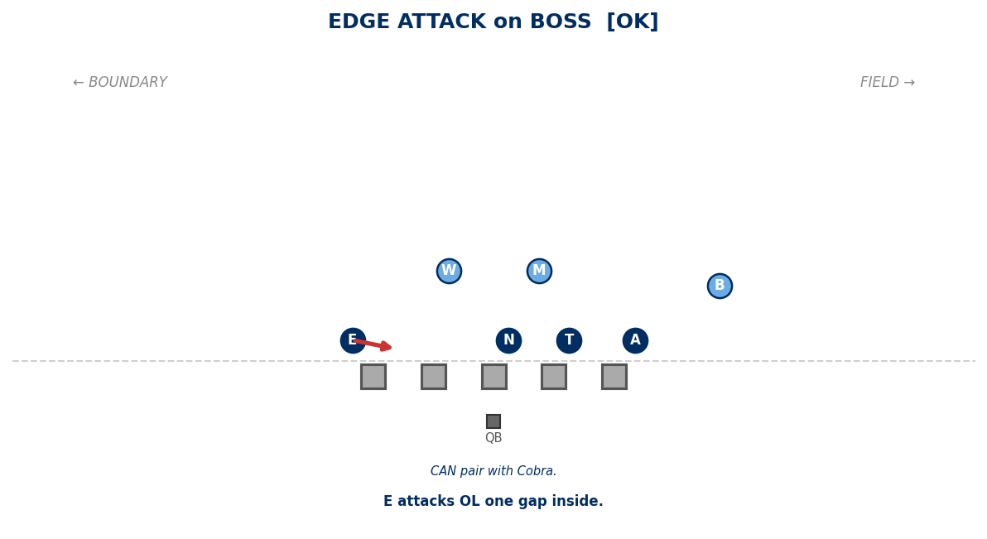

EDGE RAVEN:
E shoots B gap from 5-tech.
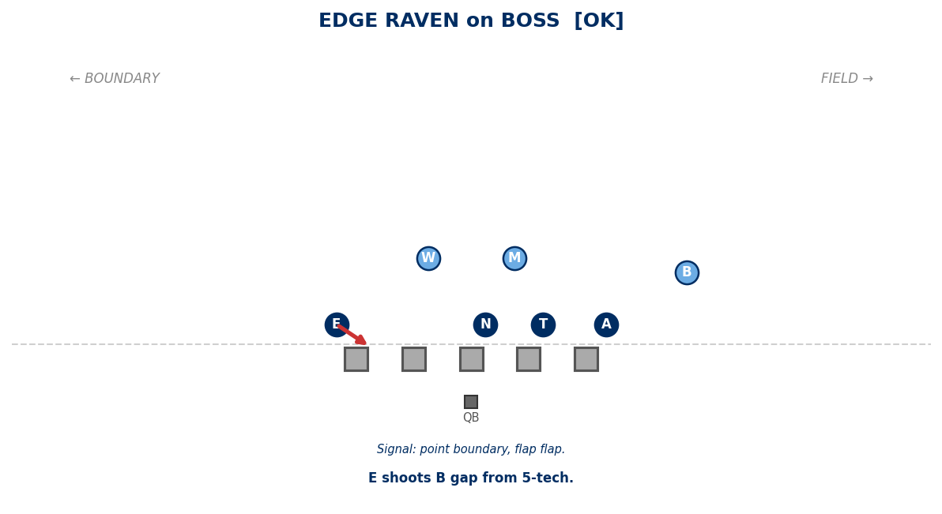

JACKS:
T+N shoot B gaps. A and E contain.
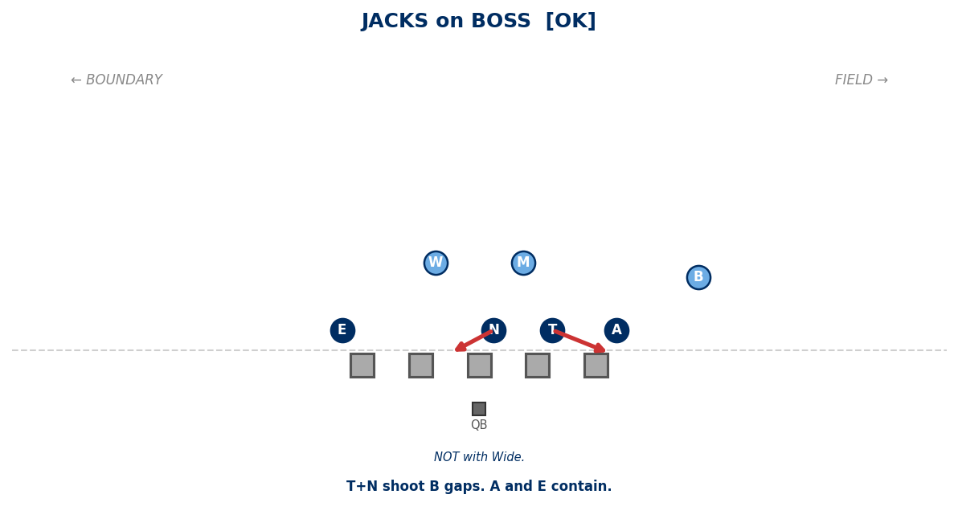

PINCH:
T+N pinch A gaps. A and E normal.
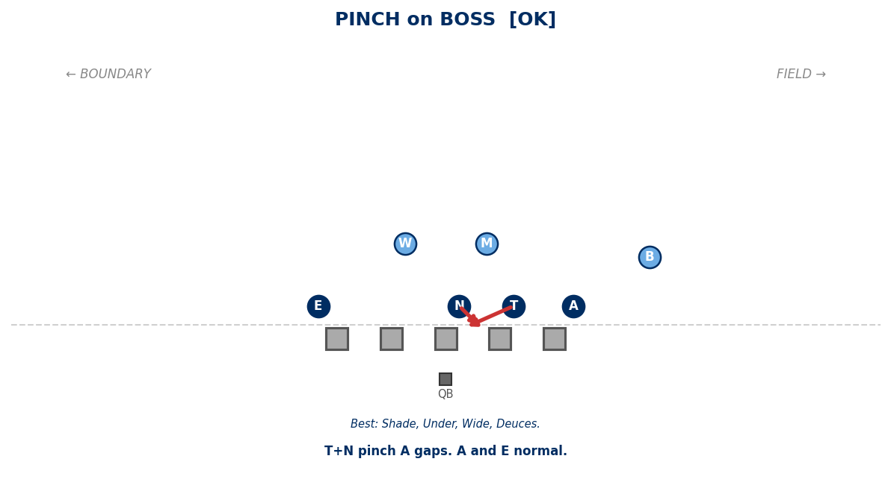

SLANT:
T+N slant to field. Edges play normal.
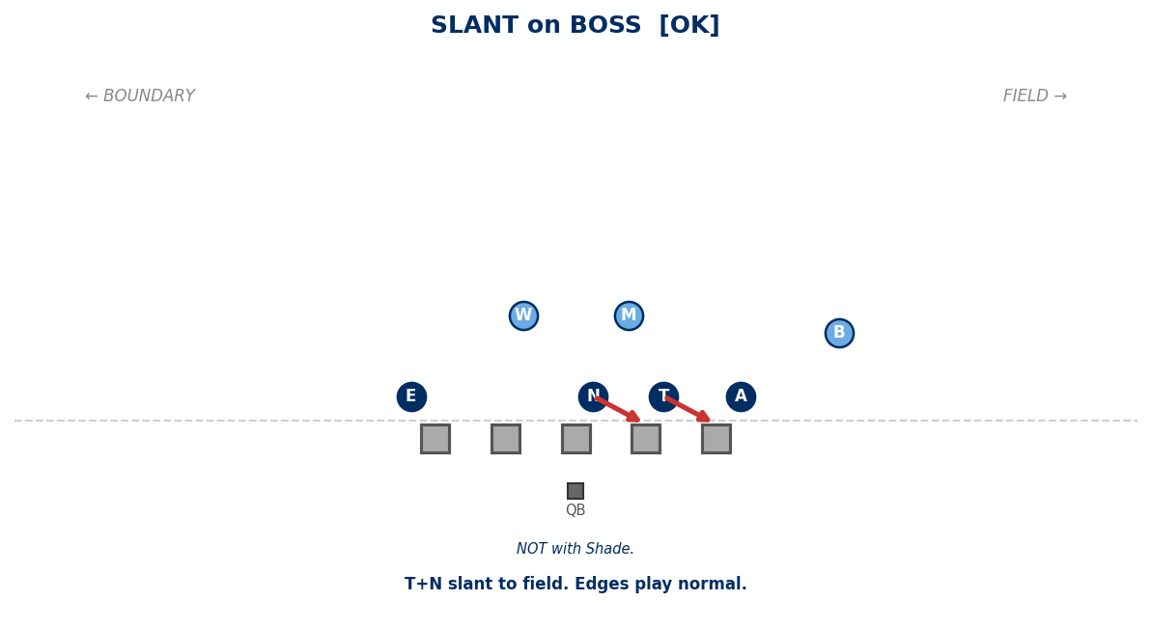

Generated: February 24, 2026 — 16 diagrams

