RIVER VALLEY VIKINGS
COVERAGES

2026 Season

CONFIDENTIAL — COACHING STAFF ONLY

COVERAGE DIAGRAMS
Dashed circles = post-snap destinations. Curved arrows = rotation. Straight arrows = drop.

NINJA (Cover 7)

NINJA vs 2×2 (MOD/CLAMP)
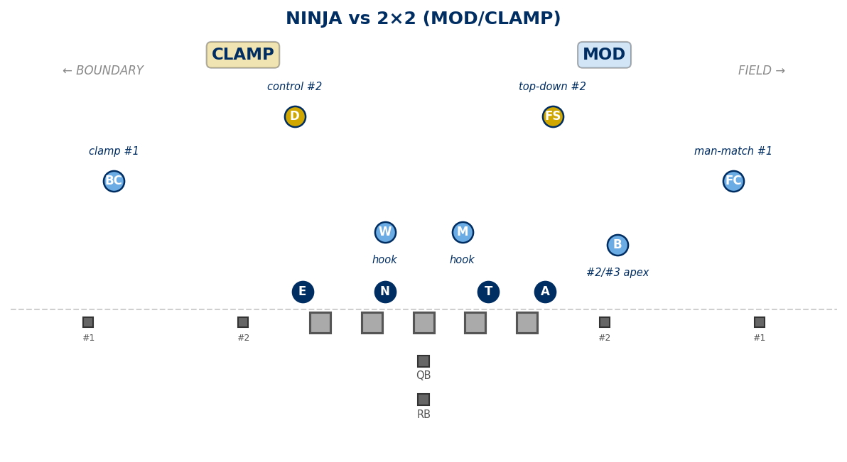

NINJA vs 3×1 (POACH)
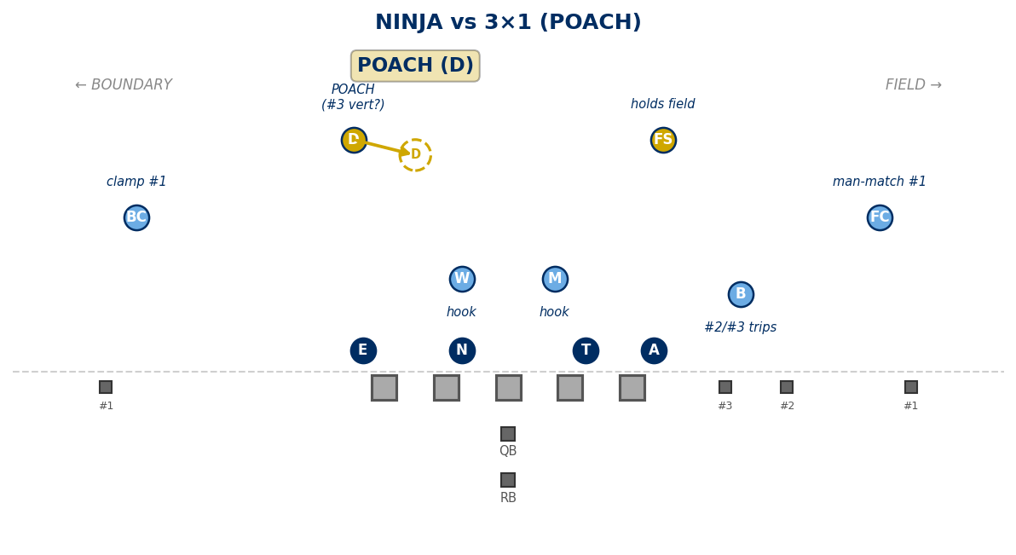

NINJA vs Empty 3×2
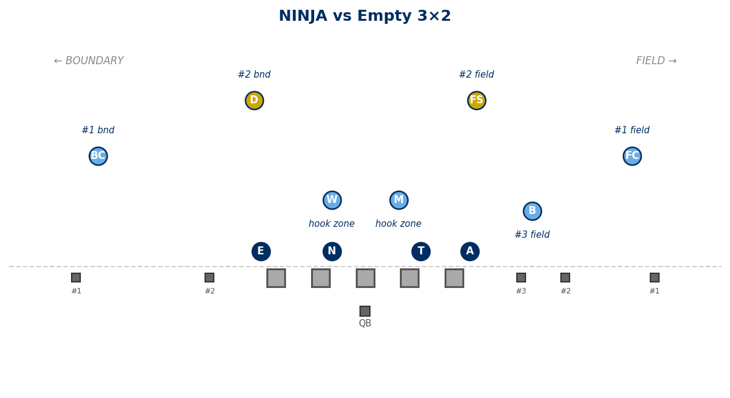

Cover 1 Family

OREGON (Cover 1, Post=FS)
FC/BC: man #1. RB funnel
vs 2×2 Spread (10 pers.):
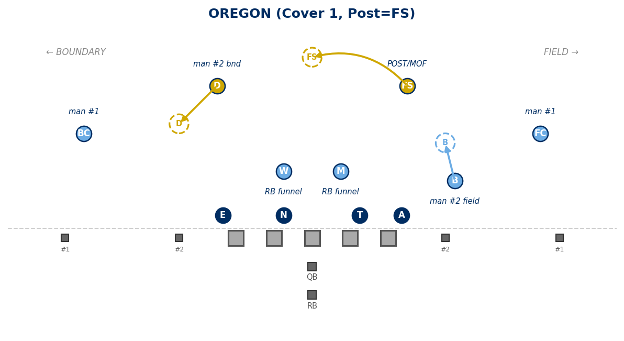
vs 3×1 Trips Field (10 pers.):
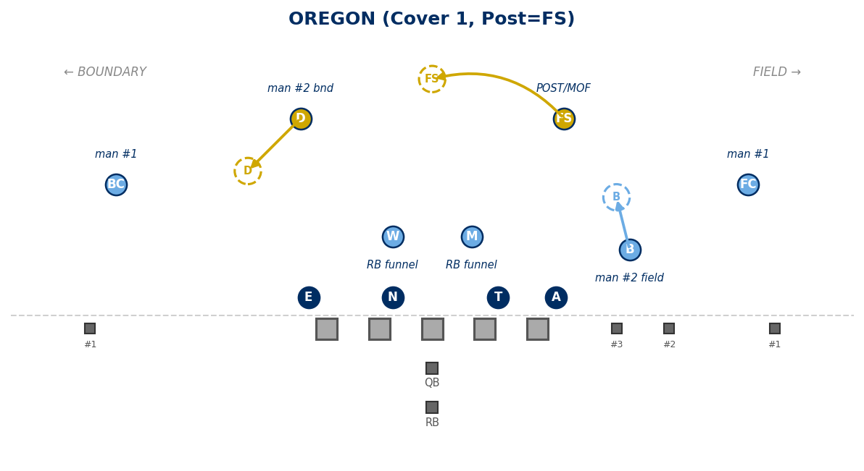

OKLAHOMA (Cover 1, Post=D)
FC/BC: man #1. RB funnel
vs 2×2 Spread (10 pers.):
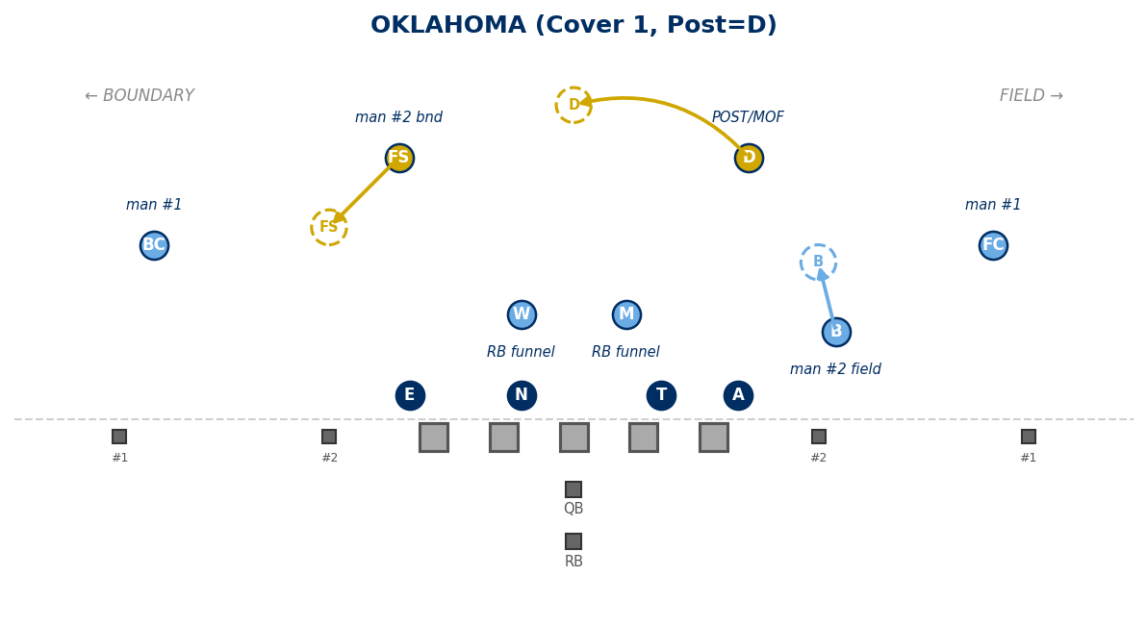
vs 3×1 Trips Field (10 pers.):
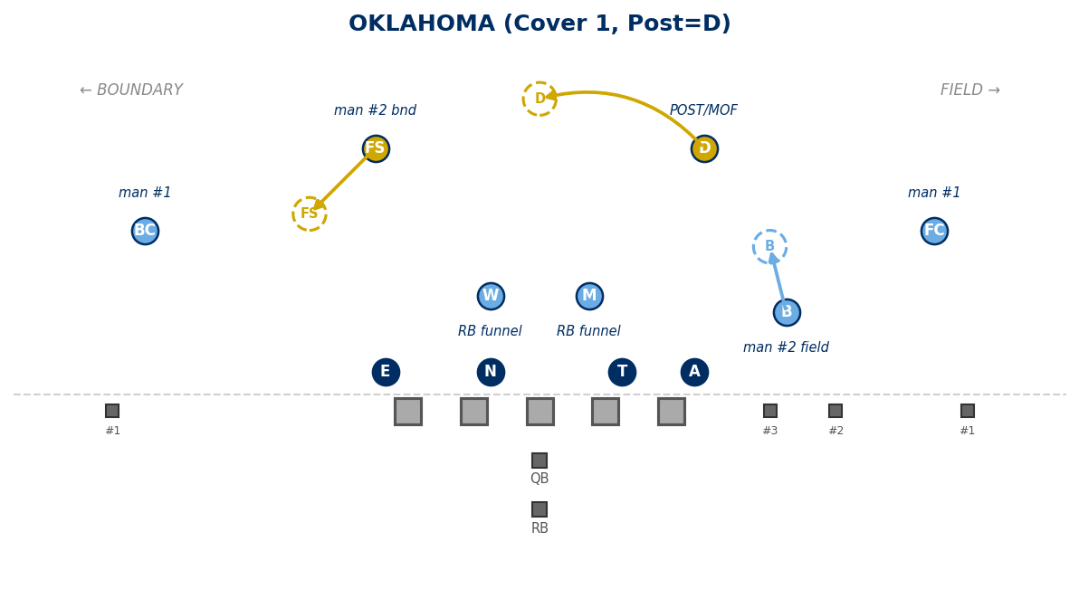

OHIO (Cover 1, Post=B) — EXCEPTION
FC/BC: man #1. RB funnel
vs 2×2 Spread (10 pers.):
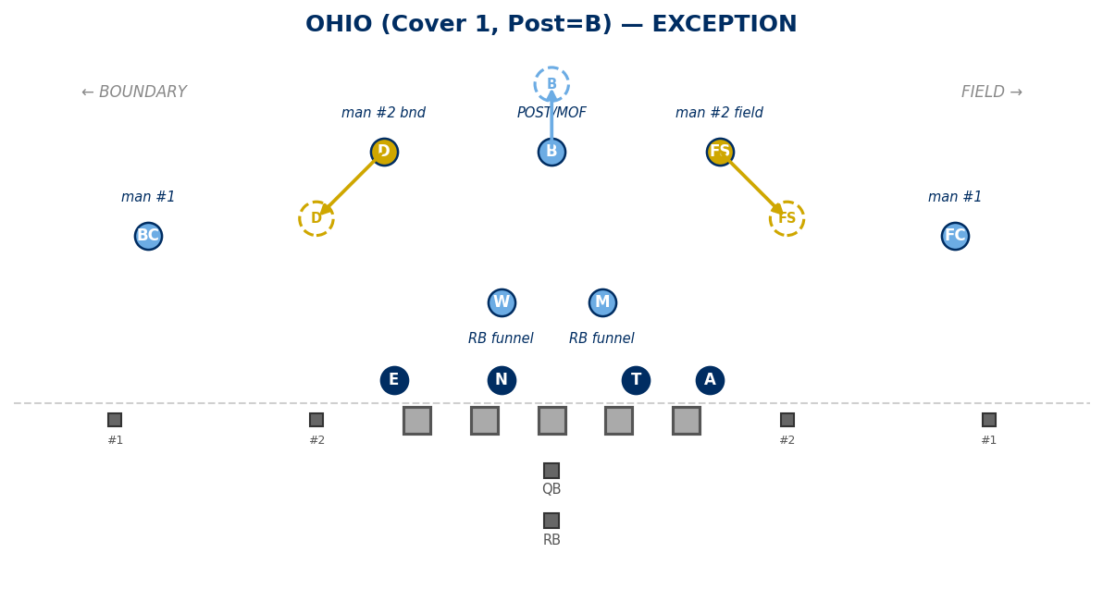
vs 3×1 Trips Field (10 pers.):
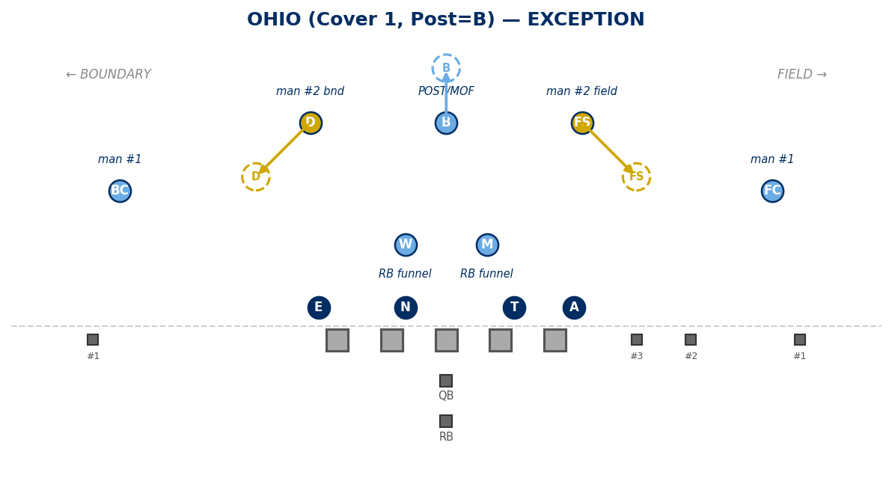

Cover 0 / Z-Family

ZEUS (Cover 0 — Run-First Pressure)
Cover 0 — No deep safety help.
vs 2×2 Spread (10 pers.):
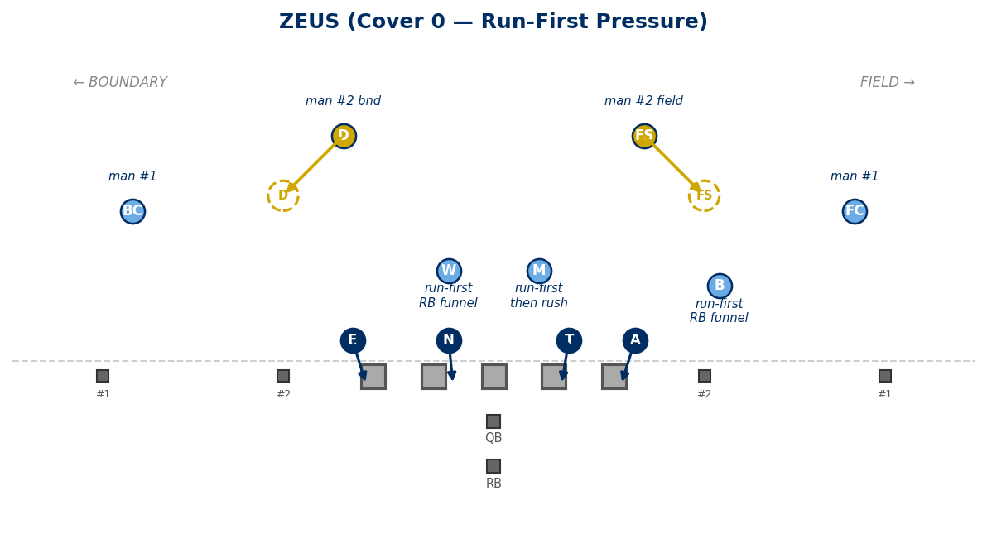
vs 3×1 Trips Field (10 pers.):
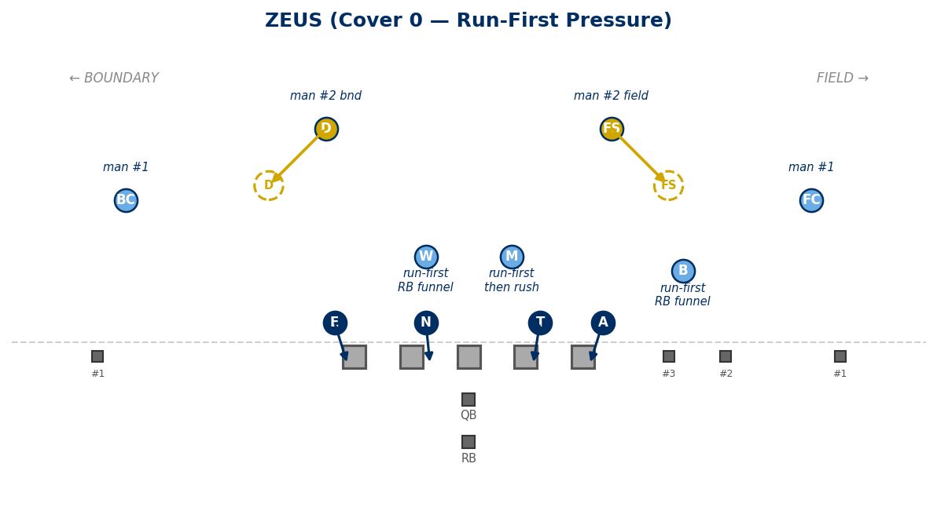

ZORRO (Cover 0) — EXCEPTION
Cover 0 — No deep safety help.
vs 2×2 Spread (10 pers.):
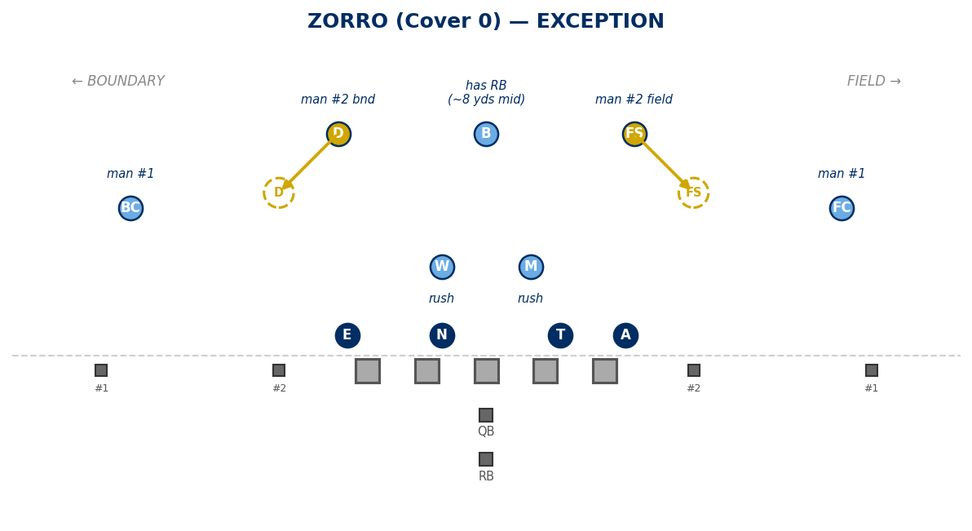

ZUNNEL (Cover 0)
Cover 0 — No deep safety help.
vs 2×2 Spread (10 pers.):
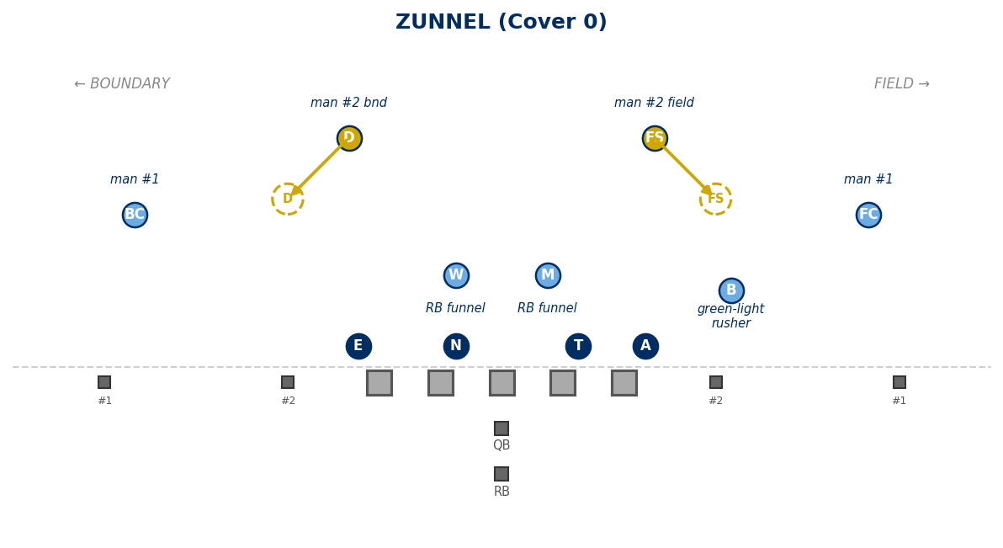

ZILL (Cover 0)
Cover 0 — No deep safety help.
vs 2×2 Spread (10 pers.):
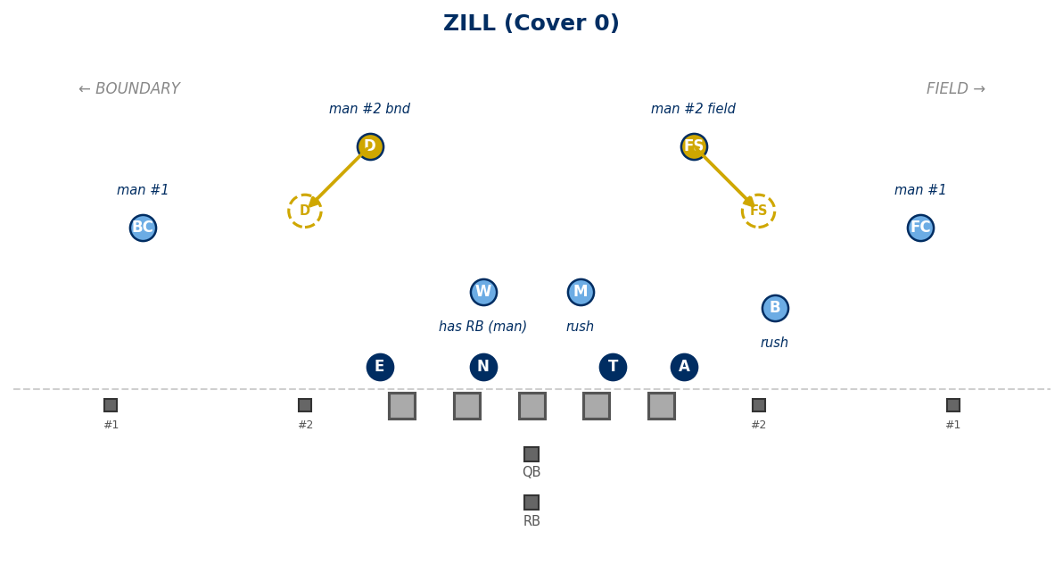

ZIKE (Cover 0)
Cover 0 — No deep safety help.
vs 2×2 Spread (10 pers.):
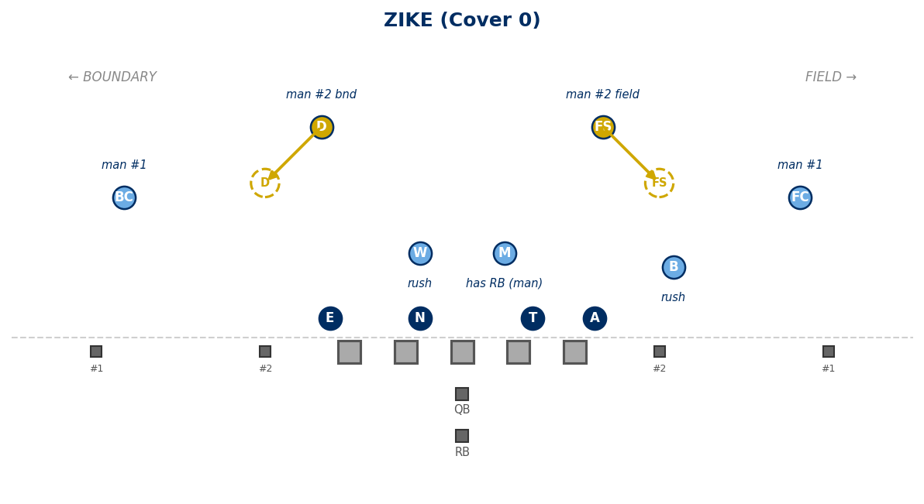

VIKING (Cover 3)

VIKING (Cover 3 — Spot Drop)
Deep 3: FC=1/3 field, FS=1/3 middle, BC=1/3 boundary. Under: B=curl/flat, D=seam-curl-flat, M=hook, W=hook.
vs 2×2 Spread (10 pers.):
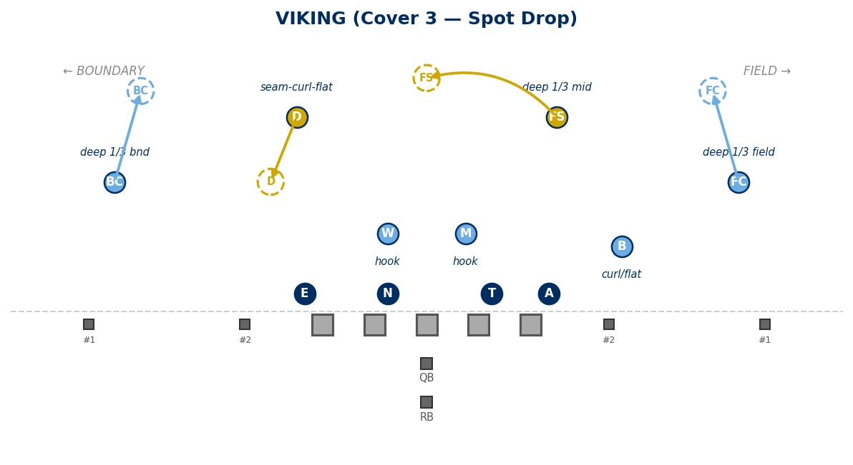
vs 3×1 Trips Field (10 pers.):
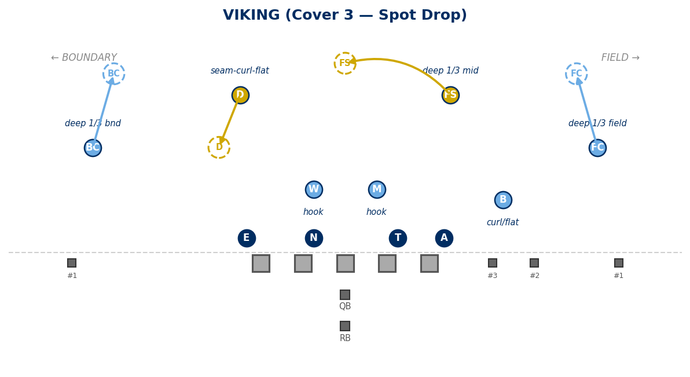

Generated: February 24, 2026 — 17 diagrams

