RIVER VALLEY VIKINGS
GRIZZLY FRONT

2026 Season

CONFIDENTIAL — COACHING STAFF ONLY

GRIZZLY
A=4i, T=2i, N=2i, E=4i. B/W=OLBs. M at LB depth (10-tech). Vs power/counter, red zone, short yardage. TE SET does NOT override.

Alignments vs Offensive Formations
vs 2×2 Spread (10 pers.):
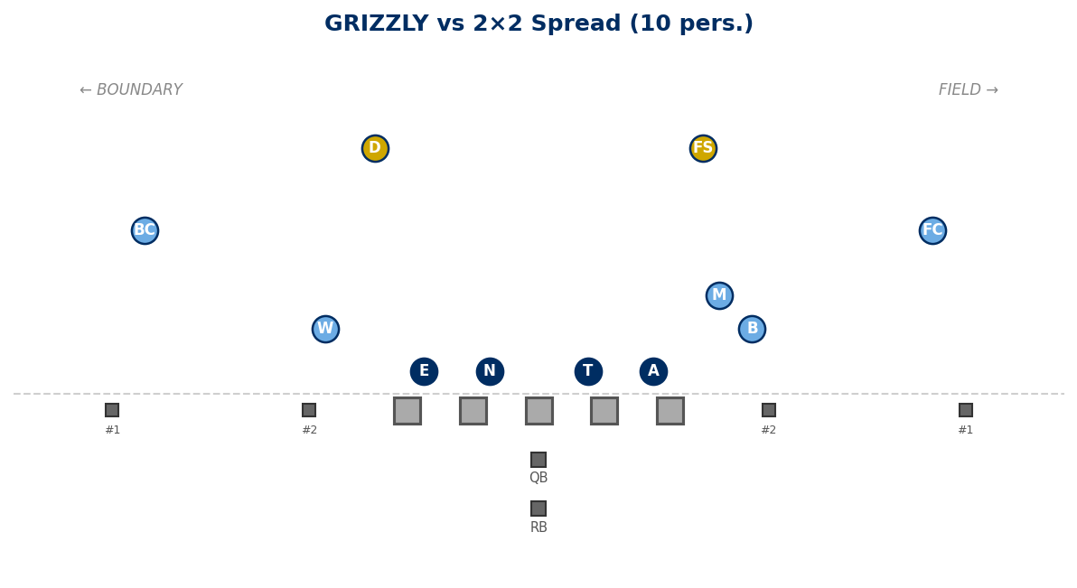

vs 3×1 Trips Field (10 pers.):
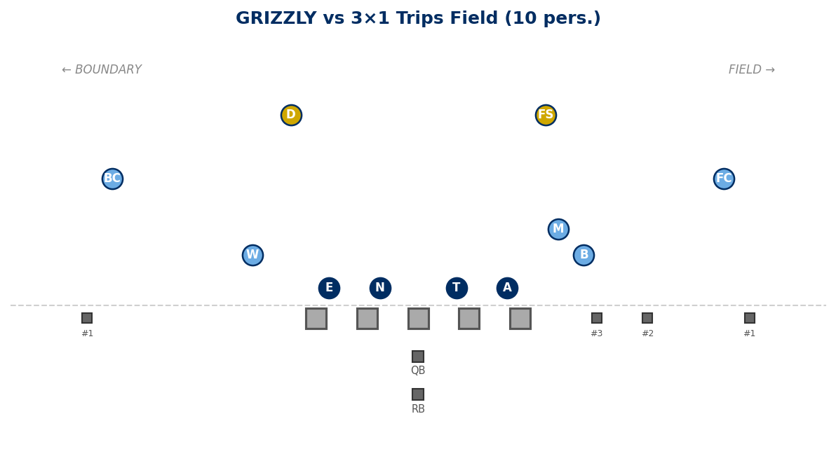

vs 21 Personnel (I-Form, TE Field):
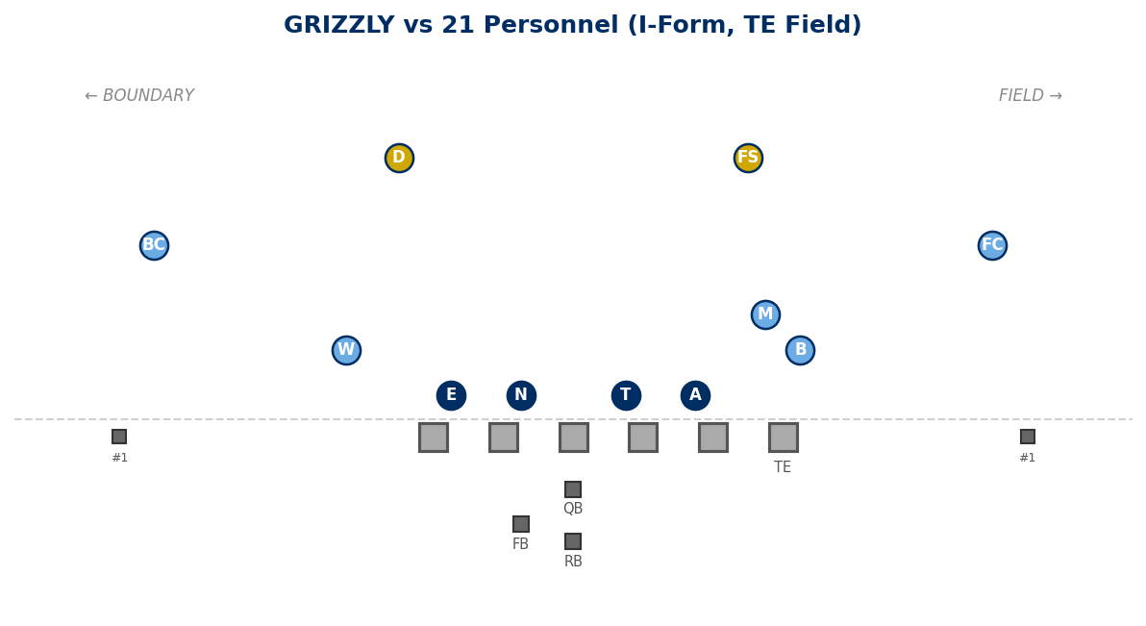

vs 22 Personnel (Heavy, 2 TE):
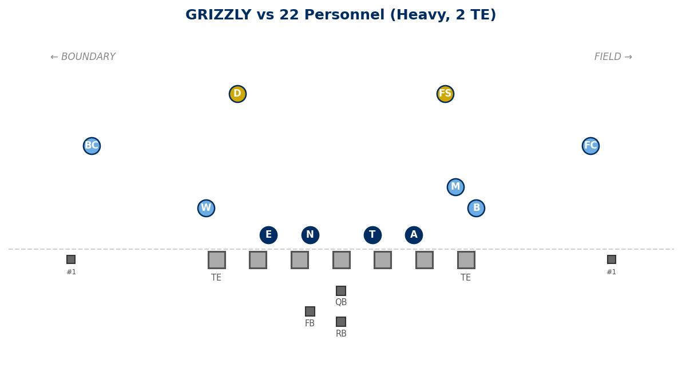

vs 2×2 + TE Field (11 pers.):
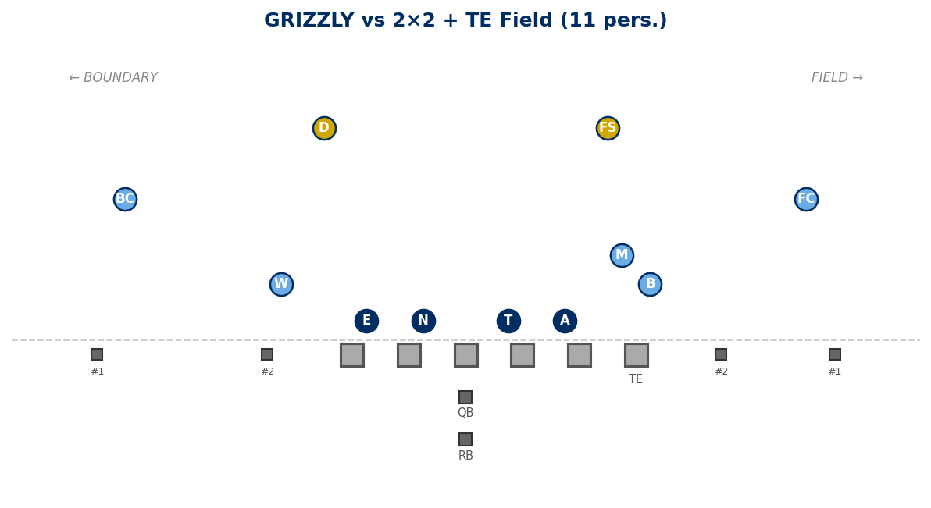

Legal Stunts on GRIZZLY

Recommended Pairings
SPLIT (BOSS):
N (1-tech) crosses C face to opp A gap.
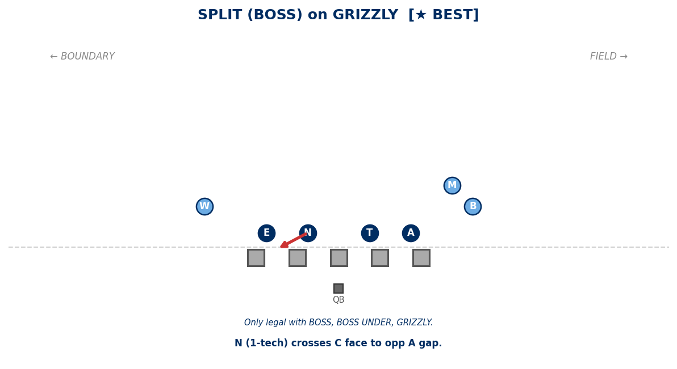

Legal Pairings
ANCHOR ATTACK:
A washes OL one gap inside.
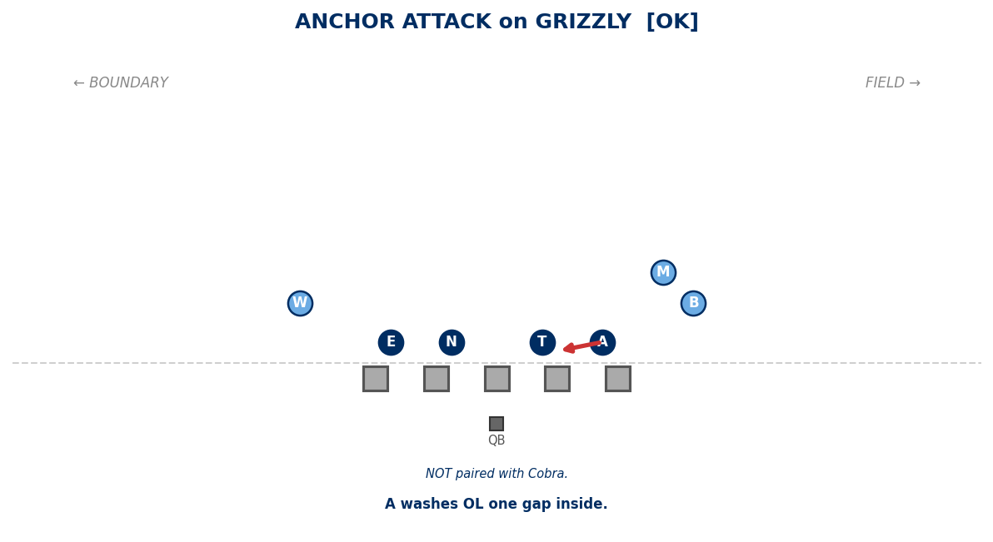

ANCHOR RAVEN:
A shoots B gap from 5-tech.
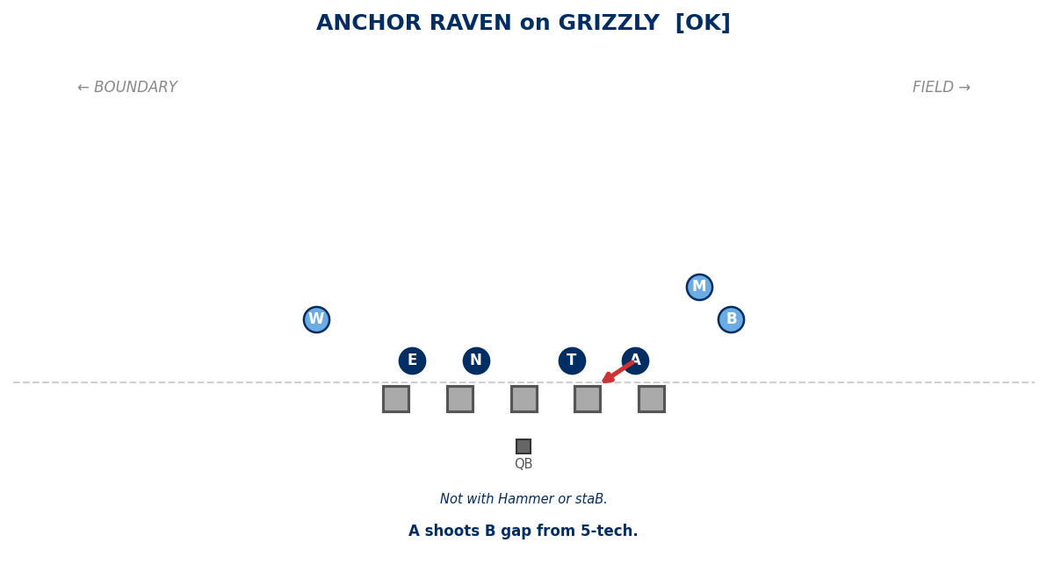

ANGLE:
T+N slant to boundary. Edges play normal.
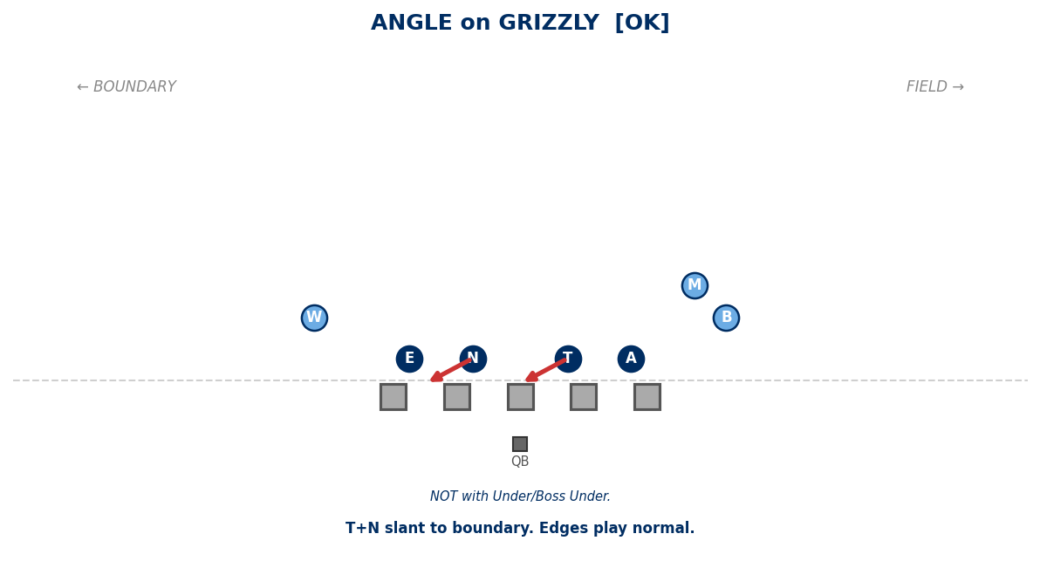

EDGE ATTACK:
E attacks OL one gap inside.
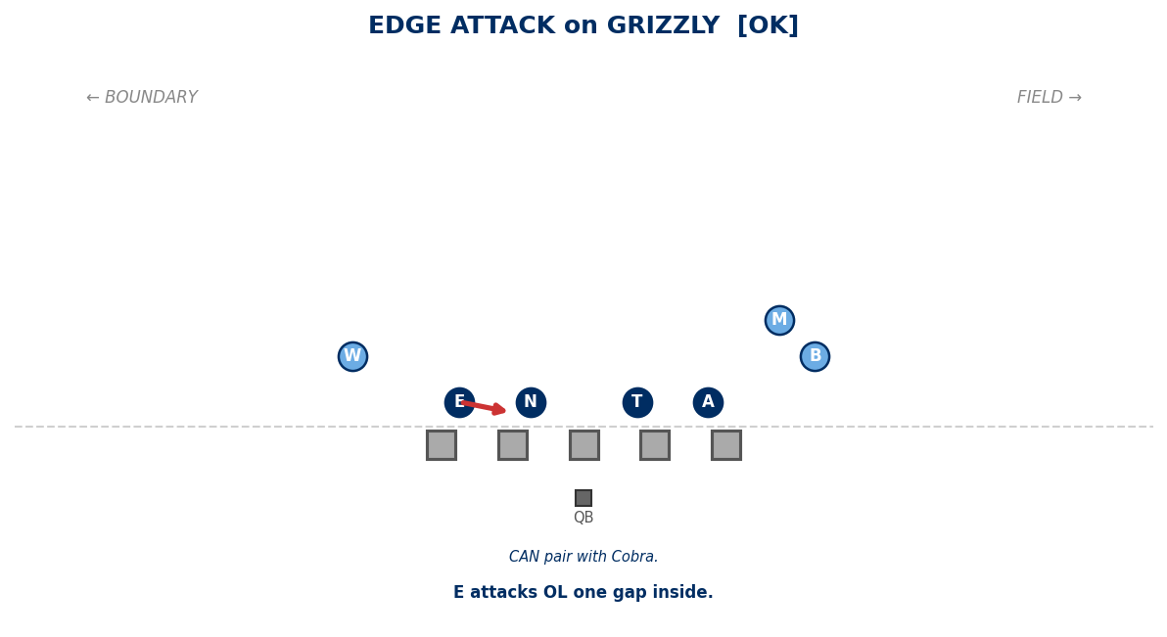

EDGE RAVEN:
E shoots B gap from 5-tech.
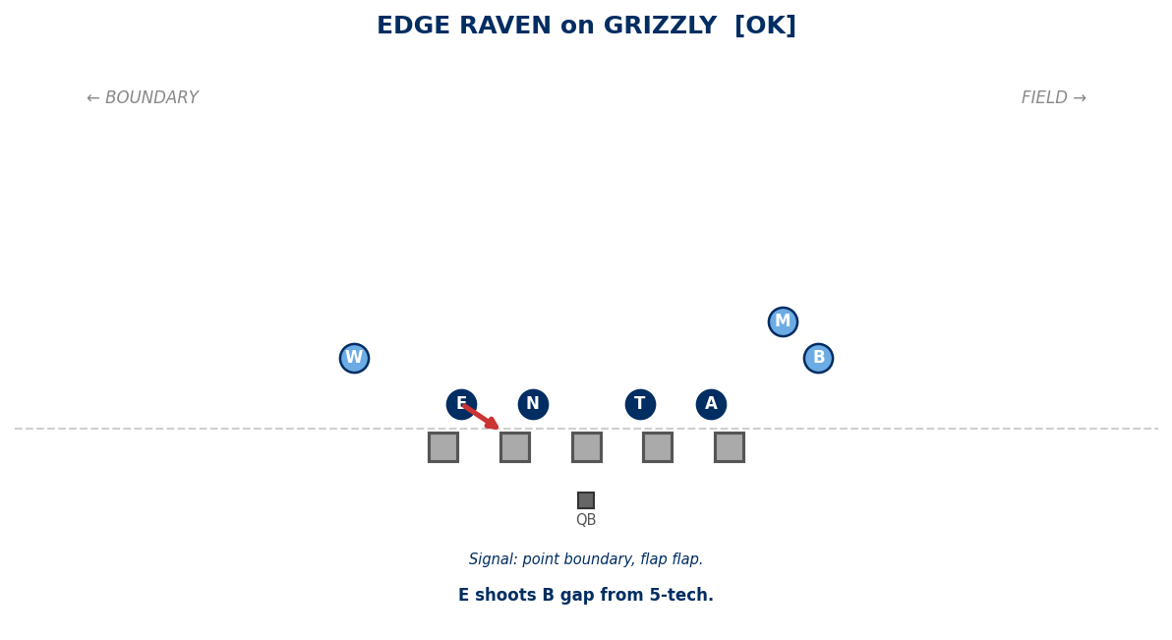

JACKS:
T+N shoot B gaps. A and E contain.
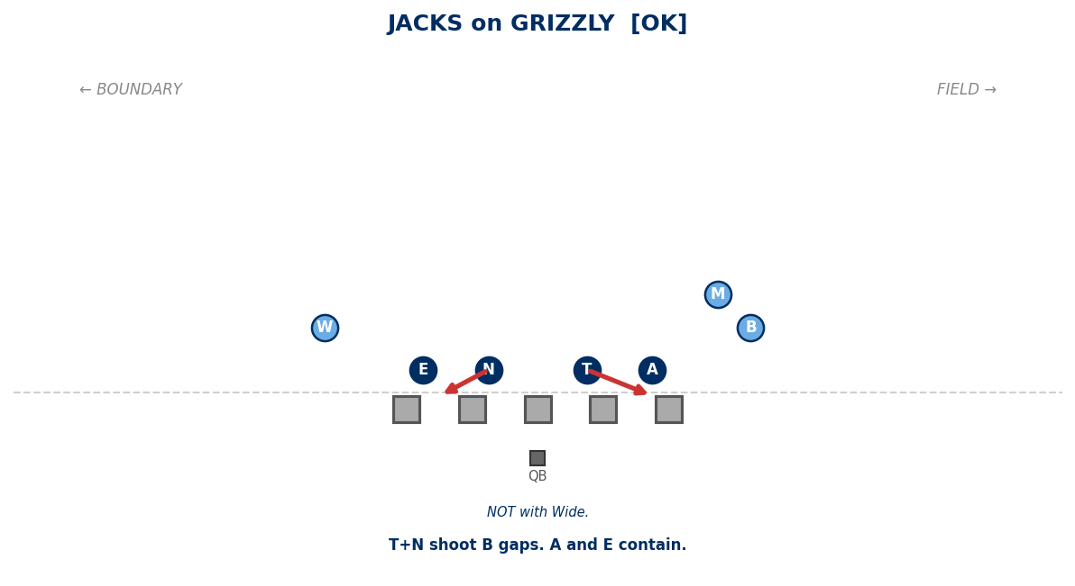

PINCH:
T+N pinch A gaps. A and E normal.
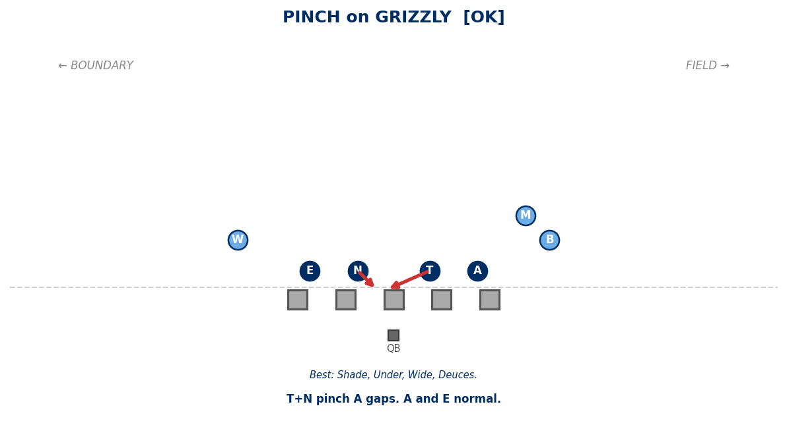

SLANT:
T+N slant to field. Edges play normal.
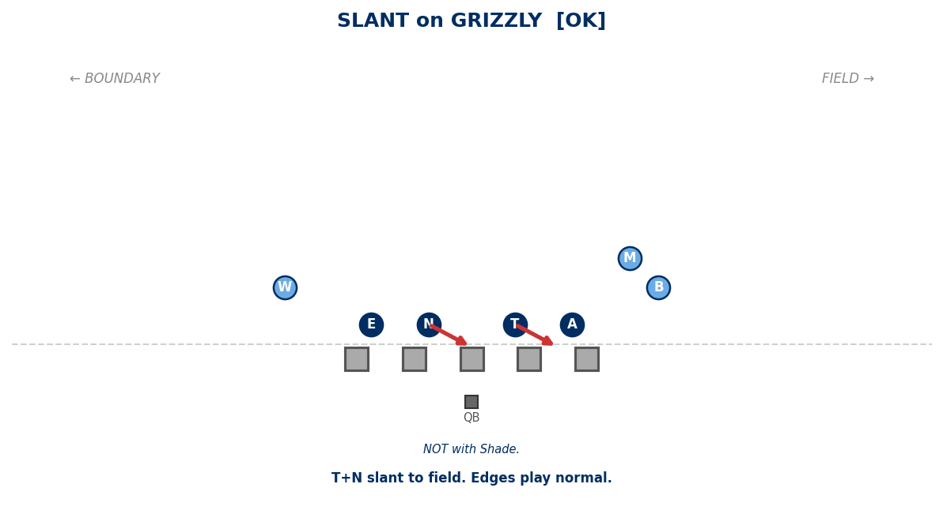

Generated: February 24, 2026 — 14 diagrams

