RIVER VALLEY VIKINGS
JET FRONT

2026 Season

CONFIDENTIAL — COACHING STAFF ONLY

JET
3-down: A=5, T=0, N=5. T is 2-gapping. A/N contain (C-gap edges).

Alignments vs Offensive Formations
vs 2×2 Spread (10 pers.):
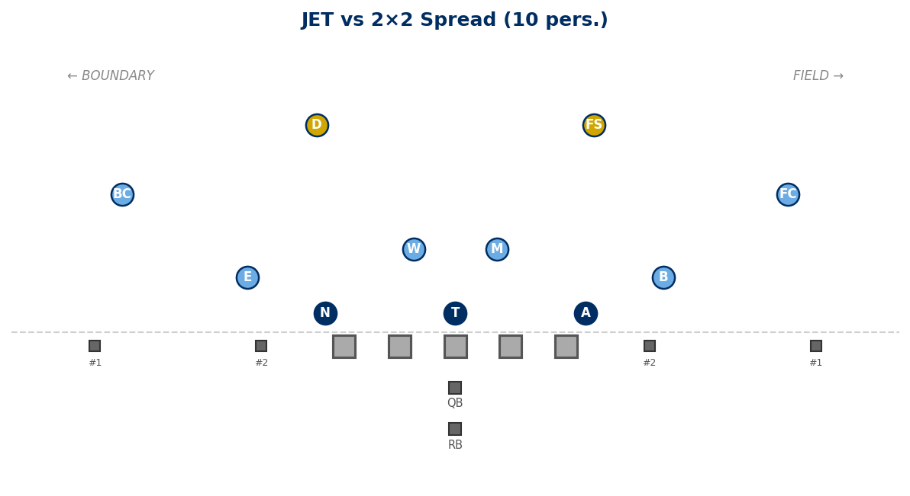

vs 3×1 Trips Field (10 pers.):
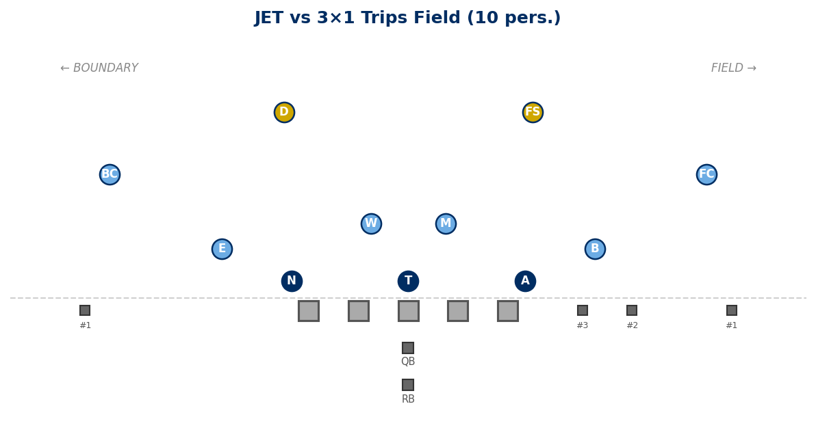

vs Empty 3×2 (10 pers.):
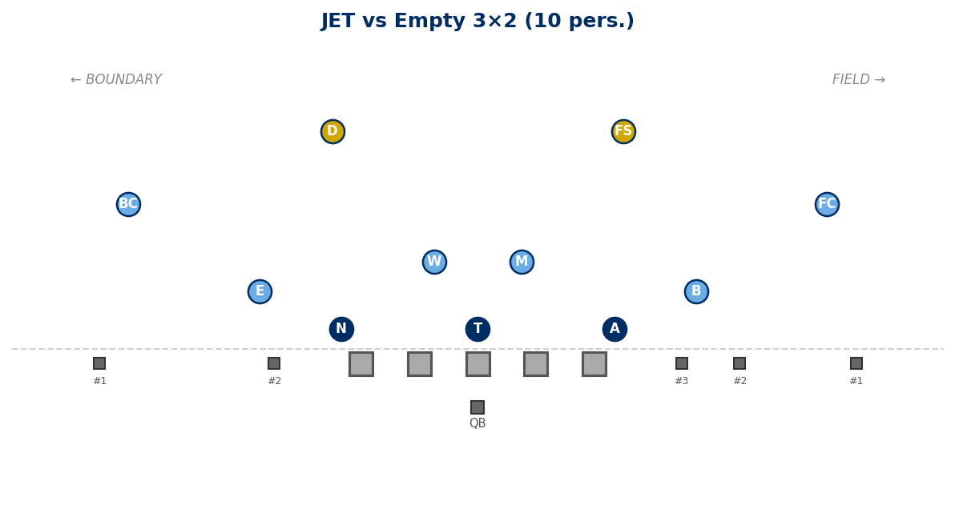

Generated: February 24, 2026 — 3 diagrams

