RIVER VALLEY VIKINGS
MINT FRONT

2026 Season

CONFIDENTIAL — COACHING STAFF ONLY

MINT
3-down: A=4i, T=0, N=4i. B/E=OLBs. Man contain=B; NINJA/VIKING=M is QB contain.

Alignments vs Offensive Formations
vs 2×2 Spread (10 pers.):
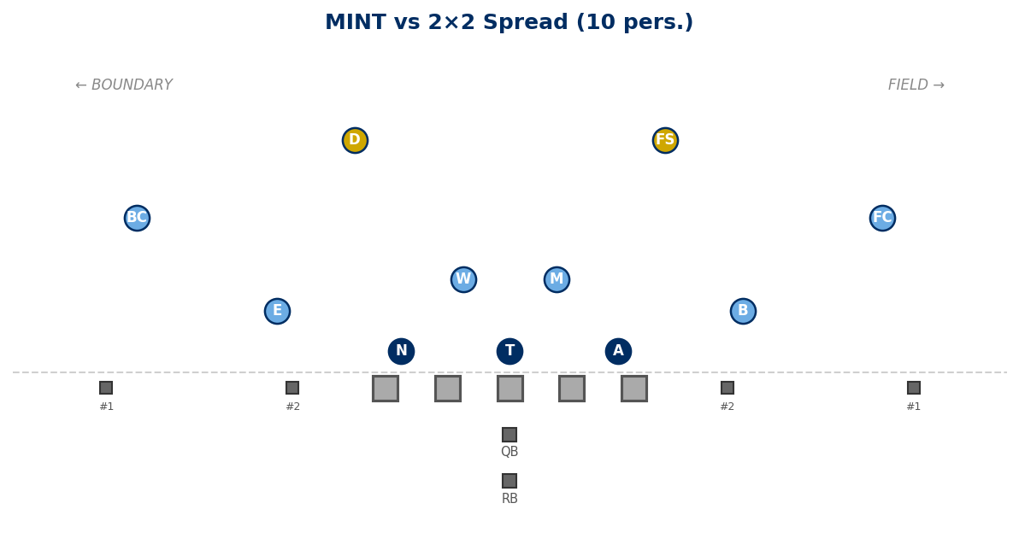

vs 3×1 Trips Field (10 pers.):
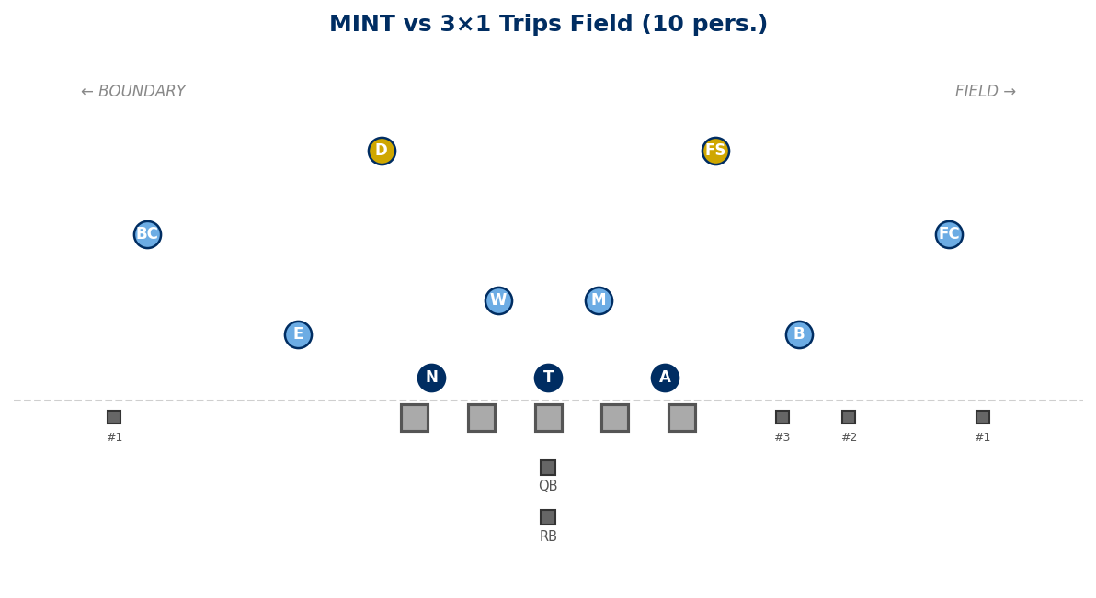

vs Empty 3×2 (10 pers.):
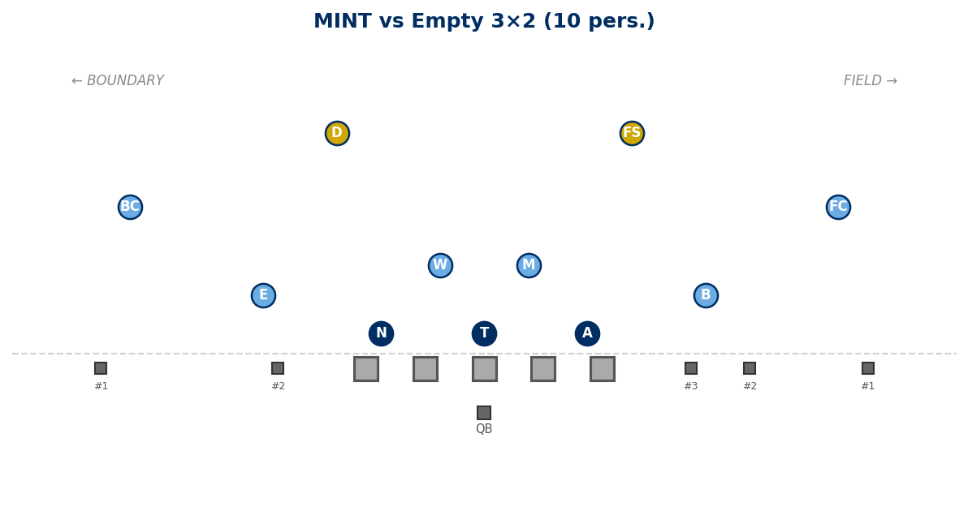

Generated: February 24, 2026 — 3 diagrams

