RIVER VALLEY VIKINGS
PRESSURES & BLITZES

2026 Season

CONFIDENTIAL — COACHING STAFF ONLY

PRESSURE / BLITZ DIAGRAMS
Light blue arrows = LB/DB blitzers. Red arrows = DL stunt movement (packaged pressures only).

Weekly Pressures (Locked Friday Menu)

Mike
M blitzes his gap.
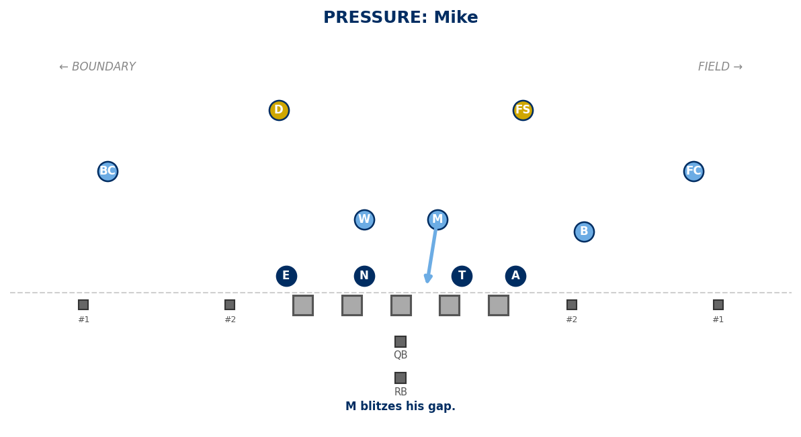

Will
W blitzes his gap.
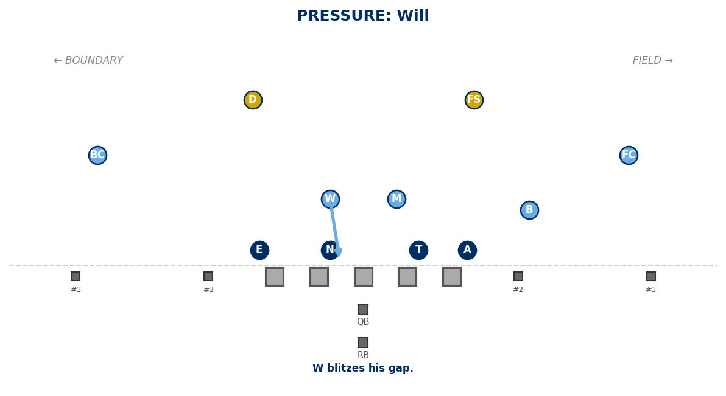

Bandit
B blitzes his gap (field edge).
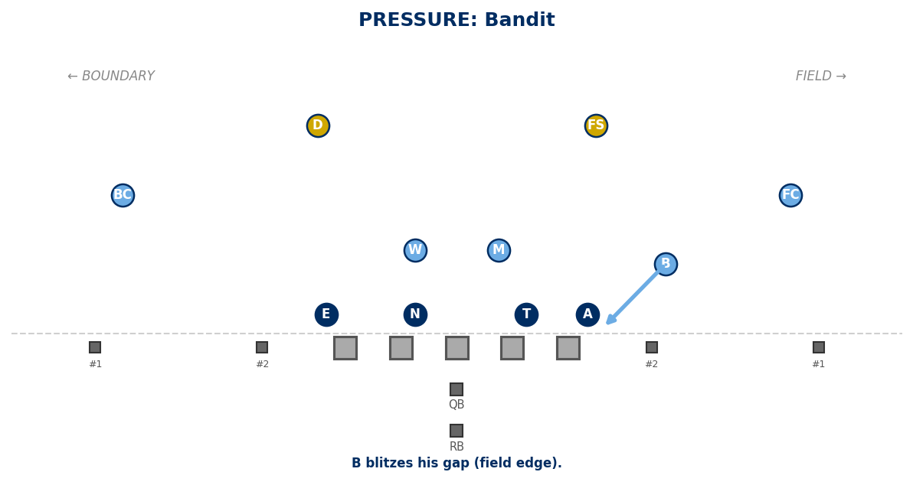

sWarM
M + W blitz their gaps.
Note: NOT legal with Cover 1.
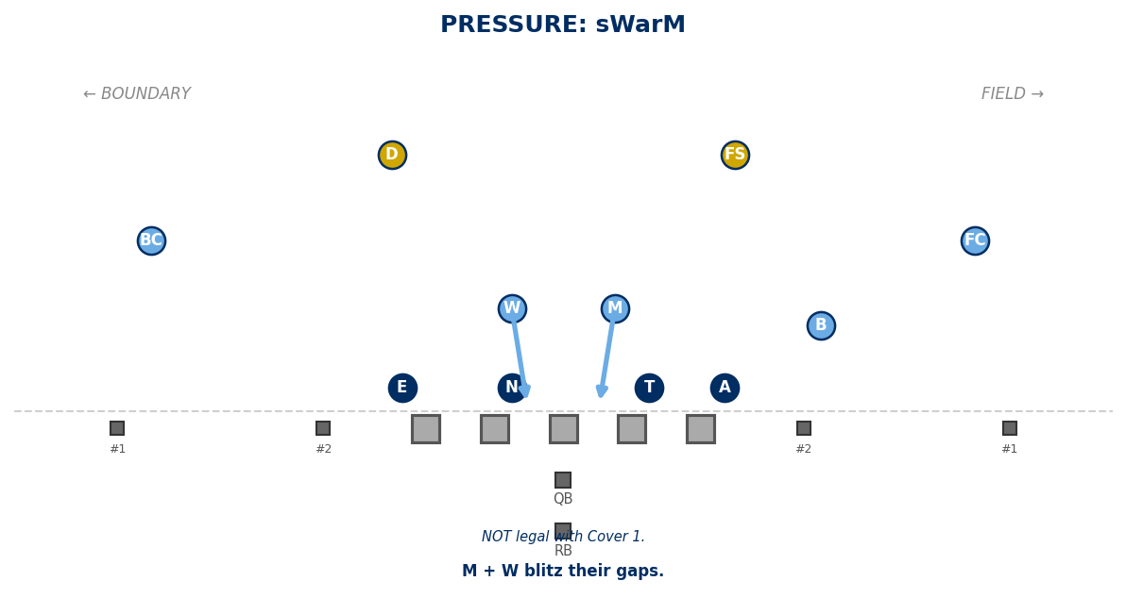

BooM
B + M blitz.
Note: Cover 1: W takes RB solo.
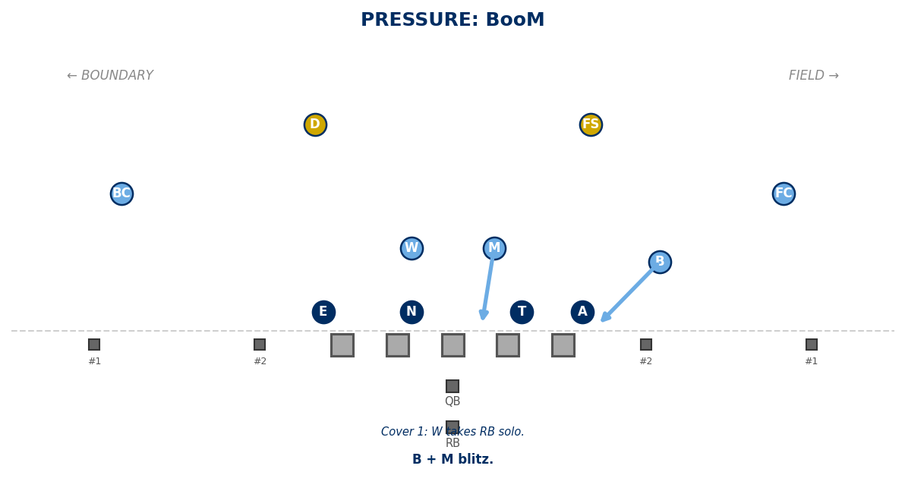

BoW
B + W blitz.
Note: Cover 1: M takes RB solo.
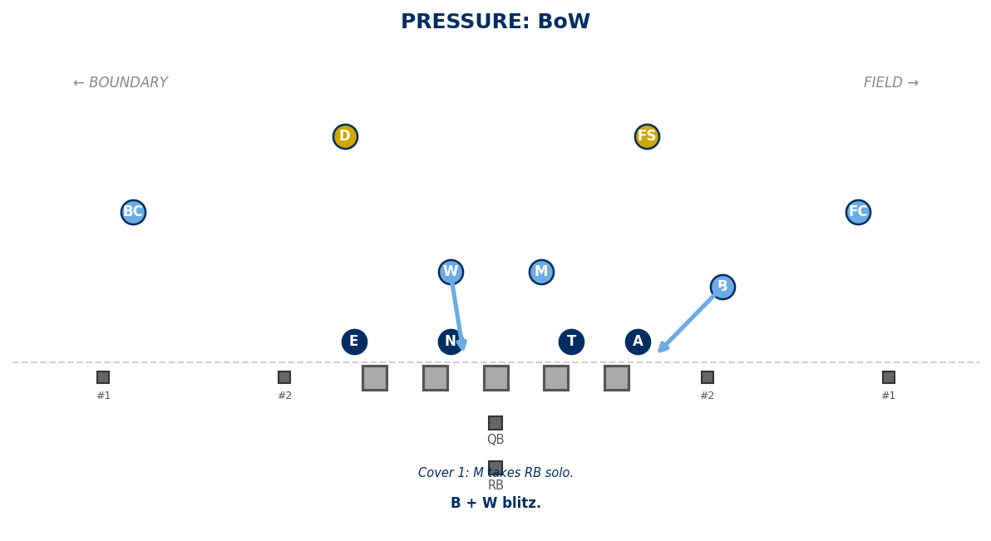

Hammer
B edge blitz + Anchor Attack (A washes inside).
Note: Packaged pressure (married to Anchor Attack).
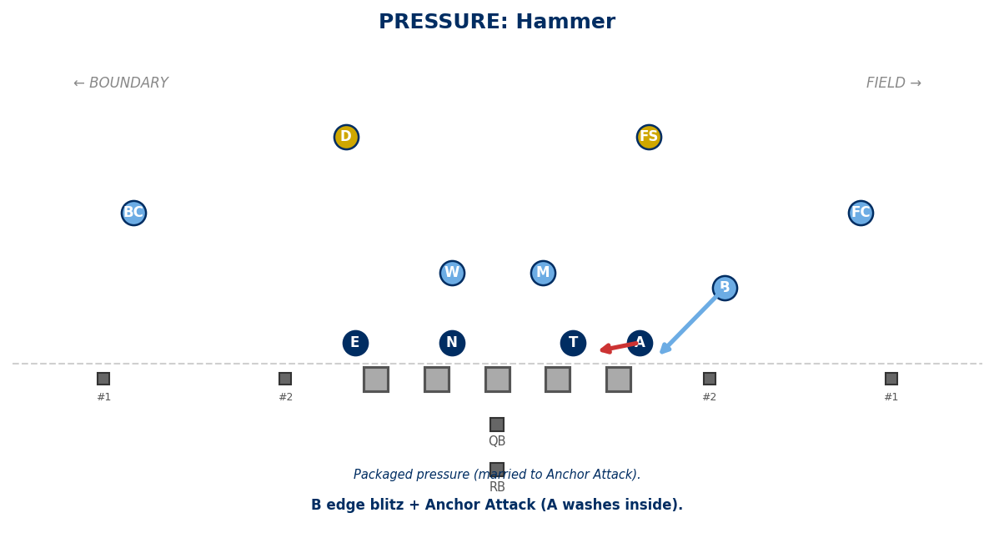

Eat
M + W + B blitz (all underneath).
Note: Cover 0 ONLY. RB unaccounted.
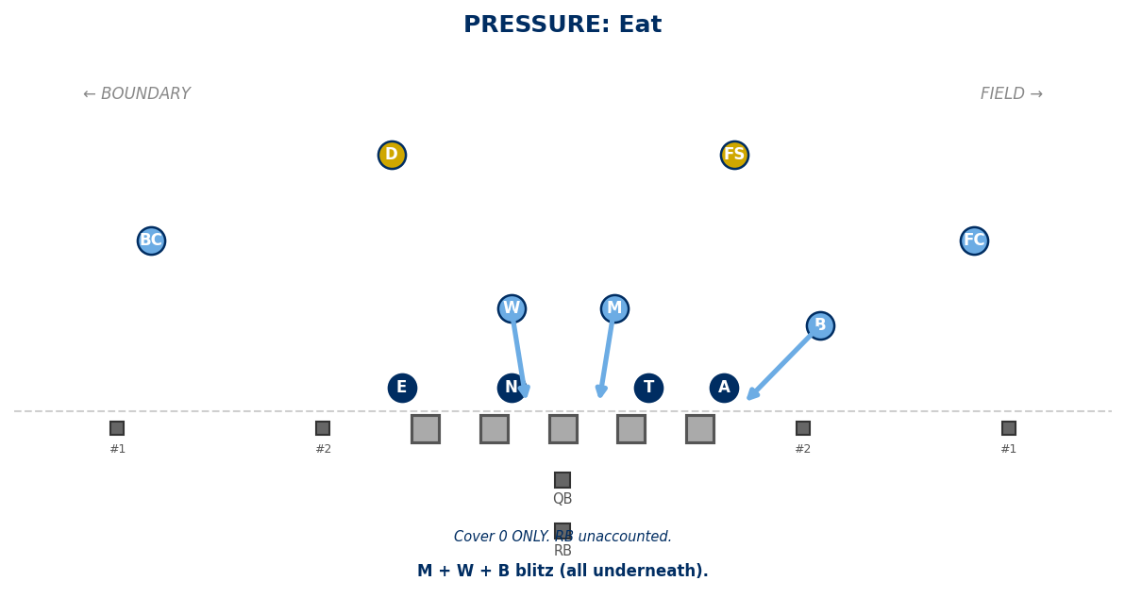

Game-Plan Specials

Dawg
D blitzes his gap (boundary).
Note: Game-plan special.
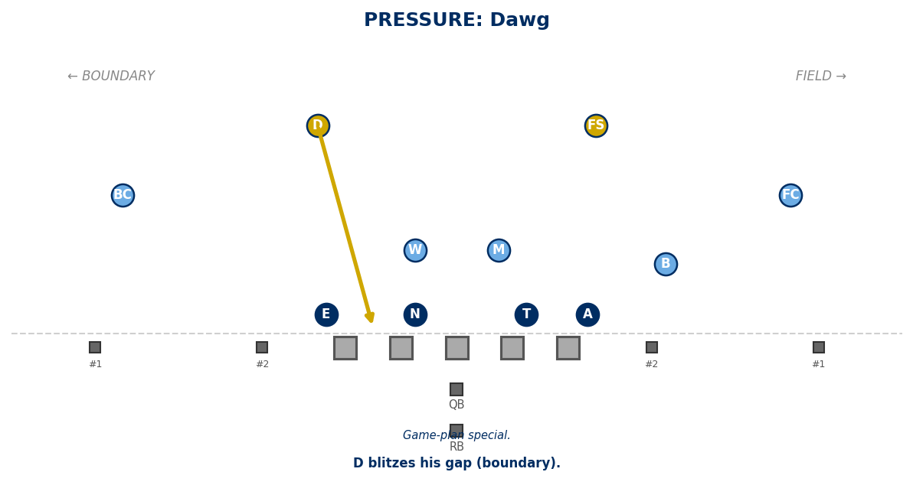

MaD
M + D blitz.
Note: Game-plan special.
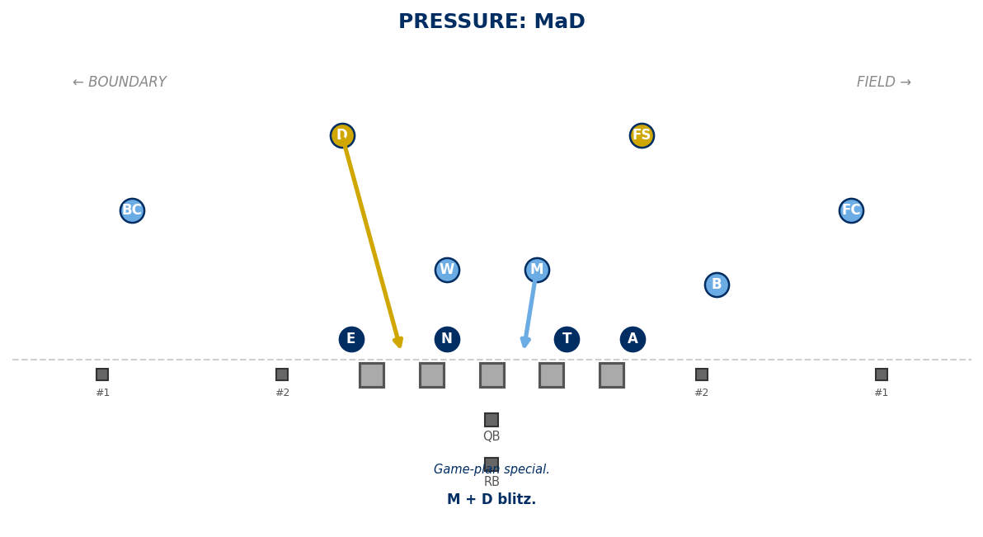

Shave
W edge blitz + Edge Attack (E attacks inside).
Note: Packaged pressure (married to Edge Attack).
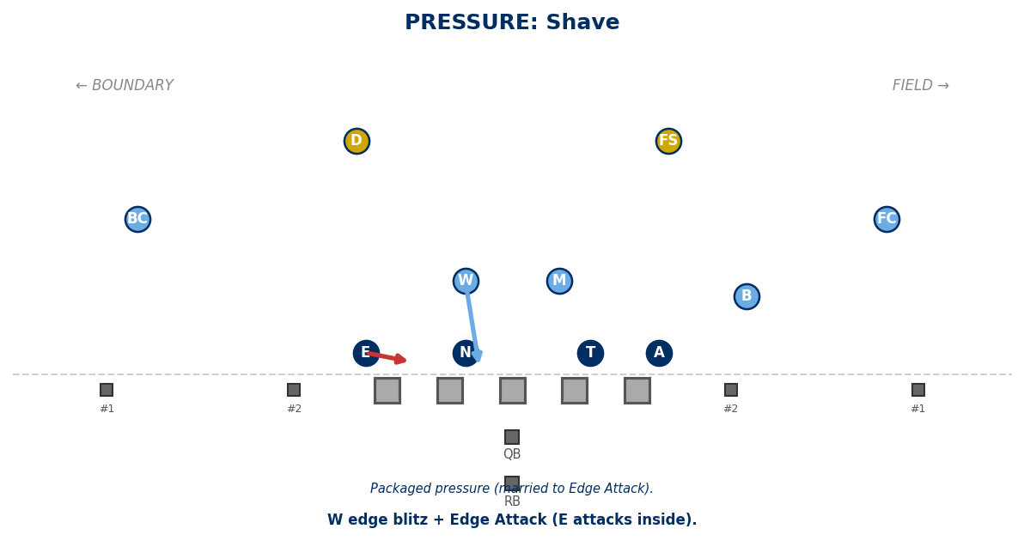

staB
B one gap inside EOL.
Note: B to B/C gap (inside normal). Game-plan special.
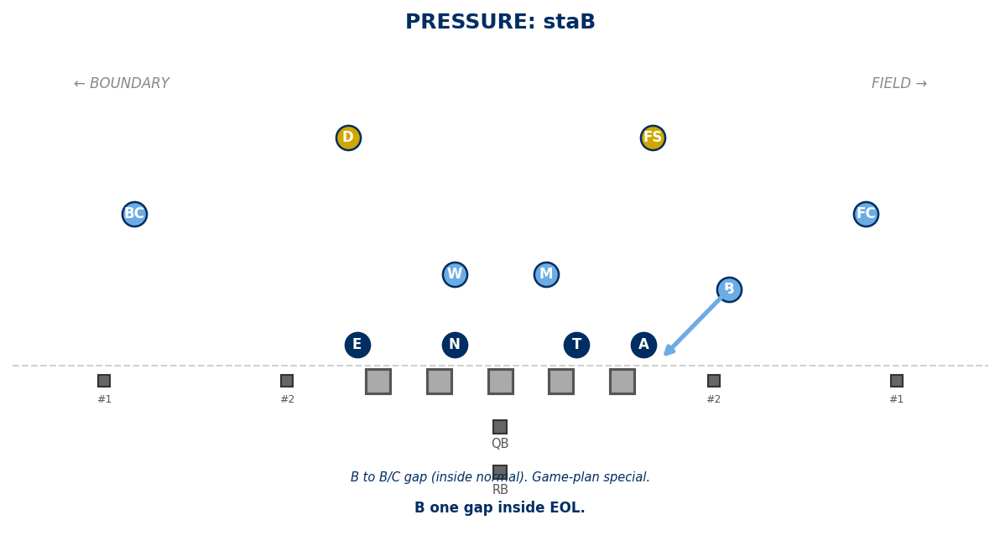

Freebird (Oregon)
FS blitzes (post safety rushes). Cover 1 only.
Note: No post safety — accept the risk.
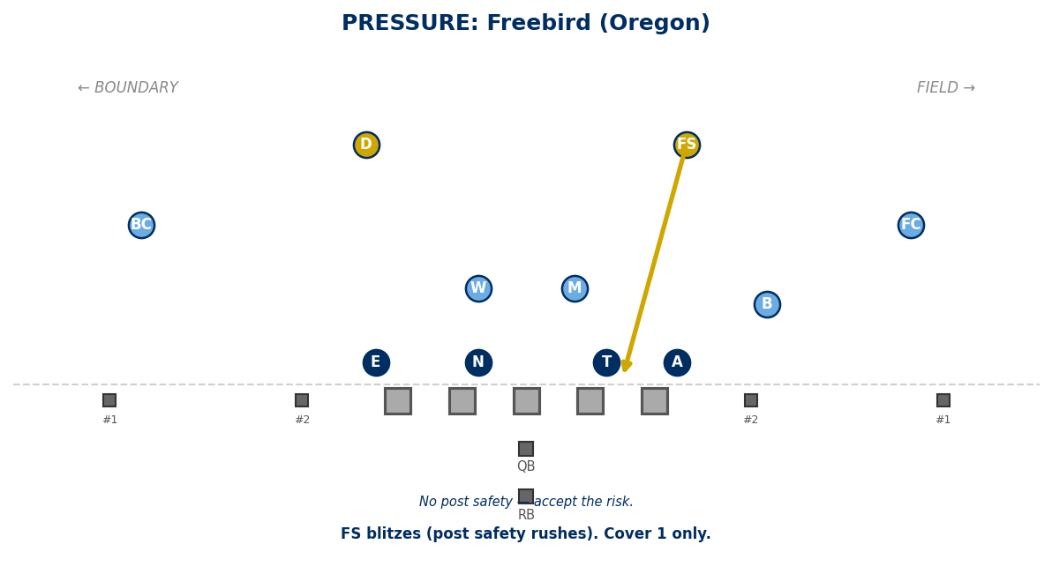

Cobra (Zunnel)
BC blitzes. D → #1 bnd. B → #2 bnd.
FS → #2 field. M/W funnel RB.
Note: Cover 0 + Zunnel only. Hash-only call.
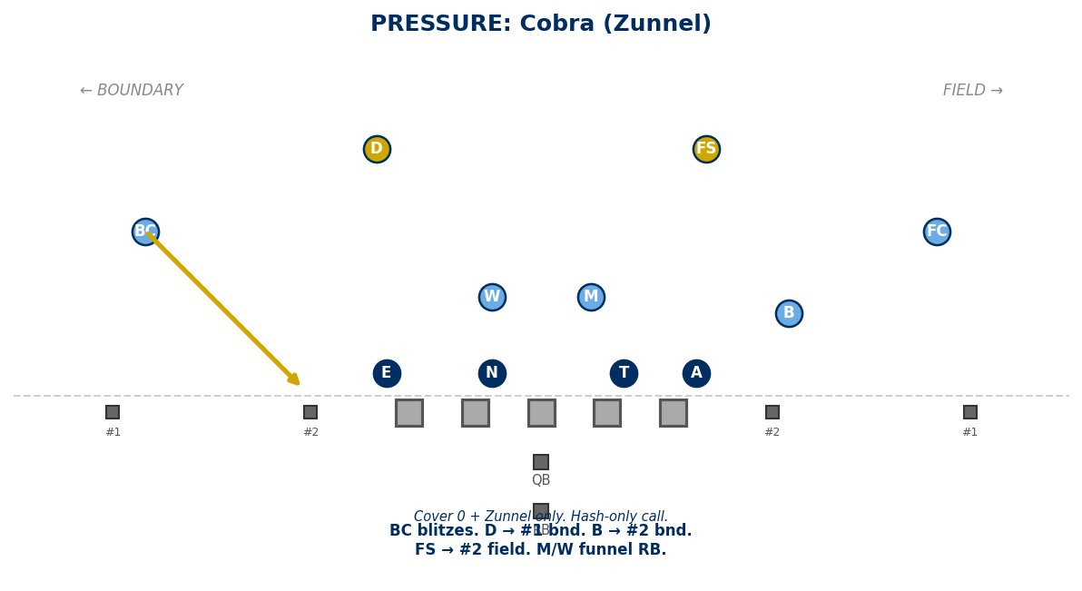

Generated: February 24, 2026 — 14 diagrams

