RIVER VALLEY VIKINGS
SHADE FRONT

2026 Season

CONFIDENTIAL — COACHING STAFF ONLY

SHADE
A=5, T=3, N=2i, E=5. M=open A (field), W=open B (boundary). Base front — set field.

Alignments vs Offensive Formations
vs 2×2 Spread (10 pers.):
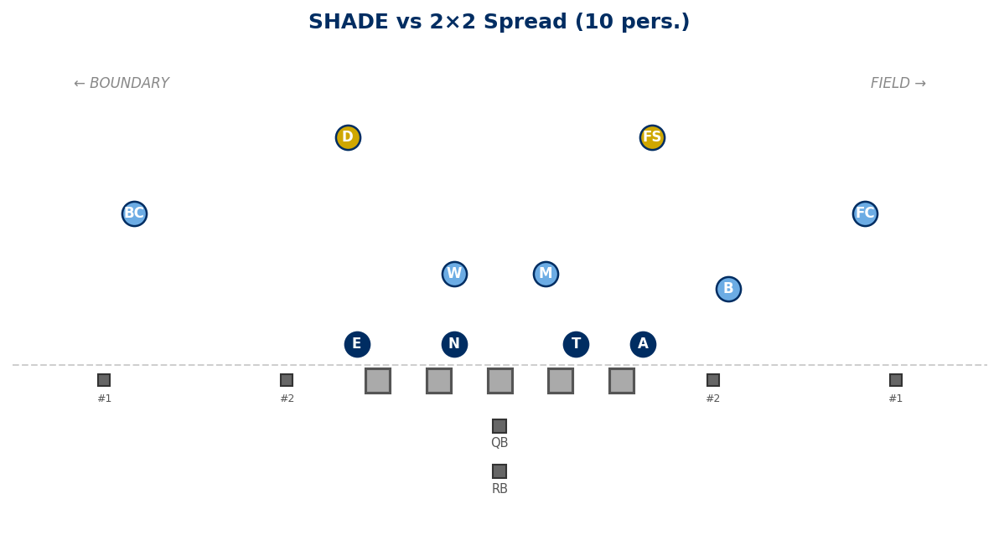

vs 3×1 Trips Field (10 pers.):
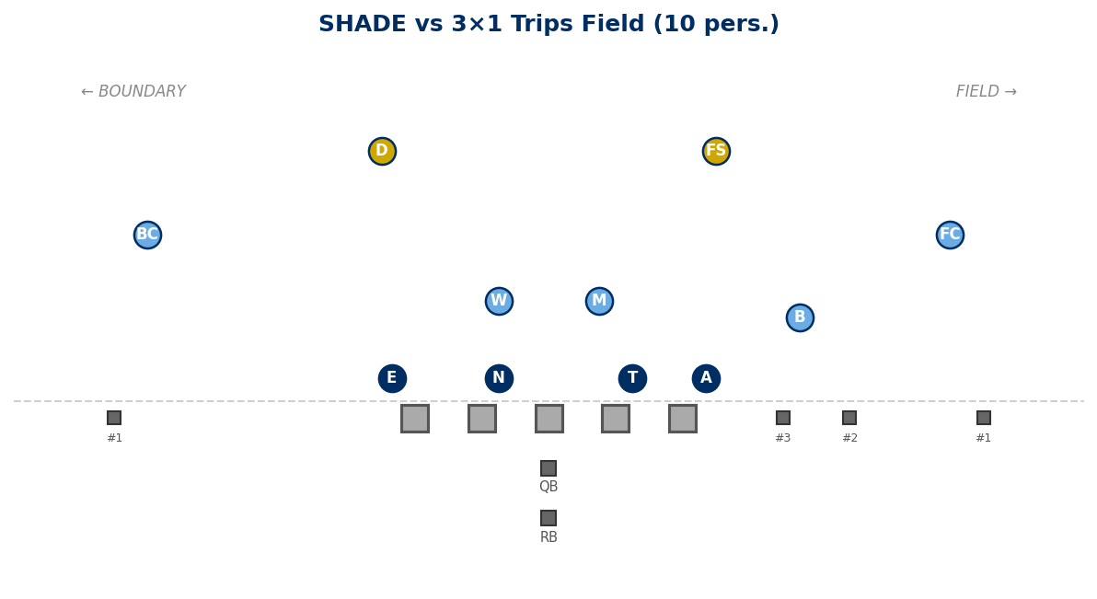

vs 2×2 + TE Field (11 pers.):
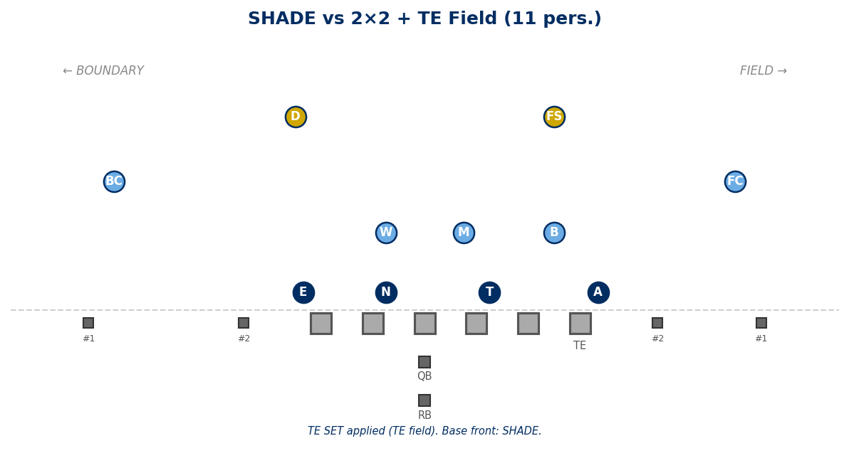

vs 2×2 + TE Boundary (11 pers.):
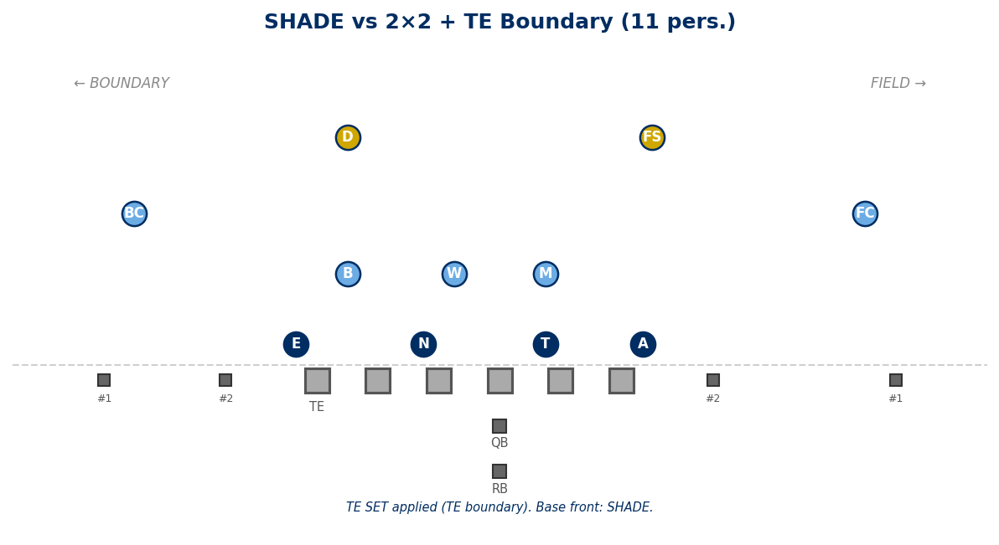

vs 21 Personnel (I-Form, TE Field):
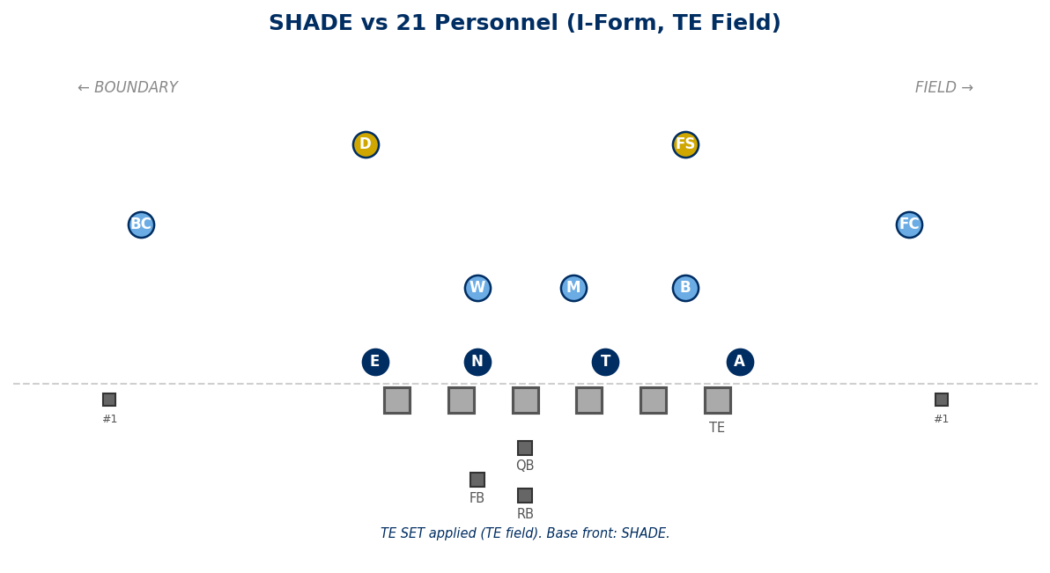

vs 22 Personnel (Heavy, 2 TE):
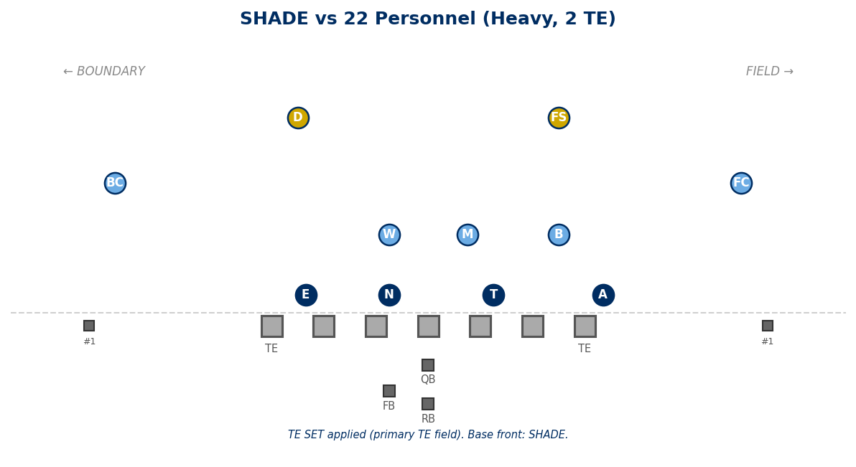

Legal Stunts on SHADE

Recommended Pairings
ANGLE:
T+N slant to boundary. Edges play normal.
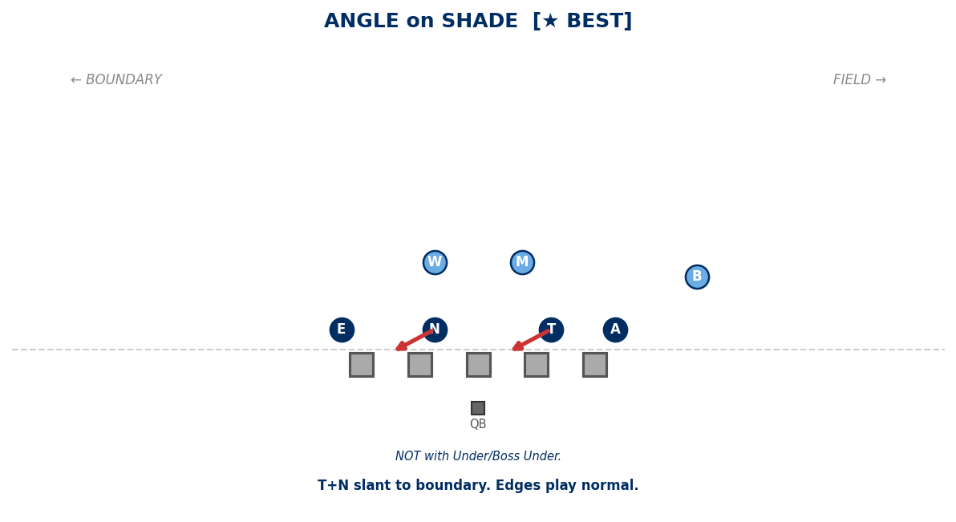

CRASH:
A+E shoot B gaps. T+N shoot A gaps.
B=field contain. W=bnd contain. M=free LB.
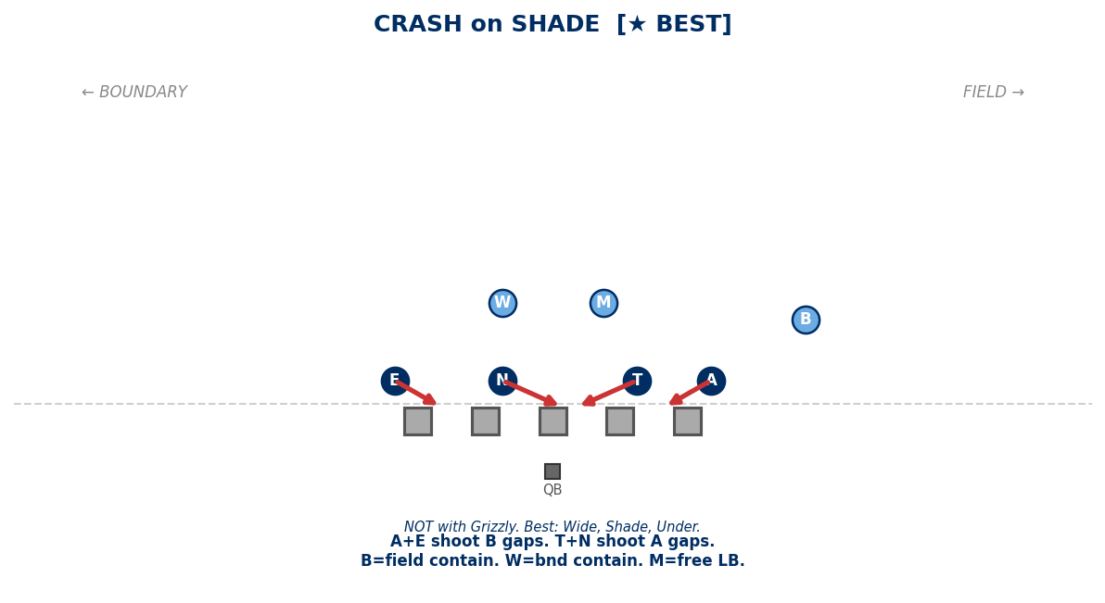

JACKS:
T+N shoot B gaps. A and E contain.
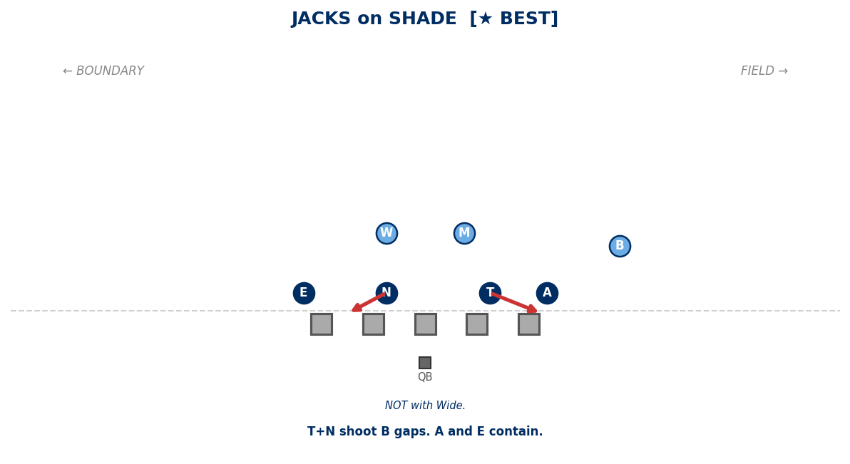

PINCH:
T+N pinch A gaps. A and E normal.
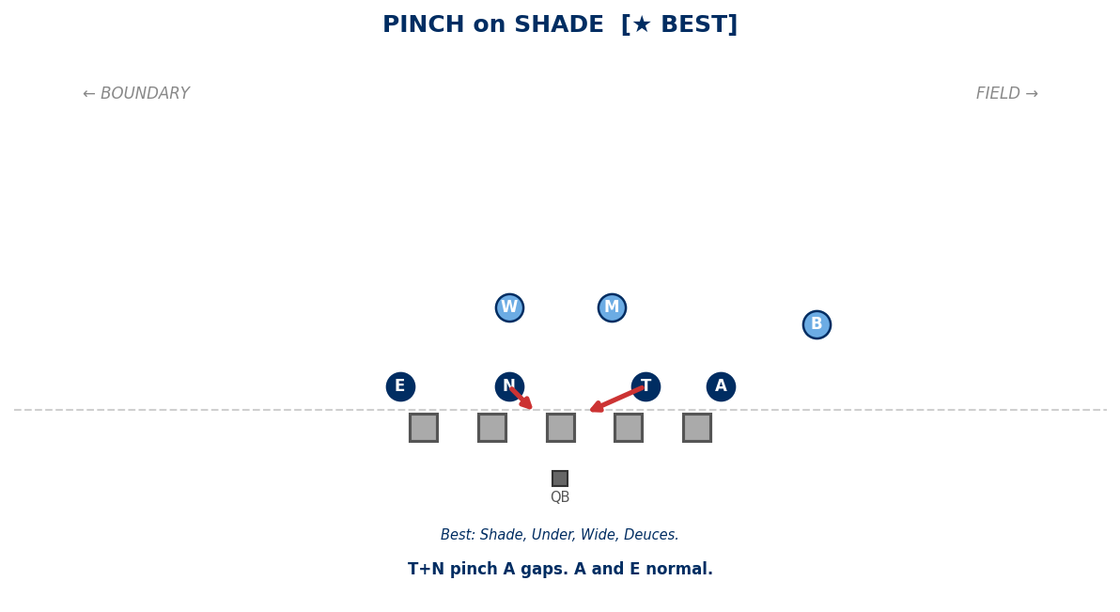

Legal Pairings
ANCHOR ATTACK:
A washes OL one gap inside.
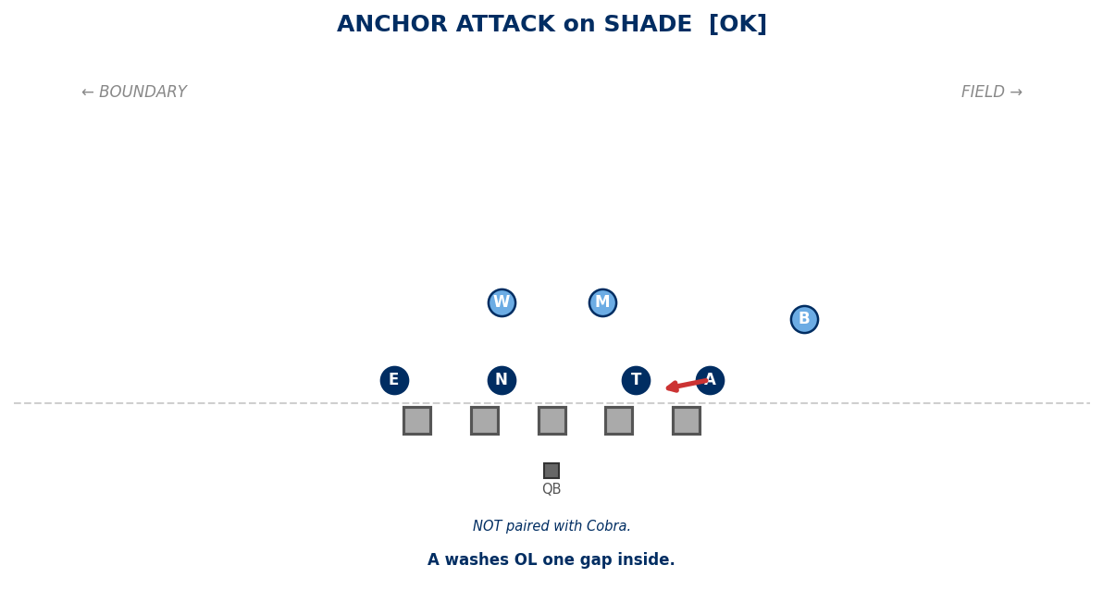

ANCHOR RAVEN:
A shoots B gap from 5-tech.
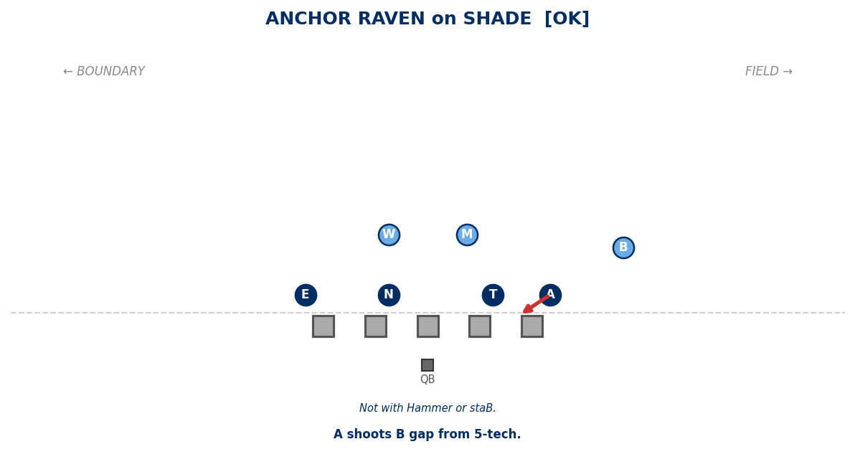

EDGE ATTACK:
E attacks OL one gap inside.
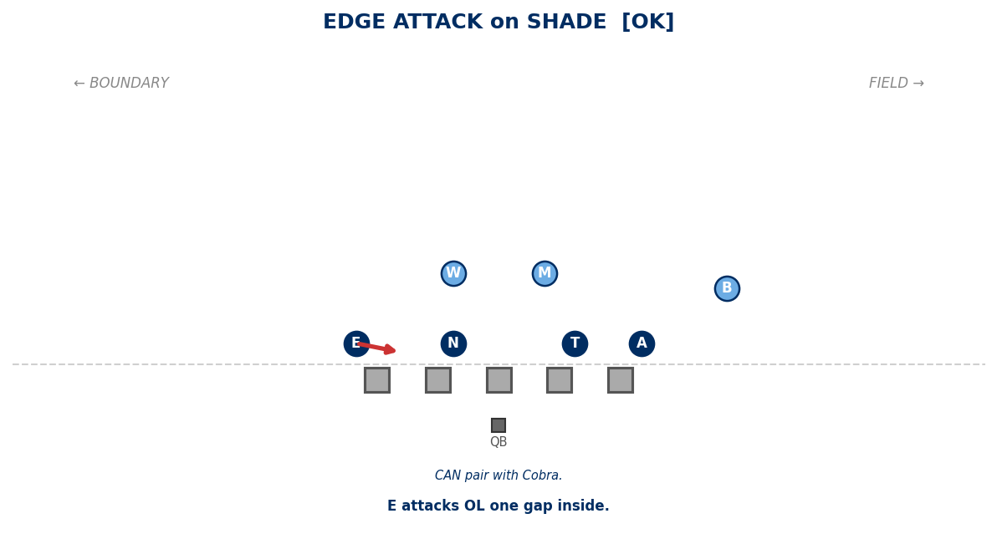

EDGE RAVEN:
E shoots B gap from 5-tech.
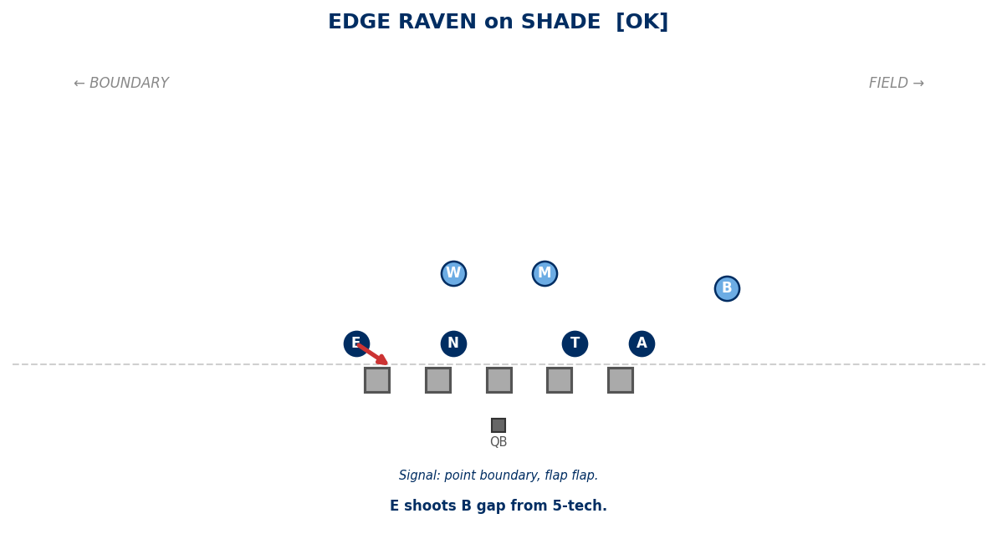

Generated: February 24, 2026 — 14 diagrams

