RIVER VALLEY VIKINGS
SLIP FRONT

2026 Season

CONFIDENTIAL — COACHING STAFF ONLY

SLIP
3-down: A=5, T=0, N=4i. 1-gap penetrating. A/E contain. B plays coverage clean. No stunts with SLIP.

Alignments vs Offensive Formations
vs 2×2 Spread (10 pers.):
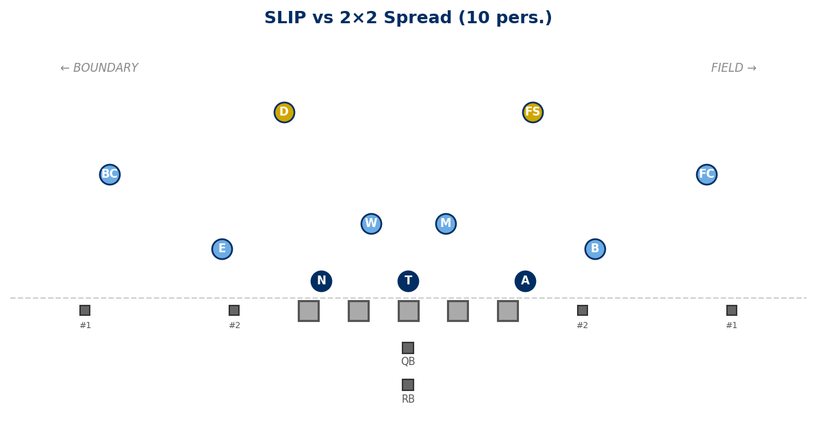

vs 3×1 Trips Field (10 pers.):
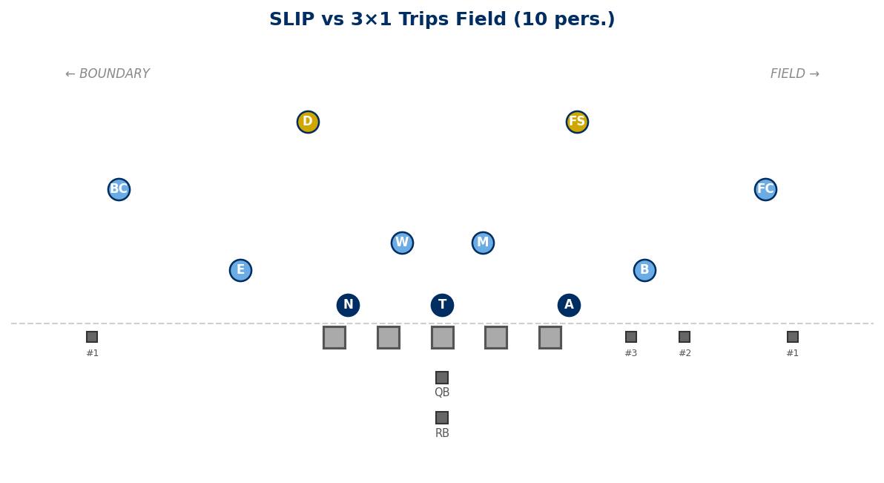

vs Empty 3×2 (10 pers.):
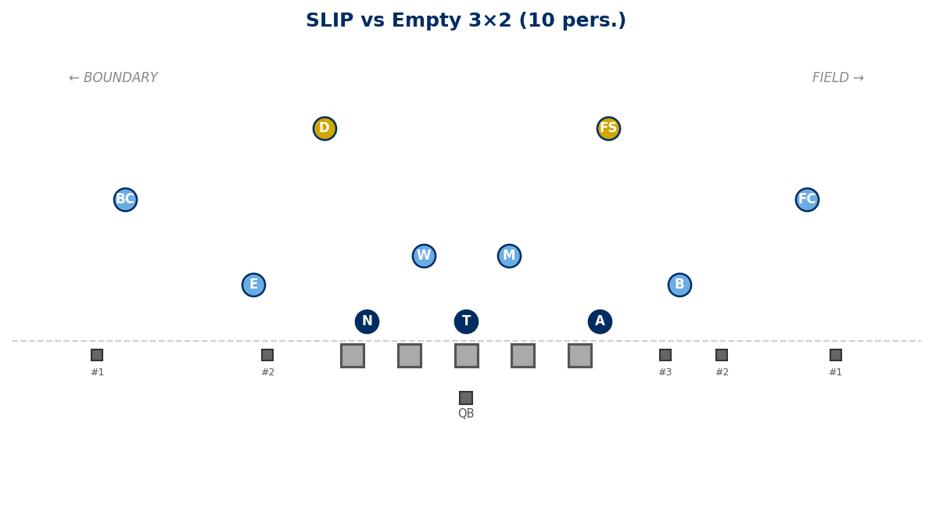

Stunts
No stunts with SLIP. The package is designed for clean 1-gap penetration with B in coverage.

Generated: February 24, 2026 — 3 diagrams

