RIVER VALLEY VIKINGS
SLIP FRONT

RUN-FIT DIAGRAMS — 2026 Season

CONFIDENTIAL — COACHING STAFF ONLY

SLIP
3-down: A=5, T=0, N=4i. 1-gap penetrating. A/E=contain. B=coverage clean.

Base Alignment — Run Fits vs Formations
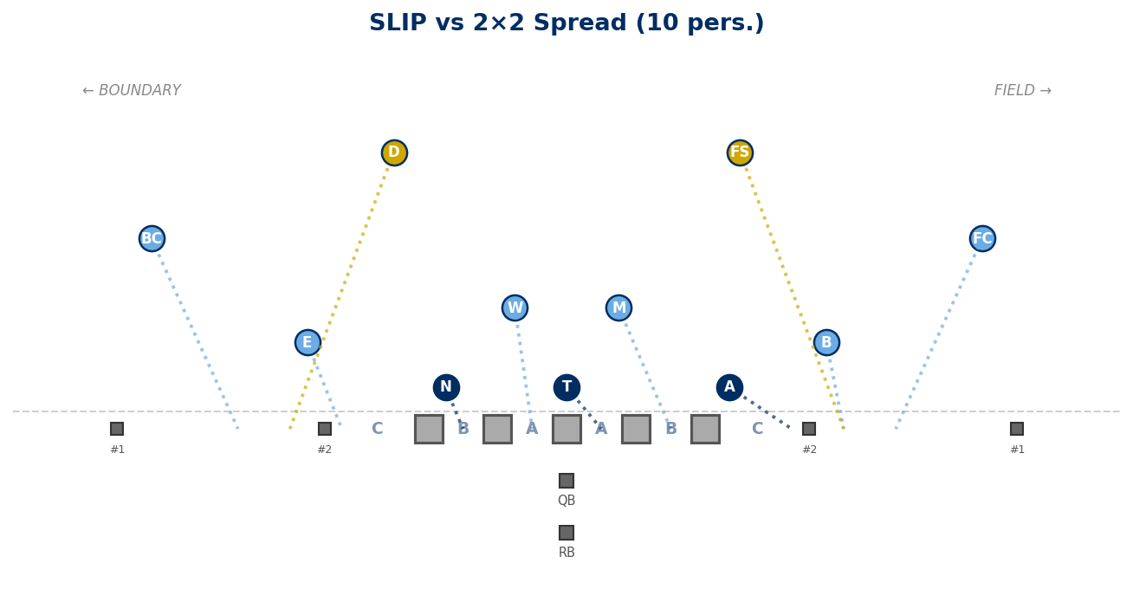

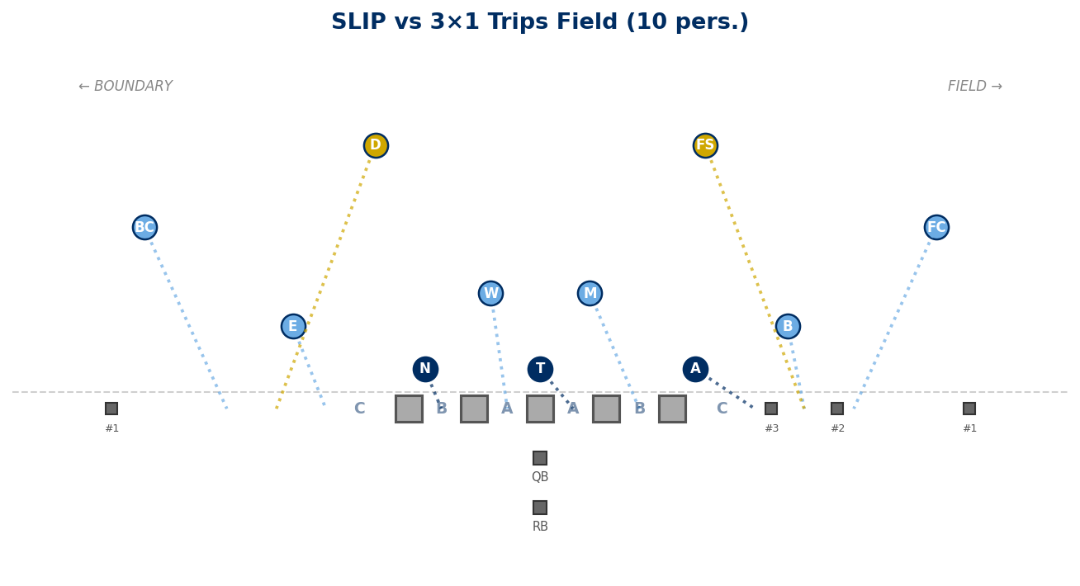

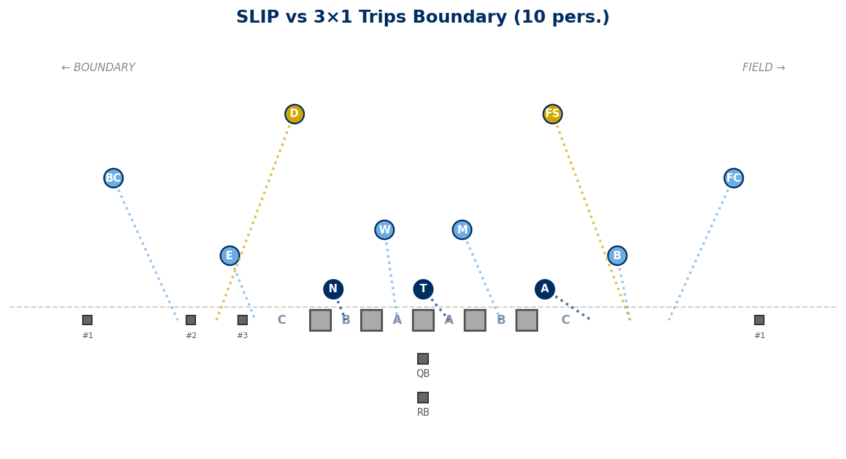

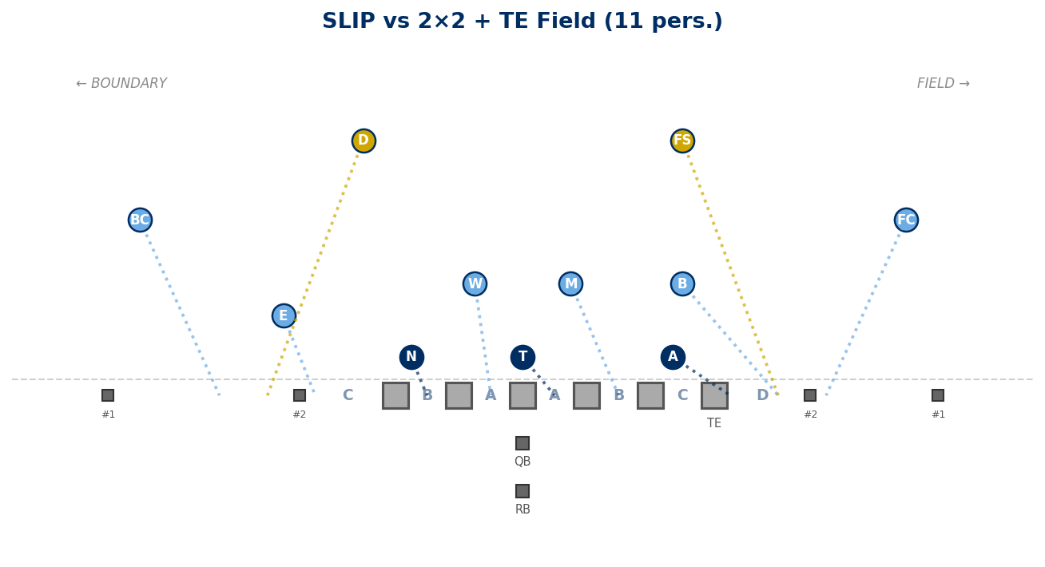

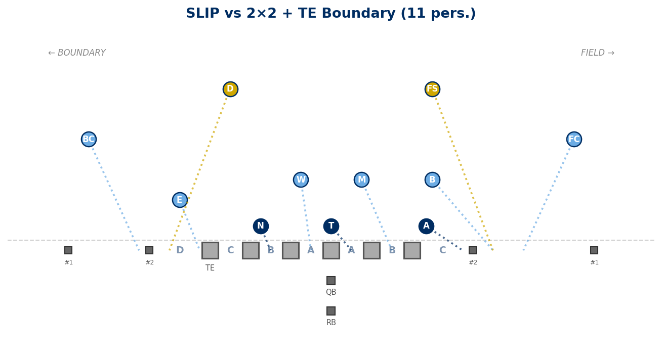

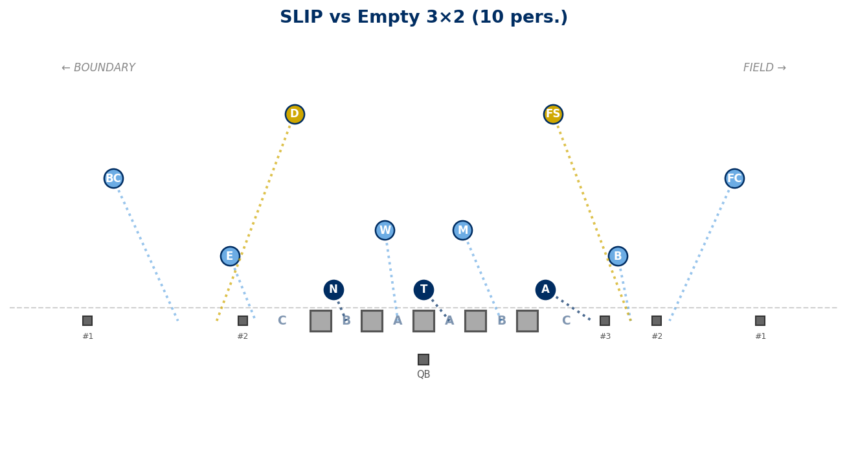

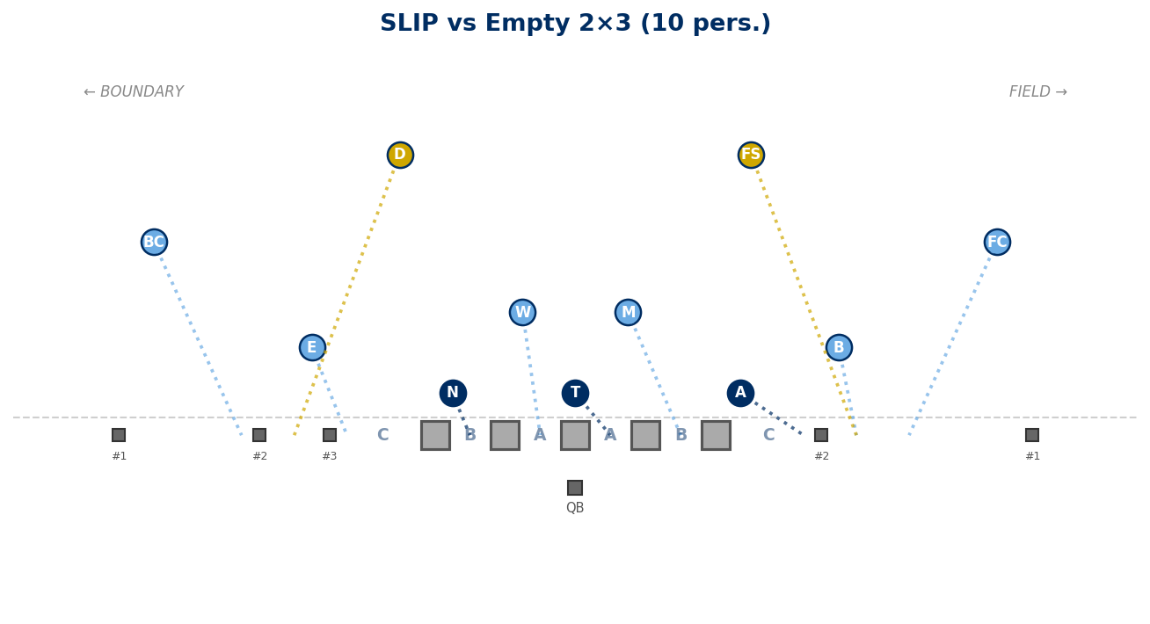

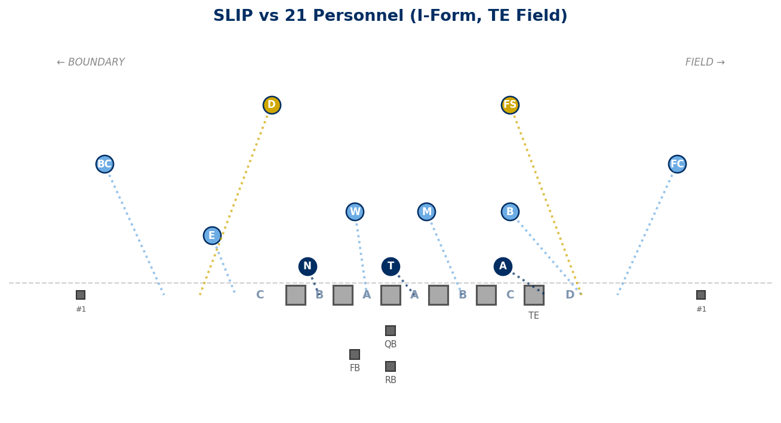

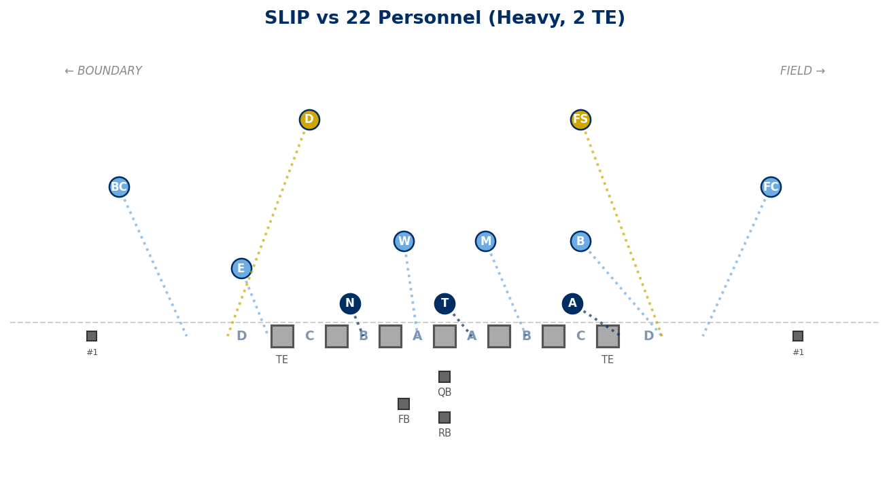

Stunts on SLIP — Run Fits vs 2×2

Legal Pairings
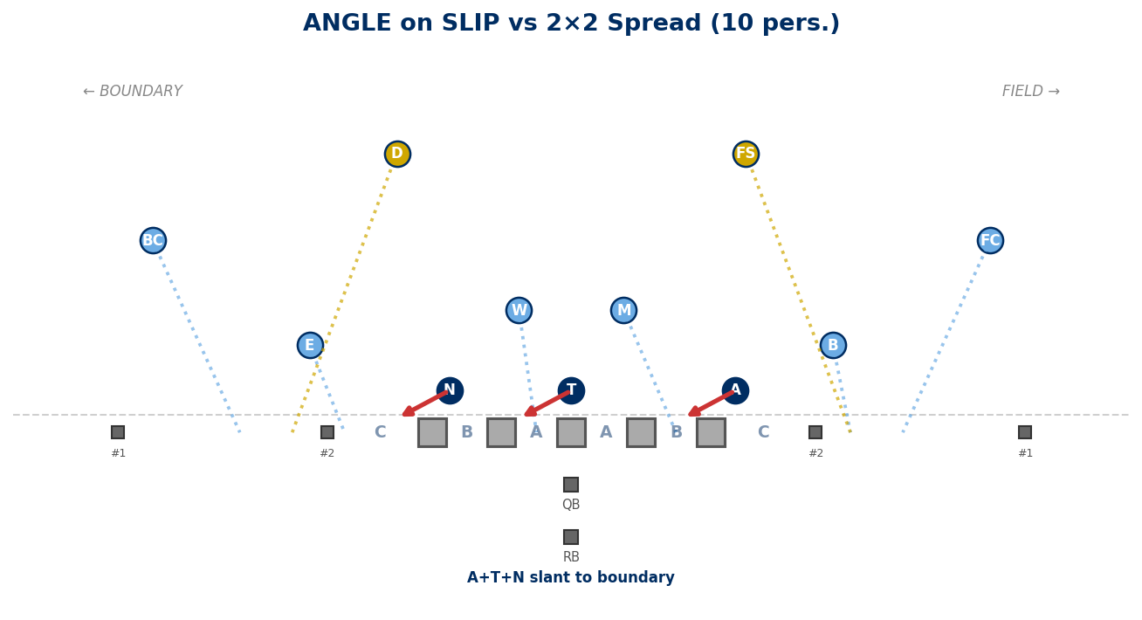

Generated: February 24, 2026 — 10 diagrams

