1. Project Profile

PROJECT TITLE: | Password Cracking
OBJECTIVE: | To simulate password cracking techniques in a controlled, ethical environment. This project aims to educate users on the vulnerabilities of weak passwords and demonstrate how penetration testers can use password auditing to strengthen authentication systems and reduce the risk of account compromise.
SUPPORT TOOLS and Technology: | HTML  CSS  JavaScript  Visual Studio Code
OPERATING SYSTEM: | Windows 10 / Windows 11
GUIDE: | Prof . Chetna prajapati
GROUP NO: | -
SUBMITTED BY: | Khushi Chokshi (23082291057)  Vyom Amin (23082291111)
SUBMITTED TO: | Department of Computer Science, Ganpat University

2. System Requirements
Hardware Requirements:
Processor: | Minimum 4 cores
RAM: | Minimum 8 GB

Software Requirements:
Operating System: | Windows 10/11
Shell Environment: | Windows PowerShell
Editor: | Visual Studio Code (v1.104)
Report Format: | HTML

3. Introduction to Password Cracking
Definition: Password cracking is the process of recovering or guessing a password by systematically testing possible combinations. It can be used ethically for penetration testing or maliciously for unauthorized access.
At its core, password cracking is a form of authentication bypass. It involves using algorithms, tools, or manual techniques to guess a password that protects access to a system, account, or encrypted data. The goal is to simulate or exploit how users create passwords — often relying on predictable patterns or weak choices.
Analogy: Imagine a locked box with a 4-digit code. Trying every combination from 0000 to 9999 is brute-force. Trying common codes like 1234 or birth years first is a dictionary attack.
Types of Cracking:
Brute-force: Tries every possible combination. Guaranteed success but time-consuming.
Dictionary Attack: Tries commonly used passwords first. Faster but not guaranteed.
Ethical Use: Password cracking should only be performed with explicit permission for educational, research, or security auditing purposes.
Why Is It Important?
Security Testing: Ethical hackers use password cracking to test the strength of authentication systems during penetration tests.
User Awareness: Demonstrating how easily weak passwords can be cracked helps users adopt stronger password habits.
Incident Response: In forensic investigations, password recovery may be necessary to access locked systems or encrypted files.
Common Cracking Techniques
Brute-Force Attack: Tries every possible combination. Guaranteed to succeed but extremely slow for complex passwords.
Dictionary Attack: Uses a list of common passwords or words. Fast and effective against human-chosen passwords.
Mask Attack: Targets passwords with known patterns (e.g., one uppercase, three lowercase, two digits).
Rule-Based Attack: Applies transformations to dictionary entries (e.g., replacing “a” with “@”, appending “123”).
Hybrid Attack: Combines dictionary and brute-force methods for more flexibility

4.UI & Navigation:-
The User Interface (UI) and Navigation design of the password cracking simulation plays a crucial role in ensuring clarity, usability, and educational value. Built with HTML, CSS, and JavaScript, the interface is structured to guide users through the simulation process in a logical and intuitive manner.
- Interface Design:
->Tabbed Layout:
Two tabs — "Create Account" and "Login & Cracker"
->Responsive Cards:
Clean layout with form controls and a live log area
->Progress Indicators:
Visual progress bar, attempt counter, estimated rate, and elapsed time
Tabbed Interface
The application uses a two-tab layout to separate core functionalities:
Create Account Tab:-
Allows users to register a demo account.
Includes input fields for username and password.
Enforces password rules with real-time validation.
Displays success or error messages based on input.
Login & Cracker Tab:-
Combines login simulation and password cracking tools.
Users can attempt login manually or initiate cracking simulations.
Includes controls for starting, stopping, and resetting the cracker.

Responsive Card Layout
The UI is built using responsive cards that adapt to different screen sizes.Each card contains grouped controls and outputs:
Form inputs
Buttons (e.g., Start, Stop, Reset)
Live log area
Progress indicators
This layout enhances readability and keeps the interface organized, even on smaller screens.
Progress Bar & Live Stats
A visual progress bar shows the percentage of cracking attempts completed (scaled to a demo cap of 1,000,000).
Live statistics include:
Attempts per second
Total attempts made
Elapsed time
Estimated cracking rate
Educational Design Choices
Monospace Log Area: Displays time-stamped messages for each attempt, making it easy to follow the simulation flow.
Speed Control Slider: Lets users adjust the attempt rate (from 10 to 200,000/sec), demonstrating how performance affects cracking time.
Feedback Messages: Clear alerts for login success/failure, account creation status, and simulation events.

Safety & Clarity
UI includes explicit warnings that the simulation is for educational use only.
No network requests are made — all data is stored locally.
Reset and Clear buttons allow users to wipe demo data and restart safely.

Account Management (Local Only)

The Account Management module is designed to simulate user registration and authentication in a secure, client-side environment. It allows users to create and manage accounts without any server or network interaction, making it ideal for educational demonstrations of password handling and validation.
Features:
Account Creation: Stores username and password in browser localStorage
Password Rules: Exactly 8 characters, lowercase letters (a–z) and digits (0–9)
Validation: Regex pattern /^[a-z0-9]{8}$/
Controls: Create, clear form, and feedback messages for success or error

Security Considerations:-
Local-Only Design All operations are performed within the browser. No data is sent to external servers, making it safe for demonstrations and testing.
No Encryption or Hashing Passwords are stored in plaintext for simplicity. In real-world applications, passwords should be hashed and salted before storage.
Single-User Limitation The system supports one account at a time. This simplifies the logic but limits multi-user scenarios.
LocalStorage Vulnerability Anyone with access to the browser profile can view or modify stored credentials. This reinforces the need for secure storage in real systems.
Educational Value
Demonstrates Basic Authentication Flow Helps learners understand how account creation and login validation work.

Highlights Password Rules and Validation Enforces strict password formats to teach the importance of complexity and consistency.Supports Cracking Simulation The stored account becomes the target for the password cracker module, allowing users to observe how guesses are evaluated against real credentials.

6. Login Simulation
Functionality Overview:
The Login Simulation module is a core part of the password cracking demo, designed to mimic the behavior of a basic authentication system in a controlled, client-side environment. It allows users to create accounts, attempt logins, and observe how password validation works — all without any server or network interaction.
The login module simulates a basic authentication system using locally stored credentials.
•Local login check — compare entered username + password to locally saved account and show success/failure messages.
the browser’s localStorage.
•Logout button — clear login inputs and show logged-out message.
Key Features:
Local Login Check: Validates user credentials against stored data.
Feedback Mechanism: Displays success or failure messages based on login attempt.
Logout Option: Clears input fields and resets the session state.
How It Works
Account Creation
Users create an account by entering a username and password.
The password must follow strict rules: exactly 8 characters, using only lowercase letters (a–z) and digits (0–9).
Validation is enforced using a regular expression: /^[a-z0-9]{8}$/.
Local Storage
Once validated, the account is saved in the browser’s localStorage as a JSON object:
Limitations
No Hashing Passwords are stored in plaintext for simplicity. In real systems, passwords should be hashed and salted.
Single Account Only The demo supports one account at a time, limiting multi-user scenarios.
LocalStorage Vulnerability Anyone with access to the browser profile can view or modify stored credentials.
This ensures the data is stored locally and never transmitted over the internet, maintaining privacy and safety.
Login Attempt:
Users enter their credentials in the login form.
The system compares the input against the stored account using a simple string match.
If the username and password match, a success message is displayed.
If they don’t match, a failure message is shown, and the attempt is logged.
Logout Functionality:
A logout button clears the login form and resets the interface.
This simulates session termination and prepares the UI for a new login attempt.

7. Logging & Export
Live Logging: Real-Time Feedback and Transparency
The live logging feature is a critical component of the password cracking simulation. It provides a dynamic, time-stamped record of every significant action performed during the simulation, including:
Login attempts: Whether successful or failed, each login attempt is logged with the exact time and input used.
Cracking attempts: Every password guess generated by the cracker (random or sequential) is recorded in real time.
System messages: Events like "Simulation started", "Password found", "Simulation stopped", or "Reset triggered" are also logged.
Use Cases for Exported Logs:
Academic Reporting: Students can include logs in project submissions to demonstrate the simulation’s behavior and results.
Pattern Analysis: Reviewing exported logs helps identify trends, such as how many attempts were needed to crack a password or which methods were more efficient.
Security Audits: In real-world penetration testing, logs are essential for documenting scope, methods, and outcomes.
Performance Benchmarking: Logs can be used to compare cracking speeds across different configurations or attempt rates.
Benefits of Live Logging:
Transparency: Users can observe the internal workings of the simulation, making the process more understandable and trustworthy.
Educational Insight: Seeing how guesses are generated and evaluated helps learners grasp the logic behind brute-force and dictionary attacks.
Debugging Aid: If something goes wrong (e.g., incorrect login logic or unexpected behavior), the log provides clues for troubleshooting.
User Engagement: The live feed creates a sense of activity and progress, making the simulation more interactive and engaging.
The log is displayed in a monospace font within a scrollable UI panel, ensuring readability and alignment of entries. Recent entries are shown at the top or bottom (depending on design), and older entries can be reviewed by scrolling.
Export Feature:
Users can export the log data as a CSV file.
Useful for reviewing attempts, analyzing patterns, or demonstrating results in reports.

[12:03:45] Attempt #1: Guess = "abc12345" → Incorrect
[12:03:46] Attempt #2: Guess = "password" → Incorrect

Cracker Simulation (Educational)
Cracker Simulation (Educational):-
The Cracker Simulation module is the centerpiece of this project, designed to demonstrate how password cracking techniques operate in a safe, controlled, and educational environment. It allows users to simulate brute-force and random guessing attacks against a locally stored password, helping them understand the mechanics, limitations, and ethical boundaries of password cracking
Modes of Operation:
Random Non-Repeating Sampling:
Generates random 8-character guesses from the allowed alphabet (a–z, 0–
Fast and unpredictable, but may repeat guesses in long runs.
Sequential (Lexicographic):
Generates guesses in alphabetical order.
Useful for small-scale demos; limited to avoid performance issues.
Controls:
Speed Slider: Adjusts attempts per second (10 to 200,000).
Start/Stop/Reset: Manage simulation flow.
Batching Loop: Keeps UI responsive while simulating high-speed attempts.
Progress Scaling:
Full space of 36⁸ combinations (~2.8 trillion) is impractical to simulate.
Progress bar is scaled to a demo cap of 1,000,000 attempts for visibility.
Controls and Features
Start / Stop / Reset Buttons
-Start: Begins the cracking simulation.
-Stop: Pauses the simulation mid-run.
-Reset: Clears counters and logs (requires stopping first).
Speed Control Slider
-Allows users to adjust the attempt rate from 10 to 200,000 attempts/sec.
-Live numeric display shows current speed.
Progress Bar
-Scaled to a demo cap of 1,000,000 attempts for visibility.
-Shows percentage of progress relative to the capped space.
Live Statistics
-Displays:
-Total attempts made
-Attempts per second
-Elapsed time
-Total password space (36⁸ = 2.8 trillion)
Limitations:-
Not Exhaustive
The simulation does not attempt all 2.8 trillion combinations — it samples or stops early.
No Hashing
Passwords are compared in plaintext; no hash functions are used.
Random Mode May Repeat
Due to sampling, guesses may occasionally repeat, though the probability is low.

- Statistics & math display

The Statistics & Math Display module is designed to help users understand the mathematical scale and computational effort involved in password cracking. It transforms abstract numbers into visual and interactive insights, making the complexity of brute-force attacks more tangible and educational.
Combinatorics:

Total combinations: 368=2,821,109,907,45636^8 = 2,821,109,907,456

Alphabet size: 36 (26 letters + 10 digits)

Time Estimates:
Attempts/sec | Time to Exhaust Space
1,000 | ~89 years
10,000 | ~8.9 years
1,000,000 | ~32 days
Live Counters:
Live Counters
The UI includes real-time counters that update as the simulation runs:
Attempts Made: Total number of guesses generated so far.
Rate Estimate: Current speed in attempts/sec.
Elapsed Time: Duration since simulation started (formatted as HH:MM:SS).
Progress Bar: Scaled to a demo cap (e.g., 1,000,000 attempts) to show visible progress.

These counters help users visualize the cracking process and understand the relationship between speed, time, and password complexity.
•Example time estimates — illustrative estimates for different attempt rates (1k/sec, 10k/sec, 1M/sec) so viewers get a feel for scale.

Educational Impact
Demystifies Brute-Force Attacks: Shows why long, complex passwords are exponentially harder to crack.
Reinforces Password Strength: Demonstrates how adding just one character can multiply the search space.
Encourages Strong Practices: Helps users appreciate the value of using diverse character sets and longer passwords.

10. Safety & Ethics
The Safety & Ethics module is a foundational part of this project, ensuring that all password cracking demonstrations are conducted responsibly, legally, and with clear educational intent. In cybersecurity, ethical boundaries are critical — especially when simulating techniques that could be misused if not properly controlled.
Educational Purpose Only:
The tool is designed for learning and awareness.
It does not perform real password cracking or network attacks.

Local-Only Design for Safety
No Network Requests The simulation runs entirely in the browser using client-side technologies (HTML, CSS, JavaScript). It does not send or receive data from external servers, ensuring complete isolation from real systems.
LocalStorage Usage All account data and cracking attempts are stored temporarily in the browser’s localStorage. This keeps the simulation self-contained and prevents any risk of data leakage.
No Real Passwords or Hashes The simulation uses plaintext demo passwords for educational purposes. It does not interact with real user credentials or perform hash-based attacks.

Local-Only Operation:

No data is sent over the internet.
All actions occur within the browser using localStorage.

Ethical Guidelines:
Explicit Consent Modal Before initiating the cracking simulation, users must confirm that they understand the educational nature of the tool and agree not to use it for unauthorized access.
Clear Warnings The interface includes repeated notices that the tool is for learning only and must not be used against real systems without written permission.
Wipe Controls A “Clear Demo Data” button allows users to erase all stored credentials and logs, reinforcing safe usage and cleanup practices.
Never use password cracking tools without explicit permission.
Intended for penetration testing, training, and research under authorized conditions.

Legal and Institutional Guidelines
Authorization Requirement Ethical hacking — including password testing — must always be performed with written permission from the system owner.
Compliance with Laws Users are reminded to follow local, national, and institutional laws regarding cybersecurity, data privacy, and digital forensics.
Documentation of Scope and Methods In real-world penetration testing, ethical hackers must document their testing scope, tools used, and results to ensure transparency and accountability.

Educational Purpose
Awareness Building The simulation helps users understand how weak passwords can be exploited and why strong authentication is essential.
Promotes Responsible Behavior By emphasizing ethics and safety, the project encourages learners to use their skills for protection, not exploitation.
Supports Cybersecurity Training This module aligns with academic and professional standards for ethical hacking, making it suitable for classroom use, workshops, and certifications.

11. Implementation Details
Implementation Details (Technical Overview)
The password cracking simulation is implemented entirely on the client-side using HTML, CSS, and JavaScript, making it lightweight, portable, and safe for educational use. This section outlines the technical architecture, logic flow, and key components that power the simulation.
Architecture:

Client-Side Only: Technology Stack
HTML: Structures the interface into tabs, forms, buttons, and display areas.
CSS: Styles the UI with responsive cards, progress bars, and layout grids for clarity and usability.
JavaScript: Handles all logic — from account creation and validation to cracking algorithms and logging.
Browser-Based: Runs in any modern browser without installation.

Technical Highlights:
Alphabet Generation: Programmatically creates an array of allowed characters (a–z, 0–9).
Combinatorics: Calculates total password space using BigInt for precision.
Regex Validation: Enforces password rules using /^[a-z0-9]{8}$/.
Performance Safety: Sequential mode has a demo limit; random mode avoids memory-heavy tracking.
Formatting Helpers: Functions to format large numbers and elapsed time (HH:MM:SS).

Password Rules & Validation
Passwords must be exactly 8 characters, using only lowercase letters (a–z) and digits (0–9).

Validation is enforced using a regular expression:
/^[a-z0-9]{8}$/
Invalid inputs trigger error messages and prevent account creation.

Local Storage Management

Accounts are stored in the browser’s localStorage as JSON objects:
{
"username": "demoUser",
"password": "abc123xy"
}

Cracking Logic
· Alphabet Array: Programmatically generated to include all allowed characters:
const alphabet = [...'abcdefghijklmnopqrstuvwxyz0123456789'];
· Random Mode: Generates random guesses using Math.random() and compares them to the stored password.
· Sequential Mode: Iterates through combinations in lexicographic order, capped for demo purposes

Performance & Safety Controls
Speed Slider: Users can set attempt rates from 10 to 200,000/sec.
Batching Loop: Attempts are processed in small batches to keep the UI responsive.
Demo Cap: Progress bar is scaled to a maximum of 1,000,000 attempts to avoid freezing the browser.

Logging & Export
Each attempt is logged with a timestamp and result.
Logs are displayed in a live monospace area and can be exported as a .csv file for analysis

Helper Functions
BigInt Formatting: Converts large numbers (like 36⁸) into readable strings with commas.
Elapsed Time Formatter: Displays simulation duration in HH:MM:SS format.

Ethical Safeguards
No hashing or network requests.
Explicit warnings and consent modals reinforce educational intent.
Reset and wipe controls allow users to clear all demo data safely.

12. Limitations
While the password cracking simulation provides valuable educational insights, it is intentionally designed with several limitations to ensure safety, simplicity, and ethical compliance. These constraints help maintain a controlled learning environment and prevent misuse or misinterpretation of the tool’s capabilities.
Scope Constraints:

1. Not Exhaustive
The simulation does not attempt all 2.8 trillion combinations for an 8-character password using 36 characters.
Instead, it uses sampling or demo caps (e.g., 1,000,000 attempts) to keep the process practical and responsive.
This means the simulation may not always find the password unless it’s weak or randomly guessed early.

2. No Hashing or Encryption
Passwords are stored and compared in plaintext, without using hash functions like MD5, SHA-256, or bcrypt.
This simplifies the logic but does not reflect real-world authentication systems, which always use hashed and salted passwords.
As a result, the simulation cannot demonstrate hash cracking or rainbow table attacks.
3. Random Mode May Repeat Guesses
In random sampling mode, guesses are generated independently without tracking previously tried combinations.
This avoids memory overload but introduces the possibility of duplicate guesses, especially in short runs.
While the probability of repetition is low, it means the simulation is not fully optimized for coverage.
4. Simplified Account Storage
User credentials are stored in the browser’s localStorage, which is not secure and can be accessed or modified by anyone using the same browser profile.
This is acceptable for educational demos but not suitable for real applications or sensitive data.
5. No Real Attack Simulation
The tool does not interact with live systems, login endpoints, or networked services.
It cannot simulate attacks on hashed databases, web applications, or APIs.
This ensures safety but limits realism for advanced cybersecurity training.
6. Single-User Limitation
The simulation supports only one account at a time, stored locally.
Multi-user scenarios, role-based access, or session management are not implemented, keeping the scope narrow.
7. Performance Constraints
Attempt rates are capped (e.g., 200,000/sec) to prevent browser freezing or device overload.
Sequential mode is limited to small runs to avoid impractical iteration over trillions of combinations.
These constraints prioritize user experience and device safety over brute-force realism.
- Not a real cracker
it does not compute or compare hashes, nor does it attack networked services. It only compares plaintext guesses to the locally stored plaintext password..
- No Network Interaction:
Cannot crack passwords from external systems or databases.

Security Caveats:
LocalStorage Exposure: Saved credentials are visible to anyone with access to the browser profile
Random Mode Repeats: May generate duplicate guesses due to sampling nature.
Educational Focus:
This tool is not a real password cracker. It is designed to demonstrate concepts safely and ethically.

Key Features of Password-Cracking Tools
Password-cracking tools are specialized software applications designed to recover passwords by simulating various attack strategies. While their use must always be ethical and authorized, these tools offer powerful capabilities that make them essential in penetration testing, forensic analysis, and cybersecurity education
1. Attack Types Supported
Most tools support multiple cracking strategies to adapt to different scenarios:
Brute-Force: Tries every possible combination. Guaranteed to succeed but computationally expensive.
Dictionary Attack: Uses precompiled wordlists of common passwords. Fast and effective against human-chosen passwords.
Mask Attack: Targets passwords with known patterns (e.g., ?u?l?l?d for one uppercase, two lowercase, one digit).
Rule-Based Attack: Applies transformations to dictionary entries (e.g., replacing “a” with “@”, appending “123”).
Hybrid Attack: Combines dictionary and brute-force methods for more flexibility.
2. GPU Acceleration
Tools like Hashcat leverage GPU power to perform millions of password guesses per second.
This parallel processing dramatically increases cracking speed, especially for hash-based attacks.
3. Multi-Threading Support
Password-cracking tools utilize multiple CPU cores to run concurrent threads.
This improves performance and reduces time required for large-scale cracking operations.• Hash & salt handling for realistic offline cracking
4. Hash & Salt Handling
Real-world systems store passwords as hashed values, often with added salt for security.
Tools support various hash algorithms:
MD5, SHA-1, SHA-256
bcrypt, PBKDF2, Argon2
Salt handling allows tools to simulate realistic cracking scenarios by combining salt with password guesses before hashing.
5. Session Resume & Progress Tracking
Long cracking sessions can be paused and resumed without losing progress.
Tools save session data, including:
Last attempted password
Cracking mode and configuration
Wordlist position or hash index
6. Ethical & Educational Use
Tools include disclaimers and usage guidelines to promote responsible use.
Many are used in certified ethical hacking (CEH) courses and penetration testing labs.
They help security professionals identify weak passwords and improve authentication systems.Performance Enhancements:
GPU acceleration for parallel processing
Multi-threading to utilize multiple CPU cores
Deep Dive — Attack Types
•Brute-force: try all combinations — guaranteed but slow
•Dictionary: use common words/password lists (fast for human-chosen passwords)
•Mask attacks: target patterns (e.g., ?u?l?l?d for 1 upper, 2 lower, 1 digit)
•Rule-based: transform dictionary entries (leet substitutions, append years)
•Hybrid: combine dictionary + brute-force for variants
Mask Attacks — Practical Example
•Define mask: pattern describing character types and positions
•Example mask: ?u?l?l?l?d?d (1 uppercase, 3 lowercase, 2 digits)
•Why it’s faster: reduces search space dramatically (targeted guessing)
•When to use: when you know password policy or have partial info

Security Features:
Hash and salt handling for realistic offline cracking
Session resume and progress tracking
Tool Comparison — Hashcat vs John the Ripper:
•Hashcat: GPU-accelerated, excellent for large hashlists and performance
•John the Ripper: versatile, scriptable, good for hybrid workflows
•Both support rule-based, mask, and dictionary attacks and many hash types
•Pick Hashcat for raw speed; John for flexibility and integration

Ethical Use:
•Always obtain written permission before testing real systems
•Use demos for education, not for unauthorized access
•Record scope, methods, and results during authorized tests
•Understand local laws and institutional policies on security testing

14. Cracking Workflow

The Cracking Workflow outlines the step-by-step process through which the password cracking simulation operates. It demonstrates how input data is handled, how guesses are generated, and how comparisons are made — all within a safe, client-side environment. This workflow is essential for understanding the logic behind brute-force and dictionary-based attacks.

Input / Target

Source: Plain password field (demo) or imported hash/salt (future scope)where the password data comes from (plain-text demo field, imported hash file, or captured/login endpoint)
Input Field: The cracker reads the stored plaintext password or a simulated hash (in future enhancements).
Account Store: Contains {username, password} or {username, hash, salt} depending on the mode.

Guess Generators

•Brute-force generator — produces every possible combination from the charset (usually impractical for large spaces).

•Dictionary generator — reads a wordlist of likely passwords.

•Hybrid generator — combines dictionary words + rule transforms.

•Random sampler — picks random guesses (useful in demos or probabilistic attacks).

•Sequential (lexicographic) generator — steps through candidates in a deterministic order.

Hashing / Comparison
•Hashes each guess (if needed) and checks whether it matches the stored value.
•Hash function implementation — computes hashes (MD5, SHA-1, SHA-256, or KDFs
like PBKDF2/bcrypt/argon2) to compare guesses to stored hashes.
•Salt handling — supports prefix/suffix or stored salts when comparing salted hashes.
Plaintext compare — simple string compare used in basic demos
Hashing Methods Overview
•MD5 – very fast but not secure
•SHA-1 – outdated, also unsafe
•SHA-256 – stronger but still needs a salt
•bcrypt / Argon2 – modern, slow and secure

Performance Control
•Rate/batching and optional acceleration (simulate GPU or tune attempts/sec) to
manage speed and responsiveness.
•Acceleration & Safe Simulation — simulate or optionally
use hardware acceleration (GPU/native) while providing safe defaults;
don’t let the app saturate the device.
4. Progress Tracking & Logging
Live Log: Each guess is time-stamped and recorded in a visible log area.

Progress Bar: Scaled to a demo cap (e.g., 1,000,000 attempts) to show visible progress.
Statistics Display:
Attempts made
Attempts/sec
Elapsed time
Total password space
5. Control Flow
Start: Begins the cracking process.
Stop: Pauses the simulation mid-run.
Reset: Clears counters and logs (requires stopping first).
Speed Control: Slider adjusts attempt rate from 10 to 200,000/sec.
6. Safety & Ethics Enforcement
Local-Only Execution: No network requests or external data access.
Consent Modal: Users must confirm they understand the educational purpose.
Wipe Controls: Clear stored data and logs to reset the environment.

UI / Logging & Safety
Start/stop controls, progress display, log/export, and mandatory consent

local-only warnings.
Consent modal — explicit confirmation that user has authorization.

Local-only enforcement — no network uploads, explicit localStorage usage or
ephemeral mode.

Wipe / clear data button to remove saved values.

Safe defaults — capped speeds and simulated heavy workloads instead of
actually freezing the browser

Role of Ethical Hackers

•They test security legally with permission

•Use tools like password crackers to find weak spots

•Help protect systems by fixing vulnerabilities

•Always follow laws and company rules

15. Client-Side Flow Diagrams

1. PIN Creation Module
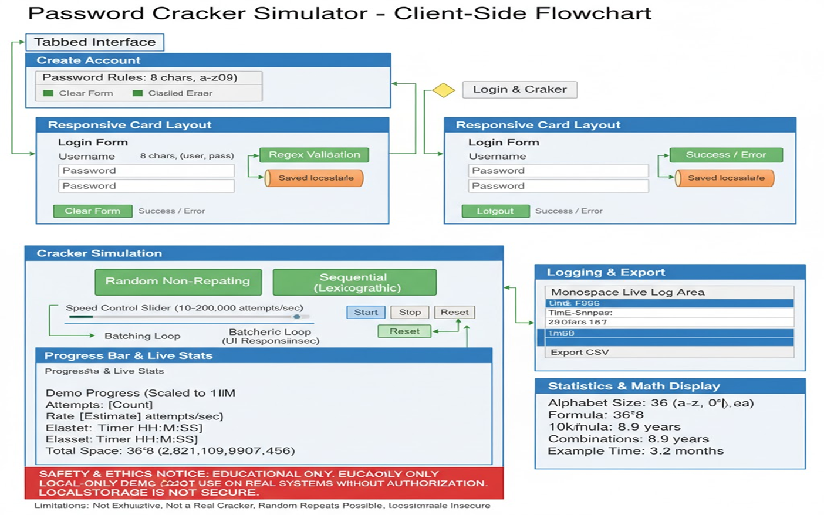

-> User enters username and password
->Regex validation checks format
->Credentials saved in localStorage

2. PIN Verification & Cracking Result Display
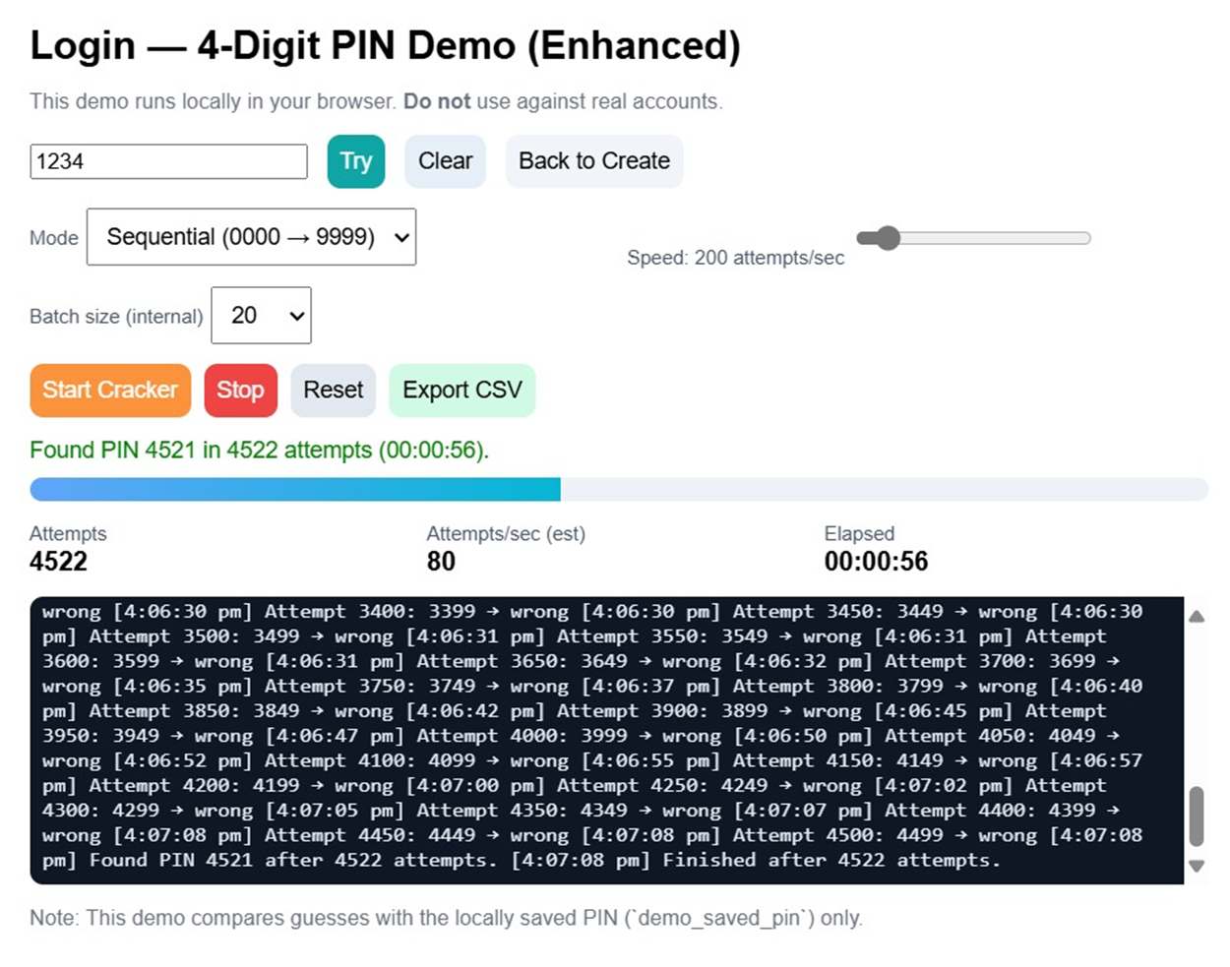
->Cracker compares guesses to stored password
->Displays success/failure message
->Logs each attempt with timestamp

3. Password Generation and Complexity Analysis
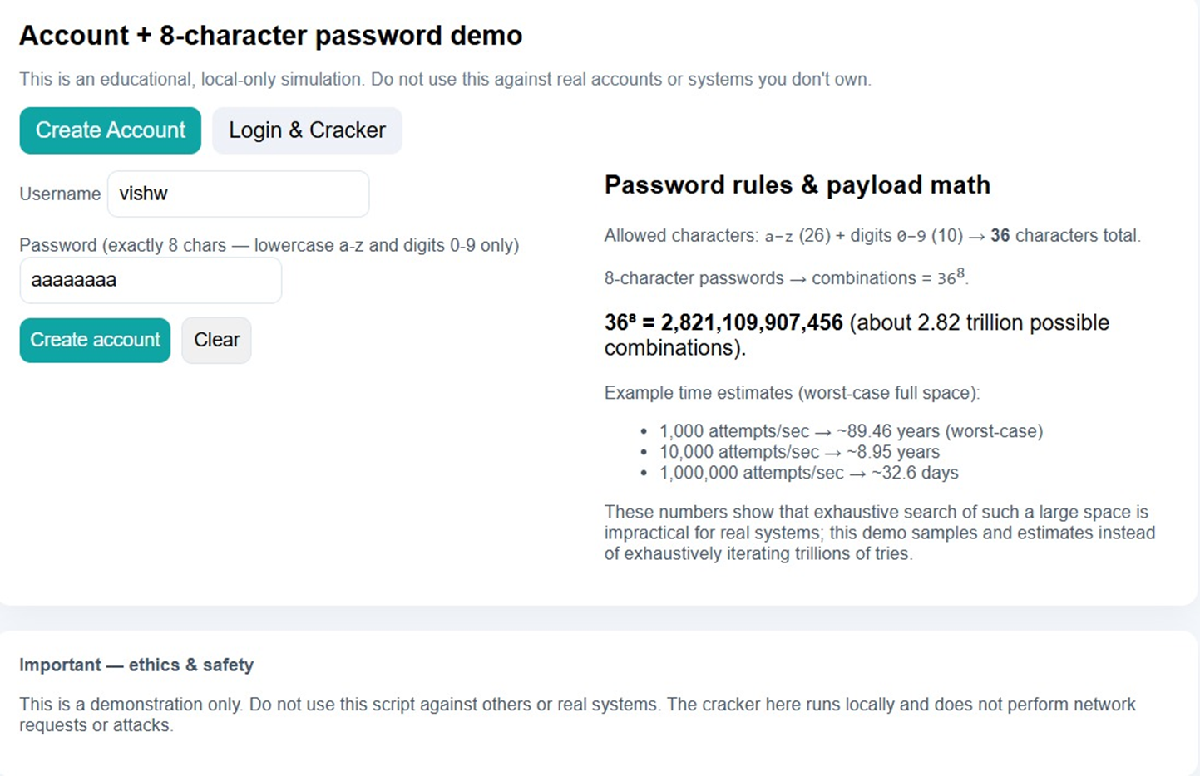
->Shows total keyspace (36⁸)
->Estimates time to crack based on speed
->Highlights importance of password strength

4. Brute Force Simulation for 8-Character Password
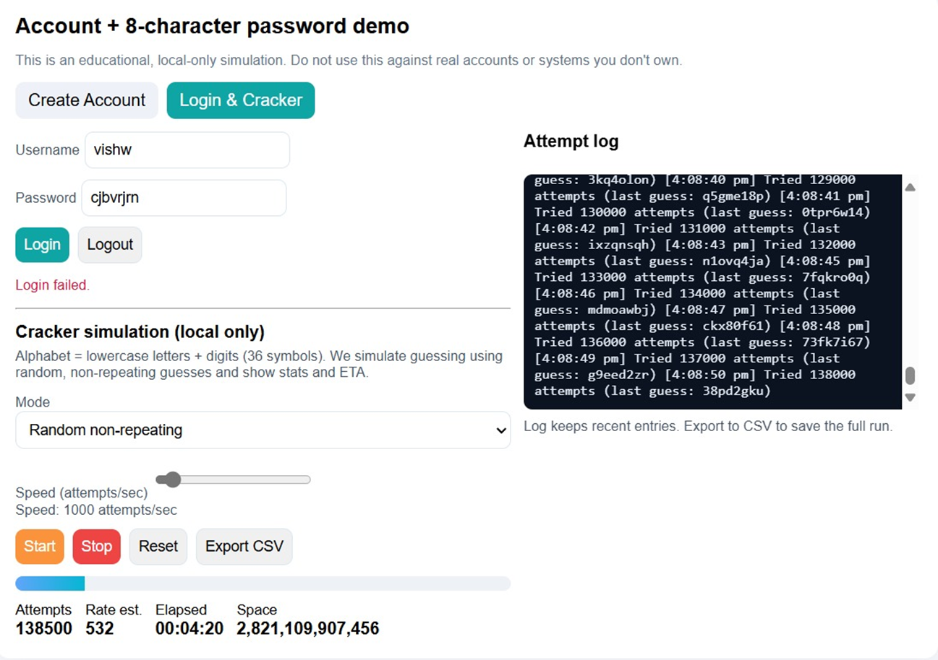
->Demonstrates how long it takes to crack a simple password
Visual progress bar and live stats

Password Generation & Complexity
Password generation is the process of creating secure, unpredictable strings that serve as authentication credentials. The strength of a password is determined by its complexity, which directly affects how resistant it is to cracking attempts. Complexity is influenced by several factors:

1. Length

Longer passwords exponentially increase the number of possible combinations.

For example, a password with 8 characters from a set of 36 (a–z, 0–9) has:

368=2,821,109,907,456 combinations36^8 = 2,821,109,907,456 \text{ combinations}

Increasing the length to 10 characters raises this to over 3.6 quadrillion combinations.
2. Character Set Diversity
Including uppercase letters, lowercase letters, digits, and symbols expands the character set.

A password using all 94 printable ASCII characters (e.g., Aa1@) is far harder to crack than one using only lowercase letters

3. Entropy
Entropy measures unpredictability. Higher entropy means more randomness.

A password like x7$Bq9!L has high entropy, while password123 has low entropy due to common patterns.
4. Avoiding Predictable Patterns
Avoid dictionary words, keyboard sequences (qwerty, 123456), and personal info (birthdates, names).

Attackers use these patterns in dictionary and rule-based attacks.
5. Password Generators
Tools like Bitwarden, LastPass, or custom scripts can generate random, complex passwords.

6. Complexity vs Usability
Highly complex passwords may be hard to remember.
Solution: Use passphrases (e.g., CorrectHorseBatteryStaple) or password managers.
7. Impact on Cracking Time
A simple 8-character password using only lowercase letters can be cracked in seconds.
A 12-character password with mixed characters may take centuries at 1 million attempts per second.

*Password Generation Techniques

1.Manual Creation:-
Users often choose memorable but weak passwords.
Example: sunshine123 (predictable, low entropy)

2.Passphrases:-
Combine unrelated words for strength and memorability.
Example: PurpleTigerDrinksTea

3.Random Generators
Use scripts or password managers to create unpredictable strings.
Example: x7$Bq9!L@2

4.Pattern-Based Generation
Use masks like ?u?l?l?d?d to enforce structure.
Example: Abe12x (1 uppercase, 2 lowercase, 2 digits)

Future Enhancements
While the current password cracking simulation provides a safe and educational experience, there are several opportunities to expand its functionality, realism, and interactivity. These future enhancements aim to improve technical depth, user engagement, and alignment with real-world cybersecurity practices.
To make the simulation more realistic and educational, the following features are proposed:
1. Hash-Based Cracking Support
Current Limitation: Passwords are stored and compared in plaintext.
Enhancement: Implement support for common hashing algorithms such as:
MD5, SHA-1, SHA-256
bcrypt, PBKDF2, Argon2
Benefit: Simulates realistic cracking scenarios where attackers must reverse hashed values.
2. Salt Handling
Enhancement: Introduce salt values during password storage and simulate cracking with salt.
Benefit: Demonstrates how salts protect against rainbow table attacks and increase cracking complexity.
3. Dictionary Import & Rule Engine
Enhancement: Allow users to upload custom wordlists and apply transformation rules (e.g., password → P@ssw0rd123).
Benefit: Enables dictionary and rule-based attacks, mimicking tools like Hashcat.
4. AI-Powered Guessing
Enhancement: Integrate basic AI models to generate guesses based on user behavior or common patterns.
Benefit: Shows how machine learning can improve cracking efficiency and simulate targeted attacks.
5. Advanced Statistics & Visualization
Enhancement: Add charts and graphs to display:
Guess distribution
Cracking speed trends
Entropy analysis
Benefit: Makes the simulation more interactive and data-driven.
6. Multi-User Support
Enhancement: Allow creation and management of multiple demo accounts.
Benefit: Simulates real-world environments with multiple targets and access levels.
7. Offline Mode with Exportable Reports
Enhancement: Enable full offline functionality and generate downloadable PDF or CSV reports.
Benefit: Useful for classroom demonstrations, workshops, and academic submissions.
8. Ethical Hacking Sandbox
Enhancement: Create a sandbox environment where users can ethically test cracking techniques against simulated systems.

Benefit: Encourages responsible learning and aligns with cybersecurity certifications.
9. Modular Architecture
Enhancement: Refactor codebase to support plug-and-play modules (e.g., new cracking algorithms, UI themes).
Benefit: Makes the tool extensible and easier to maintain or customize.
10.Offline Hash Mode (with Salt):
-> Accept a password hash (and optional salt) and test guesses locally to show how real cracking works.
->Demonstrates real-world cracking techniques

11.Wordlists + Simple Rules-
->Let users upload/choose common wordlists
->apply transforms (add “123”, capitalize) so attacks look practical, not random.

12.Consent + Wipe Controls
-> Require a permission checkbox before running
->add a one-click “Wipe demo data” to erase local Storage for safety.

13.Visual Presets & Charts
-> Add one-click scenarios (e.g., “Weak PIN”, “Salted hash”)
->simple charts (attempts/sec, ETA) to teach faster

Hashing & Salting (Future Scope)
.As password security evolves, hashing and salting have become essential techniques for protecting stored credentials. While the current simulation uses plaintext passwords for simplicity, future enhancements will incorporate hashing and salting to reflect real-world authentication systems and demonstrate more advanced cracking scenarios.
Hashing: A hash is a one-way transformation of a password into a scrambled string. It cannot be reversed, making it ideal for secure storage
Salting: A salt is a random value added to the password before hashing. It ensures that identical passwords produce different hashes, preventing rainbow table attacks.
What Is Hashing?
Hashing is a one-way cryptographic transformation that converts a password into a fixed-length string.
Common algorithms include:
MD5: Fast but outdated and vulnerable to collisions.
SHA-1 / SHA-256: More secure, widely used in modern systems.
bcrypt / Argon2: Designed for password hashing with built-in resistance to brute-force attacks.
What Is Salting?
Salting adds a unique, random string (salt) to each password before hashing.
This prevents attackers from using precomputed hash tables (rainbow tables).
Even if two users have the same password, their hashes will be different due to unique salts.
Why It Matters:
one-way transform: password → scrambled string (not reversible)
random value added before hashing (unique per password)
Salting prevents rainbow-table attacks and makes identical passwords produce different hashes
Future enhancement: Offline Hash Mode (with salt) to demo real comparisons safely
Hashing protects passwords from being stored in plaintext.
Salting adds uniqueness and security to each password.
Together, they form the foundation of secure authentication systems.
Educational Simulation (Future Scope)
In future versions of the simulation:
Users will create accounts with passwords that are hashed and salted before storage.
The cracker module will simulate hash-based attacks, requiring:
Hash comparison logic
Dictionary or brute-force guess hashing
Optional salt handling
This will allow learners to explore:
Hash collisions
Salt reuse vulnerabilities
Cracking time differences between algorithms
Learning Outcomes
Understand how modern systems store passwords securely.
Learn why plaintext storage is dangerous.
Explore how attackers attempt to reverse hashes using brute-force or dictionary attacks.
Appreciate the role of salting in defending against rainbow tables.
Future Enhancement: The simulation can be extended to include offline hash mode with salting, allowing users to test guesses against real hashed values safely.

Real-World Importance
1. Cybersecurity Defense

Penetration Testing: Ethical hackers use password cracking tools to identify weak credentials during security audits.

Vulnerability Assessment: Organizations simulate attacks to evaluate how easily their systems can be breached.

Incident Response: Forensic teams may need to recover passwords from compromised systems to investigate breaches.

2. User Awareness & Education

Many users still rely on weak passwords like 123456, password, or personal info.

Demonstrating how easily these can be cracked helps promote:

Strong password habits

Use of password managers

Adoption of multi-factor authentication (MFA)

3. Enterprise Risk Management

Data Breaches: Weak passwords are a leading cause of corporate data leaks.

Compliance: Industries like finance and healthcare must meet strict password policies under regulations like GDPR, HIPAA, and PCI-DSS.

Reputation Damage: A single cracked admin password can lead to massive financial and reputational loss.

🧠 4. Ethical Hacking & Certifications
Password cracking is a core skill in certifications such as:

CEH (Certified Ethical Hacker)

OSCP (Offensive Security Certified Professional)

Simulations help learners understand attack vectors and defense strategies.

⚠️ 5. Criminal Exploitation

Unauthorized Access: Attackers use cracking tools to break into accounts, steal data, or deploy ransomware.

Credential Stuffing: Reusing cracked passwords across multiple sites leads to widespread compromise.

Dark Web Markets: Cracked credentials are sold or traded, fueling cybercrime.

🧪 6. Research & Innovation

Password cracking simulations contribute to:

Cryptographic research

Development of stronger hashing algorithms

Studies on human password behavior

Security Risks of Weak Passwords:
Easy to guess or crack
Leads to data breaches, identity theft, and unauthorized access

Ethical Cracking:
Helps security teams identify vulnerabilities
Used in penetration testing and audits with permission

Best Practices:
Use of strong, unique passwords reduces risk
Enable multi-factor authentication (MFA)
Never reuse passwords across accounts
Security Risks of Weak Passwords
Easily Guessable Patterns Many users still rely on predictable passwords like 123456, password, or their birthdate. These are the first guesses in any dictionary or brute-force attack, making them highly vulnerable.

Credential Stuffing Attacks When users reuse passwords across multiple platforms, a breach on one site can lead to unauthorized access on others. Attackers use automated tools to test stolen credentials on various services.

Plaintext Storage by Companies Some organizations store passwords without hashing or encryption. If breached, attackers gain direct access to user credentials, as seen in the 2019 Facebook incident.

Social Engineering Amplification Weak passwords make it easier for attackers to combine technical and psychological tactics (like phishing) to gain access to sensitive systems.

Educational Value: This project raises awareness about password strength and cracking techniques, helping users make informed decisions about their digital security.

20. Conclusion
Password cracking is a powerful concept that highlights the importance of strong authentication practices. Through this simulation, we’ve demonstrated how different cracking methods work and how even simple passwords can be vulnerable.
The project emphasizes ethical use, educational value, and future enhancements like hash comparison and salting. By understanding the mechanics of cracking, users can better protect themselves and contribute to safer digital environments.
Key Takeaways:-
Cracking Techniques in Action: The simulation showcased multiple cracking strategies — including brute-force, random sampling, and sequential guessing — to illustrate how attackers approach password recovery.
Vulnerability of Weak Passwords: Users witnessed firsthand how short or predictable passwords (e.g., abc123xy) can be cracked in seconds, even with limited computational power.
Importance of Complexity: The project emphasized how password length, character diversity, and randomness significantly increase resistance to attacks, making cracking exponentially harder.
Educational Value
This simulation was designed with a strong focus on learning and awareness:
It provides a safe, local-only environment to explore password security without any risk to real systems.
It helps users understand the mathematical scale of password spaces and the impact of entropy.
It encourages the adoption of best practices, such as using password managers, avoiding reuse, and enabling multi-factor authentication.
Ethical Emphasis
Throughout the project, ethical boundaries were clearly defined:
All cracking was performed on locally stored demo accounts.

The tool includes explicit warnings and consent prompts to reinforce responsible use.
No real-world systems, networks, or hashed credentials were targeted or simulated.
Looking Ahead
The simulation lays the groundwork for future enhancements, including:
Hash-based cracking using algorithms like SHA-256 or bcrypt
Salting mechanisms to demonstrate modern password storage practices
Dictionary and rule-based attacks for more realistic simulations
Advanced analytics and visualization to deepen user understanding

21. References

OWASP Foundation – Password Storage Cheat Sheet

NIST Guidelines on Digital Identity

Mozilla Developer Network (MDN) – JavaScript Documentation

Wikipedia – Password Cracking

Ethical Hacking Tutorials and Blogs

