**update接口字段置空**

问题背景：通过update接口置空一个或多个字段

实现逻辑：更新接口入参中"needSetNullAttrs"表示用户需置空的字段集合，多个字段以逗号分隔

样例：

<http://hicuat.huawei.com/rdm_general_app/services/api/DM20201031GY/update>

入参：

{

"params": {

"creator": "liuyongfang 00442553",

"modifier": "liuyongfang 00442553",

"id": "198096685224800256",

"name": "test",

"description": null,

"xx": null,

"aaaaaaaaaaaaaaa": "3.00000000000",

"aaaaaaaaaaaaaaa_Unit": "Y",

"kiaGuid": null,

"securityLevel": "secret",

"needSetNullAttrs": [

"description",

"xx"

]

}

}

出参：

{

"result": "SUCCESS",

"data": [

{

"id": "198096685224800256",

"creator": "liuyongfang 00442553",

"createTime": "2021-02-02T15:25:30.000+0800",

"modifier": "liuyongfang 00442553",

"lastUpdateTime": "2021-02-02T15:26:47.000+0800",

"name": "test",

"description": null,

"rdmVersion": 4,

"rdmOperationType": "UPDATE",

"kiaGuid": null,

"securityLevel": "secret",

"xx": null,

"aaaaaaaaaaaaaaa": "3.00000000000",

"rdmExtensionType": "DM20201031GY",

"aaaaaaaaaaaaaaa_Unit": {

"unitType": "T",

"enName": "24",

"name": "4",

"unitSymbol": "Y"

}

}

],

"errors": []

}

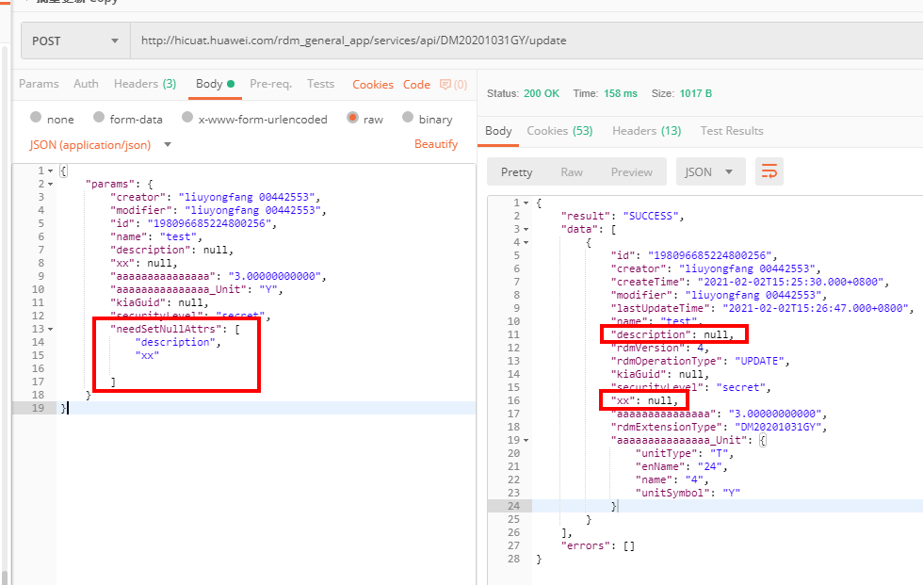  
  
批量更新接口也是同样原理，参考如下：

