Machine Learning HW5-2

309551064 張凱翔
1. Code With Detailed Explanations
The figure below is my main function.
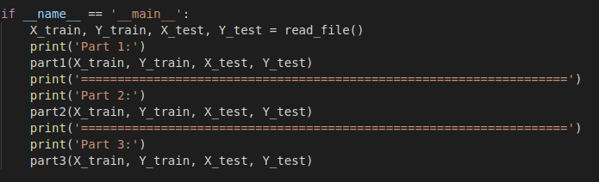
First, I read data from “X_train.csv”, “Y_train.csv”, “X_test.csv” and “Y_test.csv with numpy function “loadtxt” and parameters setting with dtype=np.float and delimeter=’,’ respectively.
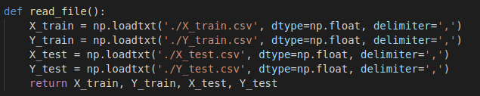
Part 1.
After reading files, I call the function named part1.
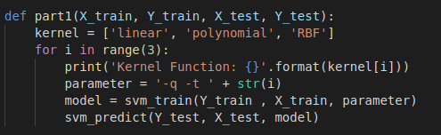

I initialize a list with different kernel name and follow the order of the parameters in [1] and add parameters ‘-q’ to disable screen output of ‘svm_train’ found in [2].
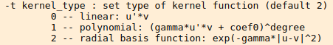

At last, call ‘svm_train’ and ‘svm_predict’ to train the model with different kernels and evaluate them.

Part 2.
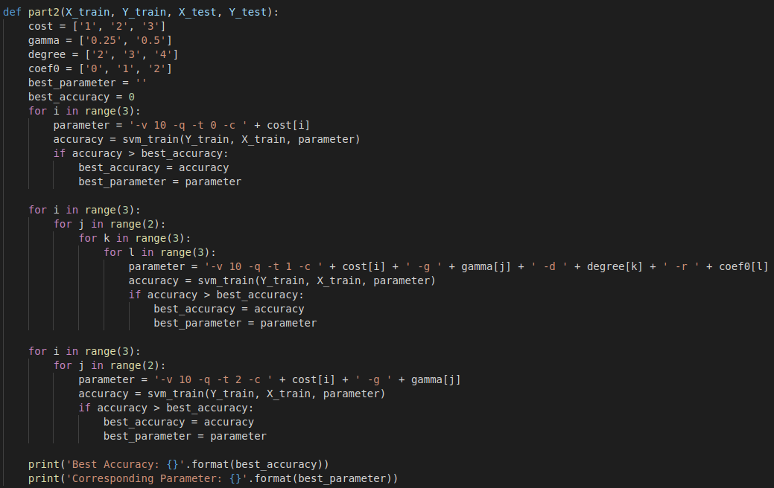
After finishing the function part1, I call the function named part2.
First, I initialize four lists of different parameters for grid search and two variables to store best parameters and accuracy.
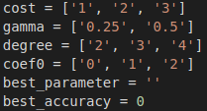

The first one is linear kernel and it has no specific parameters needed to set, so I only set parameters of cross-validation ‘-v 10’ for 10-folds, ‘-q’ to disable screen output of ‘svm_train’, ‘-t 0’ for linear kernel and ‘-c *’ for different costs to C-SVC. After calculating one accuracy, it will compare with the best one and update if needed.
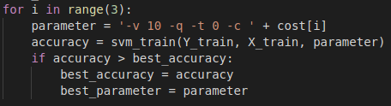

The second one is polynomial kernel and it has three specific parameters degree, gamma and coef0 needed to set respectively. I set parameters of cross-validation ‘-v 10’ for 10-folds, ‘-q’ to disable screen output of ‘svm_train’, ‘-t 1’ for polynomial kernel, ‘-c *’ for different costs to C-SVC, ‘-g *’ for different gammas, ‘-d *’ for different degrees and ‘-r *’ for different coef0s. After calculating one accuracy, it will compare with the best one and update if needed.
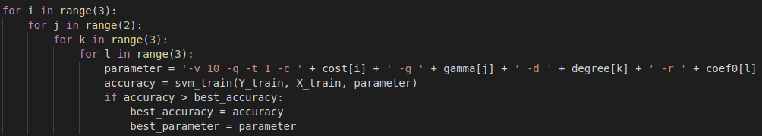
The last one is RBF kernel and it has one specific parameters gamma needed to set. I set parameters of cross-validation ‘-v 10’ for 10-folds, ‘-q’ to disable screen output of ‘svm_train’, ‘-t 2’ for RBF kernel, ‘-c *’ for different costs to C-SVC and ‘-g *’ for different gammas. After calculating one accuracy, it will compare with the best one and update if needed.
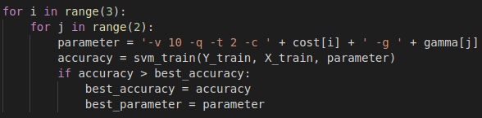
Finally, I output the best parameters and accuracy.

Part 3.
After finishing the function part2, I call the function named part3.
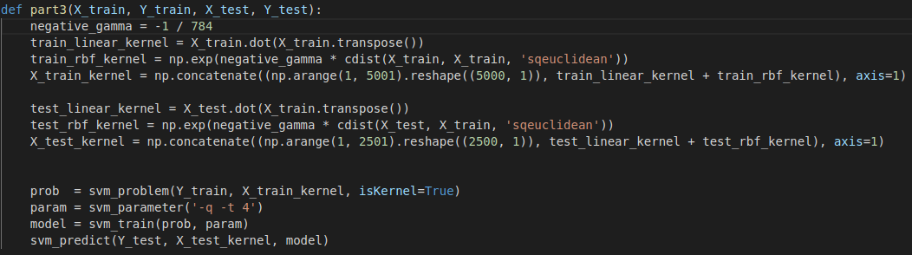
To use a user-defined kernel, I should calculate training data and testing data according to the kernel needed to use and original data.

Linear Kernel:
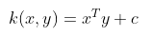

RBF Kernel:
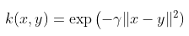
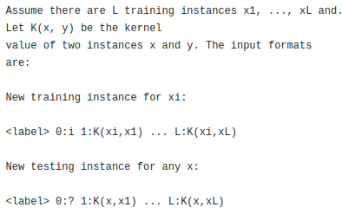

I calculate the data with kernel functions according to the input of the figure above, add the two kernel data and add a label in front of each data just like the format asked to.
At last, call ‘svm_problem’ and set ‘isKernel=True’ for precomputed kernel, set parameters ‘-q’ to disable screen output of ‘svm_train’ and ‘-t 4’ for precomputed kernel to predict the result.

2. Experiments Settings and Results
Part 1.
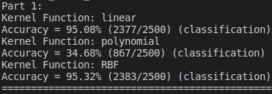

Part 2.
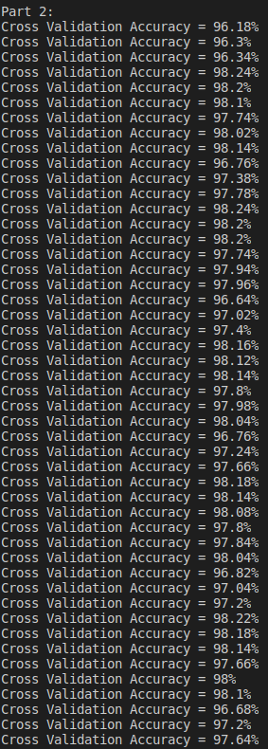
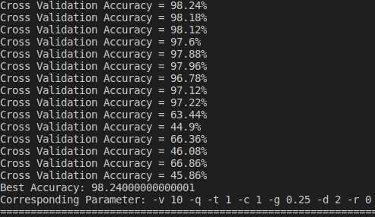
Part 3.

3. Observation and Discussion
I add polynomial kernel with parameters ‘alpha=1’, ‘c=0’ and ‘d=3’ to part3 and predict the result.
Polynomial kernel:
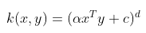
The result is much better than linear + RBF kernel but it is still a little bit lower than the result of grid search, so I think grid search is necessary for the best result.

Reference:
[1] https://www.jianshu.com/p/e9cd040de6ce
[2] https://www.csie.ntu.edu.tw/~cjlin/libsvm/
[3] https://www.csie.ntu.edu.tw/~cjlin/libsvm/faq.html
[4] http://crsouza.com/2010/03/17/kernel-functions-for-machine-learning-applications/
[5] https://github.com/cjlin1/libsvm/blob/master/README
[6] https://blog.csdn.net/Olaking/article/details/43017329
[7] http://blog.sina.com.cn/s/blog_664f17ce0102w5rd.html

