**Public leaderboard**

**Environment**

Anaconda

Python 3.9.15

numpy 1.23.4

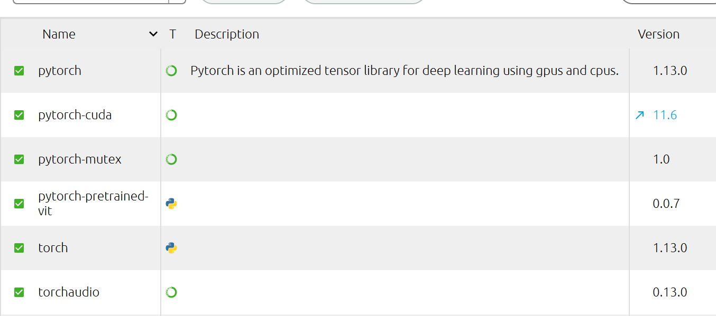



**Implementation details**

1. Model architecture

I test the performance of ResNet, WideResNet, DenseNet, Vision Transformer.

Eventually, I use ResNet152 for task1 and ResNet50 for task2 and task3. All of them are pretrained. However, the pretrained models for task1 and task2 are pretrained on ImageNet, while task3 is pretrained on my task2.

1. Hyperparameters

Adam is used in all tasks.

Task1:

My best model performance occurs in learning rate 0.005, batch size 500 and no data augmentations.

Task2:

Learning rate 0.008, batch size 32 with data augmentations.

Task3:

Learning rate = 0.001, batch size 32 with data augmentations.

1. Used deep learning framework

I use pytorch to train and evaluate all tasks.

1. Only task1 does not perform addition transformation and augmentation such as color jittering and random perspective.

**Model weights**: [Link](https://drive.google.com/drive/u/1/folders/11dUI_MjCJm8EhKLD7vBgse02hC8zWX6V)