Module 2 Tutorial - Understanding the Command Line and Django

I'm unsure why I found this assignment so challenging. I was not successful in moving the "moveme.txt" file from the "myfolder" directory to its parent directory, and I'm currently unclear on the reason. Additionally, I couldn't find the correct command to create a new text file in the "useful commands" section of the tutorial. I tried using "notepad filename.txt," which was one of the results I found on Google. I will continue to practice these tasks as they do seem very useful!

Part One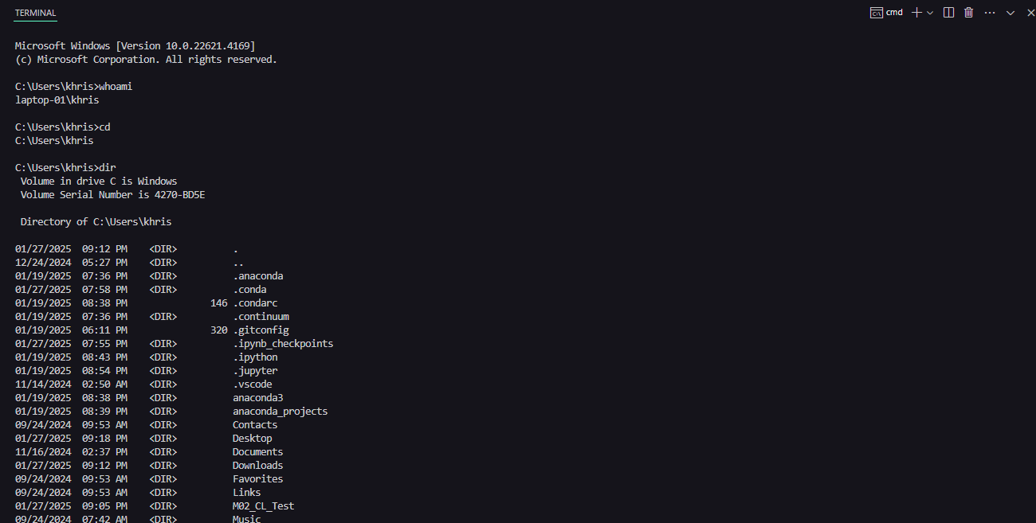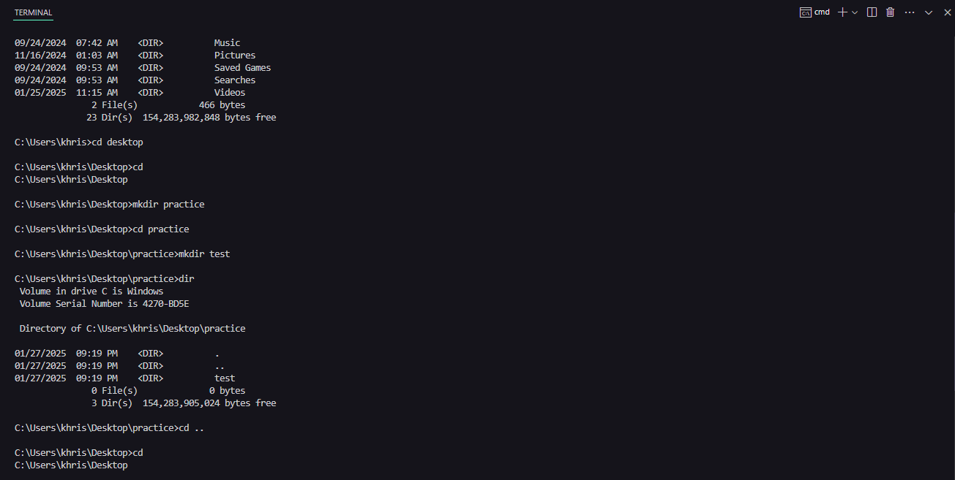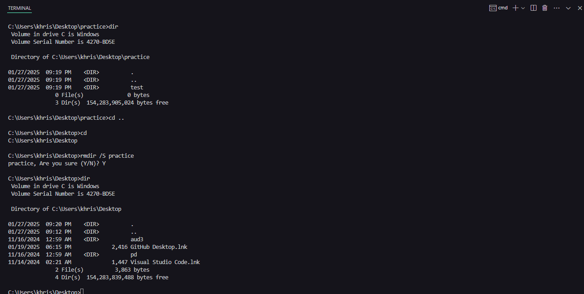

## Part 2

