Reddit Sentiment Analysis Instructions

1. Create an API here: <https://old.reddit.com/prefs/apps/>
2. Select ‘script’ and put <http://localhost:8080> as the redirect uri (or any valid url, like https://www.google.com). This allows web apps to redirect users to a URI after an API request happens. In our case, we don’t [really need it](https://www.reddit.com/r/redditdev/comments/5mzts3/what_do_you_put_in_for_redirect_uri_i_keep/), but it’s required to create the app. Then click ‘create app’.

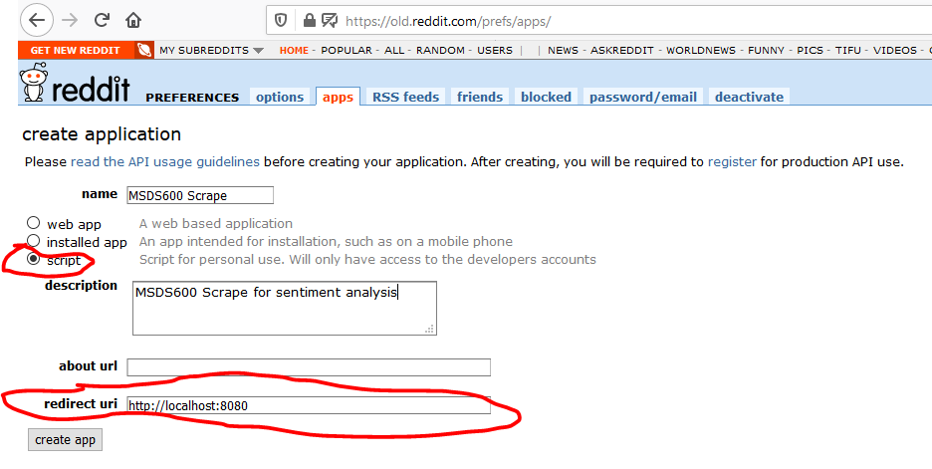

1. This screen has the User agent, Client_ID, and Client_secret for using PRAW.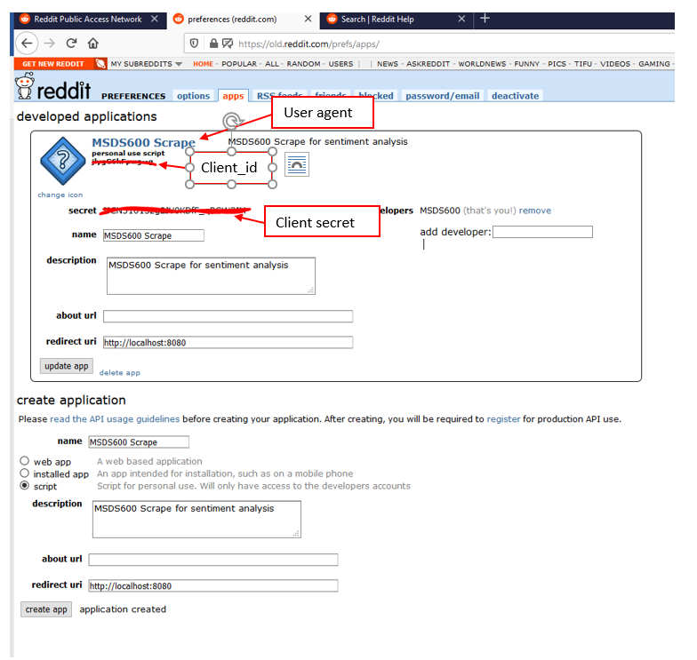
2. Open a Terminal or command prompt (assuming Anaconda is in your Path, otherwise open the Anaconda Prompt, or run from within Jupyter) and type:

conda install praw -y

This installs the PRAW package. If a library does not install via conda for whatever reason, you can also try pip:

pip install praw