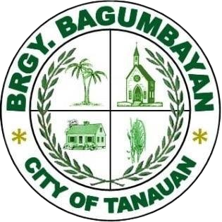**Republic Act of the Philippines  
Barangay Bagumbayan  
Tanauan City, Batangas  
  
BARANGAY CLEARANCE**

______________________________________________________________________________________________________________

**BARANGAY CLEARANCE**

**TO WHOM IT MAY CONCERN:  
  
This is to certify that, based on the records of this Barangay, the person whose name and personal circumstances are indicated below has not been accused nor has a pending case with Barangay Bagumbayan involving moral turpitude or any act contrary to existing law:  
  
First Name:** 6u **Middle Name:** ytu **Last Name:** yti **Address:** ti **Purpose:** Government Transactions

This certification is issued upon the request of the above-named person to support whatever legal purposes it may serve best.  
  
Given this ____ day of __________ 20__ at Barangay Bagumbayan, Tanauan City, Batangas, Philippines.  
  
HON. **********  
  
Punong Barangay