1. **AIM**

* Learn a new language by native speakers’ school learning technology.
* Make expert in language by proper understanding method.

1. **RISKS**

* Less users

1. **TAKS PERFORMED**

* nothing

1. **REQUIREMENTS DESCRIPTION**

* Contains the following tabs
* **Beginners’ :**

Contains **the** following Items

* **Letters:** Based on language it changes some are vowels, consonants, dialects’, conjuncts, so on. User should follows such tags. In Sanskrit shisha
* **Simple Vocabulary and Sentences:** User can understand the language what natives speak like how are you, what is up, some common things.
* **Intermediate :**

Contains the following Items

* **Deep Grammar:** Based on language it changes some are sandhi, nanartha, paryayapadha, samasa, active/passive, tense, so on. In Sanskrit vyakarana
* **Deep Vocabulary and Sentences:** User can speak fluent and understand scripts like ramayana, bharatha, bagavatha, examples only. Like differs in others languages.
* **Etymology:** User can find words roots. In Sanskrit nirutha Shastra(nigantu).
* **Expert :**
* **(No heading decided):** User can able to write poems, stories in deep. Some are chandas, based on language it changes. In Sanskrit Chanda
* **Deep research:** In Sanskrit kalpa, jyothisha
* **Scripts :**
* **Ancient Texts:** Available old texts.
* **Modern Texts:** Available new texts.
* **Own Texts :**
* **No Headings it is like Facebook feeds:** User can upload his own scripts.
* **Dictionary :**
* **Custom Dictionary:** User can add his own words. In addition, share it to others for references. It should also contains tables
* **Transliteration :**
* Converting one script text to other but not meaning. Like అవును for avunu.
* **Games :**
* **New Concept:** May contains crossword, jumble, error find in words, match, choose, so on.

1. **SOFTWARES USING**

* **IDE :** Microsoft Visual Studio 2017
* **Framework :** .NET Framework v4.6.2
* **GUI :** ASP.NET MVC, WPF, Xamarin.
* **Database :** MySQL
* **ORM :** ADO.NET

1. **FLOW OF TOOLS**

* **See this image**

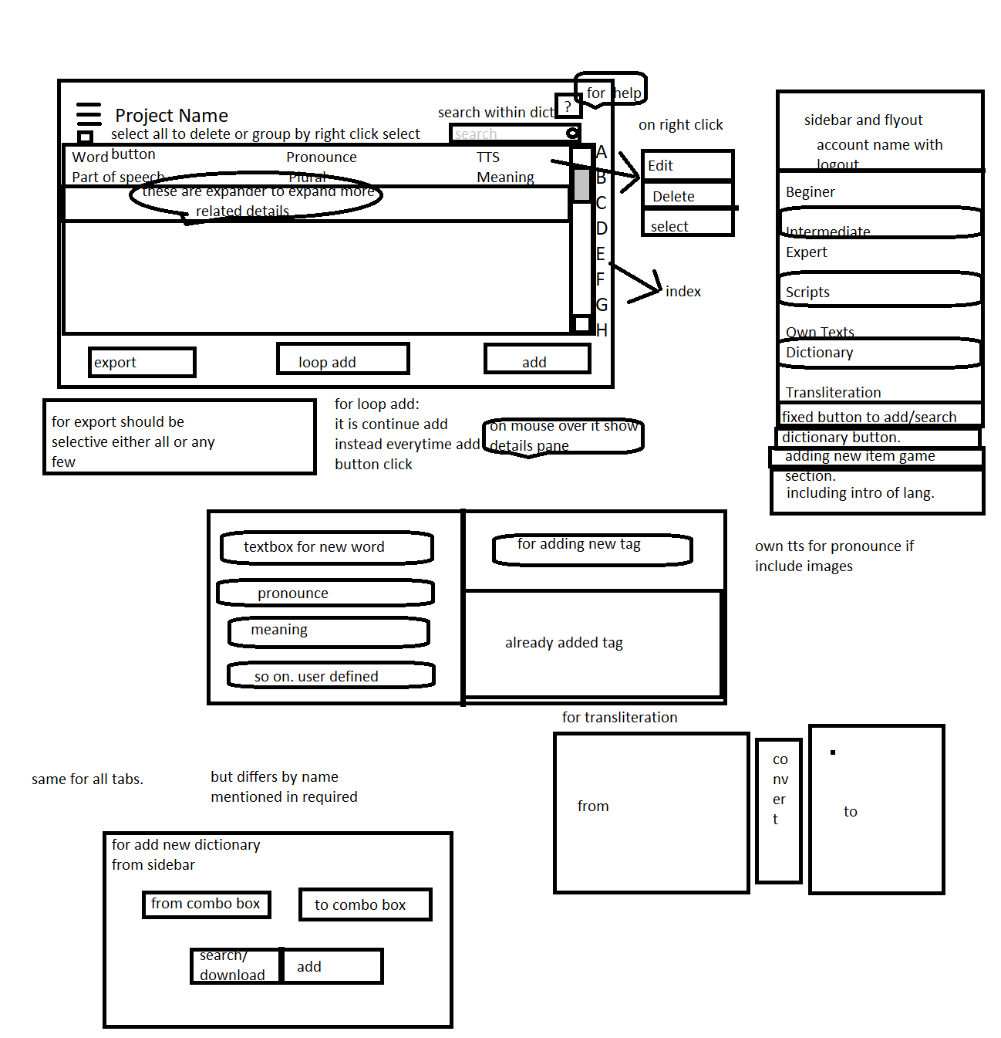

1. **OPEN ITEMS**

* **In Local SQLite or sql server.**
* **Comparing WebAPI with WCF.**
* **UI should more friendly**
* **In web, wpf, (uwp, android) -> for reading purpose only if want to edit or change or add use web or wpf.**
* **All should contains refernce, external links, comments(talk).**
* **In word processing:**
* **Heading**
* **Bold**
* **Italic**
* **Underline**
* **Sub script**
* **Super script**
* **Ins script**
* **Center**
* **Left**
* **Right**
* **Justify**
* **Table**
* **Images**
* **Hr line**
* **Font and size**
* **Links**
* **Merge 2 files**
* **Bullets**
* **Color**
* **Style**
* **Highlight**
* **Line indent and space**
* **Case change**
* **Find/replace**

1. **Test scenarios:**

* **NA.**

1. **Results/Reports:**

* **NA.**

1. **Refernce**

* **https://m.mediawiki.org/wiki/Manual:Database_layout**