Resilience Survey Overview

Valentyn Hatsko

Andriy Koval

Last updated: 2023-01-20

Table of Contents

This report visualizes key information about Resilience Survey

***Important Definitions***

Research Sample: Hromadas who responded to the survey.

# Environment

Reviews the components of the working environment of the report. Non-technical readers are welcomed to skip. Come back if you need to understand the origins of custom functions, scripts, or data objects.

Packages used

Packages used in current report

External scripts

Collection of custom functions used in current repository (sda-information-requests)

Global values

Values used throughout the report.

Functions

Custom functions defined for use in this report.

# Data

## Input

click to glimpse

Rows: 138  
Columns: 282  
$ index <dbl> 2, 3, 5, 6, 7, 8, 9, 11, 12, 13, 14, 15~  
$ today <dttm> 2022-10-12, 2022-10-12, 2022-10-19, 20~  
$ `_id` <dbl> 191541757, 191560222, 193449048, 193452~  
$ hromada_code <chr> "UA12060190000043514", "UA4606037000006~  
$ hromada_name <chr> "Лозуватська", "Пустомитівська", "Поміч~  
$ hromada_full_name <chr> "Лозуватська сільська громада", "Пустом~  
$ raion_code <chr> "UA12060000000022633", "UA4606000000004~  
$ raion_name <chr> "Криворізький", "Львівський", "Новоукра~  
$ oblast_code <chr> "UA12000000000090473", "UA4600000000002~  
$ oblast_name <chr> "Дніпропетровська", "Львівська", "Кіров~  
$ type <chr> "сільська", "міська", "міська", "селищн~  
$ occupation <chr> "not_occupied", NA, "not_occupied", "no~  
$ military_action <chr> "no_combat", NA, "no_combat", "no_comba~  
$ population_text <dbl> 18957, 16133, 12000, 14500, 4742, 18851~  
$ partners_text <dbl> 0, 1, 0, 0, 5, 0, 0, 0, 0, 0, NA, 0, 4,~  
$ friends_text <dbl> 0, 3, 0, 0, 0, 0, 0, 0, 0, 0, NA, 0, 4,~  
$ state_communication <chr> "yes", "yes", "no", "yes", "yes", "yes"~  
$ prep_first_aid_water <dbl> 1, 1, 1, 1, 1, 2, 1, 1, 1, 1, 0, 1, 1, ~  
$ prep_first_aid_fuel <dbl> 2, 1, 1, 0, 2, 0, 2, NA, 1, 1, 0, NA, 1~  
$ prep_reaction_plan <dbl> 2, 2, 2, 2, 2, 2, 0, 1, 1, 1, 0, 1, 2, ~  
$ prep_evacuation_plan <dbl> 2, 0, 2, 2, 1, 2, 1, 1, 1, 1, 0, 1, 2, ~  
$ prep_reaction_plan_oth_hromadas <dbl> 1, 0, 0, 1, 1, 0, 0, 1, 1, 1, 0, 1, 1, ~  
$ prep_reaction_plan_oda <dbl> 2, 0, 2, 1, 1, 2, 0, 1, 1, 1, 0, 0, 1, ~  
$ prep_dftg_creation <dbl> NA, 1, 1, 1, 1, 0, 1, 1, 1, 0, 2, 1, 1,~  
$ prep_national_resistance <dbl> 1, 1, 0, 0, 1, 0, 0, 1, 1, 0, 0, 0, 1, ~  
$ prep_starosta_meeting <dbl> 2, 1, 1, 1, 1, 2, 1, 1, 1, 1, 0, 2, 1, ~  
$ prep_communal_meetiing <dbl> 2, 1, 1, 1, 1, 1, 1, NA, 1, 1, 0, 2, 1,~  
$ prep_online_map <dbl> 2, 2, 1, 1, 2, 0, 0, NA, 0, 0, 0, 0, 0,~  
$ prep_shelter_list <dbl> 2, 2, 1, 1, 2, 2, 1, 1, 0, 1, 0, 0, 2, ~  
$ prep_notification_check <dbl> 2, 2, 1, 1, 0, 0, 1, NA, 1, 1, 0, 0, 2,~  
$ prep_backup <dbl> 2, 0, 1, 0, 2, 0, 0, NA, 0, 0, 0, 0, 1,~  
$ prep_partly_backup <dbl> NA, NA, 1, 1, 2, 0, 0, 1, 1, 0, 0, 0, 2~  
$ shelter_capacity_before_text <chr> "близько 1600 осіб", "1518 - місткість ~  
$ shelter_capacity_before_coded <dbl> 1600, 1518, 2000, 20, 2000, 600, 1000, ~  
$ shelter_capacity_now_text <chr> "близько 1600 осіб (+найпростіші)", "15~  
$ shelter_capacity_now_coded <dbl> NA, NA, NA, NA, NA, NA, NA, NA, NA, NA,~  
$ telegram <dbl> 2, 0, 1, 1, 2, 0, 0, 0, 0, 2, 0, 0, 2, ~  
$ viber <dbl> 2, 0, 0, 0, 0, 0, 0, 2, 2, 2, 0, 0, 0, ~  
$ facebook <dbl> 2, 2, 2, 2, 2, 2, 2, 2, 2, 2, 0, 2, 2, ~  
$ chat_help <dbl> 0, 0, 0, 0, 1, 0, 0, 0, 1, 0, 0, 0, 1, ~  
$ hotline <dbl> 0, 2, 0, 0, 2, 0, 1, 2, 2, 0, 0, 2, 2, ~  
$ telegram_link <chr> "https://t.me/loz_sirena/", NA, "https:~  
$ facebook_link <chr> "https://www.facebook.com/lozuvatka.otg~  
$ head_hromada_communication <chr> "few_times_a_week", "once_a_day", "few_~  
$ dftg_creation <chr> "still_not", "yes", "still_not", "yes",~  
$ dftg_creation_date <dttm> NA, 2022-02-25, NA, 2022-02-25, 2022-0~  
$ help_for_military <chr> "rooms transport money products other",~  
$ `help_for_military/rooms` <dbl> 1, 1, 1, 1, 0, NA, 1, 0, 1, 0, NA, 1, N~  
$ `help_for_military/transport` <dbl> 1, 0, 1, 1, 0, NA, 1, 0, 1, 1, NA, 0, N~  
$ `help_for_military/money` <dbl> 1, 1, 1, 1, 1, NA, 1, 0, 1, 0, NA, 1, N~  
$ `help_for_military/products` <dbl> 1, 1, 1, 1, 1, NA, 1, 1, 1, 1, NA, 1, N~  
$ `help_for_military/other` <dbl> 1, 0, 0, 0, 0, NA, 1, 1, 0, 1, NA, 1, N~  
$ `help_for_military/none` <dbl> 0, 0, 0, 0, 0, NA, 0, 0, 0, 0, NA, 1, N~  
$ help_for_military_text <chr> "Амуніція, різні пристрої та апаратура"~  
$ transport_help_communal <chr> "5", NA, "4", "-", NA, NA, "1", NA, "1"~  
$ transport_help_bought <chr> "0", NA, "0", "3-4", NA, NA, "0", NA, "~  
$ transport_help_communal_coded <dbl> 5, NA, 4, 0, NA, NA, 1, NA, 1, 0, NA, N~  
$ transport_help_bought_coded <dbl> 0, NA, 0, 4, NA, NA, 0, NA, 2, 0, NA, N~  
$ percent_working_march <dbl> 95.0, 98.0, 100.0, 100.0, 100.0, 90.0, ~  
$ percent_working_now <dbl> 95.0, 100.0, 100.0, 100.0, 100.0, 85.0,~  
$ commun_between_hromadas <chr> "Daily", "Daily", "Several times a mont~  
$ evacuation <chr> "no", "no", "no", "no", "no", "yes_note~  
$ idp_accept <chr> "yes", NA, "yes", "yes", "yes", NA, "ye~  
$ idp_registration_date <dttm> 2022-02-26, NA, 2022-02-25, 2022-02-25~  
$ idp_registration_number <dbl> 959, NA, 1162, 1600, 370, NA, 101, 1115~  
$ idp_real_number <dbl> 1420, NA, 1220, 1600, 410, NA, 101, 111~  
$ idp_help <chr> "communal_placement humanitar_help empl~  
$ `idp_help/communal_placement` <dbl> 1, NA, 1, 1, 1, NA, 0, 0, 1, 0, NA, 0, ~  
$ `idp_help/private_placement` <dbl> 0, NA, 1, 1, 1, NA, 1, 0, 1, 1, NA, 1, ~  
$ `idp_help/regular_meal` <dbl> 0, NA, 0, 1, 0, NA, 0, 0, 0, 0, NA, 0, ~  
$ `idp_help/humanitar_help` <dbl> 1, NA, 1, 1, 1, NA, 1, 1, 1, 1, NA, 1, ~  
$ `idp_help/fundraising` <dbl> 0, NA, 0, 0, 0, NA, 0, 0, 1, 0, NA, 0, ~  
$ `idp_help/employ` <dbl> 1, NA, 0, 0, 0, NA, 1, 0, 0, 0, NA, 0, ~  
$ `idp_help/psych_help` <dbl> 1, NA, 1, 1, 1, NA, 1, 1, 1, 0, NA, 0, ~  
$ `idp_help/law_help` <dbl> 1, NA, 0, 0, 0, NA, 0, 1, 1, 0, NA, 0, ~  
$ `idp_help/transit_center` <dbl> 1, NA, 0, 0, 0, NA, 0, 0, 0, 0, NA, 0, ~  
$ idp_place_rooms <chr> "101_250_beds", NA, "0_100_beds", "over~  
$ idp_room_number <chr> NA, NA, NA, "1600", NA, NA, NA, NA, NA,~  
$ idp_child_education <dbl> 18, NA, 21, 200, 26, NA, 7, NA, 15, 17,~  
$ special_fund_relocation <chr> "yes", "yes", "no", "no", "no", "no", "~  
$ special_fund_relocation_needs <chr> "defense public_order", "economic_activ~  
$ `special_fund_relocation_needs/state_functions` <dbl> 0, 0, NA, NA, NA, NA, NA, NA, 0, NA, NA~  
$ `special_fund_relocation_needs/defense` <dbl> 1, 0, NA, NA, NA, NA, NA, NA, 0, NA, NA~  
$ `special_fund_relocation_needs/public_order` <dbl> 1, 0, NA, NA, NA, NA, NA, NA, 0, NA, NA~  
$ `special_fund_relocation_needs/economic_activity` <dbl> 0, 1, NA, NA, NA, NA, NA, NA, 0, NA, NA~  
$ `special_fund_relocation_needs/environment` <dbl> 0, 0, NA, NA, NA, NA, NA, NA, 0, NA, NA~  
$ `special_fund_relocation_needs/utilities` <dbl> 0, 1, NA, NA, NA, NA, NA, NA, 1, NA, NA~  
$ `special_fund_relocation_needs/spirit_development` <dbl> 0, 0, NA, NA, NA, NA, NA, NA, 0, NA, NA~  
$ `special_fund_relocation_needs/education` <dbl> 0, 0, NA, NA, NA, NA, NA, NA, 0, NA, NA~  
$ `special_fund_relocation_needs/social_protection` <dbl> 0, 1, NA, NA, NA, NA, NA, NA, 0, NA, NA~  
$ `special_fund_relocation_needs/healthcare` <dbl> 0, 1, NA, NA, NA, NA, NA, NA, 0, NA, NA~  
$ relocated_companies_text <chr> "0", NA, "0", "0", "0", NA, "0", "0", "~  
$ created_jobs <chr> "dk", NA, "dk", "dk", "dk", NA, "dk", "~  
$ bussiness_stimules <chr> "tax_benefits", NA, "free_rooms", "othe~  
$ `bussiness_stimules/tax_benefits` <dbl> 1, NA, 0, 0, 0, NA, 0, 0, 0, 1, NA, 0, ~  
$ `bussiness_stimules/free_rooms` <dbl> 0, NA, 1, 0, 0, NA, 0, 0, 0, 0, NA, 0, ~  
$ `bussiness_stimules/education` <dbl> 0, NA, 0, 0, 1, NA, 0, 0, 0, 0, NA, 0, ~  
$ `bussiness_stimules/other` <dbl> 0, NA, 0, 1, 0, NA, 1, 1, 1, 0, NA, 1, ~  
$ bussiness_stimules_none <dbl> 0, NA, 0, 1, 0, NA, 0, 0, 1, 0, NA, 1, ~  
$ bussiness_stimules_other <chr> NA, NA, NA, "-", NA, NA, "відстрочка в ~  
$ humanitarian_hub <chr> NA, NA, NA, NA, NA, "no", NA, NA, NA, N~  
$ hromada_cooperation <chr> NA, NA, NA, NA, NA, "other", NA, NA, NA~  
$ `hromada_cooperation/medicine` <dbl> NA, NA, NA, NA, NA, 0, NA, NA, NA, NA, ~  
$ `hromada_cooperation/food` <dbl> NA, NA, NA, NA, NA, 0, NA, NA, NA, NA, ~  
$ `hromada_cooperation/pensions` <dbl> NA, NA, NA, NA, NA, 0, NA, NA, NA, NA, ~  
$ `hromada_cooperation/evacuation` <dbl> NA, NA, NA, NA, NA, 0, NA, NA, NA, NA, ~  
$ `hromada_cooperation/other` <dbl> NA, NA, NA, NA, NA, 1, NA, NA, NA, NA, ~  
$ `hromada_cooperation/none` <dbl> NA, NA, NA, NA, NA, 1, NA, NA, NA, NA, ~  
$ hromada_cooperation_text <chr> NA, NA, NA, NA, NA, "співпраця не відбу~  
$ is_damaged <chr> "no", "no", "no", "no", "no", "yes", "n~  
$ percent_damaged <chr> NA, NA, NA, NA, NA, "0_10_percent", NA,~  
$ damage_evaluation_persons <chr> NA, NA, NA, NA, NA, "no", NA, "yes", NA~  
$ damage_evaluation_communal <chr> NA, NA, NA, NA, NA, "no", NA, "yes", NA~  
$ damage_evaluation_bussiness <chr> NA, NA, NA, NA, NA, "no", NA, "yes", NA~  
$ reconstruction_plan <chr> NA, NA, NA, NA, NA, NA, NA, "yes", NA, ~  
$ reconstruction_financing <chr> NA, NA, NA, NA, NA, NA, NA, "no", NA, N~  
$ reconstruction_financing_text <chr> NA, NA, NA, NA, NA, NA, NA, NA, NA, NA,~  
$ international_projects <chr> "0", NA, "1", "1", "3", NA, "0", NA, "0~  
$ percent_reconstructed <chr> NA, NA, NA, NA, NA, NA, NA, "76_100_per~  
$ finance_school_shelters <chr> "0", NA, "50 000 грн.", "не маємо інфор~  
$ finance_school_shelters_coded <dbl> 0, NA, 50000, NA, 520671, NA, 286900, 7~  
$ info_campaign <dbl> 1, NA, 0, 1, 1, NA, 1, 1, 1, 0, NA, 0, ~  
$ reserves <dbl> 1, NA, 1, 1, 1, NA, 1, 1, 1, 0, NA, 1, ~  
$ count_power_sources <dbl> 1, NA, 0, 1, 1, NA, 1, NA, 1, 0, NA, 1,~  
$ count_heaters_need <dbl> 0, NA, 0, 1, 1, NA, 0, NA, 0, 0, NA, 0,~  
$ solid_fuel_boiler <dbl> 0, NA, 0, 1, 1, NA, 0, NA, NA, 0, NA, 0~  
$ no_school_days <chr> "Дистанційно проводились в усі навчальн~  
$ no_school_days_coded <chr> "0", NA, "0", "0", "81", NA, "0", NA, "~  
$ hromada_exp <chr> "yes", "yes", "no", "no", "yes", "no", ~  
$ hromada_problem_info <chr> "idp bussiness", "citizens bussiness", ~  
$ `hromada_problem_info/idp` <dbl> 1, 0, NA, NA, 0, NA, NA, NA, 1, 0, NA, ~  
$ `hromada_problem_info/citizens` <dbl> 0, 1, NA, NA, 1, NA, NA, NA, 0, 1, NA, ~  
$ `hromada_problem_info/bussiness` <dbl> 1, 1, NA, NA, 1, NA, NA, NA, 0, 1, NA, ~  
$ `hromada_problem_info/experts` <dbl> 0, 0, NA, NA, 0, NA, NA, NA, 0, 0, NA, ~  
$ `hromada_problem_info/ngo` <dbl> 0, 0, NA, NA, 0, NA, NA, NA, 0, 0, NA, ~  
$ `hromada_problem_info/nobody` <dbl> 0, 0, NA, NA, 0, NA, NA, NA, 0, 0, NA, ~  
$ hromada_problem_consultation <chr> "idp", "bussiness", NA, NA, "citizens e~  
$ `hromada_problem_consultation/idp` <dbl> 1, 0, NA, NA, 0, NA, NA, NA, 0, 0, NA, ~  
$ `hromada_problem_consultation/citizens` <dbl> 0, 0, NA, NA, 1, NA, NA, NA, 0, 0, NA, ~  
$ `hromada_problem_consultation/bussiness` <dbl> 0, 1, NA, NA, 0, NA, NA, NA, 0, 0, NA, ~  
$ `hromada_problem_consultation/experts` <dbl> 0, 0, NA, NA, 1, NA, NA, NA, 0, 0, NA, ~  
$ `hromada_problem_consultation/ngo` <dbl> 0, 0, NA, NA, 1, NA, NA, NA, 0, 0, NA, ~  
$ `hromada_problem_consultation/nobody` <dbl> 0, 0, NA, NA, 0, NA, NA, NA, 1, 1, NA, ~  
$ hromada_problem_proposition <chr> "citizens", "nobody", NA, NA, "idp citi~  
$ `hromada_problem_proposition/idp` <dbl> 0, 0, NA, NA, 1, NA, NA, NA, 0, 0, NA, ~  
$ `hromada_problem_proposition/citizens` <dbl> 1, 0, NA, NA, 1, NA, NA, NA, 0, 0, NA, ~  
$ `hromada_problem_proposition/bussiness` <dbl> 0, 0, NA, NA, 1, NA, NA, NA, 1, 0, NA, ~  
$ `hromada_problem_proposition/experts` <dbl> 0, 0, NA, NA, 0, NA, NA, NA, 0, 0, NA, ~  
$ `hromada_problem_proposition/ngo` <dbl> 0, 0, NA, NA, 0, NA, NA, NA, 0, 0, NA, ~  
$ `hromada_problem_proposition/nobody` <dbl> 0, 1, NA, NA, 0, NA, NA, NA, 0, 1, NA, ~  
$ hromada_problem_system <chr> "idp", "bussiness", NA, NA, "citizens b~  
$ `hromada_problem_system/idp` <dbl> 1, 0, NA, NA, 0, NA, NA, NA, 0, 0, NA, ~  
$ `hromada_problem_system/citizens` <dbl> 0, 0, NA, NA, 1, NA, NA, NA, 0, 0, NA, ~  
$ `hromada_problem_system/bussiness` <dbl> 0, 1, NA, NA, 1, NA, NA, NA, 1, 0, NA, ~  
$ `hromada_problem_system/experts` <dbl> 0, 0, NA, NA, 1, NA, NA, NA, 0, 0, NA, ~  
$ `hromada_problem_system/ngo` <dbl> 0, 0, NA, NA, 1, NA, NA, NA, 0, 0, NA, ~  
$ `hromada_problem_system/nobody` <dbl> 0, 0, NA, NA, 0, NA, NA, NA, 0, 1, NA, ~  
$ hromada_problem_feedback <chr> "idp", "bussiness", NA, NA, "idp citize~  
$ `hromada_problem_feedback/idp` <dbl> 1, 0, NA, NA, 1, NA, NA, NA, 0, 0, NA, ~  
$ `hromada_problem_feedback/citizens` <dbl> 0, 0, NA, NA, 1, NA, NA, NA, 0, 0, NA, ~  
$ `hromada_problem_feedback/bussiness` <dbl> 0, 1, NA, NA, 1, NA, NA, NA, 0, 0, NA, ~  
$ `hromada_problem_feedback/experts` <dbl> 0, 0, NA, NA, 1, NA, NA, NA, 0, 0, NA, ~  
$ `hromada_problem_feedback/ngo` <dbl> 0, 0, NA, NA, 0, NA, NA, NA, 0, 0, NA, ~  
$ `hromada_problem_feedback/nobody` <dbl> 0, 0, NA, NA, 0, NA, NA, NA, 1, 1, NA, ~  
$ hromada_problem_execution <chr> "idp citizens", "bussiness", NA, NA, "c~  
$ `hromada_problem_execution/idp` <dbl> 1, 0, NA, NA, 0, NA, NA, NA, 0, 0, NA, ~  
$ `hromada_problem_execution/citizens` <dbl> 1, 0, NA, NA, 1, NA, NA, NA, 0, 0, NA, ~  
$ `hromada_problem_execution/bussiness` <dbl> 0, 1, NA, NA, 1, NA, NA, NA, 0, 0, NA, ~  
$ `hromada_problem_execution/experts` <dbl> 0, 0, NA, NA, 0, NA, NA, NA, 0, 0, NA, ~  
$ `hromada_problem_execution/ngo` <dbl> 0, 0, NA, NA, 0, NA, NA, NA, 1, 0, NA, ~  
$ `hromada_problem_execution/nobody` <dbl> 0, 0, NA, NA, 0, NA, NA, NA, 0, 1, NA, ~  
$ skills_needed <chr> "fundraising project_management", "fund~  
$ `skills_needed/fundraising` <dbl> 1, 1, 1, 1, 1, 1, 1, 1, 0, 1, 1, 1, 0, ~  
$ `skills_needed/project_management` <dbl> 1, 1, 1, 1, 0, 0, 0, 1, 0, 1, 1, 1, 0, ~  
$ `skills_needed/longterm_planning` <dbl> 0, 0, 1, 1, 0, 0, 0, 1, 0, 0, 1, 1, 0, ~  
$ `skills_needed/crisis_planning` <dbl> 0, 1, 0, 1, 0, 0, 1, 1, 0, 0, 0, 1, 1, ~  
$ `skills_needed/data_analysis` <dbl> 0, 1, 0, 1, 0, 0, 0, 0, 0, 0, 1, 1, 0, ~  
$ `skills_needed/human_resourse` <dbl> 0, 0, 1, 1, 0, 0, 1, 0, 1, 0, 1, 0, 0, ~  
$ `skills_needed/other` <dbl> 0, 0, 0, 0, 0, 0, 0, 0, 0, 0, 0, 0, 0, ~  
$ skills_needed_text <chr> NA, NA, NA, NA, NA, NA, NA, NA, NA, NA,~  
$ contact_text <chr> "Петренко Ігор, 0980913068", "Ірина При~  
$ evacuation_001 <chr> "no", "no", "no", "no", "no", "yes_note~  
$ hromada_exp_problem <lgl> NA, NA, NA, NA, NA, NA, NA, NA, NA, NA,~  
$ `_uuid` <chr> "699df016-92c6-406e-a2d2-4c62a7b47e1c",~  
$ `_submission_time` <dttm> 2022-10-12 11:35:13, 2022-10-12 12:25:~  
$ `_validation_status` <lgl> NA, NA, NA, NA, NA, NA, NA, NA, NA, NA,~  
$ `_status` <chr> "submitted_via_web", "submitted_via_web~  
$ `_submitted_by` <lgl> NA, NA, NA, NA, NA, NA, NA, NA, NA, NA,~  
$ `_tags` <lgl> NA, NA, NA, NA, NA, NA, NA, NA, NA, NA,~  
$ region_en <chr> "East", "West", "Center", "Center", "Ce~  
$ `idp_help/communal_placement_number` <dbl> 959, NA, 1162, 1600, 370, NA, 0, 0, 565~  
$ `idp_help/private_placement_number` <dbl> 0, NA, 1162, 1600, 370, NA, 101, 0, 565~  
$ `idp_help/regular_meal_number` <dbl> 0, NA, 0, 1600, 0, NA, 0, 0, 0, 0, NA, ~  
$ `idp_help/humanitar_help_number` <dbl> 959, NA, 1162, 1600, 370, NA, 101, 1115~  
$ `idp_help/fundraising_number` <dbl> 0, NA, 0, 0, 0, NA, 0, 0, 565, 0, NA, 0~  
$ `idp_help/employ_number` <dbl> 959, NA, 0, 0, 0, NA, 101, 0, 0, 0, NA,~  
$ `idp_help/psych_help_number` <dbl> 959, NA, 1162, 1600, 370, NA, 101, 1115~  
$ `idp_help/law_help_number` <dbl> 959, NA, 0, 0, 0, NA, 0, 1115, 565, 0, ~  
$ `idp_help/transit_center_number` <dbl> 959, NA, 0, 0, 0, NA, 0, 0, 0, 0, NA, 0~  
$ idp_help_count <dbl> 627, 627, 627, 627, 627, 627, 627, 627,~  
$ prep_count <dbl> 23, 14, 16, 14, 20, 13, 9, 10, 12, 10, ~  
$ comm_channels_count <dbl> 6, 4, 3, 3, 7, 2, 3, 6, 7, 6, 0, 4, 7, ~  
$ help_military_count <dbl> 5, 3, 4, 4, 2, 0, 5, 2, 4, 3, 0, 4, 0, ~  
$ hromada_cooperation_count <dbl> 0, 0, 0, 0, 0, 2, 0, 0, 0, 0, 1, 0, 3, ~  
$ dftg_creation_time <chr> "2", NA, "1", "1", "7", NA, "0", "36", ~  
$ idp_registration_time <chr> NA, "1", NA, "1", "1", NA, "0", "5", "1~  
$ prep_winter_count <dbl> 3, 0, 1, 5, 5, 0, 3, 2, 3, 0, 0, 2, 0, ~  
$ oblast_center <dbl> 0, 0, 0, 0, 0, 0, 0, 0, 0, 0, 0, 0, 1, ~  
$ hromada_center_code <chr> "UA12060190010077883", "UA4606037001003~  
$ hromada_center <chr> "Лозуватка", "Пустомити", "Помічна", "Н~  
$ lat_center <dbl> 48.06131, 49.71896, 48.24331, 48.66450,~  
$ lon_center <dbl> 33.28102, 23.90473, 31.40372, 30.80485,~  
$ travel_time <dbl> 160.3, 27.5, 88.1, 112.2, 141.1, 93.8, ~  
$ n_settlements <dbl> 32, 10, 4, 21, 10, 8, 9, 33, 15, 3, 68,~  
$ square <dbl> 563.8, 95.7, 77.4, 487.6, 209.7, 250.7,~  
$ occipied_before_2022 <dbl> 0, 0, 0, 0, 0, 0, 0, 0, 0, 0, 0, 0, 0, ~  
$ total_population_2022 <dbl> 18464, 15121, 9738, 12161, 4111, 16755,~  
$ urban_population_2022 <dbl> 1312, 9372, 8608, 5882, 0, 10108, 0, 26~  
$ urban_pct <dbl> 0.07105719, 0.61980028, 0.88395975, 0.4~  
$ budget_code <chr> "04579000000", "13573000000", "11513000~  
$ budget_name <chr> "Бюджет Лозуватської сільської територі~  
$ oblast_name_en <chr> "Driproptrovska", "Lviv", "Kirovograd",~  
$ region_en.x <chr> "East", "West", "Center", "Center", "Ce~  
$ region_code_en <chr> "E", "W", "C", "C", "C", "S", "S", "N",~  
$ income_total_2021 <dbl> 67902340, 83142969, 49372216, 59091396,~  
$ income_transfert_2021 <dbl> 28360223, 26747544, 14842391, 26289209,~  
$ income_military_2021 <dbl> 165437.16, 1471468.72, 161315.18, 45314~  
$ income_pdfo_2021 <dbl> 21860190, 33743437, 23556614, 18257048,~  
$ income_unified_tax_2021 <dbl> 5038856.5, 7871346.5, 1446555.9, 429707~  
$ income_property_tax_2021 <dbl> 5898847.8, 9690968.4, 6446093.4, 601961~  
$ income_excise_duty_2021 <dbl> 3740238.35, 1989744.71, 1370209.27, 296~  
$ income_own_2021 <dbl> 39542117, 56395425, 34529825, 32802187,~  
$ own_income_prop_2021 <dbl> 0.58, 0.68, 0.70, 0.56, 0.61, 0.55, 0.3~  
$ transfert_prop_2021 <dbl> 0.42, 0.32, 0.30, 0.44, 0.39, 0.45, 0.6~  
$ military_tax_prop_2021 <dbl> 0.00, 0.02, 0.00, 0.01, 0.00, 0.00, 0.0~  
$ pdfo_prop_2021 <dbl> 0.32, 0.41, 0.48, 0.31, 0.15, 0.29, 0.1~  
$ unified_tax_prop_2021 <dbl> 0.07, 0.09, 0.03, 0.07, 0.05, 0.06, 0.0~  
$ property_tax_prop_2021 <dbl> 0.09, 0.12, 0.13, 0.10, 0.34, 0.13, 0.1~  
$ excise_duty_prop_2021 <dbl> 0.06, 0.02, 0.03, 0.05, 0.01, 0.05, 0.0~  
$ own_income_change <dbl> 0.06, 0.30, -0.02, 0.03, -0.35, -0.55, ~  
$ own_prop_change <dbl> 0.03, 0.06, 0.04, 0.05, -0.07, -0.20, -~  
$ total_income_change <dbl> 0.02, 0.19, -0.07, -0.06, -0.26, -0.29,~  
$ income_own <dbl> 41909616, 73349537, 33842591, 33684971,~  
$ income_total <dbl> 69264708, 99182114, 45977305, 55515961,~  
$ income_transfert <dbl> 27355092, 25832577, 12134714, 21830990,~  
$ dfrr_executed <dbl> NA, 51740.635, NA, 8979.148, 611.900, 4~  
$ turnout_2020 <dbl> 0.3736239, 0.4272969, 0.2801991, 0.3610~  
$ sex_head <chr> "female", "female", "female", "female",~  
$ age_head <dbl> 45, 40, 62, 56, 65, 64, 66, 63, 61, 54,~  
$ education_head <chr> "higher", "higher", "higher", "higher",~  
$ incumbent <dbl> 0, 1, 1, 1, 1, 1, 0, 0, 1, 1, 1, 0, 0, ~  
$ rda <dbl> 1, 0, 0, 0, 0, 0, 0, 0, 0, 0, 0, 0, 0, ~  
$ not_from_here <dbl> 0, 0, 0, 0, 0, 0, 0, 1, 0, 0, 0, 1, 0, ~  
$ party <chr> "Слуга народу", "Самовисування", "Самов~  
$ enterpreuner <dbl> 0, 0, 0, 0, 0, 0, 0, 0, 0, 0, 0, 0, 0, ~  
$ unemployed <dbl> 0, 0, 0, 0, 0, 0, 0, 0, 0, 0, 0, 0, 0, ~  
$ priv_work <dbl> 0, 1, 0, 0, 0, 0, 0, 0, 0, 0, 0, 0, 1, ~  
$ polit_work <dbl> 1, 0, 1, 1, 0, 1, 1, 1, 1, 1, 1, 1, 0, ~  
$ communal_work <dbl> 0, 0, 0, 0, 0, 0, 0, 0, 0, 0, 0, 0, 0, ~  
$ ngo_work <dbl> 0, 0, 0, 0, 0, 0, 0, 0, 0, 0, 0, 0, 0, ~  
$ party_national_winner <dbl> 1, 0, 0, 0, 0, 0, 0, 0, 0, 0, 0, 0, 0, ~  
$ no_party <dbl> 0, 1, 1, 1, 1, 1, 0, 1, 1, 1, 0, 1, 0, ~  
$ male <dbl> 0, 0, 0, 0, 1, 0, 0, 0, 0, 1, 0, 0, 0, ~  
$ high_educ <dbl> 1, 1, 1, 1, 1, 1, 1, 1, 1, 1, 1, 1, 1, ~  
$ sum_osbb_2020 <dbl> NA, 29, 28, 6, NA, NA, NA, 12, NA, NA, ~  
$ edem_total <dbl> 1, 2, 0, 0, 0, 0, 0, 0, 0, 1, 0, 0, 2, ~  
$ edem_petitions <dbl> 0, 1, 0, 0, 0, 0, 0, 0, 0, 1, 0, 0, 1, ~  
$ edem_consultations <dbl> 1, 0, 0, 0, 0, 0, 0, 0, 0, 0, 0, 0, 1, ~  
$ edem_participatory_budget <dbl> 0, 0, 0, 0, 0, 0, 0, 0, 0, 0, 0, 0, 0, ~  
$ edem_open_hromada <dbl> 0, 1, 0, 0, 0, 0, 0, 0, 0, 0, 0, 0, 0, ~  
$ youth_councils <dbl> 0, 0, 0, 0, 0, 0, 0, 0, 0, 0, 0, 0, 1, ~  
$ youth_centers <dbl> 0, 2, 0, 0, 0, 0, 0, 0, 0, 0, 0, 0, 0, ~  
$ business_support_centers <dbl> 0, 1, 0, 0, 0, 1, 0, 0, 1, 0, 1, 0, 17,~  
$ region_en.y <chr> "East", "West", "Center", "Center", "Ce~  
$ creation_date <dttm> 2020-08-16, 2020-08-16, 2017-08-20, 20~  
$ creation_year <dbl> 2020, 2020, 2017, 2020, 2017, 2020, 201~  
$ time_before_24th <dbl> 556.7917, 556.7917, 1648.7917, 556.7917~  
$ voluntary <dbl> 0, 0, 1, 0, 1, 0, 1, 0, 1, 0, 0, 0, 0, ~  
$ war_zone_27_04_2022 <dbl> 0, 0, 0, 0, 0, 1, 0, 0, 0, 0, 1, 0, 1, ~  
$ war_zone_20_06_2022 <dbl> 0, 0, 0, 0, 0, 1, 0, 1, 0, 0, 1, 0, 1, ~  
$ war_zone_23_08_2022 <dbl> 0, 0, 0, 0, 0, 1, 0, 1, 0, 0, 1, 0, 1, ~  
$ war_zone_10_10_2022 <dbl> 0, 0, 0, 0, 0, 1, 0, 0, 0, 0, 1, 0, 1, ~

# A tibble: 1 x 14  
 group item_~1 label~2 label~3 type name label requi~4 appea~5 media~6 relev~7 const~8 const~9  
 <chr> <dbl> <chr> <chr> <chr> <chr> <chr> <list> <chr> <chr> <chr> <chr> <chr>   
1 preamble NA <NA> <NA> note <NA> "Суп~ <NULL> <NA> kse_in~ <NA> <NA> <NA>   
# ... with 1 more variable: hint <chr>, and abbreviated variable names 1: item_number, 2: label_en,  
# 3: label_ua, 4: required, 5: appearance, 6: `media::image`, 7: relevant, 8: constraint,  
# 9: constraint_message

[1] "UA12060190000043514" "UA46060370000065608" "UA35060190000079777" "UA35020130000045875"  
 [5] "UA53060250000043118" "UA65060250000073379" "UA51040110000040346" "UA59080230000084731"  
 [9] "UA05100110000070795" "UA51100250000055079" "UA65040010000061104" "UA74040130000094076"  
 [13] "UA65100150000057191" "UA12040170000019083" "UA63020090000096294" "UA21120190000082169"  
 [17] "UA63100010000016136" "UA07060370000022360" "UA21020070000015036" "UA21080190000094580"  
 [21] "UA21080150000014443" "UA26060250000064599" "UA21040250000010914" "UA46060230000093092"  
 [25] "UA46080130000077112" "UA21100130000055002" "UA73060250000049790" "UA18020050000058053"  
 [29] "UA74040050000013413" "UA23060230000071243" "UA46100070000076013" "UA32120090000034281"  
 [33] "UA23060130000058533" "UA12100030000084605" "UA51020170000041393" "UA51120070000097161"  
 [37] "UA35020090000039429" "UA21080070000025254" "UA53060070000077527" "UA65020190000013272"  
 [41] "UA21060070000049340" "UA12140150000054570" "UA63120210000075842" "UA12040210000039759"  
 [45] "UA32140070000012102" "UA35040030000074104" "UA12100050000045992" "UA71080450000083423"  
 [49] "UA51120210000054996" "UA59100010000064812" "UA12040030000066040" "UA07080170000013585"  
 [53] "UA71040130000029175" "UA71040090000047664" "UA46080090000029798" "UA32080210000074136"  
 [57] "UA59020050000012539" "UA53060230000098362" "UA59020110000066430" "UA51120230000084853"  
 [61] "UA61060070000098188" "UA74040330000024949" "UA26060090000054411" "UA53040130000097690"  
 [65] "UA53040110000034949" "UA26040230000035526" "UA56080150000069525" "UA56060050000010769"  
 [69] "UA26040130000010870" "UA73060410000077092" "UA05100170000071290" "UA26060170000091466"  
 [73] "UA59080030000075526" "UA05120070000075759" "UA61060130000045755" "UA12080070000077032"  
 [77] "UA26120050000087602" "UA32020230000012716" "UA61020030000060484" "UA23060150000085288"  
 [81] "UA26040110000023512" "UA05060130000030729" "UA35040190000012514" "UA51020110000041005"  
 [85] "UA26100050000019570" "UA63100030000050119" "UA26060110000025739" "UA46020010000073886"  
 [89] "UA56060310000066585" "UA51060030000044366" "UA05020110000052014" "UA18060170000069581"  
 [93] "UA53040030000088898" "UA26040290000025886" "UA26040270000047749" "UA59040010000075530"  
 [97] "UA26060030000011364" "UA26060130000047466" "UA74080150000033167" "UA74100090000064336"  
[101] "UA21020130000047547" "UA65100130000084882" "UA26120070000067596" "UA21040110000099623"  
[105] "UA21120130000025618" "UA46140010000081849" "UA59060110000049734" "UA12140110000060935"  
[109] "UA26040350000024417" "UA12140250000015858" "UA26080070000092582" "UA61060270000084790"  
[113] "UA18040410000025491" "UA48040150000011861" "UA32060030000048241" "UA73040170000011490"  
[117] "UA71020030000059581" "UA74080130000060606" "UA12140270000072109" "UA46100150000087495"  
[121] "UA07020130000036300" "UA74080010000063011" "UA51100070000063635" "UA53060290000047345"  
[125] "UA51140110000053825" "UA56060290000044465" "UA46140030000023506" "UA07060290000054842"  
[129] "UA68040430000052699" "UA51020030000095942" "UA12020130000022909" "UA59040130000041676"  
[133] "UA51120050000071748" "UA65080070000011930" "UA07060390000098670" "UA53040010000091190"  
[137] "UA65020150000047137" "UA71080070000050993"

Next, we define useful sets of variable names to be used throughout the report

click to see the groups

[1] "help_for_military" "evacuation_actions" "idp_help"   
 [4] "special_fund_relocation_needs" "bussiness_stimules" "hromada_cooperation"   
 [7] "hromada_problem_inv_labels" "hromada_problem_info" "hromada_problem_consultation"   
[10] "hromada_problem_proposition" "hromada_problem_system" "hromada_problem_feedback"   
[13] "hromada_problem_execution" "skills_needed"

[1] "prep_first_aid_water" "prep_first_aid_fuel"   
 [3] "prep_reaction_plan" "prep_evacuation_plan"   
 [5] "prep_reaction_plan_oth_hromadas" "prep_reaction_plan_oda"   
 [7] "prep_dftg_creation" "prep_national_resistance"   
 [9] "prep_starosta_meeting" "prep_communal_meetiing"   
[11] "prep_online_map" "prep_shelter_list"   
[13] "prep_notification_check" "prep_backup"   
[15] "prep_partly_backup"

[1] "telegram" "viber" "facebook" "chat_help" "hotline"

[1] "idp_help/communal_placement" "idp_help/private_placement" "idp_help/regular_meal"   
[4] "idp_help/humanitar_help" "idp_help/fundraising" "idp_help/employ"   
[7] "idp_help/psych_help" "idp_help/law_help" "idp_help/transit_center"

[1] "help_for_military/rooms" "help_for_military/transport" "help_for_military/money"   
[4] "help_for_military/products" "help_for_military/other" "help_for_military/none"

[1] "hromada_cooperation/medicine" "hromada_cooperation/food"   
[3] "hromada_cooperation/pensions" "hromada_cooperation/evacuation"  
[5] "hromada_cooperation/other" "hromada_cooperation/none"

[1] "own_income_prop_2021" "transfert_prop_2021" "military_tax_prop_2021"  
[4] "pdfo_prop_2021" "unified_tax_prop_2021" "property_tax_prop_2021"  
[7] "excise_duty_prop_2021"

meta data

Rows: 132  
Columns: 14  
$ group <chr> NA, NA, NA, NA, NA, NA, "preamble", "general_information", "general_inf~  
$ item_number <dbl> NA, NA, NA, NA, NA, NA, NA, NA, NA, NA, NA, NA, NA, NA, NA, NA, NA, NA,~  
$ label_en <chr> NA, NA, NA, NA, NA, NA, NA, NA, NA, NA, NA, NA, NA, NA, NA, NA, NA, NA,~  
$ label_ua <chr> NA, NA, NA, NA, NA, NA, NA, NA, NA, NA, NA, NA, NA, NA, NA, NA, NA, NA,~  
$ type <chr> "start", "end", "today", "deviceid", "begin_group", "begin_group", "not~  
$ name <chr> "start", "end", "today", "deviceid", "general_information", "general_in~  
$ label <chr> NA, NA, NA, NA, NA, NA, "Супротив України у загарбницькій війні Російсь~  
$ required <list> <NULL>, <NULL>, <NULL>, <NULL>, <NULL>, "field-list", <NULL>, TRUE, TR~  
$ appearance <chr> NA, NA, NA, NA, NA, NA, NA, NA, NA, NA, NA, NA, NA, NA, NA, NA, NA, NA,~  
$ `media::image` <chr> NA, NA, NA, NA, NA, NA, "kse_institute.png", NA, NA, NA, NA, NA, NA, NA~  
$ relevant <chr> NA, NA, NA, NA, NA, NA, NA, NA, NA, NA, NA, NA, NA, NA, NA, NA, NA, NA,~  
$ constraint <chr> NA, NA, NA, NA, NA, NA, NA, NA, NA, NA, NA, NA, NA, NA, NA, NA, NA, NA,~  
$ constraint_message <chr> NA, NA, NA, NA, NA, NA, NA, NA, NA, NA, NA, NA, NA, NA, NA, NA, NA, NA,~  
$ hint <chr> NA, NA, NA, NA, NA, NA, "Заповнення опитувальника займе орієнтовно 25 х~

# A tibble: 32 x 5  
 group item_number label_en label_ua type   
 <chr> <dbl> <chr> <chr> <chr>   
 1 <NA> NA <NA> <NA> begin_group  
 2 <NA> NA <NA> <NA> begin_group  
 3 <NA> NA <NA> <NA> end_group   
 4 <NA> NA <NA> <NA> end_group   
 5 <NA> NA <NA> <NA> begin_group  
 6 <NA> NA <NA> <NA> end_group   
 7 <NA> NA <NA> <NA> begin_group  
 8 <NA> NA <NA> <NA> end_group   
 9 <NA> NA <NA> <NA> begin_group  
10 <NA> NA <NA> <NA> begin_group  
11 <NA> NA <NA> <NA> end_group   
12 <NA> NA <NA> <NA> end_group   
13 <NA> NA <NA> <NA> begin_group  
14 <NA> NA <NA> <NA> end_group   
15 <NA> NA <NA> <NA> begin_group  
16 <NA> NA <NA> <NA> end_group   
17 <NA> NA <NA> <NA> begin_group  
18 <NA> NA <NA> <NA> end_group   
19 <NA> NA <NA> <NA> begin_group  
20 <NA> NA <NA> <NA> end_group   
21 <NA> NA <NA> <NA> begin_group  
22 <NA> NA <NA> <NA> end_group   
23 <NA> NA <NA> <NA> begin_group  
24 <NA> NA <NA> <NA> begin_group  
25 <NA> NA <NA> <NA> end_group   
26 <NA> NA <NA> <NA> end_group   
27 <NA> NA <NA> <NA> begin_group  
28 <NA> NA <NA> <NA> begin_group  
29 <NA> NA <NA> <NA> end_group   
30 <NA> NA <NA> <NA> begin_group  
31 <NA> NA <NA> <NA> end_group   
32 <NA> NA <NA> <NA> end_group

Rows: 132  
Columns: 14  
$ group <chr> NA, NA, NA, NA, NA, NA, "preamble", "general_information", "general_inf~  
$ item_number <dbl> NA, NA, NA, NA, NA, NA, NA, NA, NA, NA, NA, NA, NA, NA, NA, NA, NA, NA,~  
$ label_en <chr> NA, NA, NA, NA, NA, NA, NA, NA, NA, NA, NA, NA, NA, NA, NA, NA, NA, NA,~  
$ label_ua <chr> NA, NA, NA, NA, NA, NA, NA, NA, NA, NA, NA, NA, NA, NA, NA, NA, NA, NA,~  
$ type <chr> "start", "end", "today", "deviceid", "begin_group", "begin_group", "not~  
$ name <chr> "start", "end", "today", "deviceid", "general_information", "general_in~  
$ label <chr> NA, NA, NA, NA, NA, NA, "Супротив України у загарбницькій війні Російсь~  
$ required <list> <NULL>, <NULL>, <NULL>, <NULL>, <NULL>, "field-list", <NULL>, TRUE, TR~  
$ appearance <chr> NA, NA, NA, NA, NA, NA, NA, NA, NA, NA, NA, NA, NA, NA, NA, NA, NA, NA,~  
$ `media::image` <chr> NA, NA, NA, NA, NA, NA, "kse_institute.png", NA, NA, NA, NA, NA, NA, NA~  
$ relevant <chr> NA, NA, NA, NA, NA, NA, NA, NA, NA, NA, NA, NA, NA, NA, NA, NA, NA, NA,~  
$ constraint <chr> NA, NA, NA, NA, NA, NA, NA, NA, NA, NA, NA, NA, NA, NA, NA, NA, NA, NA,~  
$ constraint_message <chr> NA, NA, NA, NA, NA, NA, NA, NA, NA, NA, NA, NA, NA, NA, NA, NA, NA, NA,~  
$ hint <chr> NA, NA, NA, NA, NA, NA, "Заповнення опитувальника займе орієнтовно 25 х~

## Transformations

For the state ds0, we augment the focal table of the report with additional columns and transform existing variable to better fit visualization/modeling needs

To make our analysis more nimble we create four alternative versions of ds1 with Invasion Preparedness questions

show transformations

# A tibble: 138 x 4  
 hromada_code prep_score_combo prep_score_feb prep_score_oct  
 <chr> <dbl> <dbl> <dbl>  
 1 UA12060190000043514 23 10 13  
 2 UA46060370000065608 14 4 10  
 3 UA35060190000079777 16 3 13  
 4 UA35020130000045875 14 2 12  
 5 UA53060250000043118 20 6 14  
 6 UA65060250000073379 13 6 7  
 7 UA51040110000040346 9 1 8  
 8 UA59080230000084731 10 0 10  
 9 UA05100110000070795 12 0 12  
10 UA51100250000055079 10 0 10  
# ... with 128 more rows

# A tibble: 3 x 4  
 list_name name label label_en  
 <chr> <chr> <chr> <chr>   
1 commun_prep before_24 Було створено до 24 лютого <NA>   
2 commun_prep after_24 Було створено після 24 лютого <NA>   
3 commun_prep none Немає <NA>

examine the versions

# Variable List

The following variables are present in the processed data table of survey responses:

# 0. Introduction

0.1 What is the goal of this report?

This report overviews the responses to the survey conducted by KSE Institute in Ukraine during 2022

# 1. General Information

Супротив України у загарбницькій війні Російської Федерації великою мірою пов’язаний зі стійкістю, яку виявили територіальні громади.   
Щоб оцінити, як різні потрясіння вплинули на громади та перевірити, які фактори впливають на стійкість громад у війні, Київська Школа Економіки проводить опитування.  
Ми гарантуємо конфіденційність Ваших відповідей. Всі отримані дані будуть аналізуватись тільки в узагальненому вигляді.  
Крайній термін заповнення анкети - 4 листопада.

1.1 How many hromadas contributed responses to so far?

As of 2023-01-20, 138 hromadas contributed valid response to the survey

1.2 What regions are represented in this sample?

| Region | ATCs in the survey | Total number of ATCs | Proportion of Region in the Survey | Proportion of Region in the General Population |
| --- | --- | --- | --- | --- |
| Center | 24 | 298 | 17.4% | 20.7% |
| East | 19 | 281 | 13.8% | 19.5% |
| North | 23 | 243 | 16.7% | 16.9% |
| South | 20 | 192 | 14.5% | 13.4% |
| West | 52 | 424 | 37.7% | 29.5% |

1.3 What oblasts are represented in this sample?

| Oblast | ATCs in the survey | Total number of ATCs | Proportion of Oblast in the Survey | Proportion of Oblast in the General Population |
| --- | --- | --- | --- | --- |
| West |
| Ivano-Frankivsk | 16 | 62 | 11.6% | 4.3% |
| Zakarpatska | 11 | 64 | 8.0% | 4.5% |
| Lviv | 9 | 73 | 6.5% | 5.1% |
| Volyn | 5 | 54 | 3.6% | 3.8% |
| Rivenska | 4 | 64 | 2.9% | 4.5% |
| Ternopilska | 4 | 55 | 2.9% | 3.8% |
| Cherniveska | 3 | 52 | 2.2% | 3.6% |
| South |
| Odesa | 12 | 91 | 8.7% | 6.3% |
| Kherson | 7 | 49 | 5.1% | 3.4% |
| Mykolayiv | 1 | 52 | 0.7% | 3.6% |
| North |
| Sumska | 8 | 51 | 5.8% | 3.5% |
| Chernigiv | 7 | 57 | 5.1% | 4.0% |
| Kyiv-oblast | 5 | 69 | 3.6% | 4.8% |
| Zhytomir | 3 | 66 | 2.2% | 4.6% |
| East |
| Dnipro | 12 | 86 | 8.7% | 6.0% |
| Kharkiv | 4 | 56 | 2.9% | 3.9% |
| Zaporizka | 3 | 67 | 2.2% | 4.7% |
| Donetks | 0 | 46 | NA | 3.2% |
| Luhansk | 0 | 26 | NA | 1.8% |
| Center |
| Poltava | 8 | 60 | 5.8% | 4.2% |
| Cherkassy | 5 | 66 | 3.6% | 4.6% |
| Kirovograd | 5 | 49 | 3.6% | 3.4% |
| Vinnytsia | 5 | 63 | 3.6% | 4.4% |
| Khmelnitsk | 1 | 60 | 0.7% | 4.2% |

1.4 What type of hromadas are represented in the sample?

| Type of Hromada | ATCs in the survey | Total number of ATCs | Proportion of Hromada Type in the Survey | Proportion of Hromada Type in the General Population |
| --- | --- | --- | --- | --- |
| urban | 46 | 409 | 33.3% | 27.8% |
| urban village | 46 | 435 | 33.3% | 29.6% |
| village | 46 | 625 | 33.3% | 42.5% |

1.5 What hromadas experienced military occupation or military actions?

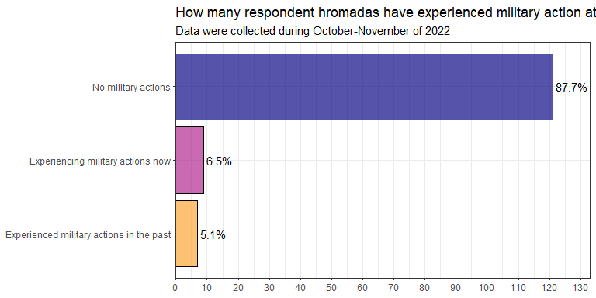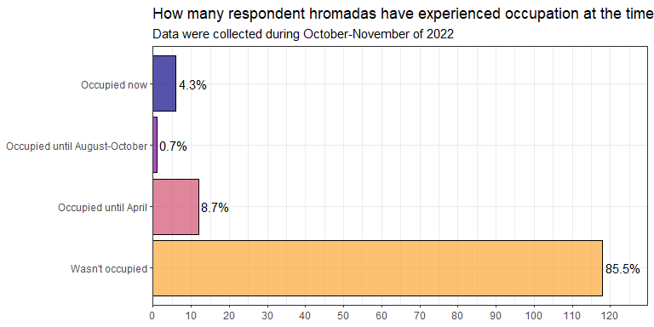

Table 1: Crosstable of Hromadas that experienced occupation and/or military actions

|  | Wasn't occupied | Occupied until April | Occupied until August-October | Occupied now |
| --- | --- | --- | --- | --- |
| Experienced military actions in the past | 1 | 6 | 0 | 0 |
| Experiencing military actions now | 1 | 3 | 1 | 4 |
| No military actions | 116 | 3 | 0 | 2 |

1.6 How many partherships with other hromadas in Ukraine hromadas have?

Median number of partnerships that hromada has is 0, mean - 1.34. Maximum number of partnerships that hromada has in our survey is 20.

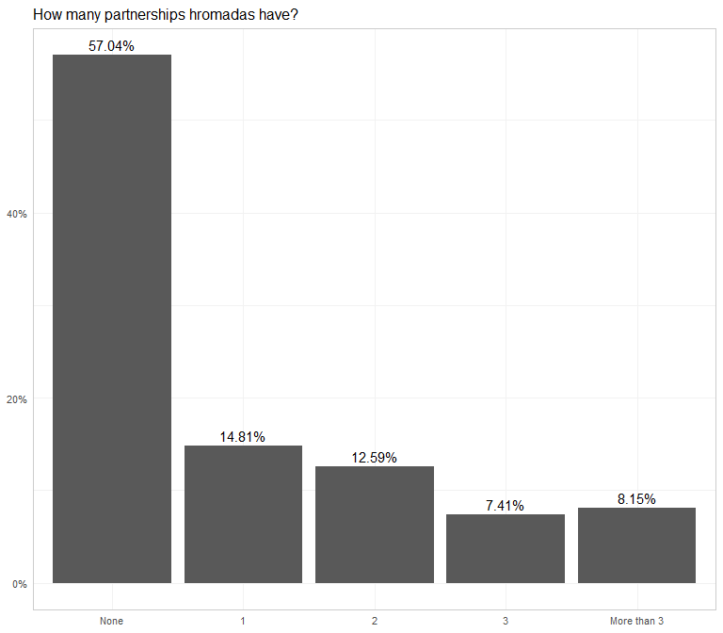

These are hromadas in our survey that have the most partnerships:

| Hromada Name | Number of hromada's partnerships in Ukraine |
| --- | --- |
| Ясінянська селищна громада | 20 |
| Кутська селищна громада | 20 |
| Коломийська міська громада | 10 |
| Бориславська міська громада | 7 |
| Брошнів-Осадська селищна громада | 6 |

1.6 How many hromadas-friends abroad hromadas have?

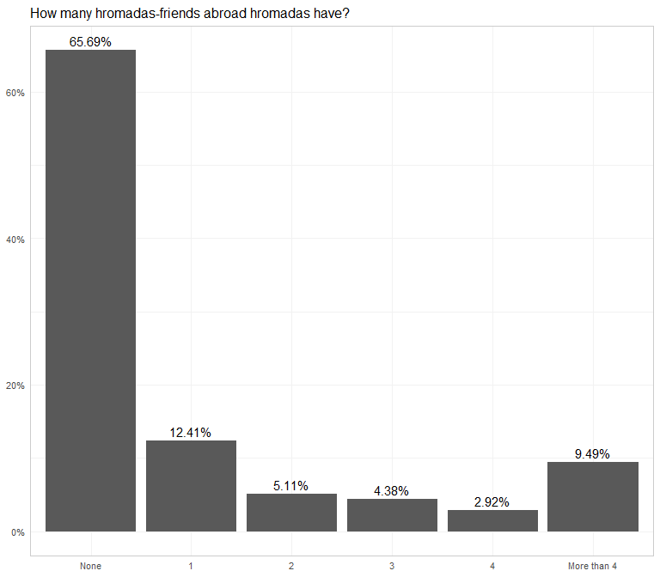

These are hromadas in our survey that have the most friends abroad:

| Hromada Name | Number of hromada's friends abroad |
| --- | --- |
| Луцька міська громада | 17 |
| Тячівська міська громада | 13 |
| Перечинська міська громада | 12 |
| Самбірська міська громада | 11 |
| Коломийська міська громада | 11 |
| Нововолинська міська громада | 10 |
| Великобийганська сільська громада | 9 |
| Миргородська міська громада | 7 |
| Долинська міська громада | 7 |
| Бориславська міська громада | 6 |
| Болградська міська громада | 6 |

# 2. Preparation

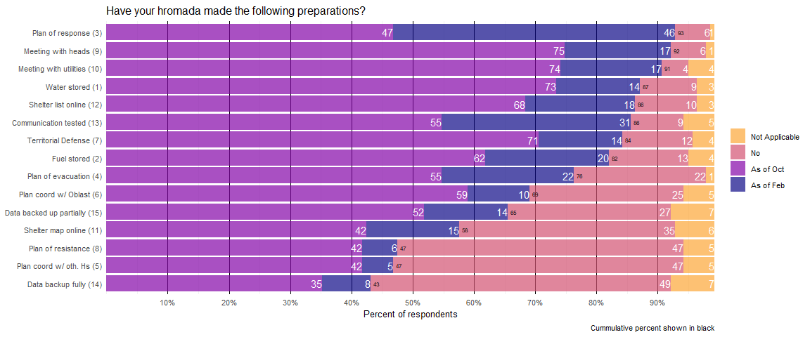

2.1 What questions were asked about preparations hromadas made?

variable

label_en

label

prep_first_aid_water

Water stored (1)

Сформовані запаси товарів першої необхідності (вода, їжа, медичні засоби)

prep_first_aid_fuel

Fuel stored (2)

Сформовані запаси товарів першої необхідності (паливо)

prep_reaction_plan

Plan of response (3)

Оновлено чи затверджено план реагування на надзвичайні ситуації

prep_evacuation_plan

Plan of evacuation (4)

Складено спеціальний план евакуації населення при загрозі збройного конфлікту

prep_reaction_plan_oth_hromadas

Plan coord w/ oth. Hs (5)

Узгоджено план реагування/дій у разі повномасштабного вторгнення з представниками інших громад

prep_reaction_plan_oda

Plan coord w/ Oblast (6)

Узгоджено план реагування/дій у разі повномасштабного вторгнення з представниками ОДА

prep_dftg_creation

Territorial Defense (7)

Розпочато створення (добровольчого) формування територіальної громади

prep_national_resistance

Plan of resistance (8)

Затверджена та опрацьована представниками ОМС програма національного спротиву на території громади

prep_starosta_meeting

Meeting with heads (9)

Проведена зустріч зі старостами з приводу дій у випадку вторгнення

prep_communal_meetiing

Meeting with utilities (10)

Проведена зустріч з головами комунальних підприємств з приводу дій у випадку вторгнення

prep_online_map

Shelter map online (11)

Опублікована онлайн-мапа укриттів в громаді

prep_shelter_list

Shelter list online (12)

Опублікований перелік адрес укриттів в соцмережах або на сайті громади

prep_notification_check

Communication tested (13)

Перевірено засоби оповіщення населення

prep_backup

Data backup fully (14)

Здійснено повне централізоване резервне копіювання даних громади (критично важливої інформації, наприклад, даних про інфраструктуру)

prep_partly_backup

Data backed up partially (15)

Здійснено часткове резервне копіювання даних громади (критично важливої інформації, наприклад, даних про інфраструктуру)

## Item-total correlations

We can conceptualize hromadas’ the preparation for invasion as two quantities:  
- prep_score_feb - the number of security measures implemented as of February 2022  
- prep_score_oct - the number of security measures implemented as of October 2022

# A tibble: 138 x 4  
 hromada_code prep_score_combo prep_score_feb prep_score_oct  
 <chr> <dbl> <dbl> <dbl>  
 1 UA12060190000043514 23 10 13  
 2 UA46060370000065608 14 4 10  
 3 UA35060190000079777 16 3 13  
 4 UA35020130000045875 14 2 12  
 5 UA53060250000043118 20 6 14  
 6 UA65060250000073379 13 6 7  
 7 UA51040110000040346 9 1 8  
 8 UA59080230000084731 10 0 10  
 9 UA05100110000070795 12 0 12  
10 UA51100250000055079 10 0 10  
# ... with 128 more rows

We also compute prep_score_combo, which is a sum of prep_score_feb and prep_score_oct, the quantity equivalent to weighting the implementation of security measures prior to Feb 24, 2022 **twice as important**.

These three scores are distributed as follows:  
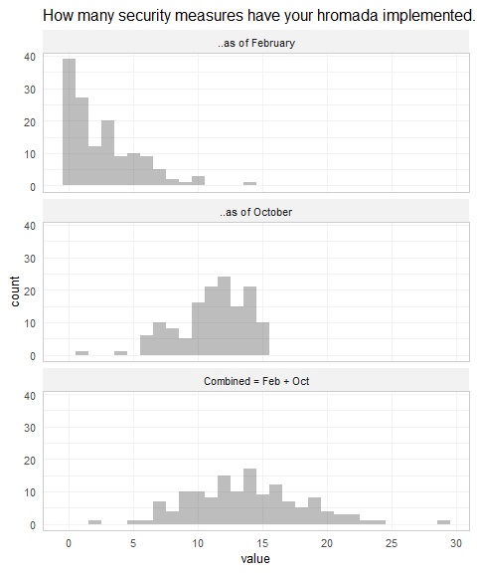

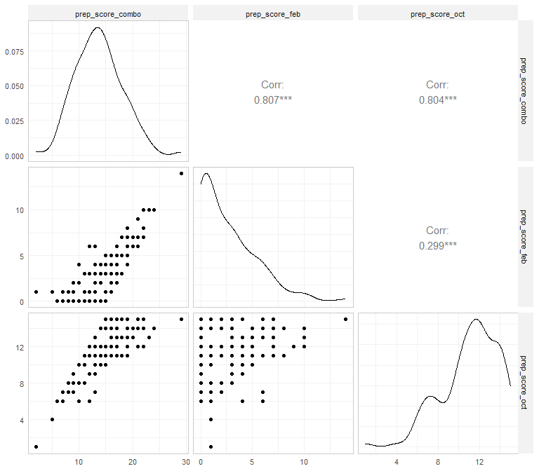

The item-total correlations indicates that all three preparedness scores are adequate unidimensional measures.

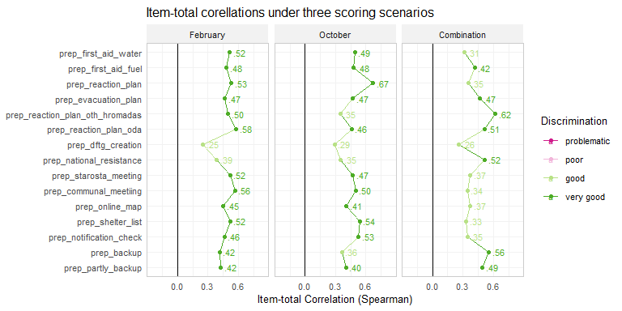

While all three metrics should be considered during modeling, the next section demonstrates why and how the interpreations of these scores will differ

## Prep score change

Let’s us visualize individual scores of invasion preparedness 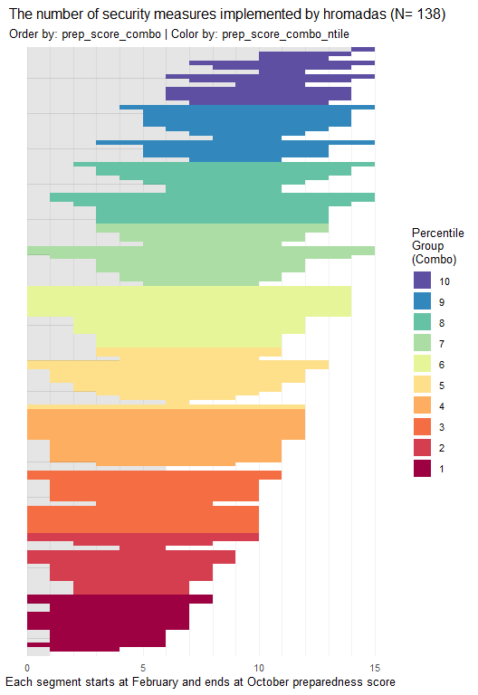

However,this scoring method may not work for operationalizing preparedness as of October

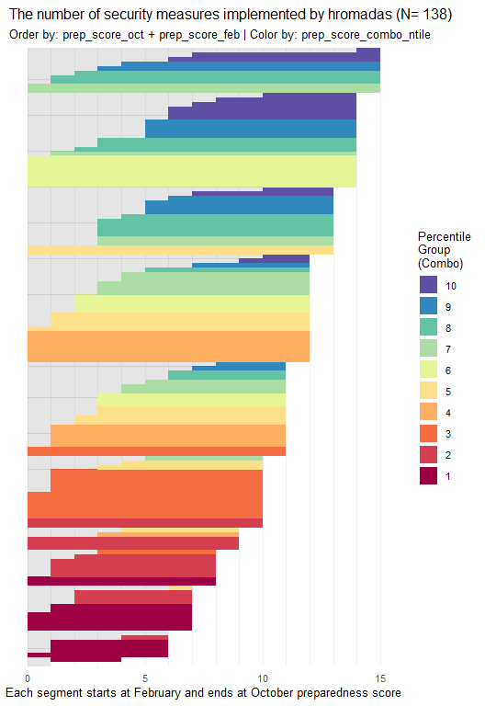

or as of February

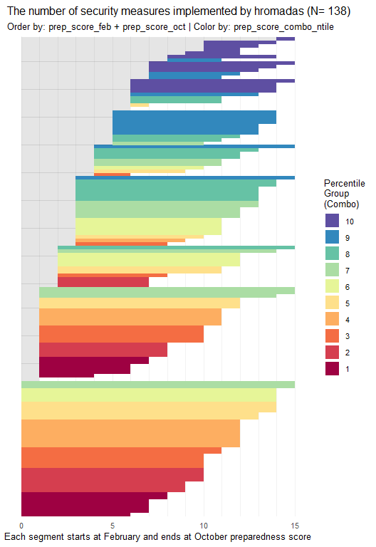

**Conclusion**

Both prep_score_feb and prep_score_oct are meaningful, adequate unidimensional measures with a straightforward interpretation: *Number of security measures implemented as of a given date*.

The measure prep_score_combo is also an adequate unidimensional measure, but it does not have a clear interpretation of its value.

# 3. Information

Який з перелічених нижче засобів використовується громадою для інформування населення...

The most popular channel of communication for hromadas before February 24th and still is Facebook. Before February 24th, only about a quarter of hromadas in our sample had accounts on Viber and Telegram.  
After February, hromadas doubled their use of alternative channels for communicating with their hromada: Viber, Telegram, Chat for getting help, hotline - now about half of hromadas have official groups on Viber and a hotline.

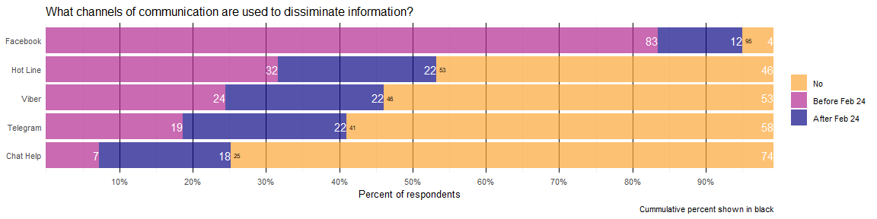

Most hromadas had at least one account in social networks before the invasion.

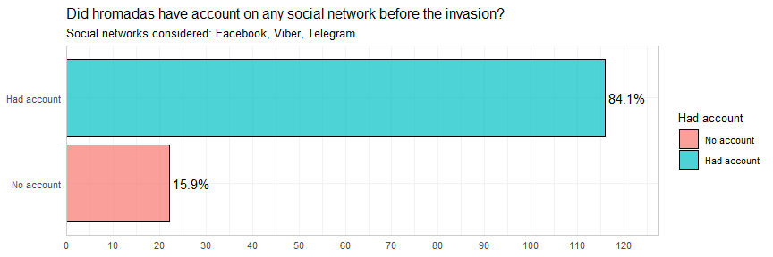

Як часто в середньому голова громади звертався (відео чи повідомлення) до населення громади стосовно стану справ у перший місяць від повномасштабного вторгнення?

Almost all hromada heads actively communicated with their hromada during the first month of the invasion: 95% addressed the hromada once a week or more, and 37% did it daily.

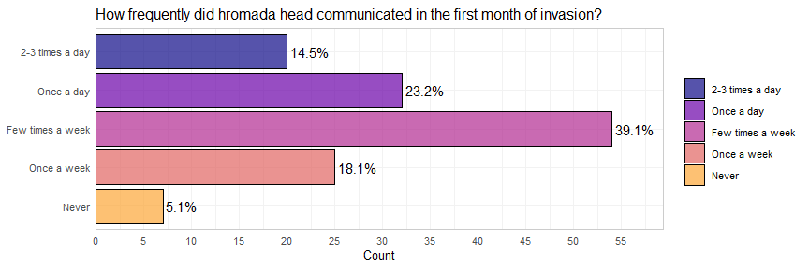

Mayors of hromadas that had any social account before February 24th on average adressed hromada about the state of affairs significantly more during first month of invasion than those that didn’t have.

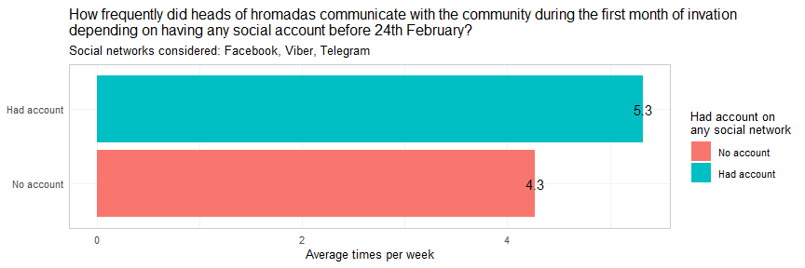

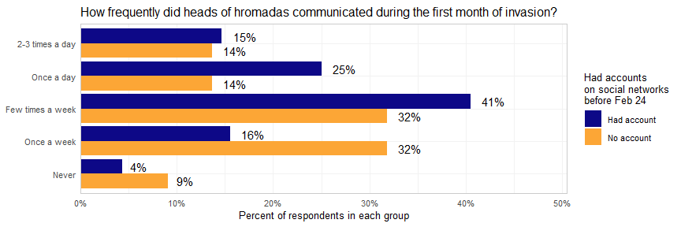

# 4. National Resistance

Чи було у вашій громаді офіційно сформоване добровольче формування територіальної громади?

About a third of hromadas in our survey had not yet created a volunteer defense force of territorial communities (VDF) as of October.

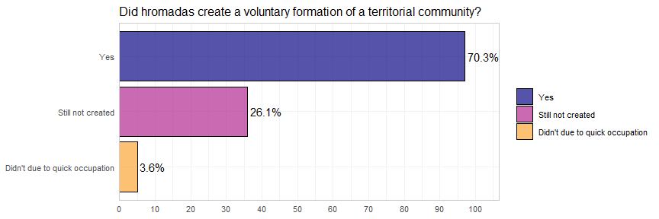

Among village and urban village communities, a higher proportion of hromadas had not yet created a volunteer defense force of territorial communities (VDF).

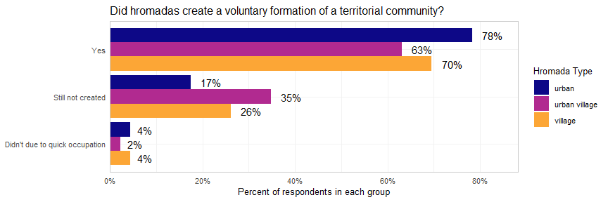

Here you can see the timeline of creation of these forces for our sample.

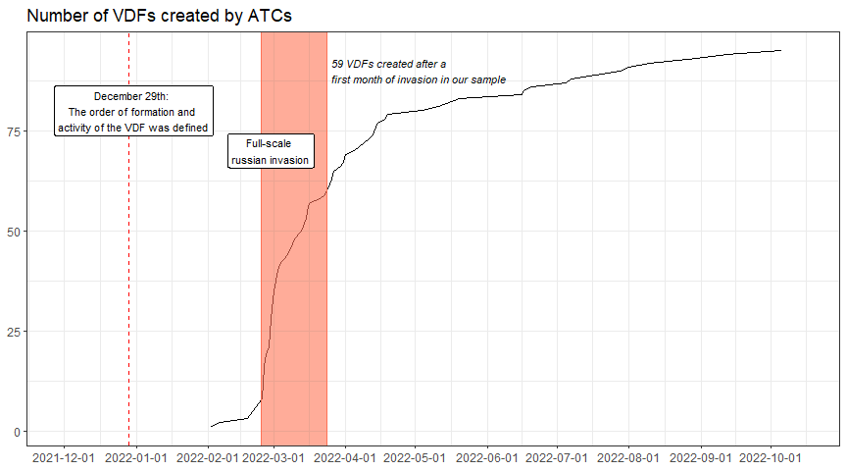

Only a few hromadas have created VDF before the invasion.  
However, more than a half quickly reacted and managed to create VDF in the first month of the invasion.  
Moreover, there are differences in speed of reaction by hromada type.

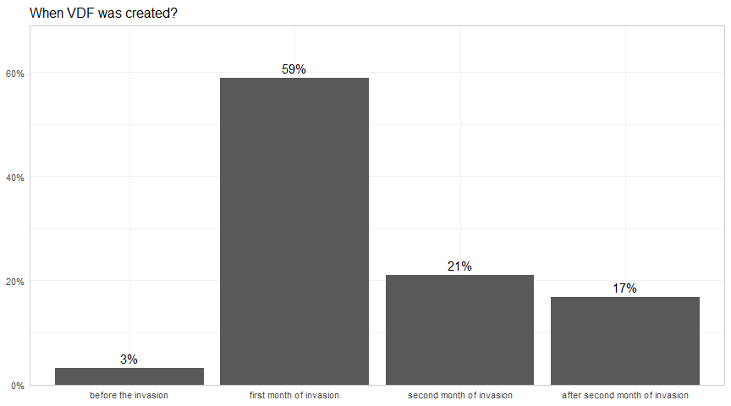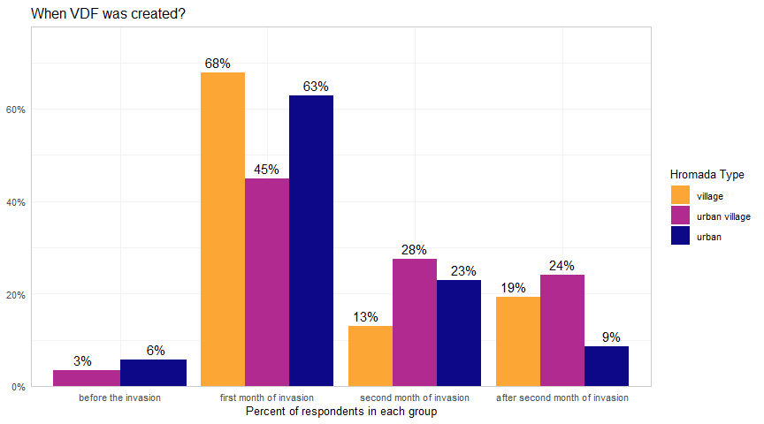

Almost all communities provided at least products for military, significant majority allocated rooms and provided money and transport.

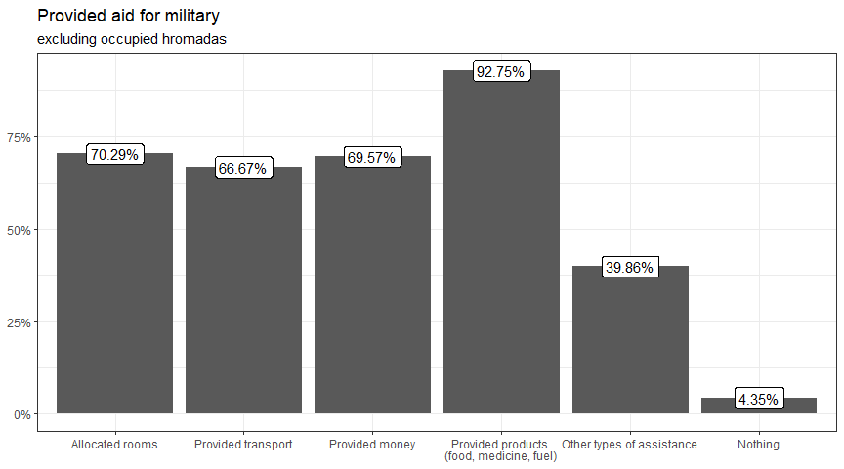

Most communities provided several types of aid: 42% provided transport, money and products, and allocated rooms for military; 72% provided three and more of those  
Only 5% of communities haven’t provided anything from our list to military.

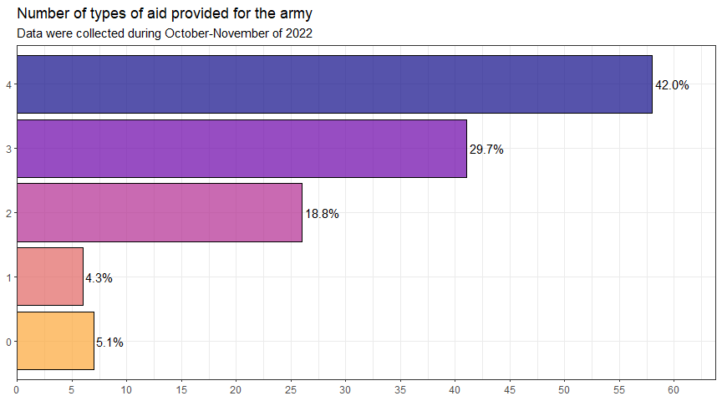

# 5. Administrative Adaptation

Який відсоток працівників виконавчих органів влади (від усіх працівників станом на 23 лютого) фактично працювали станом на 1 березня (в тому числі віддалено)?

Який відсоток працівників виконавчих органів влади (від усіх працівників станом на 23 лютого) фактично працюють станом на сьогоднішній день (в тому числі віддалено)?

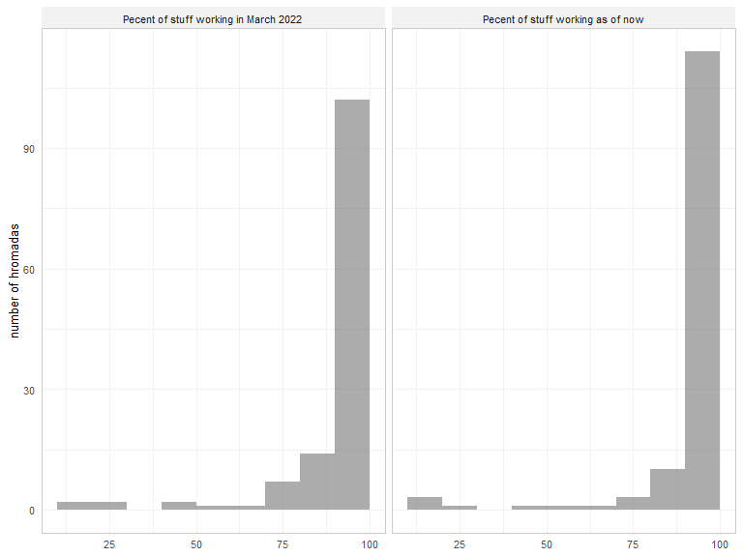

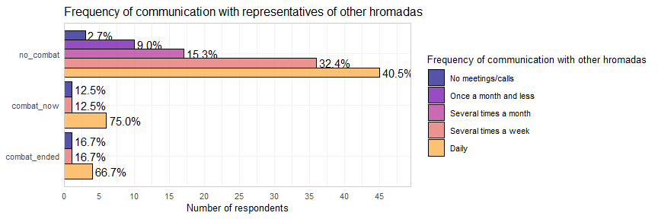

# 6. Evacuation

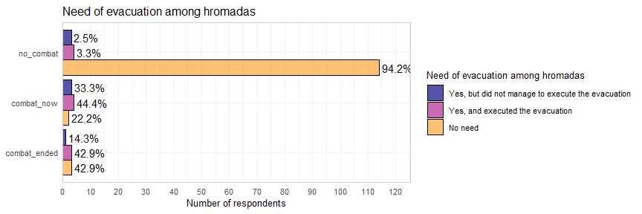 # 7. IDP

# 8. Economics

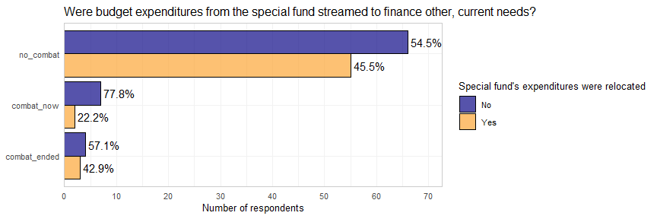

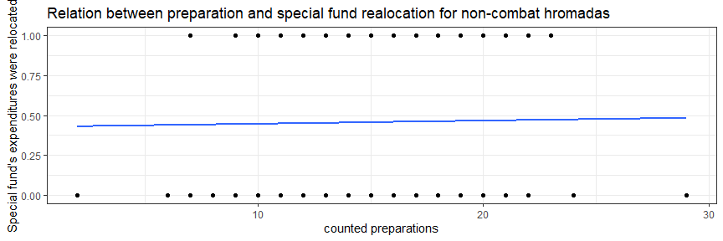

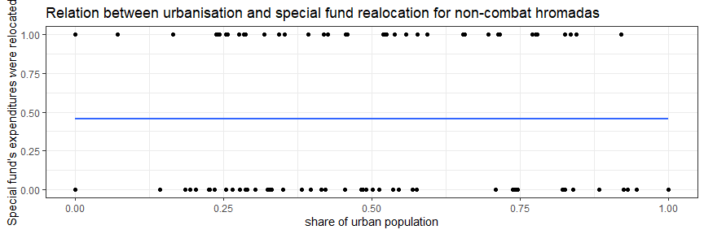

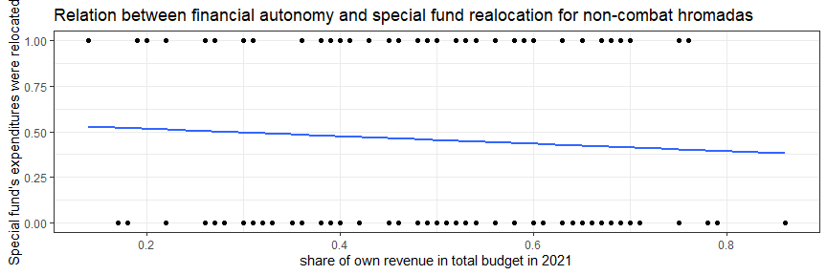

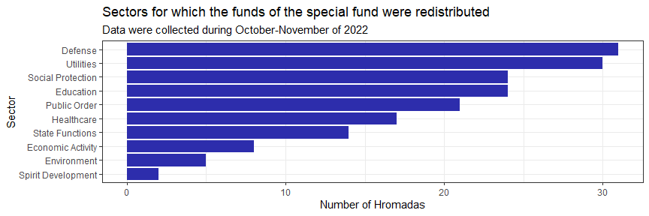

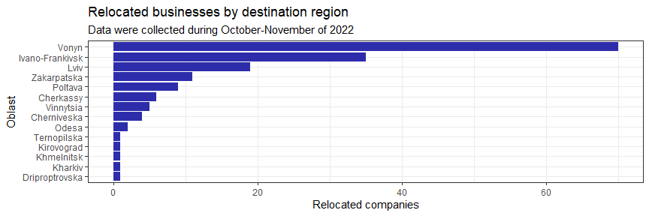

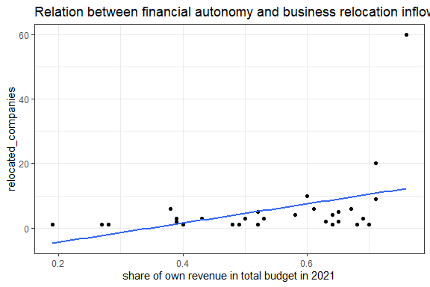

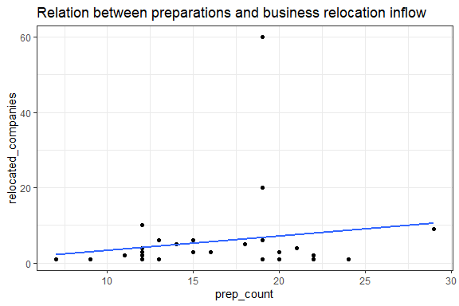

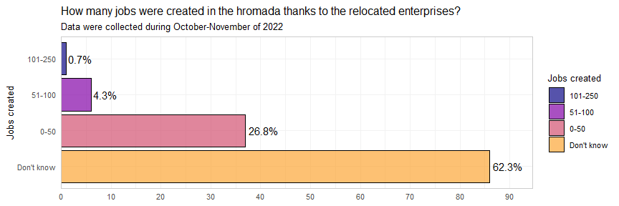

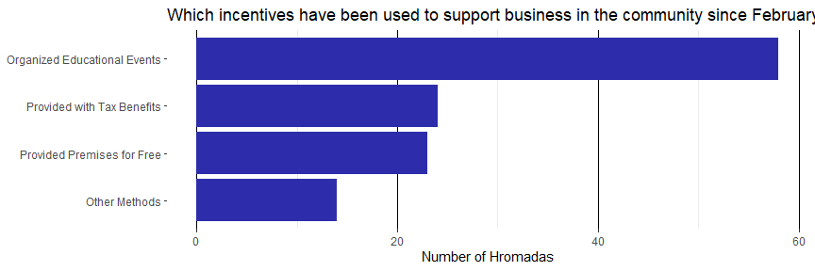

# 9. Humanitarian

# 10. Reconstructioin

  small number of answers (38) - omit at this stage

## 10.1 Damage Evaluation

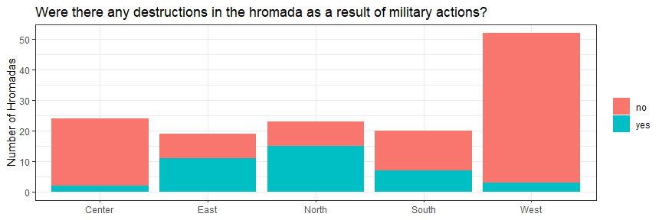

# 11. Current Challenges

#poor quality of answerts regarding days without schooling - consider to omit at all

## 11.1 Heating season

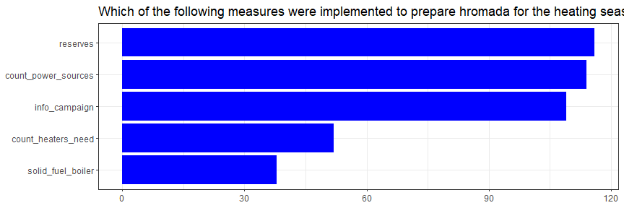

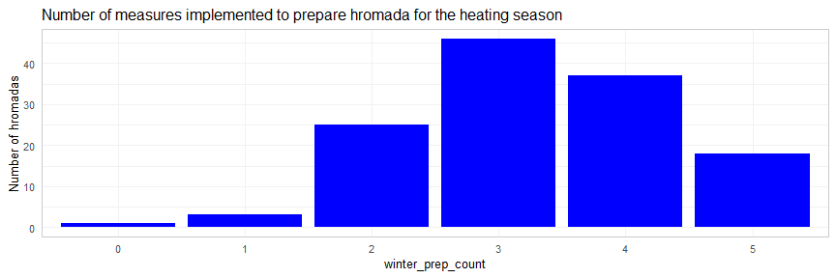

Dependent variable:

winter_prep_count

(1)

(2)

(3)

(4)

log(income_total_2021)

-0.041 (0.608)

0.091 (0.609)

-0.155 (0.632)

1.041 (0.908)

own_income_prop_2021

-0.797 (1.098)

-1.270 (1.114)

-0.947 (1.152)

-2.188 (1.577)

turnout_2020

3.298* (1.724)

3.437* (1.771)

6.324*** (2.251)

travel_time

0.002 (0.002)

0.003 (0.002)

0.005* (0.003)

typeurban village

-0.115 (0.421)

-0.251 (0.422)

-0.174 (0.432)

-0.979 (0.724)

typeurban

-0.337 (0.561)

-0.494 (0.560)

-0.407 (0.583)

-1.489* (0.867)

square

0.0002 (0.001)

-0.0001 (0.001)

0.00000 (0.001)

0.0001 (0.001)

log(total_population_2022)

0.202 (0.619)

0.310 (0.619)

0.599 (0.642)

-0.240 (0.877)

urban_pct

-0.110 (0.771)

0.169 (0.774)

-0.004 (0.804)

0.514 (1.050)

n_settlements

0.001 (0.010)

0.003 (0.010)

0.0004 (0.010)

-0.010 (0.011)

region_enEast

0.206 (0.344)

0.427 (0.351)

0.442 (0.357)

-0.015 (0.648)

region_enNorth

0.372 (0.413)

0.322 (0.411)

0.298 (0.417)

1.285 (0.799)

region_enSouth

-0.521 (0.397)

-0.542 (0.396)

-0.548 (0.400)

0.508 (0.972)

region_enWest

0.176 (0.359)

0.022 (0.378)

0.072 (0.394)

-0.256 (0.503)

occupationoccupied_april

-0.296 (0.576)

-0.439 (0.572)

-0.448 (0.592)

-1.404 (1.283)

military_actioncombat_now

0.136 (0.710)

0.246 (0.701)

0.197 (0.708)

-0.709 (1.097)

military_actionno_combat

0.196 (0.612)

0.075 (0.605)

-0.006 (0.628)

-0.628 (1.525)

voluntary

-0.042 (0.209)

0.047 (0.213)

0.036 (0.217)

-0.151 (0.279)

sex_headmale

0.056 (0.230)

-0.052 (0.326)

age_head

-0.008 (0.012)

-0.011 (0.018)

education_headnon-higher

0.399 (0.418)

0.315 (0.546)

incumbent

0.191 (0.224)

0.087 (0.302)

rda

-0.489 (0.423)

0.073 (0.485)

youth_councils

-0.075 (0.488)

youth_centers

-0.103 (0.299)

sum_osbb_2020

0.009 (0.020)

region_enEast:sum_osbb_2020

0.027 (0.034)

region_enNorth:sum_osbb_2020

-0.035 (0.024)

region_enSouth:sum_osbb_2020

-0.211** (0.089)

region_enWest:sum_osbb_2020

-0.006 (0.019)

Constant

2.330 (5.461)

-2.222 (5.805)

-0.445 (6.080)

-12.656 (8.927)

Observations

130

129

129

72

R2

0.089

0.136

0.168

0.546

Adjusted R2

-0.040

-0.006

-0.014

0.213

Residual Std. Error

1.075 (df = 113)

1.059 (df = 110)

1.064 (df = 105)

0.916 (df = 41)

F Statistic

0.691 (df = 16; 113)

0.958 (df = 18; 110)

0.923 (df = 23; 105)

1.641* (df = 30; 41)

Note:

*p<0.1;* ***p<0.05;*** p<0.01

## 11.2 Problem Involvement

Dependent variable:

hromada_exp

(1)

(2)

(3)

(4)

log(income_total_2021)

0.135 (1.503)

0.093 (1.517)

-0.736 (1.677)

-84.725 (692,099.900)

own_income_prop_2021

0.107 (2.818)

0.181 (2.838)

1.581 (2.970)

114.139 (730,084.900)

turnout_2020

-0.826 (4.510)

-2.146 (4.699)

135.893 (2,141,099.000)

travel_time

0.002 (0.005)

0.001 (0.005)

-0.343 (3,853.388)

typeurban village

1.061 (1.127)

1.019 (1.146)

1.402 (1.230)

-4.701 (819,133.200)

typeurban

0.307 (1.459)

0.174 (1.477)

0.566 (1.571)

-27.317 (1,039,895.000)

square

-0.003** (0.002)

-0.003** (0.002)

-0.003* (0.002)

-0.060 (265.870)

log(total_population_2022)

0.459 (1.513)

0.516 (1.557)

1.281 (1.709)

125.880 (495,023.100)

urban_pct

-0.679 (2.098)

-0.732 (2.123)

-1.165 (2.271)

7.480 (1,382,325.000)

n_settlements

0.048 (0.030)

0.054* (0.032)

0.050 (0.033)

0.270 (14,526.640)

region_enEast

1.519 (1.175)

1.595 (1.187)

1.294 (1.218)

29.804 (367,404.000)

region_enNorth

0.529 (1.207)

0.600 (1.224)

0.461 (1.263)

56.732 (691,508.000)

region_enSouth

0.383 (0.936)

0.486 (0.949)

0.395 (0.971)

-45.057 (371,854.300)

region_enWest

-0.103 (0.893)

0.062 (0.947)

0.187 (1.025)

32.596 (512,285.700)

occupationoccupied_april

-1.840 (1.633)

-1.811 (1.649)

-1.800 (1.712)

-25.166 (621,634.500)

occupationoccupied_august

-19.982 (3,956.181)

-20.257 (3,956.181)

-21.439 (6,522.639)

occupationoccupied_now

-1.855 (1.777)

-1.854 (1.803)

-1.905 (1.884)

-49.613 (460,278.900)

military_actioncombat_now

-16.271 (1,403.286)

-16.298 (1,402.541)

-17.289 (2,250.865)

-43.202 (606,589.200)

military_actionno_combat

-17.568 (1,403.286)

-17.583 (1,402.541)

-18.544 (2,250.864)

37.331 (652,535.300)

voluntary

0.614 (0.578)

0.691 (0.591)

0.901 (0.641)

42.242 (212,131.500)

sex_headmale

-0.026 (0.640)

-7.225 (289,236.300)

age_head

-0.036 (0.034)

-4.669 (29,066.870)

education_headnon-higher

17.630 (1,980.788)

15.497 (478,058.400)

incumbent

0.421 (0.592)

-34.180 (285,656.300)

rda

-0.308 (1.097)

-19.316 (352,081.200)

youth_councils

31.807 (358,561.700)

youth_centers

5.807 (252,011.000)

sum_osbb_2020

0.133 (9,351.328)

region_enEast:sum_osbb_2020

1.884 (20,336.010)

region_enNorth:sum_osbb_2020

-0.734 (24,690.320)

region_enSouth:sum_osbb_2020

-0.171 (10,036.550)

region_enWest:sum_osbb_2020

-0.917 (9,813.355)

Constant

11.849 (1,403.349)

12.078 (1,402.611)

21.914 (2,250.919)

498.071 (7,397,994.000)

Observations

137

136

136

75

Log Likelihood

-54.208

-53.722

-50.852

-0.000

Akaike Inf. Crit.

146.415

149.444

153.703

64.000

Note:

*p<0.1;* ***p<0.05;*** p<0.01

[1] "prep_first_aid_water" "prep_first_aid_fuel"   
 [3] "prep_reaction_plan" "prep_evacuation_plan"   
 [5] "prep_reaction_plan_oth_hromadas" "prep_reaction_plan_oda"   
 [7] "prep_dftg_creation" "prep_national_resistance"   
 [9] "prep_starosta_meeting" "prep_communal_meetiing"   
[11] "prep_online_map" "prep_shelter_list"   
[13] "prep_notification_check" "prep_backup"   
[15] "prep_partly_backup"

# Session Information

For the sake of documentation and reproducibility, the current report was rendered in the following environment. Click the line below to expand.

Environment

- Session info -----------------------------------------------------------------------------------  
 setting value  
 version R version 4.2.2 (2022-10-31 ucrt)  
 os Windows 10 x64 (build 22621)  
 system x86_64, mingw32  
 ui RTerm  
 language (EN)  
 collate Ukrainian_Ukraine.utf8  
 ctype Ukrainian_Ukraine.1251  
 tz Europe/Helsinki  
 date 2023-01-20  
 pandoc 2.19.2 @ C:/Program Files/RStudio/bin/quarto/bin/tools/ (via rmarkdown)  
  
- Packages ---------------------------------------------------------------------------------------  
 package * version date (UTC) lib source  
 assertthat 0.2.1 2019-03-21 [1] CRAN (R 4.2.2)  
 backports 1.4.1 2021-12-13 [1] CRAN (R 4.2.0)  
 broom 1.0.1 2022-08-29 [1] CRAN (R 4.2.2)  
 bslib 0.4.1 2022-11-02 [1] CRAN (R 4.2.2)  
 cachem 1.0.6 2021-08-19 [1] CRAN (R 4.2.2)  
 callr 3.7.3 2022-11-02 [1] CRAN (R 4.2.2)  
 cellranger 1.1.0 2016-07-27 [1] CRAN (R 4.2.2)  
 cli 3.4.1 2022-09-23 [1] CRAN (R 4.2.2)  
 colorspace 2.0-3 2022-02-21 [1] CRAN (R 4.2.2)  
 crayon 1.5.2 2022-09-29 [1] CRAN (R 4.2.2)  
 crosstalk 1.2.0 2021-11-04 [1] CRAN (R 4.2.2)  
 DBI 1.1.3 2022-06-18 [1] CRAN (R 4.2.2)  
 dbplyr 2.2.1 2022-06-27 [1] CRAN (R 4.2.2)  
 devtools 2.4.5 2022-10-11 [1] CRAN (R 4.2.2)  
 dichromat * 2.0-0.1 2022-05-02 [1] CRAN (R 4.2.0)  
 digest 0.6.31 2022-12-11 [1] CRAN (R 4.2.2)  
 dplyr * 1.0.10 2022-09-01 [1] CRAN (R 4.2.2)  
 DT 0.26 2022-10-19 [1] CRAN (R 4.2.2)  
 ellipsis 0.3.2 2021-04-29 [1] CRAN (R 4.2.2)  
 evaluate 0.18 2022-11-07 [1] CRAN (R 4.2.2)  
 explore 1.0.0 2022-11-11 [1] CRAN (R 4.2.2)  
 fansi 1.0.3 2022-03-24 [1] CRAN (R 4.2.2)  
 farver 2.1.1 2022-07-06 [1] CRAN (R 4.2.2)  
 fastDummies * 1.6.3 2020-11-29 [1] CRAN (R 4.2.2)  
 fastmap 1.1.0 2021-01-25 [1] CRAN (R 4.2.2)  
 forcats * 0.5.2 2022-08-19 [1] CRAN (R 4.2.2)  
 fs 1.5.2 2021-12-08 [1] CRAN (R 4.2.2)  
 gargle 1.2.1 2022-09-08 [1] CRAN (R 4.2.2)  
 generics 0.1.3 2022-07-05 [1] CRAN (R 4.2.2)  
 ggplot2 * 3.4.0 2022-11-04 [1] CRAN (R 4.2.2)  
 glue 1.6.2 2022-02-24 [1] CRAN (R 4.2.2)  
 googledrive 2.0.0 2021-07-08 [1] CRAN (R 4.2.2)  
 googlesheets4 1.0.1 2022-08-13 [1] CRAN (R 4.2.2)  
 gridExtra 2.3 2017-09-09 [1] CRAN (R 4.2.2)  
 gt * 0.8.0 2022-11-16 [1] CRAN (R 4.2.2)  
 gtable 0.3.1 2022-09-01 [1] CRAN (R 4.2.2)  
 haven 2.5.1 2022-08-22 [1] CRAN (R 4.2.2)  
 highr 0.9 2021-04-16 [1] CRAN (R 4.2.2)  
 hms 1.1.2 2022-08-19 [1] CRAN (R 4.2.2)  
 htmltools 0.5.4 2022-12-07 [1] CRAN (R 4.2.2)  
 htmlwidgets 1.5.4 2021-09-08 [1] CRAN (R 4.2.2)  
 httpuv 1.6.6 2022-09-08 [1] CRAN (R 4.2.2)  
 httr 1.4.4 2022-08-17 [1] CRAN (R 4.2.2)  
 import 1.3.0 2022-05-23 [1] CRAN (R 4.2.2)  
 janitor 2.1.0 2021-01-05 [1] CRAN (R 4.2.2)  
 jquerylib 0.1.4 2021-04-26 [1] CRAN (R 4.2.2)  
 jsonlite 1.8.4 2022-12-06 [1] CRAN (R 4.2.2)  
 kableExtra 1.3.4 2021-02-20 [1] CRAN (R 4.2.2)  
 knitr * 1.41 2022-11-18 [1] CRAN (R 4.2.2)  
 labeling 0.4.2 2020-10-20 [1] CRAN (R 4.2.0)  
 labelled * 2.10.0 2022-09-14 [1] CRAN (R 4.2.2)  
 later 1.3.0 2021-08-18 [1] CRAN (R 4.2.2)  
 lattice 0.20-45 2021-09-22 [2] CRAN (R 4.2.2)  
 lifecycle 1.0.3 2022-10-07 [1] CRAN (R 4.2.2)  
 lubridate * 1.9.0 2022-11-06 [1] CRAN (R 4.2.2)  
 magrittr 2.0.3 2022-03-30 [1] CRAN (R 4.2.2)  
 Matrix * 1.5-1 2022-09-13 [2] CRAN (R 4.2.2)  
 memoise 2.0.1 2021-11-26 [1] CRAN (R 4.2.2)  
 mgcv 1.8-41 2022-10-21 [2] CRAN (R 4.2.2)  
 mime 0.12 2021-09-28 [1] CRAN (R 4.2.0)  
 miniUI 0.1.1.1 2018-05-18 [1] CRAN (R 4.2.2)  
 mitools 2.4 2019-04-26 [1] CRAN (R 4.2.2)  
 modelr 0.1.10 2022-11-11 [1] CRAN (R 4.2.2)  
 munsell 0.5.0 2018-06-12 [1] CRAN (R 4.2.2)  
 nlme 3.1-160 2022-10-10 [2] CRAN (R 4.2.2)  
 pacman 0.5.1 2019-03-11 [1] CRAN (R 4.2.2)  
 pillar 1.8.1 2022-08-19 [1] CRAN (R 4.2.2)  
 pkgbuild 1.4.0 2022-11-27 [1] CRAN (R 4.2.2)  
 pkgconfig 2.0.3 2019-09-22 [1] CRAN (R 4.2.2)  
 pkgload 1.3.2 2022-11-16 [1] CRAN (R 4.2.2)  
 prettyunits 1.1.1 2020-01-24 [1] CRAN (R 4.2.2)  
 processx 3.8.0 2022-10-26 [1] CRAN (R 4.2.2)  
 profvis 0.3.7 2020-11-02 [1] CRAN (R 4.2.2)  
 promises 1.2.0.1 2021-02-11 [1] CRAN (R 4.2.2)  
 ps 1.7.2 2022-10-26 [1] CRAN (R 4.2.2)  
 purrr * 0.3.5 2022-10-06 [1] CRAN (R 4.2.2)  
 R6 2.5.1 2021-08-19 [1] CRAN (R 4.2.2)  
 RColorBrewer * 1.1-3 2022-04-03 [1] CRAN (R 4.2.0)  
 Rcpp 1.0.9 2022-07-08 [1] CRAN (R 4.2.2)  
 readr * 2.1.3 2022-10-01 [1] CRAN (R 4.2.2)  
 readxl * 1.4.1 2022-08-17 [1] CRAN (R 4.2.2)  
 remotes 2.4.2 2021-11-30 [1] CRAN (R 4.2.2)  
 reprex 2.0.2 2022-08-17 [1] CRAN (R 4.2.2)  
 rlang 1.0.6 2022-09-24 [1] CRAN (R 4.2.2)  
 rmarkdown 2.18 2022-11-09 [1] CRAN (R 4.2.2)  
 rstudioapi 0.14 2022-08-22 [1] CRAN (R 4.2.2)  
 rvest 1.0.3 2022-08-19 [1] CRAN (R 4.2.2)  
 sass 0.4.4 2022-11-24 [1] CRAN (R 4.2.2)  
 scales 1.2.1 2022-08-20 [1] CRAN (R 4.2.2)  
 sessioninfo 1.2.2 2021-12-06 [1] CRAN (R 4.2.2)  
 shiny 1.7.3 2022-10-25 [1] CRAN (R 4.2.2)  
 snakecase 0.11.0 2019-05-25 [1] CRAN (R 4.2.2)  
 stargazer 5.2.3 2022-03-04 [1] CRAN (R 4.2.0)  
 stringi 1.7.8 2022-07-11 [1] CRAN (R 4.2.1)  
 stringr * 1.5.0 2022-12-02 [1] CRAN (R 4.2.2)  
 survey * 4.1-1 2021-07-19 [1] CRAN (R 4.2.2)  
 survival * 3.4-0 2022-08-09 [2] CRAN (R 4.2.2)  
 svglite 2.1.0 2022-02-03 [1] CRAN (R 4.2.2)  
 systemfonts 1.0.4 2022-02-11 [1] CRAN (R 4.2.2)  
 testit 0.13 2021-04-14 [1] CRAN (R 4.2.2)  
 tibble * 3.1.8 2022-07-22 [1] CRAN (R 4.2.2)  
 tidyr * 1.2.1 2022-09-08 [1] CRAN (R 4.2.2)  
 tidyselect 1.2.0 2022-10-10 [1] CRAN (R 4.2.2)  
 tidyverse * 1.3.2 2022-07-18 [1] CRAN (R 4.2.2)  
 timechange * 0.1.1 2022-11-04 [1] CRAN (R 4.2.2)  
 tzdb 0.3.0 2022-03-28 [1] CRAN (R 4.2.2)  
 urlchecker 1.0.1 2021-11-30 [1] CRAN (R 4.2.2)  
 usethis 2.1.6 2022-05-25 [1] CRAN (R 4.2.2)  
 utf8 1.2.2 2021-07-24 [1] CRAN (R 4.2.2)  
 vctrs 0.5.1 2022-11-16 [1] CRAN (R 4.2.2)  
 viridisLite 0.4.1 2022-08-22 [1] CRAN (R 4.2.2)  
 webshot 0.5.4 2022-09-26 [1] CRAN (R 4.2.2)  
 withr 2.5.0 2022-03-03 [1] CRAN (R 4.2.2)  
 xfun 0.35 2022-11-16 [1] CRAN (R 4.2.2)  
 xml2 1.3.3 2021-11-30 [1] CRAN (R 4.2.2)  
 xtable 1.8-4 2019-04-21 [1] CRAN (R 4.2.2)  
 yaml 2.3.6 2022-10-18 [1] CRAN (R 4.2.2)  
  
 [1] C:/Users/Valentyn Hatsko/AppData/Local/R/win-library/4.2  
 [2] C:/Program Files/R/R-4.2.2/library  
  
--------------------------------------------------------------------------------------------------

Report rendered by Valentyn Hatsko at 2023-01-20, 12:05 +0200 in 21 seconds.