Kevin Seelaus

10/28/2018

Human-Computer Interaction Institute

Carnegie Mellon University

PUI, Section B

Homework 6: Adding Functionality to a Website with JS

**Reflection**

Although there are still several dead links and limited functionality, I am happy with the way I was able to get my website wo work. Having now spent a lot of time playing with HTML, CSS, and JavaScript, I am confident I could get a lot more features and pages working without too much trouble if needed. Although overall less time-intensive, I found JavaScript much trickier to code successfully than HTML and CSS. JS was much trickier to find out where and why things weren’t working, and the Console.log() function proved invaluable while debugging. Most of my initial struggles involved getting the hang of the syntax – I’m used to using python for this sort of functional and data-driven programming. I did a lot of googling basic things and copying snippets of code from the in-lab assignments. A few specific challenges took the longest time to figure out were the ‘undo’ feature and the ‘remove’ button from shopping cart page. For some reason (still not 100% what I did wrong initially) I could only get the ‘undo’ feature on the purchase confirmation to clear the entire cart, rather than just the most recent item. This was eventually fixed once I re-structured all of the JS code to be within the $(document).ready((){ container, and separated several nested functions I had written – this is apparently best practice, which a classmate in the SSUI section kindly pointed out to me. I also needed the ‘remove’ button on the checkout page to both take out the html code, and to update the array in the local memory. This was tough, but I ended up searching within the html code using the .closest() and .find() functions to look up and down the DOM to grab the number of the item within the shopping cart list. I then removed this from the array, updated the local memory, and forced the page to reload, which ended up working.

**Lo-Fi Prototype of ‘View Cart’ Page:**

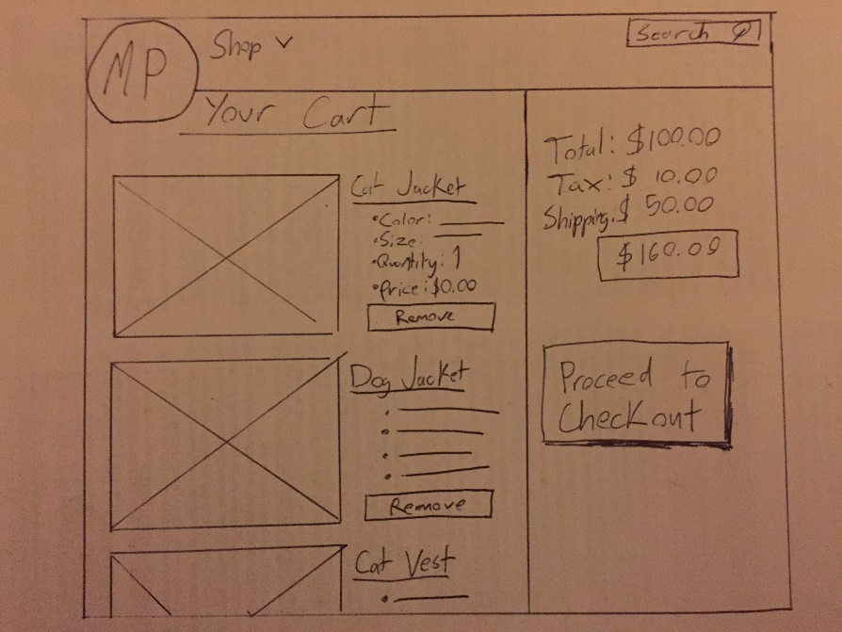

**Hi-Fi** **Prototype of ‘View Cart’ Page:**

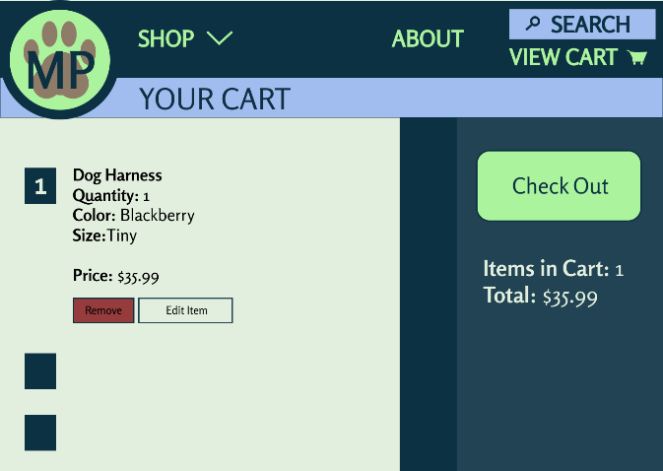 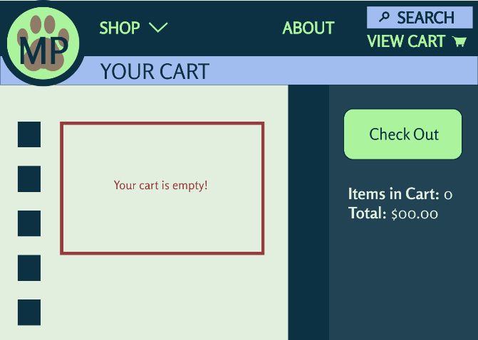

Code for this assignment is stored at: <https://github.com/kseelaus/PUI/tree/master/homework6>

The following files are contained in this folder:

* pics
  + Folder containing all pictures used. Everything taken from the Pexels or Unsplash websites, and were marked as free for use without attribution.
* homepage.html
* browse.html
* harness.html
* viewcart.html
  + New page added for this assignment.
* master_style.css
* paws_main.js
  + JavaScript file for harness, browse, and homepage
* paws_viewcart.js
  + JavaScript file for viewcart page