Field Chlorophyll Analysis of Old and Young Leaves

Kenia E. Segura Aba

5/2/2020

This tutorial uses R version 4.0.0, RRPP version 0.5.2, tidyverse version 1.3.0, and kableExtra version 1.1.0.

1. load necessary packages

library(RRPP)  
library(tidyverse)

## ── Attaching packages ────────────────────────────────────────────── tidyverse 1.3.0 ──

## ✓ ggplot2 3.2.1 ✓ purrr 0.3.3  
## ✓ tibble 2.1.3 ✓ dplyr 0.8.4  
## ✓ tidyr 1.0.2 ✓ stringr 1.4.0  
## ✓ readr 1.3.1 ✓ forcats 0.4.0

## ── Conflicts ───────────────────────────────────────────────── tidyverse_conflicts() ──  
## x dplyr::filter() masks stats::filter()  
## x dplyr::lag() masks stats::lag()

library(kableExtra)

##   
## Attaching package: 'kableExtra'

## The following object is masked from 'package:dplyr':  
##   
## group_rows

1. Upload data

path <- "~/Box/Summer 2018 TX Endo Field Samples and Analysis/Statistics/Old + Young Chlorophyll/"  
  
chldata <- read.csv(paste(path, "chlorophyll_data.csv", sep=""), header = T, row.names = 1)  
  
# create a total chlorophyll column (a + b)  
chldata$Total <- chldata$Chl.a + chldata$Chl.b

1. Calculate total chlorophyll content, summary statistics, and visualize data.

# plot chl a  
chla <- chldata %>% ggplot(aes(x=Fungus, y=Chl.a, fill=Water)) + geom_boxplot() + theme_classic() + facet_wrap(~Age,dir="v")  
print(chla + labs(title="Chlorophyll a Content in Leaves"))

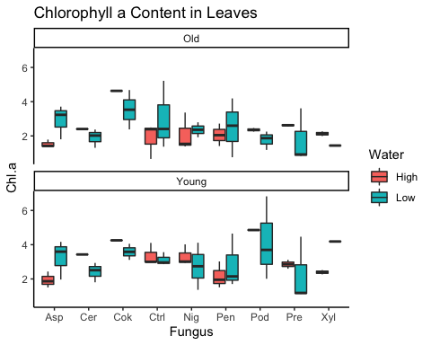

# plot chl b  
chlb <- chldata %>% ggplot(aes(x=Fungus, y=Chl.b, fill=Water)) + geom_boxplot() + theme_classic() + facet_wrap(~Age,dir="v")  
print(chlb + labs(title="Chlorophyll b Content in Leaves"))

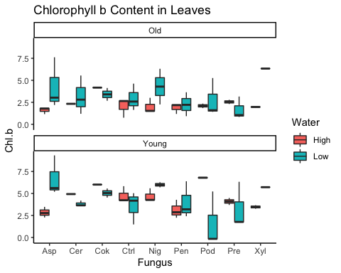

# plot total chlorophyll  
tot <- chldata %>% ggplot(aes(x=Fungus, y=Total, fill=Water)) + geom_boxplot() + theme_classic() + facet_wrap(~Age,dir="v")  
print(tot + labs(title="Total Chlorophyll Content in Leaves"))

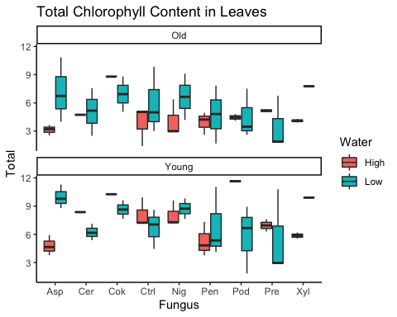

# plot chl b/a ratio  
chlb.a <- chldata %>% ggplot(aes(x=Fungus, y=Chl.b.a.ratio, fill=Water)) + geom_boxplot() + theme_classic() + facet_wrap(~Age,dir="v")  
print(chlb.a + labs(title="Chlorophyll b/a Ratio"))

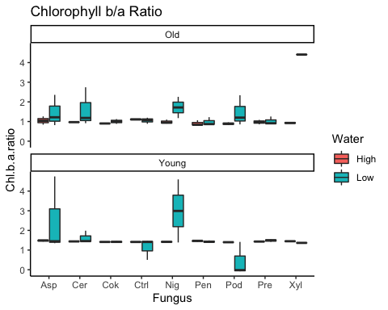

# summary statistics  
stats <- chldata %>% group_by(Water, Fungus) %>% select(Chl.a) %>% summarise_each(funs(Min = min, Q1 = quantile(., 0.25), Median = median, Q3 = quantile(., 0.75), Max = max, Mean = mean, SD = sd))

## Adding missing grouping variables: `Water`, `Fungus`

## Warning: funs() is soft deprecated as of dplyr 0.8.0  
## Please use a list of either functions or lambdas:   
##   
## # Simple named list:   
## list(mean = mean, median = median)  
##   
## # Auto named with `tibble::lst()`:   
## tibble::lst(mean, median)  
##   
## # Using lambdas  
## list(~ mean(., trim = .2), ~ median(., na.rm = TRUE))  
## This warning is displayed once per session.

stats2 <- chldata %>% group_by(Water, Fungus) %>% select(Chl.b) %>% summarise_each(funs(Min = min, Q1 = quantile(., 0.25), Median = median, Q3 = quantile(., 0.75), Max = max, Mean = mean, SD = sd))

## Adding missing grouping variables: `Water`, `Fungus`

stats3 <- chldata %>% group_by(Water, Fungus) %>% select(Chl.b.a.ratio) %>% summarise_each(funs(Min = min, Q1 = quantile(., 0.25), Median = median, Q3 = quantile(., 0.75), Max = max, Mean = mean, SD = sd))

## Adding missing grouping variables: `Water`, `Fungus`

stats4 <- chldata %>% group_by(Water, Fungus) %>% select(Total) %>% summarise_each(funs(Min = min, Q1 = quantile(., 0.25), Median = median, Q3 = quantile(., 0.75), Max = max, Mean = mean, SD = sd))

## Adding missing grouping variables: `Water`, `Fungus`

stats %>% kable() %>% kable_styling(full_width = F) %>% add_header_above(c(" " = 2, "Chl a" = 7)) %>% collapse_rows()

Chl a

Water

Fungus

Min

Q1

Median

Q3

Max

Mean

SD

High

Asp

1.3785

1.438375

1.64465

1.845525

2.4325

1.730400

0.3969141

Cer

2.4034

2.659700

2.91600

3.172300

3.4286

2.916000

0.7249259

Cok

4.2542

4.348175

4.44215

4.536125

4.6301

4.442150

0.2658014

Ctrl

0.6543

2.416075

2.74235

2.996475

4.1046

2.605350

1.1327896

Nig

1.3885

1.886175

2.97785

3.276550

4.0201

2.710450

1.0410501

Pen

1.4103

1.623000

1.99855

2.549825

3.0217

2.110083

0.6443822

Pod

2.2508

2.407100

3.64395

4.842250

4.8829

3.605400

1.4465113

Pre

2.5646

2.589350

2.64125

2.792350

3.1147

2.740450

0.2546096

Xyl

1.9925

2.196050

2.26565

2.330000

2.5178

2.260400

0.2145433

Low

Asp

1.8032

2.282550

3.41230

3.680150

4.1644

3.077933

0.9724927

Cer

1.3056

1.858450

2.19620

2.475375

2.9348

2.157850

0.5733045

Cok

2.3816

2.930825

3.58330

4.209275

4.6790

3.556800

1.0136576

Ctrl

1.3706

2.521075

2.91315

3.413525

5.2171

3.064117

1.2833496

Nig

1.3661

1.783475

2.35900

3.125225

4.1147

2.549700

1.1977419

Pen

0.7559

1.814325

2.37305

3.791275

4.6496

2.673950

1.4901283

Pod

1.1815

1.904725

2.13075

3.335300

6.8223

2.971917

2.0599131

Pre

0.8341

0.970475

1.15580

3.003875

4.4658

2.023350

1.5892062

Xyl

1.4374

2.124750

2.81210

3.499450

4.1868

2.812100

1.9441194

stats2 %>% kable() %>% kable_styling(full_width = F) %>% add_header_above(c(" " = 2, "Chl b" = 7)) %>% collapse_rows()

Chl b

Water

Fungus

Min

Q1

Median

Q3

Max

Mean

SD

High

Asp

1.1578

1.802800

2.06590

2.651275

3.4807

2.221967

0.8188023

Cer

2.3279

2.979350

3.63080

4.282250

4.9337

3.630800

1.8425789

Cok

4.1675

4.628375

5.08925

5.550125

6.0110

5.089250

1.3035514

Ctrl

0.7493

2.652775

3.44605

4.228750

5.8297

3.391517

1.7540252

Nig

1.4517

1.897100

3.63340

4.264575

5.5941

3.350983

1.6580124

Pen

1.1784

2.192475

2.23820

2.712925

4.2843

2.497917

1.0301252

Pod

1.8431

2.224775

4.54235

6.762600

6.8523

4.445025

2.7190193

Pre

2.3051

2.662850

3.23910

3.894375

4.4892

3.318125

0.9708800

Xyl

1.9172

1.994675

2.64285

3.366050

3.6686

2.717875

0.8814486

Low

Asp

2.1927

3.570600

5.40600

7.116375

9.3309

5.496817

2.6947445

Cer

1.1950

2.996500

3.61605

4.056800

5.5423

3.493850

1.4477185

Cok

2.6757

3.764025

4.33190

4.794500

5.5670

4.226625

1.1983699

Ctrl

1.4843

1.872325

3.38255

4.510275

5.0331

3.256267

1.5551574

Nig

2.2579

4.842175

5.99005

6.284650

6.3091

5.136775

1.9392895

Pen

0.9236

2.263875

2.80870

3.530525

6.3876

3.130333

1.8490598

Pod

-0.1698

0.237575

1.50615

4.320025

5.2567

2.195317

2.4760652

Pre

0.8355

1.220800

1.75545

2.810150

6.3290

2.479950

2.0534522

Xyl

5.7141

5.869250

6.02440

6.179550

6.3347

6.024400

0.4388305

stats3 %>% kable() %>% kable_styling(full_width = F) %>% add_header_above(c(" " = 2, "Chl b/a" = 7)) %>% collapse_rows()

Chl b/a

Water

Fungus

Min

Q1

Median

Q3

Max

Mean

SD

High

Asp

0.8399000

1.0947000

1.345747

1.473605

1.513249

1.261981

0.2721681

Cer

0.9686000

1.0861968

1.203794

1.321390

1.438987

1.203794

0.3326139

Cok

0.9001000

1.0283148

1.156530

1.284744

1.412959

1.156530

0.3626463

Ctrl

1.0730000

1.1162250

1.277402

1.411244

1.420294

1.261076

0.1690156

Nig

0.8948000

0.9843500

1.245312

1.409754

1.446971

1.199054

0.2498186

Pen

0.8204000

0.8932000

1.242076

1.456214

1.484446

1.182250

0.3142204

Pod

0.8189000

0.9220250

1.175364

1.396577

1.403323

1.143238

0.3004410

Pre

0.8585000

1.0282250

1.253842

1.427493

1.441321

1.201876

0.2815388

Xyl

0.8925000

0.9447750

1.201136

1.444321

1.457067

1.187960

0.3023483

Low

Asp

0.8165000

1.2490922

1.397398

2.129357

4.745607

1.988317

1.4430095

Cer

0.9153000

1.2432041

1.441539

1.852052

2.742500

1.617810

0.6550962

Cok

0.8820000

1.0631250

1.248568

1.394481

1.457018

1.209038

0.2600366

Ctrl

0.5008402

0.9324500

1.133150

1.357552

1.460632

1.087613

0.3580767

Nig

1.1744000

1.3332090

1.821573

2.841354

4.594418

2.352991

1.5660008

Pen

0.8517000

0.9573000

1.297849

1.408012

1.489756

1.204278

0.2805299

Pod

-0.0844468

0.1964067

1.026300

1.360309

2.335800

0.949229

0.9190565

Pre

0.8746000

0.9963500

1.335999

1.474218

1.545791

1.249302

0.2936034

Xyl

1.3647763

2.1253072

2.885838

3.646369

4.406900

2.885838

2.1511063

stats4 %>% kable() %>% kable_styling(full_width = F,) %>% add_header_above(c(" " = 2, "Total Chlorophyll" = 7)) %>% collapse_rows()

Total Chlorophyll

Water

Fungus

Min

Q1

Median

Q3

Max

Mean

SD

High

Asp

2.5363

3.311200

3.71055

4.426775

5.9132

3.952367

1.184572

Cer

4.7313

5.639050

6.54680

7.454550

8.3623

6.546800

2.567505

Cok

8.7976

9.164500

9.53140

9.898300

10.2652

9.531400

1.037750

Ctrl

1.4036

5.068850

6.18840

7.225225

9.9343

5.996867

2.870463

Nig

2.9146

3.833050

6.78635

7.260450

9.6142

6.061433

2.640505

Pen

2.5887

3.875550

4.52275

4.916675

7.3060

4.608000

1.573892

Pod

4.0939

4.631875

8.18630

11.604850

11.7352

8.050425

4.165380

Pre

4.9900

5.257525

5.82020

6.621250

7.6039

6.058575

1.167894

Xyl

3.9097

4.190725

4.90850

5.696050

6.1864

4.978275

1.063039

Low

Asp

3.9959

7.250750

9.28470

10.581175

11.2971

8.574750

2.771967

Cer

2.5006

5.226200

5.77320

6.885400

7.5632

5.651700

1.806590

Cok

5.0573

7.002500

8.22835

9.009275

9.6197

7.783425

1.988842

Ctrl

3.0058

4.583650

6.01750

8.208475

9.8370

6.320383

2.620370

Nig

4.1805

6.777075

8.37355

9.282950

9.8183

7.686475

2.506609

Pen

1.6795

4.293075

5.07940

7.209275

11.0372

5.804283

3.241293

Pod

1.8412

2.814625

5.06620

7.297150

8.9249

5.167233

2.912251

Pre

1.7535

2.128350

2.91125

5.814025

10.7948

4.503300

3.583994

Xyl

7.7721

8.304300

8.83650

9.368700

9.9009

8.836500

1.505289

1. Run Linear models in RRPP for each fungal treatment and estimate model coefficients. “d” is the amount of change in a variable for the coefficient indicated.

high <- chldata %>% filter(Water=="High") %>% droplevels.data.frame()  
low <- chldata %>% filter(Water=="Low") %>% droplevels.data.frame()  
  
# chl b/a ratio linear models and coefficient tests  
highLM <- lm.rrpp(Chl.b.a.ratio ~ Block*Fungus*Age, data=high, SS.type="III", print.progress=F) ; summary(highLM)

##   
## Warning: Because variables in the linear model are redundant,  
## the linear model design has been truncated (via QR decomposition).  
## Original X columns: 36  
## Final X columns (rank): 32  
## Check coefficients or degrees of freedom in ANOVA to see changes.

##   
## Warning: Because variables in the linear model are redundant,  
## the linear model design has been truncated (via QR decomposition).  
## Original X columns: 36  
## Final X columns (rank): 32  
## Check coefficients or degrees of freedom in ANOVA to see changes.

##   
## Linear Model fit with lm.rrpp  
##   
## Number of observations: 40  
## Number of dependent variables: 1   
## Data space dimensions: 1   
## Sums of Squares and Cross-products: Type III  
## Number of permutations: 1000  
##   
## Full Model Analysis of Variance  
##   
## Df Residual Df SS Residual SS Rsq F  
## Block * Fungus * Age 31 8 2.392622 0.01395011 0.9942033 44.26136  
## Z (from F) Pr(>F)  
## Block * Fungus * Age 7.565094 0.001  
##   
##   
## Redundancy Analysis (PCA on fitted values and residuals)  
##   
## Trace Proportion Rank  
## Fitted 0.06134928 0.9942034 1  
## Residuals 0.00035770 0.0057968 1  
## Total 0.06170697 1.0000000 1  
##   
## Eigenvalues  
##   
## PC1  
## Fitted 0.06134928  
## Residuals 0.00035770  
## Total 0.06170697

coef(highLM, test = T)

##   
## Linear Model fit with lm.rrpp  
##   
## Number of observations: 40  
## Number of dependent variables: 1  
## Data space dimensions: 1  
## Sums of Squares and Cross-products: Type III  
## Number of permutations: 1000  
##   
## Statistics (distances) of coefficients with 95 percent confidence intervals,  
## effect sizes, and probabilities of exceeding observed values based on  
## 1000 random permutations using RRPP   
##   
## d.obs UCL (95%) Zd Pr(>d)  
## (Intercept) 0.62593333 0.78240545 -1.61026300 0.940  
## Block 0.21035000 0.10644294 6.17690316 0.001  
## FungusCer 0.13231667 0.13025502 2.03270522 0.047  
## FungusCok 0.06381667 0.13567589 0.34866901 0.309  
## FungusCtrl 0.44870000 0.21121828 5.32948001 0.001  
## FungusNig 0.14976667 0.20847996 1.03705091 0.159  
## FungusPen 0.03556667 0.20911076 -0.69398103 0.694  
## FungusPod 0.46796667 0.25391620 4.60884320 0.001  
## FungusPre 0.11941667 0.20343556 0.59221237 0.251  
## FungusXyl 0.19686667 0.26144524 1.21008749 0.124  
## AgeYoung 0.76904060 0.28815474 7.38986713 0.001  
## Block:FungusCtrl 0.19355000 0.09351292 5.20915960 0.001  
## Block:FungusNig 0.10820000 0.09778119 2.32840271 0.032  
## Block:FungusPen 0.08740000 0.08993824 1.86990070 0.055  
## Block:FungusPod 0.34785000 0.14343138 6.07693157 0.001  
## Block:FungusPre 0.09720000 0.08836244 2.13479907 0.033  
## Block:FungusXyl 0.14065000 0.14044561 1.90008510 0.050  
## Block:AgeYoung 0.16917263 0.06077501 7.02633383 0.001  
## FungusCer:AgeYoung 0.12948086 0.13349893 1.77002306 0.058  
## FungusCok:AgeYoung 0.08700861 0.13480982 0.75017254 0.219  
## FungusCtrl:AgeYoung 0.41916536 0.21472050 5.08899738 0.001  
## FungusNig:AgeYoung 0.09549141 0.21626233 0.08565683 0.394  
## FungusPen:AgeYoung 0.02459043 0.21354610 -0.97526937 0.823  
## FungusPod:AgeYoung 0.47760590 0.26753430 4.38983017 0.001  
## FungusPre:AgeYoung 0.10072544 0.20879287 0.18385219 0.382  
## FungusXyl:AgeYoung 0.16876311 0.26846199 0.66919439 0.251  
## Block:FungusCtrl:AgeYoung 0.14707756 0.08723097 4.09145843 0.003  
## Block:FungusNig:AgeYoung 0.05145228 0.08926494 0.54736940 0.269  
## Block:FungusPen:AgeYoung 0.07179740 0.08828676 1.28525319 0.118  
## Block:FungusPod:AgeYoung 0.31566678 0.14426725 5.85033910 0.001  
## Block:FungusPre:AgeYoung 0.06524132 0.08845217 1.07151266 0.153  
## Block:FungusXyl:AgeYoung 0.11646746 0.14196521 1.32866227 0.117

lowLM <- lm.rrpp(Chl.b.a.ratio ~ Block*Fungus*Age, data=low, SS.type="III", print.progress=F) ; summary(lowLM)

##   
## Warning: Because variables in the linear model are redundant,  
## the linear model design has been truncated (via QR decomposition).  
## Original X columns: 36  
## Final X columns (rank): 34  
## Check coefficients or degrees of freedom in ANOVA to see changes.

##   
## Warning: Because variables in the linear model are redundant,  
## the linear model design has been truncated (via QR decomposition).  
## Original X columns: 36  
## Final X columns (rank): 34  
## Check coefficients or degrees of freedom in ANOVA to see changes.

##   
## Linear Model fit with lm.rrpp  
##   
## Number of observations: 46  
## Number of dependent variables: 1   
## Data space dimensions: 1   
## Sums of Squares and Cross-products: Type III  
## Number of permutations: 1000  
##   
## Full Model Analysis of Variance  
##   
## Df Residual Df SS Residual SS Rsq F  
## Block * Fungus * Age 33 12 38.48417 4.291964 0.8996645 3.260568  
## Z (from F) Pr(>F)  
## Block * Fungus * Age 1.596751 0.058  
##   
##   
## Redundancy Analysis (PCA on fitted values and residuals)  
##   
## Trace Proportion Rank  
## Fitted 0.8552037 0.8996645 1  
## Residuals 0.0953770 0.1003355 1  
## Total 0.9505807 1.0000000 1  
##   
## Eigenvalues  
##   
## PC1  
## Fitted 0.8552037  
## Residuals 0.0953770  
## Total 0.9505807

coef(lowLM, test = T)

##   
## Linear Model fit with lm.rrpp  
##   
## Number of observations: 46  
## Number of dependent variables: 1  
## Data space dimensions: 1  
## Sums of Squares and Cross-products: Type III  
## Number of permutations: 1000  
##   
## Statistics (distances) of coefficients with 95 percent confidence intervals,  
## effect sizes, and probabilities of exceeding observed values based on  
## 1000 random permutations using RRPP   
##   
## d.obs UCL (95%) Zd Pr(>d)  
## (Intercept) 2.604166667 2.3812771 2.20410896 0.033  
## Block 0.570500000 0.5182633 2.39472974 0.023  
## FungusCer 0.569933333 2.5153066 -0.43813451 0.582  
## FungusCok 1.963666667 3.1369098 0.75802946 0.163  
## FungusCtrl 1.861066667 2.4327801 1.17769678 0.102  
## FungusNig 0.194133333 2.6074282 -0.88687596 0.863  
## FungusPen 1.976066667 2.5036802 1.27796647 0.104  
## FungusPod 0.004266667 2.5230863 -1.14346043 0.998  
## FungusPre 1.971166667 2.4519874 1.32155944 0.094  
## FungusXyl 2.373233333 1.5507146 3.30853828 0.025  
## AgeYoung 3.487937297 1.8351196 4.70526110 0.001  
## Block:FungusCer 0.210000000 0.7316576 -0.42391780 0.590  
## Block:FungusCok 0.812000000 1.1892988 0.92705073 0.173  
## Block:FungusCtrl 0.724250000 0.7455906 1.81465289 0.057  
## Block:FungusNig 0.029200000 0.7266514 -1.20670602 0.932  
## Block:FungusPen 0.746900000 0.7732649 1.79272389 0.060  
## Block:FungusPod 0.001950000 0.7500426 -1.37779019 0.998  
## Block:FungusPre 0.760600000 0.7510175 2.00685659 0.046  
## Block:AgeYoung 2.269119123 0.9889150 5.82392308 0.001  
## FungusCer:AgeYoung 1.380191764 3.2901755 0.02929035 0.408  
## FungusCok:AgeYoung 4.137690011 4.1991110 1.85918413 0.054  
## FungusCtrl:AgeYoung 4.781024939 3.3113151 3.27755878 0.008  
## FungusNig:AgeYoung 0.471646460 3.2815666 -0.89368918 0.799  
## FungusPen:AgeYoung 4.241875805 3.4237166 2.69264946 0.018  
## FungusPod:AgeYoung 2.760631578 3.3447833 1.37856771 0.109  
## FungusPre:AgeYoung 4.264315316 3.4016271 2.88634671 0.018  
## FungusXyl:AgeYoung 1.823305527 2.0418265 1.51061262 0.083  
## Block:FungusCer:AgeYoung 1.210536461 1.5631762 1.25734412 0.122  
## Block:FungusCok:AgeYoung 2.427236353 2.3633451 2.01267211 0.044  
## Block:FungusCtrl:AgeYoung 2.878650458 1.5046734 4.79128042 0.001  
## Block:FungusNig:AgeYoung 0.123682936 1.4894862 -1.08974218 0.884  
## Block:FungusPen:AgeYoung 2.422709974 1.5582108 3.76434507 0.002  
## Block:FungusPod:AgeYoung 2.419037276 1.5234606 3.83380075 0.002  
## Block:FungusPre:AgeYoung 2.421205917 1.5330067 3.91195236 0.001

1. Run ANOVA in RRPP for each linear model.

# chl b/a ratio anovas  
highANOVA <- anova(highLM, effect.type = "F", error = c("Residuals", "Block:Fungus", "Block:Fungus:Age", "Residuals", "Block:Fungus:Age", "Block:Fungus:Age", "Residuals")) ; summary(highANOVA)

## Warning in log(Z): NaNs produced

##   
## Analysis of Variance, using Residual Randomization  
## Permutation procedure: Randomization of null model residuals   
## Number of permutations: 1000   
## Estimation method: Ordinary Least Squares   
## Sums of Squares and Cross-products: Type III   
## Effect sizes (Z) based on F distributions  
##   
## Df SS MS Rsq F Z Pr(>F)   
## Block 1 0.08849 0.088494 0.036772 50.7490 0.002 **  
## Fungus 8 0.07465 0.009331 0.031019 0.8201 -0.47624 0.671   
## Age 1 0.12673 0.126734 0.052661 29.0071 0.023 *   
## Block:Fungus 6 0.06827 0.011378 0.028368 6.5250 1.77838 0.036 *   
## Block:Age 1 0.02862 0.028619 0.011892 6.5505 0.025 *   
## Fungus:Age 8 0.03616 0.004520 0.015025 1.0345 -0.42391 0.658   
## Block:Fungus:Age 6 0.02621 0.004369 0.010893 2.5055 1.16914 0.104   
## Residuals 8 0.01395 0.001744 0.005797   
## Total 39 2.40657   
## ---  
## Signif. codes: 0 '***' 0.001 '**' 0.01 '*' 0.05 '.' 0.1 ' ' 1  
##   
## Call: lm.rrpp(f1 = Chl.b.a.ratio ~ Block * Fungus * Age, SS.type = "III",   
## data = high, print.progress = F)

lowANOVA <- anova(lowLM, effect.type = "F", error = c("Residuals", "Block:Fungus", "Block:Fungus:Age", "Residuals", "Block:Fungus:Age", "Block:Fungus:Age", "Residuals")) ; summary(lowANOVA)

## Warning in log(Z): NaNs produced

##   
## Analysis of Variance, using Residual Randomization  
## Permutation procedure: Randomization of null model residuals   
## Number of permutations: 1000   
## Estimation method: Ordinary Least Squares   
## Sums of Squares and Cross-products: Type III   
## Effect sizes (Z) based on F distributions  
##   
## Df SS MS Rsq F Z Pr(>F)   
## Block 1 0.651 0.6509 0.015217 1.8200 0.215   
## Fungus 8 10.522 1.3153 0.245979 3.9387 0.88560 0.196   
## Age 1 2.607 2.6069 0.060944 2.1006 1.16837 0.088 .  
## Block:Fungus 7 2.338 0.3339 0.054645 0.9336 0.00261 0.480   
## Block:Age 1 5.149 5.1489 0.120369 4.1489 0.036 *  
## Fungus:Age 8 9.881 1.2351 0.230997 0.9953 -0.21371 0.566   
## Block:Fungus:Age 7 8.687 1.2410 0.203084 3.4698 1.83670 0.034 *  
## Residuals 12 4.292 0.3577 0.100336   
## Total 45 42.776   
## ---  
## Signif. codes: 0 '***' 0.001 '**' 0.01 '*' 0.05 '.' 0.1 ' ' 1  
##   
## Call: lm.rrpp(f1 = Chl.b.a.ratio ~ Block * Fungus * Age, SS.type = "III",   
## data = low, print.progress = F)

1. Test pairwise differences between least squares means. Similar to tukeyHSD function in the r stats package. The pairwise function will generate tables with confidence intervals and p‐values for the pairwise statistic, Euclidean distance between least‐squares means.

# chl b/a ratio pairwise  
highpw <- pairwise(highLM, groups = high$Fungus) ; summary(highpw, confidence = 0.95, stat.table = T)

##   
## Pairwise comparisons  
##   
## Groups: Asp Cer Cok Ctrl Nig Pen Pod Pre Xyl   
##   
## RRPP: 1000 permutations  
##   
## LS means:  
## Vectors hidden (use show.vectors = TRUE to view)  
##   
## Pairwise distances between means, plus statistics  
## d UCL (95%) Z Pr > d  
## Asp:Cer 0.058187450 0.10320322 -0.044024032 0.502  
## Asp:Cok 0.105451323 0.14814480 0.041087763 0.459  
## Asp:Ctrl 0.000905116 0.03538716 -1.237179248 0.954  
## Asp:Nig 0.062926762 0.09129584 0.021800062 0.496  
## Asp:Pen 0.079731152 0.10842561 0.010537412 0.484  
## Asp:Pod 0.118743037 0.15235664 0.016767643 0.505  
## Asp:Pre 0.060104737 0.09291459 0.004794364 0.505  
## Asp:Xyl 0.074021132 0.10700516 0.015703933 0.489  
## Cer:Cok 0.047263873 0.10101312 0.002161435 0.472  
## Cer:Ctrl 0.057282333 0.10012902 -0.042094826 0.514  
## Cer:Nig 0.004739313 0.04883312 -1.076294211 0.872  
## Cer:Pen 0.021543703 0.06225822 -0.286323700 0.553  
## Cer:Pod 0.060555587 0.10416286 0.035535283 0.479  
## Cer:Pre 0.001917287 0.05311203 -1.220478644 0.946  
## Cer:Xyl 0.015833683 0.06087528 -0.489894704 0.619  
## Cok:Ctrl 0.104546207 0.14777001 0.040224596 0.475  
## Cok:Nig 0.042524561 0.08314593 -0.012700058 0.487  
## Cok:Pen 0.025720171 0.06850836 -0.157550447 0.499  
## Cok:Pod 0.013291714 0.06150881 -0.636031187 0.681  
## Cok:Pre 0.045346586 0.08738173 0.009293654 0.484  
## Cok:Xyl 0.031430191 0.07517390 -0.125850341 0.503  
## Ctrl:Nig 0.062021646 0.08977578 0.020903726 0.481  
## Ctrl:Pen 0.078826036 0.10927781 0.009019397 0.490  
## Ctrl:Pod 0.117837921 0.15023118 0.015882660 0.492  
## Ctrl:Pre 0.059199621 0.09347071 0.003756734 0.493  
## Ctrl:Xyl 0.073116016 0.10799845 0.014913400 0.504  
## Nig:Pen 0.016804390 0.04686381 -0.245379009 0.530  
## Nig:Pod 0.055816275 0.09024489 -0.003497201 0.494  
## Nig:Pre 0.002822025 0.03919538 -1.143384126 0.894  
## Nig:Xyl 0.011094370 0.04488742 -0.556207991 0.651  
## Pen:Pod 0.039011885 0.07297390 -0.013586489 0.490  
## Pen:Pre 0.019626415 0.05038415 -0.231720558 0.549  
## Pen:Xyl 0.005710020 0.04160410 -0.957946450 0.823  
## Pod:Pre 0.058638300 0.09500790 0.009237436 0.496  
## Pod:Xyl 0.044721905 0.08167184 -0.011530614 0.502  
## Pre:Xyl 0.013916396 0.05103364 -0.428795664 0.587

highpw2 <- pairwise(highLM, groups = high$Age) ; summary(highpw2, confidence = 0.95, stat.table = T)

##   
## Pairwise comparisons  
##   
## Groups: Old Young   
##   
## RRPP: 1000 permutations  
##   
## LS means:  
## Vectors hidden (use show.vectors = TRUE to view)  
##   
## Pairwise distances between means, plus statistics  
## d UCL (95%) Z Pr > d  
## Old:Young 0.4570754 0.4736502 0.006216987 0.498

lowpw <- pairwise(lowLM, groups = low$Fungus) ; summary(lowpw, confidence = 0.95, stat.table = T)

##   
## Pairwise comparisons  
##   
## Groups: Asp Cer Cok Ctrl Nig Pen Pod Pre Xyl   
##   
## RRPP: 1000 permutations  
##   
## LS means:  
## Vectors hidden (use show.vectors = TRUE to view)  
##   
## Pairwise distances between means, plus statistics  
## d UCL (95%) Z Pr > d  
## Asp:Cer 0.370507246 0.8853904 -0.1478610225 0.510  
## Asp:Cok 0.779278707 1.3278286 -0.0301422487 0.513  
## Asp:Ctrl 0.900704655 1.4166997 0.0486720988 0.485  
## Asp:Nig 0.364673628 0.9258853 -0.1976350688 0.536  
## Asp:Pen 0.784038739 1.2985573 0.0088839580 0.495  
## Asp:Pod 1.039088154 1.5506775 0.0209061636 0.481  
## Asp:Pre 0.739014926 1.2434961 -0.0191867912 0.505  
## Asp:Xyl 0.897521008 1.6177589 -0.0001802989 0.475  
## Cer:Cok 0.408771460 0.9782648 -0.1582706790 0.527  
## Cer:Ctrl 0.530197409 1.0277899 0.0238848355 0.478  
## Cer:Nig 0.735180874 1.3045299 -0.0315741826 0.511  
## Cer:Pen 0.413531493 0.9050760 -0.0688173046 0.483  
## Cer:Pod 0.668580908 1.1598071 0.0258294564 0.487  
## Cer:Pre 0.368507680 0.8352309 -0.1049670821 0.503  
## Cer:Xyl 1.268028254 2.0212365 0.0033059568 0.467  
## Cok:Ctrl 0.121425948 0.7199995 -0.7945657985 0.753  
## Cok:Nig 1.143952335 1.7831922 -0.0328399848 0.541  
## Cok:Pen 0.004760032 0.6678481 -1.3446792124 0.992  
## Cok:Pod 0.259809448 0.7947886 -0.3253185841 0.556  
## Cok:Pre 0.040263781 0.6994316 -1.1684395589 0.926  
## Cok:Xyl 1.676799715 2.4291577 -0.0067111061 0.504  
## Ctrl:Nig 1.265378283 1.8612714 0.0336356330 0.491  
## Ctrl:Pen 0.116665916 0.6621089 -0.7131360410 0.722  
## Ctrl:Pod 0.138383499 0.6261081 -0.6820100797 0.697  
## Ctrl:Pre 0.161689729 0.6341678 -0.5632679557 0.635  
## Ctrl:Xyl 1.798225663 2.4793894 0.0473879461 0.481  
## Nig:Pen 1.148712367 1.7261930 -0.0020162903 0.496  
## Nig:Pod 1.403761782 1.9775184 0.0071805840 0.497  
## Nig:Pre 1.103688554 1.6846964 -0.0219302947 0.507  
## Nig:Xyl 0.532847380 1.3106403 -0.0995566621 0.491  
## Pen:Pod 0.255049415 0.7280045 -0.2874635575 0.553  
## Pen:Pre 0.045023813 0.6042290 -1.0595525678 0.870  
## Pen:Xyl 1.681559747 2.4276324 0.0190719930 0.472  
## Pod:Pre 0.300073228 0.7769037 -0.2061556458 0.526  
## Pod:Xyl 1.936609162 2.6851716 0.0257284921 0.473  
## Pre:Xyl 1.636535934 2.3562280 0.0036599286 0.477

lowpw2 <- pairwise(lowLM, groups = low$Age) ; summary(lowpw2, confidence = 0.95, stat.table = T)

##   
## Pairwise comparisons  
##   
## Groups: Old Young   
##   
## RRPP: 1000 permutations  
##   
## LS means:  
## Vectors hidden (use show.vectors = TRUE to view)  
##   
## Pairwise distances between means, plus statistics  
## d UCL (95%) Z Pr > d  
## Old:Young 0.1482125 0.4063939 -0.2117849 0.515

1. Examine RRPP plots to check for assumptions.

## chl b/a ratio  
# residuals vs fitted values (homoscedasticity check)  
hdiagnostics <- plot(highLM, type = "diagnostics")

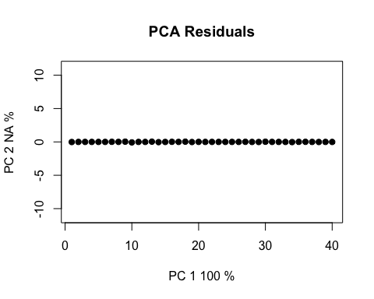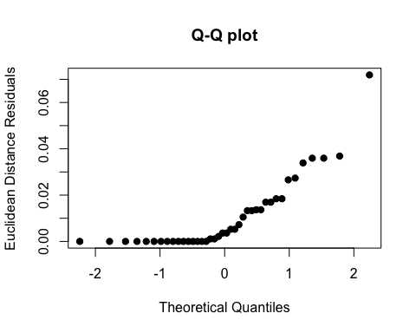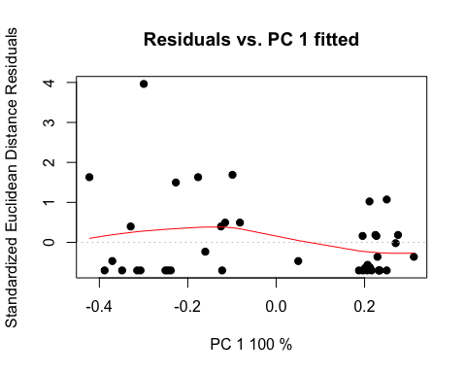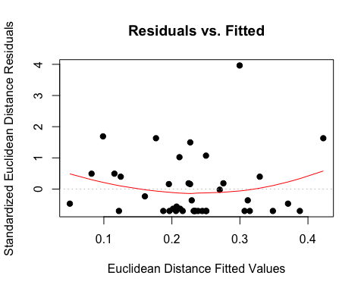

# pca plot  
hpcplot <- plot(highLM, type = "PC", pch = 19, col = interaction(high$Water, high$Fungus))

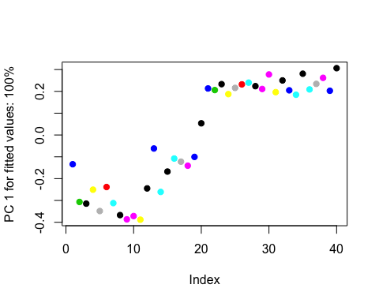

# residuals vs fitted values (homoscedasticity check)  
ldiagnostics <- plot(lowLM, type = "diagnostics")

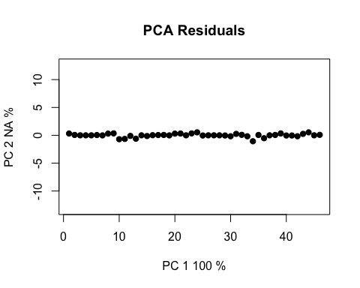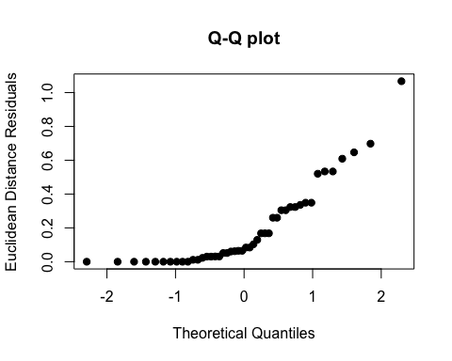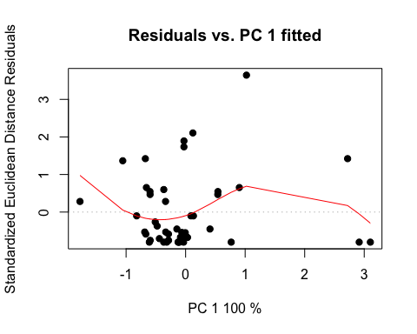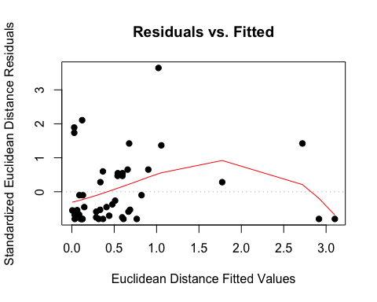

# pca plot  
lpcplot <- plot(lowLM, type = "PC", pch = 19, col = interaction(low$Water, low$Fungus))

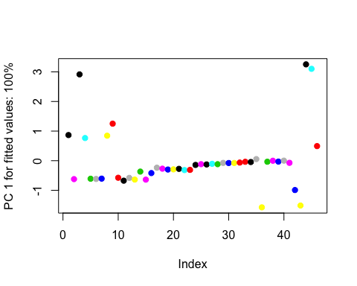

1. Repeat steps 4 - 7 for chlorophyll a and b

## chl a  
# linear models and coefficient tests  
highLM <- lm.rrpp(Chl.a ~ Block*Fungus*Age, data=high, SS.type="III", print.progress=F) ; summary(highLM)

##   
## Warning: Because variables in the linear model are redundant,  
## the linear model design has been truncated (via QR decomposition).  
## Original X columns: 36  
## Final X columns (rank): 32  
## Check coefficients or degrees of freedom in ANOVA to see changes.

##   
## Warning: Because variables in the linear model are redundant,  
## the linear model design has been truncated (via QR decomposition).  
## Original X columns: 36  
## Final X columns (rank): 32  
## Check coefficients or degrees of freedom in ANOVA to see changes.

##   
## Linear Model fit with lm.rrpp  
##   
## Number of observations: 40  
## Number of dependent variables: 1   
## Data space dimensions: 1   
## Sums of Squares and Cross-products: Type III  
## Number of permutations: 1000  
##   
## Full Model Analysis of Variance  
##   
## Df Residual Df SS Residual SS Rsq F  
## Block * Fungus * Age 31 8 34.62868 4.896895 0.8761082 1.824918  
## Z (from F) Pr(>F)  
## Block * Fungus * Age 0.8611391 0.191  
##   
##   
## Redundancy Analysis (PCA on fitted values and residuals)  
##   
## Trace Proportion Rank  
## Fitted 0.8879149 0.8761082 1  
## Residuals 0.1255614 0.1238918 1  
## Total 1.0134763 1.0000000 1  
##   
## Eigenvalues  
##   
## PC1  
## Fitted 0.8879149  
## Residuals 0.1255614  
## Total 1.0134763

coef(highLM, test = T)

##   
## Linear Model fit with lm.rrpp  
##   
## Number of observations: 40  
## Number of dependent variables: 1  
## Data space dimensions: 1  
## Sums of Squares and Cross-products: Type III  
## Number of permutations: 1000  
##   
## Statistics (distances) of coefficients with 95 percent confidence intervals,  
## effect sizes, and probabilities of exceeding observed values based on  
## 1000 random permutations using RRPP   
##   
## d.obs UCL (95%) Zd Pr(>d)  
## (Intercept) 1.4887000 3.1132605 -0.88671633 0.844  
## Block 0.0189000 0.5625146 -0.98230634 0.800  
## FungusCer 0.8958000 1.7774671 0.66888479 0.181  
## FungusCok 3.1225000 1.6911105 4.86491341 0.003  
## FungusCtrl 0.4613333 2.7235718 -0.58767526 0.646  
## FungusNig 2.5825333 2.4298071 2.25902054 0.045  
## FungusPen 1.2428667 2.3409168 0.54841450 0.238  
## FungusPod 1.1789000 3.1386469 0.10645855 0.327  
## FungusPre 1.2563500 2.7923820 0.39384042 0.248  
## FungusXyl 1.0466000 3.3762310 -0.08388678 0.398  
## AgeYoung 1.3735000 1.6506508 1.43495466 0.099  
## Block:FungusCtrl 0.0708500 0.7875661 -1.01948406 0.868  
## Block:FungusNig 1.0067000 0.7849443 2.89710866 0.009  
## Block:FungusPen 0.3558500 0.7568903 0.17981382 0.374  
## Block:FungusPod 0.2273000 1.2103392 -0.67305703 0.706  
## Block:FungusPre 0.0790500 0.7999934 -0.95453805 0.853  
## Block:FungusXyl 0.2903000 1.3270783 -0.47649035 0.604  
## Block:AgeYoung 0.4828500 0.7235837 0.84909850 0.191  
## FungusCer:AgeYoung 0.1345500 1.6145549 -1.03855928 0.867  
## FungusCok:AgeYoung 1.2665500 1.6356655 1.18829425 0.134  
## FungusCtrl:AgeYoung 1.1549333 2.7405931 0.06908845 0.393  
## FungusNig:AgeYoung 2.1915667 2.7141535 1.33164332 0.115  
## FungusPen:AgeYoung 0.8735667 2.5730234 -0.26025976 0.518  
## FungusPod:AgeYoung 0.7334000 3.2372444 -0.60698556 0.671  
## FungusPre:AgeYoung 1.7795000 2.6980775 0.85127825 0.193  
## FungusXyl:AgeYoung 1.8918000 3.3456213 0.56228249 0.240  
## Block:FungusCtrl:AgeYoung 0.0221500 1.1421181 -1.29161849 0.977  
## Block:FungusNig:AgeYoung 1.5067000 1.1835913 2.78562240 0.011  
## Block:FungusPen:AgeYoung 0.2853000 1.1521380 -0.56824518 0.656  
## Block:FungusPod:AgeYoung 0.7454500 1.7567748 0.05991203 0.410  
## Block:FungusPre:AgeYoung 0.8015500 1.1512449 0.95806001 0.174  
## Block:FungusXyl:AgeYoung 1.0046500 1.8482219 0.47163597 0.267

lowLM <- lm.rrpp(Chl.a ~ Block*Fungus*Age, data=low, SS.type="III", print.progress=F) ; summary(lowLM)

##   
## Warning: Because variables in the linear model are redundant,  
## the linear model design has been truncated (via QR decomposition).  
## Original X columns: 36  
## Final X columns (rank): 34  
## Check coefficients or degrees of freedom in ANOVA to see changes.

##   
## Warning: Because variables in the linear model are redundant,  
## the linear model design has been truncated (via QR decomposition).  
## Original X columns: 36  
## Final X columns (rank): 34  
## Check coefficients or degrees of freedom in ANOVA to see changes.

##   
## Linear Model fit with lm.rrpp  
##   
## Number of observations: 46  
## Number of dependent variables: 1   
## Data space dimensions: 1   
## Sums of Squares and Cross-products: Type III  
## Number of permutations: 1000  
##   
## Full Model Analysis of Variance  
##   
## Df Residual Df SS Residual SS Rsq F  
## Block * Fungus * Age 33 12 67.19567 13.12627 0.8365793 1.861519  
## Z (from F) Pr(>F)  
## Block * Fungus * Age 1.033254 0.139  
##   
##   
## Redundancy Analysis (PCA on fitted values and residuals)  
##   
## Trace Proportion Rank  
## Fitted 1.4932372 0.8365793 1  
## Residuals 0.2916948 0.1634207 1  
## Total 1.7849320 1.0000000 1  
##   
## Eigenvalues  
##   
## PC1  
## Fitted 1.4932372  
## Residuals 0.2916948  
## Total 1.7849320

coef(lowLM, test = T)

##   
## Linear Model fit with lm.rrpp  
##   
## Number of observations: 46  
## Number of dependent variables: 1  
## Data space dimensions: 1  
## Sums of Squares and Cross-products: Type III  
## Number of permutations: 1000  
##   
## Statistics (distances) of coefficients with 95 percent confidence intervals,  
## effect sizes, and probabilities of exceeding observed values based on  
## 1000 random permutations using RRPP   
##   
## d.obs UCL (95%) Zd Pr(>d)  
## (Intercept) 4.3430667 6.5795080 -0.5677956 0.736  
## Block 0.7142000 0.9534942 1.5016766 0.083  
## FungusCer 2.7943333 3.2320490 1.5055108 0.085  
## FungusCok 2.6333333 4.2156378 0.7341268 0.213  
## FungusCtrl 2.5017333 3.3287671 1.1785583 0.134  
## FungusNig 1.1112667 3.5222104 -0.2301015 0.501  
## FungusPen 1.6043667 3.3251946 0.2064703 0.361  
## FungusPod 1.5069667 3.4805683 0.1252120 0.374  
## FungusPre 0.2210000 3.3565091 -1.0215211 0.881  
## FungusXyl 2.1914667 2.0939637 2.1208716 0.042  
## AgeYoung 1.0963333 2.5607897 0.1976930 0.323  
## Block:FungusCer 0.8895000 1.3143093 0.8830000 0.197  
## Block:FungusCok 1.5832000 2.0953984 1.1345885 0.144  
## Block:FungusCtrl 1.2090500 1.2828312 1.6897109 0.067  
## Block:FungusNig 0.2778000 1.3244636 -0.6598018 0.695  
## Block:FungusPen 1.0023500 1.3873875 0.9907349 0.164  
## Block:FungusPod 0.1797000 1.3821395 -0.9159896 0.796  
## Block:FungusPre 0.6740500 1.2605982 0.3783323 0.298  
## Block:AgeYoung 0.3849000 1.1710396 -0.1370970 0.446  
## FungusCer:AgeYoung 0.9018000 4.1265671 -0.6110257 0.664  
## FungusCok:AgeYoung 3.0812333 5.0500914 0.5812771 0.263  
## FungusCtrl:AgeYoung 4.2113000 4.2977626 1.8382194 0.058  
## FungusNig:AgeYoung 1.1608667 4.0980392 -0.3985153 0.571  
## FungusPen:AgeYoung 1.2637000 4.2613209 -0.2857590 0.518  
## FungusPod:AgeYoung 2.8811000 4.2696158 0.9053959 0.175  
## FungusPre:AgeYoung 0.1191667 4.1067099 -1.2141235 0.962  
## FungusXyl:AgeYoung 2.0379667 2.5317165 1.2242357 0.113  
## Block:FungusCer:AgeYoung 0.3556500 1.9430340 -0.7476500 0.728  
## Block:FungusCok:AgeYoung 1.7435000 3.0711511 0.5126096 0.268  
## Block:FungusCtrl:AgeYoung 2.0082000 2.0210904 1.9235037 0.055  
## Block:FungusNig:AgeYoung 0.5530000 1.9265238 -0.3930890 0.560  
## Block:FungusPen:AgeYoung 0.6282000 1.9548830 -0.2591984 0.505  
## Block:FungusPod:AgeYoung 2.4821000 2.0151741 2.7198075 0.011  
## Block:FungusPre:AgeYoung 0.1321000 1.9961832 -1.0811244 0.885

# ratio anovas  
highANOVA <- anova(highLM, effect.type = "F", error = c("Residuals", "Block:Fungus", "Block:Fungus:Age", "Residuals", "Block:Fungus:Age", "Block:Fungus:Age", "Residuals")) ; summary(highANOVA)

## Warning in log(Z): NaNs produced

##   
## Analysis of Variance, using Residual Randomization  
## Permutation procedure: Randomization of null model residuals   
## Number of permutations: 1000   
## Estimation method: Ordinary Least Squares   
## Sums of Squares and Cross-products: Type III   
## Effect sizes (Z) based on F distributions  
##   
## Df SS MS Rsq F Z Pr(>F)  
## Block 1 0.001 0.00071 0.000018 0.0012 0.843  
## Fungus 8 6.835 0.85442 0.172936 3.6871 0.81970 0.207  
## Age 1 0.404 0.40425 0.010228 1.3942 0.223  
## Block:Fungus 6 1.390 0.23174 0.035178 0.3786 -0.91017 0.813  
## Block:Age 1 0.233 0.23314 0.005899 0.8041 0.339  
## Fungus:Age 8 2.416 0.30205 0.061134 1.0417 -0.17869 0.556  
## Block:Fungus:Age 6 1.740 0.28994 0.044013 0.4737 -0.82082 0.817  
## Residuals 8 4.897 0.61211 0.123892   
## Total 39 39.526   
##   
## Call: lm.rrpp(f1 = Chl.a ~ Block * Fungus * Age, SS.type = "III", data = high,   
## print.progress = F)

lowANOVA <- anova(lowLM, effect.type = "F", error = c("Residuals", "Block:Fungus", "Block:Fungus:Age", "Residuals", "Block:Fungus:Age", "Block:Fungus:Age", "Residuals")) ; summary(lowANOVA)

## Warning in log(Z): NaNs produced

##   
## Analysis of Variance, using Residual Randomization  
## Permutation procedure: Randomization of null model residuals   
## Number of permutations: 1000   
## Estimation method: Ordinary Least Squares   
## Sums of Squares and Cross-products: Type III   
## Effect sizes (Z) based on F distributions  
##   
## Df SS MS Rsq F Z Pr(>F)  
## Block 1 1.020 1.02016 0.012701 0.9326 0.287  
## Fungus 8 14.156 1.76956 0.176246 1.5751 0.34461 0.330  
## Age 1 0.258 0.25756 0.003207 0.2084 0.08224 0.542  
## Block:Fungus 7 7.864 1.12346 0.097909 1.0271 0.06854 0.469  
## Block:Age 1 0.148 0.14815 0.001844 0.1199 0.648  
## Fungus:Age 8 8.488 1.06096 0.105671 0.8586 -0.27319 0.623  
## Block:Fungus:Age 7 8.649 1.23563 0.107684 1.1296 0.15859 0.444  
## Residuals 12 13.126 1.09386 0.163421   
## Total 45 80.322   
##   
## Call: lm.rrpp(f1 = Chl.a ~ Block * Fungus * Age, SS.type = "III", data = low,   
## print.progress = F)

# pairwise  
highpw <- pairwise(highLM, groups = high$Fungus) ; summary(highpw, confidence = 0.95, stat.table = T)

##   
## Pairwise comparisons  
##   
## Groups: Asp Cer Cok Ctrl Nig Pen Pod Pre Xyl   
##   
## RRPP: 1000 permutations  
##   
## LS means:  
## Vectors hidden (use show.vectors = TRUE to view)  
##   
## Pairwise distances between means, plus statistics  
## d UCL (95%) Z Pr > d  
## Asp:Cer 1.1856000 1.7444579 -0.0397153304 0.529  
## Asp:Cok 2.7117500 3.2527296 -0.0138542613 0.524  
## Asp:Ctrl 0.8749500 1.2538255 0.0044563947 0.513  
## Asp:Nig 0.9800500 1.3816918 -0.0173411982 0.519  
## Asp:Pen 0.3796833 0.7757114 -0.1107287911 0.510  
## Asp:Pod 1.8750000 2.2842005 0.0036071225 0.509  
## Asp:Pre 1.0100500 1.4193045 -0.0263544834 0.522  
## Asp:Xyl 0.5300000 0.9526171 -0.0065051864 0.499  
## Cer:Cok 1.5261500 2.1563458 0.0217534315 0.521  
## Cer:Ctrl 0.3106500 0.8739857 -0.3158461812 0.587  
## Cer:Nig 0.2055500 0.7563966 -0.5139173573 0.636  
## Cer:Pen 0.8059167 1.3612361 -0.0010300757 0.506  
## Cer:Pod 0.6894000 1.2618955 0.0155048542 0.488  
## Cer:Pre 0.1755500 0.7747262 -0.6314269116 0.670  
## Cer:Xyl 0.6556000 1.2782708 -0.0756869893 0.505  
## Cok:Ctrl 1.8368000 2.3667611 -0.0172371496 0.516  
## Cok:Nig 1.7317000 2.2762065 -0.0015446047 0.519  
## Cok:Pen 2.3320667 2.8416513 0.0340602484 0.511  
## Cok:Pod 0.8367500 1.4346393 -0.0192224934 0.511  
## Cok:Pre 1.7017000 2.2525063 0.0063877794 0.505  
## Cok:Xyl 2.1817500 2.7618799 -0.0257520695 0.517  
## Ctrl:Nig 0.1051000 0.5202463 -0.6938997811 0.706  
## Ctrl:Pen 0.4952667 0.8692005 0.0585394076 0.469  
## Ctrl:Pod 1.0000500 1.4013555 -0.0003978616 0.525  
## Ctrl:Pre 0.1351000 0.5844879 -0.6359027729 0.677  
## Ctrl:Xyl 0.3449500 0.8074781 -0.1043138089 0.490  
## Nig:Pen 0.6003667 0.9585536 0.0489269640 0.483  
## Nig:Pod 0.8949500 1.3359137 0.0185405734 0.494  
## Nig:Pre 0.0300000 0.5394487 -1.1504355699 0.929  
## Nig:Xyl 0.4500500 0.9370759 -0.0728146707 0.512  
## Pen:Pod 1.4953167 1.9238148 0.0628278002 0.471  
## Pen:Pre 0.6303667 1.0312906 0.0285803512 0.505  
## Pen:Xyl 0.1503167 0.5646290 -0.5158031070 0.630  
## Pod:Pre 0.8649500 1.3322021 0.0255257998 0.483  
## Pod:Xyl 1.3450000 1.8434605 -0.0118110166 0.489  
## Pre:Xyl 0.4800500 0.9827610 -0.0830715955 0.502

highpw2 <- pairwise(highLM, groups = high$Age) ; summary(highpw2, confidence = 0.95, stat.table = T)

##   
## Pairwise comparisons  
##   
## Groups: Old Young   
##   
## RRPP: 1000 permutations  
##   
## LS means:  
## Vectors hidden (use show.vectors = TRUE to view)  
##   
## Pairwise distances between means, plus statistics  
## d UCL (95%) Z Pr > d  
## Old:Young 0.82123 1.037333 -0.02091859 0.511

lowpw <- pairwise(lowLM, groups = low$Fungus) ; summary(lowpw, confidence = 0.95, stat.table = T)

##   
## Pairwise comparisons  
##   
## Groups: Asp Cer Cok Ctrl Nig Pen Pod Pre Xyl   
##   
## RRPP: 1000 permutations  
##   
## LS means:  
## Vectors hidden (use show.vectors = TRUE to view)  
##   
## Pairwise distances between means, plus statistics  
## d UCL (95%) Z Pr > d  
## Asp:Cer 0.92008333 1.5637361 0.034915227 0.486  
## Asp:Cok 0.47886667 1.2148622 -0.237263641 0.544  
## Asp:Ctrl 0.01381667 0.8055051 -1.284002224 0.974  
## Asp:Nig 0.52823333 1.2857103 -0.142772260 0.516  
## Asp:Pen 0.40398333 1.0660547 -0.185969668 0.499  
## Asp:Pod 0.10601667 0.8330731 -0.912835344 0.809  
## Asp:Pre 1.05458333 1.6798158 0.055895891 0.479  
## Asp:Xyl 0.26583333 1.2734648 -0.611330189 0.661  
## Cer:Cok 1.39895000 2.1223384 -0.001324945 0.510  
## Cer:Ctrl 0.90626667 1.5679645 0.019518183 0.488  
## Cer:Nig 0.39185000 1.1775226 -0.267746528 0.528  
## Cer:Pen 0.51610000 1.1430992 -0.094326711 0.508  
## Cer:Pod 0.81406667 1.4922583 -0.014336746 0.510  
## Cer:Pre 0.13450000 0.7951180 -0.779960179 0.740  
## Cer:Xyl 0.65425000 1.5515824 -0.117681477 0.490  
## Cok:Ctrl 0.49268333 1.2511124 -0.196753111 0.534  
## Cok:Nig 1.00710000 1.8471925 -0.045723063 0.489  
## Cok:Pen 0.88285000 1.6387334 -0.019665302 0.490  
## Cok:Pod 0.58488333 1.3201755 -0.098747059 0.498  
## Cok:Pre 1.53345000 2.2844860 0.013598997 0.504  
## Cok:Xyl 0.74470000 1.7943119 -0.192932164 0.547  
## Ctrl:Nig 0.51441667 1.2486167 -0.159330575 0.511  
## Ctrl:Pen 0.39016667 1.0559846 -0.201126915 0.533  
## Ctrl:Pod 0.09220000 0.7990792 -0.938361296 0.811  
## Ctrl:Pre 1.04076667 1.6776556 0.044181027 0.503  
## Ctrl:Xyl 0.25201667 1.2459252 -0.646607176 0.688  
## Nig:Pen 0.12425000 0.9377064 -0.884333831 0.799  
## Nig:Pod 0.42221667 1.2071220 -0.265216655 0.530  
## Nig:Pre 0.52635000 1.2571673 -0.095886477 0.481  
## Nig:Xyl 0.26240000 1.3506374 -0.641769147 0.698  
## Pen:Pod 0.29796667 0.9418610 -0.378561888 0.576  
## Pen:Pre 0.65060000 1.2658125 -0.027096504 0.502  
## Pen:Xyl 0.13815000 1.1938933 -0.859080303 0.788  
## Pod:Pre 0.94856667 1.5939658 0.010123718 0.485  
## Pod:Xyl 0.15981667 1.2629318 -0.856348834 0.782  
## Pre:Xyl 0.78875000 1.6942014 -0.034614641 0.475

lowpw2 <- pairwise(lowLM, groups = low$Age) ; summary(lowpw2, confidence = 0.95, stat.table = T)

##   
## Pairwise comparisons  
##   
## Groups: Old Young   
##   
## RRPP: 1000 permutations  
##   
## LS means:  
## Vectors hidden (use show.vectors = TRUE to view)  
##   
## Pairwise distances between means, plus statistics  
## d UCL (95%) Z Pr > d  
## Old:Young 0.7019609 1.050308 0.01081928 0.496

# residuals vs fitted values (homoscedasticity check)  
hdiagnostics <- plot(highLM, type = "diagnostics")

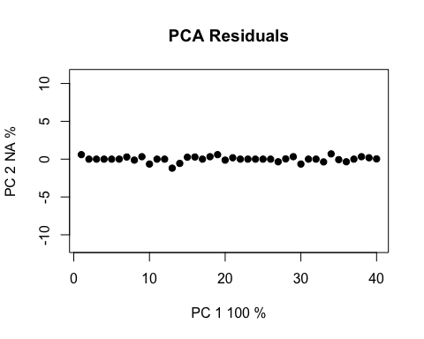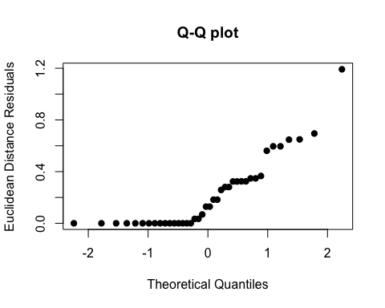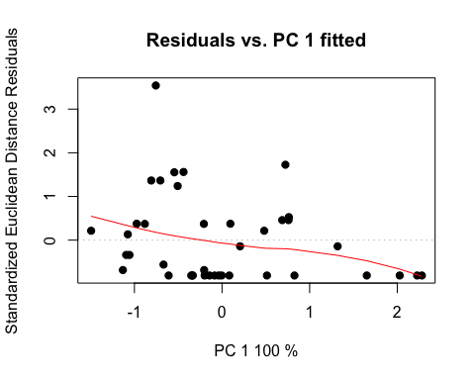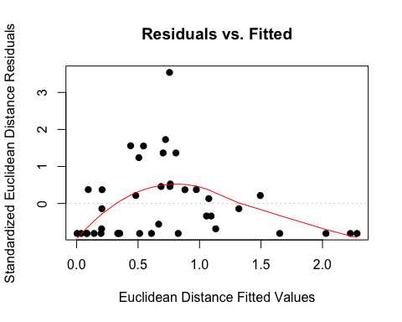

# pca plot  
hpcplot <- plot(highLM, type = "PC", pch = 19, col = interaction(high$Water, high$Fungus))

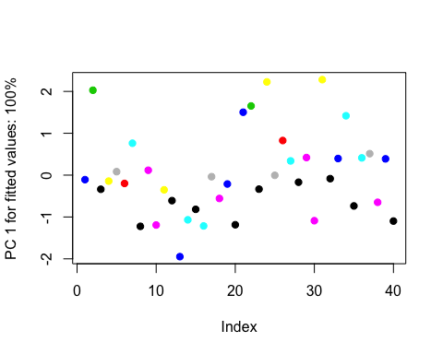

# residuals vs fitted values (homoscedasticity check)  
ldiagnostics <- plot(lowLM, type = "diagnostics")

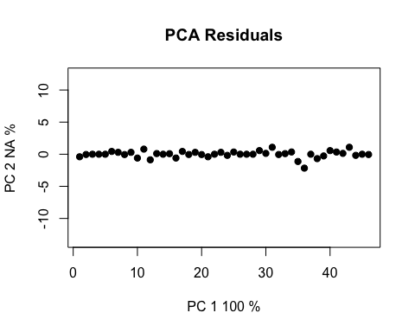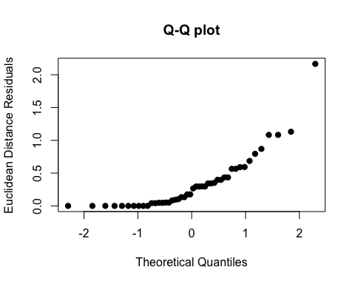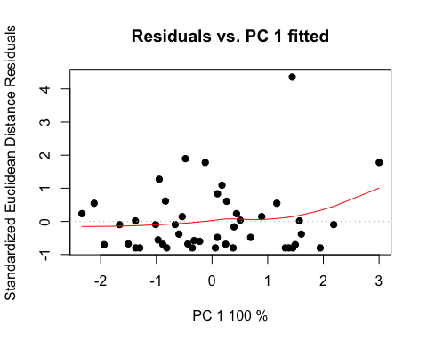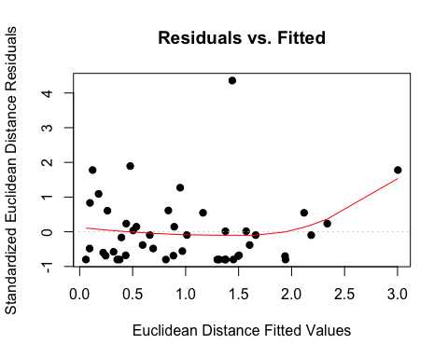

# pca plot  
lpcplot <- plot(lowLM, type = "PC", pch = 19, col = interaction(low$Water, low$Fungus))

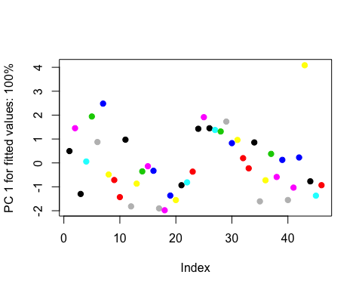

## chl b  
# linear models and coefficient tests  
highLM <- lm.rrpp(Chl.b ~ Block*Fungus*Age, data=high, SS.type="III", print.progress=F) ; summary(highLM)

##   
## Warning: Because variables in the linear model are redundant,  
## the linear model design has been truncated (via QR decomposition).  
## Original X columns: 36  
## Final X columns (rank): 32  
## Check coefficients or degrees of freedom in ANOVA to see changes.

##   
## Warning: Because variables in the linear model are redundant,  
## the linear model design has been truncated (via QR decomposition).  
## Original X columns: 36  
## Final X columns (rank): 32  
## Check coefficients or degrees of freedom in ANOVA to see changes.

##   
## Linear Model fit with lm.rrpp  
##   
## Number of observations: 40  
## Number of dependent variables: 1   
## Data space dimensions: 1   
## Sums of Squares and Cross-products: Type III  
## Number of permutations: 1000  
##   
## Full Model Analysis of Variance  
##   
## Df Residual Df SS Residual SS Rsq F  
## Block * Fungus * Age 31 8 87.50118 6.465898 0.9311898 3.492315  
## Z (from F) Pr(>F)  
## Block * Fungus * Age 2.036384 0.034  
##   
##   
## Redundancy Analysis (PCA on fitted values and residuals)  
##   
## Trace Proportion Rank  
## Fitted 2.2436201 0.9311898 1  
## Residuals 0.1657923 0.0688103 1  
## Total 2.4094123 1.0000000 1  
##   
## Eigenvalues  
##   
## PC1  
## Fitted 2.2436201  
## Residuals 0.1657923  
## Total 2.4094123

coef(highLM, test = T)

##   
## Linear Model fit with lm.rrpp  
##   
## Number of observations: 40  
## Number of dependent variables: 1  
## Data space dimensions: 1  
## Sums of Squares and Cross-products: Type III  
## Number of permutations: 1000  
##   
## Statistics (distances) of coefficients with 95 percent confidence intervals,  
## effect sizes, and probabilities of exceeding observed values based on  
## 1000 random permutations using RRPP   
##   
## d.obs UCL (95%) Zd Pr(>d)  
## (Intercept) 0.9718000 2.8586074 -1.03555526 0.846  
## Block 0.3138000 0.6370833 0.48006561 0.291  
## FungusCer 1.0423000 1.5886509 0.95618364 0.156  
## FungusCok 2.8819000 1.5980151 4.60564538 0.003  
## FungusCtrl 1.0827667 2.5596319 0.13473711 0.357  
## FungusNig 2.5081667 2.3652114 2.19739768 0.038  
## FungusPen 0.9413333 2.3066913 0.09063560 0.366  
## FungusPod 1.8891000 3.0356122 0.79880817 0.186  
## FungusPre 1.0948000 2.6725431 0.17522571 0.336  
## FungusXyl 1.1520000 3.4087934 -0.02631461 0.390  
## AgeYoung 3.0766333 2.0489802 3.55937998 0.002  
## Block:FungusCtrl 0.3293500 0.8954640 -0.14763723 0.484  
## Block:FungusNig 1.0558000 0.8658242 2.64201607 0.011  
## Block:FungusPen 0.3389500 0.8589332 -0.06408513 0.464  
## Block:FungusPod 0.8227000 1.3600749 0.65215662 0.234  
## Block:FungusPre 0.0753000 0.9176346 -1.01598028 0.871  
## Block:FungusXyl 0.4171000 1.4458540 -0.30661780 0.531  
## Block:AgeYoung 0.9157500 0.8609529 2.11985292 0.040  
## FungusCer:AgeYoung 0.4449167 1.8168762 -0.47636122 0.610  
## FungusCok:AgeYoung 0.3173833 1.7661016 -0.74526101 0.725  
## FungusCtrl:AgeYoung 1.2420667 2.9113518 0.04990791 0.404  
## FungusNig:AgeYoung 1.8611000 3.0423215 0.72779843 0.234  
## FungusPen:AgeYoung 0.4409667 2.8346250 -0.85528411 0.770  
## FungusPod:AgeYoung 0.6755667 3.5070109 -0.72511390 0.719  
## FungusPre:AgeYoung 1.8436833 2.8716802 0.75353808 0.220  
## FungusXyl:AgeYoung 2.3386333 3.6527518 0.82694472 0.185  
## Block:FungusCtrl:AgeYoung 0.1244500 1.3340999 -1.06173665 0.865  
## Block:FungusNig:AgeYoung 1.6630000 1.3789928 2.57631759 0.017  
## Block:FungusPen:AgeYoung 0.2330000 1.3324569 -0.79560761 0.742  
## Block:FungusPod:AgeYoung 1.5442500 2.0773416 1.14486290 0.139  
## Block:FungusPre:AgeYoung 1.0738000 1.3315547 1.31612559 0.109  
## Block:FungusXyl:AgeYoung 1.4224500 2.1255591 0.87637559 0.181

lowLM <- lm.rrpp(Chl.b ~ Block*Fungus*Age, data=low, SS.type="III", print.progress=F) ; summary(lowLM)

##   
## Warning: Because variables in the linear model are redundant,  
## the linear model design has been truncated (via QR decomposition).  
## Original X columns: 36  
## Final X columns (rank): 34  
## Check coefficients or degrees of freedom in ANOVA to see changes.

##   
## Warning: Because variables in the linear model are redundant,  
## the linear model design has been truncated (via QR decomposition).  
## Original X columns: 36  
## Final X columns (rank): 34  
## Check coefficients or degrees of freedom in ANOVA to see changes.

##   
## Linear Model fit with lm.rrpp  
##   
## Number of observations: 46  
## Number of dependent variables: 1   
## Data space dimensions: 1   
## Sums of Squares and Cross-products: Type III  
## Number of permutations: 1000  
##   
## Full Model Analysis of Variance  
##   
## Df Residual Df SS Residual SS Rsq F  
## Block * Fungus * Age 33 12 183.9456 24.99044 0.8803919 2.676596  
## Z (from F) Pr(>F)  
## Block * Fungus * Age 1.937795 0.028  
##   
##   
## Redundancy Analysis (PCA on fitted values and residuals)  
##   
## Trace Proportion Rank  
## Fitted 4.087680 0.8803919 1  
## Residuals 0.555343 0.1196081 1  
## Total 4.643023 0.9999999 1  
##   
## Eigenvalues  
##   
## PC1  
## Fitted 4.087680  
## Residuals 0.555343  
## Total 4.643023

coef(lowLM, test = T)

##   
## Linear Model fit with lm.rrpp  
##   
## Number of observations: 46  
## Number of dependent variables: 1  
## Data space dimensions: 1  
## Sums of Squares and Cross-products: Type III  
## Number of permutations: 1000  
##   
## Statistics (distances) of coefficients with 95 percent confidence intervals,  
## effect sizes, and probabilities of exceeding observed values based on  
## 1000 random permutations using RRPP   
##   
## d.obs UCL (95%) Zd Pr(>d)  
## (Intercept) 9.7034333 8.816860 2.33761312 0.016  
## Block 2.7120500 1.422906 4.74788676 0.001  
## FungusCer 3.7832333 3.768123 1.96151405 0.050  
## FungusCok 4.1255333 4.457614 1.60711471 0.077  
## FungusCtrl 3.7724667 3.819256 1.85177735 0.058  
## FungusNig 1.3687333 3.911751 -0.24312995 0.528  
## FungusPen 4.7273333 3.880863 2.59762256 0.017  
## FungusPod 3.1066000 3.901550 1.28390922 0.116  
## FungusPre 5.9124000 3.676641 3.75924811 0.003  
## FungusXyl 0.6566833 2.421600 -0.46066377 0.604  
## AgeYoung 6.7049333 3.942629 4.20728026 0.002  
## Block:FungusCer 1.3418000 1.550478 1.51614632 0.095  
## Block:FungusCok 1.2609500 2.364624 0.39779491 0.306  
## Block:FungusCtrl 1.2197000 1.597281 1.14330704 0.137  
## Block:FungusNig 0.6864500 1.642021 0.08730734 0.390  
## Block:FungusPen 1.3535000 1.638861 1.36514635 0.105  
## Block:FungusPod 0.7918000 1.517556 0.31453734 0.332  
## Block:FungusPre 1.6565000 1.583976 2.10592274 0.036  
## Block:AgeYoung 4.5699500 2.113529 5.55921594 0.001  
## FungusCer:AgeYoung 5.2040333 6.041119 1.50370100 0.097  
## FungusCok:AgeYoung 7.7240333 7.405409 2.05086828 0.038  
## FungusCtrl:AgeYoung 7.8890333 6.050129 2.93704559 0.011  
## FungusNig:AgeYoung 3.7873833 6.208656 0.69611436 0.220  
## FungusPen:AgeYoung 9.7007000 6.213026 3.80655669 0.002  
## FungusPod:AgeYoung 7.1257000 6.062376 2.59846744 0.020  
## FungusPre:AgeYoung 10.7553667 6.072150 4.37963889 0.002  
## FungusXyl:AgeYoung 1.5143833 3.614567 0.01095824 0.419  
## Block:FungusCer:AgeYoung 3.5053500 3.096614 2.51432025 0.026  
## Block:FungusCok:AgeYoung 4.1488500 4.741278 1.61552360 0.084  
## Block:FungusCtrl:AgeYoung 4.8520000 2.971325 3.92849142 0.003  
## Block:FungusNig:AgeYoung 2.2579000 2.970890 1.12751412 0.155  
## Block:FungusPen:AgeYoung 5.1965000 3.174421 4.17789026 0.001  
## Block:FungusPod:AgeYoung 5.3413500 2.962565 4.47570144 0.002  
## Block:FungusPre:AgeYoung 5.7951500 3.018835 4.86979362 0.001

# ratio anovas  
highANOVA <- anova(highLM, effect.type = "F", error = c("Residuals", "Block:Fungus", "Block:Fungus:Age", "Residuals", "Block:Fungus:Age", "Block:Fungus:Age", "Residuals")) ; summary(highANOVA)

## Warning in log(Z): NaNs produced

##   
## Analysis of Variance, using Residual Randomization  
## Permutation procedure: Randomization of null model residuals   
## Number of permutations: 1000   
## Estimation method: Ordinary Least Squares   
## Sums of Squares and Cross-products: Type III   
## Effect sizes (Z) based on F distributions  
##   
## Df SS MS Rsq F Z Pr(>F)   
## Block 1 0.197 0.19694 0.002096 0.2437 0.611   
## Fungus 8 5.524 0.69044 0.058781 2.7711 0.83328 0.197   
## Age 1 2.028 2.02836 0.021586 5.0392 1.30952 0.044 *  
## Block:Fungus 6 1.495 0.24916 0.015909 0.3083 -1.26420 0.894   
## Block:Age 1 0.839 0.83860 0.008924 2.0834 0.140   
## Fungus:Age 8 2.190 0.27375 0.023306 0.6801 -0.74888 0.796   
## Block:Fungus:Age 6 2.415 0.40251 0.025701 0.4980 -0.78923 0.793   
## Residuals 8 6.466 0.80824 0.068810   
## Total 39 93.967   
## ---  
## Signif. codes: 0 '***' 0.001 '**' 0.01 '*' 0.05 '.' 0.1 ' ' 1  
##   
## Call: lm.rrpp(f1 = Chl.b ~ Block * Fungus * Age, SS.type = "III", data = high,   
## print.progress = F)

lowANOVA <- anova(lowLM, effect.type = "F", error = c("Residuals", "Block:Fungus", "Block:Fungus:Age", "Residuals", "Block:Fungus:Age", "Block:Fungus:Age", "Residuals")) ; summary(lowANOVA)

## Warning in log(Z): NaNs produced

##   
## Analysis of Variance, using Residual Randomization  
## Permutation procedure: Randomization of null model residuals   
## Number of permutations: 1000   
## Estimation method: Ordinary Least Squares   
## Sums of Squares and Cross-products: Type III   
## Effect sizes (Z) based on F distributions  
##   
## Df SS MS Rsq F Z Pr(>F)   
## Block 1 14.710 14.7104 0.070406 7.0637 0.034 *  
## Fungus 8 11.605 1.4506 0.055542 2.7036 1.62775 0.070 .  
## Age 1 9.633 9.6335 0.046107 2.5619 1.04319 0.089 .  
## Block:Fungus 7 3.756 0.5365 0.017976 0.2576 -1.68648 0.945   
## Block:Age 1 20.884 20.8844 0.099956 5.5539 0.019 *  
## Fungus:Age 8 19.625 2.4531 0.093927 0.6524 -0.70537 0.776   
## Block:Fungus:Age 7 26.322 3.7604 0.125983 1.8057 0.97428 0.160   
## Residuals 12 24.990 2.0825 0.119608   
## Total 45 208.936   
## ---  
## Signif. codes: 0 '***' 0.001 '**' 0.01 '*' 0.05 '.' 0.1 ' ' 1  
##   
## Call: lm.rrpp(f1 = Chl.b ~ Block * Fungus * Age, SS.type = "III", data = low,   
## print.progress = F)

# pairwise  
highpw <- pairwise(highLM, groups = high$Fungus) ; summary(highpw, confidence = 0.95, stat.table = T)

##   
## Pairwise comparisons  
##   
## Groups: Asp Cer Cok Ctrl Nig Pen Pod Pre Xyl   
##   
## RRPP: 1000 permutations  
##   
## LS means:  
## Vectors hidden (use show.vectors = TRUE to view)  
##   
## Pairwise distances between means, plus statistics  
## d UCL (95%) Z Pr > d  
## Asp:Cer 1.40883333 2.0532160 -0.0391402115 0.530  
## Asp:Cok 2.86728333 3.5092806 -0.0134255369 0.527  
## Asp:Ctrl 1.16955000 1.6009888 0.0033440133 0.489  
## Asp:Nig 1.12901667 1.5862536 -0.0210603207 0.524  
## Asp:Pen 0.27595000 0.7440610 -0.2560781352 0.546  
## Asp:Pod 2.22305833 2.7093197 0.0020466769 0.512  
## Asp:Pre 1.09615833 1.6013929 -0.0224875134 0.529  
## Asp:Xyl 0.49590833 0.9711726 -0.0503802905 0.508  
## Cer:Cok 1.45845000 2.1850596 0.0209170861 0.516  
## Cer:Ctrl 0.23928333 0.8741738 -0.5177538498 0.643  
## Cer:Nig 0.27981667 0.8940755 -0.4278919033 0.591  
## Cer:Pen 1.13288333 1.7934800 0.0098670038 0.497  
## Cer:Pod 0.81422500 1.4804144 0.0191380830 0.484  
## Cer:Pre 0.31267500 0.9778259 -0.3690143297 0.580  
## Cer:Xyl 0.91292500 1.6322366 -0.0459847725 0.500  
## Cok:Ctrl 1.69773333 2.3133186 -0.0159375395 0.506  
## Cok:Nig 1.73826667 2.3711863 0.0013238243 0.514  
## Cok:Pen 2.59133333 3.1784924 0.0368552549 0.516  
## Cok:Pod 0.64422500 1.3186784 -0.0638176448 0.517  
## Cok:Pre 1.77112500 2.4275900 0.0038223452 0.509  
## Cok:Xyl 2.37137500 3.0480770 -0.0160075182 0.512  
## Ctrl:Nig 0.04053333 0.5490805 -1.1279636621 0.890  
## Ctrl:Pen 0.89360000 1.3344906 0.0741060292 0.463  
## Ctrl:Pod 1.05350833 1.5178074 -0.0009301432 0.519  
## Ctrl:Pre 0.07339167 0.5959994 -0.9744038737 0.837  
## Ctrl:Xyl 0.67364167 1.1927018 -0.0092211324 0.488  
## Nig:Pen 0.85306667 1.2725337 0.0512371617 0.481  
## Nig:Pod 1.09404167 1.6021957 0.0206345254 0.501  
## Nig:Pre 0.03285833 0.6268016 -1.1470251872 0.915  
## Nig:Xyl 0.63310833 1.1760572 -0.0365071319 0.512  
## Pen:Pod 1.94710833 2.4327228 0.0649084515 0.477  
## Pen:Pre 0.82020833 1.2881646 0.0397701337 0.491  
## Pen:Xyl 0.21995833 0.7078684 -0.3647109876 0.579  
## Pod:Pre 1.12690000 1.6651442 0.0217463297 0.487  
## Pod:Xyl 1.72715000 2.3004922 -0.0017083427 0.484  
## Pre:Xyl 0.60025000 1.1600314 -0.0558601571 0.495

highpw2 <- pairwise(highLM, groups = high$Age) ; summary(highpw2, confidence = 0.95, stat.table = T)

##   
## Pairwise comparisons  
##   
## Groups: Old Young   
##   
## RRPP: 1000 permutations  
##   
## LS means:  
## Vectors hidden (use show.vectors = TRUE to view)  
##   
## Pairwise distances between means, plus statistics  
## d UCL (95%) Z Pr > d  
## Old:Young 2.190885 2.437061 -0.0217629 0.516

lowpw <- pairwise(lowLM, groups = low$Fungus) ; summary(lowpw, confidence = 0.95, stat.table = T)

##   
## Pairwise comparisons  
##   
## Groups: Asp Cer Cok Ctrl Nig Pen Pod Pre Xyl   
##   
## RRPP: 1000 permutations  
##   
## LS means:  
## Vectors hidden (use show.vectors = TRUE to view)  
##   
## Pairwise distances between means, plus statistics  
## d UCL (95%) Z Pr > d  
## Asp:Cer 2.0029667 3.036590 0.0006948353 0.508  
## Asp:Cok 1.2701917 2.449669 -0.0369686944 0.499  
## Asp:Ctrl 2.2405500 3.208026 0.0591384880 0.485  
## Asp:Nig 0.3600417 1.541545 -0.5661175530 0.642  
## Asp:Pen 2.3664833 3.420721 0.0346965415 0.477  
## Asp:Pod 3.3015000 4.329931 0.0381348759 0.496  
## Asp:Pre 3.0168667 4.022630 0.0078963105 0.485  
## Asp:Xyl 0.5275833 2.039301 -0.4596796837 0.588  
## Cer:Cok 0.7327750 1.817063 -0.1786804299 0.519  
## Cer:Ctrl 0.2375833 1.290320 -0.7064443750 0.706  
## Cer:Nig 1.6429250 2.704958 -0.0025738725 0.520  
## Cer:Pen 0.3635167 1.390792 -0.4524038522 0.593  
## Cer:Pod 1.2985333 2.256281 0.0333987898 0.484  
## Cer:Pre 1.0139000 1.982522 -0.0204402406 0.479  
## Cer:Xyl 2.5305500 4.004337 0.0081304370 0.478  
## Cok:Ctrl 0.9703583 2.116997 -0.0140104255 0.467  
## Cok:Nig 0.9101500 2.106143 -0.1512865037 0.529  
## Cok:Pen 1.0962917 2.151256 -0.0135297032 0.479  
## Cok:Pod 2.0313083 3.148278 0.0424149024 0.475  
## Cok:Pre 1.7466750 2.915110 0.0131353986 0.474  
## Cok:Xyl 1.7977750 3.312103 -0.0238677671 0.497  
## Ctrl:Nig 1.8805083 2.978263 0.0550075896 0.473  
## Ctrl:Pen 0.1259333 1.216929 -1.0020940115 0.842  
## Ctrl:Pod 1.0609500 2.034873 -0.0520971158 0.514  
## Ctrl:Pre 0.7763167 1.818599 -0.1372043863 0.516  
## Ctrl:Xyl 2.7681333 4.270618 0.0498277153 0.462  
## Nig:Pen 2.0064417 3.137083 0.0329286981 0.477  
## Nig:Pod 2.9414583 4.073581 0.0357682822 0.496  
## Nig:Pre 2.6568250 3.772914 0.0086836026 0.484  
## Nig:Xyl 0.8876250 2.423975 -0.1882226477 0.503  
## Pen:Pod 0.9350167 1.975069 -0.0565680218 0.501  
## Pen:Pre 0.6503833 1.666200 -0.2064797620 0.538  
## Pen:Xyl 2.8940667 4.355614 0.0319462746 0.475  
## Pod:Pre 0.2846333 1.295458 -0.6190877269 0.672  
## Pod:Xyl 3.8290833 5.340200 0.0338894566 0.472  
## Pre:Xyl 3.5444500 4.991688 0.0131360352 0.484

lowpw2 <- pairwise(lowLM, groups = low$Age) ; summary(lowpw2, confidence = 0.95, stat.table = T)

##   
## Pairwise comparisons  
##   
## Groups: Old Young   
##   
## RRPP: 1000 permutations  
##   
## LS means:  
## Vectors hidden (use show.vectors = TRUE to view)  
##   
## Pairwise distances between means, plus statistics  
## d UCL (95%) Z Pr > d  
## Old:Young 1.035035 1.546003 0.01878663 0.489

# residuals vs fitted values (homoscedasticity check)  
hdiagnostics <- plot(highLM, type = "diagnostics")

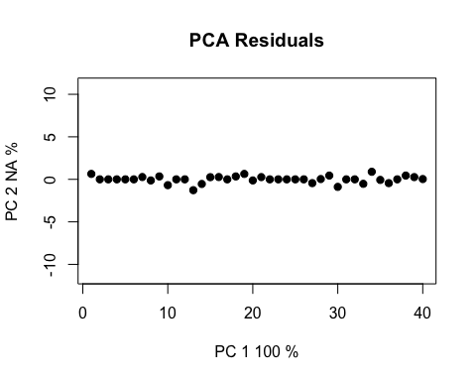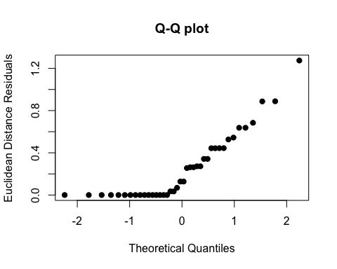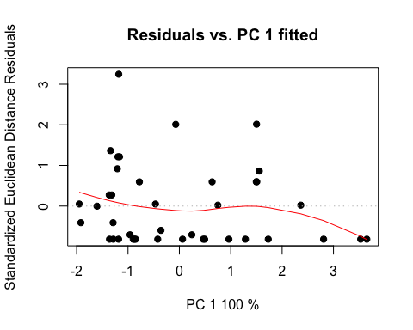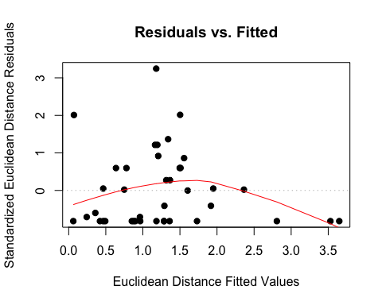

# pca plot  
hpcplot <- plot(highLM, type = "PC", pch = 19, col = interaction(high$Water, high$Fungus))

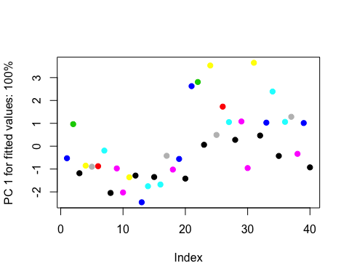

# residuals vs fitted values (homoscedasticity check)  
ldiagnostics <- plot(lowLM, type = "diagnostics")

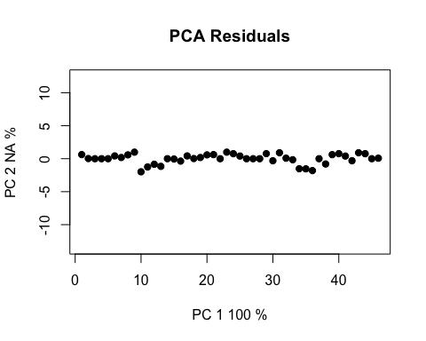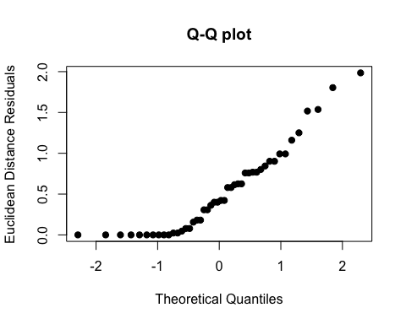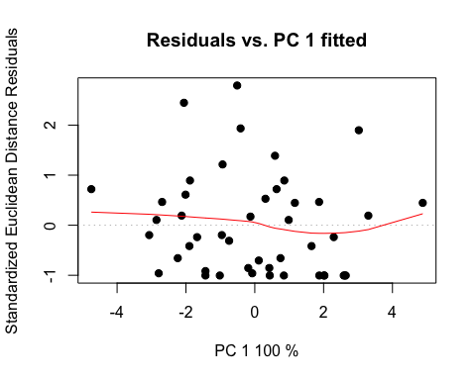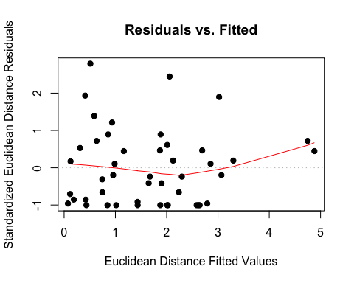

# pca plot  
lpcplot <- plot(lowLM, type = "PC", pch = 19, col = interaction(low$Water, low$Fungus))

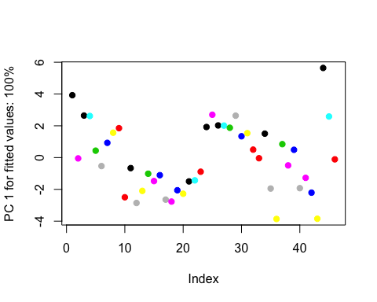

## Total  
# linear models and coefficient tests  
highLM <- lm.rrpp(Total ~ Block*Fungus*Age, data=high, SS.type="III", print.progress=F) ; summary(highLM)

##   
## Warning: Because variables in the linear model are redundant,  
## the linear model design has been truncated (via QR decomposition).  
## Original X columns: 36  
## Final X columns (rank): 32  
## Check coefficients or degrees of freedom in ANOVA to see changes.

##   
## Warning: Because variables in the linear model are redundant,  
## the linear model design has been truncated (via QR decomposition).  
## Original X columns: 36  
## Final X columns (rank): 32  
## Check coefficients or degrees of freedom in ANOVA to see changes.

##   
## Linear Model fit with lm.rrpp  
##   
## Number of observations: 40  
## Number of dependent variables: 1   
## Data space dimensions: 1   
## Sums of Squares and Cross-products: Type III  
## Number of permutations: 1000  
##   
## Full Model Analysis of Variance  
##   
## Df Residual Df SS Residual SS Rsq F  
## Block * Fungus * Age 31 8 221.9666 22.53375 0.9078376 2.542041  
## Z (from F) Pr(>F)  
## Block * Fungus * Age 1.45138 0.083  
##   
##   
## Redundancy Analysis (PCA on fitted values and residuals)  
##   
## Trace Proportion Rank  
## Fitted 5.691452 0.9078375 1  
## Residuals 0.577788 0.0921624 1  
## Total 6.269241 1.0000000 1  
##   
## Eigenvalues  
##   
## PC1  
## Fitted 5.691452  
## Residuals 0.577788  
## Total 6.269241

coef(highLM, test = T)

##   
## Linear Model fit with lm.rrpp  
##   
## Number of observations: 40  
## Number of dependent variables: 1  
## Data space dimensions: 1  
## Sums of Squares and Cross-products: Type III  
## Number of permutations: 1000  
##   
## Statistics (distances) of coefficients with 95 percent confidence intervals,  
## effect sizes, and probabilities of exceeding observed values based on  
## 1000 random permutations using RRPP   
##   
## d.obs UCL (95%) Zd Pr(>d)  
## (Intercept) 2.4605000 5.965483 -0.95729564 0.842  
## Block 0.3327000 1.170195 -0.19550994 0.524  
## FungusCer 1.9381000 3.371012 0.81834791 0.168  
## FungusCok 6.0044000 3.262008 4.75793997 0.003  
## FungusCtrl 1.5441000 5.092658 -0.23232550 0.491  
## FungusNig 5.0907000 4.756851 2.24948871 0.040  
## FungusPen 2.1842000 4.664580 0.33220964 0.292  
## FungusPod 3.0680000 6.215268 0.45468859 0.242  
## FungusPre 2.3511500 5.412914 0.29631293 0.283  
## FungusXyl 2.1986000 6.671164 -0.04890224 0.403  
## AgeYoung 4.4501333 3.592018 2.65381638 0.017  
## Block:FungusCtrl 0.4002000 1.665440 -0.55555368 0.636  
## Block:FungusNig 2.0625000 1.641081 2.79178268 0.009  
## Block:FungusPen 0.6948000 1.594835 0.05782493 0.415  
## Block:FungusPod 1.0500000 2.609495 0.03176724 0.401  
## Block:FungusPre 0.1543500 1.713732 -0.98513696 0.855  
## Block:FungusXyl 0.7074000 2.734658 -0.38407267 0.556  
## Block:AgeYoung 1.3986000 1.565950 1.55086533 0.081  
## FungusCer:AgeYoung 0.5794667 3.367753 -0.74130802 0.746  
## FungusCok:AgeYoung 1.5839333 3.410924 0.20011719 0.354  
## FungusCtrl:AgeYoung 2.3970000 5.642273 0.07070170 0.394  
## FungusNig:AgeYoung 4.0526667 5.726562 1.03328104 0.166  
## FungusPen:AgeYoung 1.3145333 5.410354 -0.56281946 0.647  
## FungusPod:AgeYoung 1.4089667 6.736242 -0.65953491 0.704  
## FungusPre:AgeYoung 3.6231833 5.582544 0.81975980 0.205  
## FungusXyl:AgeYoung 4.2304333 6.870825 0.71704352 0.197  
## Block:FungusCtrl:AgeYoung 0.1023000 2.455576 -1.22318440 0.939  
## Block:FungusNig:AgeYoung 3.1697000 2.543829 2.68840384 0.014  
## Block:FungusPen:AgeYoung 0.5183000 2.468054 -0.69008022 0.701  
## Block:FungusPod:AgeYoung 2.2897000 3.856709 0.65193013 0.221  
## Block:FungusPre:AgeYoung 1.8753500 2.470363 1.15902044 0.131  
## Block:FungusXyl:AgeYoung 2.4271000 3.971562 0.69529753 0.221

lowLM <- lm.rrpp(Total ~ Block*Fungus*Age, data=low, SS.type="III", print.progress=F) ; summary(lowLM)

##   
## Warning: Because variables in the linear model are redundant,  
## the linear model design has been truncated (via QR decomposition).  
## Original X columns: 36  
## Final X columns (rank): 34  
## Check coefficients or degrees of freedom in ANOVA to see changes.

##   
## Warning: Because variables in the linear model are redundant,  
## the linear model design has been truncated (via QR decomposition).  
## Original X columns: 36  
## Final X columns (rank): 34  
## Check coefficients or degrees of freedom in ANOVA to see changes.

##   
## Linear Model fit with lm.rrpp  
##   
## Number of observations: 46  
## Number of dependent variables: 1   
## Data space dimensions: 1   
## Sums of Squares and Cross-products: Type III  
## Number of permutations: 1000  
##   
## Full Model Analysis of Variance  
##   
## Df Residual Df SS Residual SS Rsq F  
## Block * Fungus * Age 33 12 314.3371 57.59527 0.8451458 1.984614  
## Z (from F) Pr(>F)  
## Block * Fungus * Age 1.404311 0.09  
##   
##   
## Redundancy Analysis (PCA on fitted values and residuals)  
##   
## Trace Proportion Rank  
## Fitted 6.985269 0.8451459 1  
## Residuals 1.279895 0.1548542 1  
## Total 8.265164 1.0000000 1  
##   
## Eigenvalues  
##   
## PC1  
## Fitted 6.985269  
## Residuals 1.279895  
## Total 8.265164

coef(lowLM, test = T)

##   
## Linear Model fit with lm.rrpp  
##   
## Number of observations: 46  
## Number of dependent variables: 1  
## Data space dimensions: 1  
## Sums of Squares and Cross-products: Type III  
## Number of permutations: 1000  
##   
## Statistics (distances) of coefficients with 95 percent confidence intervals,  
## effect sizes, and probabilities of exceeding observed values based on  
## 1000 random permutations using RRPP   
##   
## d.obs UCL (95%) Zd Pr(>d)  
## (Intercept) 14.046500 13.965178 1.598502712 0.045  
## Block 3.426250 1.984917 4.119848819 0.001  
## FungusCer 6.577567 5.511842 2.719404246 0.017  
## FungusCok 1.492200 6.902350 -0.552599128 0.640  
## FungusCtrl 1.270733 5.781253 -0.499083591 0.601  
## FungusNig 2.480000 5.710512 0.127061132 0.377  
## FungusPen 3.122967 5.753718 0.477962269 0.270  
## FungusPod 4.613567 5.726922 1.352948507 0.115  
## FungusPre 5.691400 5.417928 2.107465113 0.036  
## FungusXyl 2.848150 3.540888 1.375778288 0.110  
## AgeYoung 5.608600 5.420489 2.086786232 0.044  
## Block:FungusCer 2.231300 2.310645 1.812591958 0.066  
## Block:FungusCok 0.322250 3.716870 -0.947388077 0.844  
## Block:FungusCtrl 0.010650 2.423836 -1.238000970 0.991  
## Block:FungusNig 0.964250 2.379073 -0.004997778 0.417  
## Block:FungusPen 0.351150 2.509073 -0.833822189 0.765  
## Block:FungusPod 0.971500 2.415302 -0.001782977 0.428  
## Block:FungusPre 0.982450 2.343578 0.088170677 0.394  
## Block:AgeYoung 4.185050 2.642521 3.748898429 0.003  
## FungusCer:AgeYoung 6.105833 7.714816 1.267998376 0.123  
## FungusCok:AgeYoung 4.642800 9.503512 0.253820819 0.353  
## FungusCtrl:AgeYoung 3.677733 7.795574 0.247276859 0.319  
## FungusNig:AgeYoung 4.948250 7.609501 0.764640533 0.204  
## FungusPen:AgeYoung 8.437000 7.892359 2.201506176 0.040  
## FungusPod:AgeYoung 4.244600 7.824488 0.512062670 0.267  
## FungusPre:AgeYoung 10.636200 7.769286 3.127722259 0.011  
## FungusXyl:AgeYoung 3.552350 4.693658 1.159082705 0.131  
## Block:FungusCer:AgeYoung 3.861000 3.700948 2.117453293 0.040  
## Block:FungusCok:AgeYoung 2.405350 5.646958 0.053699113 0.412  
## Block:FungusCtrl:AgeYoung 2.843800 3.702787 1.184145831 0.135  
## Block:FungusNig:AgeYoung 2.810900 3.493581 1.226205299 0.124  
## Block:FungusPen:AgeYoung 4.568300 3.804095 2.649358373 0.017  
## Block:FungusPod:AgeYoung 2.859250 3.766930 1.227770762 0.131  
## Block:FungusPre:AgeYoung 5.663050 3.580884 3.674304102 0.006

# ratio anovas  
highANOVA <- anova(highLM, effect.type = "F", error = c("Residuals", "Block:Fungus", "Block:Fungus:Age", "Residuals", "Block:Fungus:Age", "Block:Fungus:Age", "Residuals")) ; summary(highANOVA)

## Warning in log(Z): NaNs produced

##   
## Analysis of Variance, using Residual Randomization  
## Permutation procedure: Randomization of null model residuals   
## Number of permutations: 1000   
## Estimation method: Ordinary Least Squares   
## Sums of Squares and Cross-products: Type III   
## Effect sizes (Z) based on F distributions  
##   
## Df SS MS Rsq F Z Pr(>F)   
## Block 1 0.221 0.2214 0.000905 0.0786 0.712   
## Fungus 8 24.327 3.0408 0.099495 3.3018 0.87448 0.188   
## Age 1 4.244 4.2436 0.017356 3.1404 0.094 .  
## Block:Fungus 6 5.526 0.9210 0.022600 0.3270 -1.13474 0.869   
## Block:Age 1 1.956 1.9561 0.008000 1.4475 0.206   
## Fungus:Age 8 8.799 1.0999 0.035989 0.8140 -0.49572 0.703   
## Block:Fungus:Age 6 8.108 1.3513 0.033161 0.4797 -0.81835 0.811   
## Residuals 8 22.534 2.8167 0.092162   
## Total 39 244.500   
## ---  
## Signif. codes: 0 '***' 0.001 '**' 0.01 '*' 0.05 '.' 0.1 ' ' 1  
##   
## Call: lm.rrpp(f1 = Total ~ Block * Fungus * Age, SS.type = "III", data = high,   
## print.progress = F)

lowANOVA <- anova(lowLM, effect.type = "F", error = c("Residuals", "Block:Fungus", "Block:Fungus:Age", "Residuals", "Block:Fungus:Age", "Block:Fungus:Age", "Residuals")) ; summary(lowANOVA)

## Warning in log(Z): NaNs produced

##   
## Analysis of Variance, using Residual Randomization  
## Permutation procedure: Randomization of null model residuals   
## Number of permutations: 1000   
## Estimation method: Ordinary Least Squares   
## Sums of Squares and Cross-products: Type III   
## Effect sizes (Z) based on F distributions  
##   
## Df SS MS Rsq F Z Pr(>F)   
## Block 1 23.48 23.4784 0.063125 4.8917 0.068 .  
## Fungus 8 15.97 1.9959 0.042930 1.7917 0.91703 0.153   
## Age 1 6.74 6.7407 0.018123 2.4616 0.97890 0.122   
## Block:Fungus 7 7.80 1.1140 0.020966 0.2321 -1.60813 0.939   
## Block:Age 1 17.51 17.5146 0.047091 6.3962 0.014 *  
## Fungus:Age 8 15.32 1.9152 0.041195 0.6994 -0.72922 0.784   
## Block:Fungus:Age 7 19.17 2.7383 0.051536 0.5705 -0.62258 0.744   
## Residuals 12 57.60 4.7996 0.154854   
## Total 45 371.93   
## ---  
## Signif. codes: 0 '***' 0.001 '**' 0.01 '*' 0.05 '.' 0.1 ' ' 1  
##   
## Call: lm.rrpp(f1 = Total ~ Block * Fungus * Age, SS.type = "III", data = low,   
## print.progress = F)

# pairwise  
highpw <- pairwise(highLM, groups = high$Fungus) ; summary(highpw, confidence = 0.95, stat.table = T)

##   
## Pairwise comparisons  
##   
## Groups: Asp Cer Cok Ctrl Nig Pen Pod Pre Xyl   
##   
## RRPP: 1000 permutations  
##   
## LS means:  
## Vectors hidden (use show.vectors = TRUE to view)  
##   
## Pairwise distances between means, plus statistics  
## d UCL (95%) Z Pr > d  
## Asp:Cer 2.594433333 3.812039 -3.954665e-02 0.533  
## Asp:Cok 5.579033333 6.757072 -1.367275e-02 0.524  
## Asp:Ctrl 2.044500000 2.865631 3.875306e-03 0.505  
## Asp:Nig 2.109066667 2.953394 -1.940906e-02 0.525  
## Asp:Pen 0.655633333 1.518069 -1.647441e-01 0.525  
## Asp:Pod 4.098058333 5.001203 2.778474e-03 0.511  
## Asp:Pre 2.106208333 3.012280 -2.436674e-02 0.529  
## Asp:Xyl 1.025908333 1.915073 -2.668556e-02 0.503  
## Cer:Cok 2.984600000 4.323065 2.153141e-02 0.515  
## Cer:Ctrl 0.549933333 1.727749 -4.089082e-01 0.603  
## Cer:Nig 0.485366667 1.636969 -4.659161e-01 0.612  
## Cer:Pen 1.938800000 3.154183 5.623168e-03 0.499  
## Cer:Pod 1.503625000 2.742521 1.824930e-02 0.480  
## Cer:Pre 0.488225000 1.740016 -4.744391e-01 0.614  
## Cer:Xyl 1.568525000 2.907379 -5.774385e-02 0.500  
## Cok:Ctrl 3.534533333 4.676755 -1.659699e-02 0.508  
## Cok:Nig 3.469966667 4.651340 2.638330e-06 0.518  
## Cok:Pen 4.923400000 5.998903 3.570479e-02 0.513  
## Cok:Pod 1.480975000 2.759216 -3.243378e-02 0.516  
## Cok:Pre 3.472825000 4.669348 5.027707e-03 0.508  
## Cok:Xyl 4.553125000 5.809938 -2.061802e-02 0.513  
## Ctrl:Nig 0.064566667 1.040871 -1.170930e+00 0.913  
## Ctrl:Pen 1.388866667 2.212370 7.117354e-02 0.461  
## Ctrl:Pod 2.053558333 2.917332 -6.862494e-04 0.526  
## Ctrl:Pre 0.061708333 1.103822 -1.193488e+00 0.920  
## Ctrl:Xyl 1.018591667 1.991286 -2.842164e-02 0.492  
## Nig:Pen 1.453433333 2.231779 5.055845e-02 0.482  
## Nig:Pod 1.988991667 2.943447 1.983241e-02 0.496  
## Nig:Pre 0.002858333 1.136061 -1.308734e+00 0.998  
## Nig:Xyl 1.083158333 2.101251 -5.034647e-02 0.510  
## Pen:Pod 3.442425000 4.356699 6.420656e-02 0.471  
## Pen:Pre 1.450575000 2.304164 3.488796e-02 0.491  
## Pen:Xyl 0.370275000 1.253998 -4.289162e-01 0.601  
## Pod:Pre 1.991850000 3.006670 2.368274e-02 0.488  
## Pod:Xyl 3.072150000 4.135326 -6.425890e-03 0.482  
## Pre:Xyl 1.080300000 2.137962 -6.751978e-02 0.497

highpw2 <- pairwise(highLM, groups = high$Age) ; summary(highpw2, confidence = 0.95, stat.table = T)

##   
## Pairwise comparisons  
##   
## Groups: Old Young   
##   
## RRPP: 1000 permutations  
##   
## LS means:  
## Vectors hidden (use show.vectors = TRUE to view)  
##   
## Pairwise distances between means, plus statistics  
## d UCL (95%) Z Pr > d  
## Old:Young 3.012115 3.472667 -0.02145217 0.512

lowpw <- pairwise(lowLM, groups = low$Fungus) ; summary(lowpw, confidence = 0.95, stat.table = T)

##   
## Pairwise comparisons  
##   
## Groups: Asp Cer Cok Ctrl Nig Pen Pod Pre Xyl   
##   
## RRPP: 1000 permutations  
##   
## LS means:  
## Vectors hidden (use show.vectors = TRUE to view)  
##   
## Pairwise distances between means, plus statistics  
## d UCL (95%) Z Pr > d  
## Asp:Cer 2.9230500 4.191613 0.021014198 0.501  
## Asp:Cok 0.7913250 2.275334 -0.218102220 0.501  
## Asp:Ctrl 2.2543667 3.451344 0.053541805 0.473  
## Asp:Nig 0.8882750 2.421483 -0.155071014 0.482  
## Asp:Pen 2.7704667 3.989263 0.048371138 0.479  
## Asp:Pod 3.4075167 4.581617 0.051997772 0.491  
## Asp:Pre 4.0714500 5.330438 0.036290539 0.471  
## Asp:Xyl 0.2617500 2.222896 -0.914283250 0.806  
## Cer:Cok 2.1317250 3.437677 0.000642411 0.508  
## Cer:Ctrl 0.6686833 1.864353 -0.310715671 0.571  
## Cer:Nig 2.0347750 3.382907 0.011476309 0.496  
## Cer:Pen 0.1525833 1.411810 -1.043842561 0.851  
## Cer:Pod 0.4844667 1.657651 -0.402741842 0.586  
## Cer:Pre 1.1484000 2.402595 -0.034185797 0.481  
## Cer:Xyl 3.1848000 4.758612 0.034303087 0.507  
## Cok:Ctrl 1.4630417 2.755800 0.001137154 0.490  
## Cok:Nig 0.0969500 1.792232 -1.141932269 0.918  
## Cok:Pen 1.9791417 3.298245 0.022819396 0.495  
## Cok:Pod 2.6161917 4.017258 0.034244268 0.489  
## Cok:Pre 3.2801250 4.669605 0.018793900 0.484  
## Cok:Xyl 1.0530750 2.971412 -0.259364195 0.538  
## Ctrl:Nig 1.3660917 2.664379 -0.021987340 0.479  
## Ctrl:Pen 0.5161000 1.737725 -0.421214597 0.596  
## Ctrl:Pod 1.1531500 2.305679 -0.053278230 0.510  
## Ctrl:Pre 1.8170833 3.024396 -0.023286737 0.506  
## Ctrl:Xyl 2.5161167 4.166173 0.045079752 0.484  
## Nig:Pen 1.8821917 3.166039 0.030281828 0.483  
## Nig:Pod 2.5192417 3.813857 0.040294181 0.501  
## Nig:Pre 3.1831750 4.456738 0.031100619 0.481  
## Nig:Xyl 1.1500250 3.066943 -0.200683755 0.520  
## Pen:Pod 0.6370500 1.935758 -0.279985065 0.539  
## Pen:Pre 1.3009833 2.552229 -0.047965977 0.512  
## Pen:Xyl 3.0322167 4.664688 0.048599721 0.492  
## Pod:Pre 0.6639333 1.994558 -0.259396330 0.526  
## Pod:Xyl 3.6692667 5.352557 0.056020427 0.503  
## Pre:Xyl 4.3332000 6.034100 0.045998381 0.490

lowpw2 <- pairwise(lowLM, groups = low$Age) ; summary(lowpw2, confidence = 0.95, stat.table = T)

##   
## Pairwise comparisons  
##   
## Groups: Old Young   
##   
## RRPP: 1000 permutations  
##   
## LS means:  
## Vectors hidden (use show.vectors = TRUE to view)  
##   
## Pairwise distances between means, plus statistics  
## d UCL (95%) Z Pr > d  
## Old:Young 1.736996 2.386233 0.02114367 0.496

# residuals vs fitted values (homoscedasticity check)  
hdiagnostics <- plot(highLM, type = "diagnostics")

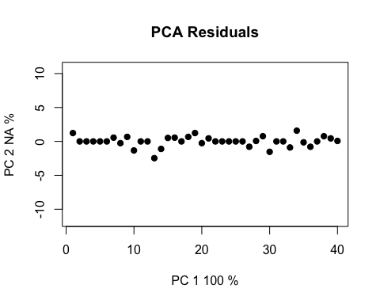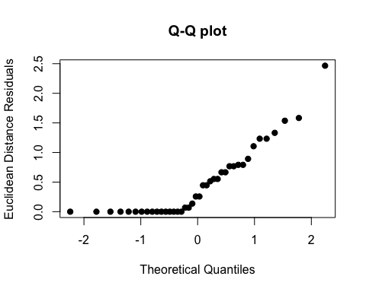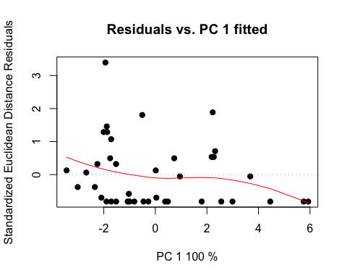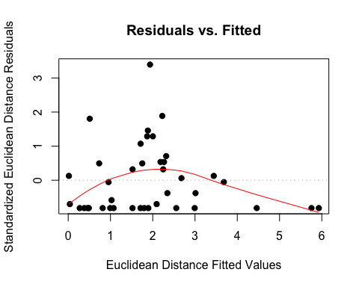

# pca plot  
hpcplot <- plot(highLM, type = "PC", pch = 19, col = interaction(high$Water, high$Fungus))

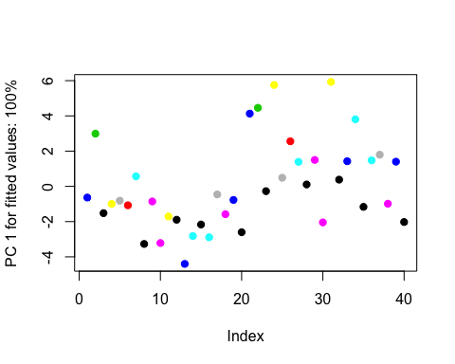

# residuals vs fitted values (homoscedasticity check)  
ldiagnostics <- plot(lowLM, type = "diagnostics")

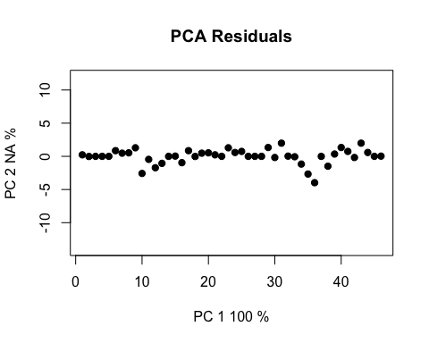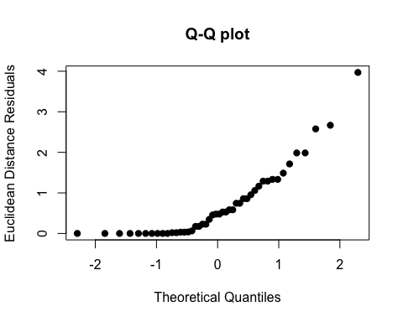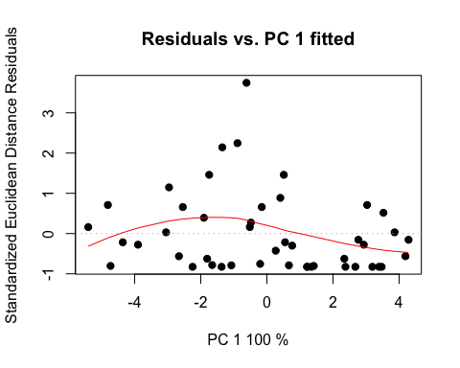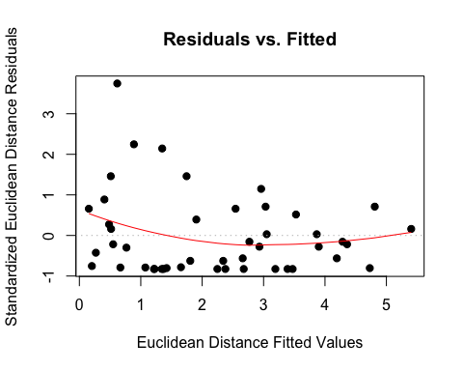

# pca plot  
lpcplot <- plot(lowLM, type = "PC", pch = 19, col = interaction(low$Water, low$Fungus))

