Field Old and Young Leaves Lipid Analysis

Kenia E. Segura Aba

4/30/2020

This file was run in R version 3.5.3. The packages used are tidyverse version 1.3.0, readr version 1.3.1, RRPP version 0.4.2.9000, mixOmics version 6.6.2, and labdsv version 2.0-1. This file must be in the same directory as the Box sync folder in order to run. The following analysis of lipid metabolites was conducted using a split-plot analysis of variance (ANOVA) of Young and Old *P. virgatum* leaves using residual randomization permutation procedure (RRPP). Patterns in metabolite classification were visualized using mixOmics for principle component analysis (PCA) and partial least squares discriminant analysis (PLS-DA). Dufrene-Legendre indicator analysis was performed to identify specific metabolites indicative of plant response to water treatment and fungal treatment (labdsv).

1. Load necessary packages

library(tidyverse)  
library(readr)  
library(RRPP)  
library(mixOmics)  
library(labdsv)

# Lipids (Neg)

## RRPP

1. Define dependent variable matrix and class matrix.

path <- "~/Box/Summer 2018 TX Endo Field Samples and Analysis/Statistics/Kenia_Thesis_Analysis/"  
  
O_L_neg <- read_tsv(paste(path, "XCMS Online Results/O_L_Neg/XCMS.annotated.Report_1394368.tsv",   
 sep = ""))  
  
Y_L_neg <- read_tsv(paste(path, "XCMS Online Results/Y_L_Neg/XCMS.annotated.Report_1394408.tsv",   
 sep = ""))  
  
# dependent variable: metabolite intensities  
Y_old <- O_L_neg[, c(2, 12:54)] %>% data.frame(row.names = 1) %>%   
 t %>% data.frame()  
scaled_Y_old <- scale(Y_old)  
  
Y_young <- Y_L_neg[, c(2, 12:54)] %>% data.frame(row.names = 1) %>%   
 t %>% data.frame()  
scaled_Y_young <- scale(Y_young)  
  
# class: sample factors  
class <- read.csv(paste(path, "XCMS Online Results/class.csv",   
 sep = ""), header = T, row.names = 1)

1. Define and run multivariate regression models, then print out the results.

O_LMneg <- lm.rrpp(scaled_Y_old ~ Block * Water * Fungus, data = class,   
 SS.type = "III", print.progress = F)  
summary(O_LMneg)

##   
## Linear Model fit with lm.rrpp  
##   
## Number of observations: 43  
## Number of dependent variables: 1540   
## Data space dimensions: 42   
## Sums of Squares and Cross-products: Type III  
## Number of permutations: 1000  
##   
## Full Model Analysis of Variance  
##   
## Df Residual Df SS Residual SS Rsq F  
## Block * Water * Fungus 7 35 21192.11 43487.89 0.3276455 2.436553  
## Z (from F) Pr(>F)  
## Block * Water * Fungus 4.77486 0.001  
##   
##   
## Redundancy Analysis (PCA on fitted values and residuals)  
##   
## Trace Proportion Rank  
## Fitted 504.5741 0.3276455 7  
## Residuals 1035.4259 0.6723545 35  
## Total 1540.0000 1.0000000 42  
##   
## Eigenvalues  
##   
## PC1 PC2 PC3 PC4 PC5 PC6 PC7  
## Fitted 217.2294 121.9682 74.1905 33.2772 22.0303 20.7254 15.1531  
## Residuals 245.3912 125.0163 92.2257 65.1381 52.3223 36.2104 33.0830  
## Total 338.7356 283.4179 172.5747 91.0421 61.7638 46.3547 38.5056  
## PC8 PC9 PC10 PC11 PC12 PC13 PC14  
## Fitted   
## Residuals 28.4884 25.5026 22.9833 20.8924 19.9502 17.8665 16.5646  
## Total 34.4012 28.9196 28.3485 27.4033 22.3948 21.6792 19.5353  
## PC15 PC16 PC17 PC18 PC19 PC20 PC21  
## Fitted   
## Residuals 16.0867 15.3907 14.8116 13.9240 13.6737 13.1603 12.2774  
## Total 18.6819 17.5700 16.9363 16.6384 15.3587 14.4541 13.8768  
## PC22 PC23 PC24 PC25 PC26 PC27 PC28  
## Fitted   
## Residuals 11.9370 11.6861 11.3297 10.6924 10.6138 10.1909 10.0011  
## Total 13.5260 12.8876 12.7079 12.3537 11.7770 11.5493 11.1944  
## PC29 PC30 PC31 PC32 PC33 PC34 PC35  
## Fitted   
## Residuals 9.5219 9.1020 8.7849 8.4150 8.0646 7.4229 6.7041  
## Total 10.9598 10.6132 10.5684 10.2297 9.6834 9.3750 9.2255  
## PC36 PC37 PC38 PC39 PC40 PC41 PC42  
## Fitted   
## Residuals   
## Total 8.8336 8.5891 8.3525 8.0419 7.4380 7.0363 6.4651

Y_LMneg <- lm.rrpp(scaled_Y_young ~ Block * Water * Fungus, data = class,   
 SS.type = "III", print.progress = F)  
summary(Y_LMneg)

##   
## Linear Model fit with lm.rrpp  
##   
## Number of observations: 43  
## Number of dependent variables: 1603   
## Data space dimensions: 42   
## Sums of Squares and Cross-products: Type III  
## Number of permutations: 1000  
##   
## Full Model Analysis of Variance  
##   
## Df Residual Df SS Residual SS Rsq F  
## Block * Water * Fungus 7 35 18630.05 48695.95 0.276714 1.912895  
## Z (from F) Pr(>F)  
## Block * Water * Fungus 3.805323 0.001  
##   
##   
## Redundancy Analysis (PCA on fitted values and residuals)  
##   
## Trace Proportion Rank  
## Fitted 443.5726 0.276714 7  
## Residuals 1159.4274 0.723286 35  
## Total 1603.0000 1.000000 42  
##   
## Eigenvalues  
##   
## PC1 PC2 PC3 PC4 PC5 PC6 PC7  
## Fitted 188.2474 129.9745 43.0239 26.7656 21.9474 17.0881 16.5258  
## Residuals 257.0000 179.6952 102.6573 72.5466 50.3806 46.8734 37.5463  
## Total 419.6895 234.4477 140.1842 116.2279 67.9671 55.3037 45.4514  
## PC8 PC9 PC10 PC11 PC12 PC13 PC14  
## Fitted   
## Residuals 35.2538 30.2345 27.3585 24.9055 20.4310 19.8358 18.1858  
## Total 38.0977 31.5379 30.7097 28.8956 26.7917 22.2296 22.0810  
## PC15 PC16 PC17 PC18 PC19 PC20 PC21  
## Fitted   
## Residuals 17.6850 16.5015 15.7274 14.8921 14.0276 13.6146 12.6536  
## Total 20.7628 19.1927 18.0042 16.5583 16.0051 14.9467 14.2789  
## PC22 PC23 PC24 PC25 PC26 PC27 PC28  
## Fitted   
## Residuals 12.3258 11.6761 11.4278 10.8107 10.3672 10.0471 9.6833  
## Total 14.0028 13.4649 12.8208 12.3105 12.0785 11.2245 10.8360  
## PC29 PC30 PC31 PC32 PC33 PC34 PC35  
## Fitted   
## Residuals 9.2572 8.7965 8.4393 7.8603 7.6556 7.0243 6.0502  
## Total 10.4619 10.0447 9.9788 9.5432 9.2232 8.8299 8.6136  
## PC36 PC37 PC38 PC39 PC40 PC41 PC42  
## Fitted   
## Residuals   
## Total 8.3533 7.8636 7.7013 7.4567 6.7107 6.4269 5.6909

1. Examine RRPP plots to check for assumptions.

## Old Leaves residuals vs fitted values (homoscedasticity  
## check)  
Odiagnostics <- plot(O_LMneg, type = "diagnostics")

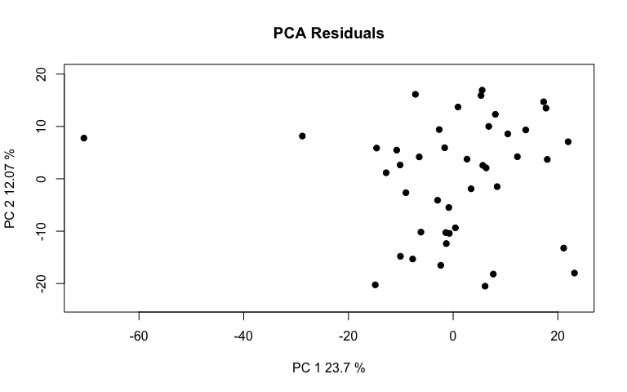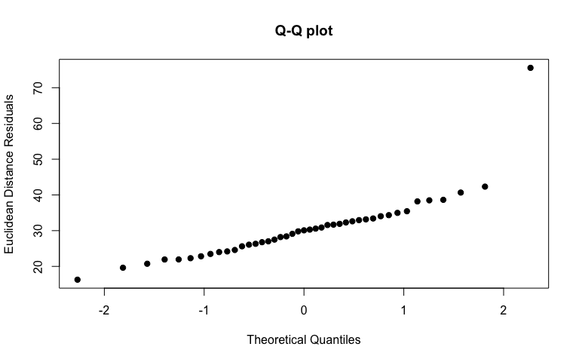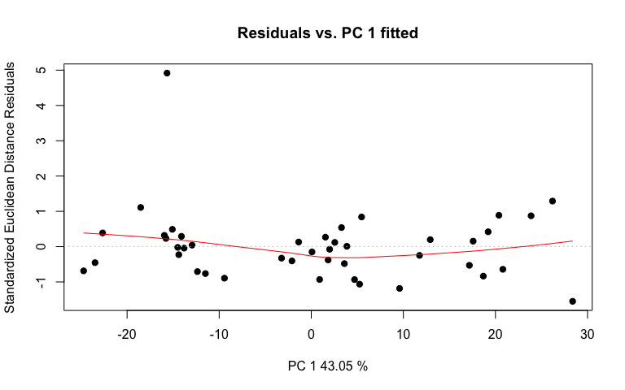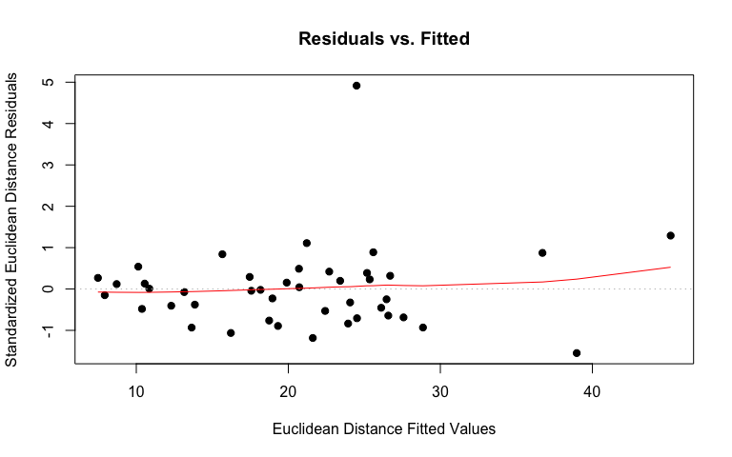

# linear regression plot  
Oregression <- plot(O_LMneg, type = "regression", predictor = class$Fungus,   
 reg.type = "RegScore")

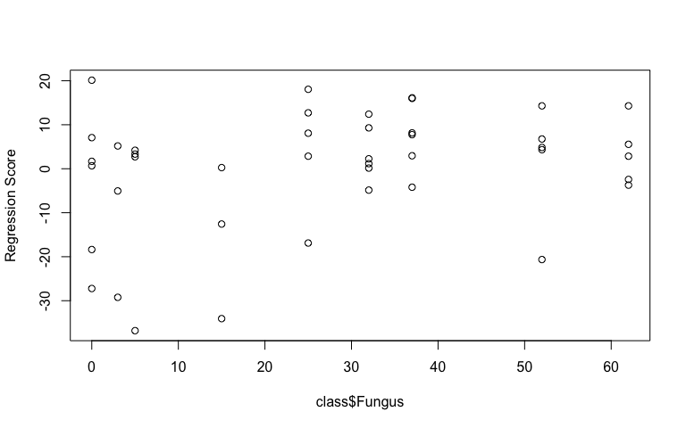

# pca plot  
Opcplot <- plot(O_LMneg, type = "PC", pch = 19, col = interaction(class$Water,   
 class$Fungus))

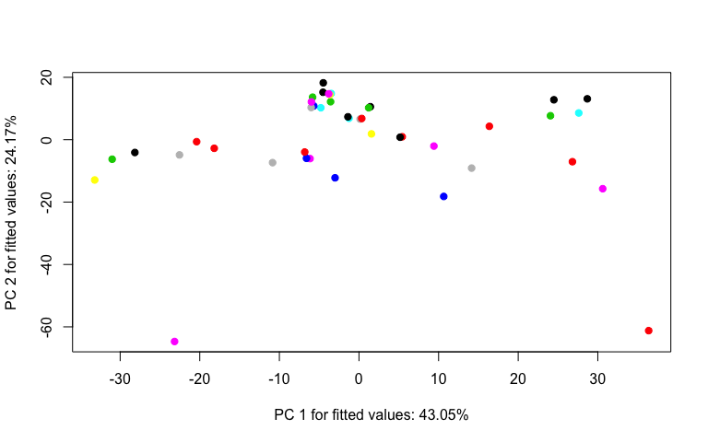

## Young Leaves residuals vs fitted values (homoscedasticity  
## check)  
Ydiagnostics <- plot(Y_LMneg, type = "diagnostics")

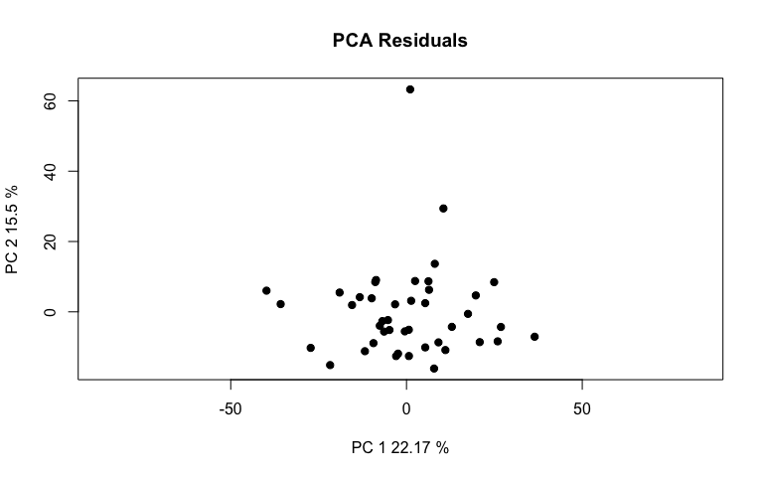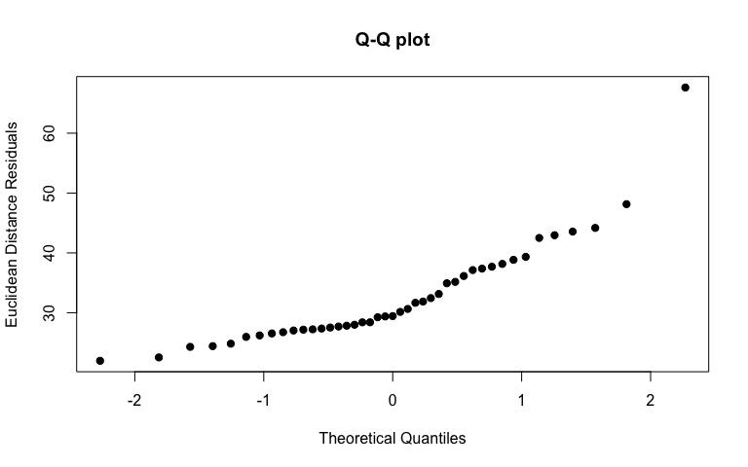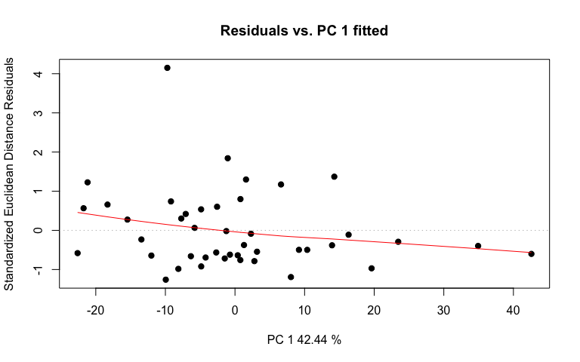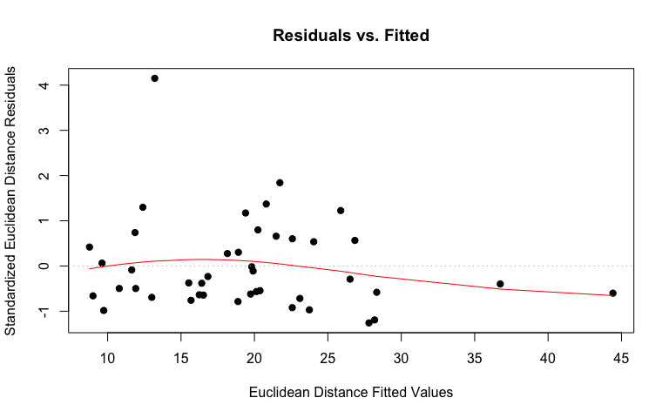

# linear regression plot  
Yregression <- plot(Y_LMneg, type = "regression", predictor = class$Fungus,   
 reg.type = "RegScore")

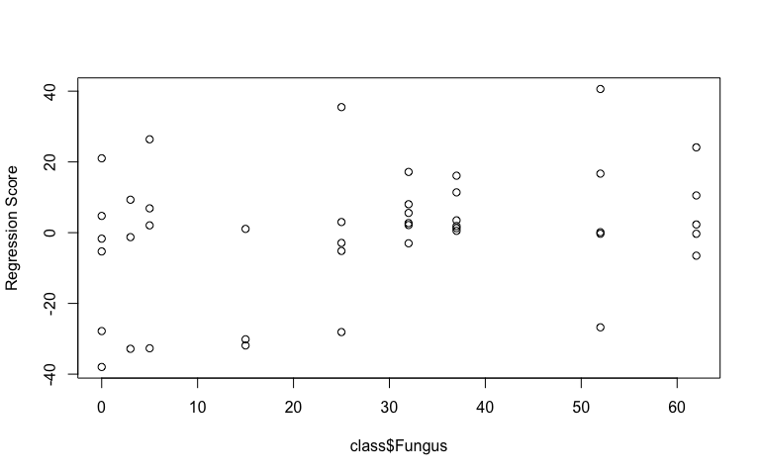

# pca plot  
Ypcplot <- plot(Y_LMneg, type = "PC", pch = 19, col = interaction(class$Water,   
 class$Fungus))

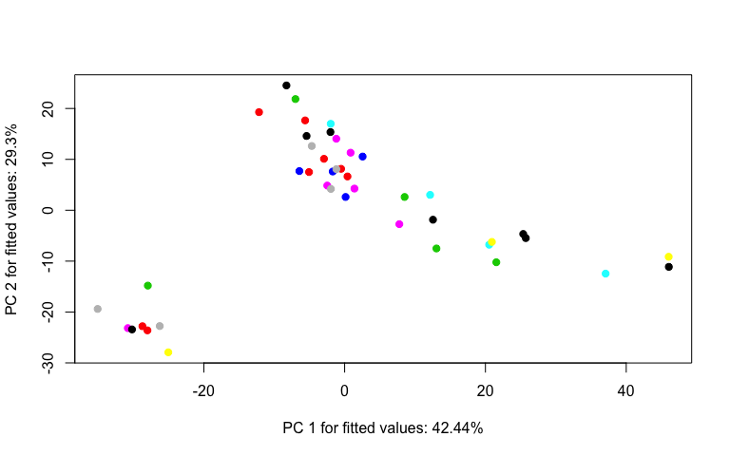

1. Perform an RRPP ANOVA and print results.

## Old Leaves  
OnegANOVA <- anova(O_LMneg, effect.type = "F", error = c("Residuals",   
 "Block:Water", "Block:Water:Fungus", "Residuals", "Block:Water:Fungus",   
 "Block:Water:Fungus", "Residuals"))  
summary(OnegANOVA, formula = T)

##   
## Analysis of Variance, using Residual Randomization  
## Permutation procedure: Randomization of null model residuals   
## Number of permutations: 1000   
## Estimation method: Ordinary Least Squares   
## Sums of Squares and Cross-products: Type III   
## Effect sizes (Z) based on F distributions  
##   
## Df SS MS Rsq F Z Pr(>F)   
## Block 1 4167 4167.5 0.06443 3.3541 3.2868 0.009 **  
## Water 1 1731 1731.4 0.02677 1.0292 0.1343 0.450   
## Fungus 1 2084 2083.8 0.03222 1.1017 0.3095 0.377   
## Block:Water 1 1682 1682.3 0.02601 1.3540 1.0381 0.146   
## Block:Fungus 1 1744 1744.4 0.02697 0.9223 -0.1898 0.567   
## Water:Fungus 1 1593 1593.0 0.02463 0.8422 -0.7313 0.784   
## Block:Water:Fungus 1 1891 1891.4 0.02924 1.5223 1.3137 0.106   
## Residuals 35 43488 1242.5 0.67235   
## Total 42 64680   
## ---  
## Signif. codes: 0 '***' 0.001 '**' 0.01 '*' 0.05 '.' 0.1 ' ' 1  
##   
## Call: lm.rrpp(f1 = scaled_Y_old ~ Block * Water * Fungus, SS.type = "III",   
## data = class, print.progress = F)

## Young Leaves  
YnegANOVA <- anova(Y_LMneg, effect.type = "F", error = c("Residuals",   
 "Block:Water", "Block:Water:Fungus", "Residuals", "Block:Water:Fungus",   
 "Block:Water:Fungus", "Residuals"))  
summary(YnegANOVA, formula = T)

##   
## Analysis of Variance, using Residual Randomization  
## Permutation procedure: Randomization of null model residuals   
## Number of permutations: 1000   
## Estimation method: Ordinary Least Squares   
## Sums of Squares and Cross-products: Type III   
## Effect sizes (Z) based on F distributions  
##   
## Df SS MS Rsq F Z Pr(>F)   
## Block 1 2341 2341.3 0.03478 1.6828 1.60747 0.070 .  
## Water 1 1323 1323.0 0.01965 1.2429 1.00561 0.160   
## Fungus 1 3180 3180.2 0.04724 2.5291 2.36145 0.012 *  
## Block:Water 1 1064 1064.4 0.01581 0.7650 -0.58460 0.704   
## Block:Fungus 1 2296 2296.2 0.03411 1.8261 1.70026 0.041 *  
## Water:Fungus 1 1391 1390.7 0.02066 1.1060 0.49091 0.305   
## Block:Water:Fungus 1 1257 1257.4 0.01868 0.9038 -0.13380 0.527   
## Residuals 35 48696 1391.3 0.72329   
## Total 42 67326   
## ---  
## Signif. codes: 0 '***' 0.001 '**' 0.01 '*' 0.05 '.' 0.1 ' ' 1  
##   
## Call: lm.rrpp(f1 = scaled_Y_young ~ Block * Water * Fungus, SS.type = "III",   
## data = class, print.progress = F)

1. Test lm.rrpp model coefficients. “d” is the amount of change in a variable for the coefficient indicated.

## Old Leaves test model coefficients  
Onegcoef <- coef(O_LMneg, test = T)  
summary(Onegcoef)

##   
## Linear Model fit with lm.rrpp  
##   
## Number of observations: 43  
## Number of dependent variables: 1540  
## Data space dimensions: 42  
## Sums of Squares and Cross-products: Type III  
## Number of permutations: 1000  
##   
## Statistics (distances) of coefficients with 95 percent confidence intervals,  
## effect sizes, and probabilities of exceeding observed values based on  
## 1000 random permutations using RRPP   
##   
## d.obs UCL (95%) Zd Pr(>d)  
## (Intercept) 56.7851643 68.2393729 0.1881122 0.404  
## Block 30.7839565 21.3721323 4.6692021 0.001  
## WaterLow 51.3669825 52.1862425 1.7171593 0.064  
## Fungus 1.1988549 1.1643577 2.1308690 0.043  
## Block:WaterLow 26.0901902 27.3651382 1.5179096 0.077  
## Block:Fungus 0.5625282 0.5990145 1.4492688 0.084  
## WaterLow:Fungus 1.4541906 1.5461400 1.3736079 0.095  
## Block:WaterLow:Fungus 0.7837857 0.7935525 1.8974730 0.059

## Young Leaves test model coefficients  
Ynegcoef <- coef(Y_LMneg, test = T)  
summary(Ynegcoef)

##   
## Linear Model fit with lm.rrpp  
##   
## Number of observations: 43  
## Number of dependent variables: 1603  
## Data space dimensions: 42  
## Sums of Squares and Cross-products: Type III  
## Number of permutations: 1000  
##   
## Statistics (distances) of coefficients with 95 percent confidence intervals,  
## effect sizes, and probabilities of exceeding observed values based on  
## 1000 random permutations using RRPP   
##   
## d.obs UCL (95%) Zd Pr(>d)  
## (Intercept) 45.4608543 61.7344120 -0.8080941 0.784  
## Block 23.0735567 22.1138801 2.1888278 0.034  
## WaterLow 44.9023881 55.6540553 0.3883270 0.308  
## Fungus 1.4810450 1.2459086 3.2164939 0.006  
## Block:WaterLow 20.7529414 28.6532397 -0.2077464 0.525  
## Block:Fungus 0.6453841 0.6435496 1.9750292 0.048  
## WaterLow:Fungus 1.3587323 1.6653060 0.5256945 0.269  
## Block:WaterLow:Fungus 0.6390634 0.8120751 0.2173253 0.359

Fungus has the largest effect on the model for young leaves. The standard is the mean for High water treatment. Block has the largest effect on the model for old leaves. Fungus coming in second.

1. Compute predicted values from the lm.rrpp model fit using bootstrapped residuals to generate confidence intervals (precision of group mean estimates).

O_pred <- predict(O_LMneg)  
plot(O_pred, PC = T, ellipse = T)

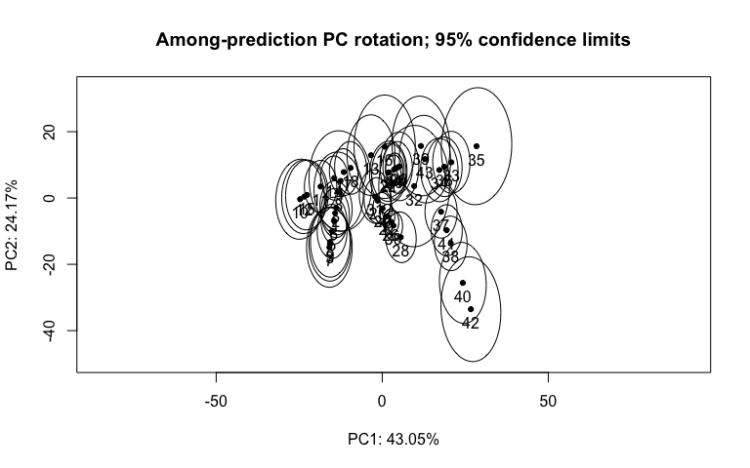

Y_pred <- predict(Y_LMneg)  
plot(Y_pred, PC = T, ellipse = T)

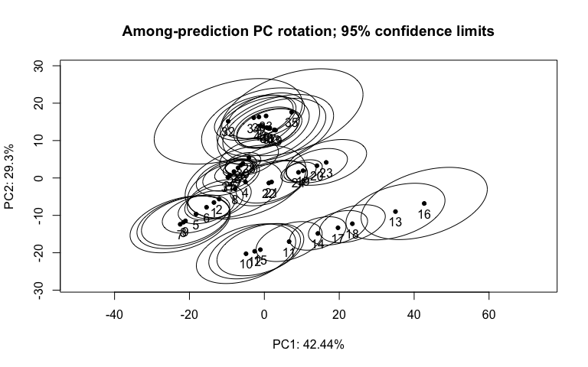

1. Test pairwise differences between least squares means. Similar to tukeyHSD function in the r stats package. The pairwise function will generate tables with confidence intervals and p‐values for the pairwise statistic, Euclidean distance between least‐squares means.

## Old Leaves pairwise differences of water  
Onegpw <- pairwise(O_LMneg, groups = class$Fungus)  
summary(Onegpw, confidence = 0.95, stat.table = T)

##   
## Pairwise comparisons  
##   
## Groups: 0 3 5 15 25 32 37 52 62   
##   
## RRPP: 1000 permutations  
##   
## LS means:  
## Vectors hidden (use show.vectors = TRUE to view)  
##   
## Pairwise distances between means, plus statistics  
## d UCL (95%) Z Pr > d  
## 0:3 14.717160 18.966988 -0.7815989 0.774  
## 0:5 9.615246 13.252094 -0.7853229 0.769  
## 0:15 14.626625 19.114954 -0.7245472 0.770  
## 0:25 8.732025 13.942737 -1.3339615 0.924  
## 0:32 10.619979 16.998242 -1.4035443 0.941  
## 0:37 12.279350 19.654217 -1.4035443 0.941  
## 0:52 18.756031 28.552349 -1.1672332 0.885  
## 0:62 20.016731 32.390554 -1.4877295 0.951  
## 3:5 9.923031 15.817301 -2.0283716 0.994  
## 3:15 6.277265 10.465867 -2.1826828 1.000  
## 3:25 16.385586 21.804195 -1.0069745 0.836  
## 3:32 17.707795 23.602854 -1.0088981 0.832  
## 3:37 18.684051 25.319513 -1.0684106 0.849  
## 3:52 22.119230 30.587804 -0.9714698 0.825  
## 3:62 24.622923 35.480760 -1.2853263 0.902  
## 5:15 7.059009 10.364090 -1.7977428 0.976  
## 5:25 10.740394 13.929872 -0.4854619 0.681  
## 5:32 12.727351 17.076660 -0.7444280 0.771  
## 5:37 13.900573 18.932075 -0.8553641 0.803  
## 5:52 18.368463 25.548722 -0.8458061 0.791  
## 5:62 20.587684 30.089895 -1.2176369 0.886  
## 15:25 13.953746 16.976759 -0.5398929 0.696  
## 15:32 15.316247 18.867668 -0.6440036 0.739  
## 15:37 16.068288 20.125304 -0.7459548 0.775  
## 15:52 18.657421 24.070424 -0.6520620 0.738  
## 15:62 21.516178 29.492937 -1.1429056 0.880  
## 25:32 2.629988 3.983467 -1.5425395 0.945  
## 25:37 4.057069 6.329472 -1.5417956 0.953  
## 25:52 10.413237 15.140523 -1.0867176 0.865  
## 25:62 11.980143 19.353471 -1.5544049 0.956  
## 32:37 1.659372 2.655975 -1.4035443 0.941  
## 32:52 8.596237 12.486425 -1.0022531 0.844  
## 32:62 9.593783 15.789034 -1.5592614 0.956  
## 37:52 7.130951 10.151648 -1.0160471 0.849  
## 37:62 8.012080 13.215906 -1.5802204 0.959  
## 52:62 5.474832 10.015951 -2.1279157 1.000

## Young Leaves pairwise differences of water  
Ynegpw <- pairwise(Y_LMneg, groups = class$Fungus)  
summary(Ynegpw, confidence = 0.95, stat.table = T)

##   
## Pairwise comparisons  
##   
## Groups: 0 3 5 15 25 32 37 52 62   
##   
## RRPP: 1000 permutations  
##   
## LS means:  
## Vectors hidden (use show.vectors = TRUE to view)  
##   
## Pairwise distances between means, plus statistics  
## d UCL (95%) Z Pr > d  
## 0:3 11.702201 17.143285 -0.9091293 0.807  
## 0:5 7.454235 11.790878 -1.0018822 0.889  
## 0:15 10.235526 16.142513 -1.0245425 0.849  
## 0:25 7.397407 12.437263 -1.7038175 0.978  
## 0:32 9.712869 16.199092 -1.4884754 0.957  
## 0:37 11.230505 18.730200 -1.4884754 0.957  
## 0:52 17.439416 27.781528 -1.2067170 0.886  
## 0:62 19.589381 32.388115 -1.3805056 0.937  
## 3:5 10.079907 16.187297 -1.5572750 0.980  
## 3:15 7.020215 11.014540 -1.9778254 0.994  
## 3:25 15.636545 21.740261 -0.8700043 0.801  
## 3:32 17.352414 24.284286 -0.7964528 0.776  
## 3:37 18.541867 26.288697 -0.8238997 0.786  
## 3:52 23.109898 33.090374 -0.7804791 0.774  
## 3:62 25.793837 38.341462 -0.9107488 0.811  
## 5:15 5.595434 9.809929 -1.4204310 0.952  
## 5:25 9.854916 14.339773 -0.8564060 0.787  
## 5:32 12.403808 18.250001 -0.8102353 0.765  
## 5:37 13.647560 20.156268 -0.8760472 0.789  
## 5:52 19.028556 28.208242 -0.7532405 0.758  
## 5:62 21.353970 32.512155 -0.9817034 0.823  
## 15:25 11.699219 15.679707 -0.6329744 0.725  
## 15:32 13.638580 18.335328 -0.6077092 0.702  
## 15:37 14.688404 19.835274 -0.6473870 0.721  
## 15:52 18.925545 26.078639 -0.5541992 0.695  
## 15:62 21.776994 31.515025 -0.8025172 0.775  
## 25:32 3.077239 4.700321 -0.9376598 0.808  
## 25:37 4.409372 7.019984 -1.1026361 0.865  
## 25:52 10.900584 16.264982 -0.8094077 0.775  
## 25:62 12.923649 20.870452 -1.1971576 0.890  
## 32:37 1.517636 2.531108 -1.4884754 0.957  
## 32:52 8.441198 12.660063 -0.8985559 0.795  
## 32:62 10.066807 16.533220 -1.2875500 0.911  
## 37:52 7.204876 10.581178 -0.8034993 0.761  
## 37:62 8.617361 14.151604 -1.2577294 0.910  
## 52:62 6.065070 10.786938 -1.5793897 0.993

## PCA

1. Identify the major source of variation in data and determine if the variation is sourced from experimental bias or biological conditions.

# Old Leaf Lipids (Neg) tune how many components to use  
tune.pca(scaled_Y_old)

## Eigenvalues for the first 10 principal components, see object$sdev^2:   
## PC1 PC2 PC3 PC4 PC5 PC6 PC7 PC8   
## 338.73562 283.41789 172.57471 91.04209 61.76376 46.35468 38.50556 34.40119   
## PC9 PC10   
## 28.91962 28.34847   
##   
## Proportion of explained variance for the first 10 principal components, see object$explained_variance:   
## PC1 PC2 PC3 PC4 PC5 PC6 PC7   
## 0.21995819 0.18403759 0.11206150 0.05911824 0.04010634 0.03010044 0.02500361   
## PC8 PC9 PC10   
## 0.02233843 0.01877898 0.01840810   
##   
## Cumulative proportion explained variance for the first 10 principal components, see object$cum.var:   
## PC1 PC2 PC3 PC4 PC5 PC6 PC7 PC8   
## 0.2199582 0.4039958 0.5160573 0.5751755 0.6152819 0.6453823 0.6703859 0.6927243   
## PC9 PC10   
## 0.7115033 0.7299114   
##   
## Other available components:   
## --------------------   
## loading vectors: see object$rotation

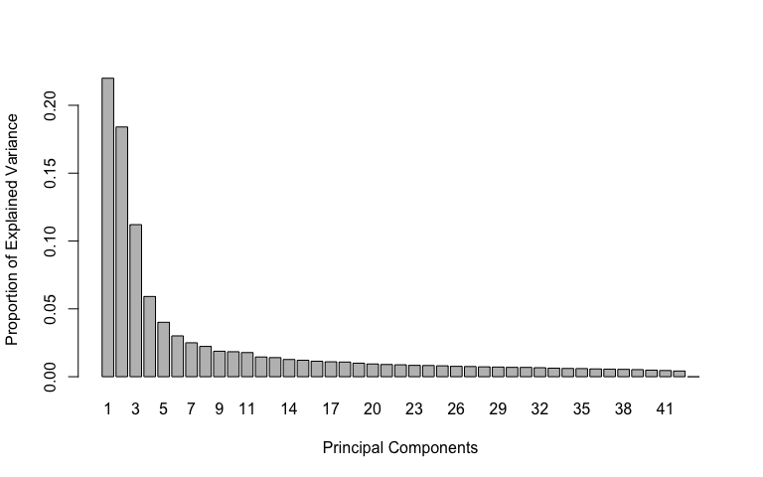

pca.res <- mixOmics::pca(scaled_Y_old, ncomp = 4, scale = F)  
  
# plot pca  
plotIndiv(pca.res, group = class$Fungus, ind.names = F, pch = as.factor(class$Water),   
 legend = T, legend.title = "Fungus", legend.title.pch = "Water",   
 title = "Old Leaf Lipids (Neg) PCA")

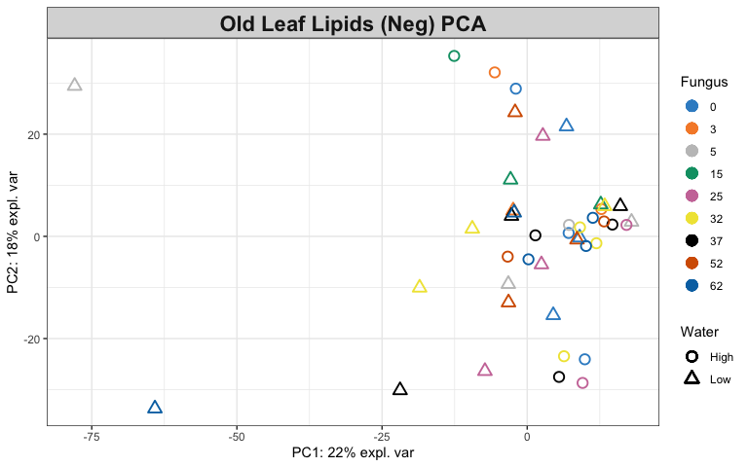

# Look at variable coefficients in each component with the  
# loading vectors The absolute value of loading vectors  
# represent the importance of each variable to define each PC  
plotLoadings(pca.res, ndisplay = 50)

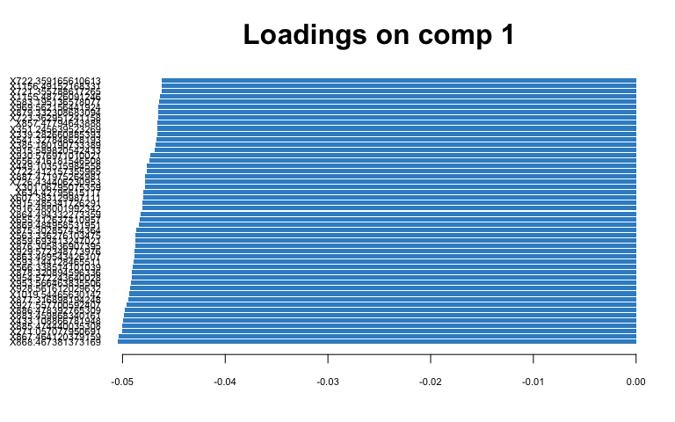

# Young Leaf Lipids (Neg) tune how many components to use  
tune.pca(scaled_Y_young)

## Eigenvalues for the first 10 principal components, see object$sdev^2:   
## PC1 PC2 PC3 PC4 PC5 PC6 PC7 PC8   
## 419.68951 234.44766 140.18419 116.22791 67.96706 55.30370 45.45138 38.09774   
## PC9 PC10   
## 31.53786 30.70965   
##   
## Proportion of explained variance for the first 10 principal components, see object$explained_variance:   
## PC1 PC2 PC3 PC4 PC5 PC6 PC7   
## 0.26181504 0.14625556 0.08745115 0.07250649 0.04239991 0.03450012 0.02835395   
## PC8 PC9 PC10   
## 0.02376652 0.01967427 0.01915761   
##   
## Cumulative proportion explained variance for the first 10 principal components, see object$cum.var:   
## PC1 PC2 PC3 PC4 PC5 PC6 PC7 PC8   
## 0.2618150 0.4080706 0.4955218 0.5680282 0.6104282 0.6449283 0.6732822 0.6970488   
## PC9 PC10   
## 0.7167230 0.7358806   
##   
## Other available components:   
## --------------------   
## loading vectors: see object$rotation

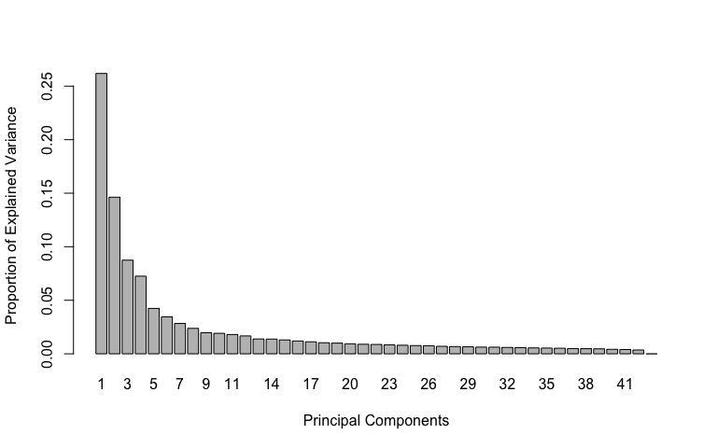

pca.res <- mixOmics::pca(scaled_Y_young, ncomp = 3, scale = F)  
  
# plot pca  
plotIndiv(pca.res, group = class$Fungus, ind.names = F, pch = as.factor(class$Water),   
 legend = T, legend.title = "Fungus", legend.title.pch = "Water",   
 title = "Young Leaf Lipids (Neg) PCA")

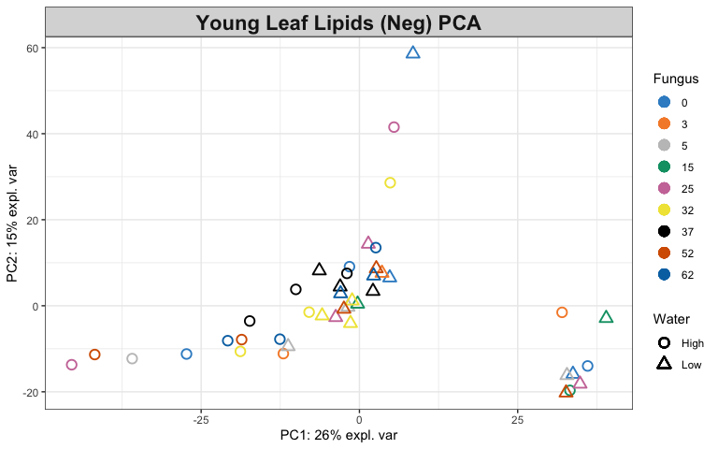

# Look at variable coefficients in each component with the  
# loading vectors The absolute value of loading vectors  
# represent the importance of each variable to define each PC  
plotLoadings(pca.res, ndisplay = 50)

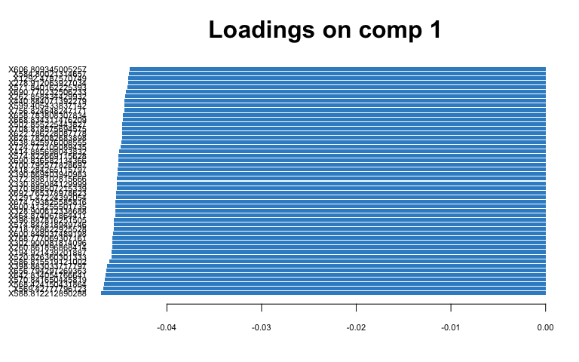

1. Identify the variables that contribute to the explained variance.

# Old Leaf  
spca.res <- mixOmics::spca(scaled_Y_old, ncomp = 4, keepX = c(100,   
 100, 10, 10))  
  
# plot spca  
plotIndiv(spca.res, group = class$Fungus, ind.names = F, pch = as.factor(class$Water),   
 legend = T, legend.title = "Fungus", legend.title.pch = "Water",   
 title = "Old Leaf Lipids (Neg) sPCA")

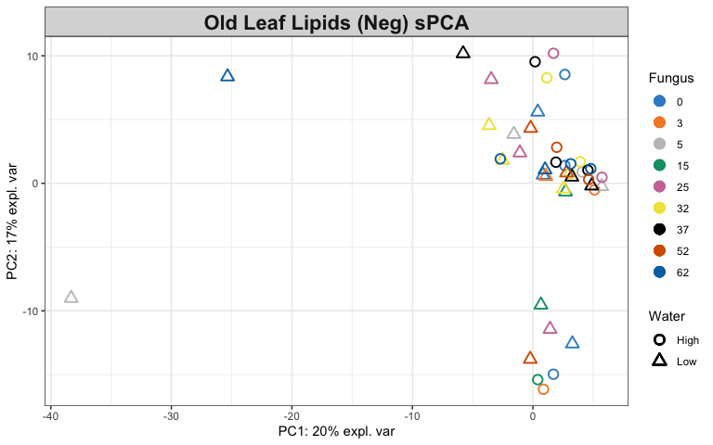

# variables contributing to each component  
plotVar(spca.res, cex = 1)

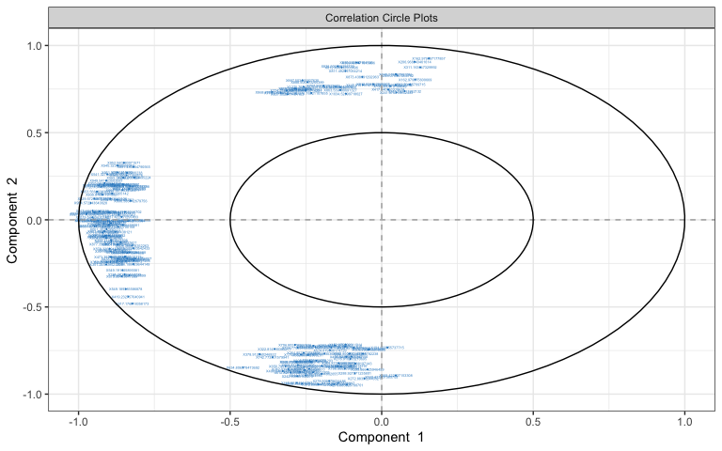

selectVar(spca.res, comp = 1)$value # view loading value of each metabolite

## value.var  
## X927.557700592407 -0.200129024  
## X928.561612029632 -0.197546772  
## X954.572243640028 -0.181364972  
## X885.474440035308 -0.179181509  
## X869.484958531951 -0.177636767  
## X1019.54465630142 -0.174351431  
## X867.464120379159 -0.173962220  
## X886.478392765309 -0.169780741  
## X929.572348773976 -0.166888358  
## X863.489543426107 -0.166493126  
## X868.467381373169 -0.165440477  
## X887.471975264981 -0.158163861  
## X953.566463835506 -0.156163460  
## X864.494332273359 -0.151929159  
## X859.693413247021 -0.147434503  
## X566.338514101039 -0.145410706  
## X726.434406230953 -0.139649889  
## X930.576971010021 -0.134385202  
## X271.057077950691 -0.133499870  
## X879.238402087358 -0.128877411  
## X969.562156441924 -0.127875447  
## X722.412157355965 -0.127653579  
## X883.459868340161 -0.126325284  
## X950.545190934768 -0.125545884  
## X877.230321611576 -0.124019635  
## X877.316898194248 -0.119613512  
## X878.233844238768 -0.118591646  
## X725.185415441698 -0.118457157  
## X949.541863503587 -0.118439810  
## X351.245639523269 -0.118133898  
## X607.383129987111 -0.117305588  
## X352.249037310216 -0.115822041  
## X541.327848628193 -0.113514255  
## X875.302857434364 -0.112398294  
## X817.210440333932 -0.107730043  
## X339.282660885393 -0.107706405  
## X876.305836907395 -0.107230853  
## X462.363501434717 -0.104597413  
## X878.320894596336 -0.104444881  
## X967.552263012126 -0.101782798  
## X593.144128465511 -0.101302939  
## X301.06795075359 -0.101030712  
## X634.42795615117 -0.099879512  
## X473.392642385381 -0.099871489  
## X323.212503923106 -0.098713804  
## X655.412637410957 -0.097764519  
## X945.566447765142 -0.094896284  
## X556.413994465444 -0.092987695  
## X963.574878407408 -0.084933227  
## X529.221677043937 -0.082089794  
## X481.202981438121 -0.081378884  
## X563.336276103475 -0.074493595  
## X602.418692524361 -0.074409967  
## X951.55635317092 -0.073939069  
## X656.416181546508 -0.072708587  
## X540.323489556083 -0.072268161  
## X433.108866781948 -0.071262503  
## X923.236620700158 -0.070057520  
## X916.488001992342 -0.067765357  
## X915.485341726291 -0.067193999  
## X324.216268087411 -0.060551519  
## X637.422951297403 -0.056338992  
## X673.33453647589 -0.055056628  
## X997.561703434011 -0.052421153  
## X879.332308683094 -0.052343999  
## X549.191625895581 -0.051897799  
## X633.427504459581 -0.050900908  
## X857.47794643888 -0.050475336  
## X283.259468997921 -0.050069033  
## X565.326423777694 -0.049311754  
## X952.560280071571 -0.046534625  
## X391.201599110739 -0.043685191  
## X565.185009512115 -0.042462913  
## X799.577065216702 -0.042284605  
## X549.189385586878 -0.039567745  
## X505.165901140672 -0.039414731  
## X564.323251386576 -0.036617339  
## X721.40842980238 -0.034558124  
## X1065.55096405435 -0.033819246  
## X880.337771387686 -0.033450733  
## X482.20668851116 -0.032480717  
## X419.232757040941 -0.029535342  
## X713.529772163544 -0.028002491  
## X608.416972280569 -0.026237761  
## X607.413210162281 -0.025258474  
## X521.158177035099 -0.025041234  
## X723.362951241158 -0.024509449  
## X619.413360639903 -0.022448051  
## X998.566442679756 -0.019612586  
## X608.388078352263 -0.013678125  
## X617.176018358173 -0.012781306  
## X894.543916014498 -0.010310911  
## X722.359165610613 -0.010003806  
## X566.188629644149 -0.008803619  
## X915.589820542433 -0.008773624  
## X721.355788617265 -0.007323427  
## X881.480204790565 -0.007287137  
## X449.103515984558 -0.005442569  
## X284.263053495224 -0.004109811  
## X861.234165316027 -0.001259647

# plot loadings for comp 1  
plotLoadings(spca.res, ndisplay = 50)

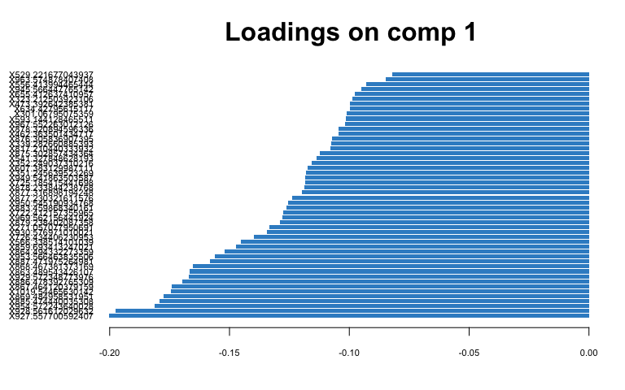

# plot loadings for comp 2  
plotLoadings(spca.res, comp = 2, ndisplay = 50)

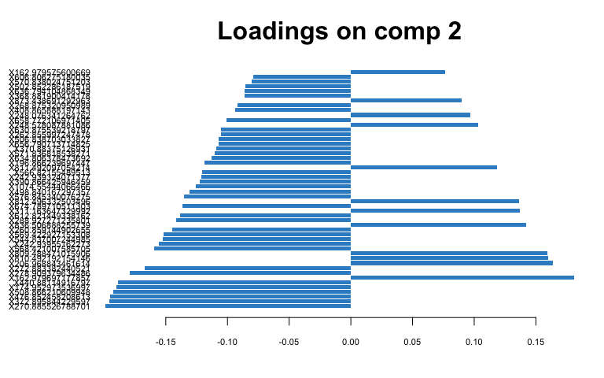

# Young Leaf  
spca.res <- mixOmics::spca(scaled_Y_young, ncomp = 3, keepX = c(100,   
 100, 10))  
  
# plot spca  
plotIndiv(spca.res, group = class$Fungus, ind.names = F, pch = as.factor(class$Water),   
 legend = T, legend.title = "Fungus", legend.title.pch = "Water",   
 title = "Young Leaf Lipids (Neg) sPCA")

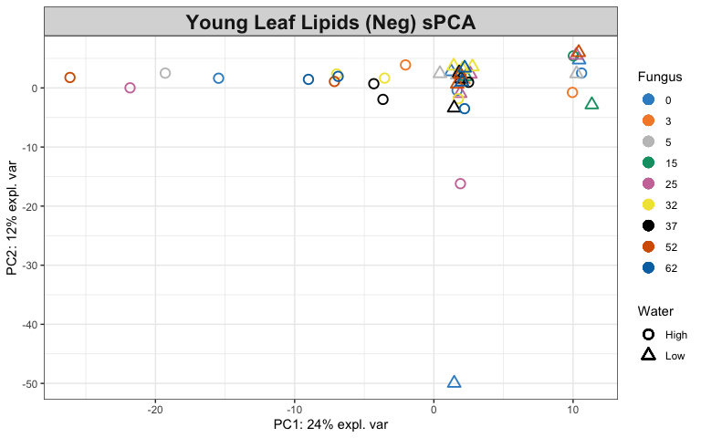

# variables contributing to each component  
plotVar(spca.res, cex = 1)

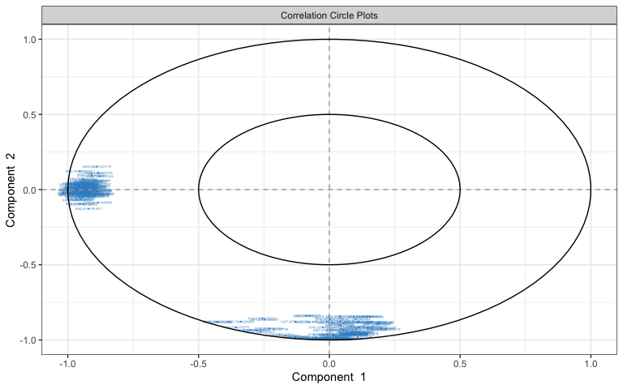

selectVar(spca.res, comp = 1)$value # view loading value of each metabolite

## value.var  
## X606.809345005257 -0.166332525  
## X632.81044229793 -0.164033296  
## X700.795577828697 -0.162314655  
## X742.777653240905 -0.159823555  
## X690.770232506233 -0.159441702  
## X804.741837515802 -0.159152506  
## X674.793825585816 -0.157780840  
## X622.786228087778 -0.155511100  
## X768.777069307161 -0.153378628  
## X664.77459723807 -0.153359576  
## X476.855526760729 -0.146572162  
## X718.768622925528 -0.144715040  
## X570.841650445819 -0.142629123  
## X782.734317130451 -0.142079026  
## X656.794297269363 -0.137096812  
## X828.723233380723 -0.136495784  
## X658.783808307834 -0.134358323  
## X724.772105089435 -0.133418607  
## X692.765378978623 -0.133304029  
## X846.72626883018 -0.128205891  
## X716.77372086649 -0.127284024  
## X544.840825120388 -0.125507826  
## X408.868682242682 -0.124423402  
## X648.788385411775 -0.124154660  
## X132.866585738847 -0.123533659  
## X134.866398083002 -0.122096708  
## X888.702181947636 -0.120228072  
## X760.744768555421 -0.119932446  
## X624.782082683898 -0.119434431  
## X574.822669115628 -0.119342557  
## X612.825567836386 -0.119295175  
## X784.756927043546 -0.119176063  
## X571.840162225393 -0.117561227  
## X778.741885458368 -0.116951708  
## X502.855225443827 -0.116641505  
## X588.812212890288 -0.116620585  
## X836.74813997007 -0.114936639  
## X872.722866438032 -0.112241264  
## X372.898102815666 -0.110050698  
## X714.756200033212 -0.109481027  
## X440.884071392279 -0.106852732  
## X520.826360301333 -0.106806024  
## X586.815519121002 -0.106783293  
## X908.691569895684 -0.106421325  
## X584.80021314657 -0.103905078  
## X758.752900853864 -0.103689450  
## X630.791702126155 -0.102151310  
## X639.818578214385 -0.099602104  
## X607.807531898434 -0.097912652  
## X776.731668175176 -0.097490903  
## X414.885698043832 -0.097005764  
## X736.759279117259 -0.095809948  
## X734.746504008811 -0.095232260  
## X840.71244925072 -0.095067631  
## X802.726364171284 -0.090732374  
## X538.822954317218 -0.088564543  
## X792.742406190328 -0.088486469  
## X654.801893963813 -0.085999724  
## X820.721435524574 -0.080331711  
## X710.762932017726 -0.078194311  
## X726.758924925928 -0.076854156  
## X1291.47224392054 -0.075280342  
## X386.860488067248 -0.074606708  
## X650.783771288888 -0.073277302  
## X786.745557215078 -0.070611027  
## X562.81111951871 -0.069375629  
## X330.895084129999 -0.066332121  
## X192.927431485322 -0.063199397  
## X666.770417878546 -0.062578639  
## X633.807819066513 -0.060452417  
## X638.825976008555 -0.060061860  
## X278.912063927034 -0.059847620  
## X396.887816251505 -0.055278165  
## X762.758305006171 -0.052866742  
## X1333.45977152431 -0.051188223  
## X134.045412963815 -0.048529538  
## X398.883033717797 -0.046987272  
## X652.782727491955 -0.046883818  
## X646.775033785773 -0.046681332  
## X642.834054766641 -0.044180357  
## X194.921439201887 -0.040248198  
## X328.900612338688 -0.032131675  
## X394.886566245554 -0.031544178  
## X720.766074903034 -0.030350572  
## X464.874067864411 -0.027062857  
## X503.856090738483 -0.026237924  
## X1177.48208484958 -0.025591727  
## X871.562283488523 -0.024961052  
## X708.75666274246 -0.024936629  
## X596.796752072116 -0.024694133  
## X322.883782987482 -0.022060861  
## X418.284265115797 -0.021872289  
## X266.086951437715 -0.021037380  
## X574.847818949746 -0.015663369  
## X390.869403940983 -0.014829995  
## X370.888507215339 -0.013332876  
## X1395.43636371835 -0.013203358  
## X600.848037489198 -0.011855578  
## X1292.4787570749 -0.003139404  
## X190.926636178104 -0.001177666

# plot loadings for comp 1  
plotLoadings(spca.res, ndisplay = 50)

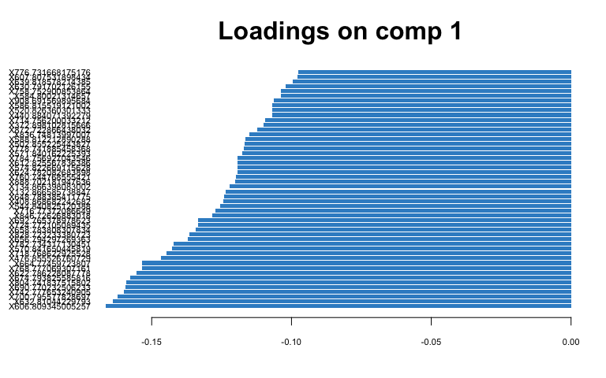

# plot loadings for comp 2  
plotLoadings(spca.res, comp = 2, ndisplay = 50)

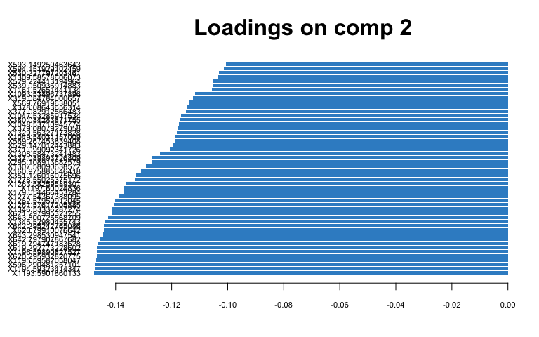

## PLS-DA

1. Classify samples into known groups and predict the class of new samples.

# Old Leaf  
old.splsda <- mixOmics::splsda(scaled_Y_old, class$Fungus, keepX = c(100,   
 100))  
  
# plot pls-da  
plotIndiv(old.splsda, ind.names = F, legend = T, title = "Old Leaf Lipids (Neg) PLS-DA",   
 legend.title = "Fungus", ellipse = T)

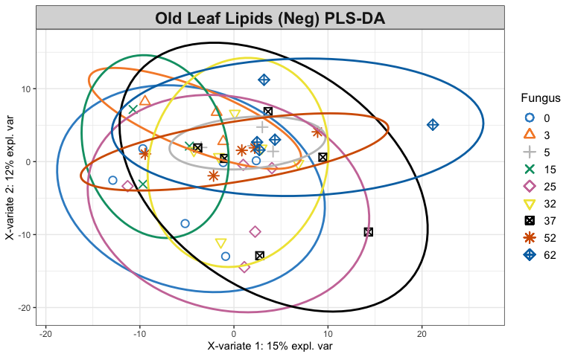

# plot and select the variables  
plotVar(old.splsda)

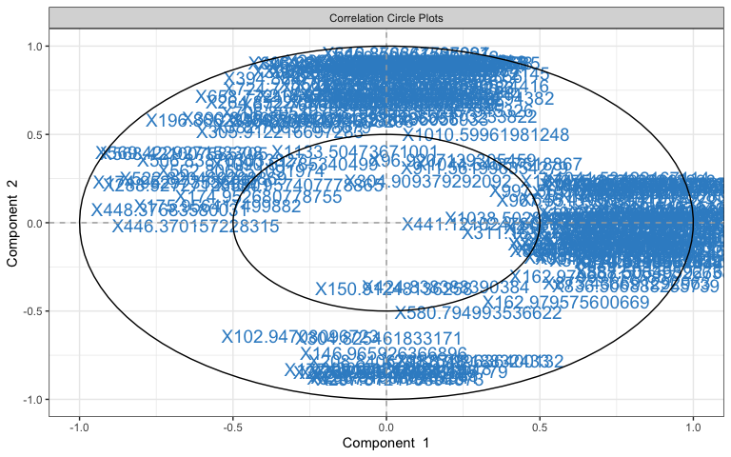

selectVar(old.splsda, comp = 1)

## $name  
## [1] "X1035.48962443178" "X1036.49347718159" "X1020.51970765987"  
## [4] "X1065.52020259569" "X1019.51531418901" "X1104.47602326089"  
## [7] "X1103.47182089502" "X1219.83038632645" "X1911.08637302008"  
## [10] "X1040.560726389" "X1039.55300143209" "X1025.58264377821"  
## [13] "X1150.47629111377" "X982.572475541333" "X877.531023445973"  
## [16] "X1026.58817280481" "X887.503465927635" "X981.569410508255"  
## [19] "X1037.49794218473" "X1041.53422167114" "X972.542617577983"  
## [22] "X936.566856256999" "X973.542313036945" "X971.539630719221"  
## [25] "X837.502547484103" "X935.563612659482" "X1149.47184992267"  
## [28] "X888.506393266389" "X878.535303010517" "X999.559483260895"  
## [31] "X820.521836188494" "X1910.08260033736" "X998.557207917445"  
## [34] "X863.539490691327" "X569.422927153308" "X819.518063757804"  
## [37] "X773.511346284299" "X1873.13688484422" "X1872.13395834801"  
## [40] "X516.143097673075" "X429.188190563143" "X847.545758880759"  
## [43] "X864.542811842905" "X889.515067367098" "X774.514600943974"  
## [46] "X448.37683580031" "X873.438691292963" "X1220.83431893991"  
## [49] "X1275.76543014561" "X974.545267741176" "X401.157603916207"  
## [52] "X1034.52090718027" "X1549.03462530533" "X277.212850028684"  
## [55] "X175.956417499882" "X288.927271235801" "X1548.03166234851"  
## [58] "X1172.4614409432" "X522.820469208869" "X848.548965929847"  
## [61] "X797.535600228753" "X675.352968613998" "X1550.03973700109"  
## [64] "X1276.76921107855" "X986.566025947242" "X1874.14077933693"  
## [67] "X386.188379924065" "X385.184945937595" "X162.979697177857"  
## [70] "X805.500384721158" "X311.163518476063" "X821.529032305061"  
## [73] "X441.121024780807" "X568.421007585705" "X515.140118980629"  
## [76] "X1066.52417490083" "X1261.75232985919" "X836.506888255739"  
## [79] "X174.952973536997" "X174.952680778755" "X134.957407778865"  
## [82] "X798.539218284514" "X506.838703033827" "X967.551395631042"  
## [85] "X967.552162080649" "X904.502555864161" "X1038.50285038777"  
## [88] "X751.527269681302" "X96.9207139305459" "X786.420127187216"  
## [91] "X752.530608553351" "X414.219499460298" "X446.370157228315"  
## [94] "X646.410608141015" "X256.231994916559" "X997.561703434011"  
## [97] "X799.547287485227" "X562.806851091974" "X162.979575600669"  
## [100] "X835.510246875002"  
##   
## $value  
## value.var  
## X1035.48962443178 2.627399e-01  
## X1036.49347718159 2.513051e-01  
## X1020.51970765987 2.143222e-01  
## X1065.52020259569 2.007954e-01  
## X1019.51531418901 1.920906e-01  
## X1104.47602326089 1.906226e-01  
## X1103.47182089502 1.890679e-01  
## X1219.83038632645 1.881703e-01  
## X1911.08637302008 1.846493e-01  
## X1040.560726389 1.825775e-01  
## X1039.55300143209 1.638365e-01  
## X1025.58264377821 1.507778e-01  
## X1150.47629111377 1.473418e-01  
## X982.572475541333 1.381628e-01  
## X877.531023445973 1.358959e-01  
## X1026.58817280481 1.353119e-01  
## X887.503465927635 1.345732e-01  
## X981.569410508255 1.342745e-01  
## X1037.49794218473 1.327396e-01  
## X1041.53422167114 1.194617e-01  
## X972.542617577983 1.187777e-01  
## X936.566856256999 1.176803e-01  
## X973.542313036945 1.174144e-01  
## X971.539630719221 1.172818e-01  
## X837.502547484103 1.166456e-01  
## X935.563612659482 1.162204e-01  
## X1149.47184992267 1.153189e-01  
## X888.506393266389 1.146029e-01  
## X878.535303010517 1.140008e-01  
## X999.559483260895 1.098241e-01  
## X820.521836188494 1.088266e-01  
## X1910.08260033736 1.085166e-01  
## X998.557207917445 1.050519e-01  
## X863.539490691327 1.049808e-01  
## X569.422927153308 -9.952883e-02  
## X819.518063757804 9.891003e-02  
## X773.511346284299 9.423627e-02  
## X1873.13688484422 9.283331e-02  
## X1872.13395834801 9.276950e-02  
## X516.143097673075 9.217410e-02  
## X429.188190563143 9.113610e-02  
## X847.545758880759 8.926203e-02  
## X864.542811842905 8.912992e-02  
## X889.515067367098 8.855838e-02  
## X774.514600943974 8.492731e-02  
## X448.37683580031 -8.234819e-02  
## X873.438691292963 8.219250e-02  
## X1220.83431893991 8.199857e-02  
## X1275.76543014561 8.158614e-02  
## X974.545267741176 8.052994e-02  
## X401.157603916207 7.362438e-02  
## X1034.52090718027 7.132232e-02  
## X1549.03462530533 6.788135e-02  
## X277.212850028684 6.533014e-02  
## X175.956417499882 -6.345424e-02  
## X288.927271235801 -5.924263e-02  
## X1548.03166234851 5.879000e-02  
## X1172.4614409432 5.830235e-02  
## X522.820469208869 -5.508273e-02  
## X848.548965929847 5.493371e-02  
## X797.535600228753 4.666910e-02  
## X675.352968613998 4.662287e-02  
## X1550.03973700109 4.524372e-02  
## X1276.76921107855 4.386131e-02  
## X986.566025947242 4.305194e-02  
## X1874.14077933693 3.981875e-02  
## X386.188379924065 3.819454e-02  
## X385.184945937595 3.630213e-02  
## X162.979697177857 3.319037e-02  
## X805.500384721158 2.912366e-02  
## X311.163518476063 2.870198e-02  
## X821.529032305061 2.864186e-02  
## X441.121024780807 2.846782e-02  
## X568.421007585705 -2.785190e-02  
## X515.140118980629 2.771866e-02  
## X1066.52417490083 2.707963e-02  
## X1261.75232985919 2.690965e-02  
## X836.506888255739 2.628472e-02  
## X174.952973536997 -2.594320e-02  
## X174.952680778755 -2.571045e-02  
## X134.957407778865 -2.538667e-02  
## X798.539218284514 2.475376e-02  
## X506.838703033827 -2.372125e-02  
## X967.551395631042 2.332715e-02  
## X967.552162080649 2.115915e-02  
## X904.502555864161 2.035914e-02  
## X1038.50285038777 1.723431e-02  
## X751.527269681302 1.080361e-02  
## X96.9207139305459 1.048247e-02  
## X786.420127187216 9.797547e-03  
## X752.530608553351 8.389689e-03  
## X414.219499460298 5.647848e-03  
## X446.370157228315 -5.260206e-03  
## X646.410608141015 4.322310e-03  
## X256.231994916559 4.038711e-03  
## X997.561703434011 1.724372e-03  
## X799.547287485227 1.699523e-03  
## X562.806851091974 -1.521586e-03  
## X162.979575600669 1.117011e-03  
## X835.510246875002 6.719878e-05  
##   
## $comp  
## [1] 1

plotLoadings(old.splsda, contrib = "max", method = "mean", ndisplay = 50)

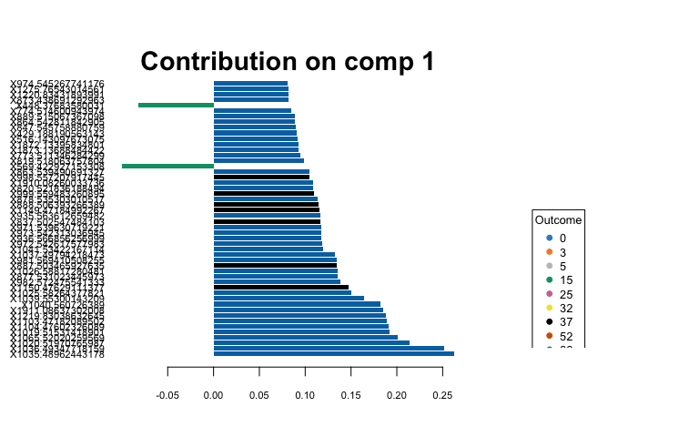

# Young Leaf  
young.splsda <- mixOmics::splsda(scaled_Y_young, class$Fungus,   
 keepX = c(100, 100))  
  
# plot pls-da  
plotIndiv(young.splsda, ind.names = F, legend = T, title = "Young Leaf Lipids (Neg) PLS-DA",   
 legend.title = "Fungus", ellipse = T)

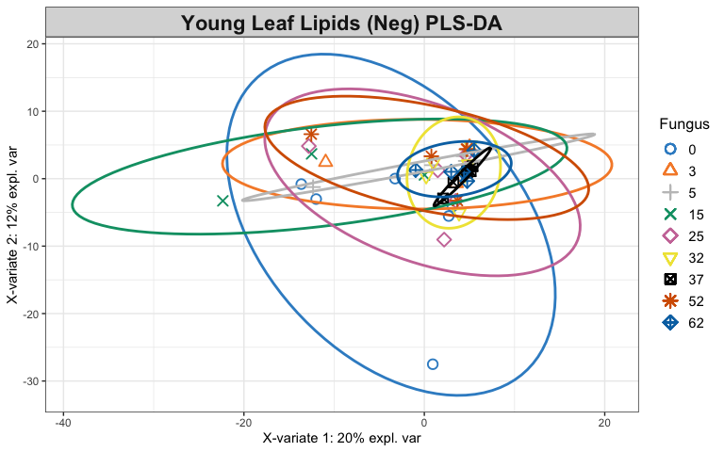

# plot and select the variables  
plotVar(young.splsda)

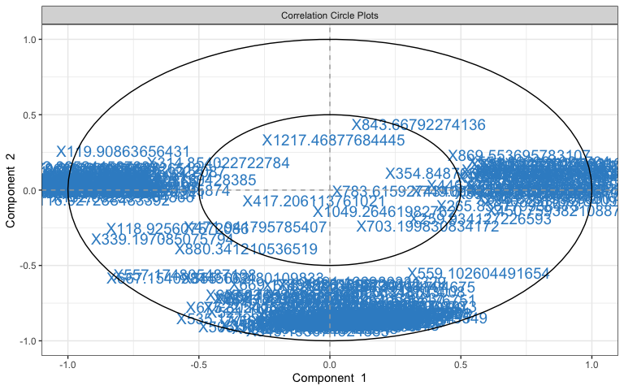

selectVar(young.splsda, comp = 1)

## $name  
## [1] "X396.744066149398" "X341.804017936133" "X338.781186589034"  
## [4] "X221.841155127441" "X238.834697469277" "X219.84461147703"   
## [7] "X210.840303174241" "X160.84073506859" "X162.837709941101"  
## [10] "X542.835721749077" "X390.805390469488" "X164.835439366587"  
## [13] "X201.904319378673" "X296.793516506344" "X127.895179592866"  
## [16] "X339.197085075794" "X199.851005340762" "X256.839536248203"  
## [19] "X129.869344980963" "X127.871261970482" "X397.76141829117"   
## [22] "X202.903970006801" "X174.885616989743" "X557.174805487108"  
## [25] "X143.864697796506" "X392.800439184252" "X295.817803817012"  
## [28] "X585.417902788316" "X174.863485441377" "X216.852456858478"  
## [31] "X141.868500922779" "X442.817238180702" "X208.826794384555"  
## [34] "X394.17204389995" "X350.758121864578" "X374.742514816533"  
## [37] "X667.154098445662" "X469.910234081819" "X228.901703337163"  
## [40] "X151.010737602026" "X379.153002727853" "X257.843006120052"  
## [43] "X330.8618245959" "X552.865663131564" "X258.834191864741"  
## [46] "X230.899454041765" "X266.801940778361" "X270.888854297753"  
## [49] "X430.703335122926" "X783.615927434096" "X255.828026038127"  
## [52] "X259.934127226593" "X450.759382108877" "X312.857261222087"  
## [55] "X172.865244587839" "X116.927288483392" "X293.821571674538"  
## [58] "X869.553695783107" "X584.415323461393" "X270.795957188362"  
## [61] "X119.90863656431" "X548.787426737795" "X354.848765964605"  
## [64] "X314.854022722784" "X488.659982912674" "X109.003224395874"  
## [67] "X268.799154723268" "X232.762175151337" "X316.783455451835"  
## [70] "X152.882339964866" "X323.884189924197" "X314.784985265431"  
## [73] "X286.860667596866" "X325.014908362498" "X510.8792724562"   
## [76] "X474.851017726839" "X170.866558879586" "X240.926846526528"  
## [79] "X1028.5795946312" "X355.103480109833" "X583.410941115392"  
## [82] "X442.891741260384" "X540.758138184099" "X372.742954316427"  
## [85] "X749.614838652779" "X840.786703094097" "X396.835199086007"  
## [88] "X109.003013726512" "X620.852616467634" "X336.786501994141"  
## [91] "X554.862981021704" "X940.601750428385" "X102.95537878551"   
## [94] "X265.856779938473" "X716.836524572973" "X646.853854191413"  
## [97] "X588.893578190363" "X1150.48670587775" "X444.888177851031"  
## [100] "X446.373066658593"  
##   
## $value  
## value.var  
## X396.744066149398 -0.237346099  
## X341.804017936133 -0.226712611  
## X338.781186589034 -0.212839599  
## X221.841155127441 -0.188603224  
## X238.834697469277 -0.187887930  
## X219.84461147703 -0.183754137  
## X210.840303174241 -0.183293976  
## X160.84073506859 -0.175122234  
## X162.837709941101 -0.174967631  
## X542.835721749077 0.174675387  
## X390.805390469488 0.168096512  
## X164.835439366587 -0.162856507  
## X201.904319378673 -0.162392668  
## X296.793516506344 -0.153997773  
## X127.895179592866 -0.152040830  
## X339.197085075794 -0.142236059  
## X199.851005340762 -0.140928992  
## X256.839536248203 -0.139463873  
## X129.869344980963 -0.139035299  
## X127.871261970482 -0.136633914  
## X397.76141829117 -0.135226336  
## X202.903970006801 -0.133281705  
## X174.885616989743 -0.131405620  
## X557.174805487108 -0.127847482  
## X143.864697796506 -0.126591305  
## X392.800439184252 0.124418002  
## X295.817803817012 -0.113167199  
## X585.417902788316 0.112654838  
## X174.863485441377 -0.111515640  
## X216.852456858478 -0.109465643  
## X141.868500922779 -0.109408381  
## X442.817238180702 -0.108616673  
## X208.826794384555 -0.105398768  
## X394.17204389995 0.101902740  
## X350.758121864578 -0.101454603  
## X374.742514816533 -0.096021798  
## X667.154098445662 -0.095905408  
## X469.910234081819 0.093491653  
## X228.901703337163 0.092339950  
## X151.010737602026 -0.091016171  
## X379.153002727853 0.089268814  
## X257.843006120052 -0.089182296  
## X330.8618245959 0.087029685  
## X552.865663131564 0.086750537  
## X258.834191864741 -0.086420449  
## X230.899454041765 0.081098315  
## X266.801940778361 -0.078957710  
## X270.888854297753 0.077217475  
## X430.703335122926 -0.077089520  
## X783.615927434096 0.073302432  
## X255.828026038127 -0.070733902  
## X259.934127226593 0.067820144  
## X450.759382108877 0.067621153  
## X312.857261222087 -0.067451324  
## X172.865244587839 -0.065297269  
## X116.927288483392 -0.064666845  
## X293.821571674538 -0.061532091  
## X869.553695783107 0.060766086  
## X584.415323461393 0.056123672  
## X270.795957188362 -0.055077183  
## X119.90863656431 -0.054443833  
## X548.787426737795 0.054088532  
## X354.848765964605 0.053425957  
## X314.854022722784 -0.045246971  
## X488.659982912674 -0.043988685  
## X109.003224395874 -0.043356673  
## X268.799154723268 -0.041148826  
## X232.762175151337 -0.039610014  
## X316.783455451835 -0.036219106  
## X152.882339964866 -0.036147621  
## X323.884189924197 -0.035881662  
## X314.784985265431 -0.032139638  
## X286.860667596866 0.032071960  
## X325.014908362498 -0.031772580  
## X510.8792724562 0.031126297  
## X474.851017726839 0.030329181  
## X170.866558879586 -0.027043350  
## X240.926846526528 0.025879617  
## X1028.5795946312 0.023187879  
## X355.103480109833 -0.022220089  
## X583.410941115392 0.021770971  
## X442.891741260384 0.019491794  
## X540.758138184099 0.019226779  
## X372.742954316427 -0.016650713  
## X749.614838652779 0.015099968  
## X840.786703094097 0.012489160  
## X396.835199086007 0.008285053  
## X109.003013726512 -0.007789797  
## X620.852616467634 0.007220824  
## X336.786501994141 -0.007203476  
## X554.862981021704 0.006193023  
## X940.601750428385 -0.004406166  
## X102.95537878551 0.004031028  
## X265.856779938473 0.002904594  
## X716.836524572973 0.002813464  
## X646.853854191413 0.002501612  
## X588.893578190363 0.002479180  
## X1150.48670587775 -0.001761621  
## X444.888177851031 0.001537349  
## X446.373066658593 0.001380297  
##   
## $comp  
## [1] 1

plotLoadings(young.splsda, contrib = "max", method = "mean",   
 ndisplay = 50)

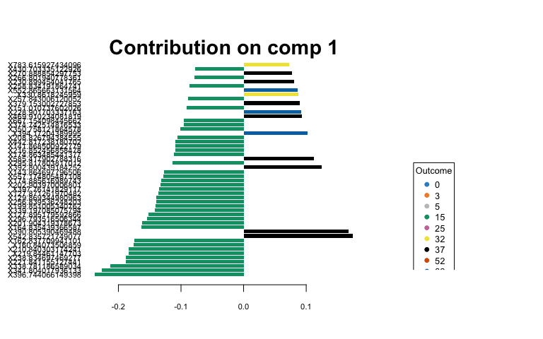

## Heatmaps of Averaged Data

1. Create averaged metabolite matrices and rerun PLS-DA to create a heatmap.

## Young Leaves  
av_Y_young <- aggregate(Y_young, by = list(class$Water, class$Fungus),   
 FUN = "mean", simplify = T, data = class)  
av.young.plsda <- mixOmics::plsda(av_Y_young[, 3:1605], av_Y_young$Group.2) # fungus  
  
# heatmap  
youngcim <- cim(av.young.plsda, title = "Young Leaf Lipids (neg) Averaged Over Fungi",   
 col.names = F, xlab = "Lipids", save = "png", name.save = "~/Box/Summer 2018 TX Endo Field Samples and Analysis/Statistics/Kenia_Thesis_Analysis/Lipids Statistics/young_fungi_avlneg_hm.png") # by fungal treatment

## Indicator Analysis

1. Identify indicator metabolites characteristic of each treatment using Dufrene-Legendre Indicator Analysis.

# Old Leaf  
indicator_Fungus <- indval(Y_young, clustering = class$Fungus,   
 numitr = 999, type = "long")  
  
# Young Leaf  
indicator_Fungus <- indval(Y_young, clustering = class$Fungus,   
 numitr = 999, type = "long")

1. Disect indval object.

Orelfrq <- indicator_Fungus$relfrq # relative frequency of species in classes  
Orelabu <- indicator_Fungus$relabu # relative abundance of species in classes  
Oindval <- indicator_Fungus$indval # the indicator value for each species  
Omaxcls <- data.frame(indicator_Fungus$maxcls) # the class each species has max indicator value for  
Oindcls <- data.frame(indicator_Fungus$indcls) # the indicator value for each species to its max class  
Opval <- data.frame(indicator_Fungus$pval) # the probability of obtaining as high an indicator value as observed over the specified iterations  
  
Yrelfrq <- indicator_Fungus$relfrq # relative frequency of species in classes  
Yrelabu <- indicator_Fungus$relabu # relative abundance of species in classes  
Yindval <- indicator_Fungus$indval # the indicator value for each species  
Ymaxcls <- data.frame(indicator_Fungus$maxcls) # the class each species has max indicator value for  
Yindcls <- data.frame(indicator_Fungus$indcls) # the indicator value for each species to its max class  
Ypval <- data.frame(indicator_Fungus$pval) # the probability of obtaining as high an indicator value as observed over the specified iterations

1. Export results to a csv file.

write.csv(cbind(Orelfrq, Orelabu, Oindval, Omaxcls, Oindcls,   
 Opval), "~/Box/Summer 2018 TX Endo Field Samples and Analysis/Statistics/Kenia_Thesis_Analysis/Lipids Statistics/Indicator_Analys_oLneg_Fungus.csv")  
write.csv(cbind(Yrelfrq, Yrelabu, Yindval, Ymaxcls, Yindcls,   
 Ypval), "~/Box/Summer 2018 TX Endo Field Samples and Analysis/Statistics/Kenia_Thesis_Analysis/Lipids Statistics/Indicator_Analys_yLneg_Fungus.csv")

# Lipids (Pos)

## RRPP

1. Define dependent variable matrix and class matrix.

path <- "~/Box/Summer 2018 TX Endo Field Samples and Analysis/Statistics/Kenia_Thesis_Analysis/"  
  
O_L_pos <- read_tsv(paste(path, "XCMS Online Results/O_L_Pos/XCMS.annotated.Report_1394374.tsv",   
 sep = ""))  
  
Y_L_pos <- read_tsv(paste(path, "XCMS Online Results/Y_L_Pos/XCMS.annotated.Report_1394370.tsv",   
 sep = ""))  
  
# dependent variable: metabolite intensities  
Y_old <- O_L_pos[, c(2, 12:54)] %>% data.frame(row.names = 1) %>%   
 t %>% data.frame()  
scaled_Y_old <- scale(Y_old)  
  
Y_young <- Y_L_pos[, c(2, 12:54)] %>% data.frame(row.names = 1) %>%   
 t %>% data.frame()  
scaled_Y_young <- scale(Y_young)  
  
# class: sample factors  
class <- read.csv(paste(path, "XCMS Online Results/class.csv",   
 sep = ""), header = T, row.names = 1)

1. Define and run multivariate regression models, then print out the results.

O_LMpos <- lm.rrpp(scaled_Y_old ~ Block * Water * Fungus, data = class,   
 SS.type = "III", print.progress = F)  
summary(O_LMpos)

##   
## Linear Model fit with lm.rrpp  
##   
## Number of observations: 43  
## Number of dependent variables: 1823   
## Data space dimensions: 42   
## Sums of Squares and Cross-products: Type III  
## Number of permutations: 1000  
##   
## Full Model Analysis of Variance  
##   
## Df Residual Df SS Residual SS Rsq F  
## Block * Water * Fungus 7 35 20563.31 56002.69 0.2685698 1.835922  
## Z (from F) Pr(>F)  
## Block * Water * Fungus 2.761617 0.006  
##   
##   
## Redundancy Analysis (PCA on fitted values and residuals)  
##   
## Trace Proportion Rank  
## Fitted 489.6027 0.2685698 7  
## Residuals 1333.3973 0.7314302 35  
## Total 1823.0000 1.0000000 42  
##   
## Eigenvalues  
##   
## PC1 PC2 PC3 PC4 PC5 PC6 PC7  
## Fitted 203.7511 142.4724 62.4085 28.1300 21.0207 17.0790 14.7411  
## Residuals 402.1919 150.3132 125.0098 79.2707 62.6699 44.2508 39.8865  
## Total 513.8609 258.2186 186.1442 115.4959 89.3826 51.6885 48.5305  
## PC8 PC9 PC10 PC11 PC12 PC13 PC14  
## Fitted   
## Residuals 36.5208 28.1299 27.5893 25.0897 23.4977 20.4194 19.0704  
## Total 44.9001 35.5187 31.1739 28.2841 27.2468 25.7007 22.5417  
## PC15 PC16 PC17 PC18 PC19 PC20 PC21  
## Fitted   
## Residuals 18.2407 17.7419 16.7325 15.3389 14.4980 13.5948 12.9893  
## Total 21.0600 19.6929 18.6159 18.1548 16.8559 16.0430 15.4500  
## PC22 PC23 PC24 PC25 PC26 PC27 PC28  
## Fitted   
## Residuals 12.7425 12.3680 11.8230 11.0709 10.9782 10.7037 10.2142  
## Total 14.4329 13.4848 12.8637 12.8111 12.6443 12.1077 11.5810  
## PC29 PC30 PC31 PC32 PC33 PC34 PC35  
## Fitted   
## Residuals 9.4416 9.3422 9.2476 8.8057 8.3472 7.7692 7.4973  
## Total 11.3027 10.6443 10.6252 10.1859 9.6192 9.4706 9.3261  
## PC36 PC37 PC38 PC39 PC40 PC41 PC42  
## Fitted   
## Residuals   
## Total 9.0376 8.9028 8.4398 8.1941 8.0756 7.4086 7.2823

Y_LMpos <- lm.rrpp(scaled_Y_young ~ Block * Water * Fungus, data = class,   
 SS.type = "III", print.progress = F)  
summary(Y_LMpos)

##   
## Linear Model fit with lm.rrpp  
##   
## Number of observations: 43  
## Number of dependent variables: 1753   
## Data space dimensions: 42   
## Sums of Squares and Cross-products: Type III  
## Number of permutations: 1000  
##   
## Full Model Analysis of Variance  
##   
## Df Residual Df SS Residual SS Rsq F  
## Block * Water * Fungus 7 35 16697.86 56928.14 0.2267929 1.466573  
## Z (from F) Pr(>F)  
## Block * Water * Fungus 2.839574 0.007  
##   
##   
## Redundancy Analysis (PCA on fitted values and residuals)  
##   
## Trace Proportion Rank  
## Fitted 397.568 0.2267929 7  
## Residuals 1355.432 0.7732071 35  
## Total 1753.000 1.0000000 42  
##   
## Eigenvalues  
##   
## PC1 PC2 PC3 PC4 PC5 PC6 PC7  
## Fitted 142.6474 84.0019 50.0644 42.8687 29.4336 25.2679 23.2842  
## Residuals 265.5398 157.3606 91.6686 74.9197 59.4149 50.7397 47.3443  
## Total 355.1520 183.2308 149.0236 94.5782 80.3546 59.2781 58.3481  
## PC8 PC9 PC10 PC11 PC12 PC13 PC14  
## Fitted   
## Residuals 41.1301 39.2101 36.4674 32.3485 28.5313 28.0699 27.5505  
## Total 49.3092 40.8127 38.5361 36.1489 35.4990 30.7850 30.2615  
## PC15 PC16 PC17 PC18 PC19 PC20 PC21  
## Fitted   
## Residuals 26.2549 24.0054 22.1261 21.8733 21.7556 20.9410 19.7891  
## Total 29.0613 26.8140 25.8752 24.6339 23.2060 22.2234 21.7140  
## PC22 PC23 PC24 PC25 PC26 PC27 PC28  
## Fitted   
## Residuals 19.0491 18.1612 17.7255 17.1035 16.7104 16.6269 16.1307  
## Total 21.2347 21.0382 19.8690 19.4048 18.6921 18.4397 17.2023  
## PC29 PC30 PC31 PC32 PC33 PC34 PC35  
## Fitted   
## Residuals 15.6475 15.3318 14.7780 13.9033 12.7712 12.3730 12.0795  
## Total 16.8355 16.7241 16.3987 15.7905 15.6259 15.3121 14.8427  
## PC36 PC37 PC38 PC39 PC40 PC41 PC42  
## Fitted   
## Residuals   
## Total 14.6820 14.0847 13.7266 13.0061 12.4638 11.7355 11.0454

1. Examine RRPP plots to check for assumptions.

## Old Leaves residuals vs fitted values (homoscedasticity  
## check)  
Odiagnostics <- plot(O_LMpos, type = "diagnostics")

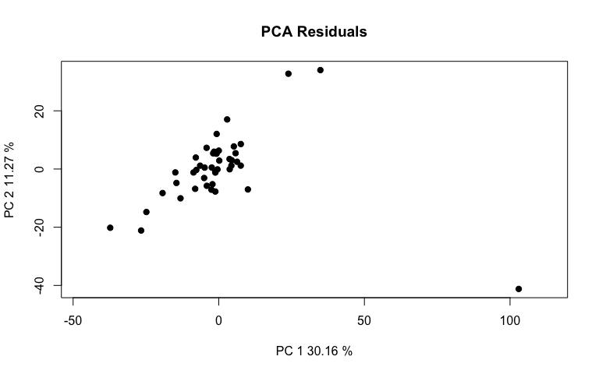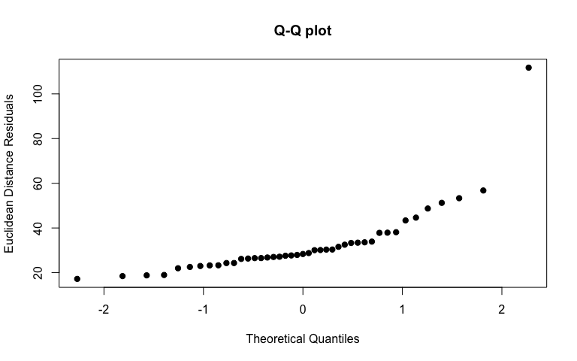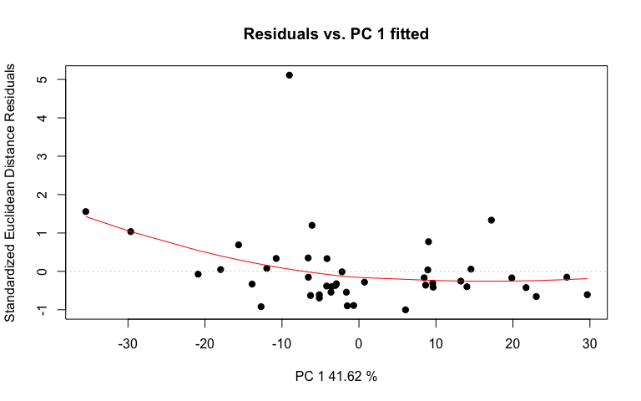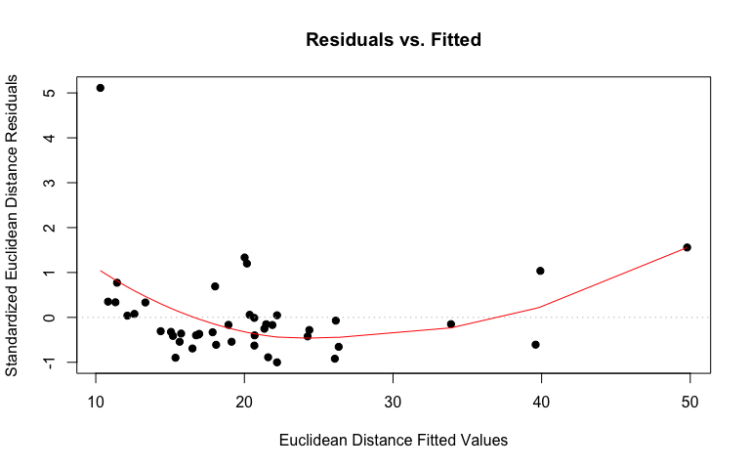

# linear regression plot  
Oregression <- plot(O_LMpos, type = "regression", predictor = class$Fungus,   
 reg.type = "RegScore")

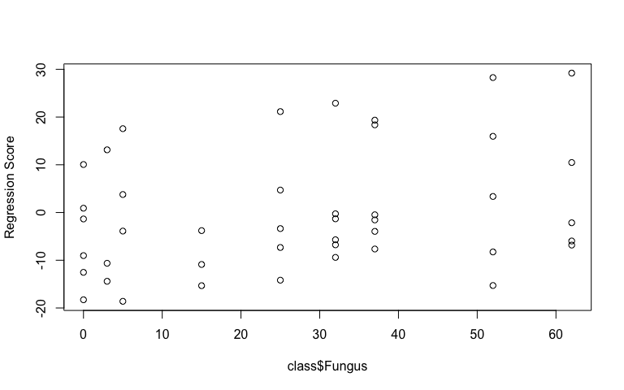

# pca plot  
Opcplot <- plot(O_LMpos, type = "PC", pch = 19, col = interaction(class$Water,   
 class$Fungus))

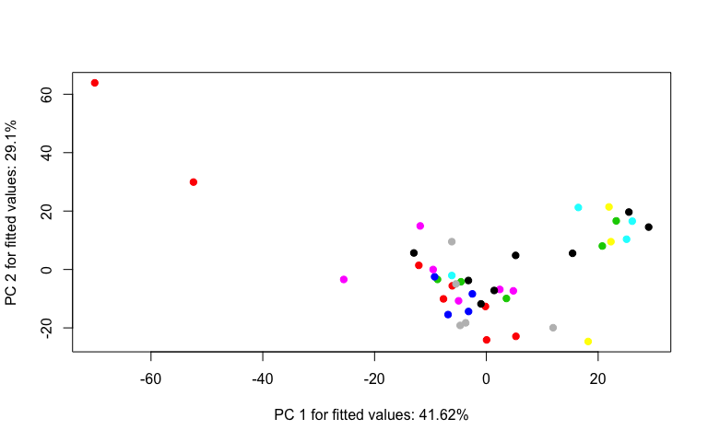

## Young Leaves residuals vs fitted values (homoscedasticity  
## check)  
Ydiagnostics <- plot(Y_LMpos, type = "diagnostics")

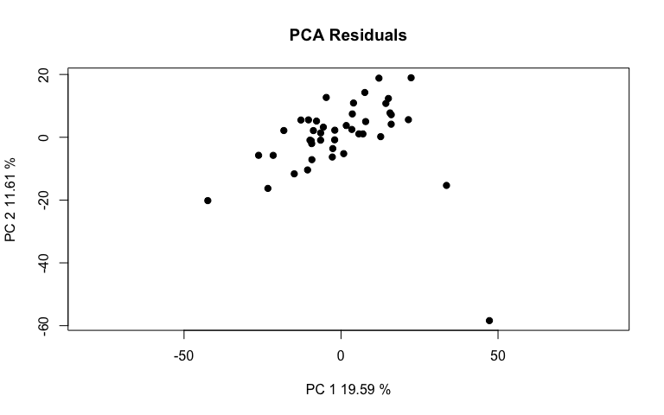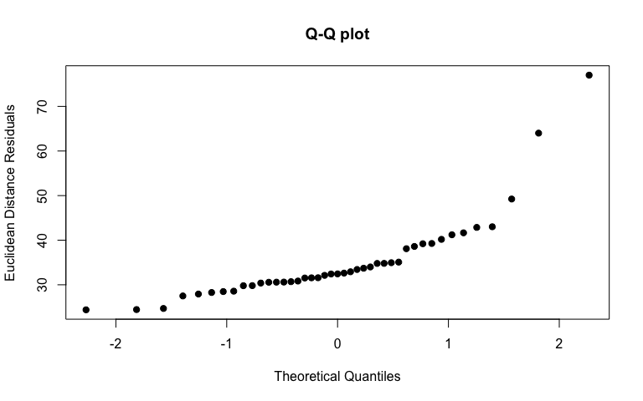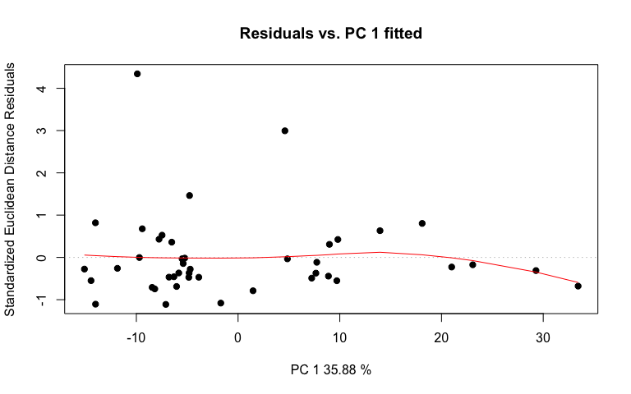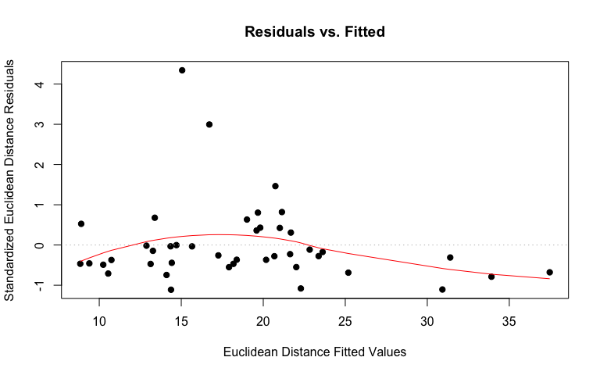

# linear regression plot  
Yregression <- plot(Y_LMpos, type = "regression", predictor = class$Fungus,   
 reg.type = "RegScore")

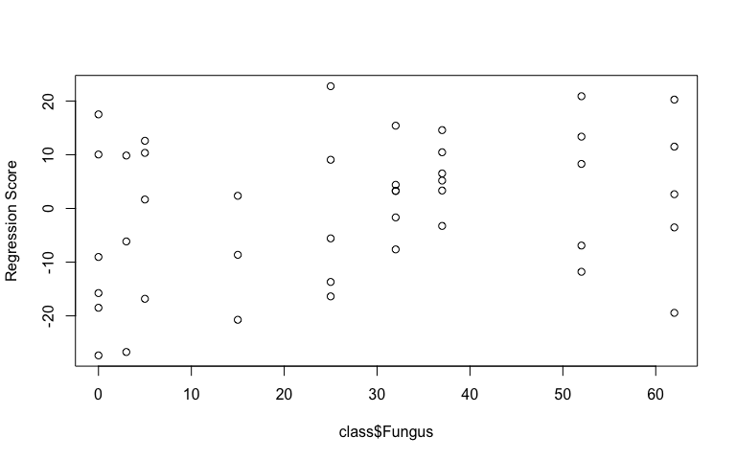

# pca plot  
Ypcplot <- plot(Y_LMpos, type = "PC", pch = 19, col = interaction(class$Water,   
 class$Fungus))

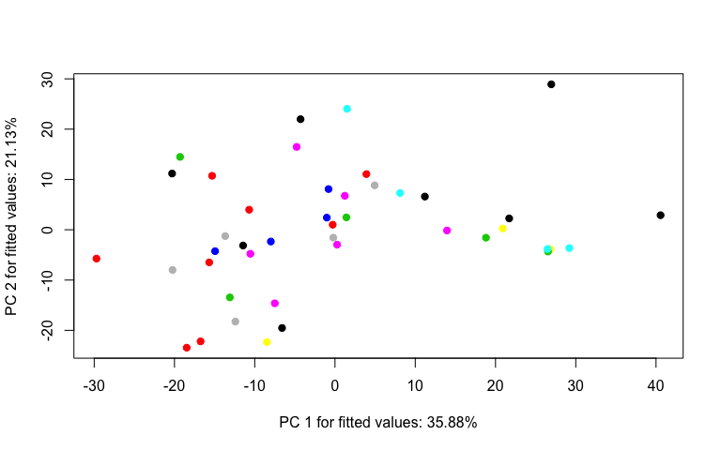

1. Perform an RRPP ANOVA and print results.

## Old Leaves  
OposANOVA <- anova(O_LMpos, effect.type = "F", error = c("Residuals",   
 "Block:Water", "Block:Water:Fungus", "Residuals", "Block:Water:Fungus",   
 "Block:Water:Fungus", "Residuals"))  
summary(OposANOVA, formula = T)

##   
## Analysis of Variance, using Residual Randomization  
## Permutation procedure: Randomization of null model residuals   
## Number of permutations: 1000   
## Estimation method: Ordinary Least Squares   
## Sums of Squares and Cross-products: Type III   
## Effect sizes (Z) based on F distributions  
##   
## Df SS MS Rsq F Z Pr(>F)  
## Block 1 1070 1069.78 0.01397 0.6686 -0.57292 0.689  
## Water 1 1330 1329.63 0.01737 1.3944 1.24172 0.107  
## Fungus 1 1769 1768.66 0.02310 1.0018 0.06379 0.465  
## Block:Water 1 954 953.56 0.01245 0.5959 -1.02809 0.863  
## Block:Fungus 1 1305 1304.63 0.01704 0.7389 -0.65351 0.758  
## Water:Fungus 1 1483 1483.16 0.01937 0.8401 -0.68090 0.768  
## Block:Water:Fungus 1 1766 1765.55 0.02306 1.1034 0.41487 0.308  
## Residuals 35 56003 1600.08 0.73143   
## Total 42 76566   
##   
## Call: lm.rrpp(f1 = scaled_Y_old ~ Block * Water * Fungus, SS.type = "III",   
## data = class, print.progress = F)

## Young Leaves  
YposANOVA <- anova(Y_LMpos, effect.type = "F", error = c("Residuals",   
 "Block:Water", "Block:Water:Fungus", "Residuals", "Block:Water:Fungus",   
 "Block:Water:Fungus", "Residuals"))  
summary(YposANOVA, formula = T)

##   
## Analysis of Variance, using Residual Randomization  
## Permutation procedure: Randomization of null model residuals   
## Number of permutations: 1000   
## Estimation method: Ordinary Least Squares   
## Sums of Squares and Cross-products: Type III   
## Effect sizes (Z) based on F distributions  
##   
## Df SS MS Rsq F Z Pr(>F)   
## Block 1 2447 2446.9 0.03323 1.5044 1.45850 0.089 .  
## Water 1 1644 1643.8 0.02233 1.1327 0.63780 0.279   
## Fungus 1 2423 2423.0 0.03291 1.6588 1.67310 0.044 *  
## Block:Water 1 1451 1451.3 0.01971 0.8923 -0.25299 0.568   
## Block:Fungus 1 2248 2248.4 0.03054 1.5393 1.58953 0.047 *  
## Water:Fungus 1 1225 1224.7 0.01663 0.8384 -1.00498 0.843   
## Block:Water:Fungus 1 1461 1460.7 0.01984 0.8981 -0.23220 0.556   
## Residuals 35 56928 1626.5 0.77321   
## Total 42 73626   
## ---  
## Signif. codes: 0 '***' 0.001 '**' 0.01 '*' 0.05 '.' 0.1 ' ' 1  
##   
## Call: lm.rrpp(f1 = scaled_Y_young ~ Block * Water * Fungus, SS.type = "III",   
## data = class, print.progress = F)

1. Test lm.rrpp model coefficients. “d” is the amount of change in a variable for the coefficient indicated.

## Old Leaves test model coefficients  
Oposcoef <- coef(O_LMpos, test = T)  
summary(Oposcoef)

##   
## Linear Model fit with lm.rrpp  
##   
## Number of observations: 43  
## Number of dependent variables: 1823  
## Data space dimensions: 42  
## Sums of Squares and Cross-products: Type III  
## Number of permutations: 1000  
##   
## Statistics (distances) of coefficients with 95 percent confidence intervals,  
## effect sizes, and probabilities of exceeding observed values based on  
## 1000 random permutations using RRPP   
##   
## d.obs UCL (95%) Zd Pr(>d)  
## (Intercept) 34.1599256 61.7702203 -1.93180616 0.993  
## Block 15.5968289 24.7476777 -0.30721242 0.535  
## WaterLow 45.0149621 60.4726540 0.05398047 0.420  
## Fungus 1.1044955 1.5009254 0.59727782 0.212  
## Block:WaterLow 19.6425423 32.5116629 -0.65799528 0.738  
## Block:Fungus 0.4864742 0.7972160 0.02949339 0.363  
## WaterLow:Fungus 1.4031743 1.8939047 0.27778080 0.324  
## Block:WaterLow:Fungus 0.7572552 0.9467192 0.72492867 0.205

## Young Leaves test model coefficients  
Yposcoef <- coef(Y_LMpos, test = T)  
summary(Yposcoef)

##   
## Linear Model fit with lm.rrpp  
##   
## Number of observations: 43  
## Number of dependent variables: 1753  
## Data space dimensions: 42  
## Sums of Squares and Cross-products: Type III  
## Number of permutations: 1000  
##   
## Statistics (distances) of coefficients with 95 percent confidence intervals,  
## effect sizes, and probabilities of exceeding observed values based on  
## 1000 random permutations using RRPP   
##   
## d.obs UCL (95%) Zd Pr(>d)  
## (Intercept) 43.3123692 57.3355802 -1.2919657 0.924  
## Block 23.5881635 23.1463030 2.0389293 0.043  
## WaterLow 50.0515288 58.4802917 0.6276905 0.229  
## Fungus 1.2927626 1.2743742 1.9727754 0.043  
## Block:WaterLow 24.2326549 30.0046238 0.2116341 0.354  
## Block:Fungus 0.6386411 0.6701481 1.6266467 0.074  
## WaterLow:Fungus 1.2750398 1.7195192 -0.3543871 0.578  
## Block:WaterLow:Fungus 0.6887842 0.8529508 0.2071387 0.360

Block and Fungus have the largest effect on the model for young leaves, but not their interaction. The standard is the mean for High water treatment.

1. Compute predicted values from the lm.rrpp model fit using bootstrapped residuals to generate confidence intervals (precision of group mean estimates).

O_pred <- predict(O_LMpos)  
plot(O_pred, PC = T, ellipse = T)

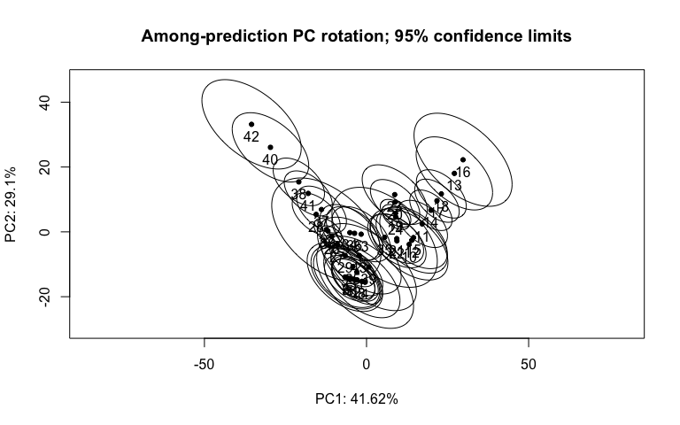

Y_pred <- predict(Y_LMpos)  
plot(Y_pred, PC = T, ellipse = T)

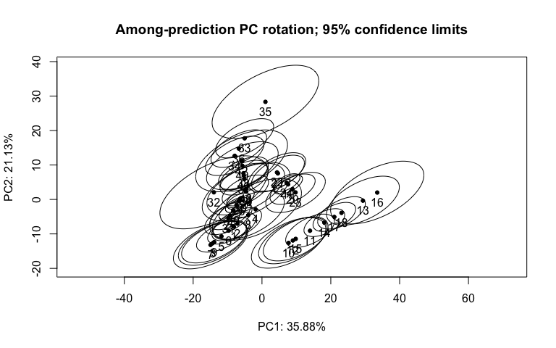

1. Test pairwise differences between least squares means. Similar to tukeyHSD function in the r stats package. The pairwise function will generate tables with confidence intervals and p‐values for the pairwise statistic, Euclidean distance between least‐squares means.

## Old Leaves pairwise differences of fungus  
Opospw <- pairwise(O_LMpos, groups = class$Fungus)  
summary(Opospw, confidence = 0.95, stat.table = T)

##   
## Pairwise comparisons  
##   
## Groups: 0 3 5 15 25 32 37 52 62   
##   
## RRPP: 1000 permutations  
##   
## LS means:  
## Vectors hidden (use show.vectors = TRUE to view)  
##   
## Pairwise distances between means, plus statistics  
## d UCL (95%) Z Pr > d  
## 0:3 9.326918 15.347732 -1.6828998 0.987  
## 0:5 6.413682 13.026220 -1.8395290 0.996  
## 0:15 8.537287 15.908701 -1.8479211 0.999  
## 0:25 9.682422 16.732834 -1.0034673 0.834  
## 0:32 11.812877 20.237608 -1.0711518 0.867  
## 0:37 13.658639 23.399735 -1.0711518 0.867  
## 0:52 20.109497 33.261520 -0.8589151 0.790  
## 0:62 22.508012 38.725115 -1.1569500 0.896  
## 3:5 10.741033 18.549288 -0.9767991 0.897  
## 3:15 7.242409 12.496847 -1.5689213 0.976  
## 3:25 13.176750 20.514654 -1.1752098 0.892  
## 3:32 14.364873 22.533596 -1.1724271 0.888  
## 3:37 15.818024 25.043488 -1.1266412 0.878  
## 3:52 20.555725 33.500601 -0.9047426 0.804  
## 3:62 23.677676 39.000291 -1.1144980 0.871  
## 5:15 6.053913 9.898580 -1.0482176 0.943  
## 5:25 9.152150 13.920104 -0.9638321 0.851  
## 5:32 11.806098 17.688517 -0.9905101 0.850  
## 5:37 13.414391 20.379021 -0.9533571 0.849  
## 5:52 19.464398 29.006170 -0.6208238 0.707  
## 5:62 21.953727 34.730775 -1.0010884 0.850  
## 15:25 8.889463 12.927338 -1.3055774 0.924  
## 15:32 10.767077 15.491585 -1.2327690 0.917  
## 15:37 12.160027 17.784690 -1.1345066 0.888  
## 15:52 17.098166 25.346009 -0.7002696 0.740  
## 15:62 20.263196 31.420478 -1.0658210 0.856  
## 25:32 3.156363 4.745157 -1.2999704 0.914  
## 25:37 4.699102 7.597054 -1.2444151 0.910  
## 25:52 11.316338 17.277691 -0.6817045 0.724  
## 25:62 13.769592 23.437792 -1.2468365 0.917  
## 32:37 1.845762 3.162126 -1.0711518 0.867  
## 32:52 8.828454 13.898701 -0.6016455 0.673  
## 32:62 10.940495 18.847249 -1.2377334 0.912  
## 37:52 7.221105 11.133099 -0.5383293 0.644  
## 37:62 9.189634 15.918771 -1.2646036 0.922  
## 52:62 5.837055 11.466108 -1.5197845 0.997

## Young Leaves pairwise differences of fungus  
Ypospw <- pairwise(Y_LMpos, groups = class$Fungus)  
summary(Ypospw, confidence = 0.95, stat.table = T)

##   
## Pairwise comparisons  
##   
## Groups: 0 3 5 15 25 32 37 52 62   
##   
## RRPP: 1000 permutations  
##   
## LS means:  
## Vectors hidden (use show.vectors = TRUE to view)  
##   
## Pairwise distances between means, plus statistics  
## d UCL (95%) Z Pr > d  
## 0:3 9.854093 14.743698 -2.0747297 0.997  
## 0:5 9.353807 13.331403 -0.7641721 0.779  
## 0:15 10.700420 16.115496 -1.4689387 0.966  
## 0:25 7.562621 12.422986 -2.4228412 1.000  
## 0:32 9.535169 15.674433 -2.2859229 1.000  
## 0:37 11.025039 18.123563 -2.2859229 1.000  
## 0:52 16.992197 27.307179 -1.8838351 0.987  
## 0:62 18.946444 31.241987 -2.2571727 1.000  
## 3:5 10.611811 16.135336 -1.9080841 0.998  
## 3:15 8.159435 12.371299 -1.9526129 0.997  
## 3:25 12.031577 17.637315 -2.3172738 0.998  
## 3:32 13.017518 19.508655 -2.1354904 0.999  
## 3:37 14.042320 21.285137 -2.1455179 0.999  
## 3:52 18.632569 28.544843 -1.8361515 0.990  
## 3:62 20.424364 31.794098 -2.1968168 1.000  
## 5:15 5.706131 9.750433 -1.8043770 0.998  
## 5:25 9.764308 14.012366 -1.1767303 0.913  
## 5:32 11.972073 17.810433 -1.2391327 0.931  
## 5:37 12.980020 19.621502 -1.3747098 0.960  
## 5:52 18.049742 27.496967 -1.1798161 0.893  
## 5:62 19.303690 30.143465 -1.7895809 0.992  
## 15:25 9.174418 12.726981 -1.4971598 0.963  
## 15:32 10.645667 15.139172 -1.3982002 0.952  
## 15:37 11.383035 16.590292 -1.4888181 0.967  
## 15:52 15.349692 22.908809 -1.1912952 0.899  
## 15:62 17.100786 26.349416 -1.8452052 0.994  
## 25:32 2.894715 4.506400 -1.4851014 0.952  
## 25:37 4.144646 6.646085 -1.7568113 0.987  
## 25:52 10.383804 15.773489 -1.3350691 0.913  
## 25:62 12.119246 19.533196 -2.0797469 1.000  
## 32:37 1.489870 2.449130 -2.2859229 1.000  
## 32:52 8.312294 12.463310 -1.4371659 0.931  
## 32:62 9.612051 15.564903 -2.2298692 1.000  
## 37:52 7.155507 10.519312 -1.2747762 0.894  
## 37:62 8.195418 13.160463 -2.2191516 1.000  
## 52:62 6.749666 10.159396 -1.9051218 0.999

## PCA

1. Identify the major source of variation in data and determine if the variation is sourced from experimental bias or biological conditions.

# Old Leaf Lipids (Pos) tune how many components to use  
tune.pca(scaled_Y_old)

## Eigenvalues for the first 10 principal components, see object$sdev^2:   
## PC1 PC2 PC3 PC4 PC5 PC6 PC7 PC8   
## 513.86089 258.21864 186.14420 115.49587 89.38257 51.68852 48.53052 44.90014   
## PC9 PC10   
## 35.51871 31.17389   
##   
## Proportion of explained variance for the first 10 principal components, see object$explained_variance:   
## PC1 PC2 PC3 PC4 PC5 PC6 PC7   
## 0.28187652 0.14164489 0.10210872 0.06335484 0.04903048 0.02835355 0.02662124   
## PC8 PC9 PC10   
## 0.02462981 0.01948366 0.01710032   
##   
## Cumulative proportion explained variance for the first 10 principal components, see object$cum.var:   
## PC1 PC2 PC3 PC4 PC5 PC6 PC7 PC8   
## 0.2818765 0.4235214 0.5256301 0.5889850 0.6380155 0.6663690 0.6929902 0.7176200   
## PC9 PC10   
## 0.7371037 0.7542040   
##   
## Other available components:   
## --------------------   
## loading vectors: see object$rotation

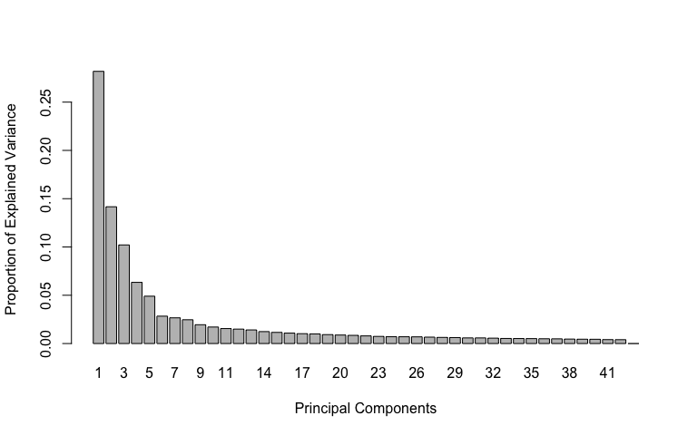

pca.res <- mixOmics::pca(scaled_Y_old, ncomp = 3, scale = F)  
  
# plot pca  
plotIndiv(pca.res, group = class$Fungus, ind.names = F, pch = as.factor(class$Water),   
 legend = T, legend.title = "Fungus", legend.title.pch = "Water",   
 title = "Old Leaf Lipids (Pos) PCA")

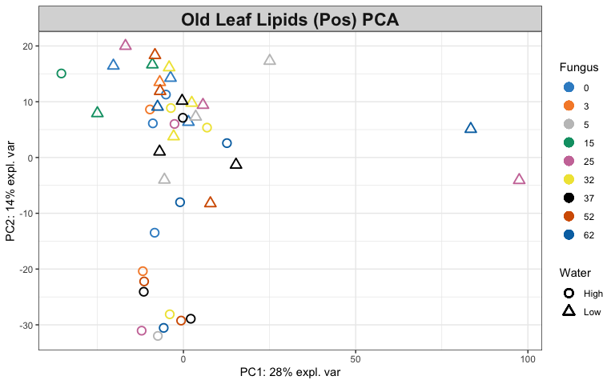

# Look at variable coefficients in each component with the  
# loading vectors The absolute value of loading vectors  
# represent the importance of each variable to define each PC  
plotLoadings(pca.res, ndisplay = 50)

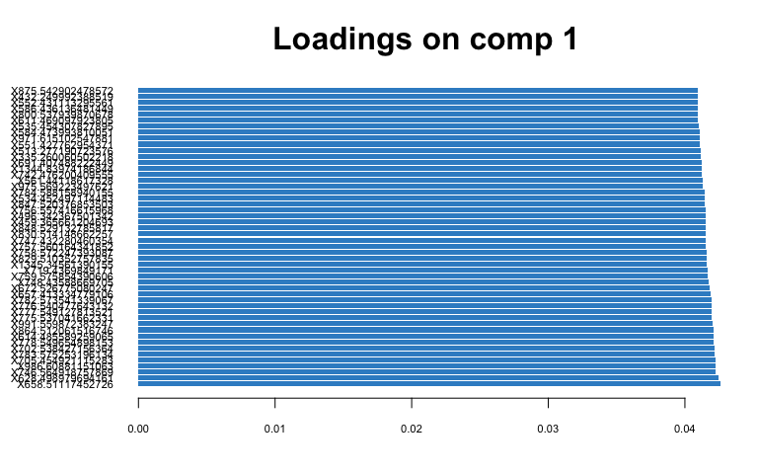

# Young Leaf Lipids (Pos) tune how many components to use  
tune.pca(scaled_Y_young)

## Eigenvalues for the first 10 principal components, see object$sdev^2:   
## PC1 PC2 PC3 PC4 PC5 PC6 PC7 PC8   
## 355.15199 183.23080 149.02358 94.57819 80.35455 59.27809 58.34810 49.30924   
## PC9 PC10   
## 40.81271 38.53615   
##   
## Proportion of explained variance for the first 10 principal components, see object$explained_variance:   
## PC1 PC2 PC3 PC4 PC5 PC6 PC7   
## 0.20259669 0.10452413 0.08501060 0.05395219 0.04583831 0.03381522 0.03328471   
## PC8 PC9 PC10   
## 0.02812849 0.02328164 0.02198297   
##   
## Cumulative proportion explained variance for the first 10 principal components, see object$cum.var:   
## PC1 PC2 PC3 PC4 PC5 PC6 PC7 PC8   
## 0.2025967 0.3071208 0.3921314 0.4460836 0.4919219 0.5257371 0.5590219 0.5871503   
## PC9 PC10   
## 0.6104320 0.6324149   
##   
## Other available components:   
## --------------------   
## loading vectors: see object$rotation

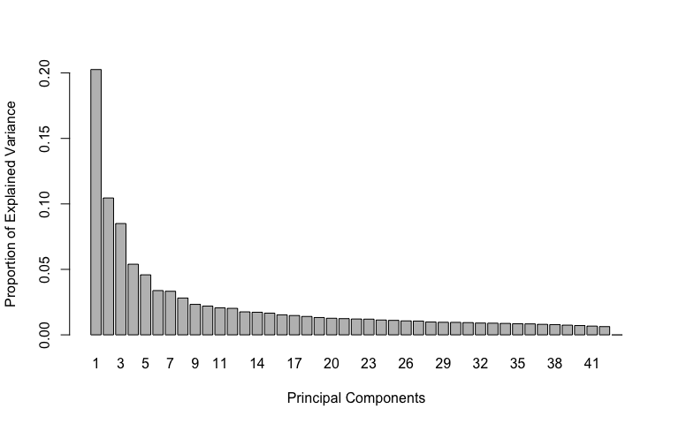

pca.res <- mixOmics::pca(scaled_Y_young, ncomp = 3, scale = F)  
  
# plot pca  
plotIndiv(pca.res, group = class$Fungus, ind.names = F, pch = as.factor(class$Water),   
 legend = T, legend.title = "Fungus", legend.title.pch = "Water",   
 title = "Young Leaf Lipids (Pos) PCA")

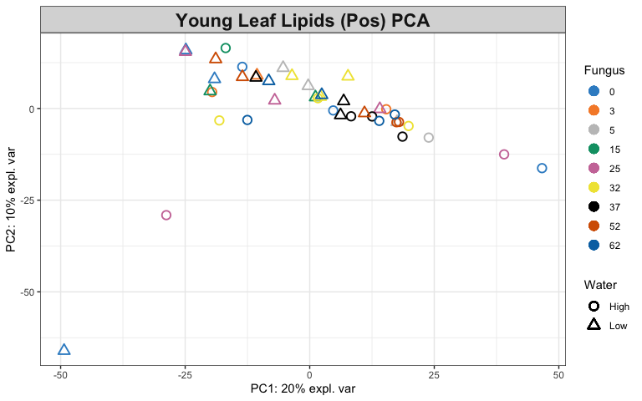

# Look at variable coefficients in each component with the  
# loading vectors The absolute value of loading vectors  
# represent the importance of each variable to define each PC  
plotLoadings(pca.res, ndisplay = 50)

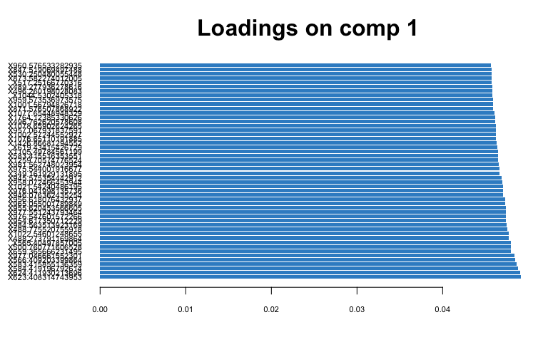

1. Identify the variables that contribute to the explained variance.

# Old Leaf  
spca.res <- mixOmics::spca(scaled_Y_old, ncomp = 3, keepX = c(100,   
 100, 10))  
  
# plot spca  
plotIndiv(spca.res, group = class$Fungus, ind.names = F, pch = as.factor(class$Water),   
 legend = T, legend.title = "Fungus", legend.title.pch = "Water",   
 title = "Old Leaf Lipids (Pos) sPCA")

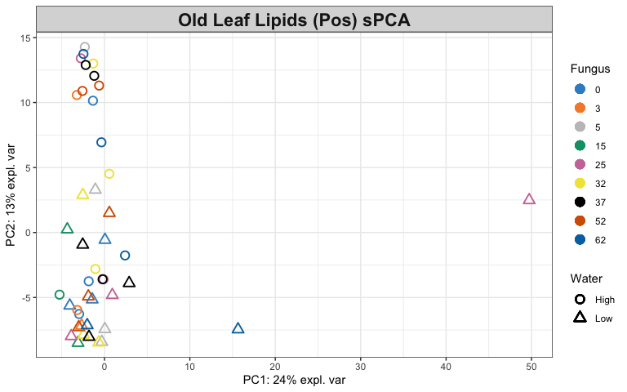

# variables contributing to each component  
plotVar(spca.res, cex = 1)

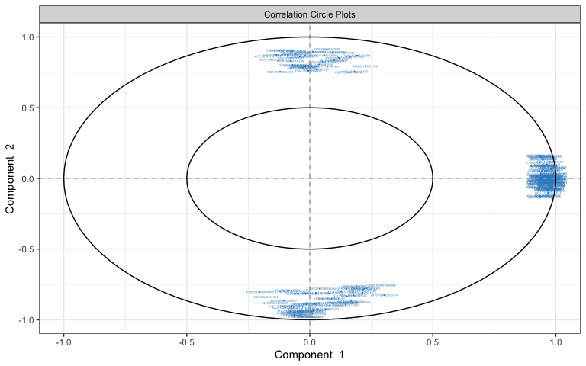

selectVar(spca.res, comp = 1)$value # view loading value of each metabolite

## value.var  
## X831.518709236631 0.172620458  
## X732.443171092481 0.168296057  
## X731.438136266847 0.167454065  
## X814.519484941161 0.166438746  
## X830.504557359875 0.164320709  
## X815.526421936588 0.163737218  
## X813.515578090397 0.163508986  
## X808.559334231922 0.161009134  
## X546.388334863329 0.160984742  
## X545.385999141925 0.153342022  
## X816.531573630009 0.151288630  
## X743.441886634262 0.150052144  
## X755.511357401208 0.149947430  
## X778.544782125781 0.148521054  
## X1263.81367373035 0.148160308  
## X611.469097923805 0.146656030  
## X804.535268781479 0.143688197  
## X746.420945538405 0.142549845  
## X374.206071654201 0.140943889  
## X780.55897895783 0.140750076  
## X529.390511583298 0.140242603  
## X779.549904558657 0.139479912  
## X745.418001691058 0.138998524  
## X824.555516706525 0.138571412  
## X1264.31686752149 0.137319501  
## X1263.3118786525 0.133758175  
## X781.562470345012 0.132132235  
## X829.502477789232 0.126553139  
## X518.326555182277 0.125737893  
## X742.476200409555 0.123710029  
## X794.568765896594 0.123558466  
## X318.301936686386 0.117975433  
## X734.456270192253 0.114664379  
## X733.452831026669 0.114303773  
## X747.432280460354 0.113584596  
## X793.569482767912 0.113278695  
## X792.566391872827 0.113173936  
## X246.244026630445 0.112776140  
## X326.379188131675 0.106900159  
## X382.705648118746 0.106833961  
## X827.492635970453 0.105282182  
## X748.43588669705 0.104892985  
## X571.456275345093 0.103289959  
## X411.197745550511 0.102627905  
## X382.205104740423 0.101332014  
## X432.750951893732 0.099918659  
## X286.311793629783 0.098645924  
## X410.188828237828 0.095175090  
## X409.185152883057 0.094132284  
## X362.328187231192 0.092960946  
## X765.445581943467 0.091584912  
## X333.244766441338 0.090869187  
## X519.329371282499 0.089682623  
## X363.331227311425 0.080353159  
## X532.410240682773 0.079368347  
## X414.739690648256 0.067791427  
## X309.253134340825 0.067106545  
## X332.332789682947 0.065975546  
## X1183.78973796016 0.060171240  
## X1182.78522288059 0.056580213  
## X1182.28366567391 0.055405026  
## X596.478037801955 0.054532813  
## X281.222474726652 0.053342219  
## X1181.78090187063 0.052643191  
## X340.283564752252 0.052030673  
## X423.74507270066 0.051520306  
## X387.181977224108 0.050024375  
## X1183.28910429712 0.048964580  
## X375.216239987552 0.048325820  
## X850.532999703027 0.044751553  
## X614.489382227607 0.044712660  
## X432.249992388519 0.044096815  
## X851.536200338849 0.042511539  
## X334.296207062515 0.041511119  
## X617.422434584689 0.040892373  
## X600.423865799132 0.040450993  
## X531.406294563801 0.039938451  
## X388.185474387062 0.038037599  
## X375.715726205822 0.037751982  
## X795.424433772223 0.033949094  
## X1344.83974186844 0.031175120  
## X423.246011998791 0.029381703  
## X274.275878507362 0.027867860  
## X595.475042420081 0.026042544  
## X657.413334779106 0.022971788  
## X986.60881151063 0.021944818  
## X415.213245299454 0.020714708  
## X207.140250943762 0.018507543  
## X409.164099604973 0.018150977  
## X538.309635918706 0.017914136  
## X393.192032923759 0.017455099  
## X896.51647657354 0.017379232  
## X875.487665919143 0.017004776  
## X800.537939870678 0.016738006  
## X830.514148662257 0.016441777  
## X537.305924903602 0.010246862  
## X864.512061516746 0.009965227  
## X1589.02230273985 0.008643349  
## X410.167418682302 0.006399847  
## X550.44710345109 0.002474784

# plot loadings for comp 1  
plotLoadings(spca.res, ndisplay = 50)

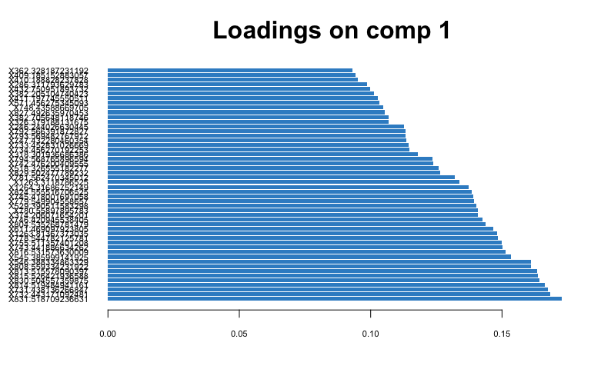

# plot loadings for comp 2  
plotLoadings(spca.res, comp = 2, ndisplay = 50)

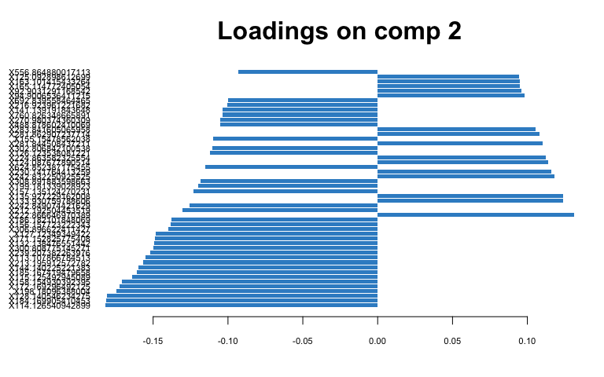

# Young Leaf  
spca.res <- mixOmics::spca(scaled_Y_young, ncomp = 3, keepX = c(100,   
 100, 10))  
  
# plot spca  
plotIndiv(spca.res, group = class$Fungus, ind.names = F, pch = as.factor(class$Water),   
 legend = T, legend.title = "Fungus", legend.title.pch = "Water",   
 title = "Young Leaf Lipids (Pos) sPCA")

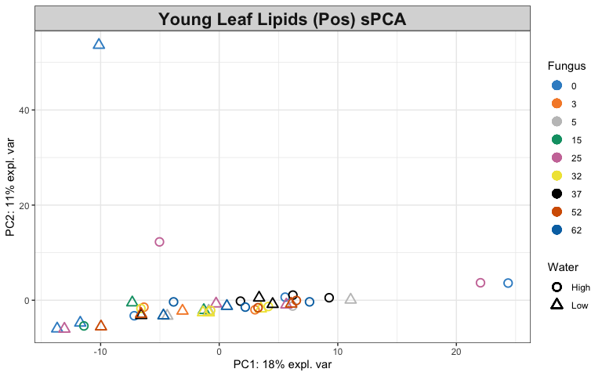

# variables contributing to each component  
plotVar(spca.res, cex = 1)

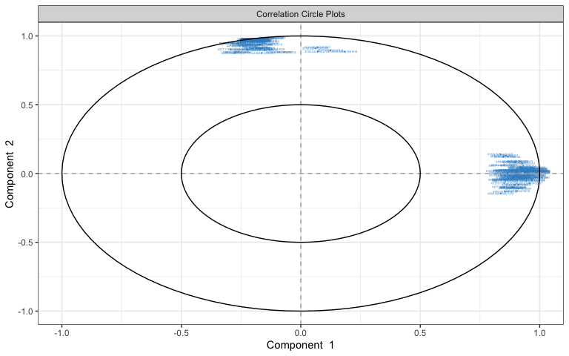

selectVar(spca.res, comp = 1)$value # view loading value of each metabolite

## value.var  
## X976.041998135736 0.164272822  
## X954.617350712229 0.163448534  
## X977.046661552301 0.162306422  
## X488.273791169864 0.161458674  
## X488.775520755918 0.160536781  
## X1022.54601248655 0.160489386  
## X955.620453566605 0.160190374  
## X1021.54240486195 0.157593782  
## X976.547601572266 0.155665956  
## X957.067931837591 0.154670263  
## X958.072466453944 0.153812952  
## X959.573536973575 0.152794534  
## X960.576533282935 0.152322088  
## X975.544001916677 0.150883330  
## X1425.86290778796 0.146142511  
## X1426.36728999806 0.145229770  
## X1424.85976253527 0.144990862  
## X1426.86681294552 0.144565735  
## X659.365666231495 0.144306082  
## X1425.36465620149 0.143198475  
## X1044.5302405318 0.140736973  
## X984.563513923169 0.140323494  
## X500.760771606528 0.140069527  
## X1105.49784561199 0.135875269  
## X613.484253189627 0.132178575  
## X614.487311675301 0.131782873  
## X1043.52514843306 0.131659191  
## X981.562748023954 0.131115658  
## X956.618076432937 0.131013597  
## X1002.57244552927 0.127964995  
## X530.250480055448 0.125847541  
## X517.25166770316 0.125451005  
## X1001.56794826718 0.120599063  
## X961.581216158607 0.116334098  
## X965.055001789849 0.111857681  
## X977.551243793464 0.109211089  
## X595.472912832874 0.105682274  
## X982.567972858134 0.104196176  
## X565.40497857005 0.103787999  
## X876.041438895017 0.101865450  
## X873.582274012005 0.099474539  
## X599.410381223173 0.099252065  
## X875.540053674342 0.095547062  
## X969.053894724155 0.095534693  
## X1076.65110191885 0.094061557  
## X1065.50960048045 0.092477157  
## X1077.65448948329 0.092406666  
## X999.521732579416 0.090490988  
## X623.408314743953 0.088684055  
## X566.409203399864 0.084787818  
## X957.609347356654 0.083278521  
## X624.411930213696 0.080258317  
## X1027.55778323275 0.080073455  
## X489.277936278616 0.078066626  
## X978.555223013531 0.076957472  
## X1028.56349217506 0.076554593  
## X480.790480251846 0.074970226  
## X349.161929131895 0.074074623  
## X600.414332602851 0.071518021  
## X517.752878732788 0.070620078  
## X1023.55012772181 0.069077483  
## X876.543723964092 0.066186012  
## X946.076362435254 0.064245671  
## X1078.65902624265 0.064236605  
## X584.419196792614 0.063199104  
## X551.425843612517 0.063176518  
## X945.575354442912 0.062090676  
## X552.429062975079 0.058517505  
## X583.415855136359 0.058038828  
## X871.576507868922 0.057795471  
## X874.584651876624 0.057747623  
## X962.586217446947 0.055082584  
## X895.015665583442 0.046338032  
## X894.514915085236 0.043939574  
## X496.260198028083 0.043827329  
## X657.408346877498 0.043428948  
## X502.259240592042 0.041649504  
## X583.415516353551 0.038963095  
## X1106.50260362597 0.038025338  
## X617.420737980743 0.037213469  
## X496.762620578608 0.036499356  
## X909.532512628987 0.032323205  
## X619.43415426729 0.031295823  
## X507.750369455364 0.030877346  
## X991.511218688387 0.029628460  
## X618.424413292171 0.028967963  
## X553.43164404136 0.028058213  
## X847.519069497488 0.027288267  
## X985.567543188756 0.026943520  
## X877.04633470551 0.025191092  
## X1259.70574776524 0.024073045  
## X599.410692576378 0.023695334  
## X614.487577459701 0.020638426  
## X992.515712573244 0.016347061  
## X530.752892698683 0.015324619  
## X600.414315574091 0.014573064  
## X660.368635116281 0.011751384  
## X568.428500821379 0.010047001  
## X1039.52144262227 0.008062114  
## X1004.54062609616 0.001874783

# plot loadings for comp 1  
plotLoadings(spca.res, ndisplay = 50)

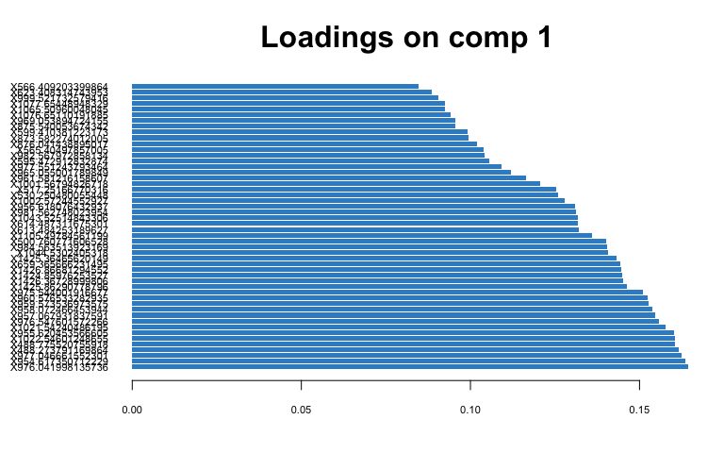

# plot loadings for comp 2  
plotLoadings(spca.res, comp = 2, ndisplay = 50)

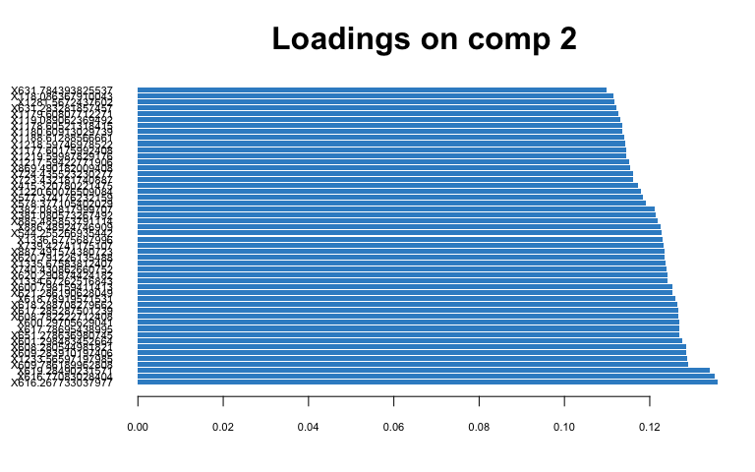

## PLS-DA

1. Classify samples into known groups and predict the class of new samples.

# Old Leaf  
old.splsda <- mixOmics::splsda(scaled_Y_old, class$Fungus, keepX = c(100,   
 100))  
  
# plot pls-da  
plotIndiv(old.splsda, ind.names = F, legend = T, title = "Old Leaf Lipids (Pos) PLS-DA",   
 legend.title = "Fungus", ellipse = T)

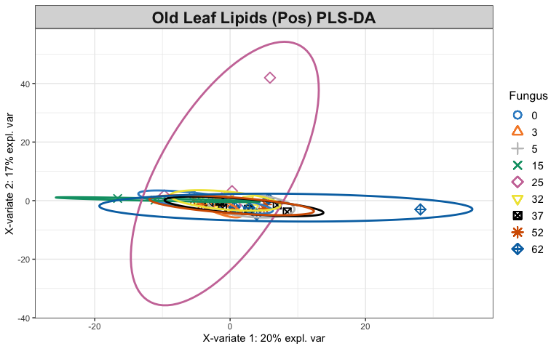

# plot and select the variables  
plotVar(old.splsda)

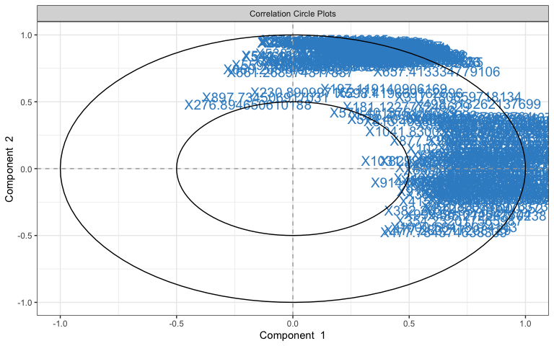

selectVar(old.splsda, comp = 1)

## $name  
## [1] "X530.251890235539" "X530.753768195125" "X488.275414364684"  
## [4] "X538.743327781972" "X488.777015051065" "X884.027506995044"  
## [7] "X538.23997319141" "X915.604140852292" "X660.373813622957"  
## [10] "X976.044489697274" "X865.051335834973" "X1022.54885683216"  
## [13] "X496.261816231193" "X1021.54523919379" "X659.369747252162"  
## [16] "X984.540629812326" "X866.05572515234" "X867.059699878059"  
## [19] "X977.047777844877" "X865.552516836676" "X480.789491043094"  
## [22] "X1077.65731355674" "X984.031307278781" "X991.5133487097"   
## [25] "X1076.65407710562" "X864.549452309306" "X992.51785183861"   
## [28] "X496.763451275431" "X878.558611078674" "X987.53280552011"   
## [31] "X495.764593225705" "X599.412394128268" "X866.556293513115"  
## [34] "X349.163202772319" "X493.76201594691" "X830.467014372042"  
## [37] "X975.547124984202" "X480.288159876163" "X945.576618927559"  
## [40] "X740.500801011646" "X986.524437394119" "X976.550427272099"  
## [43] "X485.27226370238" "X336.223807575843" "X932.634751093022"  
## [46] "X914.600991727368" "X877.539499109809" "X999.561014547874"  
## [49] "X946.078374829586" "X501.761232616786" "X539.249113810979"  
## [52] "X600.4158642877" "X364.254362067022" "X295.196082045934"  
## [55] "X613.48620846313" "X879.065097543885" "X415.7365415304"   
## [58] "X317.180659718134" "X1445.34303632503" "X496.775134400763"  
## [61] "X502.25999467882" "X1041.83003958831" "X872.53310000352"   
## [64] "X489.27954788019" "X994.523205661239" "X946.582521635004"  
## [67] "X955.623184556673" "X877.04903182984" "X1000.56418074143"  
## [70] "X959.575997758434" "X893.618592737698" "X477.283217238129"  
## [73] "X497.273508649734" "X878.055130721582" "X354.232017565987"  
## [76] "X957.070210444299" "X335.260157312681" "X954.619922134736"  
## [79] "X504.271157003764" "X960.578907599357" "X829.462641361221"  
## [82] "X342.239823636993" "X1023.55357784034" "X880.070800931978"  
## [85] "X977.554810339346" "X601.427805825546" "X349.663922662639"  
## [88] "X1444.33993604679" "X491.800145976373" "X758.531383058781"  
## [91] "X813.495852628813" "X1031.79972614852" "X296.199163537393"  
## [94] "X382.263843576394" "X498.313262137699" "X958.074259394391"  
## [97] "X477.784574638339" "X595.4746818897" "X933.638024103796"  
## [100] "X1444.84082391465"  
##   
## $value  
## value.var  
## X530.251890235539 0.2787399150  
## X530.753768195125 0.2371262941  
## X488.275414364684 0.2150767431  
## X538.743327781972 0.2039737100  
## X488.777015051065 0.1979515943  
## X884.027506995044 0.1957315327  
## X538.23997319141 0.1850202728  
## X915.604140852292 0.1768660602  
## X660.373813622957 0.1619652834  
## X976.044489697274 0.1592902240  
## X865.051335834973 0.1580346338  
## X1022.54885683216 0.1565880346  
## X496.261816231193 0.1560505238  
## X1021.54523919379 0.1528475130  
## X659.369747252162 0.1504923648  
## X984.540629812326 0.1494937360  
## X866.05572515234 0.1492380737  
## X867.059699878059 0.1377467341  
## X977.047777844877 0.1321578287  
## X865.552516836676 0.1303586523  
## X480.789491043094 0.1289828655  
## X1077.65731355674 0.1242133843  
## X984.031307278781 0.1238722544  
## X991.5133487097 0.1219637941  
## X1076.65407710562 0.1219308145  
## X864.549452309306 0.1193376111  
## X992.51785183861 0.1187054405  
## X496.763451275431 0.1154751633  
## X878.558611078674 0.1150664680  
## X987.53280552011 0.1140340310  
## X495.764593225705 0.1138238999  
## X599.412394128268 0.1115587261  
## X866.556293513115 0.1056436222  
## X349.163202772319 0.1051028921  
## X493.76201594691 0.1047411455  
## X830.467014372042 0.1029089014  
## X975.547124984202 0.1015381266  
## X480.288159876163 0.1002706043  
## X945.576618927559 0.0993092193  
## X740.500801011646 0.0954256877  
## X986.524437394119 0.0953498581  
## X976.550427272099 0.0864485551  
## X485.27226370238 0.0836839142  
## X336.223807575843 0.0822740327  
## X932.634751093022 0.0800578018  
## X914.600991727368 0.0707202362  
## X877.539499109809 0.0688353460  
## X999.561014547874 0.0675343722  
## X946.078374829586 0.0641602966  
## X501.761232616786 0.0601006955  
## X539.249113810979 0.0589843204  
## X600.4158642877 0.0588990331  
## X364.254362067022 0.0578590721  
## X295.196082045934 0.0568541536  
## X613.48620846313 0.0566359178  
## X879.065097543885 0.0543763280  
## X415.7365415304 0.0531126915  
## X317.180659718134 0.0490692525  
## X1445.34303632503 0.0485941801  
## X496.775134400763 0.0480602511  
## X502.25999467882 0.0476392303  
## X1041.83003958831 0.0465025280  
## X872.53310000352 0.0443540775  
## X489.27954788019 0.0424362509  
## X994.523205661239 0.0385777808  
## X946.582521635004 0.0375775847  
## X955.623184556673 0.0354372477  
## X877.04903182984 0.0344928726  
## X1000.56418074143 0.0317210173  
## X959.575997758434 0.0301766867  
## X893.618592737698 0.0288806933  
## X477.283217238129 0.0288038601  
## X497.273508649734 0.0265632684  
## X878.055130721582 0.0261134717  
## X354.232017565987 0.0252260680  
## X957.070210444299 0.0232778198  
## X335.260157312681 0.0230247719  
## X954.619922134736 0.0222957611  
## X504.271157003764 0.0213450974  
## X960.578907599357 0.0210706752  
## X829.462641361221 0.0203366521  
## X342.239823636993 0.0175492491  
## X1023.55357784034 0.0146647413  
## X880.070800931978 0.0133300332  
## X977.554810339346 0.0122406310  
## X601.427805825546 0.0112007391  
## X349.663922662639 0.0111267919  
## X1444.33993604679 0.0104216536  
## X491.800145976373 0.0099582362  
## X758.531383058781 0.0097578262  
## X813.495852628813 0.0094676399  
## X1031.79972614852 0.0074113278  
## X296.199163537393 0.0069973762  
## X382.263843576394 0.0066865175  
## X498.313262137699 0.0057358045  
## X958.074259394391 0.0045261897  
## X477.784574638339 0.0042601516  
## X595.4746818897 0.0025486460  
## X933.638024103796 0.0006263414  
## X1444.84082391465 0.0004178260  
##   
## $comp  
## [1] 1

plotLoadings(old.splsda, contrib = "max", method = "mean", ndisplay = 50)

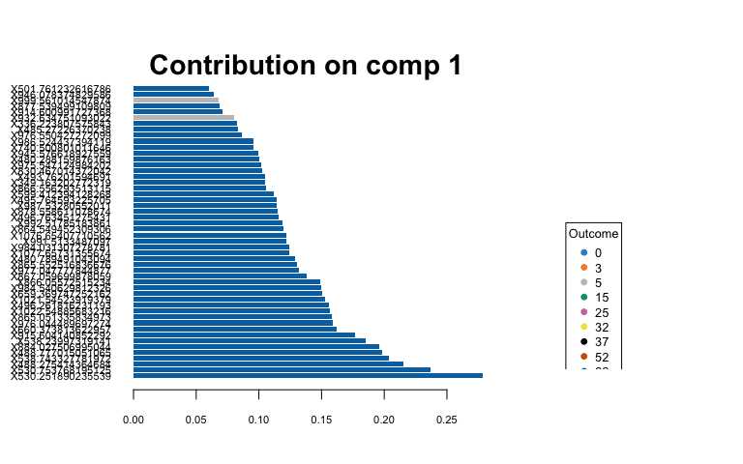

# Young Leaf  
young.splsda <- mixOmics::splsda(scaled_Y_young, class$Fungus,   
 keepX = c(100, 100))  
  
# plot pls-da  
plotIndiv(young.splsda, ind.names = F, legend = T, title = "Young Leaf Lipids (Pos) PLS-DA",   
 legend.title = "Fungus", ellipse = T)

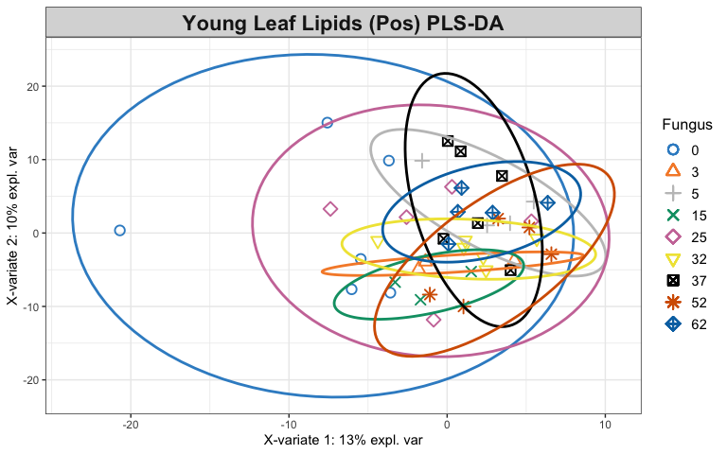

# plot and select the variables  
plotVar(young.splsda)

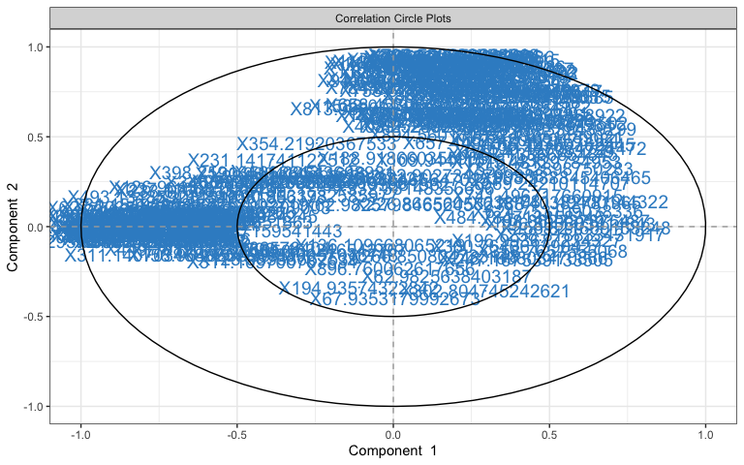

selectVar(young.splsda, comp = 1)

## $name  
## [1] "X323.14304237273" "X320.865331216044" "X295.139586284575"  
## [4] "X493.134859214546" "X1081.49400144322" "X219.102247109176"  
## [7] "X311.140703468025" "X569.24210114707" "X125.98538662539"   
## [10] "X341.140983431263" "X689.208845644225" "X690.213072804742"  
## [13] "X124.087159541443" "X908.538845406465" "X624.753109038336"  
## [16] "X459.151455061327" "X901.326376690684" "X185.889646934245"  
## [19] "X697.341230129379" "X191.140973651863" "X158.964663690357"  
## [22] "X690.274113121676" "X691.277072720664" "X90.9033982585977"  
## [25] "X573.19576286678" "X540.887752002719" "X327.160055697807"  
## [28] "X575.202673302042" "X266.850804733148" "X328.162988647859"  
## [31] "X621.215799976138" "X199.939057016748" "X346.789544256213"  
## [34] "X741.496717660915" "X120.968414511616" "X484.784713858346"  
## [37] "X184.889317750766" "X126.961522293921" "X229.141806150096"  
## [40] "X607.174079370479" "X607.207550803792" "X284.816999052287"  
## [43] "X377.085626354264" "X233.076001576199" "X163.040073994767"  
## [46] "X360.764061390427" "X627.203866379119" "X308.890061856173"  
## [49] "X237.110685328431" "X536.438084724472" "X358.7657555068"   
## [52] "X561.192552485699" "X282.094893241756" "X711.191695035036"  
## [55] "X196.993677234327" "X273.081274829421" "X120.088896864637"  
## [58] "X177.016364210501" "X549.218901747332" "X562.196381837805"  
## [61] "X281.088456911411" "X179.065348185315" "X231.141741122512"  
## [64] "X609.189377269662" "X196.865603414843" "X378.164038356871"  
## [67] "X190.126486578404" "X559.232898750283" "X638.740382781965"  
## [70] "X377.160255395164" "X137.060663669955" "X660.80142026303"   
## [73] "X198.862737375487" "X311.169700767634" "X569.199478252238"  
## [76] "X119.089062369492" "X354.21920367533" "X265.106604762037"  
## [79] "X1175.48129784953" "X547.215180396862" "X548.21957840366"   
## [82] "X617.150214310121" "X334.179688309003" "X359.149843804862"  
## [85] "X302.804745242621" "X379.112996191006" "X247.167539133505"  
## [88] "X411.09543608981" "X177.055302334209" "X274.079850557197"  
## [91] "X256.821609153248" "X634.452246542767" "X596.177215143824"  
## [94] "X595.17823477301" "X449.108904670796" "X248.169808470866"  
## [97] "X331.15494958124" "X278.895045500166" "X258.818833431917"  
## [100] "X621.286190628049"  
##   
## $value  
## value.var  
## X323.14304237273 -0.3416167438  
## X320.865331216044 -0.2955018499  
## X295.139586284575 -0.2276259767  
## X493.134859214546 -0.2106263799  
## X1081.49400144322 0.1998892746  
## X219.102247109176 -0.1834834966  
## X311.140703468025 -0.1834650636  
## X569.24210114707 0.1820321373  
## X125.98538662539 -0.1733721746  
## X341.140983431263 -0.1697275623  
## X689.208845644225 -0.1688705084  
## X690.213072804742 -0.1612449742  
## X124.087159541443 -0.1564560851  
## X908.538845406465 0.1543282802  
## X624.753109038336 0.1482127350  
## X459.151455061327 -0.1405048279  
## X901.326376690684 -0.1399217497  
## X185.889646934245 -0.1370141931  
## X697.341230129379 -0.1339946588  
## X191.140973651863 -0.1318479906  
## X158.964663690357 -0.1290596063  
## X690.274113121676 -0.1231780789  
## X691.277072720664 -0.1206881434  
## X90.9033982585977 -0.1195010844  
## X573.19576286678 -0.1172479650  
## X540.887752002719 -0.1150723215  
## X327.160055697807 -0.1139831185  
## X575.202673302042 -0.1123408534  
## X266.850804733148 0.1010303807  
## X328.162988647859 -0.0979358756  
## X621.215799976138 -0.0960407330  
## X199.939057016748 -0.0956320989  
## X346.789544256213 -0.0853501324  
## X741.496717660915 0.0839611945  
## X120.968414511616 -0.0833105448  
## X484.784713858346 0.0827437432  
## X184.889317750766 -0.0798891147  
## X126.961522293921 -0.0737213683  
## X229.141806150096 -0.0727801918  
## X607.174079370479 -0.0699263459  
## X607.207550803792 -0.0689839161  
## X284.816999052287 -0.0662973673  
## X377.085626354264 -0.0654950136  
## X233.076001576199 -0.0632242865  
## X163.040073994767 -0.0603304097  
## X360.764061390427 0.0591449838  
## X627.203866379119 -0.0580548334  
## X308.890061856173 -0.0550110532  
## X237.110685328431 -0.0539797209  
## X536.438084724472 0.0519614676  
## X358.7657555068 0.0492060182  
## X561.192552485699 -0.0485448680  
## X282.094893241756 -0.0479308899  
## X711.191695035036 -0.0476566818  
## X196.993677234327 0.0470686061  
## X273.081274829421 -0.0454925159  
## X120.088896864637 -0.0454761313  
## X177.016364210501 -0.0452816943  
## X549.218901747332 -0.0432890869  
## X562.196381837805 -0.0418095894  
## X281.088456911411 -0.0415812997  
## X179.065348185315 -0.0409394208  
## X231.141741122512 -0.0403002997  
## X609.189377269662 -0.0399387350  
## X196.865603414843 0.0376777031  
## X378.164038356871 -0.0369785833  
## X190.126486578404 -0.0351672677  
## X559.232898750283 0.0341601357  
## X638.740382781965 0.0333015118  
## X377.160255395164 -0.0329288226  
## X137.060663669955 -0.0310865370  
## X660.80142026303 -0.0302963470  
## X198.862737375487 0.0288442438  
## X311.169700767634 -0.0255553101  
## X569.199478252238 -0.0254921289  
## X119.089062369492 -0.0211187434  
## X354.21920367533 -0.0209744779  
## X265.106604762037 -0.0184500339  
## X1175.48129784953 0.0182995905  
## X547.215180396862 -0.0181184559  
## X548.21957840366 -0.0178552376  
## X617.150214310121 -0.0173720762  
## X334.179688309003 -0.0167524117  
## X359.149843804862 -0.0166710091  
## X302.804745242621 0.0155077124  
## X379.112996191006 -0.0154490252  
## X247.167539133505 0.0143220385  
## X411.09543608981 -0.0122302715  
## X177.055302334209 -0.0114308940  
## X274.079850557197 -0.0111453338  
## X256.821609153248 0.0111005249  
## X634.452246542767 -0.0103238264  
## X596.177215143824 -0.0102794991  
## X595.17823477301 -0.0100377883  
## X449.108904670796 -0.0085082813  
## X248.169808470866 0.0059334461  
## X331.15494958124 -0.0048366868  
## X278.895045500166 -0.0036005552  
## X258.818833431917 0.0031083231  
## X621.286190628049 -0.0008631579  
##   
## $comp  
## [1] 1

plotLoadings(young.splsda, contrib = "max", method = "mean",   
 ndisplay = 50)

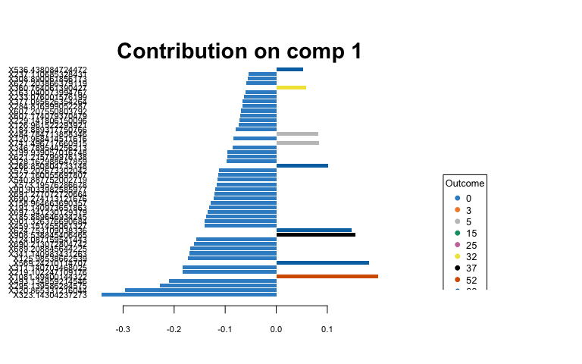

## Heatmaps of Averaged Data

1. Create averaged metabolite matrices and rerun PLS-DA to create a heatmap.

## Young Leaves  
av_Y_young <- aggregate(Y_young, by = list(class$Water, class$Fungus),   
 FUN = "mean", simplify = T, data = class)  
av.young.plsda <- mixOmics::plsda(av_Y_young[, 3:1755], av_Y_young$Group.2) # fungus  
  
# heatmap  
youngcim <- cim(av.young.plsda, title = "Young Leaf Lipids (pos) Averaged Over Fungi",   
 col.names = F, xlab = "Lipids", save = "png", name.save = "~/Box/Summer 2018 TX Endo Field Samples and Analysis/Statistics/Kenia_Thesis_Analysis/Lipids Statistics/young_fungi_avlpos_hm.png") # by fungal treatment

## Indicator Analysis

1. Identify indicator metabolites characteristic of each treatment using Dufrene-Legendre Indicator Analysis.

# Old Leaf  
indicator_Fungus <- indval(Y_young, clustering = class$Fungus,   
 numitr = 999, type = "long")  
  
# Young Leaf  
indicator_Fungus <- indval(Y_young, clustering = class$Fungus,   
 numitr = 999, type = "long")

1. Disect indval object.

Orelfrq <- indicator_Fungus$relfrq # relative frequency of species in classes  
Orelabu <- indicator_Fungus$relabu # relative abundance of species in classes  
Oindval <- indicator_Fungus$indval # the indicator value for each species  
Omaxcls <- data.frame(indicator_Fungus$maxcls) # the class each species has max indicator value for  
Oindcls <- data.frame(indicator_Fungus$indcls) # the indicator value for each species to its max class  
Opval <- data.frame(indicator_Fungus$pval) # the probability of obtaining as high an indicator value as observed over the specified iterations  
  
Yrelfrq <- indicator_Fungus$relfrq # relative frequency of species in classes  
Yrelabu <- indicator_Fungus$relabu # relative abundance of species in classes  
Yindval <- indicator_Fungus$indval # the indicator value for each species  
Ymaxcls <- data.frame(indicator_Fungus$maxcls) # the class each species has max indicator value for  
Yindcls <- data.frame(indicator_Fungus$indcls) # the indicator value for each species to its max class  
Ypval <- data.frame(indicator_Fungus$pval) # the probability of obtaining as high an indicator value as observed over the specified iterations

1. Export results to a csv file.

write.csv(cbind(Orelfrq, Orelabu, Oindval, Omaxcls, Oindcls,   
 Opval), "~/Box/Summer 2018 TX Endo Field Samples and Analysis/Statistics/Kenia_Thesis_Analysis/Lipids Statistics/Indicator_Analys_oLpos_Fungus.csv")  
write.csv(cbind(Yrelfrq, Yrelabu, Yindval, Ymaxcls, Yindcls,   
 Ypval), "~/Box/Summer 2018 TX Endo Field Samples and Analysis/Statistics/Kenia_Thesis_Analysis/Lipids Statistics/Indicator_Analys_yLpos_Fungus.csv")

## References

Collyer, M.L., Adams, D.C. 2018. RRPP: An r package for fitting linear models to high-dimensional data using residual randomization. Methods in Ecology and Evolution. 9(7):1772-1779.

Dufrene, M. and Legendre, P. 1997. Species assemblages and indicator species: the need for a flexible asymmetrical approach. Ecol. Monogr. 67(3):345-366.

Rohart, F., Gautier, B., Singh, A., & Lê Cao, K. A. 2017. mixOmics: An R package for ‘omics feature selection and multiple data integration. PLoS computational biology, 13(11):e1005752.