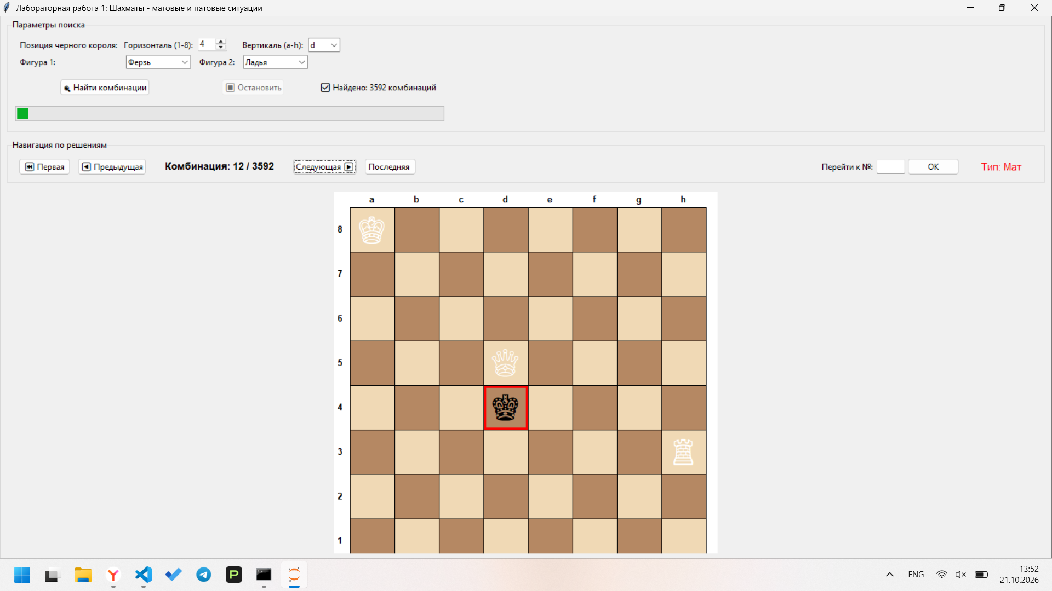
import tkinter as tk
from tkinter import ttk, messagebox
import threading

# Константы фигур
EMPTY = 0
WK = 1 # Белый король
BK = 2 # Черный король
WQ = 3 # Белый ферзь
WR = 4 # Белая ладья
WB = 5 # Белый слон
WN = 6 # Белый конь

PIECE_NAMES = {WQ: "Ферзь", WR: "Ладья", WB: "Слон", WN: "Конь"}
PIECE_SYMBOLS = {WK: "♔", BK: "♚", WQ: "♕", WR: "♖", WB: "♗", WN: "♘"}

class ChessBoard:
"""Представление шахматной доски 8x8"""

def __init__(self):
self.board = [[EMPTY] * 8 for _ in range(8)]

def copy(self):
new_board = ChessBoard()
new_board.board = [row[:] for row in self.board]
return new_board

def place(self, row, col, piece):
self.board[row][col] = piece

def get(self, row, col):
if 0 <= row < 8 and 0 <= col < 8:
return self.board[row][col]
return -1

def find_king(self, color):
target = WK if color == 'white' else BK
for r in range(8):
for c in range(8):
if self.board[r][c] == target:
return (r, c)
return None

def is_path_clear(self, from_r, from_c, to_r, to_c):
"""Проверка чистоты пути для скользящих фигур"""
dr = 0 if to_r == from_r else (1 if to_r > from_r else -1)
dc = 0 if to_c == from_c else (1 if to_c > from_c else -1)
r, c = from_r + dr, from_c + dc
while (r, c) != (to_r, to_c):
if self.board[r][c] != EMPTY:
return False
r += dr
c += dc
return True

def can_piece_attack(self, from_r, from_c, to_r, to_c, piece):
"""Может ли фигура атаковать клетку"""
dr = to_r - from_r
dc = to_c - from_c

if piece == WN:
return (abs(dr), abs(dc)) in [(1, 2), (2, 1)]

if piece == WK:
return abs(dr) <= 1 and abs(dc) <= 1 and (dr, dc) != (0, 0)

if piece in [WQ, WR]:
if (dr == 0 or dc == 0) and (dr != 0 or dc != 0):
if self.is_path_clear(from_r, from_c, to_r, to_c):
return True

if piece in [WQ, WB]:
if abs(dr) == abs(dc) and dr != 0:
if self.is_path_clear(from_r, from_c, to_r, to_c):
return True

return False

def is_square_attacked_by_white(self, row, col):
"""Атакована ли клетка белыми фигурами"""
wk = self.find_king('white')
if wk:
kr, kc = wk
if abs(kr - row) <= 1 and abs(kc - col) <= 1 and (kr, kc) != (row, col):
return True

for r in range(8):
for c in range(8):
piece = self.board[r][c]
if piece in [WQ, WR, WB, WN]:
if self.can_piece_attack(r, c, row, col, piece):
return True
return False

def get_black_king_moves(self):
"""Все легальные ходы черного короля"""
bk = self.find_king('black')
if bk is None:
return []
kr, kc = bk
moves = []
for dr in [-1, 0, 1]:
for dc in [-1, 0, 1]:
if dr == 0 and dc == 0:
continue
nr, nc = kr + dr, kc + dc
if 0 <= nr < 8 and 0 <= nc < 8:
if not self.is_square_attacked_by_white(nr, nc):
target = self.board[nr][nc]
if target not in [WK, WQ, WR, WB, WN]:
moves.append((nr, nc))
return moves

def is_in_check(self):
"""Шах черному королю?"""
bk = self.find_king('black')
if bk is None:
return False
return self.is_square_attacked_by_white(bk[0], bk[1])

def is_checkmate(self):
"""Мат?"""
return self.is_in_check() and len(self.get_black_king_moves()) == 0

def is_stalemate(self):
"""Пат?"""
return not self.is_in_check() and len(self.get_black_king_moves()) == 0

def find_solutions(bk_row, bk_col, piece1_type, piece2_type, progress_callback=None):
"""Поиск всех матовых/патовых позиций"""
solutions = []
total = 0
same_pieces = (piece1_type == piece2_type)

for wk_r in range(8):
for wk_c in range(8):
if (wk_r, wk_c) == (bk_row, bk_col):
continue
if abs(wk_r - bk_row) <= 1 and abs(wk_c - bk_col) <= 1:
continue # Короли не могут стоять рядом

for p1_r in range(8):
for p1_c in range(8):
if (p1_r, p1_c) == (bk_row, bk_col):
continue
if (p1_r, p1_c) == (wk_r, wk_c):
continue

p2_start_r = p1_r if same_pieces else 0
p2_start_c = (p1_c + 1) if (same_pieces and p2_start_r == p1_r) else 0

for p2_r in range(p2_start_r, 8):
start_c = p2_start_c if p2_r == p2_start_r else 0
for p2_c in range(start_c, 8):
if (p2_r, p2_c) == (bk_row, bk_col):
continue
if (p2_r, p2_c) == (wk_r, wk_c):
continue
if (p2_r, p2_c) == (p1_r, p1_c):
continue

total += 1
if total % 5000 == 0 and progress_callback:
progress_callback(total)

board = ChessBoard()
board.place(bk_row, bk_col, BK)
board.place(wk_r, wk_c, WK)
board.place(p1_r, p1_c, piece1_type)
board.place(p2_r, p2_c, piece2_type)

if board.is_checkmate():
solutions.append(('Мат', board.copy()))
elif board.is_stalemate():
solutions.append(('Пат', board.copy()))

return solutions

class ChessApp:
def __init__(self, root):
self.root = root
self.root.title("Лабораторная работа 1: Шахматы - матовые и патовые ситуации")
self.root.geometry("950x750")
self.root.resizable(True, True)

self.solutions = []
self.current_solution = 0
self.searching = False

self.create_widgets()

def create_widgets(self):
# Панель управления
control_frame = ttk.LabelFrame(self.root, text="Параметры поиска", padding=10)
control_frame.pack(fill=tk.X, padx=10, pady=5)

# Позиция черного короля
ttk.Label(control_frame, text="Позиция черного короля:").grid(row=0, column=0, sticky=tk.W, padx=5)

row_frame = ttk.Frame(control_frame)
row_frame.grid(row=0, column=1, columnspan=4, sticky=tk.W)

ttk.Label(row_frame, text="Горизонталь (1-8):").pack(side=tk.LEFT)
self.bk_row_var = tk.IntVar(value=4)
ttk.Spinbox(row_frame, from_=1, to=8, textvariable=self.bk_row_var, width=4).pack(side=tk.LEFT, padx=5)

ttk.Label(row_frame, text="Вертикаль (a-h):").pack(side=tk.LEFT, padx=(15, 0))
self.bk_col_var = tk.StringVar(value="d")
col_names = ['a', 'b', 'c', 'd', 'e', 'f', 'g', 'h']
self.bk_col_combo = ttk.Combobox(row_frame, textvariable=self.bk_col_var,
values=col_names, width=4, state='readonly')
self.bk_col_combo.set("d")
self.bk_col_combo.pack(side=tk.LEFT, padx=5)

# Выбор фигур
ttk.Label(control_frame, text="Фигура 1:").grid(row=1, column=0, sticky=tk.W, padx=5, pady=5)
self.piece1_var = tk.StringVar(value="Ферзь")
ttk.Combobox(control_frame, textvariable=self.piece1_var,
values=["Ферзь", "Ладья", "Слон", "Конь"], width=12, state='readonly').grid(row=1, column=1, padx=5)

ttk.Label(control_frame, text="Фигура 2:").grid(row=1, column=2, sticky=tk.W, padx=5)
self.piece2_var = tk.StringVar(value="Ладья")
ttk.Combobox(control_frame, textvariable=self.piece2_var,
values=["Ферзь", "Ладья", "Слон", "Конь"], width=12, state='readonly').grid(row=1, column=3, padx=5)

# Кнопка поиска
self.find_btn = ttk.Button(control_frame, text="🔍 Найти комбинации", command=self.start_search)
self.find_btn.grid(row=2, column=0, columnspan=2, pady=10, padx=5)

self.stop_btn = ttk.Button(control_frame, text="⏹ Остановить", command=self.stop_search, state=tk.DISABLED)
self.stop_btn.grid(row=2, column=2, columnspan=2, pady=10, padx=5)

self.status_label = ttk.Label(control_frame, text="Готов к поиску")
self.status_label.grid(row=2, column=4, columnspan=2, padx=10)

# Прогресс-бар
self.progress = ttk.Progressbar(control_frame, mode='indeterminate', length=200)
self.progress.grid(row=3, column=0, columnspan=6, sticky=tk.EW, pady=5)

# Панель навигации
nav_frame = ttk.LabelFrame(self.root, text="Навигация по решениям", padding=10)
nav_frame.pack(fill=tk.X, padx=10, pady=5)

ttk.Button(nav_frame, text="⏮ Первая", command=self.first_solution).pack(side=tk.LEFT, padx=5)
ttk.Button(nav_frame, text="◀ Предыдущая", command=self.prev_solution).pack(side=tk.LEFT, padx=5)

self.solution_label = ttk.Label(nav_frame, text="Комбинация: 0 / 0", font=("Arial", 11, "bold"))
self.solution_label.pack(side=tk.LEFT, padx=20)

ttk.Button(nav_frame, text="Следующая ▶", command=self.next_solution).pack(side=tk.LEFT, padx=5)
ttk.Button(nav_frame, text="Последняя ", command=self.last_solution).pack(side=tk.LEFT, padx=5)

self.type_label = ttk.Label(nav_frame, text="Тип: —", font=("Arial", 11))
self.type_label.pack(side=tk.RIGHT, padx=20)

# Переход к конкретной комбинации
goto_frame = ttk.Frame(nav_frame)
goto_frame.pack(side=tk.RIGHT, padx=10)
ttk.Label(goto_frame, text="Перейти к №:").pack(side=tk.LEFT)
self.goto_var = tk.StringVar()
ttk.Entry(goto_frame, textvariable=self.goto_var, width=6).pack(side=tk.LEFT, padx=3)
ttk.Button(goto_frame, text="OK", command=self.goto_solution).pack(side=tk.LEFT)

# Шахматная доска
board_frame = ttk.Frame(self.root)
board_frame.pack(expand=True, fill=tk.BOTH, padx=10, pady=5)

self.canvas = tk.Canvas(board_frame, width=560, height=560, bg='white')
self.canvas.pack(expand=True)

self.draw_empty_board()

# Информация
info_frame = ttk.Frame(self.root)
info_frame.pack(fill=tk.X, padx=10, pady=5)
ttk.Label(info_frame,
text="Условия: черный король фиксирован, белый король + 2 фигуры создают мат/пат",
font=("Arial", 9), foreground='gray').pack()

def draw_empty_board(self):
self.canvas.delete("all")
cell_size = 65
offset = 25

for r in range(8):
for c in range(8):
x = offset + c * cell_size
y = offset + r * cell_size
color = "#F0D9B5" if (r + c) % 2 == 0 else "#B58863"
self.canvas.create_rectangle(x, y, x + cell_size, y + cell_size, fill=color, outline='black')

# Координаты
col_labels = ['a', 'b', 'c', 'd', 'e', 'f', 'g', 'h']
for i in range(8):
self.canvas.create_text(offset + i * cell_size + cell_size // 2, offset - 12,
text=col_labels[i], font=("Arial", 10, "bold"))
self.canvas.create_text(offset - 15, offset + i * cell_size + cell_size // 2,
text=str(8 - i), font=("Arial", 10, "bold"))

def draw_board(self, board):
self.canvas.delete("all")
cell_size = 65
offset = 25

for r in range(8):
for c in range(8):
x = offset + c * cell_size
y = offset + r * cell_size
color = "#F0D9B5" if (r + c) % 2 == 0 else "#B58863"
self.canvas.create_rectangle(x, y, x + cell_size, y + cell_size, fill=color, outline='black')

# Координаты
col_labels = ['a', 'b', 'c', 'd', 'e', 'f', 'g', 'h']
for i in range(8):
self.canvas.create_text(offset + i * cell_size + cell_size // 2, offset - 12,
text=col_labels[i], font=("Arial", 10, "bold"))
self.canvas.create_text(offset - 15, offset + i * cell_size + cell_size // 2,
text=str(8 - i), font=("Arial", 10, "bold"))

# Фигуры
for r in range(8):
for c in range(8):
piece = board.board[r][c]
if piece != EMPTY:
x = offset + c * cell_size + cell_size // 2
y = offset + r * cell_size + cell_size // 2
symbol = PIECE_SYMBOLS.get(piece, "?")
color = "white" if piece in [WK, WQ, WR, WB, WN] else "black"
self.canvas.create_text(x, y, text=symbol, font=("Arial", 36), fill=color)

# Подсветка черного короля
bk = board.find_king('black')
if bk:
kr, kc = bk
x = offset + kc * cell_size
y = offset + kr * cell_size
self.canvas.create_rectangle(x + 2, y + 2, x + cell_size - 2, y + cell_size - 2,
outline='red', width=3)

def start_search(self):
if self.searching:
return

bk_row = 8 - self.bk_row_var.get() # Преобразование: ряд 1 = индекс 7
bk_col = ord(self.bk_col_var.get()) - ord('a') # Колонка a = индекс 0

piece_map = {"Ферзь": WQ, "Ладья": WR, "Слон": WB, "Конь": WN}
p1 = piece_map[self.piece1_var.get()]
p2 = piece_map[self.piece2_var.get()]

self.searching = True
self.find_btn.config(state=tk.DISABLED)
self.stop_btn.config(state=tk.NORMAL)
self.progress.start()
self.status_label.config(text="Поиск...")
self.solutions = []
self.current_solution = 0

# Запуск поиска в отдельном потоке
thread = threading.Thread(target=self._search_thread,
args=(bk_row, bk_col, p1, p2), daemon=True)
thread.start()

def _search_thread(self, bk_row, bk_col, p1, p2):
try:
self.solutions = find_solutions(bk_row, bk_col, p1, p2)
self.root.after(0, self._search_complete)
except Exception as e:
self.root.after(0, lambda: self._search_error(str(e)))

def _search_complete(self):
self.searching = False
self.find_btn.config(state=tk.NORMAL)
self.stop_btn.config(state=tk.DISABLED)
self.progress.stop()

if self.solutions:
self.status_label.config(text=f"✅ Найдено: {len(self.solutions)} комбинаций")
self.show_solution(0)
else:
self.status_label.config(text="❌ Комбинации не найдены для данных параметров")
self.draw_empty_board()
self.solution_label.config(text="Комбинация: 0 / 0")
self.type_label.config(text="Тип: —")

def _search_error(self, error):
self.searching = False
self.find_btn.config(state=tk.NORMAL)
self.stop_btn.config(state=tk.DISABLED)
self.progress.stop()
self.status_label.config(text=f"Ошибка: {error}")
messagebox.showerror("Ошибка", f"Произошла ошибка при поиске:\n{error}")

def stop_search(self):
self.searching = False
self.find_btn.config(state=tk.NORMAL)
self.stop_btn.config(state=tk.DISABLED)
self.progress.stop()
self.status_label.config(text="Поиск остановлен пользователем")

def show_solution(self, idx):
if 0 <= idx < len(self.solutions):
self.current_solution = idx
sol_type, board = self.solutions[idx]
self.draw_board(board)
self.solution_label.config(text=f"Комбинация: {idx + 1} / {len(self.solutions)}")
color = "red" if sol_type == "Мат" else "blue"
self.type_label.config(text=f"Тип: {sol_type}", foreground=color)

def first_solution(self):
if self.solutions:
self.show_solution(0)

def prev_solution(self):
if self.current_solution > 0:
self.show_solution(self.current_solution - 1)

def next_solution(self):
if self.current_solution < len(self.solutions) - 1:
self.show_solution(self.current_solution + 1)

def last_solution(self):
if self.solutions:
self.show_solution(len(self.solutions) - 1)

def goto_solution(self):
try:
idx = int(self.goto_var.get()) - 1
if 0 <= idx < len(self.solutions):
self.show_solution(idx)
else:
messagebox.showwarning("Внимание", f"Введите число от 1 до {len(self.solutions)}")
except ValueError:
messagebox.showwarning("Внимание", "Введите корректное число")

if __name__ == "__main__":
root = tk.Tk()
app = ChessApp(root)
root.mainloop()

