Online Marketplace Database Model

1. Business Description

1.1 Project Vision
This is a database for an online marketplace. Sellers sell products. Buyers place orders, pay, get deliveries and leave reviews. The database stores all of this data.
- Keys and constraints (PK, FK, UNIQUE, NOT NULL) keep the data correct.
- We do not overwrite old data. Prices, discounts and statuses are stored with dates, so we keep the history.
- Stock is a list of movements, so we can see every change.

2. Model description

2.1 Definitions
Term | Meaning
Seller | A user who has a shop (seller.user_id is the same as user.id).
Buyer | A user who places an order (orders.buyer_id).
Order item | One product line in an order.
Snapshot | A value saved at the time of an order (unit_price, discount_amount, total_amount). It does not change later.
Discount | A reduction with a start date and an optional end date. One discount can cover many products.
Inventory movement | A stock change: plus for a restock, minus for a sale.
PK / FK | Primary key / foreign key.
3NF | Third normal form: each column depends only on the key.

2.2 Logical Scheme
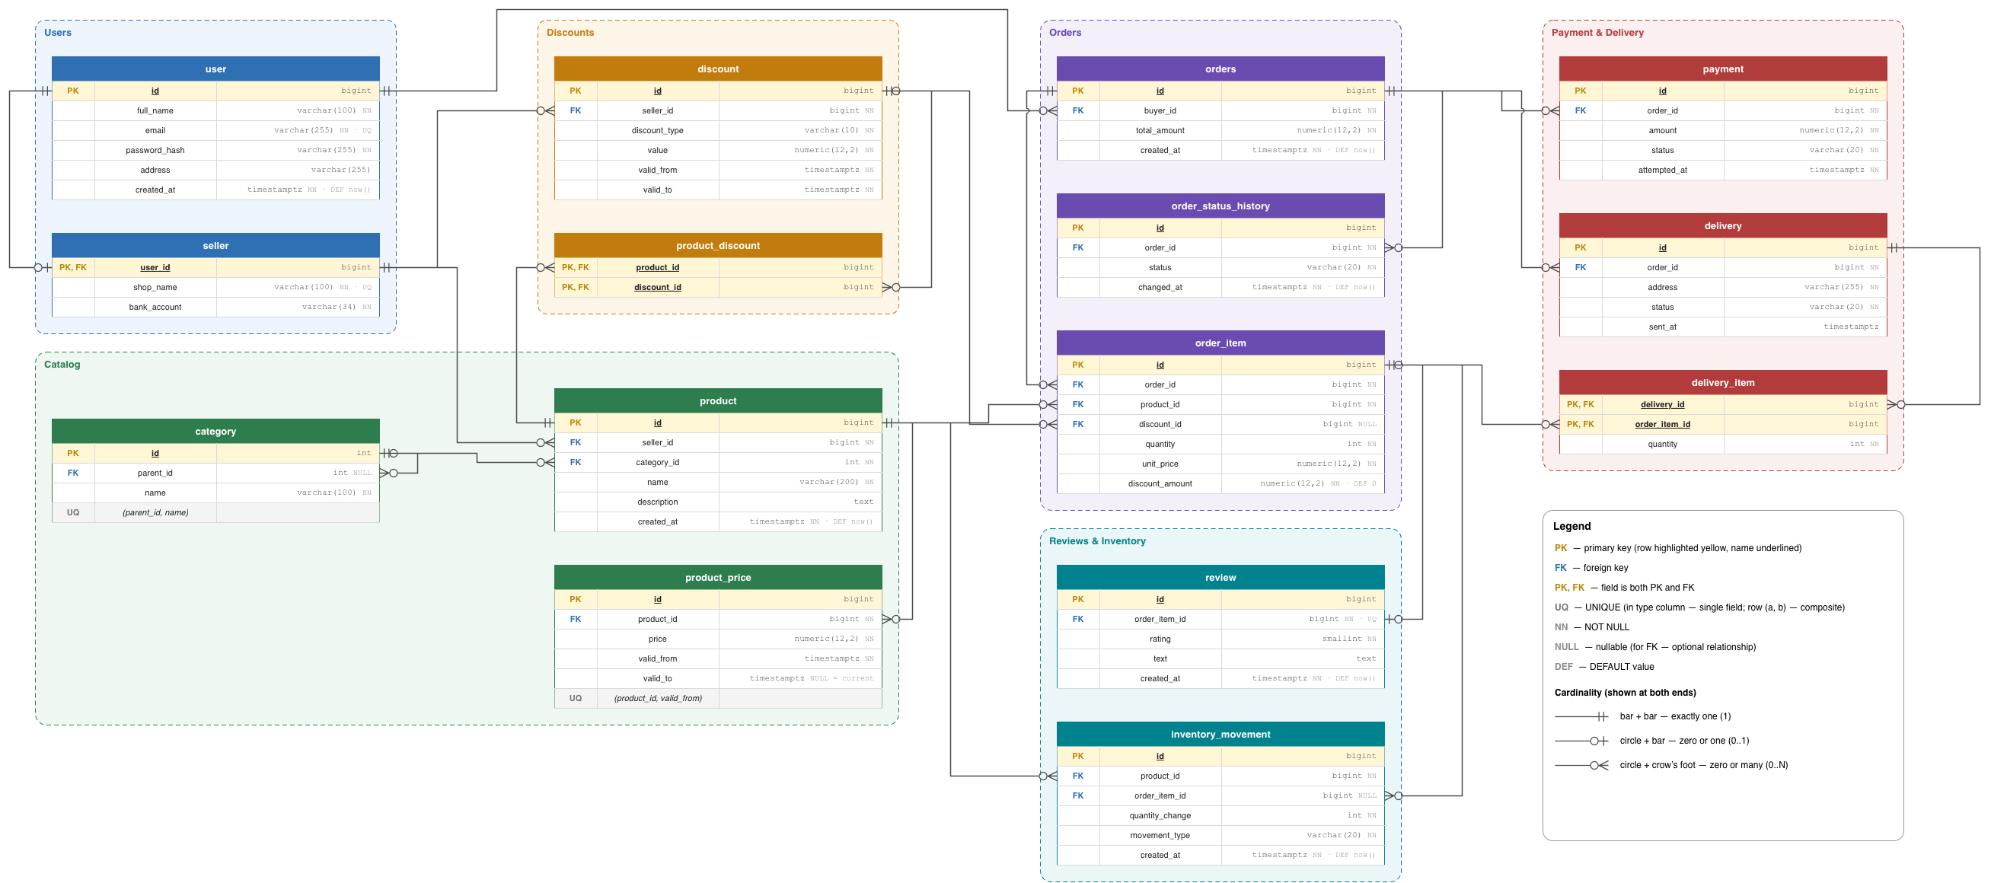
Figure 1. Logical scheme of the database.
Relationship | Cardinality | Why
user – seller | 1 : 0..1 | Only some users have a shop. seller.user_id is PK and FK.
user – orders | 1 : 0..N | A user can place many orders.
seller – product | 1 : 0..N | Each product has one seller.
seller – discount | 1 : 0..N | Each discount belongs to one seller.
category – product | 1 : 0..N | Each product is in one category.
category – category | 0..1 : 0..N | A category can have a parent category (parent_id NULL for roots).
product – product_price | 1 : 0..N | A product has many prices over time.
product – discount | M : N | Solved with the table product_discount.
orders – order_item | 1 : 1..N | An order has at least one item.
product – order_item | 1 : 0..N | A product can be in many order items.
discount – order_item | 0..1 : 0..N | An item may have no discount (discount_id NULL).
order_item – review | 1 : 0..1 | An item can have at most one review (review.order_item_id UNIQUE).
orders – order_status_history / payment / delivery | 1 : 0..N | An order can have many status changes, payment attempts and shipments.
delivery – order_item | M : N | Solved with the table delivery_item.
product – inventory_movement | 1 : 0..N | Each stock change is for one product.
order_item – inventory_movement | 0..1 : 0..N | A sale creates movements linked to the order item. Restocks have order_item_id NULL.

The most difficult part of the design was linking deliveries and order items. One parcel can contain many items, and one item can be split across several parcels, so delivery_item is needed.

2.3 Objects
Table | Why it is a separate table | Normal form
user | Buyers and sellers share one account. | 3NF
seller | Shop data is only for some users. | 3NF
category | The category name is stored once. It can have a parent. | 3NF
product | Product data. Price is not here, because it changes. | 3NF
product_price | Keeps the price history with valid_from and valid_to. | 3NF
discount | One discount can cover many products. | 3NF
product_discount | Links products and discounts (many-to-many). | 3NF
orders | One row per purchase, with the total. | 3NF (total_amount is a snapshot)
order_item | An order has many products, so each product is a row. | 3NF (unit_price and discount_amount are snapshots)
order_status_history | Keeps every status change. | 3NF
payment | An order can have several payment attempts. | 3NF
delivery | An order can ship in several parcels. | 3NF
delivery_item | Links deliveries and order items (many-to-many), with quantity. | 3NF
review | One review per purchased item. | 3NF
inventory_movement | Keeps every stock change. | 3NF

Keys: most tables use a number id as the primary key. Link tables (product_discount, delivery_item) use two columns together.

Field list
Table | Field | Data type | Constraints
user | id | bigint | PK
user | full_name | varchar(100) | NOT NULL
user | email | varchar(255) | NOT NULL, UNIQUE
user | password_hash | varchar(255) | NOT NULL
user | address | varchar(255) | NULL
user | created_at | timestamptz | NOT NULL, DEFAULT now()
seller | user_id | bigint | PK, FK → user.id
seller | shop_name | varchar(100) | NOT NULL, UNIQUE
seller | bank_account | varchar(34) | NOT NULL
category | id | int | PK
category | parent_id | int | FK → category.id, NULL
category | name | varchar(100) | NOT NULL, UNIQUE (parent_id, name)
product | id | bigint | PK
product | seller_id | bigint | FK → seller.user_id, NOT NULL
product | category_id | int | FK → category.id, NOT NULL
product | name | varchar(200) | NOT NULL
product | description | text | NULL
product | created_at | timestamptz | NOT NULL, DEFAULT now()
product_price | id | bigint | PK
product_price | product_id | bigint | FK → product.id, NOT NULL
product_price | price | numeric(12,2) | NOT NULL
product_price | valid_from | timestamptz | NOT NULL, UNIQUE (product_id, valid_from)
product_price | valid_to | timestamptz | NULL (NULL = current price)
discount | id | bigint | PK
discount | seller_id | bigint | FK → seller.user_id, NOT NULL
discount | discount_type | varchar(10) | NOT NULL
discount | value | numeric(12,2) | NOT NULL
discount | valid_from | timestamptz | NOT NULL
discount | valid_to | timestamptz | NULL
product_discount | product_id | bigint | PK, FK → product.id
product_discount | discount_id | bigint | PK, FK → discount.id
orders | id | bigint | PK
orders | buyer_id | bigint | FK → user.id, NOT NULL
orders | total_amount | numeric(12,2) | NOT NULL
orders | created_at | timestamptz | NOT NULL, DEFAULT now()
order_status_history | id | bigint | PK
order_status_history | order_id | bigint | FK → orders.id, NOT NULL
order_status_history | status | varchar(20) | NOT NULL
order_status_history | changed_at | timestamptz | NOT NULL, DEFAULT now()
order_item | id | bigint | PK
order_item | order_id | bigint | FK → orders.id, NOT NULL
order_item | product_id | bigint | FK → product.id, NOT NULL
order_item | discount_id | bigint | FK → discount.id, NULL
order_item | quantity | int | NOT NULL
order_item | unit_price | numeric(12,2) | NOT NULL
order_item | discount_amount | numeric(12,2) | NOT NULL, DEFAULT 0
payment | id | bigint | PK
payment | order_id | bigint | FK → orders.id, NOT NULL
payment | amount | numeric(12,2) | NOT NULL
payment | status | varchar(20) | NOT NULL
payment | attempted_at | timestamptz | NOT NULL
delivery | id | bigint | PK
delivery | order_id | bigint | FK → orders.id, NOT NULL
delivery | address | varchar(255) | NOT NULL
delivery | status | varchar(20) | NOT NULL
delivery | sent_at | timestamptz | NULL
delivery_item | delivery_id | bigint | PK, FK → delivery.id
delivery_item | order_item_id | bigint | PK, FK → order_item.id
delivery_item | quantity | int | NOT NULL
review | id | bigint | PK
review | order_item_id | bigint | FK → order_item.id, NOT NULL, UNIQUE
review | rating | smallint | NOT NULL
review | text | text | NULL
review | created_at | timestamptz | NOT NULL, DEFAULT now()
inventory_movement | id | bigint | PK
inventory_movement | product_id | bigint | FK → product.id, NOT NULL
inventory_movement | order_item_id | bigint | FK → order_item.id, NULL
inventory_movement | quantity_change | int | NOT NULL
inventory_movement | movement_type | varchar(20) | NOT NULL
inventory_movement | created_at | timestamptz | NOT NULL, DEFAULT now()

Example data: product_price
id | product_id | price | valid_from | valid_to
1 | 10 | 49.90 | 2026-01-01 | 2026-06-01
2 | 10 | 44.90 | 2026-06-01 | NULL (current)

2.4 History and integrity
- History: product_price (valid_from / valid_to), discount (valid_from / valid_to), order_status_history, and inventory_movement are only added to, never updated. Each payment attempt is its own row.
- Snapshots: order_item.unit_price, order_item.discount_amount and orders.total_amount keep the amount paid, even if prices change later.
- Integrity: the diagram shows PK, FK, UNIQUE, NOT NULL, NULL and DEFAULT rules.
- CHECK constraints are not shown in the diagram. They should be added for quantity > 0, price ≥ 0, rating between 1 and 5, and valid_to > valid_from.

