# BANK REPORT QUERY

### SUMMARY

#### MAIN KPI’S

**Total applications:**

SELECT COUNT(id) AS total_applications FROM bank_loan_data



**Month-to-day applications (MTD):**

SELECT COUNT(id) AS mtd_applications FROM bank_loan_data

WHERE MONTH(issue_date) = 12 AND YEAR(issue_date) = 2021



**Previous-month-to-day applications (PMTD):**



SELECT COUNT(id) AS pmtd_applications FROM bank_loan_data

WHERE MONTH(issue_date) = 11 AND YEAR(issue_date) = 2021

--------------------------------------------------------------------------------------------------------

**Total funded amount:**



SELECT SUM(loan_amount) AS total_funded_amount FROM bank_loan_data

**MTD total funded amount:**



SELECT SUM(loan_amount) AS mtd_total_funded_amount FROM bank_loan_data

WHERE MONTH(issue_date) = 12 AND YEAR(issue_date) = 2021

**PMTD total funded amount:**



SELECT SUM(loan_amount) AS pmtd_total_funded_amount FROM bank_loan_data

WHERE MONTH(issue_date) = 11 AND YEAR(issue_date) = 2021

--------------------------------------------------------------------------------------------------------

**Total received amount:**



SELECT SUM(total_payment) AS total_received_amount FROM bank_loan_data

**MTD total received amount:**



SELECT SUM(total_payment) AS mtd_total_received_amount FROM bank_loan_data

WHERE MONTH(issue_date) = 12 AND YEAR(issue_date) = 2021

**PMTD total received amount:**



SELECT SUM(total_payment) AS pmtd_total_received_amount FROM bank_loan_data

WHERE MONTH(issue_date) = 11 AND YEAR(issue_date) = 2021

--------------------------------------------------------------------------------------------------------

**Average interest rate:**



SELECT ROUND(AVG(int_rate),4) * 100 AS average_interest_rate FROM bank_loan_data

**Average MTD interest rate:**



SELECT ROUND(AVG(int_rate),4) * 100 AS mtd_average_int_rate FROM bank_loan_data

WHERE MONTH(issue_date) = 12 AND YEAR(issue_date) = 2021

**Average PMTD interest rate:**



SELECT ROUND(AVG(int_rate),4) * 100 AS pmtd_average_int_rate FROM bank_loan_data

WHERE MONTH(issue_date) = 11 AND YEAR(issue_date) = 2021

--------------------------------------------------------------------------------------------------------

**Average DTI:**



SELECT ROUND(AVG(dti),4) * 100 AS average_dti FROM bank_loan_data

**Average MTD DTI:**



SELECT ROUND(AVG(dti),4) * 100 AS mtd_average_dti FROM bank_loan_data

WHERE MONTH(issue_date) = 12 AND YEAR(issue_date) = 2021

**Average PMTD DTI:**



SELECT ROUND(AVG(dti),4) * 100 AS pmtd_average_dti FROM bank_loan_data

WHERE MONTH(issue_date) = 11 AND YEAR(issue_date) = 2021

--------------------------------------------------------------------------------------------------------

#### PERFORMING LOANS

**Performing loans percentage:**



SELECT

(COUNT(CASE WHEN loan_status = 'Current' OR loan_status = 'Fully Paid'

THEN id END) * 100.0) / COUNT(id) AS performing_loans_percentage

FROM bank_loan_data

**Performing loans applications:**



SELECT COUNT(id) AS performing_loans_applications

FROM bank_loan_data

WHERE loan_status = 'Current' OR loan_status = 'Fully Paid'

**Performing loans funded amount:**



SELECT SUM(loan_amount) AS performing_loans_funded_amount

FROM bank_loan_data

WHERE loan_status = 'Current' OR loan_status = 'Fully Paid'

**Performing loans received amount:**



SELECT SUM(total_payment) AS performing_loans_received_amount

FROM bank_loan_data

WHERE loan_status = 'Current' OR loan_status = 'Fully Paid'

--------------------------------------------------------------------------------------------------------

#### NON-PERFORMING LOANS

**Non-performing loans percentage:**



SELECT

(COUNT(CASE WHEN loan_status = 'Charged Off' THEN id END) * 100.0) / COUNT(id) AS non_performing_loans_percentage

FROM bank_loan_data

**Non-performing loans applications:**



SELECT COUNT(id) AS non_performing_loans_applications

FROM bank_loan_data

WHERE loan_status = 'Charged Off'

**Non-performing loans funded amount:**



SELECT SUM(loan_amount) AS non_performing_loans_funded_amount

FROM bank_loan_data

WHERE loan_status = 'Charged Off'

**Non-performing loans received amount:**



SELECT SUM(total_payment) AS non_performing_loans_received_amount

FROM bank_loan_data

WHERE loan_status = 'Charged Off'

--------------------------------------------------------------------------------------------------------

### OVERVIEW

#### MONTH

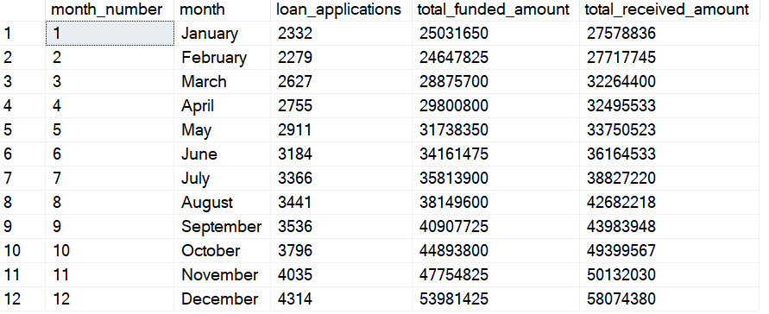

SELECT

MONTH(issue_date) AS month_number,

DATENAME(MONTH, issue_date) AS month,

COUNT(id)AS loan_applications,

SUM(loan_amount) AS total_funded_amount,

SUM(total_payment) AS total_received_amount

FROM bank_loan_data

GROUP BY MONTH(issue_date), DATENAME(MONTH, issue_date)

ORDER BY MONTH(issue_date)

#### STATE

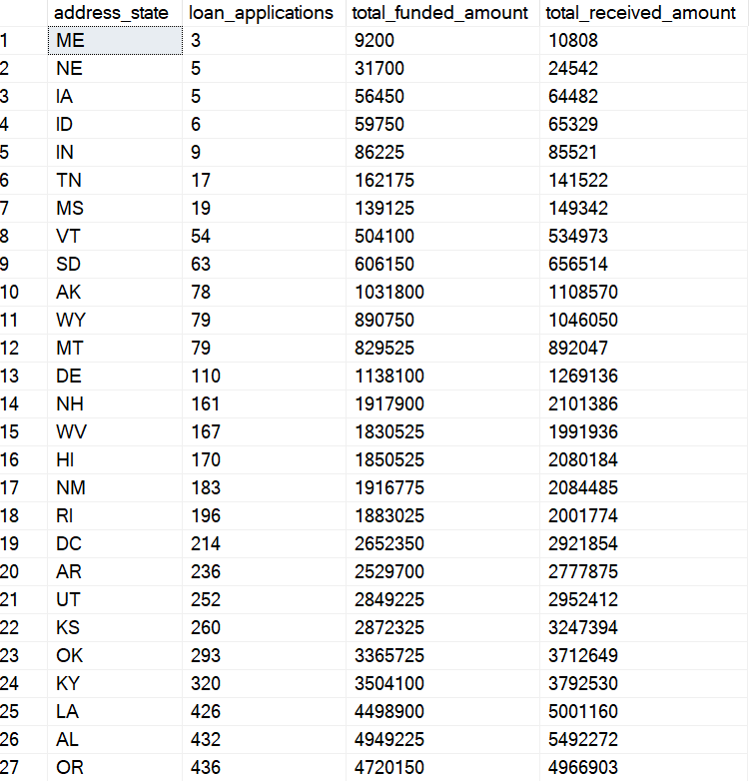

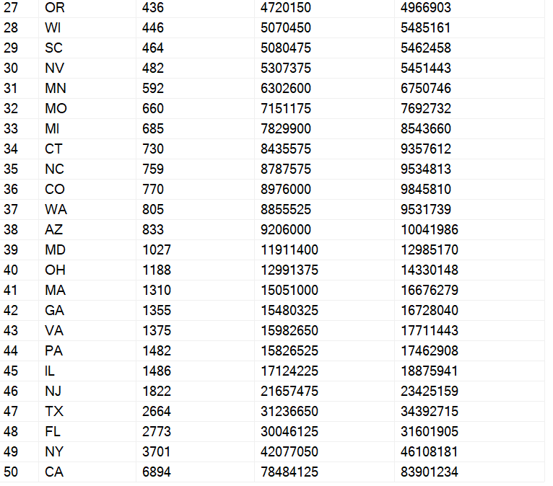

SELECT

address_state,

COUNT(id)AS loan_applications,

SUM(loan_amount) AS total_funded_amount,

SUM(total_payment) AS total_received_amount

FROM bank_loan_data

GROUP BY address_state

ORDER BY COUNT(id) DESC

#### TERM

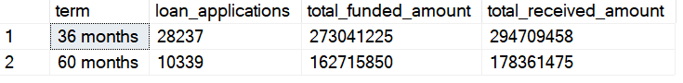

SELECT

term,

COUNT(id)AS loan_applications,

SUM(loan_amount) AS total_funded_amount,

SUM(total_payment) AS total_received_amount

FROM bank_loan_data

GROUP BY term

ORDER BY term

#### EMPLOYMENT

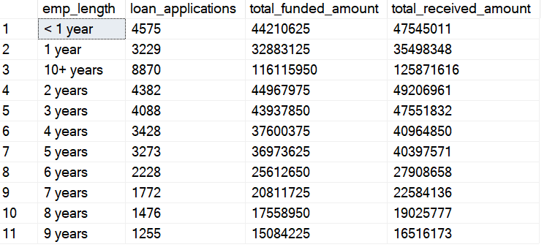

SELECT

emp_length,

COUNT(id)AS loan_applications,

SUM(loan_amount) AS total_funded_amount,

SUM(total_payment) AS total_received_amount

FROM bank_loan_data

GROUP BY emp_length

ORDER BY emp_length

#### PURPOSE

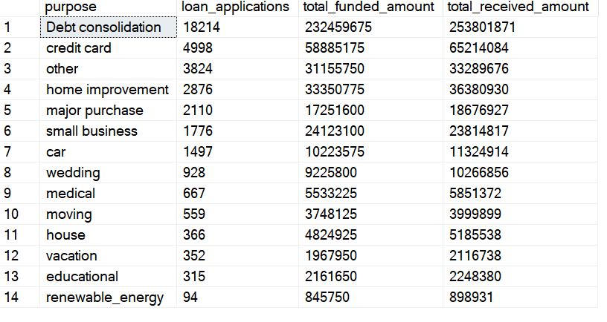

SELECT

purpose,

COUNT(id)AS loan_applications,

SUM(loan_amount) AS total_funded_amount,

SUM(total_payment) AS total_received_amount

FROM bank_loan_data

GROUP BY purpose

ORDER BY COUNT(id) DESC

#### HOME OWNERSHIP

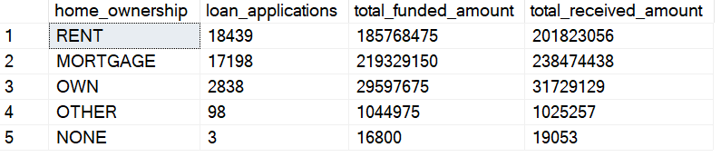

SELECT

home_ownership,

COUNT(id)AS loan_applications,

SUM(loan_amount) AS total_funded_amount,

SUM(total_payment) AS total_received_amount

FROM bank_loan_data

GROUP BY home_ownership

ORDER BY COUNT(id) DESC