Question 4

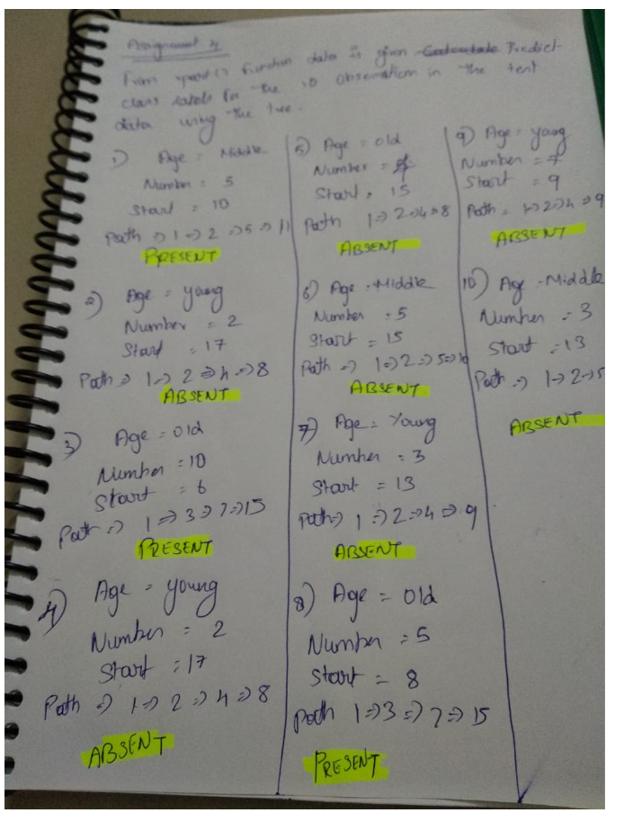

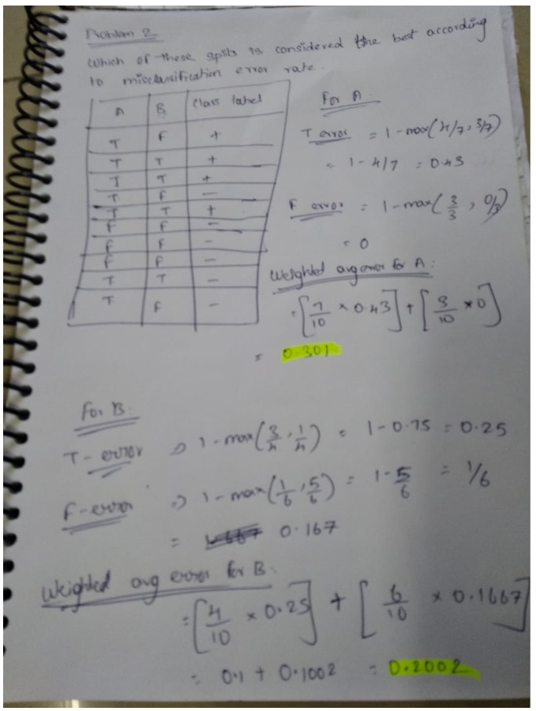

The best split is B = 0.2002

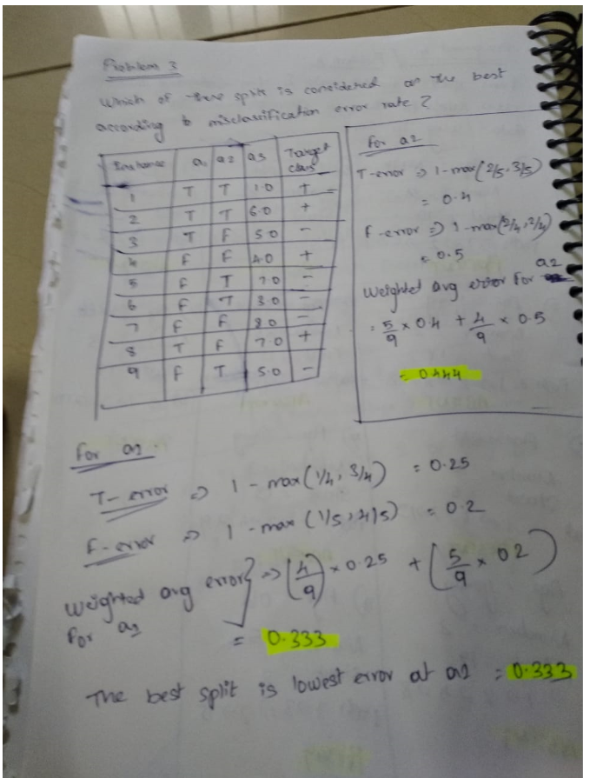

Q6.

You are asked to evaluate the performance of two classification models, M1 and M2. The test set you have chosen contains 26 binary attributes, labeled as ,4 through Z Table below shows the posterior probabilities obtained by applying the models to the test set. (Only the posterior probabilities for the positive class are shown). As this is a two-class problem, P(-) : 1- P(+) and P(-lA, . . . , Z) : I - P(+lA, . . . , Z). Assume that we are mostly interested in detecting instances from the positive class

