Introduction
Overview
GeoServer is an open source software server written in Java that allows users to share and edit geospatial data. Designed for interoperability, it publishes data from any major spatial data source using open standards.
Being a community-driven project, GeoServer is developed, tested, and supported by a diverse group of individuals and organizations from around the world.
GeoServer is the reference implementation of the Open Geospatial Consortium (OGC) Web Feature Service (WFS) and Web Coverage Service (WCS) standards, as well as a high performance certified compliant Web Map Service (WMS). GeoServer forms a core component of the Geospatial Web.
概述
GeoServer是一个用Java编写的开源软件服务器，允许用户共享和编辑地理空间数据。设计用于互操作性，它使用开放标准发布来自任何主要空间数据源的数据。
作为一个社区驱动的项目，GeoServer由来自世界各地的各种个人和组织开发、测试和支持。
GeoServer是开放地理空间联盟(OGC) Web Feature Service(WFS)和Web Coverage Service(WCS)标准的参考实现，也是高性能认证的兼容Web Map Service(WMS)。GeoServer是地理空间网络的核心组成部分。
History
GeoServer was started in 2001 by The Open Planning Project (TOPP), a non-profit technology incubator based in New York. TOPP was creating a suite of tools to enable open democracy and to help make government more transparent. The first of these was GeoServer, which came out of a recognition that a suite of tools to enable citizen involvement in government and urban planning would be greatly enhanced by the ability to share spatial data.
The GeoServer founders envisioned a Geospatial Web, analogous to the World Wide Web. With the World Wide Web, one can search for and download text. With the Geospatial Web, one can search for and download spatial data. Data providers would be able to publish their data straight to this web, and users could directly access it, as opposed to the now indirect and cumbersome methods of sharing data that exist today.
Those involved with GeoServer founded the GeoTools project, an open source GIS Java toolkit. Through GeoTools, support for shapefiles, Oracle databases, ArcSDE integration, and much more was added.
Around the same time as GeoServer was founded, The OpenGIS Consortium (now the Open Geospatial Consortium) was working on the Web Feature Service standard. It specifies a protocol to make spatial data directly available on the web, using GML (Geographic Markup Language), an interoperable data format. A Web Map Service was also created, a protocol for creating and displaying map images created from spatial data.

Other projects became interrelated. Refractions Research created PostGIS, a free and open spatial database, which enabled GeoServer to connect to a free database. Also, MetaCarta originally created OpenLayers, an open source browser-based map viewing utility. Together, these tools have all enhanced the functionality of GeoServer.
GeoServer can now read data from over a dozen spatial data sources and output to many different formats. Now in its second decade, GeoServer is continuing on its mission to make spatial data more accessible to all
历史
GeoServer于2001年由开放计划项目(TOPP)启动，这是一家位于纽约的非盈利技术孵化器。TOPP正在创建一套工具，使开放的民主和帮助政府更加透明。第一个是GeoServer，它认识到共享空间数据的能力将极大地增强公民参与政府和城市规划的一套工具。
GeoServer的创始人设想了一个类似于Web Map Service。有了万维网，人们可以搜索和下载文本。有了地理空间网络，人们可以搜索和下载空间数据。数据提供者可以直接将他们的数据发布到这个web上，用户可以直接访问它，而不是像现在这样使用间接而繁琐的方法来共享数据。
参与GeoServer的人员创建了GeoTools项目，这是一个开源GIS Java工具包。通过地理工具，对shapefile、Oracle数据库、ArcSDE集成的支持，以及更多。
大约在GeoServer成立的同时，OpenGIS联盟(现在的开放地理空间联盟)正在开发Web特性服务标准。它指定了一种协议，使用一种可互操作的数据格式GML(地理标记语言)在web上直接提供空间数据。还创建了一个Web地图服务，这是一个用于创建和显示从空间数据创建的地图图像的协议。
其他项目变得相互关联。折射研究创建了PostGIS，一个免费开放的空间数据库，它使GeoServer能够连接到一个免费的数据库。此外，MetaCarta最初创建了OpenLayers，一个开源的基于浏览器的地图查看工具。这些工具一起增强了GeoServer的功能。
GeoServer现在可以从十多个空间数据源读取数据，并将数据输出到多种不同的格式。现在已经进入第二个十年，GeoServer正在继续执行其使所有人更容易获得空间数据的任务.
Getting involved
GeoServer exists because of the efforts of people like you.
There are many ways that you can help out with the GeoServer project. GeoServer fully embraces an open source development model that does not see a split between user and developer, producer and consumer, but instead sees everyone as a valuable contributor.
参与
GeoServer的存在是因为像你这样的人的努力。
有许多方法可以帮助完成GeoServer项目。GeoServer完全支持开放源码开发模型，这种模型不把用户和开发人员、生产者和消费者分开，而是把每个人都看作有价值的贡献者。
Development
Helping to develop GeoServer is the obvious way to help out. Developers usually start with bug fixes and other small patches, and then move into larger contributions as they learn the system. Our developers are more than happy to help out as you learn and get acquainted. We try our hardest to keep our code clean and well documented.
You can find the project on GitHub. As part of the GitHub model, anyone can submit patches as pull requests, which will be evaluated by the team. To learn more about contributing to the GeoServer codebase, we highly recommend joining the GeoServer developers mailing list. See details below.
发展
帮助开发GeoServer是显而易见的帮助方式。开发人员通常从错误修复和其他小的补丁开始，然后在学习系统的过程中进行更大的贡献。我们的开发人员非常乐意帮助您学习和熟悉。我们尽最大努力保持代码的整洁和良好的文档化。
你可以在GitHub上找到这个项目。作为GitHub模型的一部分，任何人都可以将补丁作为拉请求提交，由团队进行评估。要了解更多关于对GeoServer代码库的贡献，我们强烈建议您加入GeoServer开发人员邮件列表。请参阅下面的详细信息。
Documentation
Another crucial way to help out is with documentation. Whether it’s adding tutorials or just correcting mistakes, every contribution serves to make the project more healthy. And the best part is that you do not need to be a developer in order to contribute.
Our official documentation is contained as part of our official code repository. As part of the GitHub model, anyone can submit patches as pull requests, which will be evaluated by the team.
To learn more about contributing to the GeoServer codebase, we highly recommend joining the GeoServer developers mailing list (see details below). For typos and other small changes, please see our Documentation Guide for how to make quick fixes.
文档
另一个重要的帮助方法是使用文档。无论是添加教程还是纠正错误，每个贡献都有助于使项目更加健康。最重要的是，你不需要成为一名开发人员才能有所贡献。
我们的官方文档包含在我们的官方代码库中。作为GitHub模型的一部分，任何人都可以将补丁作为拉请求提交，由团队进行评估。
要了解更多关于对GeoServer代码库的贡献，我们强烈建议您加入GeoServer开发人员邮件列表(参见下面的详细信息)。对于拼写错误和其他小的更改，请参阅我们的文档指南，了解如何快速修复。

Mailing lists
GeoServer maintains two email lists:
GeoServer Users
GeoServer Developers
The Users list is mainly for those who have questions relating to the use of GeoServer, and the Developers list is for more code-specific and roadmap-based discussions. If you see a question asked on these lists that you know the answer to, please respond!

These lists are publicly available and are a great resource for those who are new to GeoServer, who need a question answered, or who are interested in contributing code.
邮件列表
GeoServer维护两个电子邮件列表:
GeoServer用户
GeoServer开发者
用户列表主要针对那些对使用GeoServer有疑问的人，而开发人员列表则针对更具体的代码和基于路线图的讨论。如果你在这些列表中看到一个你知道答案的问题，请回复!
这些列表是公开的，对于那些刚刚接触GeoServer、需要回答问题或者对贡献代码感兴趣的人来说是一个很好的资源。
IRC
Users can join the IRC channel, #geoserver, on the Freenode network, in order to collaborate in real time. GeoServer developers occasionally will be in this channel as well.
IRC
用户可以在Freenode网络上加入IRC频道#geoserver，以便实时协作。GeoServer开发人员偶尔也会进入这个通道。
Bug tracking
If you have a problem when working with GeoServer, then please let us know through the mailing lists. GeoServer uses JIRA , a bug tracking website, to manage issue reports. In order to submit an issue, you’ll need to create an account first.
Everyone is encouraged to submit patches and, if possible, fix issues as well. We welcome patches through JIRA, or pull requests to GitHub.
Responsible Disclosure
Warning If you encounter a security vulnerability in GeoServer please take care to report the issue in a responsible fashion:
Keep exploit details out of issue report (send to developer/PSC privately – just like you would do for sensitive sample data)
Mark the issue as a vulnerability.
Be prepared to work with Project Steering Committee (PSC) members on a solution
Keep in mind PSC members are volunteers and an extensive fix may require fundraising / resources
If you are not in position to communicate in public please consider commercial support, contacting a PSC member, or reaching us via the Open Source Geospatial Foundation at info@osgeo.org.
缺陷跟踪
如果您在使用GeoServer时遇到问题，请通过邮件列表告诉我们。GeoServer使用JIRA(一个bug跟踪网站)来管理问题报告。为了提交问题，您需要首先创建一个帐户。
我们鼓励每个人都提交补丁，如果可能的话，还可以修复问题。我们欢迎通过JIRA发布补丁，或者将请求拉到GitHub。
负责信息披露
警告:如果您在GeoServer中遇到安全漏洞，请以负责任的方式报告该问题:
在问题报告中保留漏洞细节(私下发送给开发人员/PSC—就像您对敏感样本数据所做的一样)
将该问题标记为漏洞。
准备好与项目指导委员会(PSC)成员一起解决问题
请记住，PSC成员是志愿者，广泛的修复可能需要筹款/资源
如果您不能公开交流，请考虑商业支持，联系PSC成员，或通过info@osgeo.org上的开源地理空间基金会与我们联系。
Translation
We would like GeoServer available in as many languages as possible. The two areas of GeoServer to translate are the text that appears in the Web administration interface and this documentation. If you are interested in helping with this task, please let us know via the mailing lists.
翻译
我们希望GeoServer可以提供尽可能多的语言。要翻译的两个领域是出现在Web管理界面和本文档中的文本。如果您有兴趣帮助完成这项任务，请通过邮件列表告诉我们。
Suggest improvements
If you have suggestions as to how we can make GeoServer better, we would love to hear them. You can contact us through the mailing lists or submit a feature request through JIRA.
提出改进建议
如果你有关于我们如何使地理服务变得更好的建议，我们很乐意听取。您可以通过邮件列表与我们联系，或者通过JIRA提交特性请求。
Spread the word
A further way to help out the GeoServer project is to spread the word. Word-of-mouth information sharing is more powerful than any marketing, and the more people who use our software, the better it will become.
传播这个词
帮助GeoServer项目的另一种方式是传播信息。口碑信息共享比任何营销都更强大，使用我们软件的人越多，它就会变得越好。
Fund improvements
A final way to help out is to push for GeoServer to be used in your own organization. A number of commercial organizations offer support for GeoServer, and any improvements made due to that funding will benefit the entire GeoServer community.
基金的改进
帮助解决这个问题的最后一个方法是推动GeoServer在您自己的组织中使用。一些商业组织提供对GeoServer的支持，由于这种资助而做出的任何改进都将使整个GeoServer社区受益。
License
For complete license details review LICENSE.txt.

GeoServer is free software and is licensed under the GNU General Public License:
GeoServer, open geospatial information server
Copyright (C) 2014-2016 Open Source Geospatial Foundation.
Copyright (C) 2001-2014 OpenPlans
This program is free software; you can redistribute it and/or modify
it under the terms of the GNU General Public License as published by
the Free Software Foundation; either version 2 of the License, or
(at your option) any later version (collectively, "GPL").

As an exception to the terms of the GPL, you may copy, modify, propagate, and distribute a work formed by combining GeoServer with theEMF, XSD and OSHI Libraries, or a work derivative of such a combination, even ifsuch copying, modification, propagation, or distribution would otherwiseviolate the terms of the GPL. Nothing in this exception exempts you fromcomplying with the GPL in all respects for all of the code used otherthan the EMF, XSD and OSHI Libraries. You may include this exception and its grant of permissions when you distribute GeoServer. Inclusion of this notice with such a distribution constitutes a grant of such permissions. If you do not wish to grant these permissions, remove this paragraph from your distribution. "GeoServer" means the GeoServer software licensed under version 2 or any later version of the GPL, or a work based on such software and licensed under the GPL. "EMF, XSD and OSHI Libraries" means Eclipse Modeling Framework Project and XML Schema Definition software distributed by the Eclipse Foundation and the OSHI library, all licensed under the Eclipse Public License Version 1.0 ("EPL"), or a work based on such software and licensed under the EPL.
This program is distributed in the hope that it will be useful,
but WITHOUT ANY WARRANTY; without even the implied warranty of
MERCHANTABILITY or FITNESS FOR A PARTICULAR PURPOSE. See the
GNU General Public License for more details.

You should have received a copy of the GNU General Public License
along with this program; if not, write to the Free Software
Foundation, Inc., 51 Franklin Street, Suite 500, Boston, MA 02110-1335 USA This product includes software developed by the Apache Software Foundation (http://www.apache.org/) licensed under the Apache License Version 2.0 and Apache License Version 1.1.
This product includes software developed by the Eclipse Software Foundation under the Eclipse Public License.
许可证
有关完整的许可证详细信息，请查看license .txt。

GeoServer是自由软件，并在GNU通用公共许可证下授权:

GeoServer，开放的地理空间信息服务器
版权所有(C) 2014-2016开源地理空间基金会。
版权所有(C) 2001-2014开放计划

这个程序是自由软件;您可以重新发布它和/或修改它
它根据GNU通用公共许可证的条款由
自由软件基金会;许可的版本2，或者
(由您选择)任何更新版本(统称“GPL”)。

作为GPL条款的例外，您可以复制、修改、
地学与自然科学相结合形成的作品的传播、传播
EMF、XSD和OSHI库，或者此类组合的工作衍生物，即使
否则，这些复制、修改、传播或分发将会
违反GPL的条款。在这个例外中没有什么能免除你的责任
在所有方面遵守GPL的所有代码使用其他
而不是EMF、XSD和OSHI库。您可以包括此异常及其授权
发布GeoServer时的权限。包括此通知
对于这样的分发，就构成了对这种权限的授予。如果
您不希望授予这些权限，请将此段从
您的发行版。“GeoServer”指经许可的GeoServer软件
在版本2或GPL的任何更新版本下，或基于该版本的作品
软件和许可下的GPL。“EMF、XSD和OSHI库”的意思是
Eclipse建模框架项目和XML模式定义软件
由Eclipse基金会和OSHI库发布，均已获得许可
在Eclipse公共许可1.0版(“EPL”)下，或基于
该等软件已根据《能力标准说明》获发许可证。

分发这个程序是希望它会有用，
但没有任何保证;甚至连默示担保都没有
适销性对特定目的的适销性或适用性看到
GNU通用公共许可证的更多细节。

你应该已经收到GNU通用公共许可证的副本
随着这个项目;如果没有，写自由软件
美国马萨诸塞州波士顿市富兰克林街51号500室Foundation, Inc.，邮编02110-1335
本产品包括由Apache软件基金会(http://www.apache.org/)开发的软件，该软件已获得Apache许可2.0版和Apache许可1.1版的授权。

本产品包括Eclipse软件基金会根据Eclipse公共许可证开发的软件。

Installation
There are many ways to install GeoServer on your system. This section will discuss the various installation paths available.
If using Windows or OS X, we recommend using the installers.
Note To run GeoServer as part of an existing servlet container such as Tomcat, please see the Web archive section.
Warning GeoServer requires a Java 8 environment (JRE) to be installed on your system. This must be done prior to installation.
安装
有许多方法可以在您的系统上安装GeoServer。本节将讨论各种可用的安装路径。
如果使用Windows或OS X，我们建议使用安装程序。
注意，要将GeoServer作为现有servlet容器(如Tomcat)的一部分运行，请参阅Web归档部分。
警告:GeoServer要求在您的系统上安装Java 8环境(JRE)。这必须在安装之前完成。

Windows installer
The Windows installer provides an easy way to set up GeoServer on your system, as it requires no configuration files to be edited or command line settings.

1.Make sure you have a Java Runtime Environment (JRE) installed on your system. GeoServer requires a Java 8 environment. The Oracle JRE is preferred, but OpenJDK has been known to work adequately. You can download JRE 8 from Oracle.
Note Java 9 is not currently supported.
Note For more information about Java and GeoServer, please see the section on Java Considerations.
2.Navigate to the GeoServer Download page.
3.Select the version of GeoServer that you wish to download. If you’re not sure, select Stable.
4.Click the link for the Windows installer.
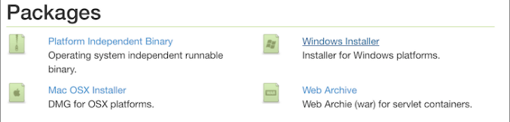
Downloading the Windows installer
5.After downloading, double-click the file to launch.
6.At the Welcome screen, click Next.
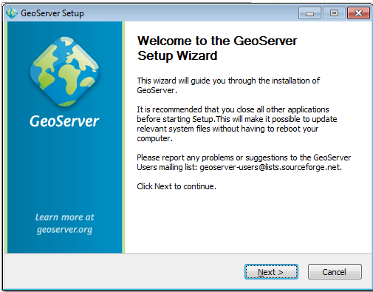
Welcome screen
7.Read the License and click I Agree.
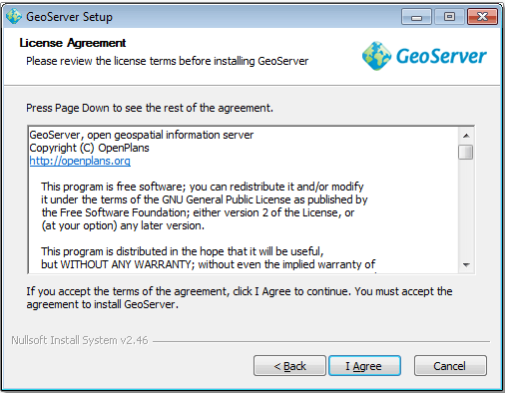
GeoServer license
8.Select the directory of the installation, then click Next.
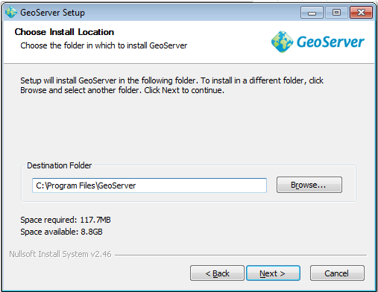
GeoServer install directory
9.Select the Start Menu directory name and location, then click Next.
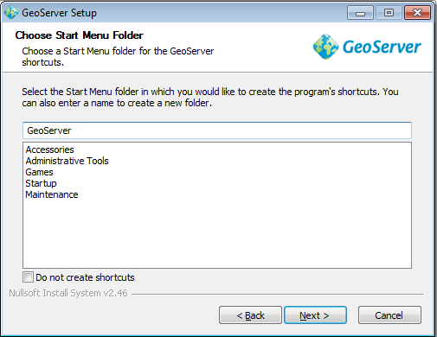
Start menu location
10.Enter the path to a valid Java Runtime Environment (JRE). GeoServer requires a valid JRE in order to run, so this step is required. The installer will inspect your system and attempt to automatically populate this box with a JRE if it is found, but otherwise you will have to enter this path manually. When finished, click Next.
Note A typical path on Windows would be C:\Program Files\Java\jre8.
Note Don’t include the \bin in the JRE path. So if java.exe is located at C:\Program Files (x86)\Java\jre8\bin\java.exe, set the path to be C:\Program Files (x86)\Java\jre8.
Note For more information about Java and GeoServer, please see the section on Java Considerations.
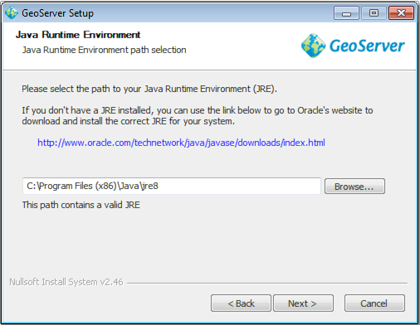
Selecting a valid JRE
- Enter the path to your GeoServer data directory or select the default. If this is your first time using GeoServer, select the Default data directory. When finished, click Next.
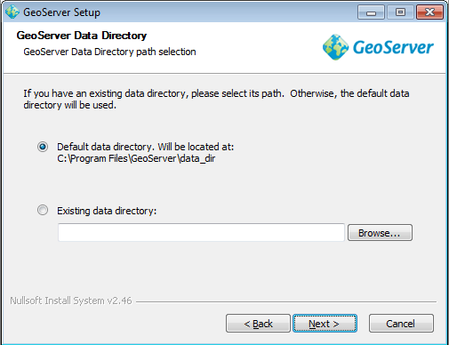
Setting a GeoServer data directory
- Enter the username and password for administration of GeoServer. GeoServer’s Web administration interface requires authentication for management, and what is entered here will become those administrator credentials. The defaults are admin / geoserver. It is recommended to change these from the defaults. When finished, click Next.
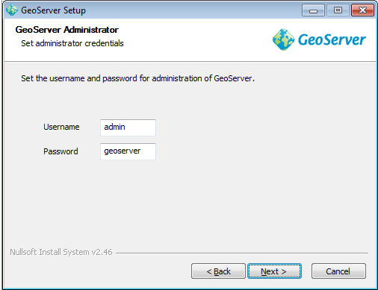
Setting the username and password for GeoServer administration
- Enter the port that GeoServer will respond on. This affects the location of the GeoServer Web administration interface, as well as the endpoints of the GeoServer services such as Web Map Service (WMS) and Web Feature Service (WFS). The default port is 8080, though any valid and unused port will work. When finished, click Next.
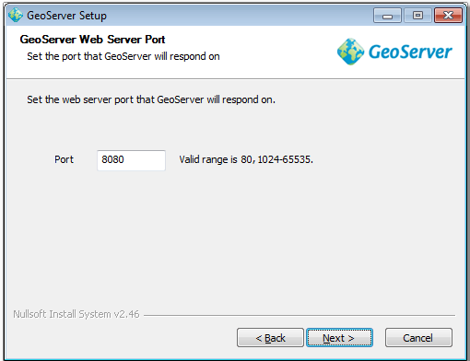
Setting the GeoServer port
14.Select whether GeoServer should be run manually or installed as a service. When run manually, GeoServer is run like a standard application under the current user. When installed as a service, GeoServer is integrated into Windows Services, and thus is easier to administer. If running on a server, or to manage GeoServer as a service, select Install as a service. Otherwise, select Run manually. When finished, click Next.
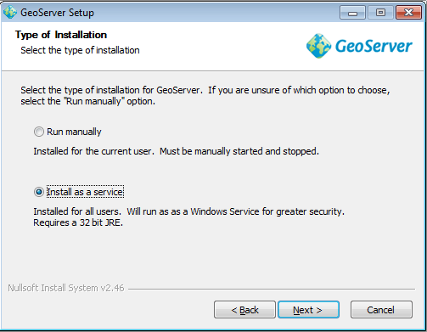
Installing GeoServer as a service
15.Review your selections and click the Back button if any changes need to be made. Otherwise, click Install.
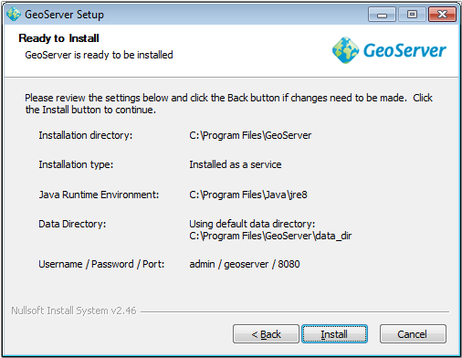
Verifying settings
16.GeoServer will install on your system. When finished, click Finish to close the installer.
17.If you installed GeoServer as a service, it is already running. Otherwise, you can start GeoServer by going to the Start Menu, and clicking Start GeoServer in the GeoServer folder.
18.Navigate to http://localhost:8080/geoserver (or wherever you installed GeoServer) to access the GeoServer Web administration interface.
19.If you see the GeoServer logo, then GeoServer is successfully installed.
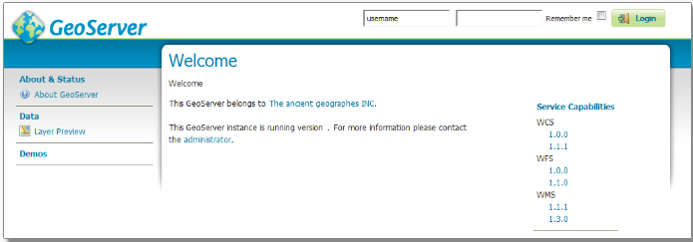
GeoServer installed and running successfully
Uninstallation
GeoServer can be uninstalled in two ways: by running the uninstall.exe file in the directory where GeoServer was installed, or by standard Windows program removal.

Windows安装程序
Windows安装程序提供了在系统上设置GeoServer的简单方法，因为它不需要编辑配置文件或命令行设置。
1.确保在系统上安装了Java运行时环境(JRE)。GeoServer需要Java 8环境。Oracle JRE是首选，但是OpenJDK已经足够工作了。您可以从Oracle下载JRE 8。
注意Java 9目前不受支持。
有关Java和GeoServer的更多信息，请参阅关于Java注意事项的部分。
2.导航到GeoServer下载页面。
3.选择要下载的GeoServer版本。如果不确定，请选择“稳定”。
4.单击Windows安装程序的链接。
Downloading the Windows installer
5下载后，双击文件启动。
6在欢迎屏幕上，单击Next。
Welcome screen
7阅读许可并点击我同意。
GeoServer license

8.选择安装目录，然后单击Next。
GeoServer install directory
- 选择开始菜单目录名和位置，然后单击Next。
Start menu location
10.输入有效Java运行时环境(JRE)的路径。GeoServer需要一个有效的JRE才能运行，因此这一步是必需的。安装程序将检查您的系统，如果找到此框，将尝试用JRE自动填充它，否则您必须手动输入此路径。完成后，单击Next。
在Windows将C:\Program Files\Java\jre8.注意典型的路径
注意，不要在JRE路径中包含\bin。所以如果java.exe位于C:\Program Files (x86)\Java\jre8\bin\java.C:\Program Files (x86)\Java\jre8. exe,设置路径
有关Java和GeoServer的更多信息，请参阅关于Java注意事项的部分。
Selecting a valid JRE
11.输入地理服务器数据目录的路径或选择默认路径。如果这是您第一次使用GeoServer，请选择默认数据目录。完成后，单击Next。
Setting a GeoServer data directory
12.输入地理服务器管理的用户名和密码。GeoServer的Web管理界面需要身份验证来进行管理，这里输入的内容将成为那些管理员凭证。默认是admin / geoserver。建议将这些设置从默认设置更改。完成后，单击Next。

Setting the username and password for GeoServer administration
13.进入GeoServer将响应的端口。这将影响地理服务器Web管理接口的位置，以及地理服务器服务(如Web地图服务(WMS)和Web功能服务(WFS))的端点。默认端口是8080，但是任何有效的和未使用的端口都可以工作。完成后，单击Next。
Setting the GeoServer port
14.选择地理服务器应该手动运行还是作为服务安装。手动运行时，GeoServer就像当前用户下的标准应用程序一样运行。当作为服务安装时，GeoServer集成到Windows服务中，因此更容易管理。如果在服务器上运行，或者将地理服务器作为服务来管理，请选择Install as a service。否则，选择“手动运行”。完成后，单击Next。
Installing GeoServer as a service

15.检查您的选择，如果需要进行任何更改，请单击Back按钮。否则,单击安装。
Verifying settings
16.GeoServer将安装在您的系统上。完成后，单击Finish关闭安装程序。
17.如果您将GeoServer安装为服务，那么它已经在运行了。否则，您可以通过进入“开始”菜单，并在“地理服务器”文件夹中单击“开始地理服务器”来启动地理服务器。
18.导航到http://localhost:8080/geoserver(或安装了geoserver的任何位置)以访问geoserver Web管理界面。
19.如果您看到GeoServer徽标，则表明GeoServer已成功安装。

卸载
可以通过两种方式卸载GeoServer:在安装了GeoServer的目录中运行uninstall.exe文件，或者通过标准的Windows程序删除。
Windows binary
Note For the wizard-based installer on Windows, please see the section on the Windows installer. For installing on Windows with an existing application server such as Tomcat, please see the Web archive section.
An alternate way of installing GeoServer on Windows is to use the platform-independent binary. This version is a GeoServer web application bundled inside Jetty, a lightweight and portable application server. It has the advantages of working very similarly across all operating systems and is very simple to set up.
Windows二进制
有关Windows上基于向导的安装程序，请参阅Windows安装程序一节。要在Windows上安装现有的应用程序服务器(如Tomcat)，请参阅Web archive部分。
在Windows上安装GeoServer的另一种方法是使用平台无关的二进制文件。这个版本是一个捆绑在Jetty内部的GeoServer web应用程序，Jetty是一个轻量级和可移植的应用服务器。它的优点是可以跨所有操作系统进行非常相似的工作，并且设置非常简单。
Installation
1.Make sure you have a Java Runtime Environment (JRE) installed on your system. GeoServer requires a Java 8 environment. The Oracle JRE is preferred, but OpenJDK has been known to work adequately. You can download JRE 8 from Oracle.
Note Java 9 is not currently supported.
Note For more information about Java and GeoServer, please see the section on Java Considerations.
2.Navigate to the GeoServer Download page.
3.Select the version of GeoServer that you wish to download. If you’re not sure, select Stable.
4.Select Platform Independent Binary on the download page.
5.Download the archive and unpack to the directory where you would like the program to be located.
Note A suggested location would be C:\Program Files\GeoServer.
安装
1.确保在系统上安装了Java运行时环境(JRE)。GeoServer需要Java 8环境。Oracle JRE是首选，但是OpenJDK已经足够工作了。您可以从Oracle下载JRE 8。
注意Java 9目前不受支持。
有关Java和GeoServer的更多信息，请参阅关于Java注意事项的部分。
2.导航到GeoServer下载页面。
3.选择要下载的GeoServer版本。如果不确定，请选择“稳定”。
4.在下载页面上选择平台无关的二进制文件。
5.下载存档并解压缩到您希望程序所在的目录。
注意C:\Program Files\GeoServer.建议的位置。
Setting environment variables
You will need to set the JAVA_HOME environment variable if it is not already set. This is the path to your JRE such that %JAVA_HOME%\bin\java.exe exists.
- Navigate to Control Panel ‣ System ‣ Advanced ‣ Environment Variables.
- 2.Under System variables click New.
3.For Variable name enter JAVA_HOME. For Variable value enter the path to your JDK/JRE.
4.Click OK three times.
Note You may also want to set the GEOSERVER_HOME variable, which is the directory where GeoServer is installed, and the GEOSERVER_DATA_DIR variable, which is the location of the GeoServer data directory (which by default is %GEOSERVER_HOME\data_dir). The latter is mandatory if you wish to use a data directory other than the default location. The procedure for setting these variables is identical to setting the JAVA_HOME variable.

设置环境变量
如果还没有设置JAVA_HOME环境变量，则需要设置它。这是到JRE的路径，以便%JAVA_HOME%\bin\java.exe存在。
1.导航到控制面板‣系统‣先进‣环境变量。
2.在“系统变量”下单击“新建”。
3.对于变量名，请输入JAVA_HOME。对于变量值，请输入JDK/JRE的路径。
4.单击OK三次。
注意，您可能还需要设置GEOSERVER_HOME变量，它是安装GeoServer的目录，以及GEOSERVER_DATA_DIR变量，它是GeoServer数据目录的位置(默认情况下是%GEOSERVER_HOME\data_dir)。如果希望使用默认位置以外的数据目录，则必须使用后者。设置这些变量的过程与设置JAVA_HOME变量相同。

Running
1.Note This can be done either via Windows Explorer or the command line.
Navigate to the bin directory inside the location where GeoServer is installed.
2.Run startup.bat. A command-line window will appear and persist. This window contains diagnostic and troubleshooting information. This window must be left open, otherwise GeoServer will shut down.
3.Navigate to http://localhost:8080/geoserver (or wherever you installed GeoServer) to access the GeoServer Web administration interface.
If you see the GeoServer logo, then GeoServer is successfully installed.
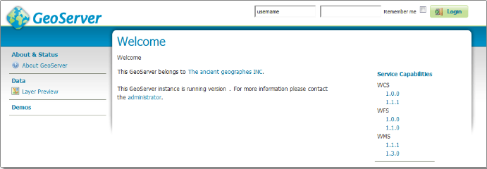
GeoServer installed and running successfully
运行
注意，这可以通过Windows资源管理器或命令行来完成。
1.导航到安装了GeoServer的位置中的bin目录。
startup.bat运行。一个命令行窗口将出现并保持。此窗口包含诊断和故障排除信息。此窗口必2.须保持打开状态，否则地理服务器将关闭。
3.导航到http://localhost:8080/geoserver(或安装了geoserver的任何位置)以访问geoserver Web管理界面。
如果您看到GeoServer徽标，则表明GeoServer已成功安装。
GeoServer installed and running successfully
Stopping
To shut down GeoServer, either close the persistent command-line window, or run the shutdown.bat file inside the bin directory.
Uninstallation
1.Stop GeoServer (if it is running).
2.Delete the directory where GeoServer is installed.

停止
要关闭GeoServer，可以关闭持久命令行窗口，或者在bin目录中运行shutdown.bat文件。
卸载
1.停止地理服务器(如果它正在运行)。
2.删除安装GeoServer的目录。

Mac OS X installer¶
The Mac OS X installer provides an easy way to set up GeoServer on your system, as it requires no configuration files to be edited or command line settings.
1.Make sure you have a Java Runtime Environment (JRE) installed on your system. GeoServer requires a Java 8 environment, and the JRE supplied by OS X is not sufficient. For more information, please see the instructions for installing Oracle Java on OS X.
Note Java 9 is not currently supported.
Note For more information about Java and GeoServer, please see the section on Java Considerations.
2.Navigate to the GeoServer Download page.
3.Select the version of GeoServer that you wish to download. If you’re not sure, select Stable.
4.Click the link for the Mac OS X installer to begin the download.
5.When downloaded, double click on the file to open it.
6.Drag the GeoServer icon to the Applications folder.
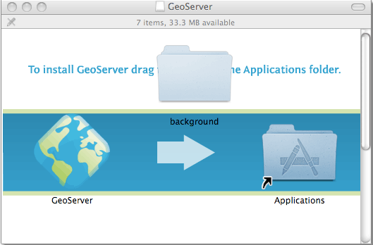
Drag the GeoServer icon to Applications to install

7.Navigate to your Applications folder and double click the GeoServer icon.
8.In the resulting GeoServer console window, start GeoServer by going to Server ‣ Start.
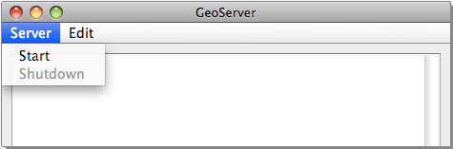
Starting GeoServer
9.The console window will be populated with log entries showing the GeoServer loading process. Once GeoServer is completely started, a browser window will open at http://localhost:8080/geoserver, which is the Web administration interface for GeoServer.

Warning If you encounter the following error during startup, you may have some invalid JAI jars from the default Mac Java install:
java.lang.NoClassDefFoundError: Could not initialize class javax.media.jai.JAI
To fix this error, locate your Java extensions folder (Usually /System/Library/Java/Extensions and/or ~/Library/Java/Extensions), and delete the following jars:

jai_codec-1.1.3.jar
jai_core-1.1.3.jar
jai_imageio-1.1.jar
If you have upgraded your OS from an older version, you may not have permission to delete these jars. In this case, you will first need to disable System Integrity Protection.

Mac OS X安装程序说明
Mac OS X安装程序提供了在系统上设置GeoServer的简单方法，因为它不需要编辑配置文件或命令行设置。
1.确保在系统上安装了Java运行时环境(JRE)。GeoServer需要Java 8环境，OS X提供的JRE是不够的。有关更多信息，请参阅在OS X上安装Oracle Java的说明。
注意Java 9目前不受支持。
有关Java和GeoServer的更多信息，请参阅关于Java注意事项的部分。
2.导航到GeoServer下载页面。
3.选择要下载的GeoServer版本。如果不确定，请选择“稳定”。
4.单击Mac OS X安装程序的链接开始下载。
5.下载后，双击文件打开它。
6.将地理服务器图标拖动到Applications文件夹。
Drag the GeoServer icon to Applications to install

7.导航到您的应用程序文件夹，双击GeoServer图标。
8.在结果GeoServer控制台窗口,开始由将服务器GeoServer‣开始。
Starting GeoServer
9.控制台窗口将填充显示地理服务器加载过程的日志条目。一旦GeoServer完全启动，一个浏览器窗口将在http://localhost:8080/geoserver处打开，这是GeoServer的Web管理界面。
警告:如果你在启动过程中遇到以下错误，你可能会从默认的Mac Java安装中获得一些无效的JAI jar:
java.lang.NoClassDefFoundError: Could not initialize class javax.media.jai.JAI
要修复此错误，请找到Java extensions文件夹(通常是/System/Library/Java/ extensions和/或~/Library/Java/ extensions)，并删除以下jar:
jai_codec-1.1.3.jar
jai_core-1.1.3.jar
jai_imageio-1.1.jar
如果您从旧版本升级了操作系统，您可能没有删除这些jar的权限。在这种情况下，首先需要禁用系统完整性保护。

Mac OS X binary
Note For the installer on OS X, please see the section on the Mac OS X installer. For installing on OS X with an existing application server such as Tomcat, please see the Web archive section.
An alternate way of installing GeoServer on OS X is to use the platform-independent binary. This version is a GeoServer web application bundled inside Jetty, a lightweight and portable application server. It has the advantages of working very similarly across all operating systems and is very simple to set up.
Mac OS X二进制
注意OS X上的安装程序，请参阅Mac OS X安装程序一节。要使用现有的应用服务器(如Tomcat)在OS X上安装，请参阅Web archive部分。
在OS X上安装GeoServer的另一种方法是使用平台无关的二进制文件。这个版本是一个捆绑在Jetty内部的GeoServer web应用程序，Jetty是一个轻量级和可移植的应用服务器。它的优点是可以跨所有操作系统进行非常相似的工作，并且设置非常简单。

Installation
1.Make sure you have a Java Runtime Environment (JRE) installed on your system. GeoServer requires a Java 8 environment, and the JRE supplied by OS X is not sufficient. For more information, please see the instructions for installing Oracle Java on OS X.
Note Java 9 is not currently supported.
Note For more information about Java and GeoServer, please see the section on Java Considerations.
2.Navigate to the GeoServer Download page.
3.Select the version of GeoServer that you wish to download. If you’re not sure, select Stable.
4.Select Platform Independent Binary on the download page.
5.Download the archive and unpack to the directory where you would like the program to be located.
Note A suggested location would be /usr/local/geoserver.
6.Add an environment variable to save the location of GeoServer by typing the following command:
echo "export GEOSERVER_HOME=/usr/local/geoserver" >> ~/.profile
. ~/.profile
7.Make yourself the owner of the geoserver folder, by typing the following command:
sudo chown -R <USERNAME> /usr/local/geoserver/
where USER_NAME is your user name
8.Start GeoServer by changing into the directory geoserver/bin and executing the startup.sh script:
cd geoserver/bin
sh startup.sh
Warning If you encounter the following error during startup, you may have some invalid JAI jars from the default Mac Java install:
java.lang.NoClassDefFoundError: Could not initialize class javax.media.jai.JAI
To fix this error, locate your Java extensions folder (Usually /System/Library/Java/Extensions and/or ~/Library/Java/Extensions), and delete the following jars:
jai_codec-1.1.3.jar
jai_core-1.1.3.jar
jai_imageio-1.1.jar
If you have upgraded your OS from an older version, you may not have permission to delete these jars. In this case, you will first need to disable System Integrity Protection.
9.In a web browser, navigate to http://localhost:8080/geoserver.
If you see the GeoServer logo, then GeoServer is successfully installed.
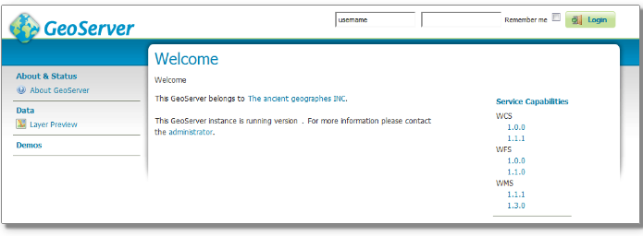
GeoServer installed and running successfully

To shut down GeoServer, either close the persistent command-line window, or run the shutdown.sh file inside the bin directory.
Uninstallation
1.Stop GeoServer (if it is running).
2.Delete the directory where GeoServer is installed.

安装
1.确保在系统上安装了Java运行时环境(JRE)。GeoServer需要Java 8环境，OS X提供的JRE是不够的。有关更多信息，请参阅在OS X上安装Oracle Java的说明。
注意Java 9目前不受支持。
有关Java和GeoServer的更多信息，请参阅关于Java注意事项的部分。
2.导航到GeoServer下载页面。
3.选择要下载的GeoServer版本。如果不确定，请选择“稳定”。
4.在下载页面上选择平台无关的二进制文件。
5.下载存档并解压缩到您希望程序所在的目录。
注意，建议的位置是/usr/local/geoserver。
6.添加一个环境变量来保存地理服务器的位置，输入以下命令:
echo "export GEOSERVER_HOME=/usr/local/geoserver" >> ~/.profile
. ~/.profile
- 通过输入以下命令，使您自己成为geoserver文件夹的所有者:
sudo chown -R <USERNAME> /usr/local/geoserver/
USER_NAME是您的用户名吗
8.通过切换到GeoServer /bin目录并执行startup.sh脚本启动GeoServer:
cd geoserver / bin
sh startup.sh

警告:如果你在启动过程中遇到以下错误，你可能会从默认的Mac Java安装中获得一些无效的JAI jar:
java.lang.NoClassDefFoundError: Could not initialize class javax.media.jai.JAI
要修复此错误，请找到Java extensions文件夹(Usually /System/Library/Java/Extensions and/or ~/Library/Java/Extensions)，并删除以下jar:
jai_codec-1.1.3.jar
jai_core-1.1.3.jar
jai_imageio-1.1.jar

如果您从旧版本升级了操作系统，您可能没有删除这些jar的权限。在这种情况下，首先需要禁用系统完整性保护。
9.在web浏览器中，导航到http://localhost:8080/geoserver。
如果您看到GeoServer徽标，则表明GeoServer已成功安装。
GeoServer installed and running successfully
要关闭GeoServer，可以关闭持久命令行窗口，或者在bin目录中运行shutdown.sh文件。
卸载
1.停止地理服务器(如果它正在运行)。
2.删除安装GeoServer的目录。

Linux binary¶
Note For installing on Linux with an existing application server such as Tomcat, please see the Web archive section.
The platform-independent binary is a GeoServer web application bundled inside Jetty, a lightweight and portable application server. It has the advantages of working very similarly across all operating systems and is very simple to set up.

Installation
1.Make sure you have a Java Runtime Environment (JRE) installed on your system. GeoServer requires a Java 8 environment. The Oracle JRE is preferred, but OpenJDK has been known to work adequately. You can download JRE 8 from Oracle.
Note Java 9 is not currently supported.
2.Select the version of GeoServer that you wish to download. If you’re not sure, select Stable.
3.Select Platform Independent Binary on the download page.
4.Download the archive and unpack to the directory where you would like the program to be located.
Note A suggested location would be /usr/share/geoserver.
- Add an environment variable to save the location of GeoServer by typing the following command:
echo "export GEOSERVER_HOME=/usr/share/geoserver" >> ~/.profile
. ~/.profile
6.Make yourself the owner of the geoserver folder. Type the following command in the terminal window, replacing USER_NAME with your own username :
sudo chown -R USER_NAME /usr/share/geoserver/
7.Start GeoServer by changing into the directory geoserver/bin and executing the startup.sh script:
cd geoserver/bin
sh startup.sh
8.In a web browser, navigate to http://localhost:8080/geoserver.
If you see the GeoServer logo, then GeoServer is successfully installed.
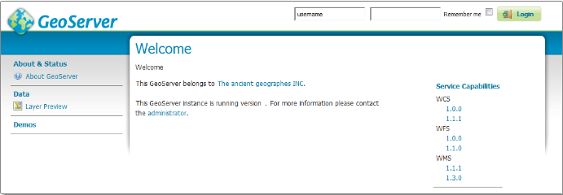
GeoServer installed and running successfully
9.To shut down GeoServer, either close the persistent command-line window, or run the shutdown.sh file inside the bin directory.
Uninstallation
1.Stop GeoServer (if it is running).
2.Delete the directory where GeoServer is installed.

Linux二进制程序¶
要在Linux上安装现有的应用程序服务器(如Tomcat)，请参阅Web archive部分。
独立于平台的二进制文件是一个绑定在Jetty内部的GeoServer web应用程序，Jetty是一个轻量级、可移植的应用服务器。它的优点是可以跨所有操作系统进行非常相似的工作，并且设置非常简单。
安装
1.确保在系统上安装了Java运行时环境(JRE)。GeoServer需要Java 8环境。Oracle JRE是首选，但是OpenJDK已经足够工作了。您可以从Oracle下载JRE 8。
注意Java 9目前不受支持。
2.选择要下载的GeoServer版本。如果不确定，请选择“稳定”。
3.在下载页面上选择平台无关的二进制文件。
4.下载存档并解压缩到您希望程序所在的目录。
注意，建议的位置是/usr/share/ geoservere。
5.添加一个环境变量来保存地理服务器的位置，输入以下命令:
echo "export GEOSERVER_HOME=/usr/share/geoserver" >> ~/.profile
. ~/.profile
6.让您自己成为geoserver文件夹的所有者。在终端窗口中输入以下命令，将USER_NAME替换为您自己的用户名:
sudo chown -R USER_NAME /usr/share/geoserver/
7.通过切换到GeoServer /bin目录并执行startup.sh脚本启动GeoServer:
cd geoserver / bin
sh startup.sh
8.在web浏览器中，导航到http://localhost:8080/geoserver。
如果您看到GeoServer徽标，则表明GeoServer已成功安装。
GeoServer installed and running successfully
- 要关闭GeoServer，可以关闭持久命令行窗口，或者在bin目录中运行shutdown.sh文件。
卸载

1.停止地理服务器(如果它正在运行)。
2.删除安装GeoServer的目录。

Web archive
GeoServer is packaged as a standalone servlet for use with existing application servers such as Apache Tomcat and Jetty.

Note GeoServer has been mostly tested using Tomcat, and so is the recommended application server. GeoServer requires a newer version of Tomcat (7.0.65 or later) that implements Servlet 3 and annotation processing. Other application servers have been known to work, but are not guaranteed.

Web存档
GeoServer被打包为一个独立的servlet，与现有的应用服务器(如Apache Tomcat和Jetty)一起使用。
注意:GeoServer主要使用Tomcat进行了测试，推荐使用的应用服务器也是如此。GeoServer需要更新版本的Tomcat(7.0.65或更高版本)来实现Servlet 3和注释处理。已知其他应用服务器可以工作，但不能保证可以工作。Web存档
GeoServer被打包为一个独立的servlet，与现有的应用服务器(如Apache Tomcat和Jetty)一起使用。
注意:GeoServer主要使用Tomcat进行了测试，推荐使用的应用服务器也是如此。GeoServer需要更新版本的Tomcat(7.0.65或更高版本)来实现Servlet 3和注释处理。已知其他应用服务器可以工作，但不能保证可以工作。

Installation
1.Make sure you have a Java Runtime Environment (JRE) installed on your system. GeoServer requires a Java 8 environment. The Oracle JRE is preferred, but OpenJDK has been known to work adequately. You can download JRE 8 from Oracle.
Note Java 9 is not currently supported.
Note For more information about Java and GeoServer, please see the section on Java Considerations.
2.Navigate to the GeoServer Download page.
3.Select Web Archive on the download page.
4.Download and unpack the archive.
5.Deploy the web archive as you would normally. Often, all that is necessary is to copy the geoserver.war file to the application server’s webapps directory, and the application will be deployed.
Note A restart of your application server may be necessary.

Running
Use your container application’s method of starting and stopping webapps to run GeoServer.
To access the Web administration interface, open a browser and navigate to http://SERVER/geoserver . For example, with Tomcat running on port 8080 on localhost, the URL would be http://localhost:8080/geoserver.

安装
1.确保在系统上安装了Java运行时环境(JRE)。GeoServer需要Java 8环境。Oracle JRE是首选，但是OpenJDK已经足够工作了。您可以从Oracle下载JRE 8。
注意Java 9目前不受支持。
有关Java和GeoServer的更多信息，请参阅关于Java注意事项的部分。
2.导航到GeoServer下载页面。
3.在下载页面上选择Web Archive。
4.下载并解压存档。
5.像往常一样部署web归档。通常，所有需要做的就是复制地理服务器。将war文件部署到应用服务器的webapps目录，并将部署应用程序。
注意，可能需要重新启动应用服务器。

运行
使用容器应用程序启动和停止webapps的方法来运行GeoServer。
要访问Web管理界面，请打开浏览器并导航到http://SERVER/geoserver。例如，Tomcat在本地主机的8080端口上运行时，URL应该是http://localhost:8080/geoserver。

Uninstallation
1.Stop the container application.
2.Remove the GeoServer webapp from the container application’s webapps directory. This will usually include the geoserver.war file as well as a geoserver directory.
卸载
1.停止容器应用程序。
2.从容器应用程序的webapps目录中删除GeoServer webapp。这通常包括地理服务器。以及一个地理服务器目录。

Upgrading existing versions¶
Warning Be aware that some upgrades are not reversible, meaning that the data directory may be changed so that it is no longer compatible with older versions of GeoServer. See Migrating a data directory between versions for more details.
The general GeoServer upgrade process is as follows:
1.Back up the current data directory. This can involve simply copying the directory to an additional place.
2.Make sure that the current data directory is external to the application (not located inside the application file structure).
3.Uninstall the old version and install the new version.
Note Alternately, you can install the new version directly over top of the old version.
4.Make sure that the new version continues to point to the same data directory used by the previous version

¶升级现有版本
警告:请注意，有些升级是不可逆的，这意味着数据目录可能会被更改，从而不再与旧版本的GeoServer兼容。有关详细信息，请参阅在版本之间迁移数据目录。
通用的地理服务器升级过程如下:
1.备份当前数据目录。这可以简单地将目录复制到其他位置。
2.确保当前数据目录位于应用程序外部(不位于应用程序文件结构内部)。
3.卸载旧版本并安装新版本。
另外，您可以直接在旧版本的基础上安装新版本。
4.确保新版本继续指向前一个版本使用的相同数据目录。

GeoServer 2.16.2 User Manual » Installation » Upgrading existing versions
modulesnext|previous|
Upgrading existing versions
Warning Be aware that some upgrades are not reversible, meaning that the data directory may be changed so that it is no longer compatible with older versions of GeoServer. See Migrating a data directory between versions for more details.
The general GeoServer upgrade process is as follows:
Back up the current data directory. This can involve simply copying the directory to an additional place.
Make sure that the current data directory is external to the application (not located inside the application file structure).
Uninstall the old version and install the new version.
Note Alternately, you can install the new version directly over top of the old version.
Make sure that the new version continues to point to the same data directory used by the previous version.
Notes on upgrading specific versions
GeoJSON encoding (GeoServer 2.6 and newer)
As of GeoServer 2.6, the GeoJSON produced by the WFS service no longer uses a non-standard encoding for the CRS. To reenable this behavior for compatibility purposes, set GEOSERVER_GEOJSON_LEGACY_CRS=true as a system property, context parameter, or environment variable.
JTS Type Bindings (GeoServer 2.14 and newer)
As of GeoServer 2.14, the output produced by REST featuretype and structured coverage requests using a different package name (org.locationtech instead of com.vividsolutions) for geometry type bindings, due to the upgrade to JTS (Java Topology Suite) 1.16.0. For example:
Before:

...
<attribute>
<name>geom</name>
<minOccurs>0</minOccurs>
<maxOccurs>1</maxOccurs>
<nillable>true</nillable>
<binding>com.vividsolutions.jts.geom.Point</binding>
</attribute>
...
After:

...
<attribute>
<name>geom</name>
<minOccurs>0</minOccurs>
<maxOccurs>1</maxOccurs>
<nillable>true</nillable>
<binding>org.locationtech.jts.geom.Point</binding>
</attribute>
...
Any REST clients which rely on this binding information should be updated to support the new names.

GeoServer 2.16.2用户手册»安装»升级现有版本
以前modulesnext | |
升级现有的版本
警告:请注意，有些升级是不可逆的，这意味着数据目录可能会被更改，从而不再与旧版本的GeoServer兼容。有关详细信息，请参阅在版本之间迁移数据目录。
通用的地理服务器升级过程如下:
备份当前数据目录。这可以简单地将目录复制到其他位置。
确保当前数据目录位于应用程序外部(不位于应用程序文件结构内部)。
卸载旧版本并安装新版本。
另外，您可以直接在旧版本的基础上安装新版本。
确保新版本继续指向前一个版本使用的相同数据目录。
升级特定版本的注意事项
GeoJSON编码(geerver 2.6及更新版本)
从geerver 2.6开始，WFS服务生成的GeoJSON不再使用CRS的非标准编码。为了实现兼容性，需要重新启用此行为，将GEOSERVER_GEOJSON_LEGACY_CRS=true设置为系统属性、上下文参数或环境变量。
JTS类型绑定(GeoServer 2.14及更新版本)
从GeoServer 2.14开始，REST功能类型和结构化覆盖请求使用不同的包名(org)生成的输出。由于升级到JTS (Java拓扑套件)1.16.0，所以几何学类型绑定使用locationtech而不是com. solutions)。例如:
Before:
...
<attribute>
<name>geom</name>
<minOccurs>0</minOccurs>
<maxOccurs>1</maxOccurs>
<nillable>true</nillable>
<binding>com.vividsolutions.jts.geom.Point</binding>
</attribute>
...
After:

...
<attribute>
<name>geom</name>
<minOccurs>0</minOccurs>
<maxOccurs>1</maxOccurs>
<nillable>true</nillable>
<binding>org.locationtech.jts.geom.Point</binding>
</attribute>
...
任何依赖于此绑定信息的REST客户机都应该进行更新以支持新名称。

Getting started
This section contains short tutorials for common tasks in GeoServer to get new users using the system quickly.

Using the web administration interface
Publishing a shapefile
Publishing a PostGIS table

开始
本节包含一些简短的教程，介绍在GeoServer中常见的任务，以便让新用户快速使用系统。
使用web管理界面
发布一个shapefile
发布PostGIS表

Using the web administration interface
GeoServer has a browser-based web administration interface application used to configure all aspects of GeoServer, from adding and publishing data to changing service settings.
The web admin interface is accessed via a web browser at:
http://<host>:<port>/geoserver
For a default installation on a server the link is:
http://localhost:8080/geoserver
When the application starts, it displays the Welcome page.
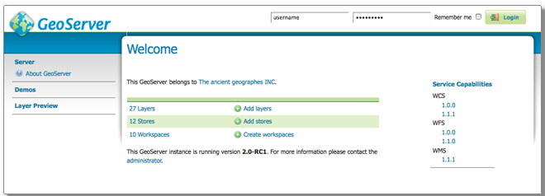
Welcome Page

使用web管理界面
GeoServer有一个基于浏览器的web管理界面应用程序，用于配置GeoServer的所有方面，从添加和发布数据到更改服务设置。
网页管理界面可透过网页浏览器(网址:
http://<host>:<port>/geoserver
对于服务器上的默认安装，链接是:
http://localhost:8080/geoserver
当应用程序启动时，它显示欢迎页面。
Welcome Page

Logging In
1.In order to change any server settings or configure data, a user must first be authenticated.
Navigate to the upper right of the web interface to log into GeoServer. The default administration credentials are:
User name: admin
Password: geoserver
Note These can be changed in the Security section.
Login
2.Once logged in, the Welcome screen changes to show the available admin functions. These are primarily shown in the menus on the left side of the page.

登录
1.要更改任何服务器设置或配置数据，必须首先对用户进行身份验证。
导航到web界面的右上角以登录到GeoServer。默认的管理凭证是:
用户名:admin
密码:geoserver
注意，这些可以在安全部分中更改。
Login
登录后，欢迎屏幕将更改为显示可用的管理功能。这些主要显示在页面左侧的菜单中。
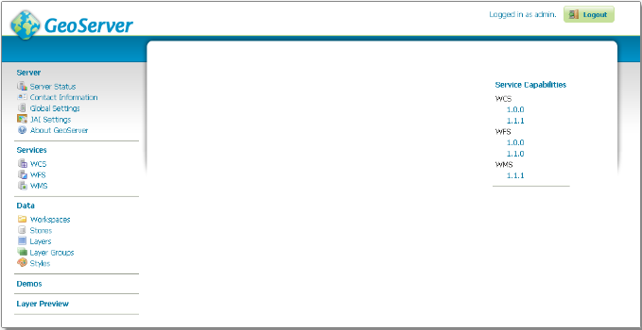
Additional options when logged in

Layer Preview
The Layer Preview page allows you to quickly view the output of published layers.
- Click the Layer Preview link on the menu to go to this page.
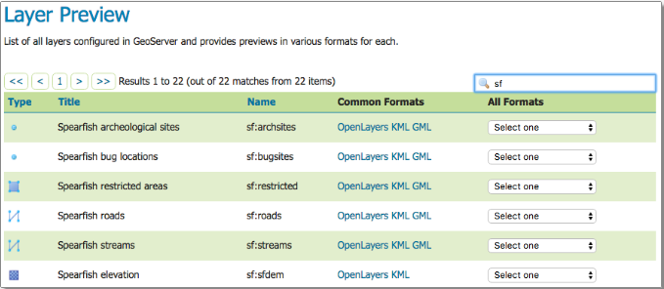
2.From here, you can find the layer you’d like to preview and click a link for an output format. Click the OpenLayers link for a given layer and the view will display.
3.To sort a column alphabetically, click the column header.
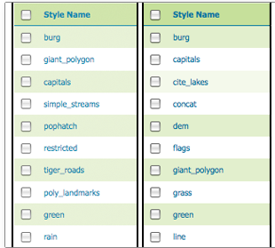
Unsorted (left) and sorted (right) columns
4.Searching can be used to filter the number of items displayed. This is useful for working with data types that contain a large number of items. To search data type items, enter the search string in the search box and click Enter. GeoServer will search the data type for items that match your query, and display a list view showing the search results.
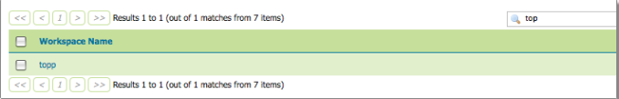
Search results for the query “top” on the Workspace page

Note Sorting and searching apply to all data configuration pages.
Note For more information, please see the Layer Preview section.

层预览
层预览页面允许您快速查看已发布层的输出。
- 点击菜单上的图层预览链接进入这个页面。
- 从这里，您可以找到您想预览的层，并单击输出格式的链接。单击给定层的OpenLayers链接，视图就会显示出来。
- 若要按字母顺序对列排序，请单击列标题。
Unsorted (left) and sorted (right) columns
- 搜索可用于筛选显示的项数。这对于处理包含大量项的数据类型非常有用。要搜索数据类型项，请在搜索框中输入搜索字符串并单击enter。GeoServer将搜索与您的查询匹配的数据类型，并显示显示搜索结果的列表视图。

Search results for the query “top” on the Workspace page

注意:排序和搜索适用于所有数据配置页面。
注:更多信息，请参阅层预览部分。

Publishing a shapefile
This tutorial walks through the steps of publishing a Shapefile with GeoServer.
Note This tutorial assumes that GeoServer is running at http://localhost:8080/geoserver.
Data preparation
First let’s gather that the data that we’ll be publishing.
1.Download the file nyc_roads.zip. This archive contains a shapefile of roads from New York City that will be used during in this tutorial.
2.Unzip the nyc_roads.zip into a new directory named nyc_roads. The archive contains the following four files:
nyc_roads.shp
nyc_roads.shx
nyc_roads.dbf
nyc_roads.prj
3.Move the nyc_roads directory into <GEOSERVER_DATA_DIR>/data, where <GEOSERVER_DATA_DIR> is the root of the GeoServer data directory. If no changes have been made to the GeoServer file structure, the path is geoserver/data_dir/data/nyc_roads.

发布一个shapefile
本教程介绍了使用GeoServer发布Shapefile的步骤。
注意，本教程假设GeoServer在http://localhost:8080/geoserver上运行。
数据准备
首先让我们收集将要发布的数据。
1.下载文件nyc_roads.zip。这个归档文件包含一个来自纽约市的道路形状文件，将在本教程中使用。
2.将nyc_roads.zip解压缩到一个名为nyc_roads的新目录中。档案包括以下四个档案:
nyc_roads.shp
nyc_roads.shx
nyc_roads.dbf
nyc_roads.prj
3.将nyc_roads目录移动到/data，其中是GeoServer数据目录的根。如果没有对GeoServer文件结构进行更改，则路径为GeoServer /data_dir/data/nyc_roads。

Creating a new workspace
The next step is to create a workspace for the shapefile. A workspace is a container used to group similar layers together.
Note This step is optional if you’d like to use an existing workspace. Usually, a workspace is created for each project, which can include stores and layers that are related to each other.
1.In a web browser, navigate to http://localhost:8080/geoserver.
2.Log into GeoServer as described in the Logging In section.
3.Navigate to Data ‣ Workspaces.
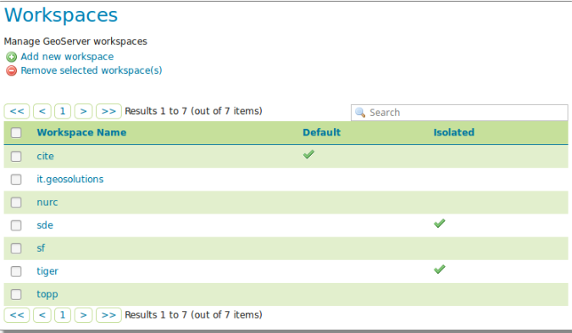
Workspaces page
4.Click the Add new workspace button.
5.You will be prompted to enter a workspace Name and Namespace URI.
6.Enter the Name as nyc and the Namespace URI as http://geoserver.org/nyc.
Note A workspace name is a identifier describing your project. It must not exceed ten characters or contain spaces. A Namespace URI (Uniform Resource Identifier) can usually be a URL associated with your project with an added trailing identifier indicating the workspace. The Namespace URI filed does not need to resolve to an actual valid web address.
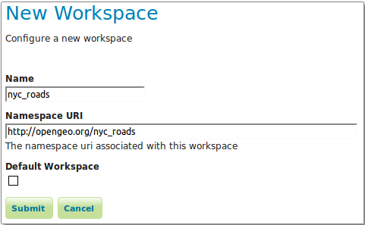
nyc workspace
7.Click the Submit button. The nyc workspace will be added to the Workspaces list.

创建一个新的工作区
下一步是为shapefile创建一个工作区。工作区是一个容器，用于将类似的层分组在一起。
注意，如果您想使用现有的工作空间，此步骤是可选的。通常，会为每个项目创建一个工作区，其中包括相互关联的存储和层。
1.在web浏览器中，导航到http://localhost:8080/geoserver。
2.按照日志一节中的描述登录到GeoServer。
3.导航到数据‣工作区。
Workspaces page

4.单击Add new workspace按钮。
5.系统将提示您输入工作区名称和名称空间URI。
6.输入名称nyc和名称空间URI http://geoserver.org/nyc。
注意，工作区名称是描述项目的标识符。它不能超过十个字符或包含空格。名称空间URI(统一资源标识符)通常可以是一个与您的项目相关联的URL，并带有一个指示工作区的附加标识符。名称空间URI不需要解析为实际有效的web地址。
nyc workspace
7.单击Submit按钮。nyc工作区将被添加到工作区列表中。

Create a store
Once the workspace is created, we are ready to add a new store. The store tells GeoServer how to connect to the shapefile.
1.Navigate to Data‣Stores.
2.You should see a list of stores, including the type of store and the workspace that the store belongs to.
3.In order to add the shapefile, you need to create a new store. Click the Add new Store button. You will be redirected to a list of the data sources supported by GeoServer. Note that the data sources are extensible, so your list may look slightly different.
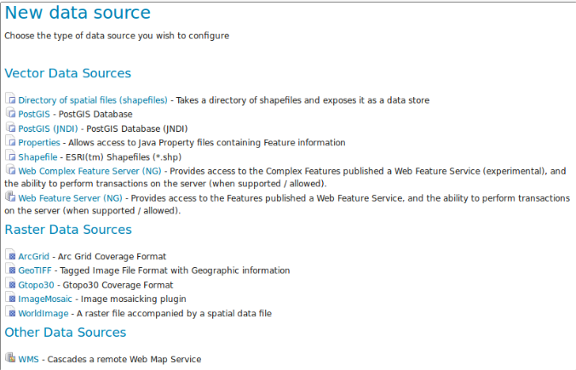
Stores

4.Click Shapefile. The New Vector Data Source page will display.
5.Begin by configuring the Basic Store Info.
Select the workspace nyc from the drop down menu.
Enter the Data Source Name as NYC Roads
Enter a brief Description (such as “Roads in New York City”).
6.Under Connection Parameters, browse to the location URL of the shapefile, typically nyc_roads/nyc_roads.shp.
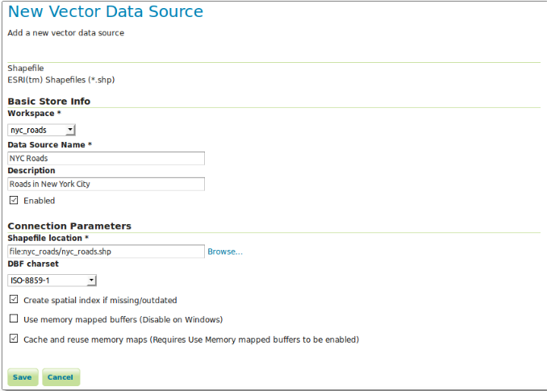
Basic Store Info and Connection Parameters
7.Click Save. You will be redirected to the New Layer page in order to configure the nyc_roads layer.

创建一个存储
一旦创建了工作区，我们就可以添加一个新的存储。存储告诉地理服务器如何连接到shapefile。
1.导航到数据‣商店。
2.您应该会看到存储的列表，包括存储的类型和存储所属的工作区。
3.为了添加shapefile，您需要创建一个新的存储。单击Add new Store按钮。您将被重定向到GeoServer支持的数据源列表。注意，数据源是可扩展的，因此您的列表可能看起来略有不同。
Stores
4.单击Shapefile。将显示新的向量数据源页面。
5.首先配置基本的存储信息。
从下拉菜单中选择工作区nyc。
输入数据源名称NYC Roads
输入一个简短的描述(例如“纽约市的道路”)。
6.在连接参数下，浏览到shapefile的位置URL，通常是nyc_roads/nyc_roads.shp。
Basic Store Info and Connection Parameters
7.单击Save。为了配置nyc_roads层，您将被重定向到新的层页面。

Creating a layer
Now that the store is loaded, we can publish the layer.
1.On the New Layer page, click Publish beside the nyc_roads layer name.
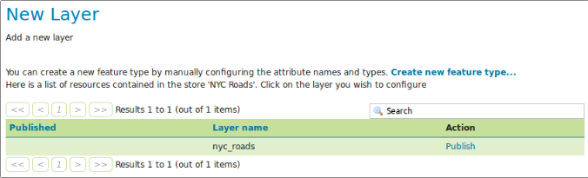
New layer
- The Edit Layer page defines the data and publishing parameters for a layer. Enter a short Title and an Abstract for the nyc_roads layer.
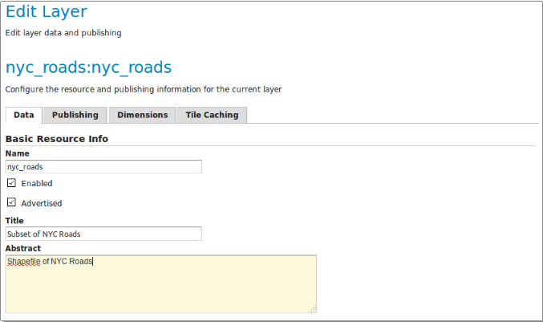
Basic Resource Information
3.Generate the layer’s bounding boxes by clicking the Compute from data and then Compute from native bounds links.
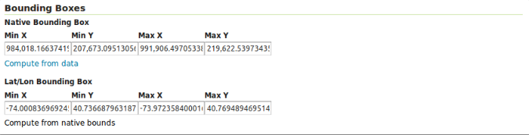
Generating bounding boxes
4.Click the Publishing tab at the top of the page.
5.We can set the layer’s style here. Under WMS Settings, ensure that the Default Style is set to line.
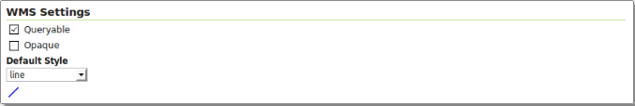
Select Default Style
6.Finalize the layer configuration by scrolling to the bottom of the page and clicking Save.

创建一个层
现在已经加载了存储，我们可以发布层了。
1.在新建层页面上，单击nyc_roads层名称旁边的Publish。
New layer
2.编辑层页面定义了一个层的数据和发布参数。为nyc_roads层输入一个简短的标题和一个摘要。
Basic Resource Information
3.通过单击来自数据的Compute，然后单击来自本机边界链接的Compute，生成层的边界框。
Generating bounding boxes
4.单击页面顶部的Publishing选项卡。
5.我们可以在这里设置图层的样式。在WMS设置下，确保将默认样式设置为line。
Select Default Style
6.通过滚动到页面底部并单击Save完成层配置。

Previewing the layer
In order to verify that the nyc_roads layer is published correctly, we can preview the layer.
- Navigate to the Layer Preview screen and find the nyc:nyc_roads layer.
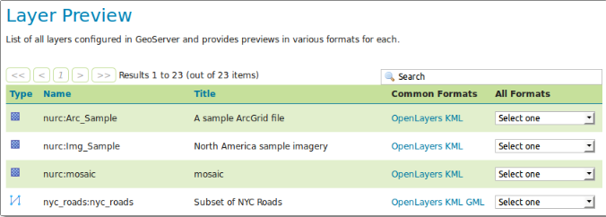
Layer Preview
2.Click the OpenLayers link in the Common Formats column.
3.An OpenLayers map will load in a new tab and display the shapefile data with the default line style. You can use this preview map to zoom and pan around the dataset, as well as display the attributes of features.
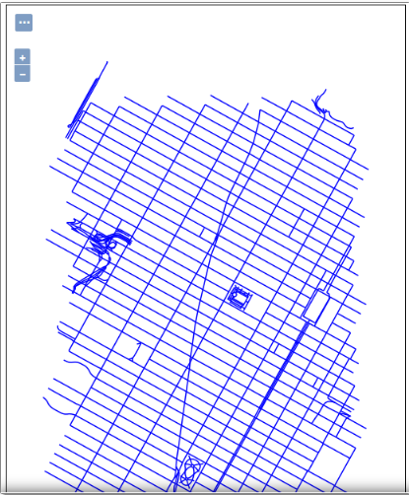
Preview map of nyc_roads

预览层
为了验证nyc_roads层是否正确发布，我们可以预览该层。
1.导航到层预览屏幕，找到nyc:nyc_roads层。
Layer Preview
2.单击公共格式列中的OpenLayers链接。
3.OpenLayers地图将加载一个新选项卡，并以默认的行样式显示shapefile数据。您可以使用此预览映射来缩放和平移数据集，以及显示特性的属性。
Preview map of nyc_roads

