**Font:**

Century gothic (all styles)

Gotham Bold for headings

I don’t know how can I help you with sizes

**Color codes:**

Wet Asphalt: 34495e (light)

Midnight Blue: 2c3e50 (dark)

Dark Blue : 163a4f

White: ffffff

Clouds: ecf0f1

Silver: bdc3c7

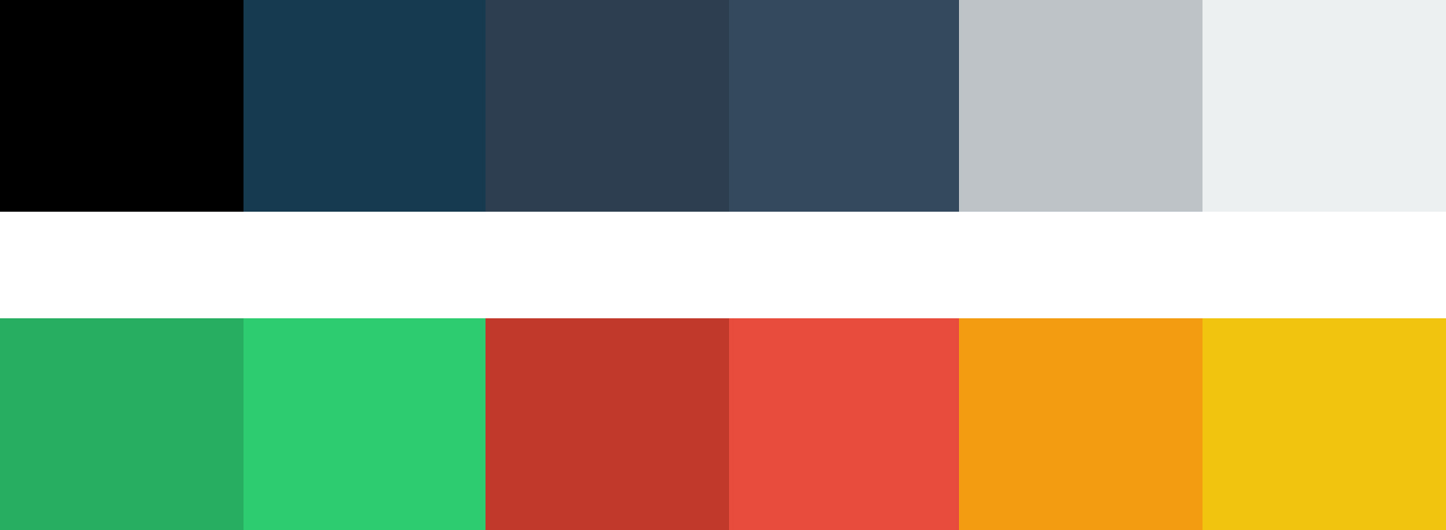

**Top menu:**

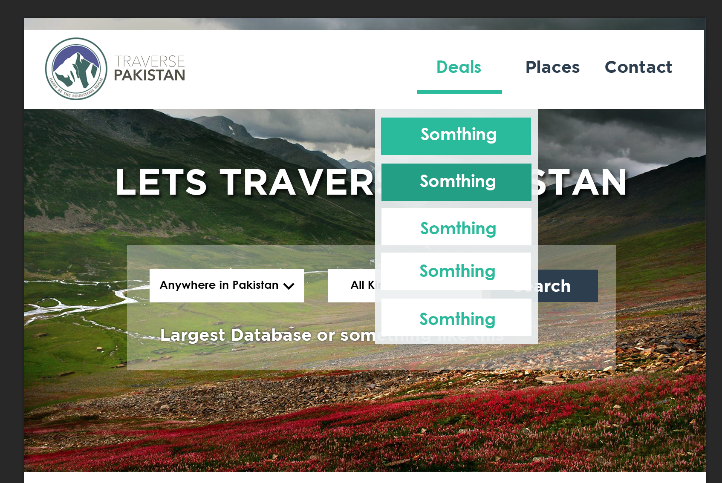

We renamed packages to deals.

Color of top bar: #ffffff

Green text : 1abc9c

Drop menu:

white: Clouds= ecf0f1 opacity : 80%

button white = ffffff

button on hover and text green = 1abc9c

button pressed green = 16a085