Database Analysis Worksheet

# Step 1: Identify Entities, Attributes, and Primary Keys

|  |  |  |  |  |
| --- | --- | --- | --- | --- |
| Entity |  | Attributes |  | Primary Key |
| Chats | ChatID, ChatName |  |  | ChatID |
| Users | UserID, Email, Phone, username, Password |  |  | UserID |
| Messages | MessageID  MessageText |  |  | MessageID |
|  |  |  |  |  |
|  |  |  |  |  |

# Step 2: Define Relationships Between the Entities

|  |  |  |  |
| --- | --- | --- | --- |
| Entity 1 | Entity 2 | How Related?  (2 sentences) | Relationship Type (1:1, 1:N, M:N) |
| Chats | Users | Many users can be in one chat. Many chats can have many users. | M:N |
| Messages | Users_Chats | You can have many messages in one chat by a user, but each message sent by a user in a chat can only pertain to that chat and user. | 1:N |
|  |  |  |  |
|  |  |  |  |
|  |  |  |  |
|  |  |  |  |
|  |  |  |  |
|  |  |  |  |
|  |  |  |  |

# Step 3: Draw your Entity-Relationship Diagram (Hand-drawn is okay!!!)

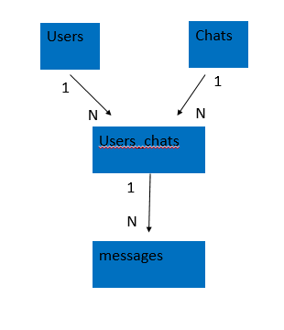

# Step 4: Specify Tables, Fields, and Data Types

Fill out a chart for each table to be included in the database. YOU MAY NEED MORE TABLES THAN THERE ARE HERE. The ones here are just to get you started. Mark the primary key with a double asterisk (**). Mark any foreign keys with the letters “fk” in parentheses, (fk).

Name of 1st Table: ______Users______________________

|  |  |
| --- | --- |
| Field Name | Data Type |
| UserID | ** |
| Email |  |
| Phone |  |
| username |  |
| password |  |

Name of 2nd Table: ________Chats_____________________

|  |  |
| --- | --- |
| Field Name | Data Type |
| ChatID | ** |
| ChatName |  |
|  |  |
|  |  |
|  |  |

Name of 3Rd Table: ____users_chats__________________________

|  |  |
| --- | --- |
| Field Name | Data Type |
| Users_chatsID | ** |
| UserID | (FK) |
| ChatID | (FK) |
|  |  |
|  |  |

Name of 3Rd Table: ____messages__________________________

|  |  |
| --- | --- |
| Field Name | Data Type |
| messageID | ** |
| Message_Text |  |
|  |  |
|  |  |
|  |  |