I have uploaded 3 folders in git as per following:

1. app.publish
2. Database Scripts
3. Project which includes Angular and API- **You can run this project locally with Angular (Frontend) and API Project**

**You can also see published code by following below steps**

1. Open IIS Manager
   1. If not available in your machine

Then refer this

<https://enterprise.arcgis.com/en/web-adaptor/latest/install/iis/enable-iis-8-components-server.htm>

<https://www.howtogeek.com/112455/how-to-install-iis-8-on-windows-8/>

1. Add Website

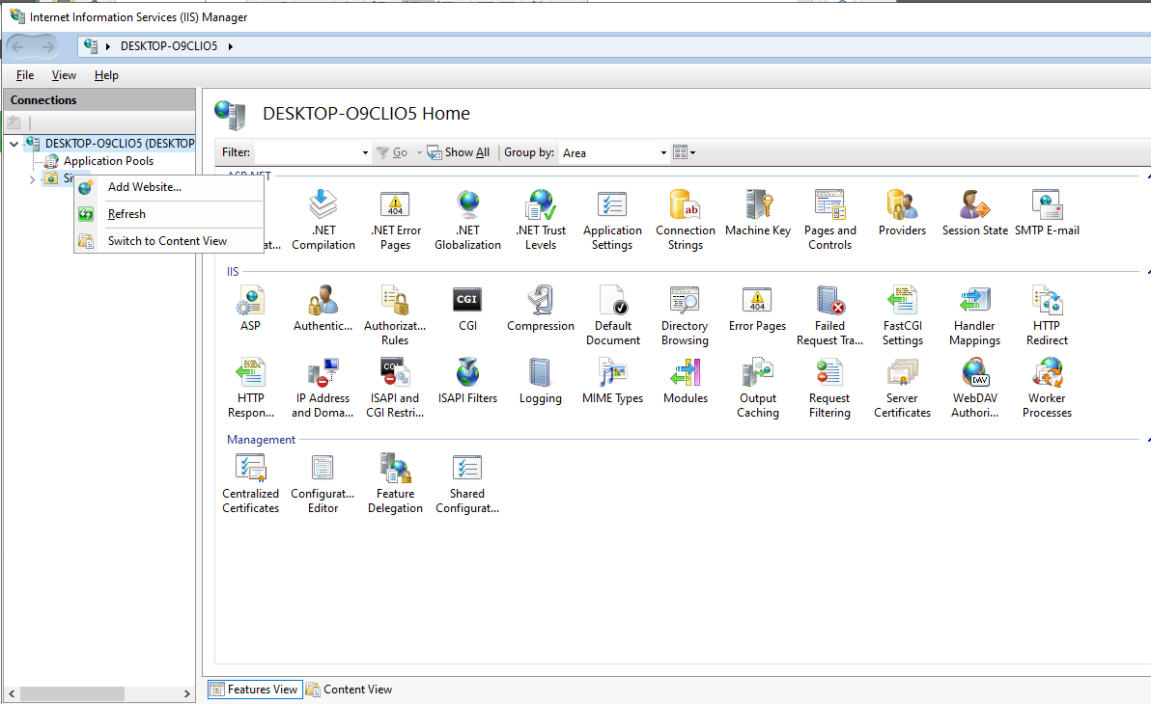

1. Set details as per the below screenshots

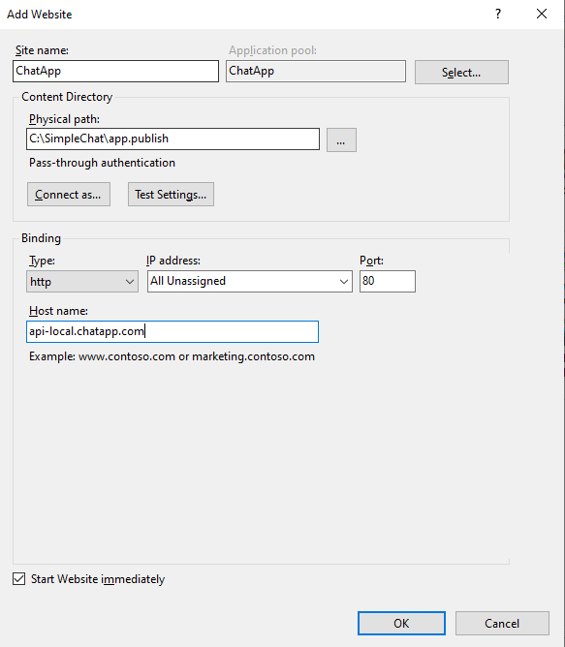

1. Press Windows Key + R.
2. Type C:\Windows\System32\drivers\etc into the Run window and click OK.
3. Open the hosts file with a text editor such as Notepad as an Administrator. Hosts will not have a file extension.
4. Add url in the last line and Save

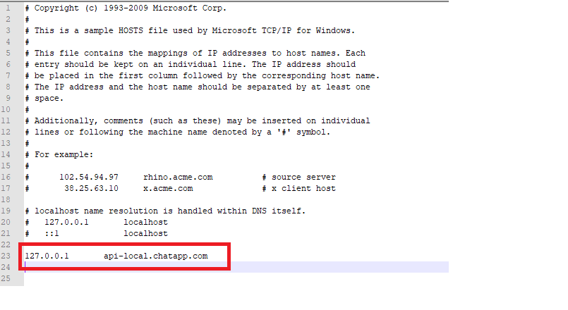

1. Execute Database and Table Script from git “Database Scripts” folder in SSMS
2. Update Connection String from Web.Config file under **/app.publish/Web.Config** folder. You need update connection string as per your SQL server and user credential details.

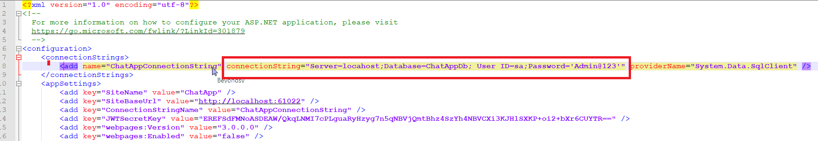

You should also update the **/Project/API/ChatApp.WebAPI/Web.Config** file if you will run directly from Visual Studio rather that **app.publish** folder.

1. Open link to browser <http://api-local.chatapp.com>