**ASSIGNEMENT-8**

GOUTHAM KS -PES1201700295

SAI TARUN-PES1201700494

ROHIT MENON-PES1201700707

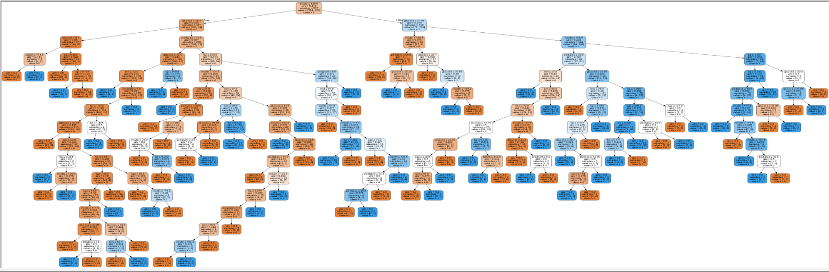

Accuracy: 0.670995670996

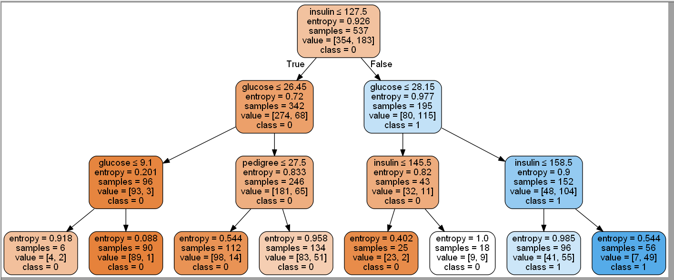

Accuracy: 0.770562770563