Assignment 1:

**1) Generate feature file for the following applications**

**- redbus.in (search)**

------------------------- -------------------------------------------------------------------------------------------------

Feature: Search for buses

Scenario Outline: Search for buses from one city to another

Given I am on the bus search page

When I select "<sourceCity>" as the source city

And I select "<destinationCity>" as the destination city

And I select "<journeyDate>" as the date of journey

And I click the "Search buses" button

Then I should see the search results for buses from "<sourceCity>" to "<destinationCity>" on "<journeyDate>"

Examples:

| sourceCity | destinationCity | journeyDate |

| Bangalore | Chennai | Today |

| Hyderabad | Bangalore | Tomorrow |

| Coimbatore | Madurai | 13 Sep, 2025 |

Scenario Outline: Search for buses with specific journey dates

Given I am on the bus search page

When I select "<sourceCity>" as the source city

When I select "<destinationCity>" as the destination city

And I click on the "Date of Journey" field

And I select "<journeyDate>" as the date of journey

And I click the "Search buses" button

Then I should see the search results for buses from "<sourceCity>" to "<destinationCity>" on "<journeyDate>"

Examples:

| sourceCity | destinationCity | journeyDate |

| Mysore | Bangalore | Today |

| Vijayawada | Hyderabad | Tomorrow |

| Tirunelveli| Chennai | 13 Sep, 2025 |

Feature: Bus Tickets Page Validation

Scenario Outline: Validate Bus Tickets Page Header

Given I open the bus tickets page

When I verify the page header

Then I should see the header text as "<headerText>"

Examples:

| headerText |

| "Bus Tickets" |

Scenario Outline: Validate Bus Tickets Page Header with Invalid Expectations

Given I open the bus tickets page

When I verify the page header

Then I should not see the header text as "<headerText>"

Examples:

| headerText |

| "Flight Tickets" |

| "Train Tickets" |

| "Hotel Booking" |

Scenario Outline: Validate Bus Tickets Page Header with Special Characters

Given I open the bus tickets page

When I verify the page header

Then I should not see the header text as "<headerText>"

Examples:

| headerText |

| "!@#$%" |

| "Bus@Tickets" |

Scenario Outline: Validate Bus Tickets Page Header with Numbers

Given I open the bus tickets page

When I verify the page header

Then I should not see the header text as "<headerText>"

Examples:

| headerText |

| "12345" |

| "Bus123Tickets" |

Scenario Outline: Validate Bus Tickets Page Header with South Indian Names

Given I open the bus tickets page

When I verify the page header

Then I should not see the header text as "<headerText>"

Examples:

| headerText |

| "Rajesh Kumar" |

| "Ramesh Bangalore" |

| "Suresh Chennai" |

| "Murali Hyderabad" |

| "Kumar Coimbatore" |

Scenario Outline: Validate Bus Tickets Page Header with South Indian Addresses

Given I open the bus tickets page

When I verify the page header

Then I should not see the header text as "<headerText>"

Examples:

| headerText |

| "123, MG Road, Bangalore - 560001" |

| "456, Anna Salai, Chennai - 600002" |

| "789, Necklace Road, Hyderabad - 500003" |

| "101, Avinashi Road, Coimbatore - 641001" |

| "202, Race Course Road, Mysore - 570001" |

Scenario Outline: Validate Bus Tickets Page Header with South Indian Mobile Numbers

Given I open the bus tickets page

When I verify the page header

Then I should not see the header text as "<headerText>"

Examples:

| headerText |

| "9876543210" |

| "9444433221" |

| "9739567890" |

| "9887766554" |

| "9030254789" |

Scenario Outline: Validate Bus Tickets Page Header with South Indian Pin Codes

Given I open the bus tickets page

When I verify the page header

Then I should not see the header text as "<headerText>"

Examples:

| headerText |

| "560001" |

| "600002" |

| "500003" |

| "641001" |

| "570001" |

[**https://login.salesforce.com/**](https://login.salesforce.com/)

Feature: Login to Salesforce

Scenario Outline: Successful login with valid credentials

Given I open the login page

When I type "<username>" into the Username field

And I type "<password>" into the Password field

And I click the Login button

Then I should be logged in successfully

Examples:

| username | password |

| ramesh.kumar@gmail.com | Ramesh123 |

| suresh.r@gmail.com | Suresh123 |

| kumar.ravi@salesforce.com | RaviKumar12 |

Scenario Outline: Unsuccessful login with invalid credentials

Given I open the login page

When I type "<username>" into the Username field

And I type "<password>" into the Password field

And I click the Login button

Then I should see an error message

Examples:

| username | password |

| ramesh.kumar@gmail.com | wrongpass |

| invaliduser@gmail.com | Ramesh123 |

| kumar.ravi@salesforce.com | wrongpass12 |

Scenario Outline: Login with remember me option

Given I open the login page

When I type "<username>" into the Username field

And I type "<password>" into the Password field

And I check the Remember me checkbox

And I click the Login button

Then I should be logged in successfully

Examples:

| username | password |

| ramesh.kumar@gmail.com | Ramesh123 |

| suresh.r@gmail.com | Suresh123 |

| kumar.ravi@salesforce.com | RaviKumar12 |

**2) Add a new groq model and confirm it is working**

Hint: add model id and label in popup.js + close / reopen

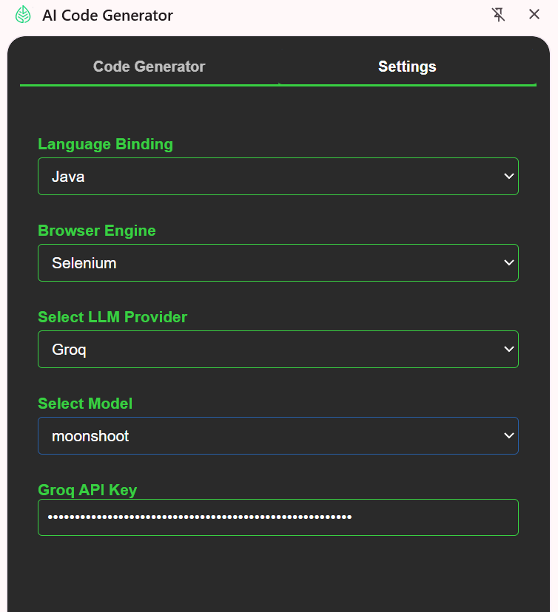

**3) Confirm 1.1 is working – Its working**

Feature: Salesforce Login

Scenario Outline: Successful login with valid credentials

Given I open the Salesforce login page

When I type "<username>" into the Username field

And I type "<password>" into the Password field

And I click the Log In button

Then I should be logged in successfully

Examples:

| username | password |

| "arun.kumar@tecksoft.com" | "Teck@2024" |

| "lakshmi.menon@keralatech.in" | "Kerala#99" |

| "rajesh.pillai@chennaiit.com" | "Pillai123" |

| "anita.devi@hydtech.co.in" | "Hyd@4567" |

| "suresh.babu@bangaloresoft.com" | "Blore#88" |

Scenario Outline: Login fails with invalid credentials

Given I open the Salesforce login page

When I type "<username>" into the Username field

And I type "<password>" into the Password field

And I click the Log In button

Then I should see an error message

Examples:

| username | password |

| "arun.kumar@tecksoft.com" | "wrongpass" |

| "lakshmi.menon@keralatech.in" | "wrongpass" |

| "rajesh.pillai@chennaiit.com" | "wrongpass" |

| "anita.devi@hydtech.co.in" | "wrongpass" |

| "suresh.babu@bangaloresoft.com" | "wrongpass" |

Scenario Outline: Remember username functionality

Given I open the Salesforce login page

When I type "<username>" into the Username field

And I type "<password>" into the Password field

And I check the Remember me checkbox

And I click the Log In button

Then the username should be remembered on next visit

Examples:

| username | password |

| "arun.kumar@tecksoft.com" | "Teck@2024" |

| "lakshmi.menon@keralatech.in" | "Kerala#99" |

Assignment 2:

1. **Generate Page class for salesforce login page & confirm all looks fine**

package com.testleaf.pages;

import org.openqa.selenium.WebDriver;

import org.openqa.selenium.WebElement;

import org.openqa.selenium.support.FindBy;

import org.openqa.selenium.support.PageFactory;

/**

* Page Object for Salesforce Login Page.

*/

public class SalesforceLoginPage {

private final WebDriver driver;

@FindBy(id = "username")

private WebElement usernameInput;

@FindBy(id = "password")

private WebElement passwordInput;

@FindBy(id = "Login")

private WebElement loginButton;

@FindBy(id = "rememberUn")

private WebElement rememberMeCheckbox;

@FindBy(id = "pwcaps")

private WebElement capsLockWarning;

public SalesforceLoginPage(WebDriver driver) {

this.driver = driver;

PageFactory.initElements(driver, this);

}

/**

* Enters the given username into the username field.

*

* @param username the username to enter

*/

public void enterUsername(String username) {

usernameInput.clear();

usernameInput.sendKeys(username);

}

/**

* Enters the given password into the password field.

*

* @param password the password to enter

*/

public void enterPassword(String password) {

passwordInput.clear();

passwordInput.sendKeys(password);

}

/**

* Clicks the Log In button to submit the login form.

*/

public void clickLogin() {

loginButton.click();

}

/**

* Toggles the Remember Me checkbox based on the given state.

*

* @param check true to check, false to uncheck

*/

public void setRememberMe(boolean check) {

if (check != rememberMeCheckbox.isSelected()) {

rememberMeCheckbox.click();

}

}

/**

* Returns true if the Caps Lock warning is displayed.

*

* @return visibility of Caps Lock warning

*/

public boolean isCapsLockWarningDisplayed() {

return capsLockWarning.isDisplayed();

}

}

**2) Configure code for playwright / typescript instead of the selenium / java**

**a) No change in the panel.html**

**b) prompt.js**

**- Get the same code template for playwright typescript**

**- Add to the prompt**

**- Append CODE_GENERATOR_TYPES as well**

**c) chat.js**

**- Add logic for Playwright/typescript using getPromptKeys**

**3) Test the playwright typescript combination**

import { Before, After, Given, When, Then } from '@cucumber/cucumber';

import { chromium, Browser, BrowserContext, Page, expect } from 'playwright';

let browser: Browser;

let context: BrowserContext;

let page: Page;

Before(async () => {

browser = await chromium.launch({ headless: false });

context = await browser.newContext();

page = await context.newPage();

});

After(async () => {

if (page) await page.close();

if (context) await context.close();

if (browser) await browser.close();

});

Given('I open the Salesforce login page', async () => {

await page.goto('https://login.salesforce.com/');

});

When('I enter {string} in the Username field', async (username: string) => {

await page.locator('#username').fill(username);

});

When('I enter {string} in the Password field', async (password: string) => {

await page.locator('#password').fill(password);

});

When('I click the Log In button', async () => {

await page.locator('input[type="submit"][value="Log In"]').click();

});

Then('I should land on the Salesforce home page', async () => {

await expect(page).toHaveURL(/.*lightning\.salesforce\.com.*/);

});