FORM 2
THE PATENTS ACT, 1970
(39 of 1970)
&
THE PATENTS RULES, 2003

COMPLETE SPECIFICATION
(See section 10 and rule 13)

1. TITLE OF THE INVENTION
SYSTEM AND METHOD FOR HOP-ATTRIBUTED TAMPER DETECTION AND AUTHORITATIVE RECOVERY OF SENSOR DATA IN AN EDGE-CLOUD INTERNET OF THINGS PIPELINE

2. APPLICANT(S)
[TODO: Name, nationality and address of applicant, e.g. the institute per its IPR policy, and/or the inventors]

3. PREAMBLE TO THE DESCRIPTION
The following specification particularly describes the invention and the manner in which it is to be performed.

FIELD OF THE INVENTION
[0001] The present invention relates to the security of data in Internet of Things (IoT) systems, and more particularly to a system and method for detecting tampering, replay and loss of sensor data as it passes from a sensor node through a gateway to parallel edge and cloud processing; for attributing every detected violation to the specific hop at which it occurred; and for recovering the original sensor reading from an authoritative backup when processed results disagree.
BACKGROUND OF THE INVENTION
[0002] Low-cost sensor nodes increasingly supply data to edge and cloud analytics. Between the sensor and the final result, a reading typically crosses several hops: a wireless link to a gateway, the gateway itself, internal networks, and one or more processing nodes. At each hop an adversary or a fault may corrupt the reading, inject fabricated readings, replay a previously captured reading, deliver a reading late, duplicate it, or drop it.
[0003] Known approaches secure individual links, for example by link-layer authentication in wireless sensor networks or by transport-layer security such as TLS or DTLS. Such protection terminates at each endpoint, so data is exposed wherever a secured channel ends, and a single verification at the network boundary gives no assurance about what happens to the data afterwards. Object-security schemes protect a message end to end, but do not by themselves verify the correctness of the computation performed on the data, nor attribute a failure to a particular hop.
[0004] Known anti-replay mechanisms use sequence numbers checked at a receiver. On constrained devices the sequence number is frequently held in volatile memory; a reboot or power loss resets it, reopening replay windows. Where the number is persisted only after a successful transmission, a failed or interrupted transmission can result in the same number being reused.
[0005] Deployments that replicate a gateway for availability commonly keep replay state per instance. The inventors have found that this silently weakens replay protection: a message accepted by one instance can be replayed to another instance that has never seen it. Even where a later stage rejects the replay, the rejection is recorded at the wrong hop, defeating any attempt to locate where the attack occurred.
[0006] Further, when an edge result and a cloud result for the same reading differ, known systems generally cannot determine which is correct, and the original reading may no longer be available. There is therefore a need for a system that (a) detects the above attacks with lightweight mechanisms suited to constrained devices, (b) attributes every rejection to a hop, (c) preserves an authoritative copy of each raw reading, and (d) maintains these guarantees when the gateway is replicated.
OBJECTS OF THE INVENTION
[0007] The principal object of the invention is to provide a system and method that detect corruption, injection, replay, duplication and delay of sensor data between a sensor node and processing nodes, and attribute each detected violation to the hop at which it was detected.
[0008] Another object of the invention is to provide replay protection anchored at the sensor node that survives reboot and power loss and cannot result in reuse of a freshness value, including after a failed transmission.
[0009] Another object of the invention is to detect modification of sensor data made after an intermediate gateway has verified it, by a party able to produce the gateway's authentication tag but not the sensor node's.
[0010] Another object of the invention is to cross-validate results computed independently by an edge node and a cloud node, and on disagreement to discard both results and recover the original reading from a backup written before any processing.
[0011] Yet another object of the invention is to preserve replay protection and hop attribution when the gateway is replicated across multiple instances for availability.
[0012] A further object of the invention is to flag anomalous readings from quantized, low-resolution sensors without false alarms caused by a zero sample deviation.
SUMMARY OF THE INVENTION
[0013] According to the invention, a sensor node acquires a reading, increments a monotonic counter and writes the incremented counter to non-volatile memory before computing a first authentication tag over a canonical encoding of the sensor identifier, timestamp, counter and data, using a key specific to that sensor node, and transmits the resulting chunk. If the reading is invalid, the network link is unavailable or the clock is not synchronized, the node skips the interval without incrementing the counter.
[0014] A gateway stage verifies the first authentication tag and, only after successful verification, checks that the counter exceeds the highest counter previously accepted for that sensor node. The gateway stage then computes a second authentication tag over the chunk including the first tag, and forwards the chunk.
[0015] A fork stage verifies the second authentication tag and independently re-verifies the first. A chunk bearing a valid second tag but an invalid first tag is recorded as modified after gateway verification. The fork stage assigns a unique chunk identifier and dispatches the reading to an edge processing node and a cloud processing node. The cloud node stores the raw reading in a backup store before processing it.
[0016] A validation stage compares the edge and cloud results field by field, requiring numeric fields to agree within a relative tolerance and categorical fields to be equal. On agreement, the result is forwarded to a final store. On disagreement, both results are discarded and the raw reading is retrieved from the backup store by its chunk identifier. Every rejection is recorded in an event log together with an identifier of the hop at which it occurred.
[0017] Where the gateway stage comprises a plurality of gateway instances, the instances share a counter store in which the counter check and update are performed as a single atomic conditional operation, such that exactly one instance can accept a given counter value and replays are rejected, and attributed, at the gateway hop regardless of which instance receives them.
BRIEF DESCRIPTION OF THE DRAWINGS
[0018] FIG. 1 is a block diagram of the system according to an embodiment of the invention, showing the sensor node, the gateway stage with replicated gateway instances and a shared counter store, the fork stage, the edge and cloud processing nodes, the backup store, the validation stage and the event log.
[0019] FIG. 2 is a flow chart of the method performed at the sensor node, including persistence of the counter before transmission and fallback transmission.
[0020] FIG. 3 is a flow chart of the verification, dispatch and validation method performed by the gateway, fork and validation stages.
DETAILED DESCRIPTION OF THE INVENTION
[0021] The following description sets out embodiments of the invention with reference to the drawings. The embodiments are illustrative; the invention is not limited to the specific devices, protocols, parameter values or software described, and variations apparent to a person skilled in the art fall within its scope.
[0022] System overview (FIG. 1). The system comprises a sensor node 100 having a sensor 102, a microcontroller 104 and a non-volatile memory 106; a gateway stage 200 reachable from the sensor node over a wireless link 110; a fork stage 300; an edge processing node 400; a cloud processing node 500 having a backup store 510; a validation stage 600; a final store 700; and an event log 800. In one embodiment, the gateway stage 200 comprises gateway instances 210 and 220 behind a load balancer 230, sharing a counter store 240.
[0023] In an exemplary embodiment, the sensor node 100 is an ESP8266- or ESP32-class microcontroller with a DHT11 temperature and humidity sensor, communicating over IEEE 802.11 WiFi using HTTPS with JSON bodies, the sensor node pinning the gateway's TLS certificate, for example by its fingerprint; the stages 200 to 600 are software services, each deployed in its own container; and the backup store 510 and counter store 240 are SQLite databases on persistent storage. The first authentication tag is an ECDSA P-256 digital signature computed with a private key held only by the sensor node, so that every verifying stage holds only the corresponding public key; the second authentication tag is an HMAC-SHA256 message authentication code. These choices are exemplary only.
[0024] Canonical encoding. A tag can only be verified if the signer and the verifier compute it over identical bytes, while firmware and server software commonly format floating-point numbers differently. The chunk is therefore encoded canonically as compact JSON with keys in sorted order, and sensor values are represented as integers in fixed sub-units, for example hundredths of a degree Celsius and hundredths of a percent of relative humidity, so that the encoding is byte-identical on all components.
[0025] Sensor-node method (FIG. 2). At each interval of a predetermined duration, for example five seconds, the microcontroller 104 acquires a reading from the sensor 102 (step S202) and determines whether the reading is valid, the wireless link is up and the clock has been synchronized, for example by NTP (step S204). If any condition fails, the interval is skipped and the counter is left unchanged, so that outages do not consume counter values. Otherwise the counter is incremented and written to the non-volatile memory 106 (step S206), and the write is confirmed (step S208); if the write fails, nothing is transmitted. Only then is the canonical encoding built (step S210), the first authentication tag computed with the device key (step S212), and the chunk transmitted to the primary gateway address (step S214).
[0026] Because every counter value used in a transmission has been persisted before the transmission, a reboot or power loss resumes above it, and a failed or interrupted transmission consumes the value rather than making it available for reuse. Gaps in the counter sequence are therefore permitted, while reuse is prevented.
[0027] If no HTTP response is received from the primary gateway address within a connection timeout, for example 1.5 seconds (step S216), the same chunk is re-sent to a fallback gateway address (step S218). An HTTP response indicating rejection is treated as definitive and does not trigger the fallback.
[0028] Gateway stage (FIG. 3, steps S302 to S306). The gateway validates the chunk against a strict schema that rejects type coercion, non-integer sensor values and unexpected fields. It rejects chunks from unknown sensor nodes and from sensor nodes marked as revoked in a key store, which each stage re-reads when it changes so that revocation takes effect without a restart, and verifies the first authentication tag (step S302). Only after successful verification does it check that the timestamp of the chunk lies within a window of the current time, for example 60 seconds, and then perform the counter check (step S304), so that unauthenticated requests cannot advance the stored counter and lock out a genuine sensor node, and a stale chunk cannot consume a counter value. The timestamp window also bounds replay should stored counter state be lost. It then computes a second authentication tag over the canonical encoding of all fields including the first tag, appends it without altering the first tag, and forwards the chunk (step S306).
[0029] Shared counter store. Where a plurality of gateway instances 210, 220 is used, the counter check of step S304 is performed against the shared counter store 240 as a single atomic conditional operation, for example: insert the pair (sensor identifier, counter) or, if a row exists, update it only where the new counter exceeds the stored counter; and accept the chunk if and only if a row was changed. Concurrent instances therefore cannot both accept the same counter value, and a replay reaching any instance is rejected at the gateway hop and recorded as such. The stored counters additionally survive restarts of the gateway instances.
[0030] Fork stage (FIG. 3, steps S308 to S312). The fork stage verifies the second authentication tag (step S308) and then independently re-verifies the first authentication tag (step S310). A chunk whose second tag is valid but whose first tag is invalid was modified after verification at the gateway by a party able to produce the second tag but not the first, which, where the first tag is a digital signature, includes a fully compromised gateway, and is recorded as tampered after verification at the gateway-fork hop. The fork stage repeats the counter check, assigns a random unique chunk identifier, and dispatches the reading in parallel to the edge node 400 and the cloud node 500 (step S312).
[0031] Processing and backup. The edge node 400 and cloud node 500 perform the same stateless computation on the reading, in one embodiment a thermal-comfort assessment comprising a heat index, a dew point and a comfort category. Because the computation is stateless, results can be compared per chunk identifier without dependence on history. The cloud node 500 writes the raw reading together with its first authentication tag to the backup store 510, keyed by chunk identifier, before performing the computation, so that the backup exists even if processing fails, and rejects a repeated chunk identifier.
[0032] Validation (FIG. 3, steps S314 to S318). The validation stage 600 compares the two results field by field (step S314). Numeric fields agree when their relative difference does not exceed a tolerance, for example 2 percent; categorical fields must be equal; a field present in only one result is a disagreement. On agreement, the result is forwarded to the final store 700 (step S316). On disagreement, both results are discarded, the raw reading is retrieved from the backup store 510 by its chunk identifier (step S318), and an event recording the chunk identifier, the failed check and a timestamp is written to the event log 800. The first authentication tag of the retrieved reading is then re-verified, so that a backup altered in storage is not trusted. If it verifies, the result is recomputed from the retrieved reading and forwarded to the final store 700 marked as recovered; if the backup is missing or fails verification, the chunk is placed in quarantine and any stored result for it is withdrawn.
[0033] Anomaly flagging. Separately from the comparison, the validation stage computes, for each measured quantity and sensor node, the deviation of the new value from the mean of the last N accepted values (for example N = 20), divided by the larger of their standard deviation and a minimum deviation. The minimum deviation is set to the resolution of the sensor, for example 1.0 unit for a sensor reporting whole units, because under stable conditions such a sensor yields a standard deviation of zero, which would otherwise cause every one-unit change to be flagged. A value exceeding a threshold, for example 3, is flagged as anomalous in a record distinct from a disagreement; flagged values are still forwarded and join the history, so that genuine level changes are absorbed, whereas values from disagreeing results never enter the history, which prevents it from being poisoned.
[0034] Hop attribution. Each rejection is recorded in the event log 800 as a structured record containing at least the reason and an identifier of the hop: for example 'sensor-gateway' for corruption, injection, replay, duplication, delay and unknown sensors; 'gateway-fork' for an invalid second tag or modification after gateway verification; 'fork-edge' or 'fork-cloud' for malformed data or a repeated chunk identifier at processing; and 'edge-cloud-validation' for disagreement between results. The location of any detected violation is thereby known. In one embodiment, each record further stores a chaining value computed with a log key over the record's fields and the chaining value of the preceding record, writers being serialized so that the chain remains linear; modification, deletion or reordering of a record breaks the chain, which cannot be recomputed without the log key.
[0035] Reduction to practice. An embodiment was implemented and exercised by injecting crafted attacks against the running stages. Corruption of a single bit of a sensor value and injection with a fabricated tag were rejected at the sensor-gateway hop as authentication failures; replay after a delay, duplication and out-of-order delivery were rejected at the sensor-gateway hop as stale counters; and modification after gateway verification, with the second tag recomputed using the gateway key, was rejected at the gateway-fork hop as tampered after verification. A dropped interval was tolerated, and subsequent chunks were accepted. With two gateway instances behind a round-robin load balancer, replays were rejected at the gateway hop by both instances, and in a concurrency test exactly one of eight simultaneous attempts to record the same counter value succeeded. A chunk ten minutes old with a fresh counter was rejected at the sensor-gateway hop on its timestamp, and a doctored edge result caused a disagreement, after which the backup verified and the true result was restored. In a benchmark of 100 genuine chunks and 80 attacks of eight classes, every attack was detected at the expected hop and every genuine chunk accepted, at a median end-to-end latency of approximately 112 milliseconds. A revoked sensor node was refused from its next chunk and re-admitted on restoration without restart.
[0036] Advantages. The invention detects and localizes a broad class of attacks within the resources of a low-cost microcontroller, including modification by a compromised gateway; prevents counter reuse across reboots and failed transmissions; distinguishes modification by a gateway-key holder from modification in transit; preserves an authoritative, independently verifiable copy of every reading for recovery; and retains correct replay protection and hop attribution when the gateway is replicated.
[0037] Variations. The authentication tags may be computed with other digital signature schemes or message authentication codes; where the first tag is a message authentication code, the re-verification of step S310 detects modification by a holder of the gateway key but not by a party holding the device key. The device key may be held in a hardware secure element. Communication may use other transports, such as MQTT, CoAP or LoRaWAN, with or without encryption. The shared counter store may be any store supporting an atomic conditional update. The tolerance, window length, threshold, minimum deviation and interval may be chosen according to the application, and the edge and cloud computations may be different implementations of the same function.
CLAIMS
We claim:
1. A method for detecting and attributing tampering of sensor data in an Internet of Things pipeline, comprising: (a) at a sensor node, acquiring a reading, incrementing a monotonic counter, writing the incremented counter to non-volatile memory, and only after said writing computing a first authentication tag over an encoding of at least a sensor identifier, the counter and the reading using a key associated with the sensor node, and transmitting a chunk comprising the reading, the counter and the first authentication tag; (b) at a gateway stage, verifying the first authentication tag and, only upon successful verification, accepting the chunk if the counter exceeds a highest counter previously accepted for the sensor identifier, and appending a second authentication tag computed over the chunk including the first authentication tag; (c) at a fork stage, verifying the second authentication tag, independently re-verifying the first authentication tag, and dispatching the reading to an edge processing node and to a cloud processing node; (d) at the cloud processing node, storing the reading in a backup store before processing it; (e) at a validation stage, comparing a result of the edge processing node with a result of the cloud processing node, forwarding a result to a final store when the results agree within a tolerance, and, when they do not, discarding the results and retrieving the reading from the backup store; and (f) recording each rejection in an event log together with an identifier of the stage at which the rejection occurred.
2. The method as claimed in claim 1, wherein, when the second authentication tag is valid and the first authentication tag is invalid, the fork stage records the chunk as having been modified after verification at the gateway stage.
3. The method as claimed in claim 1, wherein the sensor node skips an interval without incrementing the counter when the reading is invalid, a network link is unavailable, or a clock of the sensor node is not synchronized, and transmits nothing when the writing of the counter to the non-volatile memory fails.
4. The method as claimed in claim 1, wherein the gateway stage comprises a plurality of gateway instances sharing a counter store, and the accepting of step (b) is performed as a single atomic conditional operation that updates the stored counter only when the counter of the chunk exceeds it, the chunk being accepted if and only if the operation changes the stored counter.
5. The method as claimed in claim 1, wherein the encoding is a canonical encoding in which fields are ordered deterministically and sensor values are represented as integers in fixed sub-units, such that the sensor node and the verifying stages compute the authentication tags over identical bytes.
6. The method as claimed in claim 1, wherein the fork stage assigns a unique chunk identifier to the reading, the backup store is keyed by the chunk identifier, the cloud processing node rejects a repeated chunk identifier, and the retrieving of step (e) uses the chunk identifier.
7. The method as claimed in claim 1, wherein the comparing of step (e) requires numeric fields of the results to agree within a relative difference not exceeding the tolerance and categorical fields of the results to be equal.
8. The method as claimed in claim 1, further comprising flagging a reading as anomalous when its deviation from the mean of a window of previously accepted readings from the same sensor node, divided by the larger of the standard deviation of the window and a minimum deviation corresponding to a resolution of the sensor, exceeds a threshold, wherein anomalous readings are recorded separately from disagreements, and readings from disagreeing results are excluded from the window.
9. The method as claimed in claim 1, wherein the sensor node, upon receiving no response from a primary gateway address within a timeout, transmits the same chunk to a fallback gateway address, and does not do so upon receiving a response indicating rejection.
10. A system for detecting and attributing tampering of sensor data, comprising: a sensor node (100) having a sensor (102), a microcontroller (104) and a non-volatile memory (106), the microcontroller being configured to persist an incremented monotonic counter to the non-volatile memory before computing a first authentication tag over the sensor identifier, the counter and a reading, and to transmit a chunk; a gateway stage (200) configured to verify the first authentication tag, to accept the chunk only if, after successful verification, the counter exceeds a highest previously accepted counter, and to append a second authentication tag computed over the chunk including the first authentication tag; a fork stage (300) configured to verify the second authentication tag, to independently re-verify the first authentication tag, and to dispatch the reading to an edge processing node (400) and a cloud processing node (500); a backup store (510) into which the cloud processing node stores the reading before processing it; a validation stage (600) configured to compare the results of the edge and cloud processing nodes, to forward a result to a final store (700) when they agree within a tolerance, and otherwise to discard the results and retrieve the reading from the backup store; and an event log (800) in which each rejection is recorded with an identifier of the stage at which it occurred.
11. The system as claimed in claim 10, wherein the gateway stage (200) comprises a plurality of gateway instances (210, 220) behind a load balancer (230) and a shared counter store (240) supporting an atomic conditional update, such that exactly one gateway instance can accept a given counter value for a given sensor node.
12. The system as claimed in claim 10, wherein the fork stage (300) is configured to record a chunk having a valid second authentication tag and an invalid first authentication tag as modified after verification at the gateway stage.
13. The method as claimed in claim 1, wherein the first authentication tag is a digital signature computed with a private key held by the sensor node, and the gateway stage and the fork stage verify it using only a corresponding public key, such that the re-verifying of step (c) detects modification of the chunk by a party holding all keys of the gateway stage.
14. The method as claimed in claim 1, wherein the chunk further comprises a timestamp, and the gateway stage, after successful verification of the first authentication tag and before the counter check, rejects the chunk when the timestamp differs from a current time by more than a predetermined window.
15. The method as claimed in claim 1, wherein the backup store stores the reading together with the first authentication tag, and step (e) further comprises re-verifying the first authentication tag of the retrieved reading and, if it is valid, recomputing the result from the retrieved reading and forwarding it to the final store marked as recovered, and, if the backup is missing or invalid, placing the chunk in quarantine.
16. The method as claimed in claim 1, wherein each record of the event log stores a chaining value computed with a log key over the fields of the record and the chaining value of the preceding record, such that modification, deletion or reordering of a record is detectable.
17. The method as claimed in claim 1, wherein the gateway stage and the fork stage reject a chunk from a sensor node marked as revoked in a key store, the key store being re-read upon change such that revocation takes effect without restarting the stages.

Dated this [TODO: day] day of [TODO: month], [TODO: year].
[TODO: Signature, name of applicant / patent agent (IN/PA No.)]

ABSTRACT
SYSTEM AND METHOD FOR HOP-ATTRIBUTED TAMPER DETECTION AND AUTHORITATIVE RECOVERY OF SENSOR DATA IN AN EDGE-CLOUD INTERNET OF THINGS PIPELINE
A system and method for tamper detection in edge-cloud IoT sensor pipelines. A sensor node (100) persists an incremented counter to non-volatile memory (106) before computing a first authentication tag over the reading and transmitting it. A gateway stage (200) verifies the tag, then a timestamp window and the counter, and appends a second tag. A fork stage (300) verifies the second tag and re-verifies the first, detecting modification after gateway verification, then dispatches the reading to edge (400) and cloud (500) nodes; the cloud node backs up the raw reading (510) before processing. A validation stage (600) accepts a result only if both nodes agree within a tolerance, otherwise re-verifying the backed-up reading and recovering or quarantining it. Each rejection is logged with the hop at which it occurred (800). Replicated gateway instances share an atomically updated counter store (240), preserving replay protection and hop attribution. (FIG. 1)

Sheet 1 of 3
Applicant: [TODO: Applicant name]
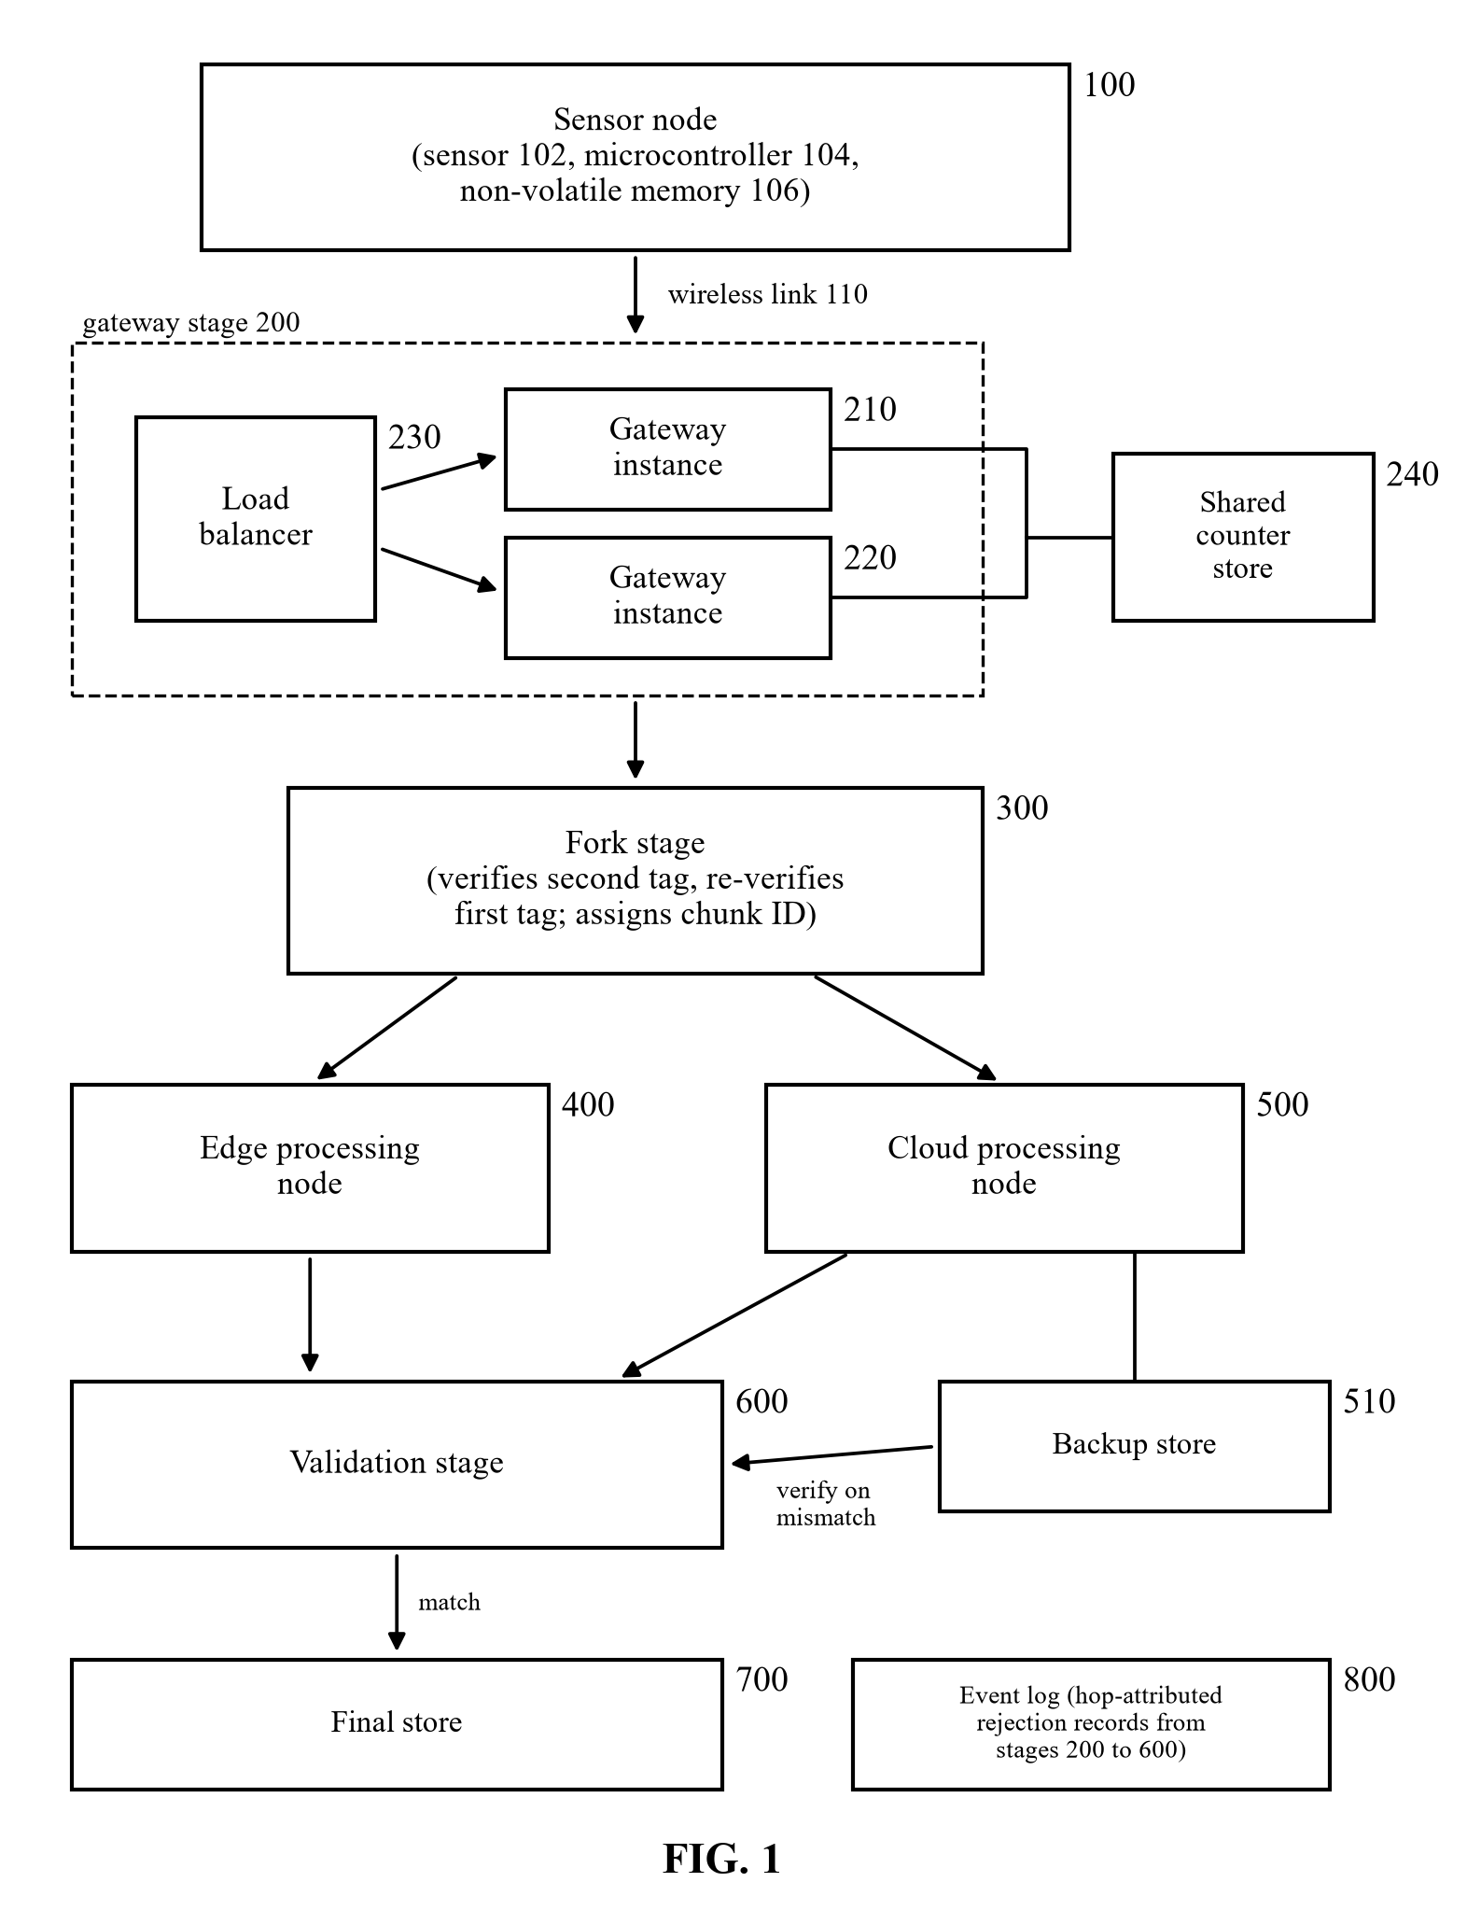
[TODO: Signature of applicant / agent]

Sheet 2 of 3
Applicant: [TODO: Applicant name]
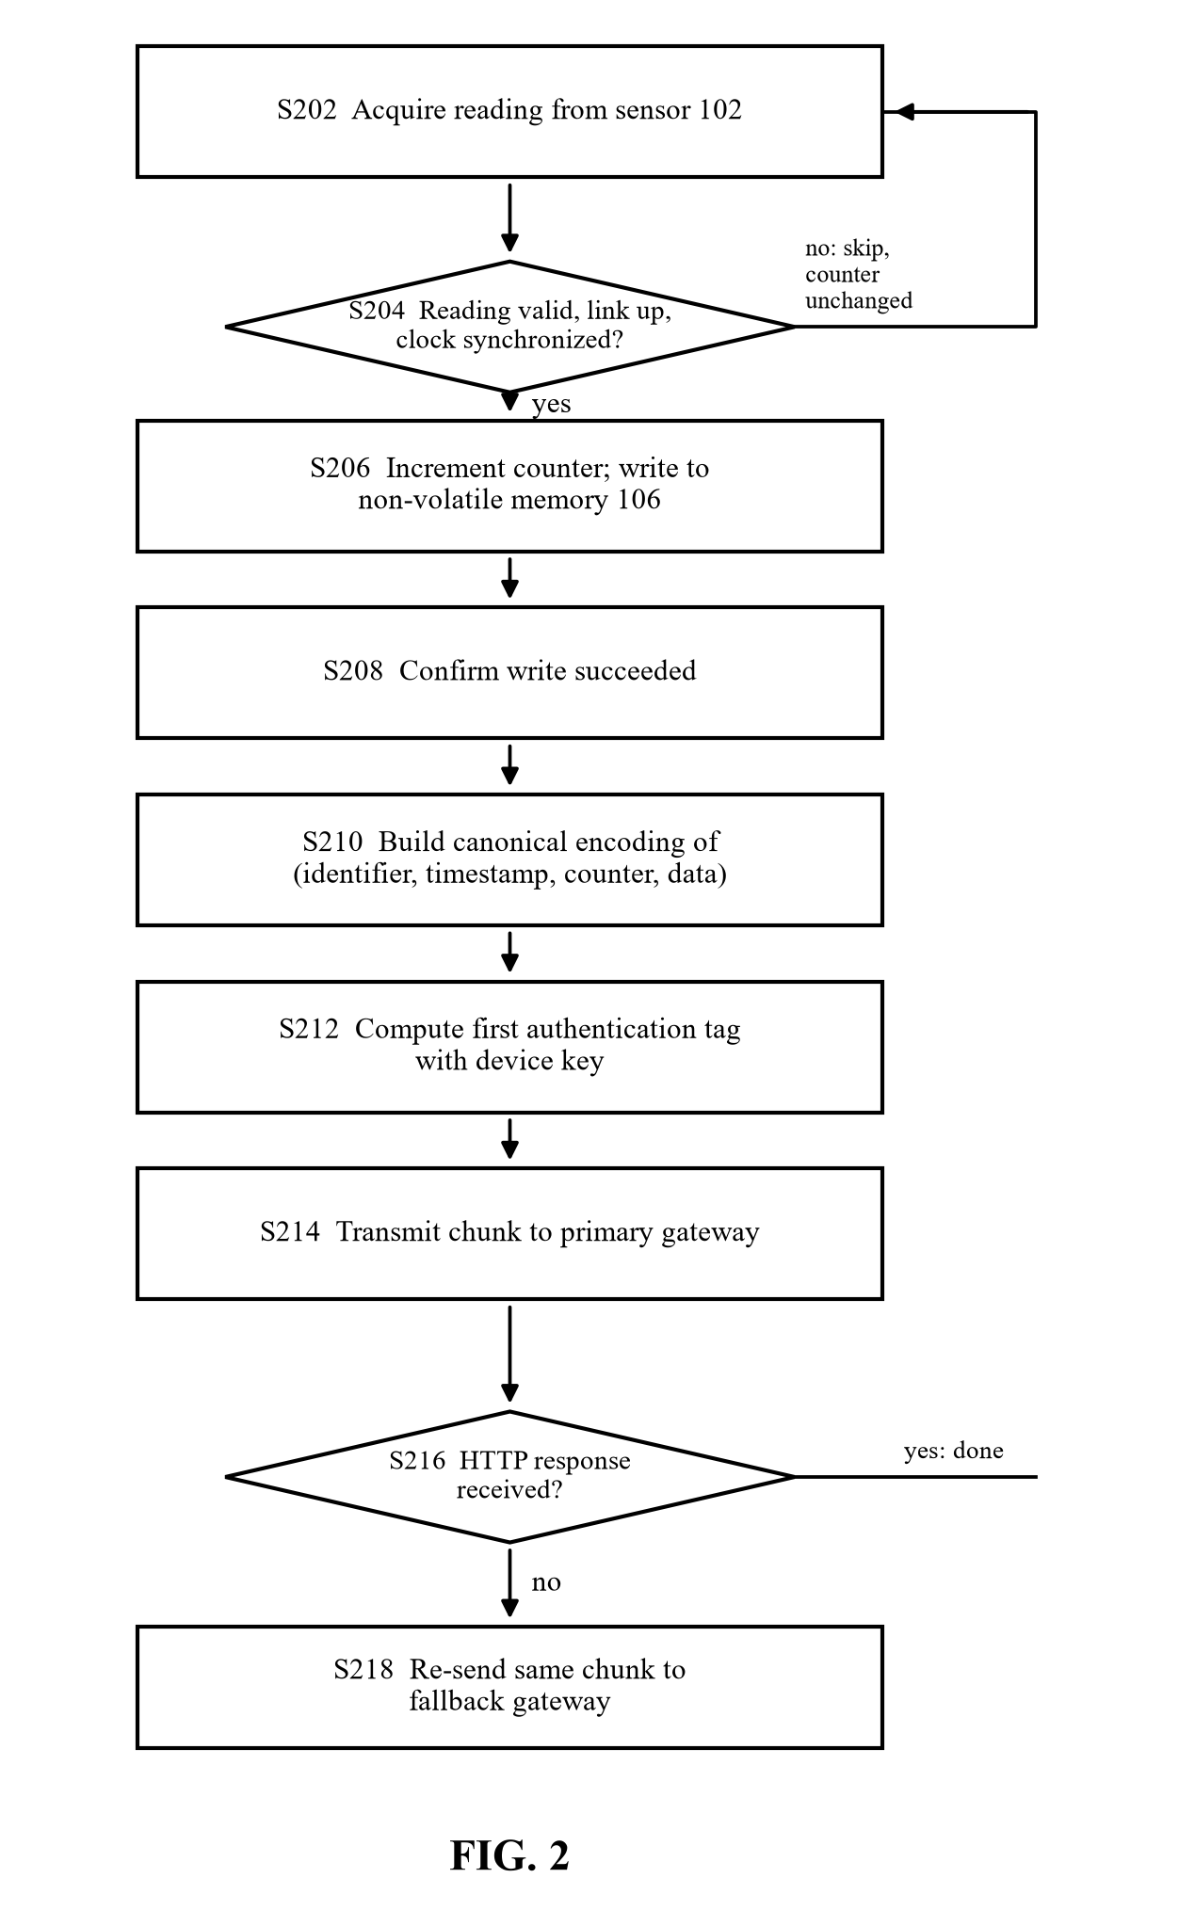
[TODO: Signature of applicant / agent]

Sheet 3 of 3
Applicant: [TODO: Applicant name]
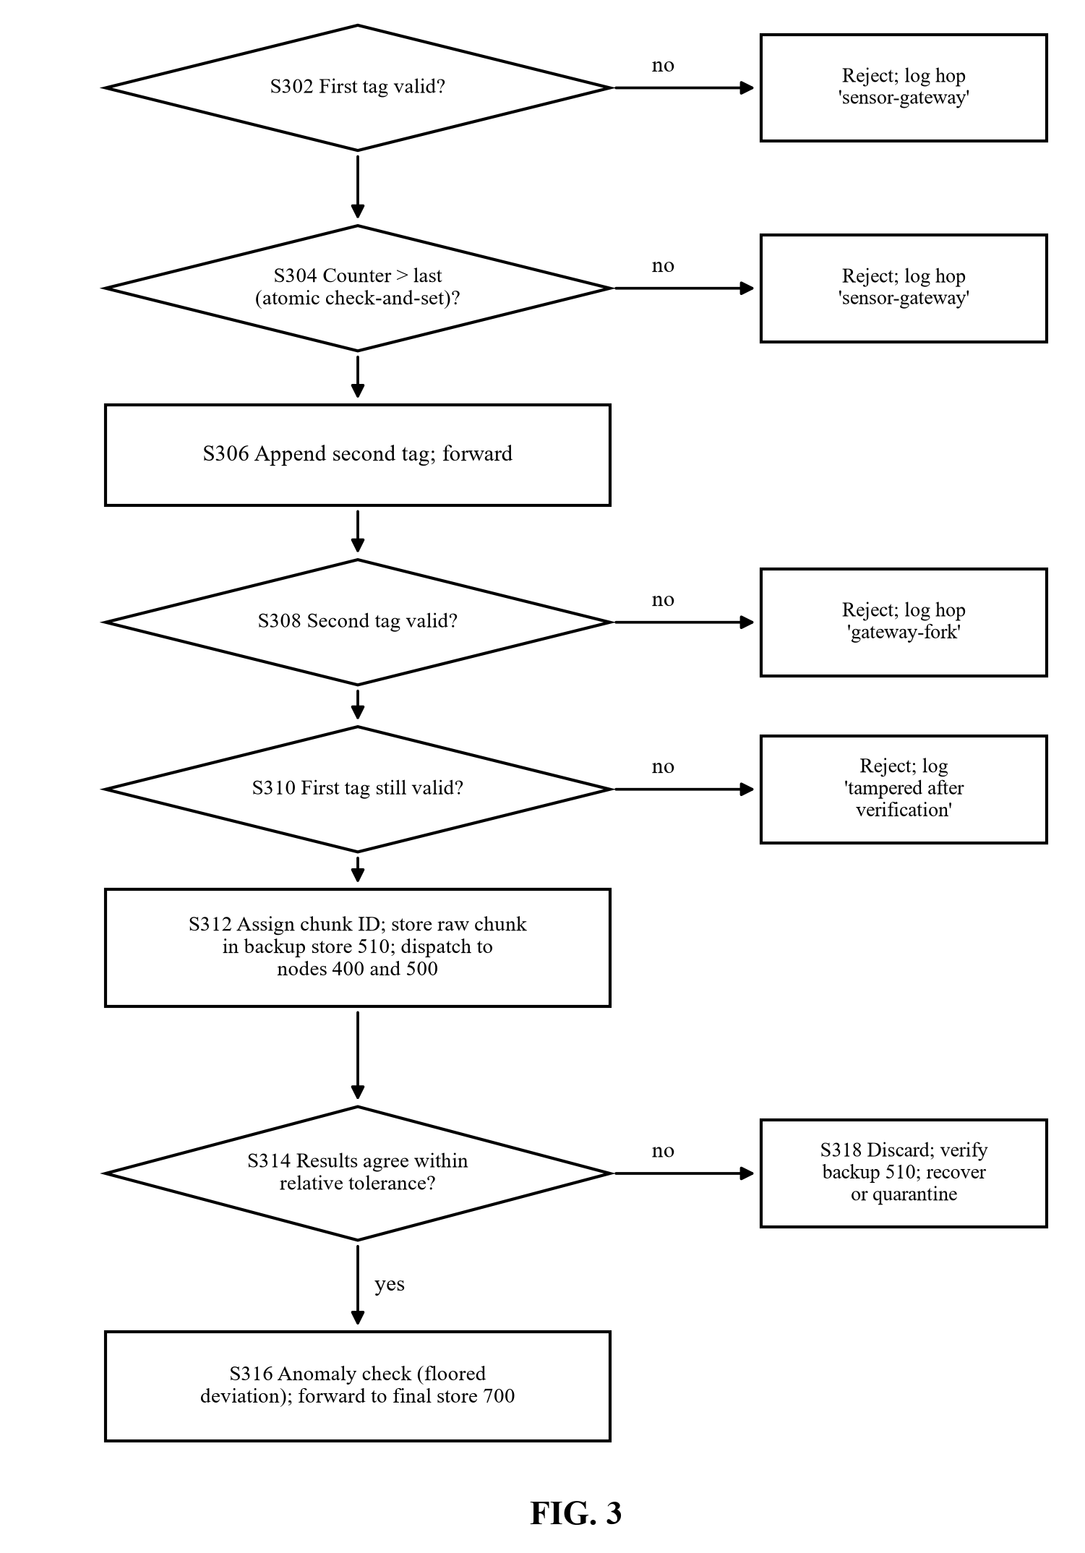
[TODO: Signature of applicant / agent]

