Tamper Localization in Edge–Cloud IoT Pipelines: An End-to-End HMAC Signature Chain with Dual-Path Validation and Authoritative Backup
[TODO: Author 1], [TODO: Author 2]
[TODO: Department, Institution, City, Country]
[TODO: email addresses]

Abstract—Low-cost IoT sensors increasingly feed edge and cloud analytics, yet many deployments authenticate data at most once, at the network boundary. When a result is wrong, operators learn that something failed but not where, and the original reading is often lost. We present a pipeline in which an ESP8266 microcontroller signs every reading with its own ECDSA P-256 private key over a counter persisted to flash before transmission, and sends it over TLS with the gateway's key pinned. A gateway verifies the signature against the device's public key, a timestamp window and the counter, and countersigns; a fork point re-verifies the device signature end to end, so even a fully compromised gateway cannot alter data undetected; edge and cloud nodes process each reading independently; and a validation service accepts a result only when both agree within a tolerance, otherwise re-verifying a signed backup written before processing and recomputing the result from it, or quarantining it. Every rejection is recorded, with the hop at which it occurred, in a keyed hash-chained log. We implement the design as ESP8266 firmware and six containerized services and evaluate it by attack injection: across 100 genuine readings and 80 attacks of eight classes, all attacks were detected at the expected hop with no false positives (F1 = 1.000), at a median end-to-end latency of 112 ms. We also show that replicating the gateway silently weakens replay protection and misattributes rejections, and resolve this with an atomically updated shared counter store.
Index Terms—IoT security, data integrity, ECDSA, replay protection, edge computing, ESP8266, tamper localization.

I. Introduction
Sensor data in a typical edge–cloud deployment crosses several hops: from the device over WiFi to a gateway, and from there to processing and storage. Each hop is an opportunity for an attacker to corrupt, inject, replay, delay, or drop readings, and compromised IoT devices and infrastructure are a well-documented reality [10]. Channel security such as TLS [15] or DTLS [3] protects individual links, but data is exposed wherever a channel terminates, and a single verification at the boundary says nothing about what happens to the data afterwards.
Two structural gaps motivated this work. First, no backups: once a processed result was found to be wrong, the original reading was gone. Second, unknown tamper location: an incorrect result showed that something had failed, but not which hop was responsible. This paper describes a pipeline that closes both gaps with mechanisms that fit on a commodity microcontroller. Our contributions are:
1) An end-to-end signature chain with asymmetric device signatures, in which a downstream stage re-verifies the original device signature, so that each rejection is attributed to a specific hop and even a fully compromised gateway cannot alter data undetected (Section IV-D).
2) Freshness anchored on the device: a monotonic counter persisted to flash before each transmission, combined with a timestamp window, so that neither a reboot, a failed send, nor lost server state reopens replay (Sections IV-B, IV-C).
3) Dual-path validation with verified recovery: edge and cloud process each chunk independently; on disagreement, a backup stored with the device's signature before processing is re-verified and the result recomputed from it, or the chunk is quarantined (Section IV-E).
4) An observation that replicating the gateway breaks per-instance replay state, and a fix using an atomically updated shared counter store (Section IV-H).
5) A prototype on real hardware with a keyed hash-chained event log, device revocation, rate limiting, and an attack-injection benchmark (Sections V–VI).

II. Related Work
Sensor network security. SPINS [1] introduced authenticated, counter-based messaging for constrained sensor nodes, and TinySec [2] provided link-layer authentication and encryption. Both secure individual radio links hop by hop; our focus is on integrity that survives across heterogeneous hops, and on locating failures.
Channel and object security. TLS 1.3 [15] and DTLS 1.3 [3] secure channels but terminate at each endpoint; we use TLS for confidentiality on the device–gateway link, not for integrity across hops. OSCORE [4] protects application-layer objects end to end across proxies, which is closest in spirit to our signature chain. We add countersigning, downstream re-verification, and a check on the computation performed on the data.
Signatures and anti-replay. HMAC [6], [7] is cheap but symmetric: every verifier can also forge. ECDSA [16] separates signing from verification; deterministic nonces [17] remove the need for a random-number generator on the device. IPsec ESP [5] rejects replays with sequence numbers at the receiver; our counter is persisted on the device and checked at two stages.
Redundant computation. Comparing independently produced results is the basis of N-version programming [9]; tolerating arbitrary faults requires more replicas than we use [13]. Our two-path comparison detects a disagreement; we resolve it from a signed backup instead of by voting. Edge computing [8] motivates running latency-sensitive processing close to devices while retaining a cloud path.

III. Threat Model and Goals
We consider four adversaries. A1, a network attacker on the WiFi network or LAN, who can read, modify, inject, replay, delay, drop, and flood messages. A2, a compromised gateway, including its signing key k_{g} and its keystore. A3, a faulty or compromised processing node (edge or cloud) that returns wrong results. A4, an attacker with write access to stored logs or backups.
We assume device private keys are not extracted from hardware and that the validation stage and its keystore are trusted. Because servers hold only device public keys, the keystore itself is not secret. Our goals are: G1 integrity and authenticity of each reading; G2 freshness, meaning no replay, duplication, reordering, or late delivery; G3 localization of any violation to a hop; G4 recoverability of the original reading; G5 availability despite the failure of one gateway; and G6 confidentiality on the wireless link. Key-compromise recovery beyond revocation is a non-goal.

IV. System Design
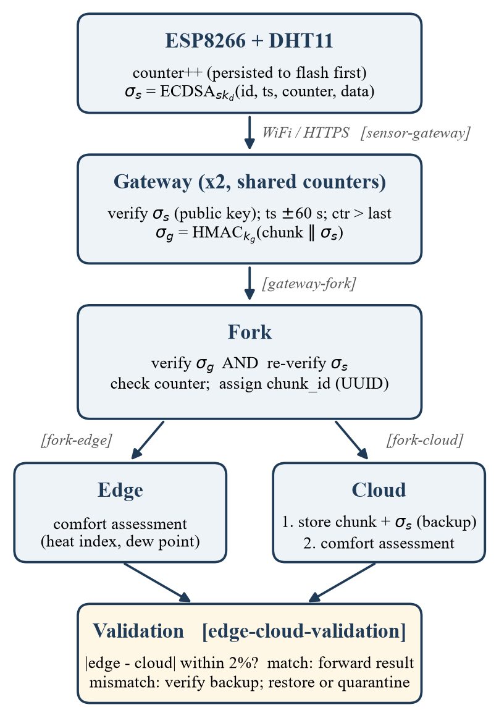
Fig. 1. Pipeline architecture. Bracketed labels are the hop names recorded in rejection logs.
Fig. 1 shows the pipeline. Each stage verifies the output of the stage before it, and each rejection is recorded as a structured event naming its hop.

A. Envelope and Canonical Encoding
A chunk carries sensor_id, a millisecond timestamp ts, a counter ctr, a data object, and signatures. A signature is only verifiable if signer and verifier hash identical bytes, and the firmware (C++) and services (Python) serialize floating-point numbers differently. We therefore define a canonical encoding C(·) as compact JSON with sorted keys and integer-only values: temperature and humidity are sent in hundredths. A unit test pins the exact byte string that the firmware must produce.

B. Device Signing and Persistent Counter
Each device holds an ECDSA P-256 private key sk_{d}, written once to flash; the gateway knows only the matching public key pk_{d}. For each reading, the device increments ctr, writes it to flash, and only then computes
σ_{s} = ECDSA-Sign(sk_{d}, SHA-256(C(id, ts, ctr, data))) (1)
using deterministic nonces [17], and transmits the chunk over TLS, pinning the gateway's TLS certificate by its fingerprint so that no other server is accepted. Because every value used for transmission has been persisted first, a reboot resumes above it, and a failed send consumes the value instead of making it available again: gaps are allowed, reuse is impossible. If the read fails, WiFi is unavailable, or the clock is not synchronized, the device skips the interval without incrementing.

C. Gateway: Verify and Countersign
The gateway validates the request against a strict schema (no type coercion, no floating-point data, no extra fields). It rejects unknown or revoked devices, verifies σ_{s} with pk_{d}, requires |now − ts| ≤ 60 s, and only then checks ctr > last(id). Checking freshness after the signature prevents unauthenticated requests from advancing the counter; checking the timestamp before the counter prevents a stale chunk from consuming a counter value. The timestamp window also bounds replay if counter state were ever lost. The gateway then adds
σ_{g} = HMAC-SHA256(k_{g}, C(id, ts, ctr, data, σ_{s})) (2)
leaving σ_{s} unchanged, and forwards the chunk.

D. Fork: End-to-End Re-Verification
The fork verifies σ_{g}, then independently re-verifies σ_{s} against pk_{d}. If σ_{g} is valid but σ_{s} is not, the data was altered after the gateway's verification; this is reported as gateway-tampered-after-verification. Because the gateway holds only public keys, this holds even against adversary A2 with the gateway's full key material. The fork repeats the counter check (with its own persisted state), assigns a random UUID chunk_id, and dispatches the reading, with σ_{s}, to the edge and cloud in parallel.

E. Dual-Path Processing and Verified Recovery
Edge and cloud compute the same per-chunk thermal-comfort assessment: the NWS heat index [11], a Magnus-type dew point [12], and a comfort band. The computation is stateless, so results are compared per chunk_id. The cloud stores the raw reading, together with σ_{s}, before processing. Validation compares numeric fields by relative difference against τ = 2% and requires categorical fields to be equal. On agreement, the result goes to final storage. On disagreement, both results are discarded and the backup is re-verified against pk_{d} before it is trusted (defeating A4 tampering with backups): if valid, the result is recomputed from it and stored as recovered; if missing or invalid, the chunk is quarantined and any stored result withdrawn.

F. Anomaly Flagging for Quantized Sensors
Separately, validation flags readings far from the sensor's recent history, using z = |x − μ| / max(σ, σ_{min}) over the last N = 20 readings with threshold z > 3. The DHT11 reports whole units, so under stable conditions σ = 0 and any 1-unit change would be flagged; we floor σ at the sensor's resolution, σ_{min} = 1.0. Flagged readings are still forwarded and join the history, which persists across restarts; results that failed the edge–cloud comparison never enter it.

G. Tamper-Evident Event Log, Revocation, and Rate Limiting
Every event from every stage is appended to a shared log in which each entry stores h_{i} = HMAC(k_{log}, fields_{i} ∥ h_{i−1}); writers are serialized so the chain stays linear. Editing, deleting, or reordering an entry breaks the chain, and unlike an unkeyed hash chain it cannot be recomputed without k_{log} (A4). A device can be revoked by a flag in the keystore, which every stage re-reads when it changes, so revocation takes effect from the next reading without a restart. Every LAN-facing port enforces a per-client rate limit (A1 flooding).

H. Availability: Replicated Gateways
For G5, two gateway instances run behind a round-robin load balancer, and the firmware falls back to a second address if the primary gives no HTTP response; an HTTP error is a definitive answer and does not trigger the fallback. Naive replication introduces a subtle flaw: with per-instance counters, a chunk accepted by one instance can be replayed to the other. The fork would still reject it, but at the wrong hop, so localization (G3) degrades. We therefore store counters in shared state, updated by a single conditional statement:
INSERT … ON CONFLICT(id) DO UPDATE SET ctr = new.ctr WHERE new.ctr > ctr
A chunk is accepted if and only if the statement changed a row, so concurrent instances cannot both accept the same counter value, and counters survive restarts.

V. Implementation
Device. A NodeMCU board with an ESP8266 (ESP-12E) module [14] and a DHT11 on GPIO4 runs Arduino-framework firmware built with PlatformIO at 160 MHz; the same source builds for the ESP32. ECDSA and TLS use BearSSL on the ESP8266 (mbedTLS on the ESP32); the counter and the one-time-provisioned private key are stored through the Preferences API (LittleFS-backed on the ESP8266); time comes from NTP. The image occupies 429,203 bytes of flash (41.1%) and 31,012 bytes of static RAM (37.9%). Two platform details mattered. ECDSA signing needs more stack than the 4 KB main loop provides, so the signing call runs on the separate stack the core reserves for BearSSL; called directly, it crashed the board. And the core's public-key pinning rejected valid ECDSA ServerKeyExchange signatures, while an unpinned handshake to the same server succeeded, so the firmware pins the gateway certificate's SHA-1 fingerprint instead.
Services. Gateway, fork, edge, cloud, validation, and a monitoring dashboard are Python 3.13 FastAPI services, using the cryptography library for ECDSA, strict request models, asynchronous HTTP between stages, and SQLite for backups, counters, history, and the event log. They run as eight Docker Compose containers, including an nginx load balancer terminating TLS. Only the TLS entry points are published to the LAN. A script generates all keys and certificates and writes the device's private key only into the firmware.
Tooling. 121 unit tests cover encoding, signatures, schema rejection, freshness, counter semantics (including concurrency), recovery and quarantine, the hash chain, revocation, and rate limiting. An attack simulator and a benchmark drive the live services, and continuous integration runs both on every push. A virtual board, with its own identity and key, reproduces the firmware's signing and transport for demonstrations without hardware.

VI. Evaluation

A. Setup
All services ran on a single Windows 11 laptop (Intel Core i7-10870H, 8 cores, 16 GB RAM) with Docker Engine 29.8. Attacks and genuine benchmark traffic were generated with a dedicated test identity, inside the Docker network so that internal stages could be targeted directly, and passed through the load balancer.

B. Detection and False Positives
TABLE I
Attack Benchmark (10 runs each)
Attack | Injection | Detected (hop)
Corruption | one bit of a data digit flipped | 10/10 (sensor-gateway)
Injection | random 512-bit signature | 10/10 (sensor-gateway)
Replay | genuine chunk resent | 10/10 (sensor-gateway)
Duplication | genuine chunk sent twice | 10/10 (sensor-gateway)
Reordering | older counter after newer | 10/10 (sensor-gateway)
Late delivery | valid chunk, 10 min old, fresh counter | 10/10 (sensor-gateway)
Gateway compromise | data altered, σ_{g} re-signed with k_{g} | 10/10 (gateway-fork)
Node compromise | edge result doctored by +15 °C | 10/10 (validation; recovered)

Table I summarizes the benchmark: 100 genuine readings and 80 attacks. All 80 attacks were detected at the expected hop and all 100 genuine readings were accepted, giving a detection rate of 100%, a false-positive rate of 0%, and F1 = 1.000. In every node-compromise run the backup's signature verified and the true result was restored. Packet dropping, which is tolerated rather than detected, left a counter gap and the next reading was accepted.

C. Network Hardening, Revocation, and Log Integrity
Readings were accepted over HTTPS on both entry points; a client without the pinned certificate was refused, and plain HTTP was unreachable from the LAN. A burst of 40 requests to each entry point was served for the first 20 and answered with HTTP 429 thereafter. Revoking a device caused its next reading to be refused (HTTP 403), and restoring it re-admitted the following one, with no restart. The event-log chain verified intact over 1,983 entries; in tests, an edited entry, a deleted entry, and an entry re-hashed with a wrong key were each detected.

D. Shared Counter State and Availability
With two gateways under round-robin, replays were rejected at the sensor-gateway hop by both instances, and in a concurrency test exactly one of eight simultaneous attempts to record the same counter succeeded. Stopping one gateway moved all traffic to the other without loss, and with the load balancer also stopped, readings were delivered via the fallback address.

E. Latency and Hardware
End-to-end latency of genuine readings, from the gateway receiving the request to the result reaching final storage, was 114 ms on average (p50 112 ms, p95 132 ms, p99 135 ms, maximum 152 ms), well within the device's 5 s budget. On real hardware, the board joined a 2.4 GHz hotspot, synchronized NTP, and streamed readings end to end; after re-flashing and rebooting mid-run its counter resumed above the last persisted value. An earlier ESP32 board suffered brownouts when its radio started, and the DHT11 variant used encodes temperatures in a way a common driver misreads as negative, which the firmware corrects. On the ESP8266 at 160 MHz, ECDSA signing took 127–128 ms per reading, comfortably inside the 5 s interval. [TODO: send time per reading, covering the TLS handshake and the pipeline's response (the firmware prints send=…ms), and a long-duration run (tests/soak_report.py).]

VII. Discussion and Limitations
Key storage. The ESP8266 cannot encrypt its flash, so physical access to a board exposes that device's private key. The damage is confined to one device, which can be revoked; fully closing this requires secure boot and flash encryption or a hardware secure element.
Key lifecycle. All keys can be replaced in one step, but the device must be connected by USB; rotating keys over the air would need an authenticated key-update protocol.
Common-mode faults. Edge and cloud run the same implementation, so validation detects a node that deviates but not a design error shared by both [9]; heterogeneous implementations would address this, and are why a tolerance rather than exact equality is used.
Other limits. NTP time is unauthenticated: an attacker controlling the network could skew the board's clock, causing its readings to be rejected (denial of service) but never wrongly accepted. All services share one host, which is a single point of failure. The board pins the gateway certificate by its SHA-1 fingerprint; no practical second-preimage attack on SHA-1 is known, but a SHA-256 pin would be preferable once the platform's public-key pinning works with ECDSA.

VIII. Conclusion
Asymmetric device signatures over a flash-persisted counter, a countersigned and end-to-end re-verified signature chain, a timestamp window, dual-path validation, and signed backups that are re-verified before recovery together close the two gaps we set out to address: every rejection is attributed to a hop in a tamper-evident log, and the original reading remains recoverable. Replicating the gateway for availability requires shared, atomically updated freshness state; otherwise replay protection and localization degrade without any visible failure. Future work includes hardware-protected keys, over-the-air key rotation, authenticated time, and multi-host deployment.
References
[TODO: verify every reference against the original source before submission.]
[1] A. Perrig, R. Szewczyk, J. D. Tygar, V. Wen, and D. E. Culler, "SPINS: Security protocols for sensor networks," Wireless Networks, vol. 8, no. 5, pp. 521–534, 2002.
[2] C. Karlof, N. Sastry, and D. Wagner, "TinySec: A link layer security architecture for wireless sensor networks," in Proc. ACM SenSys, 2004, pp. 162–175.
[3] E. Rescorla, H. Tschofenig, and N. Modadugu, "The Datagram Transport Layer Security (DTLS) protocol version 1.3," RFC 9147, IETF, 2022.
[4] G. Selander, J. Mattsson, F. Palombini, and L. Seitz, "Object Security for Constrained RESTful Environments (OSCORE)," RFC 8613, IETF, 2019.
[5] S. Kent, "IP Encapsulating Security Payload (ESP)," RFC 4303, IETF, 2005.
[6] H. Krawczyk, M. Bellare, and R. Canetti, "HMAC: Keyed-hashing for message authentication," RFC 2104, IETF, 1997.
[7] National Institute of Standards and Technology, "The keyed-hash message authentication code (HMAC)," FIPS PUB 198-1, 2008.
[8] W. Shi, J. Cao, Q. Zhang, Y. Li, and L. Xu, "Edge computing: Vision and challenges," IEEE Internet Things J., vol. 3, no. 5, pp. 637–646, 2016.
[9] A. Avizienis, "The N-version approach to fault-tolerant software," IEEE Trans. Softw. Eng., vol. SE-11, no. 12, pp. 1491–1501, 1985.
[10] M. Antonakakis et al., "Understanding the Mirai botnet," in Proc. 26th USENIX Security Symp., 2017, pp. 1093–1110.
[11] L. P. Rothfusz, "The heat index 'equation' (or, more than you ever wanted to know about heat index)," NWS Southern Region Tech. Attachment SR 90-23, 1990.
[12] O. A. Alduchov and R. E. Eskridge, "Improved Magnus form approximation of saturation vapor pressure," J. Appl. Meteorol., vol. 35, no. 4, pp. 601–609, 1996.
[13] L. Lamport, R. Shostak, and M. Pease, "The Byzantine generals problem," ACM Trans. Program. Lang. Syst., vol. 4, no. 3, pp. 382–401, 1982.
[14] Espressif Systems, ESP8266EX Datasheet. [Online]. Available: https://www.espressif.com
[15] E. Rescorla, "The Transport Layer Security (TLS) protocol version 1.3," RFC 8446, IETF, 2018.
[16] National Institute of Standards and Technology, "Digital signature standard (DSS)," FIPS PUB 186-5, 2023.
[17] T. Pornin, "Deterministic usage of the digital signature algorithm (DSA) and elliptic curve digital signature algorithm (ECDSA)," RFC 6979, IETF, 2013.

