Smart Waste Management System
(II-CSE-B B2)

The Smart Waste Management System is an IoT-enabled project designed to address inefficiencies in traditional waste collection. It uses live-time sensor data, automated dry and wet waste segregation, and web-based monitoring to ensure effective waste disposal. This system helps reduce pollution, and promote a cleaner and more sustainable environment.

Features
- Smart Detection: Uses ultrasonic sensors to detect object presence and bin fill levels.
- Automatic Lid Operation: Servo motor opens/closes lid when user approaches.
- Moisture-Based Waste Classification: Soil moisture sensor differentiates wet and dry waste.
- Automated Sorting: Waste is directed into dry/wet compartments accordingly.
- Web Dashboard: View bin fill levels and system status.

Installation Requirements

Software:
- Arduino IDE – for programming the microcontroller
- Web Development Stack: HTML, CSS, Flask (Python)

Hardware:
- Arduino Uno – Microcontroller unit
- Ultrasonic Sensors (HC-SR04) – Detects waste levels and object proximity
- Soil Moisture Sensor – Identifies type of waste
- Servo Motors – Controls lid and waste direction
- Breadboard & Jumper Wires

Project Setup

Arduino Setup:
- Connect pins using jumper wires to ultrasonic sensors, servo motors, soil-moisture sensor, and Arduino uno as per the circuit below.

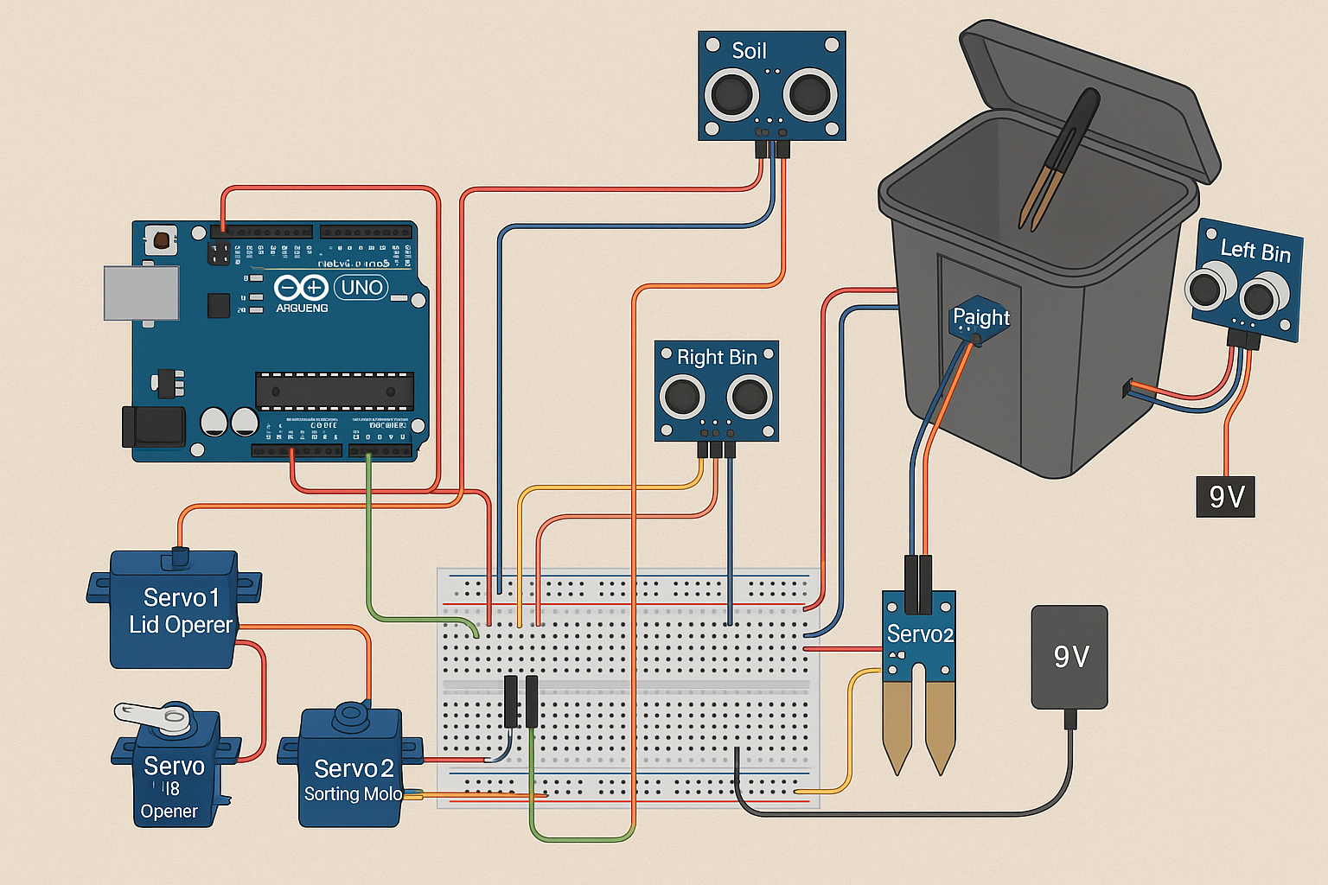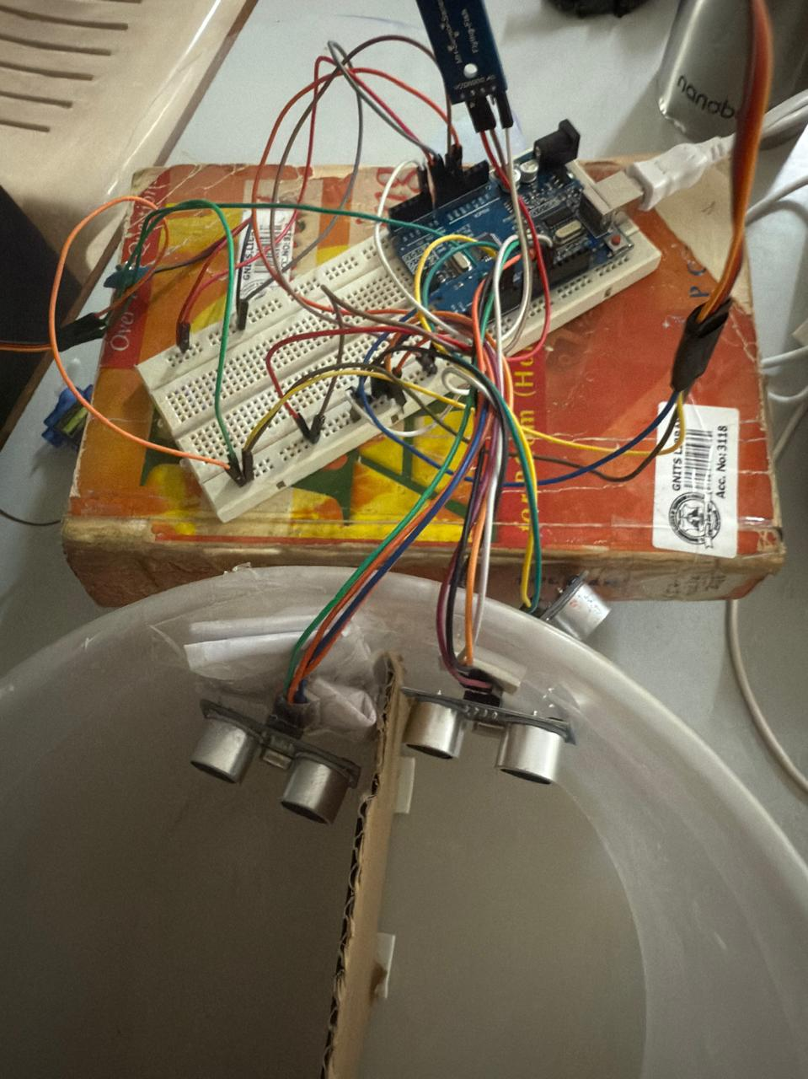

- Upload the Arduino code via Arduino IDE.
- Power the system by using a USB cable.

Web Dashboard Setup:
- Set up the Flask backend to fetch and display sensor data from the serial reader, which is real-time live data.
- Launch the HTML dashboard locally or on a hosted server.

Steps to run the project
- Take a dustbin, and make the connections as per the setup - connecting servo motors, ultrasonic sensors, soil moisture sensor using the jumper wires to the breadboard and Arduino.
- After the lid is opened by sensing an object/person in front it, place the waste on the soil moisture sensor, which will automatically detect if it’s wet/dry and segregate in it into the respective compartment.
- Parallelly, the web application dashboard keeps reading the real-time live data by using serial monitor and will display:
- Object detection (green for detected, red for not detected)
- Real-time Moisture levels
- Waste type (dry or wet waste)
- Level of fullness (both dry and wet wastes)

Usage
- Place the bin in a public area.
- When a user approaches, the lid opens automatically.
- Waste is deposited and classified as dry/wet using a moisture sensor.
- Sorted into the correct compartment.
- Data is updated to the web dashboard which reflects the current status.

Project Structure
SmartWasteManagement/
├── Arduino_Code/
│ └── " Arduino IDE"├
── WebApp/
│ ├── static/
│ │ └── styles.css
│ ├── templates/
│ │ └── dashboard.html
│ └── app.py (Flask server)
│ └── serial_read.py (Real-time data reader)
│ └── data.json (Last live data)
└── Documentation/
└── SWMS_documentation.docx

Outputs
- Bin Dashboard: Displays bin fill levels, type of waste - dry or wet waste, moisture levels, and detects object presence.
- Live-Time Data Feed
- System Interaction: Auto-classification and lid movement based on sensor inputs.

Authors
Amogha Sri Kommera - 23251A0568
Sirimalla Vyshnavi - 23251A0594
Sri Harshita Kemburu - 23251A0595

