Over the wire - Walk through
Level 0

Password - bandit 0

Level 0 -> 1

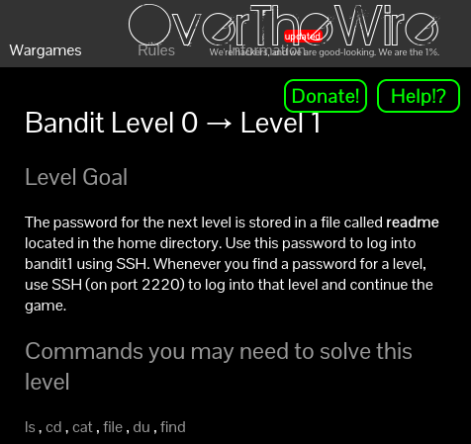

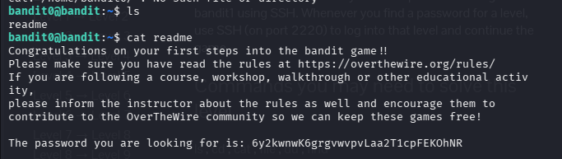

Level 1 -> 2

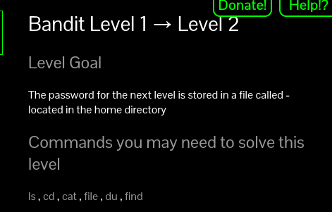

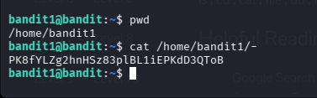

Level 2 -> 3

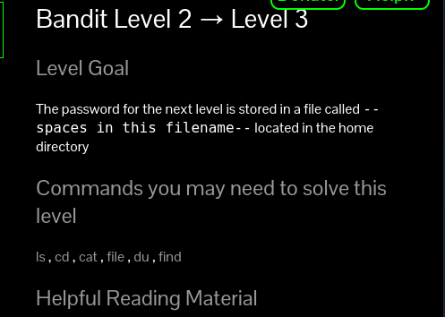
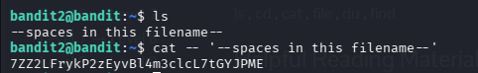

Level 3 -> 4

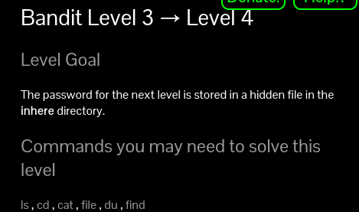

We can use ll or ls -la to list all hidden files
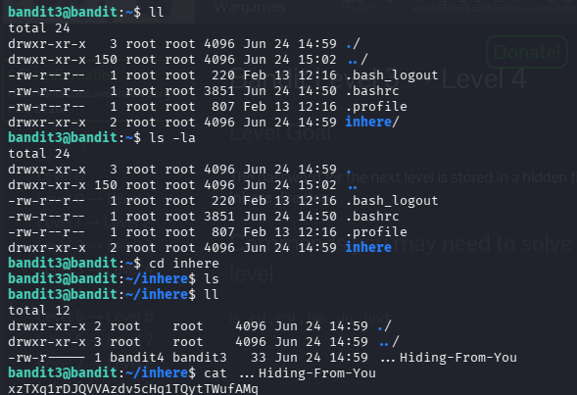

Level 4 -> 5

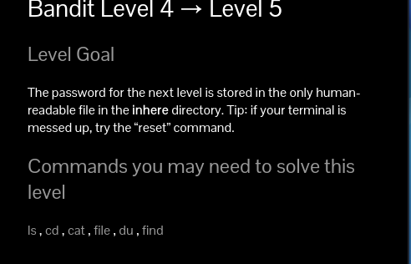

In the question it is stated that the flag is in the human readable format file, to see the file type we use the command ‘file’ instead of visiting every file we use ‘file – *’ to see all files with their type.
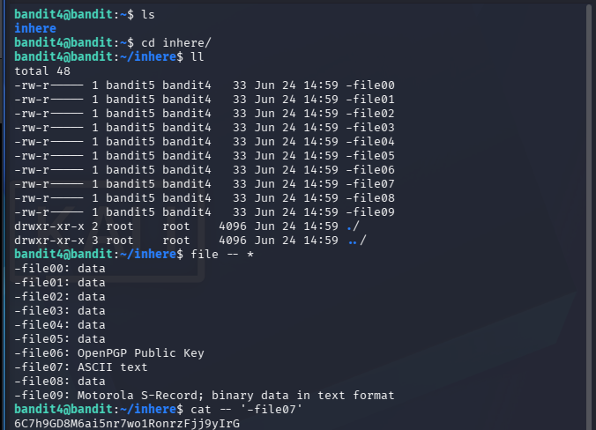

Level 5 -> 6

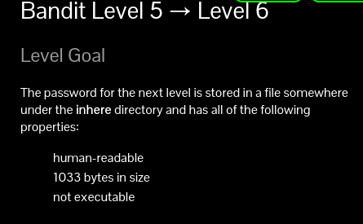
Here the file size seems to be most prominent clue so used file size and the ‘c’ denotes the bytes size.
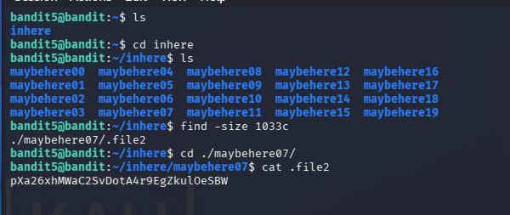

Level 6 -> 7

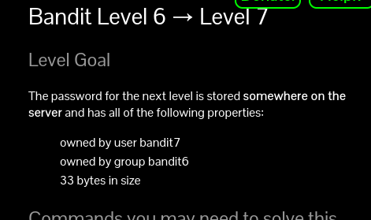
Here 2>/dev/null denotes the result regarding permission denied isn’t displayed, the permission denied has sequence code of 2.
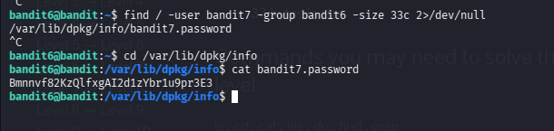

Level 7 -> 8

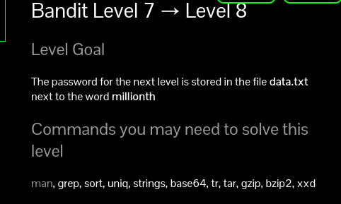

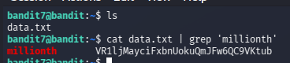

Level 8 -> 9

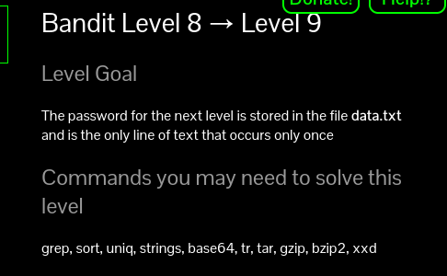
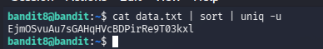

Level 9 -> 10

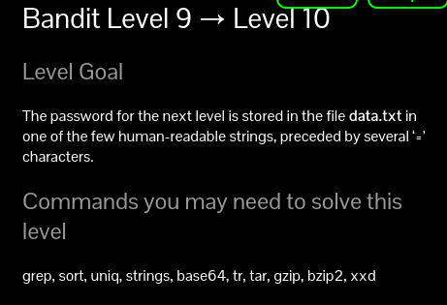

The ‘strings’ command returns only human readable characters, and in the given it is said that password is preceded by several ‘=’ to fetch the result we use ‘grep’ command.

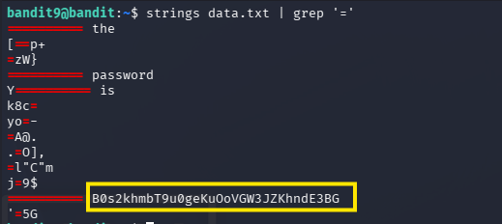

Level 10 -> 11

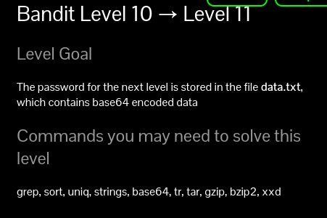
We used ‘-n’ so that the echo command doesn’t add new lines (enter) after each decoding. Sometimes it corrupts the file.
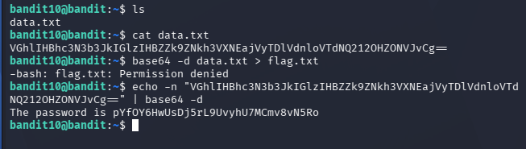

Level 11 -> 12

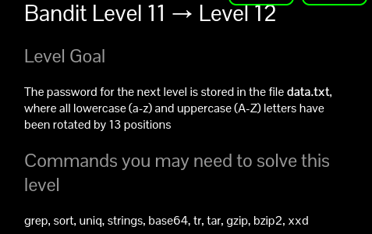
The word is rotated every 13 alphabets and to solve this we use the ‘tr’ command where it expands to “Translate” it needs two sets ‘Set1’ ‘Set2’ where it translates set1 to set2.

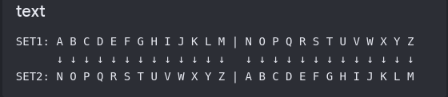

‘A-Za-z’ => Set1 and ‘N-ZA-Mn-za-m’ => Set2
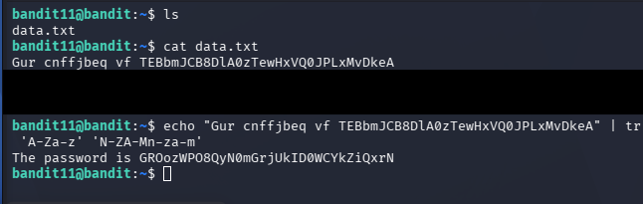

Level 12 -> 13

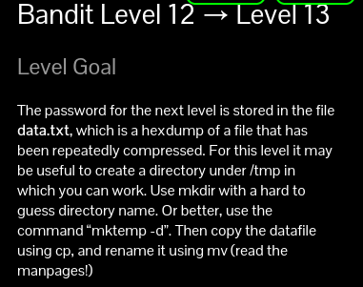

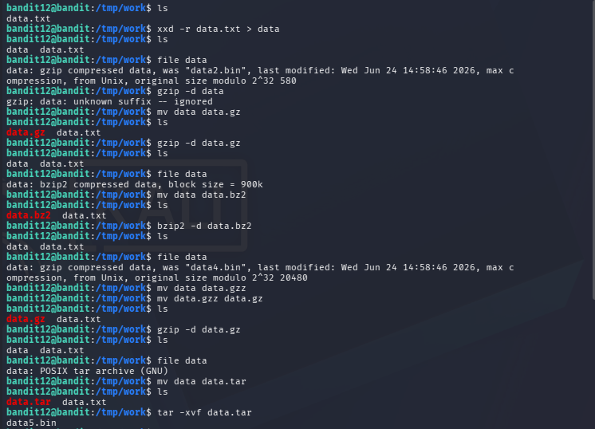
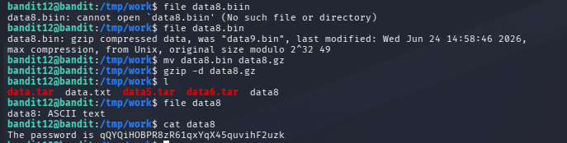
Multiple compression methods used, bzip2 - .bz2, gzip - .gz, POSIX - .tar we decompress it.

Level 13 -> 14

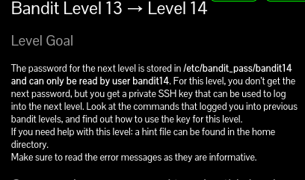

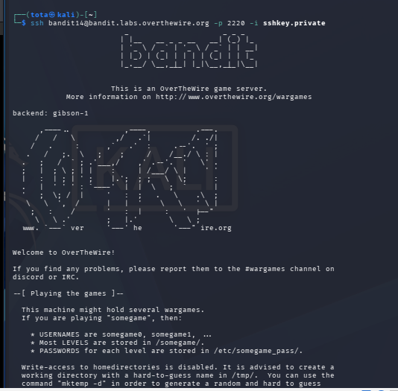

SSH connection can be established by two ways 1) Password connection and 2) Using the private key of the client. This problem is based on using private key of the client and the connection is established. It is done by using parameter ‘-i’ and the private key.While connecting with the ssh server make sure the key file has correct modification. Do that with the help of ‘chmod 000 sshkey.private’ this modification allows read write permissions to the owner only

The bandit14 connection is established and the password for the bandit is stored in a file, /etc/bandit_pass/bandit14.

Level 14 -> 15
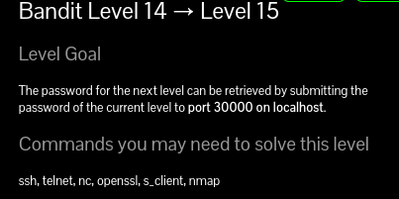
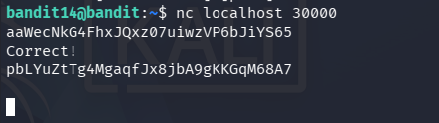

Level 15 -> 16
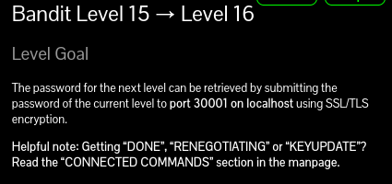

To add ssl/tls encryption while initiating connection we use –ssl command along with ncat to connect
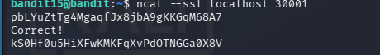

Level 16 -> 17

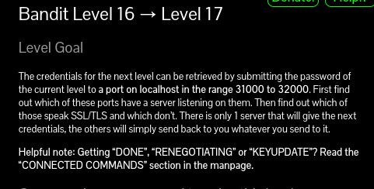

Scan the local host using the nmap, In the question it is given that the service is communicated with ssl/tls service so we try to connect the ports one by one.
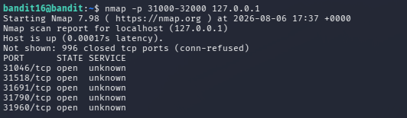

ncat –ssl localhost port is done recursively to gain the outcome. The outcome is a private key of ssh service and we use that to connect bandit17 and extract password in the
‘/etc/bandit_pass/bandit17’directory.

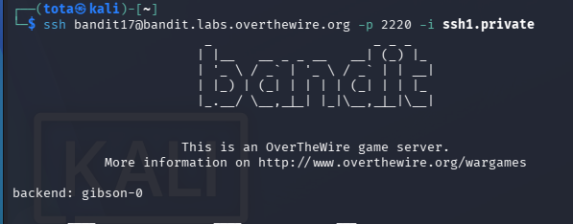

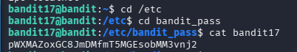

Level 17 -> 18

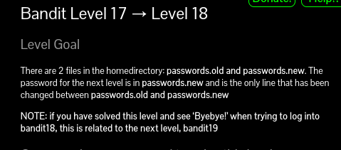

If the password is entered it shows the connction is not established blah blah.. Because teh .bashrc is rejecting request this problem is associated with level 18 -> 19.

Level 18 -> 19

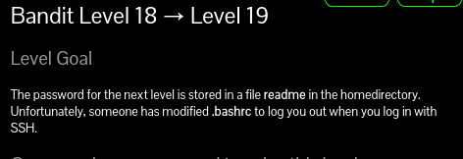

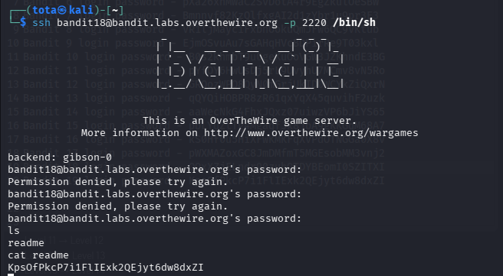
The service is degraded from ssh to sh (bourne shell) to avoid .bashrc termination.

Level 19 -> 20
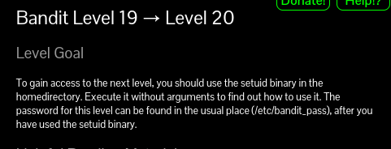

Setuid is a command allows user to escalate privilege

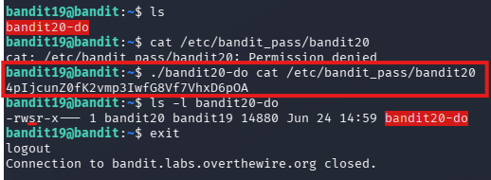

Level 20 -> 21

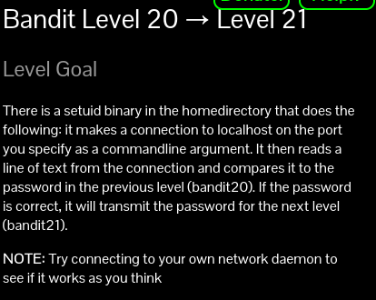

First initiate listening port on the localhost with any port number (unregistered)
Then, use ./suconnect to connect to the listening port.
So the password for the previous level is verified on the suconnect and if it matches right it provides the password for the next level.
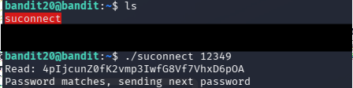

Level 21 -> 22

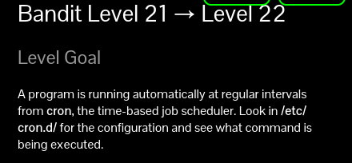

Cron job is a scheduled task in linux/unix which runs automatically at specific time or intervals.
The cron job is found at /etc/cron.d/
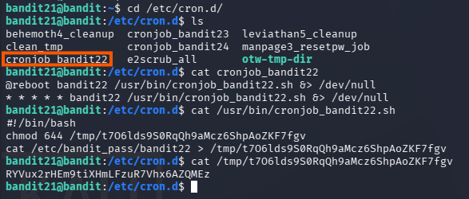
The cron job executes shell file regularly bandit22 /usr/bin/cornjob_bandit22.sh
So we cat the shell file and we saw /etc/bandit_pass/bandit22 file, the password for bandit 22 is written at /tmp/t706lds9S0RqQh9aMcz6ShpAoZKF7fgv so if we cat the file we see the password for bandit 22.

Bandit 22 -> 23

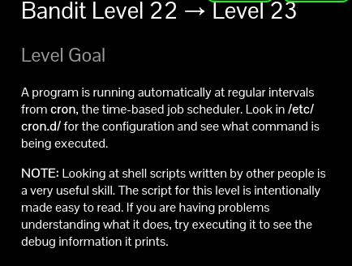

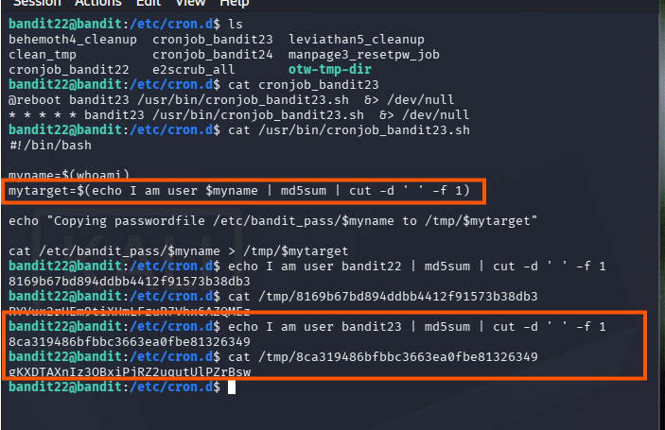
The hash value is made by the “echo I am user $username | md5sum | cut -d ‘ ‘ -f 1 “ and the hash value is the file name under tmp/.

Bandit 23 -> 24

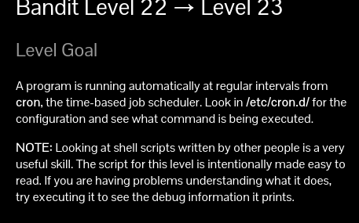
This is done by creating a directory and file in /tmp and writing a shell script and chmod 777 to all files and directories so that the cron job shell file can access it and make modifications and the cron job file scrip deletes the created script file every 60 seconds so, if the file is deleted then the password is stored in the text file or directed file to save on.
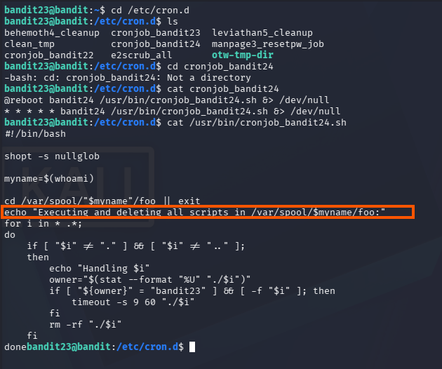

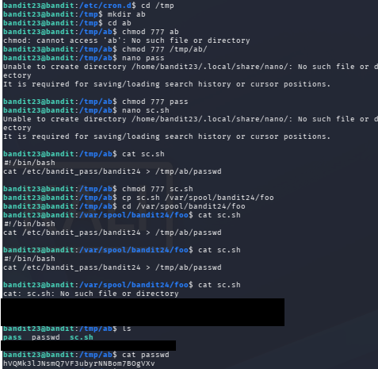

Bandit 24 ->25

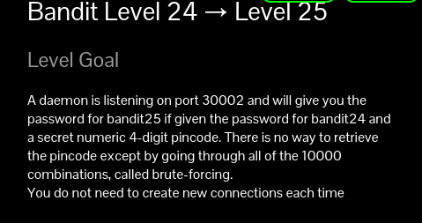

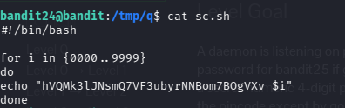

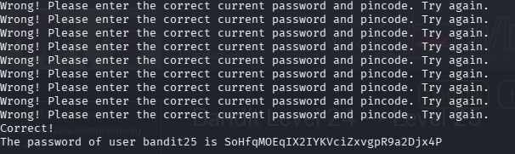

Bandit 25 -> 26

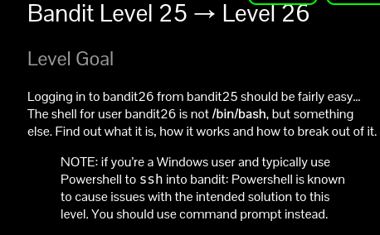

So the bandit26 uses some other connection service than ssh so we use cat /etc/passwd, this command lists all the users information
After cat /etc/passwd,
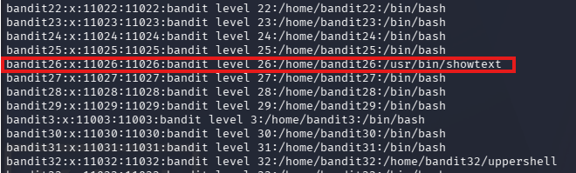
We see bandit 26 is using “/usr/bin/showtext” instead of /bin/bash.\
To connect bandit 26 use the private key to gain access to ‘more’ terminal.
After gaining terminal access enter ‘v’ to gain vim text editor with terminal interface and enter
“:r /etc/bandit_pass/bandit26” to gain flag of the bandit 26

It uses custom shell instead of bash so in the custom shell code the terminal is accessed only when the terminal is small enough and the ‘more’ is shown we get terminal with vim text editor.

Level 26 -> 27
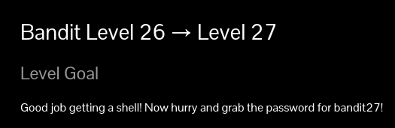

So after gaining flag of the level 26 we can’t login because level 27 follows it.
Try to connect bandit 26 with private key same as done above
After gaining terminal access enter ‘v’ to gain vim text editor with terminal interface and enter
“:set shell=/bin/bash” then type “:shell”
To gain the bandit26 terminal and ls to see all executable files and run them as privileged as bandit27.
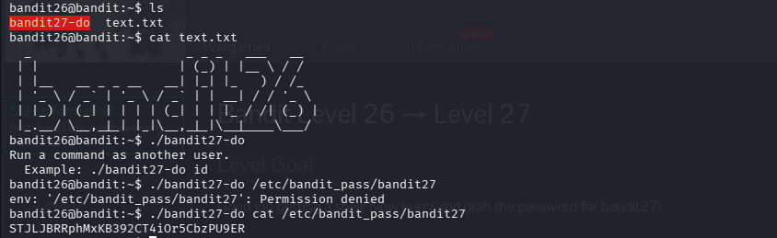

Bandit 27 -> 28
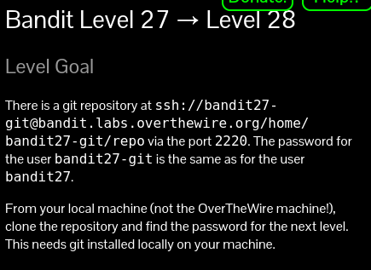
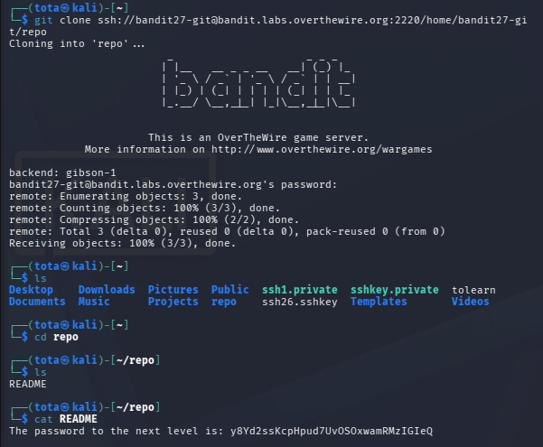

Bandit 28 -> 29

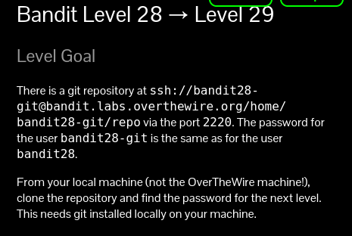

Using the git commit log we can the previous commits of credentials and gain the password, if we simply cat readme.md we see “XXXXXXX” so we use git log -p to view history of the commits.

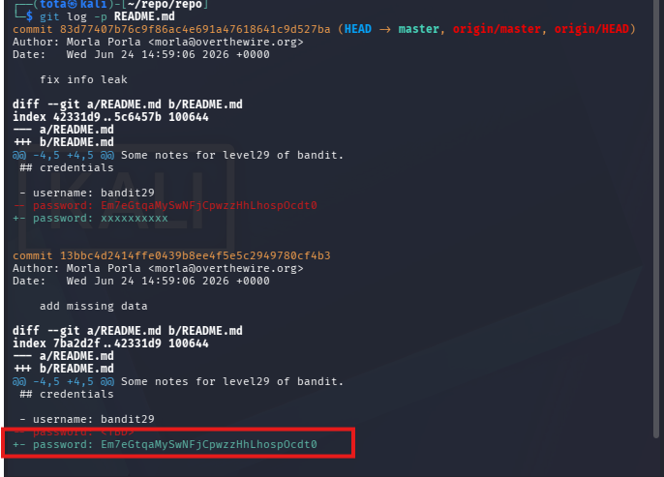

Bandit 29 -> 30

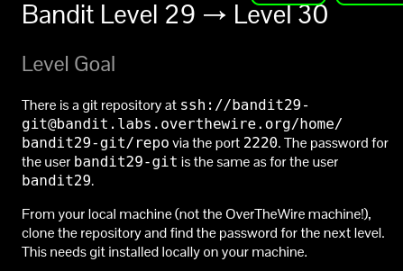
This problem is based on branches and production in git, we use git branch -a to list all git branch and use git switch <branch name> to switch git branch
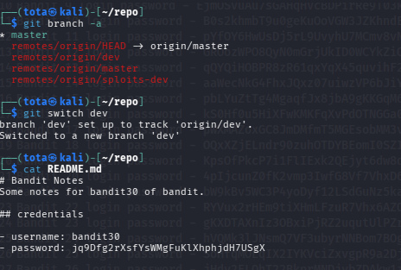

Bandit 30 -> 31

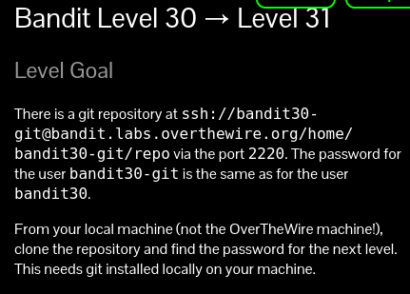

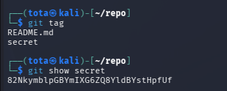
This is based on the git tag, to view tag we use show tag <tagname>
(Git tag is a fixed reference to a specific commit in the commit history)

Bandit 31 - 32

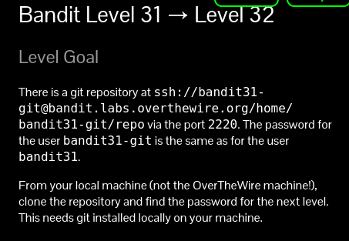

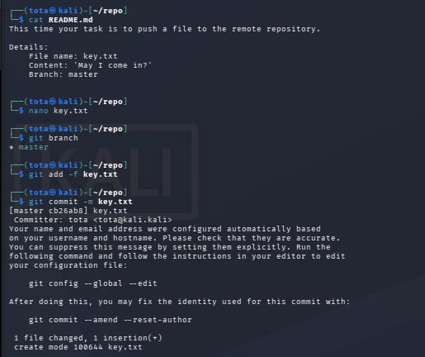

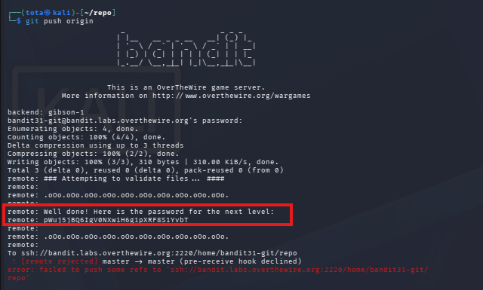

Bandit 32 -> 33

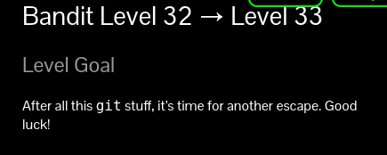

After logging into bandit 32, we enter into uppercase shell so we use ‘$0’ It holds the name of the current shell and redefines the shell that is used while logging it.
Since bandit 33 has access to uppercase file we escalated as bandit 33 and we ‘cat’ the flag easily.
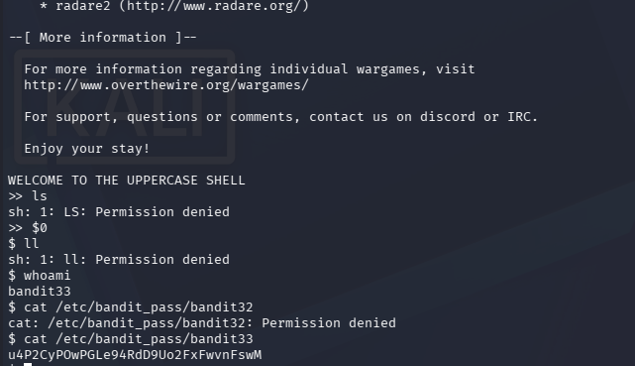

Bandit 33 -> 34

GAME OVER!!

