Integration Project Proposal
ECE 539 Fall 2026 | Team G11
Project title Leaf Doctor: a tomato disease triage assistant for real garden photos

Purpose and data
Question A home gardener sees spots on a tomato plant and cannot tell which disease it is. Input: one phone photo of a leaf. Output: one of four useful actions: retake the photo, follow care steps from an Extension fact sheet, answer one question that separates two likely diseases (the answer selects the care steps), or send a sample to the UW Plant Disease Diagnostics Clinic, which takes home gardeners' samples from Wisconsin [13]. Our Brief found that lab accuracy does not carry over to garden photos, so we judge the system by the advice a gardener gets on real photos. What makes this distinctive: other teams also work on tomato leaves, and a common version of this idea reports a label on lab photos. Ours is judged on real photos only, outputs a decision and not a label, and treats a wrong answer as harm it can avoid by asking or referring.
Data PlantVillage [1] supplies lab photos: 15,080 images in the 8 tomato classes that also appear in PlantDoc. PlantDoc [2] supplies real photos: 746 photos with 2,930 labeled leaf boxes across the same classes. Targets: bacterial spot, early blight, late blight, leaf mold, Septoria, mosaic virus, yellow leaf curl virus, or healthy. PlantVillage's spider mite and target spot classes are dropped because PlantDoc has almost none.
Readiness Access is verified: both datasets are downloaded and the split files are committed. Preprocessing crops each labeled box with a 10% margin, scales the short side to 256, and takes a 224 by 224 crop. The independent split unit is the physical leaf for PlantVillage and the photo for PlantDoc. Hashing PlantDoc found 25 near-duplicate photos, with 5 duplicate groups crossing its official train and test split, so we group duplicates before splitting.
Partition | Source | Size | Used for
Train | PlantVillage, PlantDoc in change arm | 12,047 images, 446 photos (1,829 boxes) | Parameter updates
Development | PlantVillage and PlantDoc | 3,033 images, 112 photos (427 boxes) | All choices
Final | PlantDoc only, with all official test photos | 188 photos, 674 boxes | One run after freezing

Research basis and architecture
Research basis Each stage has a distinct job for the gardener: the finder checks the photo, the classifier names likely diseases, the gate decides what to do, and the writer explains it. Sources decide each method.
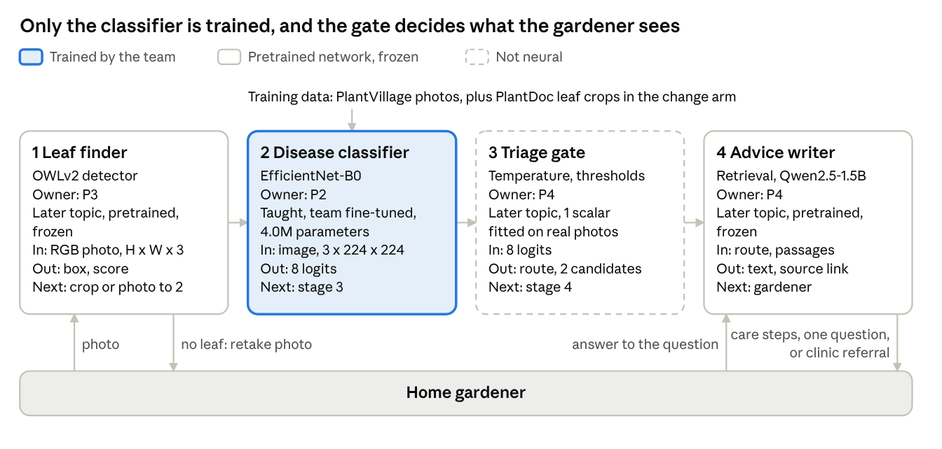
Stage | Approaches compared | Choice and reuse | Limitation
Find the leaf | Train on PlantDoc boxes, or text-prompted detectors: OWLv2 [6], Grounding DINO [7] | OWLv2 as published. It needs no training data, and we prompt it with phrases such as "a tomato leaf" | May box the wrong leaf: in our pilot, 64% of best boxes reached 0.5 overlap with a labeled leaf
Name the disease | Train from scratch or fine-tune. Lab data only or real photos too | Fine-tune EfficientNet-B0 [8]. Transfer learning always beat scratch training in [3]. Training the head first, then all layers, was 10% better under distribution shift [5] | [2] reports 15% on whole real photos when lab-trained and up to 71% cropped and fine-tuned on real photos, without saying one photo's crops stay together. 8 background pixels reached 49% on PlantVillage [4]
Decide what to do | Always answer, or decline when unsure [10]. Raw or calibrated confidence [9] | Temperature scaling, then thresholds. We fit it on real photos, because [9] assumes matching distributions | Thresholds chosen on few photos are noisy
Write the advice | Free generation, or retrieval then rewriting [11] | Retrieve the passage by class, rewrite with Qwen2.5-1.5B [12] (3 GB, Apache-2.0) | UW sheets cover 5 of 7 diseases [13]. Leaf mold and yellow leaf curl use UConn and NC State

Training The disease classifier is the team-trained stage. Data and targets are leaf images with one of 8 labels. The loss is cross-entropy with class-balanced sampling, since training classes range from 293 to 4,246 images. Updates are 200 steps on a new 8-way head with the backbone frozen, then 600 steps on all 4.0M parameters at a lower rate (AdamW, batch 64). The leaf finder and language model stay frozen. Learning needs: CNNs and fine-tuning are taught, while text-prompted detection and language models are later topics for P3 and P4.

Evaluation
Baseline and change The baseline is the complete pipeline with a classifier fine-tuned on PlantVillage only. It follows the lab-only training of [3], with our shared gate, and shows what a lab-trained system does for a real gardener. The one technical change: the 1,754 usable PlantDoc training crops fill half of each batch on average. Everything else is matched: network, 800 updates, batch size, learning schedule, augmentation, seeds 0, 1 and 2, gate fitting, and final photos. The change wins if its paired macro-F1 gain on final photos has a 95% interval above zero and wrong advice stays under 5%. A majority-class guess is the floor.
112 development photos, mean ± seed s.d. | Floor | Baseline: lab only | Change: lab and real
Macro-F1, whole photo (seed 0 photo interval) | 0.04 | 0.16 ± 0.02 (0.11 to 0.24) | 0.56 ± 0.01 (0.46 to 0.66)
Macro-F1, finder's best box |  | 0.20 ± 0.01 | 0.55 ± 0.02
Accuracy, whole photo | 20% | 24% | 59%
Macro-F1, 3,033 lab photos |  | 0.99 | 0.97
Right advice (advised, correct) / wrong advice |  | 1% / 0% | 21% / 5%
Asked one question / referred to the clinic |  | 0% / 99% | 11% / 63%

The pilot repeats the published gap: 99% on lab photos and 24% to 30% on real ones, against about 31% in [3]. Once calibrated, the baseline refers nearly every photo. The right disease is in the top two for 79% of change-arm photos, which is why asking one question is worth building. The finder's crop is within photo-level noise of the whole photo in both arms (0.20 against 0.16, 0.55 against 0.56), far from the gain in [2], so we decide its role on the change arm. Gate thresholds (0.70 to advise, 0.85 for the top two to ask) are first guesses and temperature was fitted on crops from these same photos, so the outcome rates, measured on whole photos, are optimistic.
Measures Task metric, which decides the comparison: macro-F1 over the 8 classes on real photos, with 95% intervals from resampling photos, since final classes range from 14 to 37 photos. Useful outcome: the share of photos that get right advice, wrong advice, a question, or a referral. Diagnostics: per-class confusion, whole photo against finder crop against labeled crop, a background check after [4], and whether the finder rejects about 30 non-leaf photos we collect, which tests the retake route. End-to-end check: the notebook prints each stage's output for real photos, and two teammates check that every care step traces to its fact sheet.
Fair test All choices use train and development data: learning settings, the finder's role, temperature, and thresholds. The final partition stays unread by any model (the code refuses to cache it) until the system is frozen on Dec 2. We then run it once for both arms and report the result whatever it shows. The 5 mixed-label final photos are not scored.

Feasibility
Resources The target is a free Colab GPU, which is not guaranteed [14], so checkpoints save to Google Drive, with a teammate's RTX 3090 and RTX 5070 Ti lab machines as backup. Measured: 800 updates take 55 seconds on the RTX 3090 and 4.8 minutes on an Apple M4 Pro laptop, where the finder takes 0.32 seconds per photo and the language model 2 to 3 seconds per answer. Colab timing is measured by Nov 9. Storage is about 6 GB: PlantVillage tomato 247 MB, PlantDoc 1.9 GB, models 3.7 GB. The comparison needs 6 training runs, budgeted at 30 minutes each, well under Colab's 12-hour limit [14].
Risk and fallback Main risk: real-photo results stay too weak to help. The pilot refers 63% of photos, gives wrong advice on 5%, and has a mosaic virus F1 of 0.25 on 8 photos. Test on Nov 15, on development data at 3 seeds, after tuning thresholds and training length: we need under 50% referral with under 5% wrong advice. If that fails, the fallback merges the pairs the pilot confuses most (bacterial spot with Septoria, mosaic with yellow leaf curl) and gives shared advice. Same date: if crops do not beat whole photos in the change arm, the finder only checks for a usable leaf and the classifier gets whole photos. A two-photo trace also found the language model changing a disposal step (the sheet says trash pickup) and asking from book knowledge, not what a gardener can see. The step-to-source check should flag this, and the fallback quotes the sheet and shows both symptom descriptions.

GitHub setup and responsibilities
Repository leaf-doctor, https://github.com/ksha23/leaf-doctor. Public, with workspaces P1 to P4 and final/.
Shorthand | Responsibility and deliverable
P1 | Data, splits, baseline, evaluation harness → notebook, outcome tables
P2 | Classifier, controlled comparison → 3-seed arms, loss curves, diagnostics
P3 | Leaf finder, integration → overlap results, handoff tests, final/ notebook
P4 | Gate, advice writer → fitted gate, passages, step-to-source check, demo

Work plan
Target date | Checkpoint | Owner | Completion evidence or dependency
Nov 1 | Proposal | P1 | Plan, public repository, frozen partitions, pilot results
Nov 9 | First baseline | P1 | Team reruns the baseline in Colab on development data, with Colab timing
Nov 15 | Neural stage | P2 | Both arms at 3 seeds, with confusion and background diagnostics
Nov 15 | Gate and finder | P3, P4 | Gate fitted, finder role and non-leaf check done, risk test decided
Nov 20 | Advice writer | P4 | Passages for 8 classes, first step-to-source check
Nov 22 | Progress | P1 | Report, notebook evidence, findings, next test
Nov 30 | Integration | P3 | Complete pipeline in one notebook, tracing real photos through every handoff
Dec 2 | Freeze, final run | P1 | Settings frozen, then one final-partition run for both arms
Dec 6 | Review ready | P1 | Repository, results, and presentation slides
Dec 7 or 9 | Demo | all | Assigned three-minute presentation
Dec 9 | Final | all | Team package, individual statements and reviews

References
[1] D. Hughes, M. Salathé. An open access repository of images on plant health. 2015. arXiv:1511.08060 [2] D. Singh et al. PlantDoc: A Dataset for Visual Plant Disease Detection. CoDS COMAD 2020. arXiv:1911.10317 [3] S. Mohanty, D. Hughes, M. Salathé. Using Deep Learning for Image-Based Plant Disease Detection. Front. Plant Sci. 7:1419, 2016. DOI [4] M. Noyan. Uncovering bias in the PlantVillage dataset. 2022. arXiv:2206.04374 [5] A. Kumar et al. Fine-Tuning can Distort Pretrained Features and Underperform Out-of-Distribution. ICLR 2022. arXiv:2202.10054 [6] M. Minderer et al. Scaling Open-Vocabulary Object Detection. NeurIPS 2023. Paper [7] S. Liu et al. Grounding DINO. 2023. arXiv:2303.05499 [8] M. Tan, Q. Le. EfficientNet: Rethinking Model Scaling for CNNs. ICML 2019. Paper [9] C. Guo et al. On Calibration of Modern Neural Networks. ICML 2017. Paper [10] Y. Geifman, R. El-Yaniv. Selective Classification for Deep Neural Networks. NeurIPS 2017. Paper [11] P. Lewis et al. Retrieval-Augmented Generation for Knowledge-Intensive NLP Tasks. NeurIPS 2020. Paper [12] Qwen Team. Qwen2.5-1.5B-Instruct model card. Hugging Face [13] UW-Madison fact sheets D0046, D0068, D0100, D0012, D0115, A1691. UConn leaf mold. NC State yellow leaf curl. UW clinic [14] Google. Colab FAQ. research.google.com/colaboratory/faq.html

