Linux ROS Melodic/Gazebo 9/PX4 1.10 Install Guide

*There are troubleshooting tips at the bottom of the document

1. First click this link <https://dev.px4.io/v1.10/en/simulation/ros_interface.html>

-This will take you to the ROS/Gazebo page on PX4’s webpage

-After scrolling down a bit, you will see “Installing ROS and Gazebo”

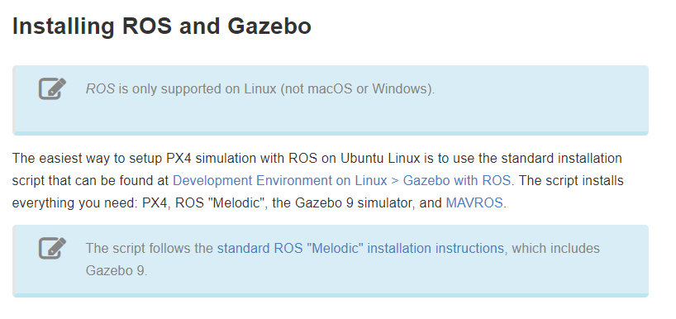

2. Clicking [“Development Environment on Linux > Gazebo with ROS”](https://dev.px4.io/v1.10/en/setup/dev_env_linux_ubuntu.html#rosgazebo) takes you to the script that will install PX4, ROS "Melodic", the Gazebo 9 simulator, and MAVROS.

-Follow these instructions to install everything

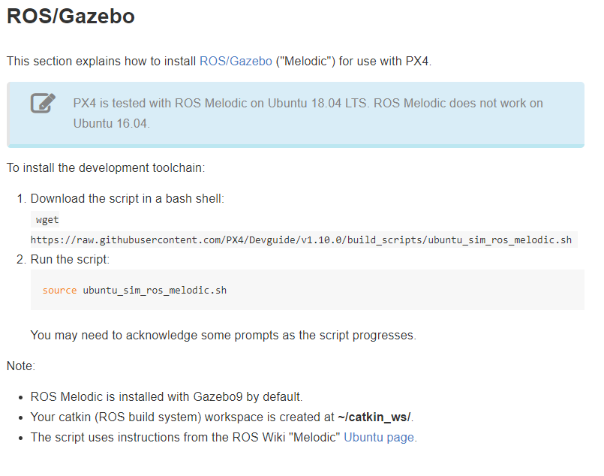

*note that if the wget command is not working the section in the URL may need to be edited to “v1.10” instead of “v1.10.0”

*If you would like to view the .sh script here is the [link](https://raw.githubusercontent.com/PX4/Devguide/v1.10/build_scripts/ubuntu_sim_ros_melodic.sh)

3. After the script has run, scroll down to “Next Steps” and continue to [“build instructions”](https://dev.px4.io/v1.10/en/setup/building_px4.html)



4. Follow the steps for “Downloading the PX4 Code”

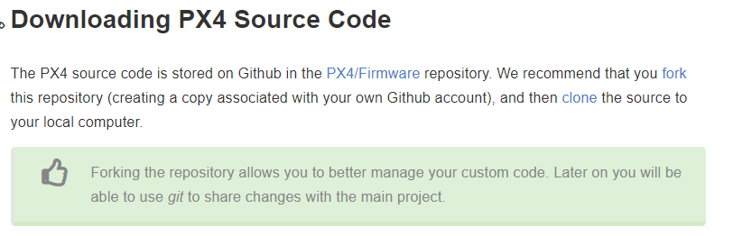

-The steps should involve forking and cloning the PX4 firmware

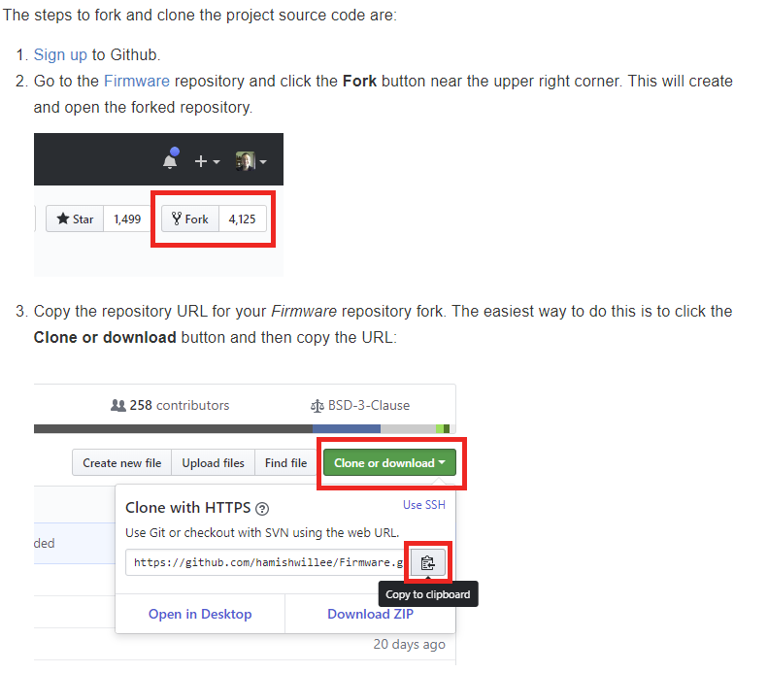

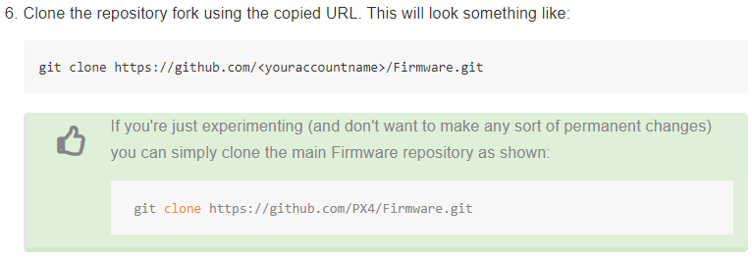

5. Go back to the link in step 1 <https://dev.px4.io/v1.10/en/simulation/ros_interface.html>

-Continue setting up Gazebo by typing in the commands listed under “Launching Gazebo with

ROS Wrappers”

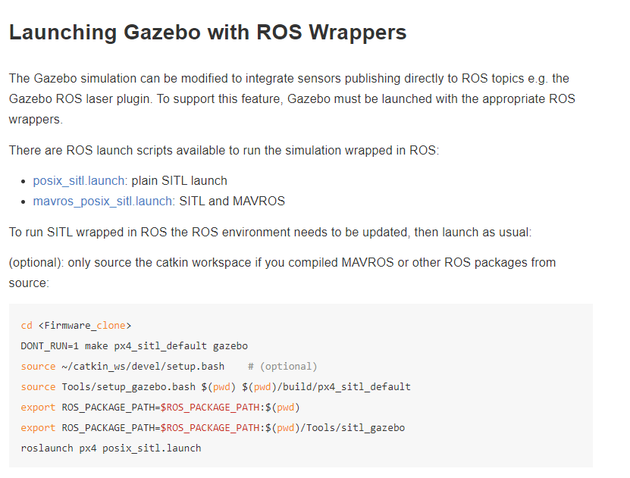

-Gazebo should be launching while connected to PX4. This setup is called simulation in the loop (SITL)

6. Test that ROS installed properly

-Type roscore in the terminal: /rosdistro should be melodic

7. Test that PX4 and Gazebo are set-up properly from this link: <https://dev.px4.io/v1.10/en/simulation/gazebo.html>

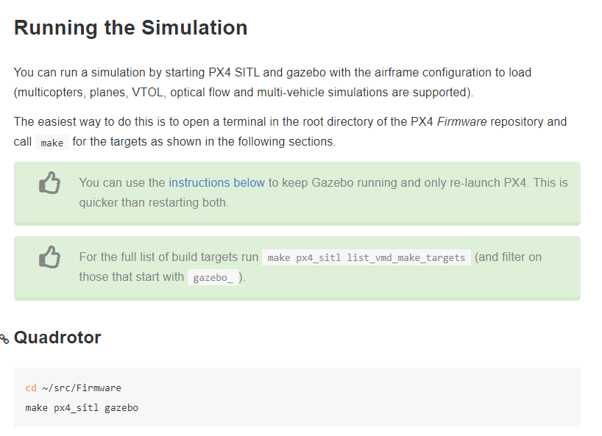

*This should start up Gazebo and PX4 in the terminal and create an empty world with a default Iris drone in Gazebo

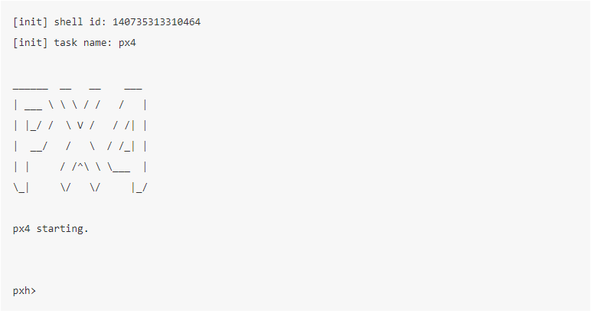

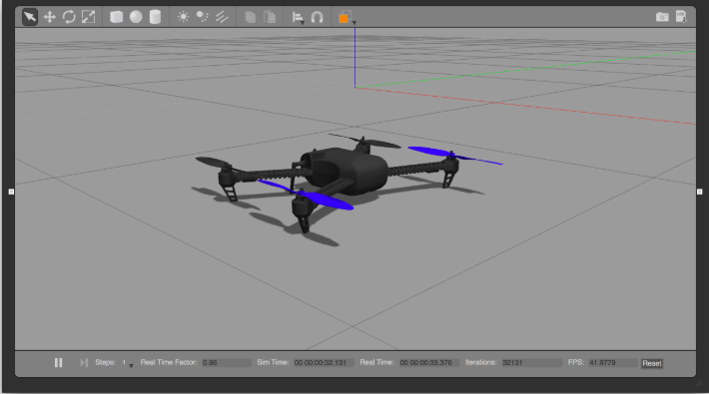

8. Create a test offboard example using the sample code in this link <https://dev.px4.io/v1.10/en/ros/mavros_offboard.html>

Troubleshooting:

1. If any issues come up mentioning “rosdep” after running the install script, try typing these commands

-Initialize rosdep

sudo apt install python-rosdep

sudo rosdep init

rosdep update

2. When testing the make px4_sitl gazebo command, if the px4 shell never starts and errors come up, the following dependencies may not be installed, try typing in the below commands

-Install sitl_gazebo plugin dependencies from the README <https://github.com/PX4/sitl_gazebo>

sudo apt-get install libprotobuf-dev libprotoc-dev protobuf-compiler libeigen3-dev libxml2-utils python-rospkg python-jinja2

sudo apt-get install libgstreamer-plugins-base1.0-dev gstreamer1.0-plugins-bad gstreamer1.0-plugins-base gstreamer1.0-plugins-good gstreamer1.0-plugins-ugly -y

sudo apt-get install python-toml python-empy python-packaging

3. If when trying to launch a node or launch file from the MAVROS package, an error comes up “ERROR: cannot launch node of type [mavros/mavros_node]: can't locate node [mavros_node] in package [mavros]”, check to see that the ROS package path includes the catkin workspace packages by typing

echo $ROS_PACKAGE_PATH

To source the catkin workspace package path, type

source ~/catkin_ws/devel/setup.bash

Now that you have a properly configured ROS Package Path, if the error persists, rebuild the catkin workspace.

cd catkin_ws  
catkin clean -y  
catkin build   
source /opt/ros/melodic/setup.bash  
source ~/catkin_ws/devel/setup.bash

The issue may be that not all the dependencies are installed. The initial setup script includes this next line, but it does not hurt to rerun this command as that can solve the above error.

rosdep install --from-paths src --ignore-src

These steps can be found in the [MAVROS Github README](https://github.com/mavlink/mavros/blob/master/mavros/README.md#installation) under “Source Installation”

In addition, you will need to Install the GeographicLib datasets using this command in the catkin_ws

./src/mavros/mavros/scripts/install_geographiclib_datasets.sh

Rebuild the catkin workspace with

catkin build

Rerun so ROS can find the nodes in the packages

source devel/setup.bash