Kanisha Shah

UID: 504958165

**2. K-Means**

For reassigning clusters, we assign the point to the closest cluster based on the following algorithm:

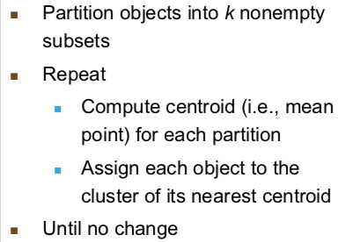

Compute the centroid (mean) using the following formula:

$$Centroid\left(x,y\right)=(\frac{\sum_{i}^{N}{x_{i}}}{N},\frac{\sum_{i}^{N}{y_{i}}}{N})$$

Where N is the total number of points.

**3. DBSCAN**

We calculate for DBSCAN based on this algorithm. We see in line 12 that we add the point to the cluster if it is not a member of any cluster.

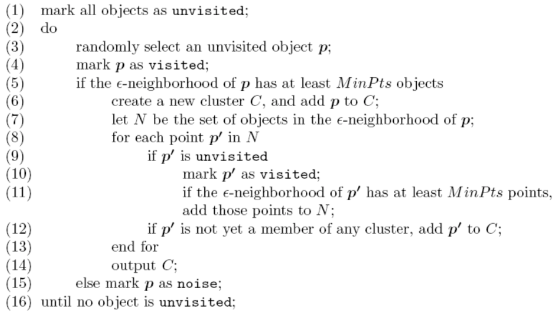

**4. GMM**

We calculate the E-step and M-step based on the following formulas:

E-step: Since we calculate the probability, the denominator for each cell would be the sum of all the possible options.

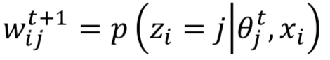

M-step: We calculate the covariance for x,y using the mean and update w[j].



**DataPoints.py**

We calculate the mean for x and y using the following formula:

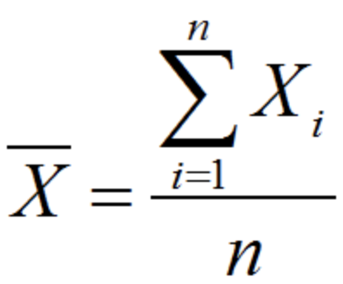

We calculate the standard deviation for x and y using the following formula:

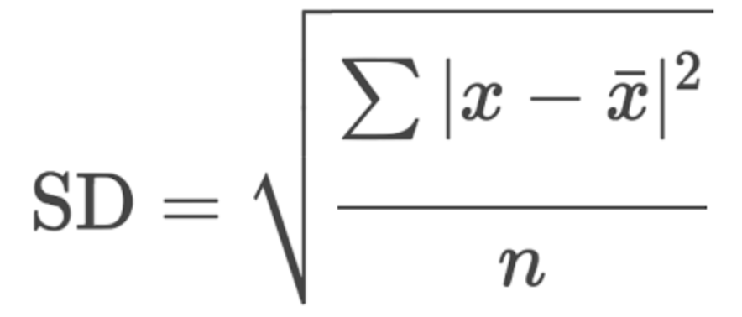

We calculate the covariance for x and y using the following formula:

