Fake News Detection Using Machine Learning and Streamlit

Title of the Project

Fake News Detection Using Machine Learning and Streamlit Web App
1. Objective
In today's digital age, the internet is the main tool for communication and sharing information. However, the easy publishing and sharing of content have caused misinformation and fake news to spread quickly. This project aims to create a smart system that can automatically label news articles as real or fake based on their content and metadata.
The system aims to provide:
• A user-friendly web application interface
• Multiple machine learning models for classification
• Evaluation of model performance using various metrics
• Interactivity for users to try different models and settings
By the end of the project, users will be able to upload or choose news data and receive a prediction about whether the news is real or fake. They will also see a visual evaluation of the performance of the chosen algorithm.

2. Proposed System

To combat the spread of fake news, we propose a machine learning-based classification system implemented as a web application using Streamlit. The system allows users to load a fake news dataset, apply preprocessing techniques, train various machine learning classifiers, and evaluate their performance using accuracy, precision, recall, and visual metrics such as confusion matrix, ROC curve, and precision-recall curve.
The classifiers integrated into the system include:
- Logistic Regression
- Random Forest Classifier
- Perceptron
- K-Nearest Neighbors (KNN)
- Decision Tree Classifier
The application is designed to be interactive and educational, enabling users to select a classifier, adjust hyperparameters, and observe how changes affect model performance. The deployed system is accessible at: https://newsfakedetection.streamlit.app/

C. Project Specifications

1. Problem Understanding & Dataset Source

The spread of false or misleading information has emerged as a serious threat to democratic institutions, public health, and individual decision-making. To train and test fake news classifiers, a synthetic dataset was used that mirrors the structure of real-world news data. The dataset contains 20,000 news articles, each labeled as real or fake.
Dataset Fields:
- title: Short headline (approx. 6 words)
- text: Full article text (200–300 words)
- date: Publication date (randomized over 3 years)
- source: Publisher (e.g., BBC, CNN, Al Jazeera) – contains ~5% missing values
- author: Author name – contains ~5% missing values
- category: News category (e.g., Politics, Health, Sports)
- label: Target label (real or fake)
The dataset provides a real-world simulation by incorporating missing values and diverse writing styles, enabling robust model development and testing.
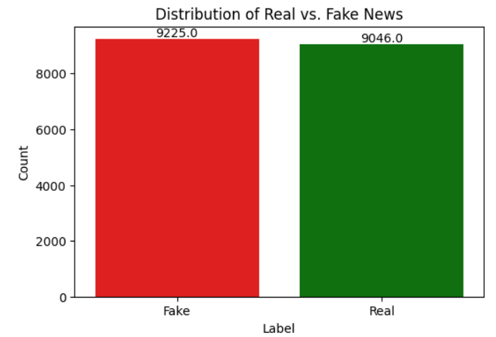

2. Tech Stack
Programming Language:
- Python 3.12
- Web Framework:
- Streamlit – used to create an interactive web application with live model predictions.
Libraries and Tools:
- Pandas & NumPy – for data handling and numerical operations
- Matplotlib & Seaborn – for data visualization (metrics and distributions)
- Scikit-learn – for preprocessing, model training, and evaluation
- Warnings – to suppress unnecessary warnings in production
Machine Learning Models:
- Logistic Regression: A linear model useful for binary classification.
- Random Forest: An ensemble method using multiple decision trees for higher accuracy and reduced overfitting.
- Perceptron: A fundamental linear classifier useful for datasets that are linearly separable.
- K-Nearest Neighbors: A distance-based classifier using the ‘k’ most similar instances.
- Decision Tree: A tree-like model that makes splits based on feature importance and thresholds.
Each model offers a unique trade-off between accuracy, interpretability, and computational complexity, allowing users to compare performance in real-time.
.

3. Hardware Requirements

Minimum system requirements to run and deploy this project:
Resource | Specification
Processor | Intel i3 or higher
RAM | 4 GB minimum
Storage | 1 GB for dataset & cache
Operating System | Windows/Linux/MacOS
Browser | Chrome, Firefox, Edge
Internet | Required for deployment

D. Problem Taken Up

Domain: Natural Language Processing (NLP) + Media Analysis
The proliferation of fake news has become a societal issue. Traditional manual fact-checking processes are time-consuming and not scalable. There is an urgent need for automated systems that can classify and detect such content with minimal human intervention.
The problem statement addressed by this project is:
“Design a machine learning solution that can distinguish between fake and real news articles using content features, and present the results in an interactive web-based dashboard.”
This system is aimed at students, journalists, media organizations, researchers, and the general public who seek a tool for real-time misinformation detection.
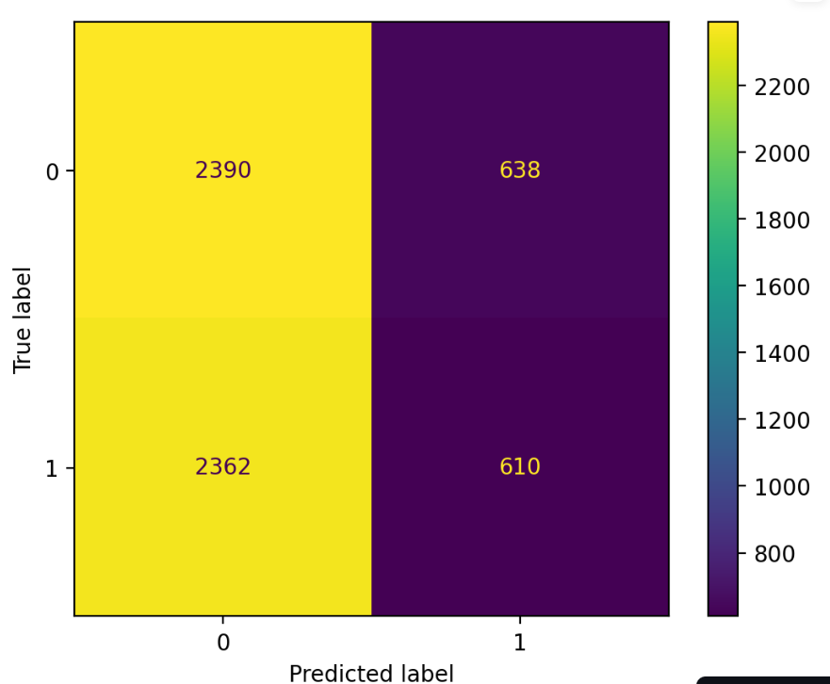

E. Analysis of the Problem

AI Project Lifecycle
Below is a detailed explanation of the AI workflow stages applied in this project:
1. Data Acquisition
The data was synthetically generated to simulate realistic news articles. It includes balanced classes (real and fake), partial missing values (~5%) and categorical data such as author and source.
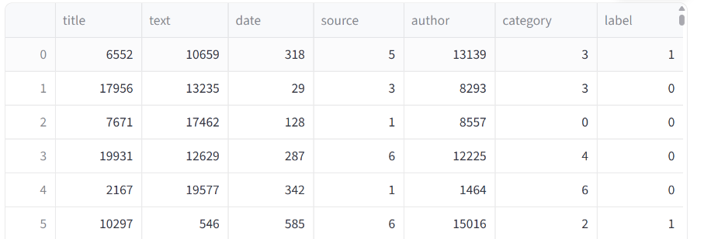
2. Data Preparation & Preprocessing
- Missing values are not imputed but encoded using LabelEncoder.
- All string-based features are converted into numeric format.
- The dataset is split into training and testing sets using train_test_split (70/30 ratio).
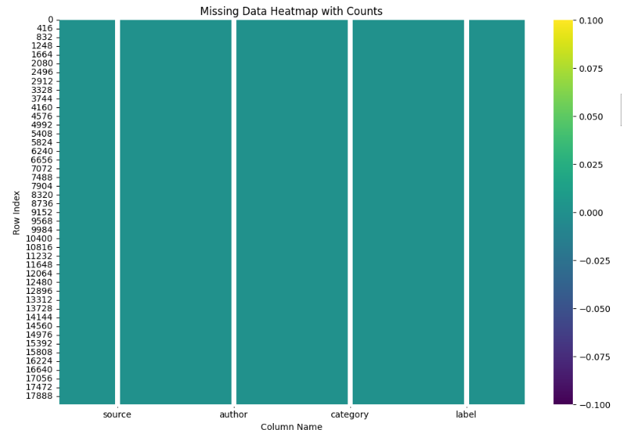
3. Model Training & Evaluation
Each classifier is trained using the training data. Evaluation is performed using:
- Accuracy: Percentage of correctly classified examples
- Precision: Ratio of correctly predicted positive observations to the total predicted positives
- Recall: Ratio of correctly predicted positives to all actual positives
- Confusion Matrix: Breakdown of predicted vs actual
- ROC Curve & AUC Score: Measures trade-off between true positive rate and false positive rate
- Precision-Recall Curve: Especially useful when data is imbalanced
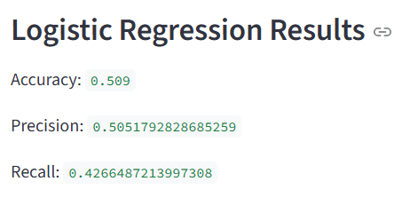
4. Deployment
- The application is deployed using Streamlit Cloud, making it accessible via a browser with no setup needed for the end-user.
- All logic is encapsulated in the fakenews.py file.
- Dynamic sidebar widgets allow real-time interaction.
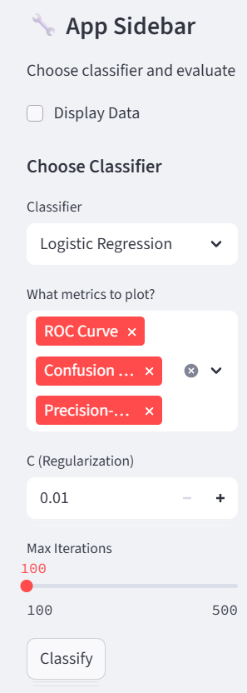
Code Explanation
The core code consists of the following components:
- Data Loading Function
@st.cache_data(persist=True)
def load():
data = pd.read_csv("fake_news_dataset.csv")
label = LabelEncoder()
for col in data.columns:
data[col] = label.fit_transform(data[col])
return data
- Train-Test Split
x_train, x_test, y_train, y_test = train_test_split(x, y, test_size=0.3, random_state=42)

- Model Training Block Example

LR = LogisticRegression()
LR.fit(X_train, y_train)

- Prediction and Evaluation

y_pred = model.predict(x_test)
accuracy = model.score(x_test, y_test)
precision = precision_score(y_test, y_pred)
recall = recall_score(y_test, y_pred)

- Metrics Visualization

ConfusionMatrixDisplay.from_estimator(model, x_test, y_test)
RocCurveDisplay.from_estimator(model, x_test, y_test)
PrecisionRecallDisplay.from_estimator(model, x_test, y_test)

F. Conclusion

This project provides a practical and efficient solution to a socially relevant problem—fake news detection. By integrating multiple machine learning classifiers in an interactive interface, the system allows users to experiment with classification techniques and gain insights into their performance. The deployed web app is lightweight, easy to use, and provides real-time feedback on model accuracy and reliability.
Each model has its strengths:
- Random Forest performed best in terms of accuracy and generalization.
- Logistic Regression offered good interpretability.
- KNN was useful for understanding local relationships but slower for large datasets.
- Perceptron showed moderate performance and was fast.
- Decision Tree gave transparent logic for decision-making.
G. Recommendations for Future Work
Advanced NLP Integration: Use TF-IDF, Word2Vec, or BERT embeddings to convert text data into more meaningful numeric vectors, improving classification.
Handling Missing Data: Instead of label encoding directly, use imputation techniques or create new features indicating missingness.
Model Optimization: Apply GridSearchCV or RandomizedSearchCV to tune model hyperparameters automatically.
User Input Interface: Allow users to input custom news text for real-time classification.
Streaming API: Integrate with news APIs to classify headlines in real-time from the internet.
Security Measures: If used at scale, ensure user data and model output integrity with security protocols.

