R. V. COLLEGE OF ENGINEERING, BENGALURU-560059

(Autonomous Institution Affiliated to VTU, Belagavi)

**DEPARTMENT OF COMPUTER SCIENCE AND ENGINEERING**



##### Subsidized Canteen Management System(SCMS)

##### Mini - Project Report

###### *Submitted by*

**JAYANT JAYAGOPAL USN 1RV16CS062**

**K SHARATH KRISHNA USN 1RV16CS067**

***DBMS Laboratory Mini Project (16CS52)***

**Under the Guidance of**

**Prof. Veena Gadad, Asst. Professor, CSE, RVCE**

**Academic Year 2018 - 2019**

**R.V. COLLEGE OF ENGINEERING, BENGALURU - 560059**

**(Autonomous Institution Affiliated to VTU, Belagavi)**

**DEPARTMENT OF COMPUTER SCIENCE AND ENGINEERING**



**CERTIFICATE**

Certified that the project work titled **‘Subsidized Canteen Management System(SCMS)’** is carried out by **Jayant Jayagopal(1RV16CS062) and Karanam Sharath Krishna (1RV16CS067),** who are bonafide students of R. V. College of Engineering, Bengaluru, in partial fulfillment of the curriculum requirement of 5th Semester Database Design Laboratory Mini Project during the academic year **2018-2019**. It is certified that all corrections/suggestions indicated for the internal Assessment have been incorporated in the report deposited in the departmental library. The report has been approved as it satisfies the academic requirements in all respect laboratory mini-project work prescribed by the institution.

**Signature of Faculty In-charge Head of the Department**

**Dept. of CSE, RVCE**

**External Examination**

**Name of Examiners Signature with date**

**1**

**2**

**Table of Contents Page No.**

1. Introduction 5
   1. Motivation.................................................................................

1.2 Existing System...................................................................................

1.3 Proposed System.................................................................................

1. Software Requirement Specification.......................................... 6
   1. Software Requirements..................................................................
   2. Hardware Requirements..................................................................
   3. Functional Requirements...................................................................
2. ER Diagram......................................................................................... 8
3. Detailed Design............................................................................... 10
   1. DFD Level 0................................................................................
   2. DFD Level 1.................................................................................
   3. DFD Level 2.................................................................................
4. Relational Schema and Normalization................................................. 14
5. Conclusion............................................................................................... 16

1. References................................................................................................. 17
2. Appendix: Snapshots........................................................................ 18

**List of Figures:-**

* Fig 3.1----------E R Diagram of SCMS
* Fig 4.1----------DFD level 0
* Fig 4.2----------DFD level 1
* Fig 4.3----------DFD level 2.1
* Fig 4.4----------DFD level 2.2
* Fig 4.5----------DFD level 2.3
* Fig 4.6----------DFD level 2.4
* Fig 5.1----------Relational Schema
* Fig A.1----------Home Page
* Fig A.2----------Administration Login
* Fig A.3----------Customer Registration
* Fig A.4----------Inventory Section
* Fig A.5----------Vendor Login
* Fig A.6----------Vendor Registration
* Fig A.7----------Menu
* Fig A.8----------Bill
* Fig A.9----------Customer Login
* Fig A.10-------- Food Token
* Fig A.11---------Give Feedback
* Fig A.12---------View Customer Feedbacks

**1. Introduction:**

Food is a vital element that provides nutritional support for living beings. Access to healthy and tasty food at an affordable price is a critical factor in sustaining human beings. History is witness to instances where unavailability and inaccessibility to food has resulted in malnutrition and often times death amongst the vulnerable sections of our society. To act as a nodal enabler to providing healthy and tasty food at an affordable price to the vulnerable sections of our society (BPL – below the poverty line citizens), we propose a software solution - "Subsidized Canteen Management System (SCMS)". We believe that the transparency, visibility, simplification of processes, and basic checks and validations will significantly help in the overarching goal of “Healthy food at an affordable cost”.

**1.1 Motivation:**

Access to healthy and tasty food at an affordable price is a critical factor in sustaining human beings. History is witness to instances where unavailability and inaccessibility to food has resulted in malnutrition and often time’s death amongst the vulnerable sections of our society.

**1.2 Existing System:**

The existing system is an offline manual canteen management system. This system is not monitored and the resources are not optimally allocated. There is no synchronization between the items in the inventory and the food being prepared. The absence of an effective token validation software makes this process of subsidized food distribution more cumbersome.

**1.3 Proposed System:**

The project will create a master database that stores relevant information about people who come under the BPL category. This information will have details such as Aadhaar card number, name, address, mobile number etc. Every person will be given a unique username and password. Once the login is successful, a token will be generated for breakfast, lunch or dinner depending on the time. Three tokens a day are highly subsidized. After that the food is reasonably charged. The main objective of this project, is to at least provide the basic minimum nutrition that is needed for an active person, while ensuring that the available resources are allocated optimally

**2. Software Requirement Specification**

* 1. **Software Requirements:**

* + 1. Operating System: Windows XP/7/Vista/10 or Ubuntu (16.04) /Fedora/Debian
    2. HTML/JSP (front end)
    3. MySQL Server with Workbench
    4. Java EE IntelliJ IDE (Ultimate Edition) with JDK 8 or later
    5. Web Browser: Microsoft Internet Explorer/Mozilla/Google Chrome/Opera
    6. Documentation Software: Microsoft Word 2010 or later edition
    7. Tomcat Apache Server 7 or later edition
    8. Antivirus Software: Kaspersky, Norton, McAfee
  1. **Hardware Requirements:** 
     1. Processor: 64-bit, 2 cores, Pentium IV or higher
     2. Processor Speed: 2.5GHz minimum per core
     3. RAM: 2GB or higher
     4. Hard disk: 2 GB free space for installation. For production use additional disk space for day to day operations.
  2. **Functional Requirements:** 
     1. **Customer’s Administrator Module:**
        1. Admin Login: Enables Administrator to login to the dashboard using administrator credentials.
        2. Add Customer: Administrator can add new staff records into Staff Table
        3. Delete Customer: Enables Administrator to remove Customer records from Database.
        4. Edit Customer: Enables Administrator to edit Customer records from Database.
        5. View Customer Database: Administrator can view Database
        6. Admin Logout: Administrator can log out of the dashboard
     2. **Customer Module:**
        1. Customer Login: Registered Customer can login using valid credentials
        2. Change of Password: Enable Password change when employee is logged in
        3. Generate token: Customer can generate token in given time slots.
        4. Order Food: Customer can order extra food at subsidised price.
        5. Logout: Customer can log out of the portal
     3. **Inventory’s Admin Module:**
        1. Admin Login: Enables Administrator to login to the dashboard using administrator credentials.
        2. Change of Password: Allows the administrator to change the password when logged in as admin.
        3. Add Worker: Administrator can add new staff records into Staff Table
        4. Delete Worker: Enables Administrator to remove Customer records from Database.
        5. List Vendors: Enables Administrator to view vendors.
        6. View Inventory Database: Administrator can view Inventory Database
        7. Admin Logout: Administrator can log out of the dashboard

**2.3.4 Feedback and Customer Rating Module:**

After placing an order the customer has a choice of giving his/her feedback. The feedback from customer is collected in the form of text and ratings(stars). This collected unstructured data forms the NoSQL database component. NoSQL was selected as it was suitable on larger databases. The support for Sharding was another advantage of using Mongo DB. Sharding is the process storing the data in different machines and utilize MongoDB’s ability to process data as the data grows. The feedback collected can be retrieved in a neat format using the pretty command in Mongo DB.

1. **ER Diagram:**

**3.1 Entities:**

* + 1. Customer( Username varchar(20), Password varchar(20), Age int(10), Name varchar(50), Cardno varchar(20))
    2. Customer_Admin( Loginname varchar(5), Password varchar(20), A_Name varchar(50) )
    3. Inventory_Admin( Loginname varchar(5), Password varchar(20), A_Name varchar(50) )
    4. Food( FoodID int(5), Name varchar(30), Cost int(5) )
    5. Worker(Age int(10), Name varchar(50), Wid int(20),Address varchar(40) ,Phone int(10))
    6. Inventory( Qauntities int(3),Items varchar(40))
    7. Vendor( Vendor_ID int(10), Name varchar(40),Items varchar(20))
  1. **Relations:**
     1. Orders(Billno int(10),Amount int(10))
     2. GenerateToken(Type varchar(20),Limit int(4))
     3. Supplies(DistributionDate date)

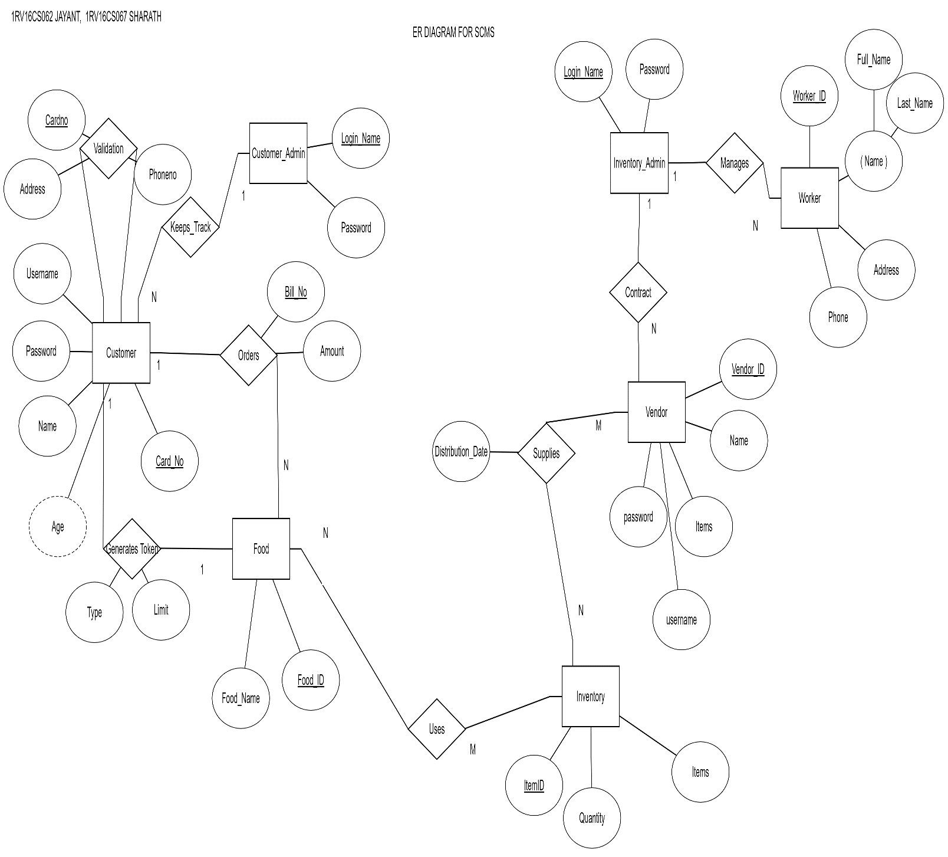

Fig 3.1-E R Diagram of SCMS

**4. Detailed Design**

**4.1 DFD LEVEL-0**

**4.1.1 Processes:**

4.1.1.1Subsidized Canteen Management System(SCMS): The whole process is the the subsidized canteen management system

**4.2.1 Entities:**

4.2.1.1 Customer Admin: Manages Customer details and grants access post validation.

4.2.1.2 Vendor Admin: Handles Vendor information and updates information post updation from Vendor

4.2.1.2 Vendor: People who supply items to the inventory.

4.2.1.3 Customer: People who order food.

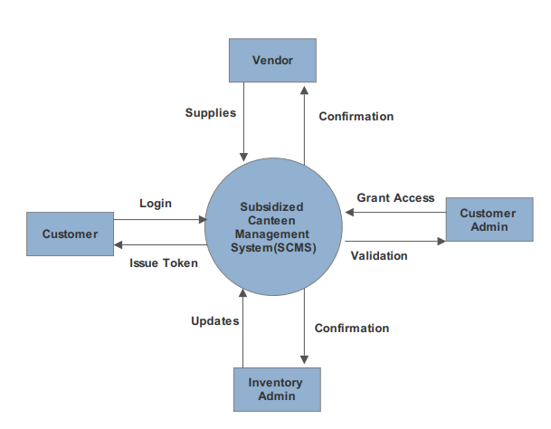

Fig 4.1-DFD level 0

**4.2 DFD LEVEL-1**

**4.2.1 Processes:**

4.2.1.1 Login:Validation of username and password and confirmation of login.

4.2.1.2 Manage Customer Records: Operations on customer records by Customer Admin

4.2.1.3 Manage Inventory Records: Operations on worker and vendor records by Vendor Administrator.

4.2.1.4 Feedback System; Customer give feedback of Food experience and service.

**4.2.2 Entities:**

4.2.2.1 Customer Administrator: Can login and Modify all types of customer records.

4.2.2.2 Inventory Administrator: Can login and Modify all types of worker and vendor records.

4.2.2.3 Customer: Can login, order food and give feedback

4.2.2.4 Vendor: Can login and add items.

**4.2.3 Datastore:**

4.2.3.1 Customer Table: Stores customer details, accessed by Customer Administrator.

4.2.3.2 Inventory Table: Stores inventory details, accessed by Inventory Administrator.

4.2.3.3 Worker Table: Stores worker details, accessed by Inventory Administrator.

4.2.3.4 Feedback: Stores feedback and ratings given by the customer.

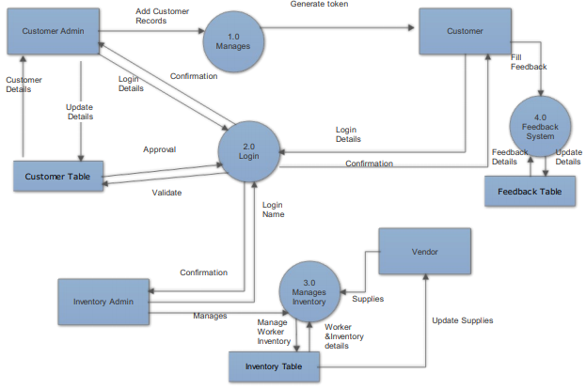

Fig 4.2-DFD level 1

**4.3 DFD LEVEL-2**

**4.3.1 Processes:**

**1.0 Manage Customer Records:**

2.1 View Customer Records: List all customers’ records by retrieving from Customer table and select a record to view it.

2.2 Edit Customer Record: Change details of a Customer record and Update in Customer table.

2.3 Delete Customer Record: Delete Customer record by identifying it with Username.

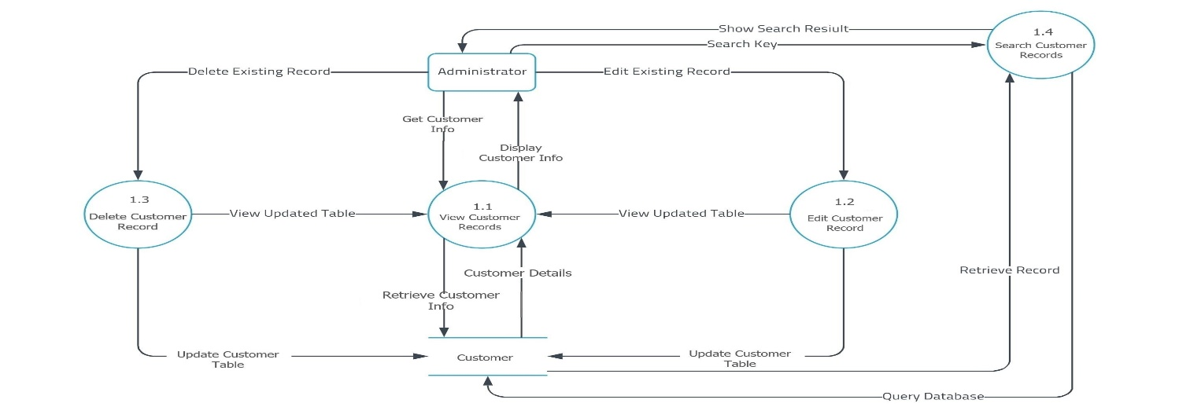

Fig 4.3-DFD level 2.1

**2.0 Login:**

1.1 New Registration: Customer Administrator registers customer by filling required details.

1.2 Check Login Credentials: The login credentials are matched against the values in the customer table to validate login.

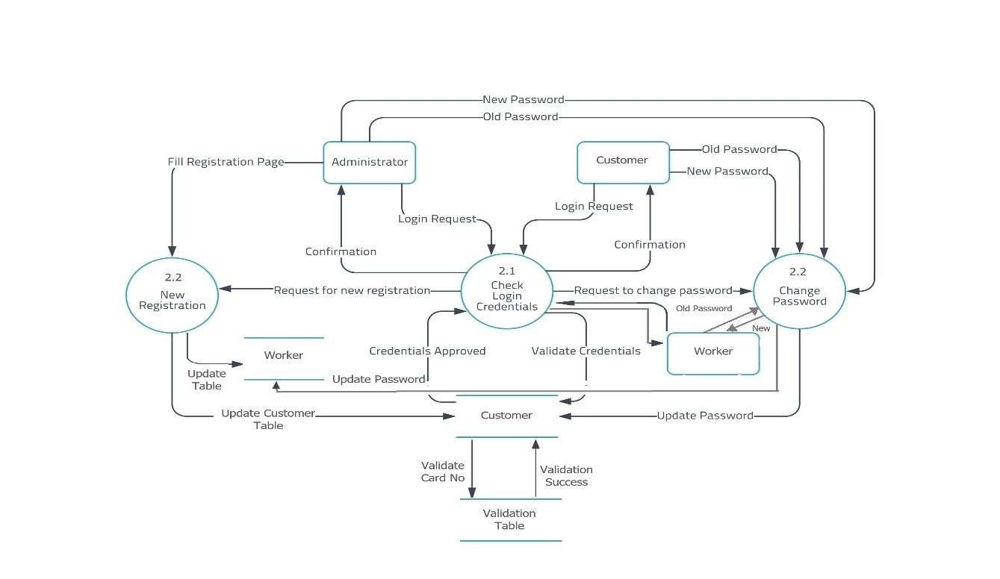

Fig 4.4-DFD level 2.2

**3.0 Manage Vendor Records:**

3.1 View Vendor Records: List all Vendors records by retrieving from Vendor table and select a record to view it.

3.2 Edit Vendor Record: Change details of a Vendor record and Update in Vendor table.

3.3 Delete Vendor Record: Delete Vendor record by identifying it with Vendor name.

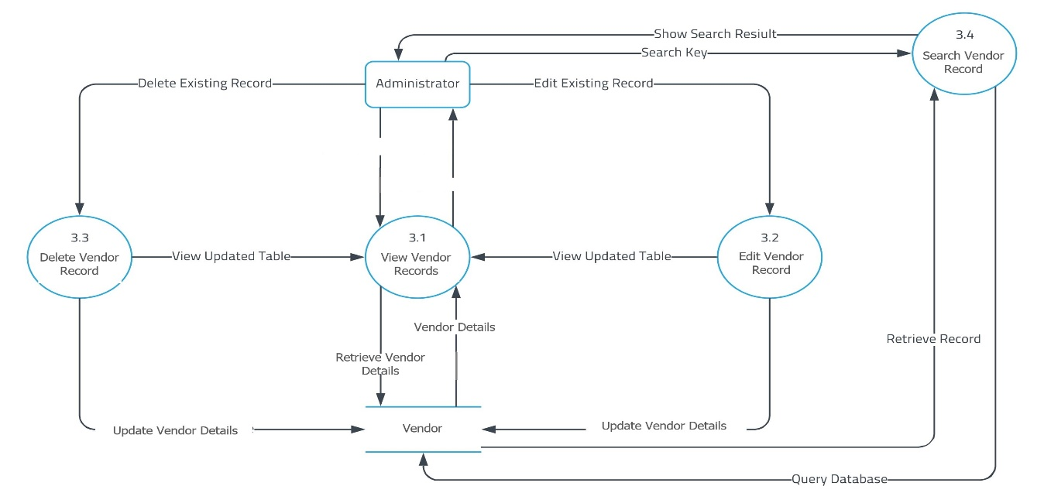

Fig 4.5-DFD level 2.3

**4.0 Feedback System:**

7.1 Feedback Entries: Customer are requested to fill Feedback form in the website. Feedbacks are stored in NoSQL database for analysis.

7.2 Feedback View: Feedbacks are retrieved from database and displayed in a neat fashion.

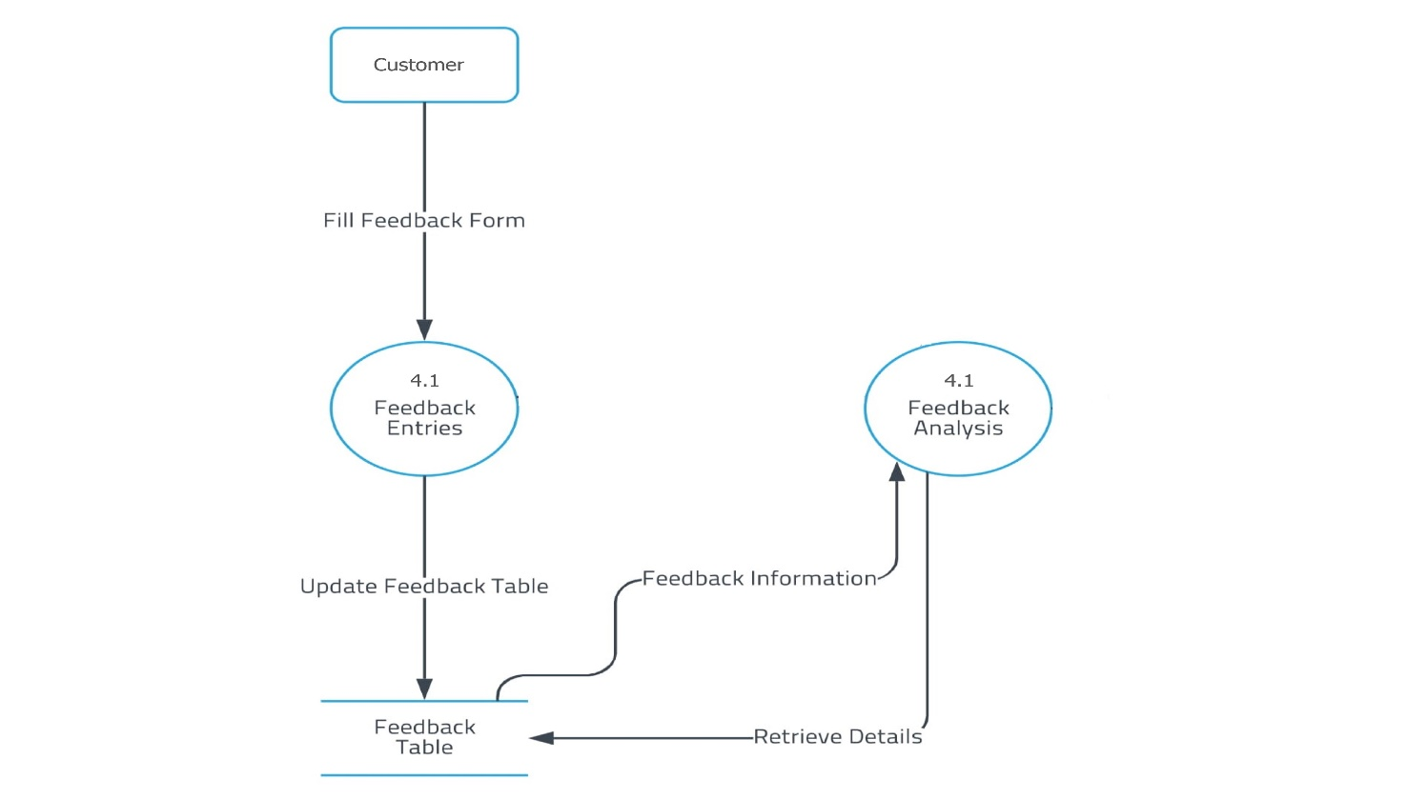

Fig 4.6-DFD level 2.4

**5 Relational Schema and Normalization:**

**5.1 Customer:**

**Functional Dependencies:**

Username-> Password,Name,Age,CardNo

Before normalisation: The table already satisfies 1NF, 2NF, 3NF and BCNF

**5.2 Worker:**

**Functional Dependencies:**

WorkerID ->Name, Age, PhoneNo, Salary

Before Normalization: The table already satisfies 1NF, 2NF, 3NF and BCNF

**5.3 Vendor:**

**Functional Dependencies:**

VendorID->Name, Username, Password, ItemID, PhoneNo

Before normalization: The table already satisfies 1NF, 2NF, 3NF and BCNF

**5.4 Validation:**

**Functional Dependencies:**

CardNo->Phone, Address

Before normalization: The table already satisfies 1NF, 2NF, 3NF and BCNF

**5.5 Food:**

**Functional Dependencies:**

FoodID->FoodName, FoodNo, Quantity, Cost, BillNo

Before normalization: The table already satisfies 1NF, 2NF, 3NF and BCNF

**5.6 Inventory:**

**Functional Dependencies:**

ItemID -> ItemName, Quantity

Before normalization: The table already satisfies 1NF, 2NF, 3NF and BCNF

**Primary Keys:**

* Username (Customer relation).
* WorkerID (Worker relation).
* VendorID (Vendor relation).
* CardNo (Validation relation).
* FoodID (Food relation).
* ItemID (Inventory relation).

**Secondary Keys:**

* CardNo (Customer relation) from Validation relation.
* ItemID (Vendor relation) from Inventory relation.

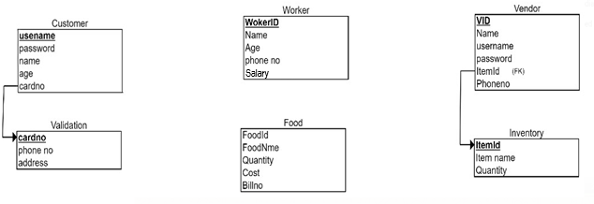

Fig 5.1 -Relational Schema

**6. Conclusion:**

The Subsidized Canteen Management System (SCMS) was built using JSP in Java. The structured data was stored using MySQL and the unstructured using MongoDB. SCMS is monitored by the Customer Admin and the Inventory Admin. The Customer can log-in using his credentials to order food. The Vendor after logging in can add supplies to the Inventory. The workers are managed by the Inv_Admin. The relational Schema has been reduced to Boyce-Codd Normal form, where multivalued attributes, composite attributes, partial and transitive dependencies have been removed. Post the order a bill is generated and the customer is provided with the feedback form.The feedback form consists of the food and service ratings along with star ratings. Thus a complete working of the Subsidized Canteen Management System has been created and built to ensure an easy yet efficient experience for the customer to place his/her order. SCMS in India has a lot of scope. Appropriate usage can lead to provision of the basic minimum nutrition that is needed for an active person, while ensuring that the available resources are allocated optimally.

**7. References:**

[1] <https://www.w3schools.com/sql/>

[2] https://docs.mongodb.com/manual/tutorial/query-documents

[3] Abraham Silberschatz, Henry F. Korth and S. Sudarshan, Database System Concepts, McGraw-Hill Education (Asia), Fifth Edition, 2006.

[4] Kyle Banker,MongoDB in Action, Manning Publications, Illustrated Edition, 2011

[5] https://www.tutorialspoint.com/mongodb/

**8. Appendix:**

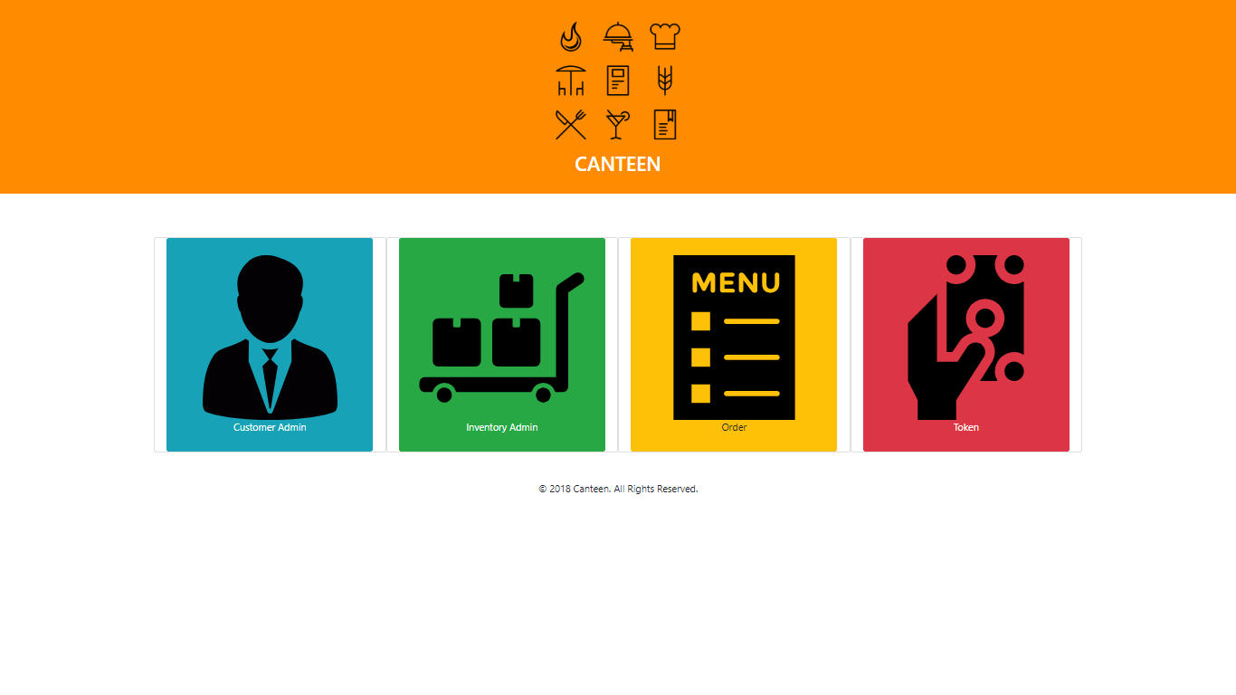

Fig A.1 **Home Page**- User has four options to select from (users can be admins, customers).

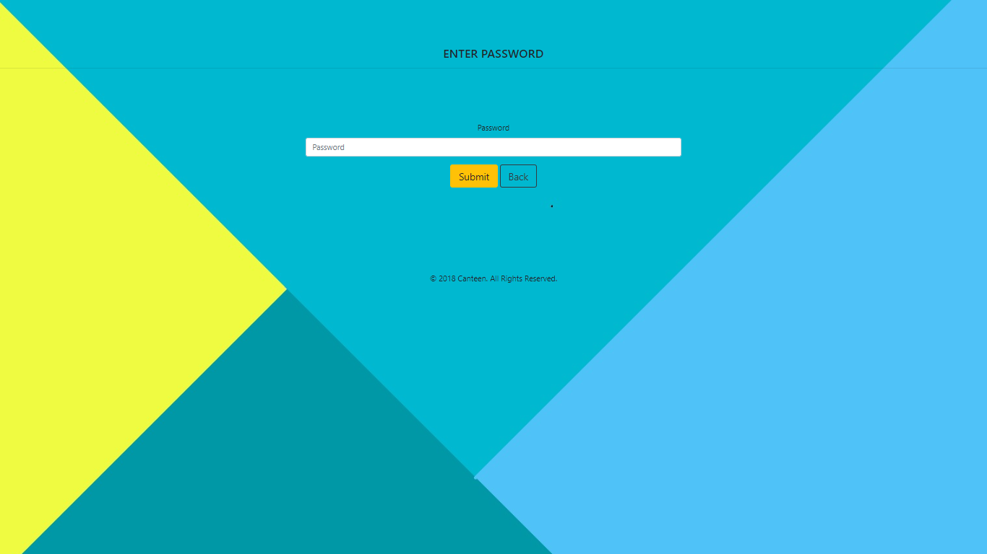

Fig A.2 **Administration Login-**Admin can login by providing correct password.

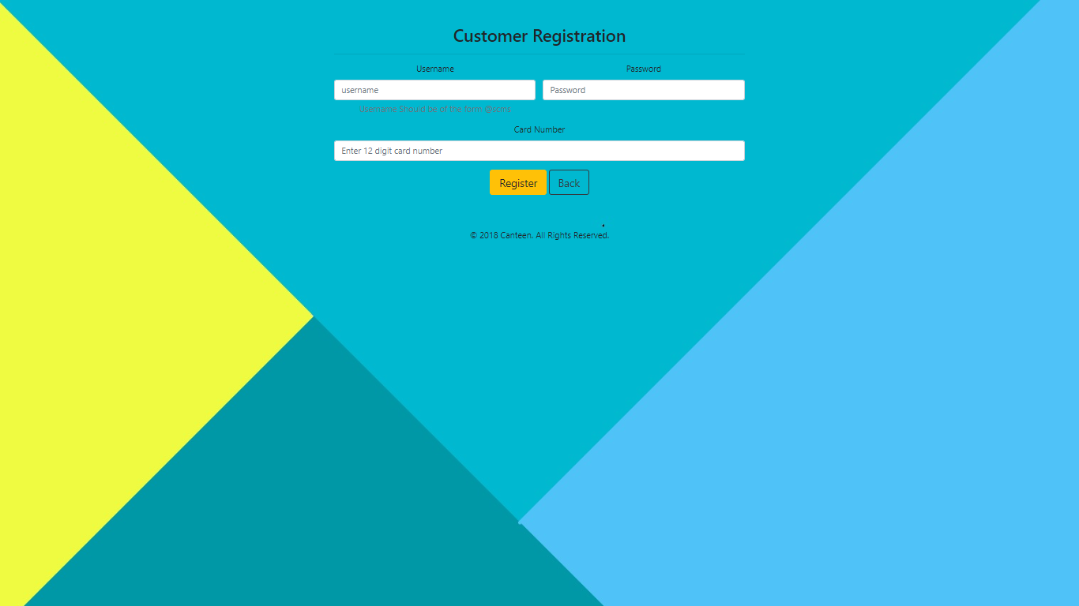

Fig A.3 **Customer Registration**-Registration processfor BPL by validating through BPL card.

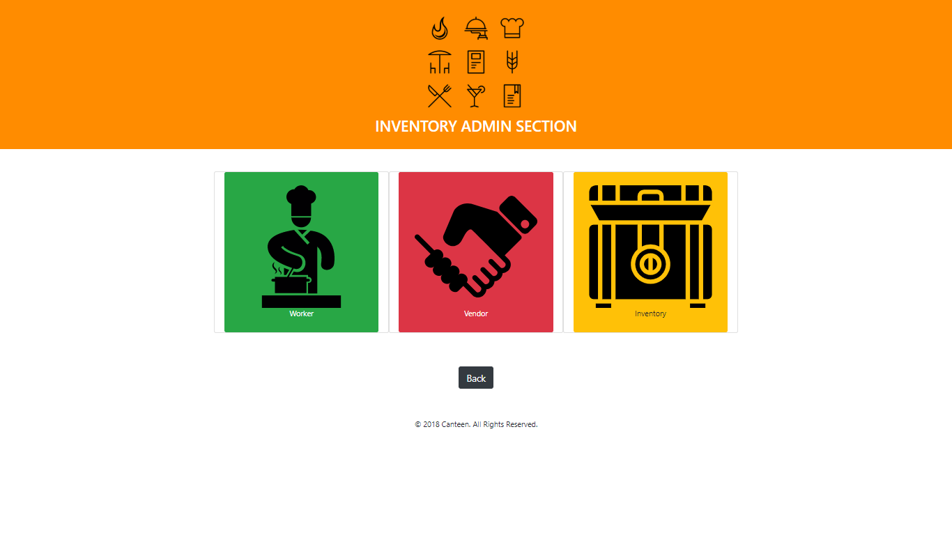

Fig A.4 **Inventory Section-**Inventory admin can manage worker ,vendor and inventory.

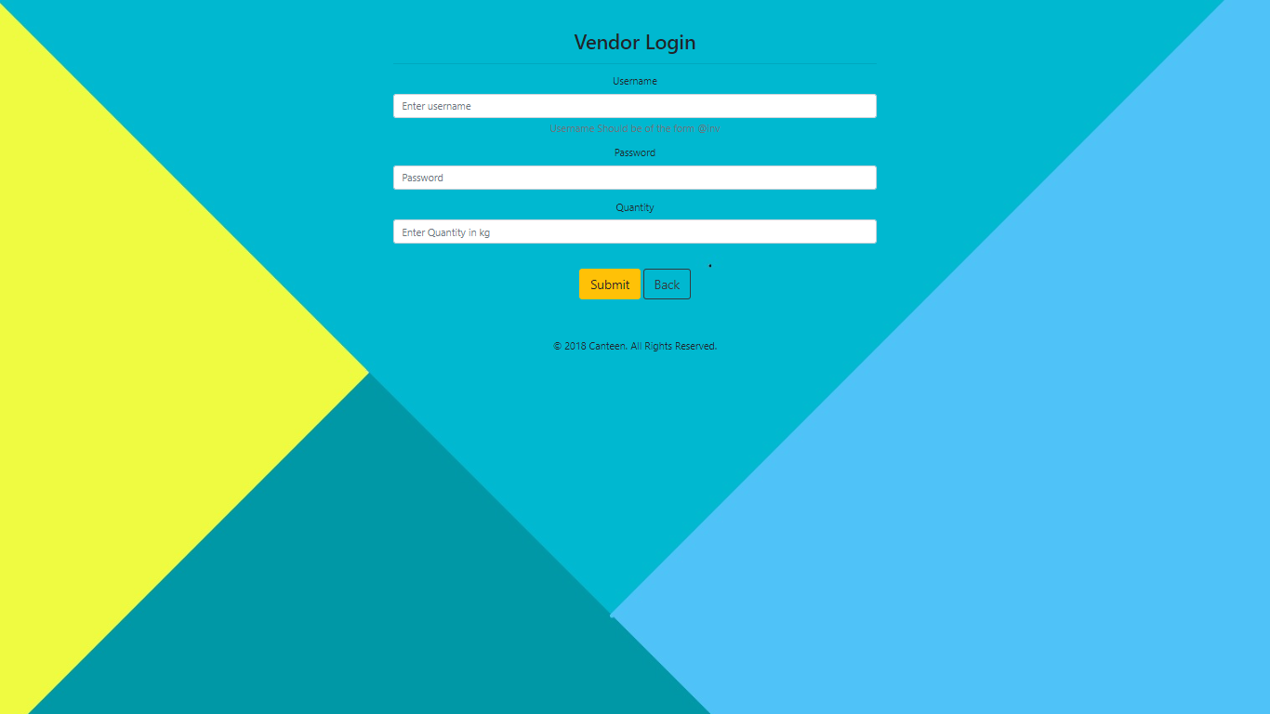

Fig A.5 **Vendor Login**-Vendor can add groceries to inventory by providing correct Login credentials.

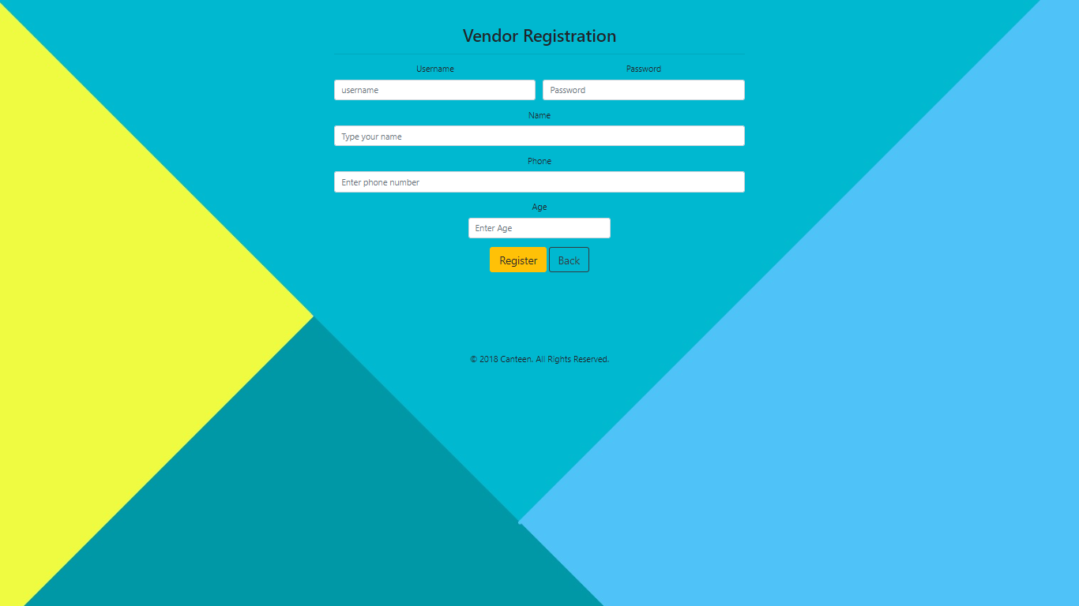

Fig A.6 **Vendor Registration-**Registration is done for user for providing grocery.

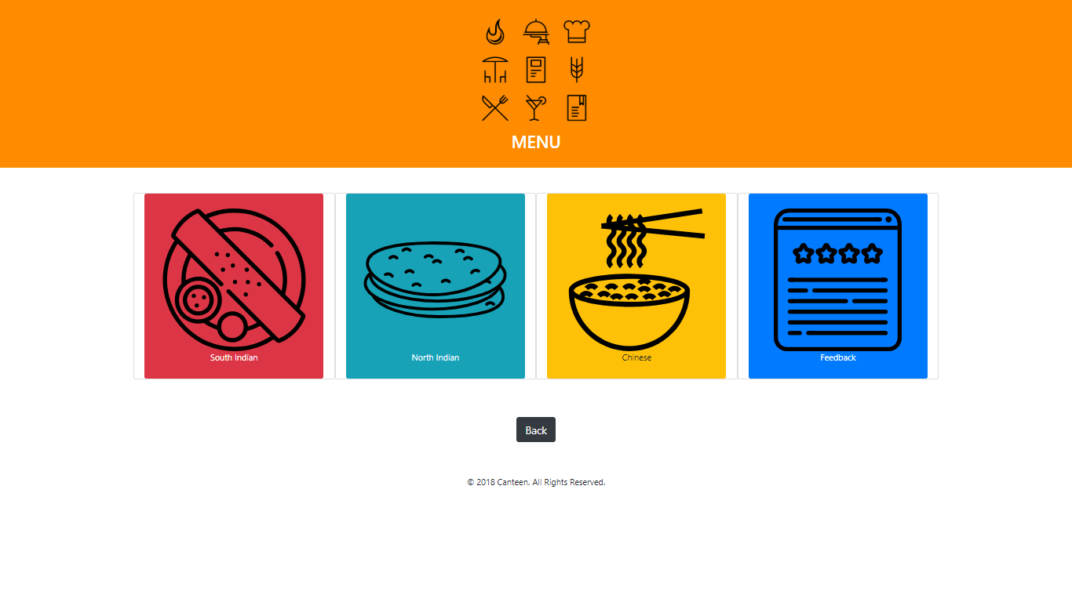

Fig A.7 **Menu**-Customer can choose food from given 3 cuisines (south ,north ,Chinese)

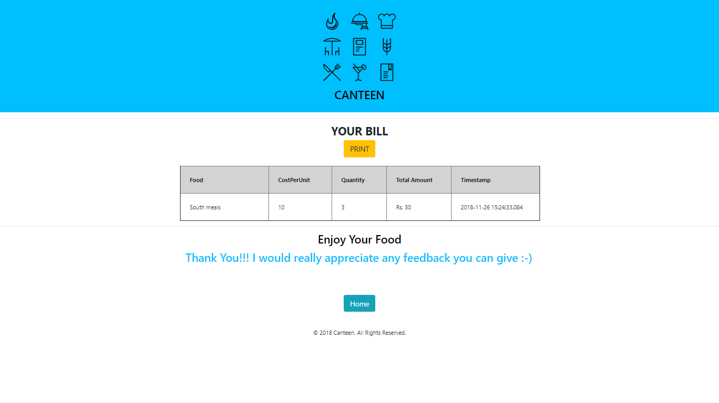

Fig A.8 **Bill**-Bill is generated after ordering of food with timestamp and total amount.



Fig A.9 **Customer Login-**providing login credentials customer gets token based on time.

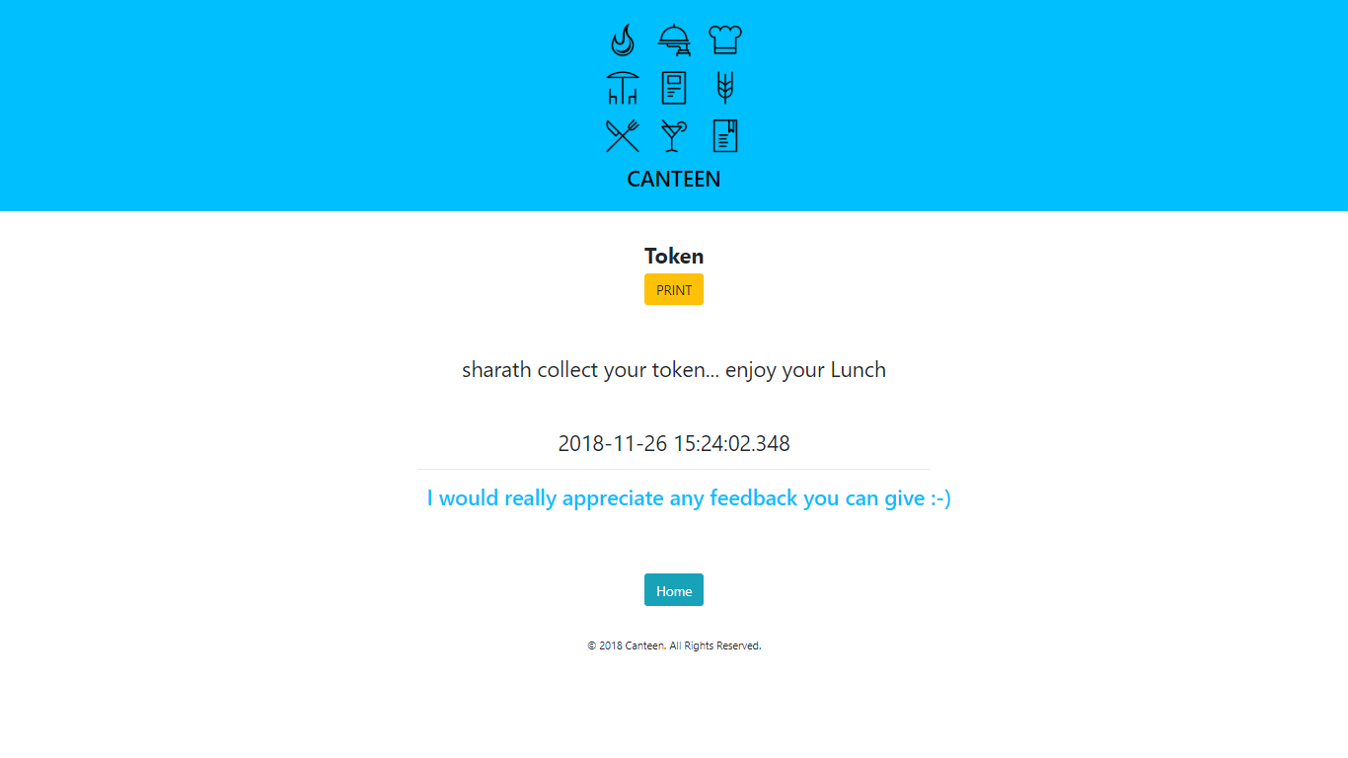

Fig A.10 **Food Token-**Token is generated and can be printed, which is used to collect food.

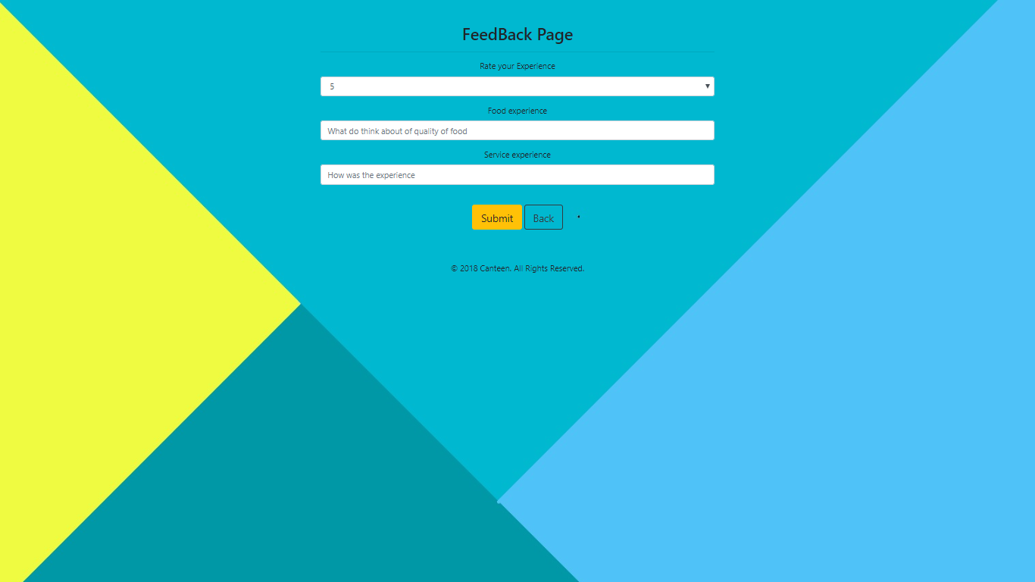

Fig A.11 **Give Feedback**-Customers can give their feedback based on their experience.

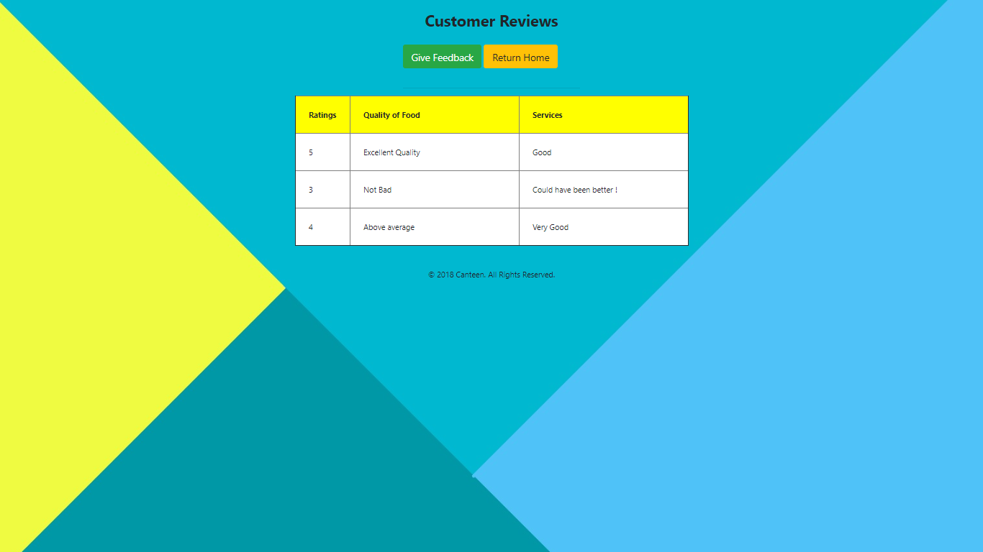

Fig A.12 **View Customer Feedbacks-**Displays all the feedbacks given by customers.