**TITLE: ONLINE SMART PARKING RESERVATION SYSTEM (USING WEBSITE)**

**ABSTRACT:**

Due to the proliferation in the number of vehicles, parking problems are profoundly found in many shopping malls. This is because the current transportation infrastructure and parking facility developed are unable to cope with the influx of vehicles to the mall. If parking problems are not solved effectively, it may lead to unnecessary traffic and waiting.

The purpose of the implementation of an online car parking system is to automate the existing manual system with the help of computerized equipment and full-fledged computer software. This project is an online parking booking system that provides customers with a way of reserving a parking space online. It helps to overcome the problem of finding a place for parking in commercial areas that unnecessarily consumes time.

The project will be a web-based reservation system(website) where users can view various parking areas and select the space to view whether the space is available or not. If the booking space is available then he/she can book it for a specific time slot. Users can also make an online payment for the booking. After making the payment users are notified about the booking with a unique parking number. This webpage will provide the user after login, with options like

1. MY ACCOUNT (ALONG WITH HISTORY OF BOOKINGS)

2. BOOK PARKING

3. VIEW BOOKING

4. CANCEL BOOKING

5. FEEDBACK

6. LOGOUT

Vehicle ingress and egress are also made more convenient with the implementation of hassle-free reservation and payment mechanism. With the implementation of the smart parking system, users can easily locate and secure a vacant parking space at any car park deemed convenient to them.

Online parking system if effectively implemented, can result in an error-free, secure, reliable and fast management system.

**SCOPE:**

Nowadays parking is very important and hence every vehicle owner must park his or her car in a secure designated parking slot available. The implementation of this project can be done from the busiest cities to towns. The only disadvantage is that it is completely online based and it cannot be implemented in remote places where manual methods are being implemented, where everything needs to be converted online to implement this procedure.

As the technology is increasing day by day so in future, there is a scope for a very good and better online slot parking system with solving all the queries and limitations in both hardware and software fields. This project mostly suits to all updated scenarios and also can be suitable, adaptable to future developments. There are many extensions such as to add more options in the car parking system like priority based parking according to park time which makes this webpage reliable over years. In future, it can be developed as an android app too.

**DELIVERABLES:**

A fully functional website that can be easily used by the users (customers and admins) to manage the bookings of the parking in the malls, airports and many more places. The website will track the location of space/lot for vehicles and reflect the same on the website. This can easily be implemented in big malls to alleviate the above-mentioned problems of time and space.

The project is first developed on a Web-based application like a website, but later it can be developed on Android/IOS applications if the customers are interested.

**REQUIREMENTS:**

**HARDWARE REQUIREMENTS:**

Processor (At least Pentium 4)

Sufficient RAM

HARD Disk

Other normal computer hardware parts

**SOFTWARE REQUIREMENTS:**

**Front End**

1. HTML

HTML is used to build the skeleton of the website, so it is essential for every webpage.

1. CSS

CSS is used to style the webpage using various functionalities like layout, colour fonts and therefore helps in formatting and displaying HTML documents.

1. PHP

PHP results in faster site loading speeds as PHP codes runs much faster and is flexible for database connectivity.

It can connect to several databases the most commonly used is MySQL.

PHP allows you to interact with your visitors in ways HTML alone can't.

1. JAVA SCRIPT

Java script helps to make websites dynamic using concepts like DOM(data object manipulation) which makes the website more interactive.

**Back End**

1. MySQL

**Advantages:**

* MySQL can be used for free
* Scalability and Flexibility
* Strong Data Protection
* Management Ease

**Design Tools**

1) Project management activity

Work breakdown structure (WBS) - Lucidchart

Lucidchart is a web-based proprietary platform that allows users to collaborate on drawing, revising and sharing charts and diagrams.

By working with both lucidchart and creately, we felt lucidchart to be more convenient to draw the shapes and connecting with the other levels. Hence lucidchart allows to create WBS diagrams in a simple and efficient way.

In the following stages of our project we are likely to use below mentioned tools.

2)Architecture diagrams – Dia

3)Detailed design – Star UML

4)Configuration management – SVN

5)Web Testing -Selenium

**Customer requirements:**

1. **Stake Holders**

The system would be used by the following persons

End users:

* Customers
* VIP Customers

Administrators:

* Admin

1. **Services Offered**

The system is mainly build to be used in public places for public parking like in malls, supermarkets, station, and so on. This is to avoid the chaos that usually occurs during the process of parking in public places.

* The system provides a graphical view(clear visualization) of the parking spaces.
* It saves user time in search of parking space available in such a long parking area in the malls which is highly crowded.
* User can pay online on the spot and confirm their space.
* It excludes the need for human efforts for managing parking spaces.
* The system generates an online bill for the requested time and even sends an email.
* Cost-effective and easy management.

The project can also be implemented in commercial companies and organizations (hospitals, schools, colleges) to automate their parking system.

**User side functionality:**

* Book parking space
* Cancellation
* Receipt Print
* Feedback

**Admin side functionality:**

* Administers parking booked
* View User Data
* Feedback view and reply

**Modules:**

1. LOGIN TO ACCOUNT (ALONG WITH HISTORY OF BOOKINGS)

* **Admin Login:** The system is under the supervision of the admin who manages the bookings made.
* **User login/registration:** Users have to first register themselves to login into the system.

2. VIEW PARKING

* **Different Parking areas outlook:** The system will provide users with three parking areas of different locations.
* **Parking availability check:** The User can click on spaces to view the availability. If space is already booked it'll be marked yellow and therefore the available ones are going to be seen in normal colour.

1. BOOK PARKING

* **The Parking booking online for date and time:** Users can book parking space for their required date and time.
* **Automatic cost calculation:** The system calculates the total cost incurred for parking based on the time that the user has asked for booking.
* **Email on successful parking booking:** When the user is successful in parking the space, the system sends a confirmation and 'thank you' email regarding the space booked.

1. CANCEL BOOKING

* **Parking cancellation:** User may even cancel their bookings by login into the system anytime.

1. FEEDBACK

* **Feedback:** The system has a feedback form, where the user can provide feedback into the system.

1. LOGOUT

**Process model applicable and why so:**

The process model that is most suitable according to the requirements, resources and time availability is WATERFALL MODEL(also known as a linear-sequential model and classic life cycle).

As mentioned above the requirements(customer requirements, hardware and software requirements) are mentioned and are consistent. There are no ambiguous requirements and all the mentioned requirements are very well documented, clear and fixed.

Time availability for the completion of this project is short. So, we should ensure that all the processes get completed without any interruptions or complications. In this model, each phase is executed completely before the beginning of the next phase. Hence the phases do not overlap in the waterfall model.This model enables us to have clearly defined stages which makes task arrangement easier.

This methodology is well suited for implementations of small projects like our project with fixed constraints, limited time and stable project definition(deliverables are well defined according to the requirements considered).

**Waterfall Model application in this project according to stages in this process model:**

**1)Communication:**

Requirement gathering (along with its analysis)

We have collected all the requirements like customer requirements, hardware and software requirements that are required to the stakeholders(end users and administrators).

**2)Planning**

Estimation

Scheduling

Tracking

It consists of the complete estimation of completion time, scheduling of tasks and tracking of tasks assigned and completed for project development.

**3)Modeling**

Analysis

Design

Modeling consists of complete requirement analysis and the design of the project i.e algorithm, flowchart etc. The algorithm is the step-by-step solution to the problem and the flow chart shows a complete flow diagram of a program.

**4) Construction**

Construction consists of code generation and the testing part.

After the code generation of the website by using software requirements of the front end(HTML, CSS, javascript) and back end(MYSQL, PHP) it is passed to the testing phase.

Testing is to check whether the flow of coding is correct or not. Testing also checks that the program provides the desired output.

**5) Deployment**

The Deployment step consists of delivering the product to the customer and taking feedback from them. The Website is delivered to the parking management team working in the mall.

If the customer(parking management) wants some corrections or demands for the additional capabilities, then the change is required for improvement in the quality of the software.

**The justification for not using other process models is stated below:**

**i) Evolutionary development model:** The model is not required because it does not require constant feedback and updates to evolve into a new system. The Evolutionary model is commonly used when the customer wants to start using the core features instead of waiting for the full software which is not required in the website development because it is hard to divide the problem into several versions that would be acceptable to the customer.

**ii) Incremental development model:** The model is delivered partially and features are incorporated in due course of time. We don’t use this model because it does not demand an early release of a product. It is all about prioritizing the requirement. The upcoming requirements should not affect the existing or estimated requirement. Usually, in large projects, System development is broken down into many mini development projects but the development of a website is a small scale-based project. Thus, this model is not used because the tool is not large.

**iii) Rapid application development:** The model involves parallel development of the product with limited time and enough resources. The functional modules are developed in parallel as prototypes and are integrated to make the complete product for faster product delivery which is not the case here. It should be used if there is a high availability of designers for Modelling. It should be used only if the budget permits use of automated code generating tools. As this is a small scale project(website development), we not going for this model.

**iv) Spiral model:** This model is used only when there is a new development product and it is a model with a high emphasis on risk analysis used for critical systems. Risk Analysis includes identifying, estimating and monitoring the technical feasibility and management risks, such as schedule slippage and cost overrun which is not the case in an online parking system because it is an existing system and does not have any critical phases.

**ER Diagram**

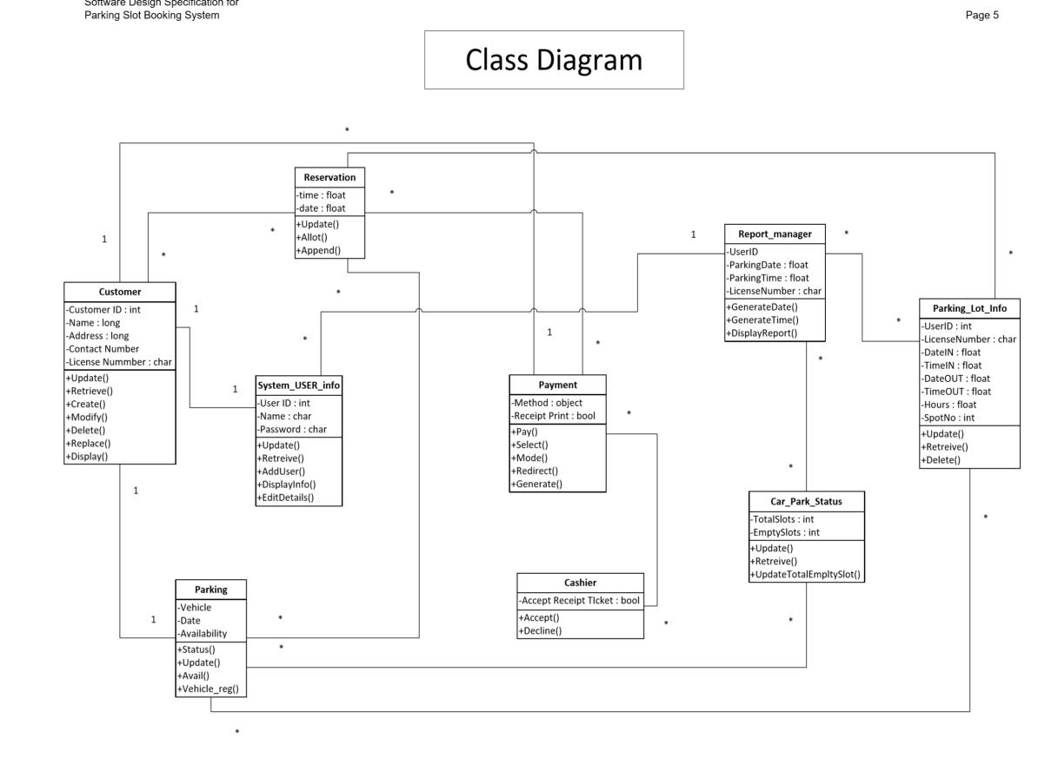We have used the Lucid chart tool to draw and construct this ER diagram according to the current requirements and our visualization. This tool is easy and convenient to draw the shapes and to connect the different levels of our ER diagram in an efficient way.